Developer tutorial for creating a Hyperledger Composer solution

https://hyperledger.github.io/composer/latest/tutorials/developer-tutorial.html

Table of Contents
About 1
Step One: Creating a business network structure 2
Step Two: Defining a business network 3
Modelling assets, participants, and transactions 3
Adding JavaScript transaction logic 3
Adding access control 4
Step Three: Generate a business network archive 4
Step Four: Deploying the business network 5
Retrieving the correct credentials 5
Deploying the business network 5
Step Five: Generating a REST server 7
Step Six: Generating an application 8
Known issues 8
Destroy previous setup 9
Deletes a business network card. 9
Command failed 9
Key Concepts in Hyperledger Composer 10
Blockchain State Storage 10
Connection Profiles 10
Assets 11
Participants 11
Identities 11
Business Network cards 11
Transactions 11
Queries 11
Events 11
Access Control 12
Historian registry 12

About
This tutorial will walk you through building a Hyperledger Composer blockchain solution from scratch. In the space of a few hours you will be able to go from an idea for a disruptive blockchain innovation, to executing transactions against a real Hyperledger Fabric blockchain network and generating/running a sample Angular 2 application that interacts with a blockchain network.

This tutorial gives an overview of the techniques and resources available to apply to your own use case.

Note: This tutorial was written against the latest Hyperledger Composer build on Ubuntu Linux running with Hyperledger Fabric v1.1 where referenced below and also tested for a Mac environment.

Prerequisites

Before beginning this tutorial:

Set up your development environment
Install an editor e.g. VSCode or Atom

Step One: Creating a business network structure
The key concept for Hyperledger Composer is the business network definition (BND). It defines the data model, transaction logic and access control rules for your blockchain solution. To create a BND, we need to create a suitable project structure on disk.
The easiest way to get started is to use the Yeoman generator to create a skeleton business network. This will create a directory containing all of the components of a business network.
- Create a skeleton business network using Yeoman. This command will require a business network name, description, author name, author email address, license selection and namespace.
yo hyperledger-composer:businessnetwork
- Enter tutorial-network for the network name, and desired information for description, author name, and author email.
- Select Apache-2.0 as the license.
- Select org.example.mynetwork as the namespace.
- Select No when asked whether to generate an empty network or not.
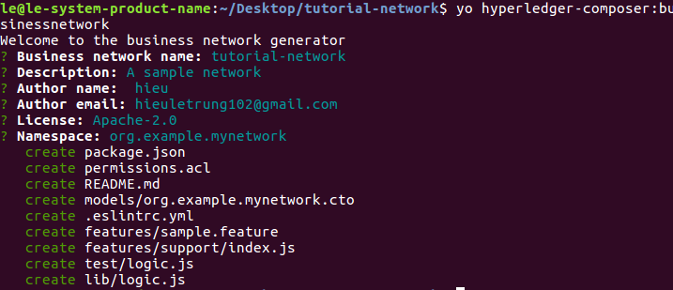

Step Two: Defining a business network
A business network is made up of assets, participants, transactions, access control rules, and optionally events and queries. In the skeleton business network created in the previous steps, there is a model (.cto) file which will contain the class definitions for all assets, participants, and transactions in the business network. The skeleton business network also contains an access control (permissions.acl) document with basic access control rules, a script (logic.js) file containing transaction processor functions, and a package.json file containing business network metadata.

Modelling assets, participants, and transactions
The first document to update is the model (.cto) file. This file is written using the Hyperledger Composer Modelling Language. The model file contains the definitions of each class of asset, transaction, participant, and event. It implicitly extends the Hyperledger Composer System Model described in the modelling language documentation.
- Open the org.example.mynetwork.cto model file.
- Replace the contents with the following:
/**
* My commodity trading network
*/
namespace org.example.mynetwork
asset Commodity identified by tradingSymbol {
o String tradingSymbol
o String description
o String mainExchange
o Double quantity
--> Trader owner
}
participant Trader identified by tradeId {
o String tradeId
o String firstName
o String lastName
}
transaction Trade {
--> Commodity commodity
--> Trader newOwner
}
- Save your changes to org.example.mynetwork.cto.

Adding JavaScript transaction logic
In the model file, a Trade transaction was defined, specifying a relationship to an asset, and a participant. The transaction processor function file contains the JavaScript logic to execute the transactions defined in the model file.
The Trade transaction is intended to simply accept the identifier of the Commodity asset which is being traded, and the identifier of the Trader participant to set as the new owner.
- Open the logic.js script file.
- Replace the contents with the following:
/**
* Track the trade of a commodity from one trader to another
* @param {org.example.mynetwork.Trade} trade - the trade to be processed
* @transaction
*/
async function tradeCommodity(trade) {
trade.commodity.owner = trade.newOwner;
let assetRegistry = await getAssetRegistry('org.example.mynetwork.Commodity');
await assetRegistry.update(trade.commodity);
}
- Save your changes to logic.js.

Adding access control
- Replace the following access control rules in the file permissions.acl :
/**
* Access control rules for tutorial-network
*/
rule Default {
description: "Allow all participants access to all resources"
participant: "ANY"
operation: ALL
resource: "org.example.mynetwork.*"
action: ALLOW
}

rule SystemACL {
description: "System ACL to permit all access"
participant: "ANY"
operation: ALL
resource: "org.hyperledger.composer.system.**"
action: ALLOW
}
- Save your changes to permissions.acl.

Step Three: Generate a business network archive
Now that the business network has been defined, it must be packaged into a deployable business network archive (.bna) file.
- Using the command line, navigate to the tutorial-network directory.
- From the tutorial-network directory, run the following command:
composer archive create -t dir -n .
After the command has run, a business network archive file called tutorial-network@0.0.1.bna has been created in the tutorial-network directory.
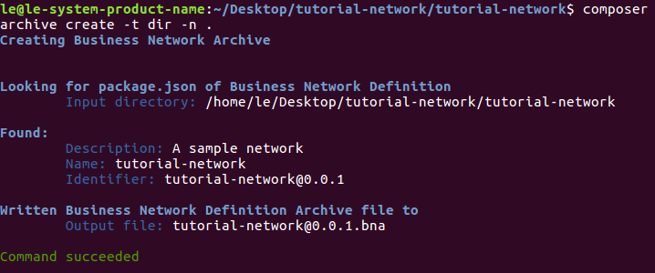

Step Four: Deploying the business network
After creating the .bna file, the business network can be deployed to the instance of Hyperledger Fabric. Normally, information from the Fabric administrator is required to create a PeerAdmin identity, with privileges to install chaincode to the peer as well as start chaincode on the composerchannel channel. However, as part of the development environment installation, a PeerAdmin identity has been created already.
cd ~/fabric-dev-servers
./startFabric.sh
./createPeerAdminCard.sh

After the business network has been installed, the network can be started. For best practice, a new identity should be created to administer the business network after deployment. This identity is referred to as a network admin.

Retrieving the correct credentials
A PeerAdmin business network card with the correct credentials is already created as part of development environment installation.

Deploying the business network
Deploying a business network to the Hyperledger Fabric requires the Hyperledger Composer business network to be installed on the peer, then the business network can be started, and a new participant, identity, and associated card must be created to be the network administrator. Finally, the network administrator business network card must be imported for use, and the network can then be pinged to check it is responding.
- To install the business network, from the tutorial-network directory, run the following command:
composer network install --card PeerAdmin@hlfv1 --archiveFile tutorial-network@0.0.1.bna
The composer network install command requires a PeerAdmin business network card (in this case one has been created and imported in advance), and the the file path of the .bna which defines the business network.
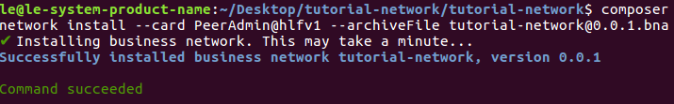
- To start the business network, run the following command:
composer network start --networkName tutorial-network --networkVersion 0.0.1 --networkAdmin admin --networkAdminEnrollSecret adminpw --card PeerAdmin@hlfv1 --file networkadmin.card
The composer network start command requires a business network card, as well as the name of the admin identity for the business network, the name and version of the business network and the name of the file to be created ready to import as a business network card.
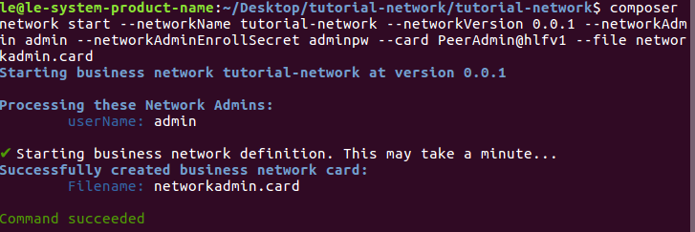
- To import the network administrator identity as a usable business network card, run the following command:
composer card import --file networkadmin.card
The composer card import command requires the filename specified in composer network start to create a card.
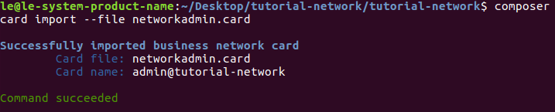
- To check that the business network has been deployed successfully, run the following command to ping the network:
composer network ping --card admin@tutorial-network
The composer network ping command requires a business network card to identify the network to ping.
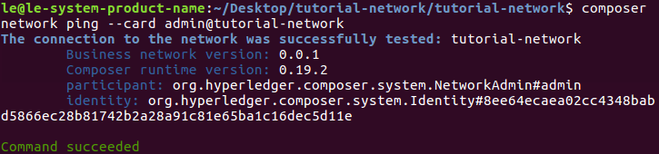

Step Five: Generating a REST server
Hyperledger Composer can generate a bespoke REST API based on a business network. For developing a web application, the REST API provides a useful layer of language-neutral abstraction.
- To create the REST API, navigate to the tutorial-network directory and run the following command:
composer-rest-server
- Enter admin@tutorial-network as the card name.
- Select use namespaces when asked whether to use namespaces in the generated API.
- Select when asked whether to secure the generated API.
- Select when asked whether to enable event publication.
- Select when asked whether to enable TLS security.
The generated API is connected to the deployed blockchain and business network.
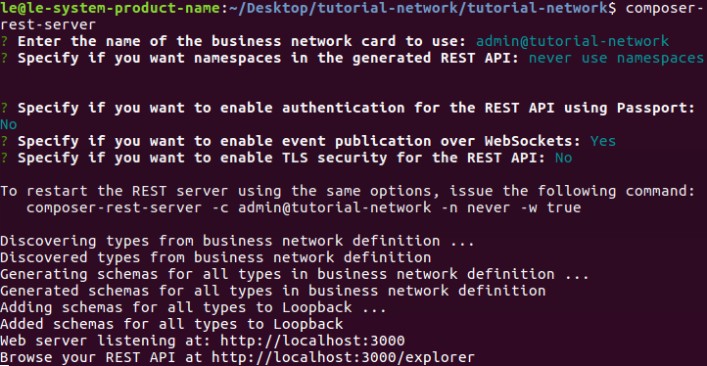

Step Six: Generating an application
Hyperledger Composer can also generate an Angular 4 application running against the REST API.
- To create your Angular 4 application, navigate to tutorial-network directory and run the following command:
yo hyperledger-composer:angular
- Select when asked to connect to running business network.
- Enter standard package.json questions (project name, description, author name, author email, license)
- Enter admin@tutorial-network for the business network card.
- Select Connect to an existing REST API
- Enter http://localhost for the REST server address.
- Enter 3000 for server port.
- Select Namespaces are not used
The Angular generator will then create the scaffolding for the project and install all dependencies. To run the application, navigate to your angular project directory and run npm start . This will fire up an Angular 4 application running against your REST API at http://localhost:4200 .

Known issues

Destroy previous setup

If you've previously used an older version of Hyperledger Composer and are now setting up a new install, you may want to kill and remove all previous Docker containers, which you can do with these commands:
docker kill $(docker ps -q)
docker rm $(docker ps -aq)
docker rmi $(docker images dev-* -q)
docker rmi -f $(docker images -a -q)

Deletes a business network card.
composer card delete --card admin@tutorial-network

Command failed
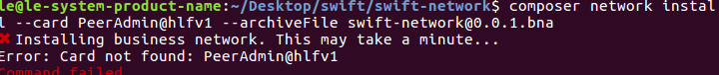
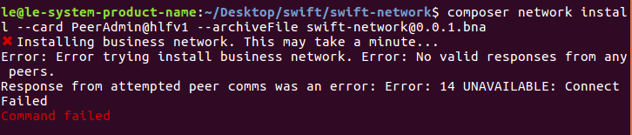
To create card PeerAdmin and peers, run below commands
cd ~/fabric-dev-servers
./startFabric.sh
./createPeerAdminCard.sh
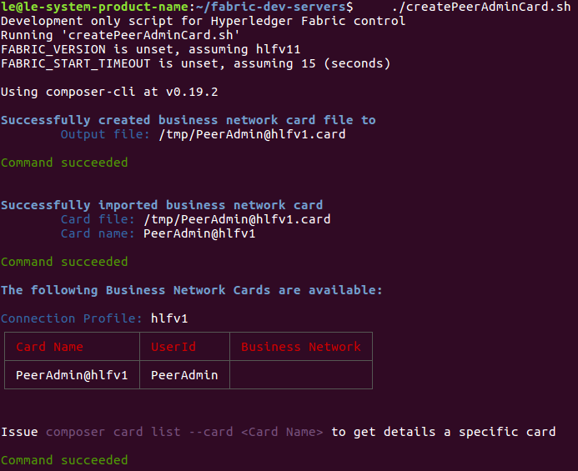

Key Concepts in Hyperledger Composer
Hyperledger Composer is a programming model containing a modeling language, and a set of APIs to quickly define and deploy business networks and applications that allow participants to send transactions that exchange assets.

Blockchain State Storage
All transactions submitted through a business network are stored on the blockchain ledger, and the current state of assets and participants are stored in the blockchain state database. The blockchain distributes the ledger and the state database across a set of peers and ensures that updates to the ledger and state database are consistent across all peers using a consensus algorithm.

Connection Profiles
Hyperledger Composer uses Connection Profiles to define the system to connect to. A connection profile is a JSON document the is part of a business network card. These profiles are usually provided by the creator of the system they refer to and should be used to create business network cards in order to be able to connect to that system.

Assets
Assets are tangible or intangible goods, services, or property, and are stored in registries. Assets can represent almost anything in a business network, for example, a house for sale, the sale listing, the land registry certificate for that house, and the insurance documents for that house may all be assets in one or more business networks.
Assets must have a unique identifier, but other than that, they can contain whatever properties you define. Assets may be related to other assets or participants.

Participants
Participants are members of a business network. They may own assets and submit transactions. Participant types are modeled, and like assets, must have an identifier and can have any other properties as required. A participant can be mapped to one or multiple identities.

Identities
An identity is a digital certificate and private key. Identities are used to transact on a business network and must be mapped to a participant in the business network. A single identity is stored in a business network card and if that identity has been mapped to a participant, it allows the user of that business network card to transact on a business network as that participant.

Business Network cards
Business network cards are a combination of an identity, a connection profile, and metadata, the metadata optionally containing the name of the business network to connect to. Business network cards simplify the process of connecting to a business network, and extend the concept of an identity outside the business network to a 'wallet' of identities, each associated with a specific business network and connection profile.

Transactions
Transactions are the mechanism by which participants interact with assets. This could be as simple as a participant placing a bid on a asset in an auction, or an auctioneer marking an auction closed, automatically transferring ownership of the asset to the highest bidder.

Queries
Queries are used to return data about the blockchain world-state. Queries are defined within a business network, and can include variable parameters for simple customization. By using queries, data can be easily extracted from your blockchain network. Queries are sent by using the Hyperledger Composer API.

Events
Events are defined in the business network definition in the same way as assets or participants. Once events have been defined, they can be emitted by transaction processor functions to indicate to external systems that something of importance has happened to the ledger. Applications can subscribe to emitted events through the composer-client API.

Access Control
Business networks may contain a set of access control rules. Access control rules allow fine-grained control over what participants have access to what assets in the business network and under what conditions. The access control language is rich enough to capture sophisticated conditions declaratively, such as "only the owner of a vehicle can transfer ownership of the vehicle". Externalizing access control from transaction processor function logic makes it easier to inspect, debug, develop and maintain.

Historian registry
The historian is a specialised registry which records successful transactions, including the participants and identities that submitted them. The historian stores transactions as HistorianRecord assets, which are defined in the Hyperledger Composer system namespace.

