Table of Contents
About 2
Getting Started 2
Prerequisites 2
Install Samples, Binaries and Images 2
Key Concepts 5
Building Your First Network 5
Generate Network Artifacts 5
Bring Up the Network 6
Run The Tools Manually 7
Manually generate the artifacts 7
Create a Channel Configuration Transaction 7
Start the network 8
Create & Join Channel 9
Update the anchor peers 10
Install & Instantiate Chaincode 11
Query 12
Invoke 12
What does this demonstrate? 13
What’s happening behind the scenes? 13
Glossary 13

About
The build your first network (BYFN) scenario provisions a sample Hyperledger Fabric network consisting of two organizations, each maintaining two peer nodes, and a “solo” ordering service.
https://hyperledger-fabric.readthedocs.io/en/latest/build_network.html

Getting Started

Prerequisites
- Install Curl
- Docker and Docker Compose
- Go language
- Node.js Runtime and NPM
- Python

The Fabric Node.js SDK requires an iteration of Python 2.7 in order for npm install operations to complete successfully. Retrieve the 2.7 version with the following command:
$ sudo apt-get install python
Check your version(s):
$ python –version

Install Samples, Binaries and Images
Determine a location on your machine where you want to place the Hyperledger Fabric Samples repository and enter that directory in a terminal window. The command that follows will perform the following steps:

- if needed, clone the hyperledger/fabric-samples repository
- checkout the appropriate version tag
- install the Hyperledger Fabric platform-specific binaries and config files for the version specified into the root of the fabric-samples repository
- download the Hyperledger Fabric docker images for the version specified

Once you are ready, and in the directory into which you will install the Fabric Samples and binaries, go ahead and execute the following command:
$ curl -sSL https://goo.gl/6wtTN5 | bash -s 1.1.0
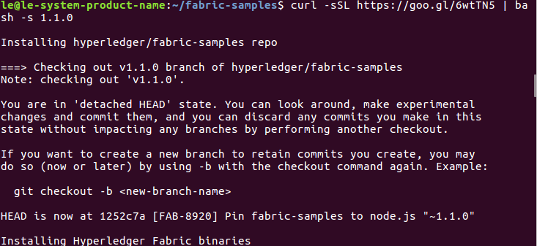
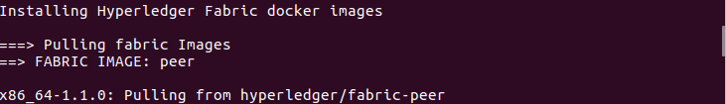
Note
If you get an error running the above curl command, you may have too old a version of curl that does not handle redirects or an unsupported environment.

Please visit the Prerequisites page for additional information on where to find the latest version of curl and get the right environment. Alternately, you can substitute the un-shortened URL: https://github.com/hyperledger/fabric/blob/master/scripts/bootstrap.sh

Note
You can use the command above for any published version of Hyperledger Fabric. Simply replace ‘1.1.0’ with the version identifier of the version you wish to install.

The command above downloads and executes a bash script that will download and extract all of the platform-specific binaries you will need to set up your network and place them into the cloned repo you created above. It retrieves six platform-specific binaries:

cryptogen,
configtxgen,
configtxlator,
peer,
orderer, and
fabric-ca-client

and places them in the bin sub-directory of the current working directory.

You may want to add that to your PATH environment variable so that these can be picked up without fully qualifying the path to each binary. e.g.:
$ export PATH=<path to download location>/bin:$PATH

Finally, the script will download the Hyperledger Fabric docker images from Docker Hub into your local Docker registry and tag them as ‘latest’.
The script lists out the Docker images installed upon conclusion.
Look at the names for each image; these are the components that will ultimately comprise our Hyperledger Fabric network. You will also notice that you have two instances of the same image ID - one tagged as “x86_64-1.x.x” and one tagged as “latest”.
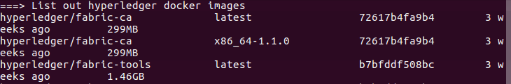
To confirm and see the list of Docker images you’ve just downloaded, run:

$ docker images

Key Concepts
Introduction
Hyperledger Fabric Functionalities
Hyperledger Fabric Model
Identity
Membership
Peers
Ledger
Use Cases

Building Your First Network
The build your first network (BYFN) scenario provisions a sample Hyperledger Fabric network consisting of two organizations, each maintaining two peer nodes, and a “solo” ordering service.
Install prerequisites
Before we begin, if you haven’t already done so, you may wish to check that you have all the Prerequisites installed on the platform(s) on which you’ll be developing blockchain applications and/or operating Hyperledger Fabric.

You will also need to Install Samples, Binaries and Images. You will notice that there are a number of samples included in the fabric-samples repository. We will be using the first-network sample. Let’s open that sub-directory now.

$ cd fabric-samples/first-network
Note
The supplied commands in this documentation MUST be run from your first-network sub-directory of the fabric-samples repository clone. If you elect to run the commands from a different location, the various provided scripts will be unable to find the binaries.

Generate Network Artifacts

Ready to give it a go? Okay then! Execute the following command:

$ ./byfn.sh -m generate

This first step generates all of the certificates and keys for our various network entities – org1 and org2, the genesis block used to bootstrap the ordering service, and a collection of configuration transactions -channel tx - required to configure a Channel.

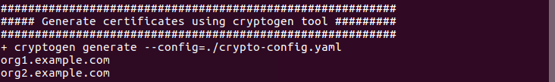
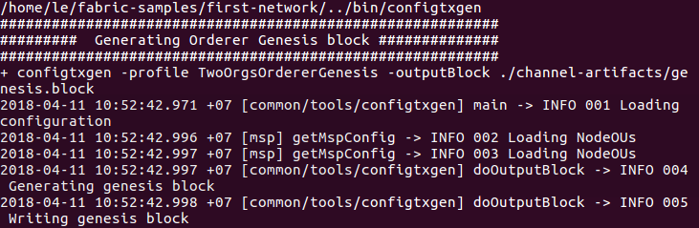
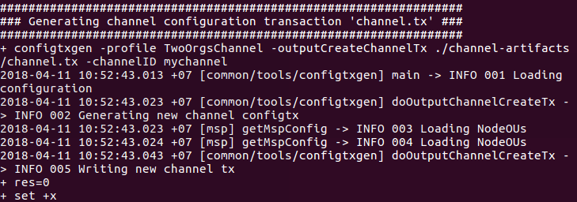

Bring Up the Network

Next, you can bring the network up with one of the following commands:

$ ./byfn.sh -m up

You can use docker ps to list the executing containers. In our case, you should see the following 6 containers executing:

Four peers (4)
The orderer (1)
The CLI (1)

Note: At any time, you can use the docker logs <container ID|Name> to view the logs.

Note: You can shut down the containers (i.e. the whole Hyperledger Fabric blockchain network) using the docker rm -f $(docker ps -aq) command. The other option is to use ./byfn.sh -m down command which removes the previously created crypto artifacts as well.
Bring Down the Network

Finally, let’s bring it all down so we can explore the network setup one step at a time. The following will kill your containers, remove the crypto material and four artifacts, and delete the chaincode images from your Docker Registry:

$ ./byfn.sh -m down

This command will kill your containers, remove the crypto material and four artifacts, and delete the chaincode images from your Docker Registry.

And that’s it for a simple demonstration!

Run The Tools Manually

Manually generate the artifacts

$ ../bin/cryptogen generate –config=./crypto-config.yaml

The certs and keys (i.e. the MSP material) will be output into a directory - crypto-config - at the root of the first-network directory.

Next, we need to tell the configtxgen tool where to look for the configtx.yaml file that it needs to ingest. We will tell it look in our present working directory:
$ export FABRIC_CFG_PATH=$PWD

Create folder channel-artifacts at the root of the project to write genesis block to
$ mkdir channel-artifacts

Then, we’ll invoke the configtxgen tool to create the orderer genesis block:

$ ../bin/configtxgen -profile TwoOrgsOrdererGenesis -outputBlock ./channel-artifacts/genesis.block

Create a Channel Configuration Transaction

Next, we need to create the channel transaction artifact. Be sure to replace $CHANNEL_NAME or set CHANNEL_NAME as an environment variable that can be used throughout these instructions:

$ export CHANNEL_NAME=mychannel
$ ../bin/configtxgen -profile TwoOrgsChannel -outputCreateChannelTx ./channel-artifacts/channel.tx -channelID $CHANNEL_NAME
Next, we will define the anchor peer for Org1 on the channel that we are constructing. Again, be sure to replace $CHANNEL_NAME or set the environment variable for the following commands. The terminal output will mimic that of the channel transaction artifact:

$ ../bin/configtxgen -profile TwoOrgsChannel -outputAnchorPeersUpdate ./channel-artifacts/Org1MSPanchors.tx -channelID $CHANNEL_NAME -asOrg Org1MSP

Now, we will define the anchor peer for Org2 on the same channel:

$ ../bin/configtxgen -profile TwoOrgsChannel -outputAnchorPeersUpdate ./channel-artifacts/Org2MSPanchors.tx -channelID $CHANNEL_NAME -asOrg Org2MSP

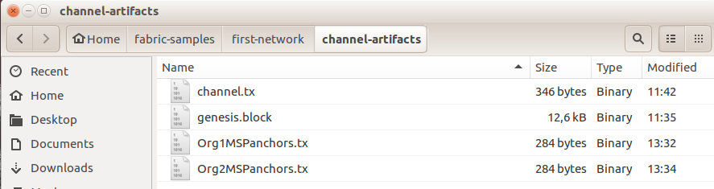

Start the network
First let’s start your network:
$ docker-compose -f docker-compose-cli.yaml up -d

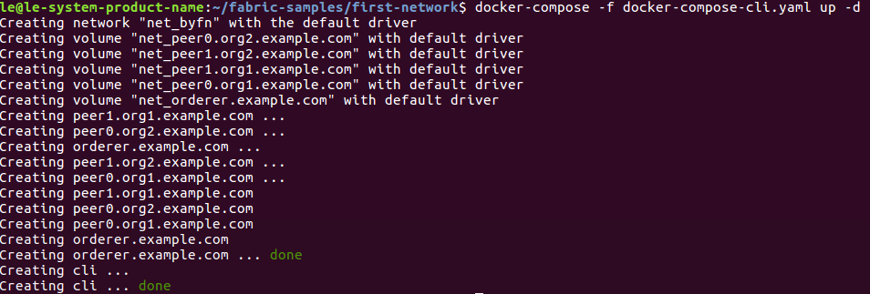
The CLI container will stick around idle for 1000 seconds. If it’s gone when you need it you can restart it with a simple command:
$ docker start cli

Environment variables
CORE_PEER_MSPCONFIGPATH=/opt/gopath/src/github.com/hyperledger/fabric/peer/crypto/peerOrganizations/org1.example.com/users/Admin@org1.example.com/msp
CORE_PEER_ADDRESS=peer0.org1.example.com:7051
CORE_PEER_LOCALMSPID="Org1MSP"
CORE_PEER_TLS_ROOTCERT_FILE=/opt/gopath/src/github.com/hyperledger/fabric/peer/crypto/peerOrganizations/org1.example.com/peers/peer0.org1.example.com/tls/ca.crt

Create & Join Channel

We will enter the CLI container using the docker exec command:

$ docker exec -it cli bash

Next, we are going to pass in the generated channel configuration transaction artifact that we created in the Create a Channel Configuration Transaction section (we called it channel.tx) to the orderer as part of the create channel request.

We specify our channel name with the -c flag and our channel configuration transaction with the -f flag. In this case it is channel.tx, however you can mount your own configuration transaction with a different name. Once again we will set the CHANNEL_NAME environment variable within our CLI container so that we don’t have to explicitly pass this argument:

export CHANNEL_NAME=mychannel

# the channel.tx file is mounted in the channel-artifacts directory within your CLI container
# as a result, we pass the full path for the file
# we also pass the path for the orderer ca-cert in order to verify the TLS handshake
# be sure to export or replace the $CHANNEL_NAME variable appropriately

peer channel create -o orderer.example.com:7050 -c $CHANNEL_NAME -f ./channel-artifacts/channel.tx --tls --cafile /opt/gopath/src/github.com/hyperledger/fabric/peer/crypto/ordererOrganizations/example.com/orderers/orderer.example.com/msp/tlscacerts/tlsca.example.com-cert.pem
This command returns a genesis block - <channel-ID.block> - which we will use to join the channel. It contains the configuration information specified in channel.tx If you have not made any modifications to the default channel name, then the command will return you a proto titled mychannel.block.

Note
You will remain in the CLI container for the remainder of these manual commands. You must also remember to preface all commands with the corresponding environment variables when targeting a
peer other than peer0.org1.example.com.

Now let’s join peer0.org1.example.com to the channel.
peer channel join -b mychannel.block

You can make other peers join the channel as necessary by making appropriate changes in the four environment variables we used in the Environment variables section, above.

Rather than join every peer, we will simply join peer0.org2.example.com so that we can properly update the anchor peer definitions in our channel. Since we are overriding the default environment variables baked into the CLI container, this full command will be the following:

CORE_PEER_MSPCONFIGPATH=/opt/gopath/src/github.com/hyperledger/fabric/peer/crypto/peerOrganizations/org2.example.com/users/Admin@org2.example.com/msp CORE_PEER_ADDRESS=peer0.org2.example.com:7051 CORE_PEER_LOCALMSPID="Org2MSP" CORE_PEER_TLS_ROOTCERT_FILE=/opt/gopath/src/github.com/hyperledger/fabric/peer/crypto/peerOrganizations/org2.example.com/peers/peer0.org2.example.com/tls/ca.crt peer channel join -b mychannel.block

Update the anchor peers

Update the channel definition to define the anchor peer for Org1 as peer0.org1.example.com:

CORE_PEER_MSPCONFIGPATH=/opt/gopath/src/github.com/hyperledger/fabric/peer/crypto/peerOrganizations/org1.example.com/users/Admin@org1.example.com/msp CORE_PEER_ADDRESS=peer0.org1.example.com:7051 CORE_PEER_LOCALMSPID="Org1MSP" CORE_PEER_TLS_ROOTCERT_FILE=/opt/gopath/src/github.com/hyperledger/fabric/peer/crypto/peerOrganizations/org1.example.com/peers/peer0.org1.example.com/tls/ca.crt

peer channel update -o orderer.example.com:7050 -c $CHANNEL_NAME -f ./channel-artifacts/Org1MSPanchors.tx --tls --cafile /opt/gopath/src/github.com/hyperledger/fabric/peer/crypto/ordererOrganizations/example.com/orderers/orderer.example.com/msp/tlscacerts/tlsca.example.com-cert.pem

Now update the channel definition to define the anchor peer for Org2 as peer0.org2.example.com. Identically to the peer channel join command for the Org2 peer, we will need to preface this call with the appropriate environment variables.

CORE_PEER_MSPCONFIGPATH=/opt/gopath/src/github.com/hyperledger/fabric/peer/crypto/peerOrganizations/org2.example.com/users/Admin@org2.example.com/msp CORE_PEER_ADDRESS=peer0.org2.example.com:7051 CORE_PEER_LOCALMSPID="Org2MSP" CORE_PEER_TLS_ROOTCERT_FILE=/opt/gopath/src/github.com/hyperledger/fabric/peer/crypto/peerOrganizations/org2.example.com/peers/peer0.org2.example.com/tls/ca.crt

peer channel update -o orderer.example.com:7050 -c $CHANNEL_NAME -f ./channel-artifacts/Org2MSPanchors.tx --tls --cafile /opt/gopath/src/github.com/hyperledger/fabric/peer/crypto/ordererOrganizations/example.com/orderers/orderer.example.com/msp/tlscacerts/tlsca.example.com-cert.pem

Install & Instantiate Chaincode
Note
We will utilize a simple existing chaincode. To learn how to write your own chaincode, see the Chaincode for Developers tutorial.
First, install the sample Go or Node.js chaincode onto one of the four peer nodes. These commands place the specified source code flavor onto our peer’s filesystem.

# this installs the Go chaincode
peer chaincode install -n mycc -v 1.0 -p github.com/chaincode/chaincode_example02/go/
# this installs the Node.js chaincode
# make note of the -l flag; we use this to specify the language
peer chaincode install -n mycc -v 1.0 -l node -p /opt/gopath/src/github.com/chaincode/chaincode_example02/node/
Next, instantiate the chaincode on the channel. This will initialize the chaincode on the channel, set the endorsement policy for the chaincode, and launch a chaincode container for the targeted peer. Take note of the -P argument. This is our policy where we specify the required level of endorsement for a transaction against this chaincode to be validated.

In the command below you’ll notice that we specify our policy as -P "OR ('Org0MSP.peer','Org1MSP.peer')". This means that we need “endorsement” from a peer belonging to Org1 OR Org2 (i.e. only one endorsement). If we changed the syntax to AND then we would need two endorsements.

Golang
# be sure to replace the $CHANNEL_NAME environment variable if you have not exported it
# if you did not install your chaincode with a name of mycc, then modify that argument as well

peer chaincode instantiate -o orderer.example.com:7050 --tls --cafile /opt/gopath/src/github.com/hyperledger/fabric/peer/crypto/ordererOrganizations/example.com/orderers/orderer.example.com/msp/tlscacerts/tlsca.example.com-cert.pem -C $CHANNEL_NAME -n mycc -v 1.0 -c '{"Args":["init","a", "100", "b","200"]}' -P "OR ('Org1MSP.peer','Org2MSP.peer')"
Node.js
# be sure to replace the $CHANNEL_NAME environment variable if you have not exported it
# if you did not install your chaincode with a name of mycc, then modify that argument as well
# notice that we must pass the -l flag after the chaincode name to identify the language

peer chaincode instantiate -o orderer.example.com:7050 --tls --cafile /opt/gopath/src/github.com/hyperledger/fabric/peer/crypto/ordererOrganizations/example.com/orderers/orderer.example.com/msp/tlscacerts/tlsca.example.com-cert.pem -C $CHANNEL_NAME -n mycc -l node -v 1.0 -c '{"Args":["init","a", "100", "b","200"]}' -P "OR ('Org1MSP.peer','Org2MSP.peer')"
See the endorsement policies documentation for more details on policy implementation.

If you want additional peers to interact with ledger, then you will need to join them to the channel, and install the same name, version and language of the chaincode source onto the appropriate peer’s filesystem. A chaincode container will be launched for each peer as soon as they try to I nteract with that specific chaincode. Again, be cognizant of the fact that the Node.js images will be slower to compile.

Once the chaincode has been instantiated on the channel, we can forgo the l flag. We need only pass in the channel identifier and name of the chaincode.

Query

Let’s query for the value of a to make sure the chaincode was properly instantiated and the state DB was populated. The syntax for query is as follows:
# be sure to set the -C and -n flags appropriately

peer chaincode query -C $CHANNEL_NAME -n mycc -c '{"Args":["query","a"]}'
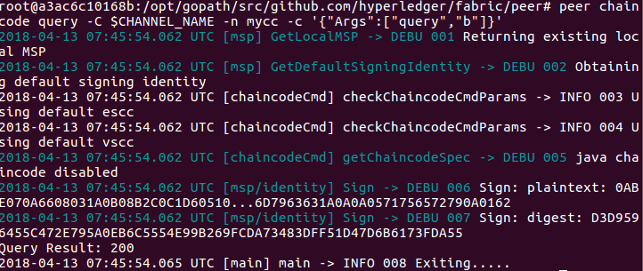

Invoke

Now let’s move 10 from a to b. This transaction will cut a new block and update the state DB. The syntax for invoke is as follows:

peer chaincode invoke -o orderer.example.com:7050 --tls --cafile /opt/gopath/src/github.com/hyperledger/fabric/peer/crypto/ordererOrganizations/example.com/orderers/orderer.example.com/msp/tlscacerts/tlsca.example.com-cert.pem -C $CHANNEL_NAME -n mycc -c '{"Args":["invoke","a","b","10"]}'

Let’s confirm that our previous invocation executed properly. We initialized the key a with a value of 100 and just removed 10 with our previous invocation. Therefore, a query against a should reveal 90. The syntax for query is as follows.
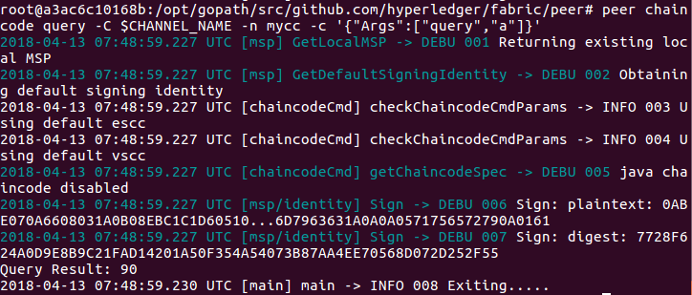
Feel free to start over and manipulate the key value pairs and subsequent invocations.

What does this demonstrate?
Chaincode MUST be installed on a peer in order for it to successfully perform read/write operations against the ledger. Furthermore, a chaincode container is not started for a peer until an init or traditional transaction - read/write - is performed against that chaincode (e.g. query for the value of “a”). The transaction causes the container to start. Also, all peers in a channel maintain an exact copy of the ledger which comprises the blockchain to store the immutable, sequenced record in blocks, as well as a state database to maintain a snapshot of the current state. This includes those peers that do not have chaincode installed on them (like peer1.org1.example.com in the above example) . Finally, the chaincode is accessible after it is installed (like peer1.org2.example.com in the above example) because it has already been instantiated.

What’s happening behind the scenes?

Glossary
cryptogen
cryptogen tool to generate the cryptographic material (x509 certs and signing keys) for our various network entities. These certificates are representative of identities, and they allow for sign/verify authentication to take place as our entities communicate and transact. After we run the cryptogen tool, the generated certificates and keys will be saved to a folder titled crypto-config.

crypto-config.yaml
A file that contains the network topology and allows us to generate a set of certificates and keys for both the Organizations and the components that belong to those Organizations.

ca-cert
Each Organization is provisioned a unique root certificate (ca-cert) that binds specific components (peers and orderers) to that Org.

configtxgen
The configtxgen tool is used to create four configuration artifacts:

- orderer genesis block,
- channel configuration transaction,
- and two anchor peer transactions - one for each Peer Org.

configtx.yaml
A file that contains the definitions for the sample network that configtxgen consumes. There are three members - one Orderer Org (OrdererOrg) and two Peer Orgs (Org1 & Org2) each managing and maintaining two peer nodes. This file also specifies a consortium - SampleConsortium - consisting of our two Peer Orgs. Pay specific attention to the “Profiles” section at the top of this file. You will notice that we have two unique headers. One for the orderer genesis block - TwoOrgsOrdererGenesis - and one for our channel - TwoOrgsChannel.

channel.tx
The channel.tx artifact contains the definitions for our sample channel

Membership Service Providers (MSP)
Membership Service Provider (MSP) is a component that aims to offer an abstraction of a membership operation architecture.

Chaincode
Applications interact with the blockchain ledger through chaincode. As such we need to install the chaincode on every peer that will execute and endorse our transactions, and then instantiate the chaincode on the channel.

