Table of Contents
About 2
Prerequisite 2
Getting Started 4
Finishing Up 5
File Structure of Application 6
Application Flow Basics 7
Application Flow Example 8
Elements 8
Understanding chaincode 9
Chaincode Key APIs 9
Chaincode Program 10
Sample Chaincode Decomposed - Dependencies 10
Sample Chaincode Decomposed - Struct 11
Sample Chaincode Decomposed – Init method 11
Sample Chaincode Decomposed - Invoke Method 12
Sample Chaincode Decomposed - Main Function 13
Setting the Stage 14
Defining the Asset Attributes 14
Invoke Method (Part I) 14
Invoke Method (Part II) 15
Chaincode Methods – queryTuna 16
Chaincode Methods – initLedger 16
Chaincode Methods – recordTuna 17
Chaincode Methods – queryAllTuna 18
Chaincode Methods – changeTunaHolder 19

About
Globally, three trillion dollars are spent every year on marine coastal resources and industries. Marine fisheries employ over 200 million people, from fishing, to processing, to shipping, and sales. As much as 40% of our oceans are heavily affected by human activities like illegal fishing. Every year, five million tons of tuna, with an estimated value of forty billion dollars, are sold. This is a huge industry, and one that could benefit greatly from innovation and transparency.
With the Tuna 2020 Traceability Declaration in mind, our goal is to eliminate illegal, unreported, and unregulated fishing. We will use Hyperledger Fabric to bring transparency and clarity to a real-world example: the supply chain of tuna fishing. We will be describing how tuna fishing can be improved, starting from the source, fisherman Sarah, and the process by which her tuna ends up at Miriam's restaurant. In between, we'll have other parties involved, such as the regulator who verify the validity of the data and the sustainability of the tuna catches.
We will be using Hyperledger Fabric's framework to keep track of each part of this process.
Now, as you read through the demonstrated scenario section, there are two main ideas to pay attention to:
1. There are many actors within the network, and you will see how these actors interact, and how a transaction is conducted.
2. Private channels allow Sarah and Miriam to privately agree on the terms of their interaction, while still maintaining transparency, so other actors can corroborate and confirm their transaction.
Using private channels, regulators and restaurateurs can confirm whether a particular shipment of tuna was sustainably and legally sourced, without needing to see the details of the entire journey. Only the fisherman and the restaurateur are privy to such specific details.
Source
EdX: LinuxFoundationX: LFS171x Blockchain for Business - An Introduction to Hyperledger Technologies: Chapter 7. Introduction to Hyperledger Fabric

Prerequisite
In order to successfully install Hyperledger Fabric, you should be familiar with Go and Node.js programming languages, and have the following features installed on your computer: cURL, Node.js, npm package manager, Go language, Docker, and Docker Compose.

Also, make sure that you have completed the Installing Hyperledger Fabric section in this chapter before moving on to this application section, as you will likely experience errors.

Installing Hyperledger Fabric Docker Images and Binaries

Next, we will download the latest released Docker images for Hyperledger Fabric, and tag them with the latest tag. Execute the command from within the directory into which you will extract the platform-specific binaries:

$ curl -sSL https://goo.gl/Q3YRTi | bash

NOTE: Check https://hyperledger-fabric.readthedocs.io/en/latest/samples.html#binaries for the latest URL (the blue portion in the above curl command) to pull in binaries.

This command downloads binaries for cryptogen, configtxgen, configxlator, peer AND downloads the Hyperledger Fabric Docker images. These assets are placed in a bin subdirectory of the current working directory.

To confirm and see the list of Docker images you’ve just downloaded, run:

$ docker images
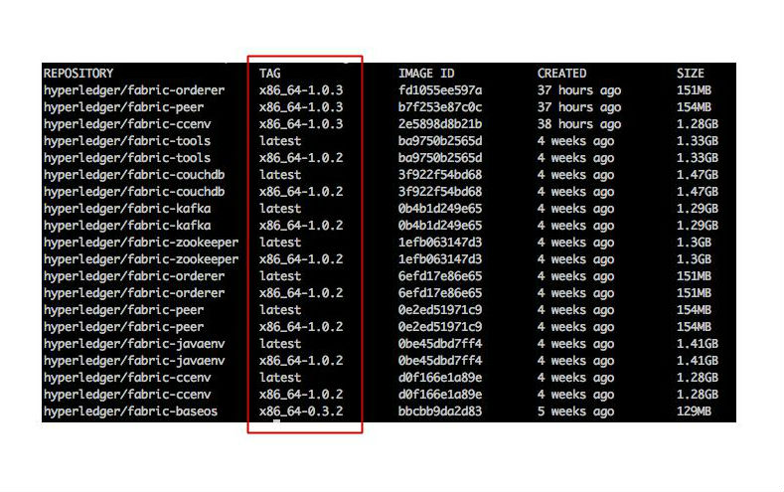
Note the tags for each of the repositories above boxed in red. If the Docker images are not already tagged with the latest tag, perform the following command for each of the Docker images:

$ docker tag hyperledger/fabric-tools:x86_64-1.0.2 hyperledger/fabric-tools:latest

Swap out the blue portion with the tags you see in your list of repositories. Also, swap out the red portion with the name of the Docker image you are switching the tag for (e.g.: fabric-tools, fabric-ccenv, fabric-orderer, etc.). Repeat this step for all Docker images you see in the list.

In the screenshot above, the Docker images are already tagged. If this is the case for you, you do not need to do this extra step.

Getting Started
In case you haven’t downloaded the education repository for this course, follow the below directions in your terminal window:

$ git clone https://github.com/hyperledger/education.git

$ cd education/LFS171x/fabric-material/tuna-app

First, remove any pre-existing containers, as it may conflict with commands in this tutorial:

$ docker rm -f $(docker ps -aq)

Then, let’s start the Hyperledger Fabric network with the following command:

$ ./startFabric.sh

Troubleshooting: If, after running the above you are getting an error similar to the following:

ERROR: failed to register layer: rename
/var/lib/docker/image/overlay2/layerdb/tmp/write-set-091347846 /var/lib/docker/image/overlay2/layerdb/sha256/9d3227c1793b7494e598caafd0a5013900e17dcdf1d7bdd31d39c82be04fcf28: file exists

try running the following command:
$ rm -rf ~/Library/Containers/com.docker.docker/Data/*

Install the required libraries from the package.json file, register the Admin and User components of our network, and start the client application with the following commands:

$ npm install

$ node registerAdmin.js

$ node registerUser.js

$ node server.js

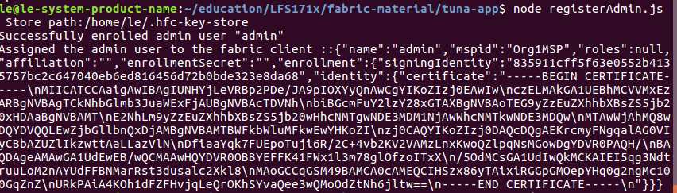
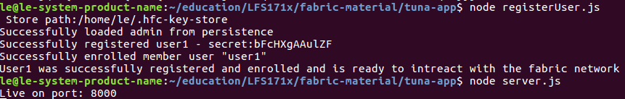
Load the client simply by opening localhost:8000 in any browser window of your choice, and you should see the user interface for our simple application at this URL (as in the screenshot below).

Troubleshooting: If you are getting an error similar to the one below while attempting to perform any of the functions on the application:

Error: [client-utils.js]: sendPeersProposal - Promise is rejected: Error: Connect Failed

error from query = { Error: Connect Failed at /Desktop/prj/education/LFS171x/fabric-material/tuna-app/node_modules/grpc/src/node/src/client.js:554:15 code: 14, metadata: Metadata { _internal_repr: {} } }

try running the following commands:

$ cd ~

$ rm -rf .hfc-key-store/

Then, run the commands above starting with:

$ node registerAdmin.js
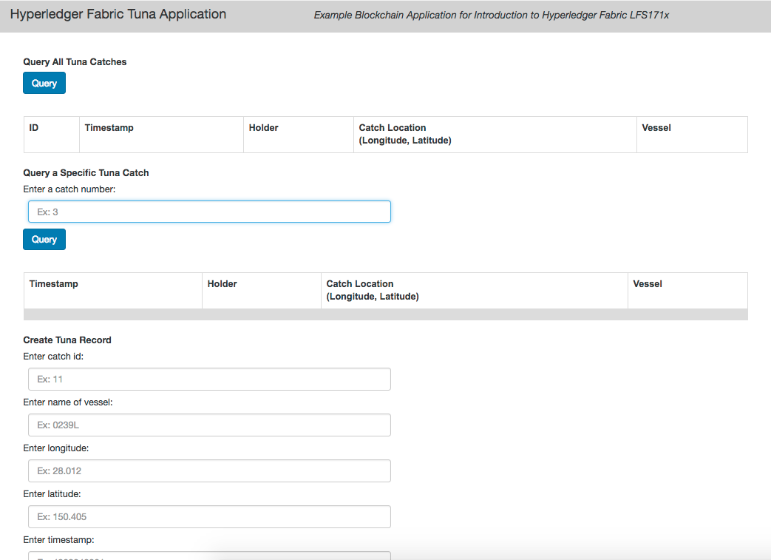

Finishing Up
Remove all Docker containers and images that we created in this tutorial with the following command in the tuna-app folder:

$ docker rm -f $(docker ps -aq)

$ docker rmi -f $(docker images -a -q)

File Structure of Application
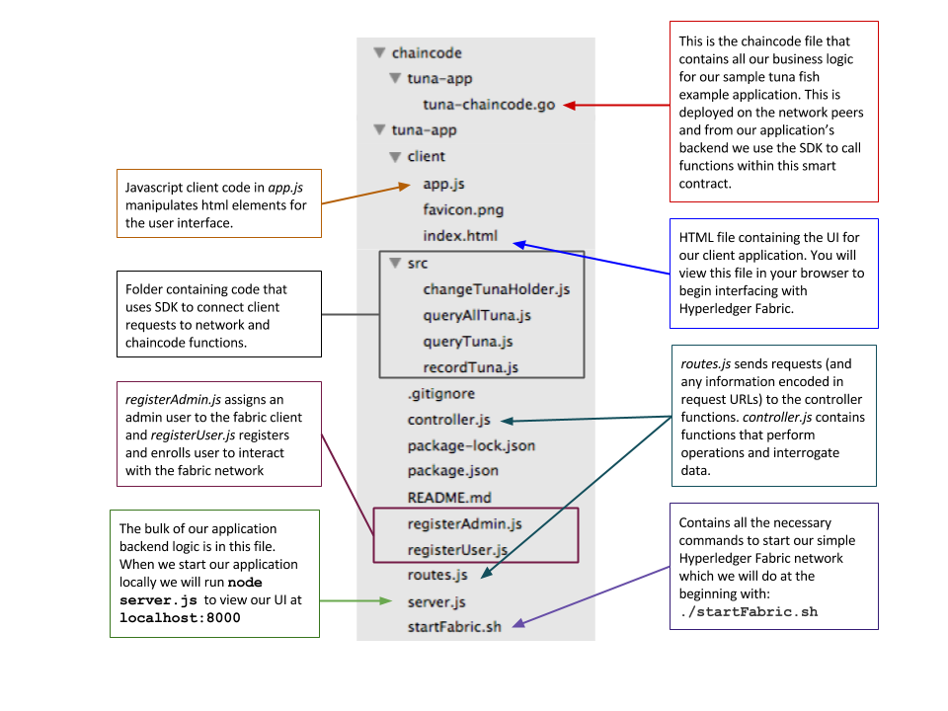

Application Flow Basics
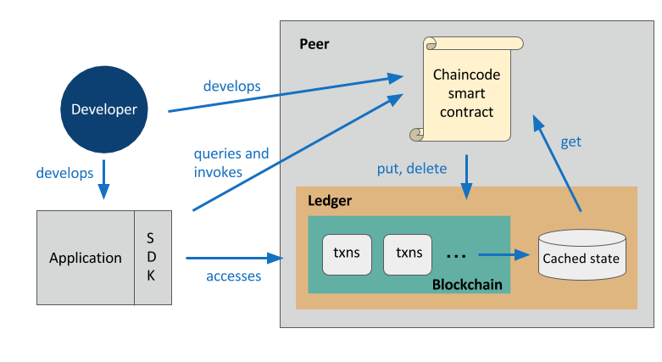

- A developer creates an application and smart contract.
- The application will invoke calls within the smart contract via the Hyperledger Fabric Client SDK.
- These calls are processed by the business logic within the chaincode smart contract.
- A put or delete command will go through the consensus process and will be added to the blockchain within the ledger.
- A get command can only read from the world state, but it is not recorded on the blockchain.
- The application can access blockchain information via APIs.

Application Flow Example
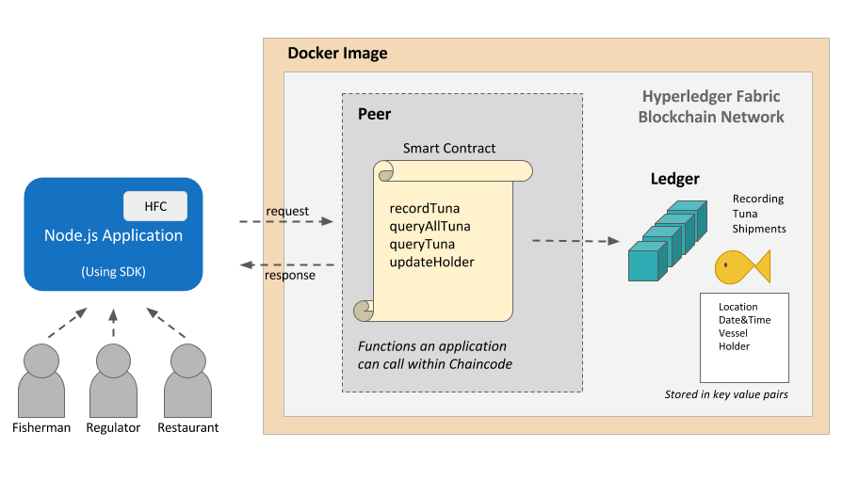
- Various users (fisherman, regulators, or restaurateurs etc.) will interact with the Node.js application.
- The client JS will send messages to the backend when the user interacts with the application.
- Reading or writing the ledger is known as a proposal (for example, querying a specific Tuna catch - queryTuna- or recording a tuna catch - recordTuna). This proposal is built by our application via the SDK, and then sent to the endorsing peers.
- The endorsing peers will use the application-specific chaincode smart contract to simulate the transaction. If there are no issues, the transaction will be endorsed, and sent back to our application.
- Our application will then send the endorsed proposal to the ordering service via the SDK. The orderer will package many proposals from the whole network into a block. Then, it will broadcast the new block to the committing peers in the network.
- Finally, each committing peer will validate the block and write it to its ledger (shown in teal above). The transaction has now been committed, and any reads will reflect this change.

Elements
Channels are data partitioning mechanisms that allow transaction visibility for stakeholders only. Each channel is an independent chain of transaction blocks containing only transactions for that particular channel.
The chaincode (Smart Contracts) encapsulates both the asset definitions and the business logic (or transactions) for modifying those assets. Transaction invocations result in changes to the ledger.
The ledger contains the current world state of the network and a chain of transaction invocations. A shared, permissioned ledger is an append-only system of records and serves as a single source of truth.
The network is the collection of data processing peers that form a blockchain network. The network is responsible for maintaining a consistently replicated ledger.
The ordering service is a collection of nodes that orders transactions into a block.
The world state reflects the current data about all the assets in the network. This data is stored in a database for efficient access. Current supported databases are LevelDB and CouchDB.
The membership service provider (MSP) manages identity and permissioned access for clients and peers.

Understanding chaincode
In Hyperledger Fabric, chaincode is the 'smart contract' that runs on the peers and creates transactions. More broadly, it enables users to create transactions in the Hyperledger Fabric network's shared ledger and update the world state of the assets.
Chaincode is programmable code, written in Go, and instantiated on a channel. Developers use chaincode to develop business contracts, asset definitions, and collectively-managed decentralized applications. The chaincode manages the ledger state through transactions invoked by applications. Assets are created and updated by a specific chaincode, and cannot be accessed by another chaincode.
Applications interact with the blockchain ledger through the chaincode. Therefore, the chaincode needs to be installed on every peer that will endorse a transaction and instantiated on the channel.
There are two ways to develop smart contracts with Hyperledger Fabric:
- Code individual contracts into standalone instances of chaincode
- (More efficient way) Use chaincode to create decentralized applications that manage the lifecycle of one or multiple types of business contracts, and let the end users instantiate instances of contracts within these applications.

Chaincode Key APIs
An important interface that you can use when writing your chaincode is defined by Hyperledger Fabric - ChaincodeStub and ChaincodeStubInterface. The ChaincodeStub provides functions that allow you to interact with the underlying ledger to query, update, and delete assets. The key APIs for chaincode include:
  - func (stub *ChaincodeStub) GetState(key string) ([]byte, error)
Returns the value of the specified key from the ledger. Note that GetState doesn't read data from the Write set, which has not been committed to the ledger. In other words, GetState doesn't consider data modified by PutState that has not been committed. If the key does not exist in the state database, (nil, nil) is returned.
  - func (stub *ChaincodeStub) PutState(key string, value []byte) error
Puts the specified key and value into the transaction's Write set as a data-write proposal. PutState doesn't affect the ledger until the transaction is validated and successfully committed.
  - func (stub *ChaincodeStub) DelState(key string) error
Records the specified key to be deleted in the Write set of the transaction proposal. The key and its value will be deleted from the ledger when the transaction is validated and successfully committed.

Chaincode Program
When creating a chaincode, there are two methods that you will need to implement:
- Init
Called when a chaincode receives an instantiate or upgrade transaction. This is where you will initialize any application state.
- Invoke
Called when the invoke transaction is received to process any transaction proposals.
As a developer, you must create both an Init and an Invoke method within your chaincode. The chaincode must be installed using the peer chaincode install command, and instantiated using the peer chaincode instantiate command before the chaincode can be invoked. Then, transactions can be created using the peer chaincode invoke or peer chaincode query commands.

Sample Chaincode Decomposed - Dependencies
Let’s now walk through a sample chaincode written in Go, piece by piece:
package main
import (
"fmt"
"github.com/hyperledger/fabric/core/chaincode/shim"
"github.com/hyperledger/fabric/protos/peer"
)
The import statement lists a few dependencies that you will need for your chaincode to build successfully.
  - fmt - contains Println for debugging/logging
  - github.com/hyperledger/fabric/core/chaincode/shim - contains the definition for the chaincode interface and the chaincode stub, which you will need to interact with the ledger, as we described in the Chaincode Key APIs section
  - github.com/hyperledger/fabric/protos/peer - contains the peer protobuf package.

Sample Chaincode Decomposed - Struct
type SampleChaincode struct {
}
This might not look like much, but this is the statement that begins the definition of an object/class in Go. SampleChaincode implements a simple chaincode to manage an asset.

Sample Chaincode Decomposed – Init method
Next, we’ll implement the Init method. Init is called during the chaincode instantiation to initialize data required by the application. In our sample, we will create the initial key/value pair for an asset, as specified on the command line:
func (t *SampleChaincode) Init(stub shim.ChainCodeStubInterface) peer.Response {
// Get the args from the transaction proposal
args := stub.GetStringArgs()
if len(args) != 2 {
return shim.Error("Incorrect arguments. Expecting a key and a value")
}
// We store the key and the value on the ledger
err := stub.PutState(args[0], []byte(args[1]))
if err != nil {
return shim.Error(fmt.Sprintf("Failed to create asset: %s", args[0]))
}
return shim.Success(nil)
}
The Init implementation accepts two parameters as inputs, and proposes to write a key/value pair to the ledger by using the stub.PutState function. GetStringArgs retrieves and checks the validity of arguments which we expect to be a key/value pair. Therefore, we check to ensure that there are two arguments specified. If not, we return an error from the Init method, to indicate that something went wrong. Once we have verified the correct number of arguments, we can store the initial state in the ledger. In order to accomplish this, we call the stub.PutState function, specifying the first argument as the key, and the second argument as the value for that key. If no errors are returned, we will return success from the Init method.

Sample Chaincode Decomposed - Invoke Method
Now, we’ll explore the Invoke method, which gets called when a transaction is proposed by a client application. In our sample, we will either get the value for a given asset, or propose to update the value for a specific asset.
func (t *SampleChaincode) Invoke(stub shim.ChaincodeStubInterface) peer.Response {
// Extract the function and args from the transaction proposal
fn, args := stub.GetFunctionAndParameters()
var result string
var err error
if fn == "set" {
result, err = set(stub, args)
} else { // assume 'get' even if fn is nil
result, err = get(stub, args)
}
if err != nil { //Failed to get function and/or arguments from transaction proposal
return shim.Error(err.Error())
}
// Return the result as success payload
return shim.Success([]byte(result))
}
There are two basic actions a client can invoke: get and set.
  - The get method will be used to query and return the value of an existing asset.
  - The set method will be used to create a new asset or update the value of an existing asset.
To start, we’ll call GetFunctionandParameters to isolate the function name and parameter variables. Each transaction is either a set or a get. Let's first look at how the set method is implemented:
func set(stub shim.ChaincodeStubInterface, args []string) (string, error) {
if len(args) != 2 {
return "", fmt.Errorf("Incorrect arguments. Expecting a key and a value")
}
err := stub.PutState(args[0], []byte(args[1]))
if err != nil {
return "", fmt.Errorf("Failed to set asset: %s", args[0])
}
return args[1], nil
}
The set method will create or modify an asset identified by a key with the specified value. The set method will modify the world state to include the key/value pair specified. If the key exists, it will override the value with the new one, using the PutState method; otherwise, a new asset will be created with the specified value.
Next, let's look at how the get method is implemented:
func get(stub shim.ChaincodeStubInterface, args []string) (string, error) {
if len(args) != 1 {
return "", fmt.Errorf("Incorrect arguments. Expecting a key")
}
value, err := stub.GetState(args[0])
if err != nil {
return "", fmt.Errorf("Failed to get asset: %s with error: %s", args[0], err)
}
if value == nil {
return "", fmt.Errorf("Asset not found: %s", args[0])
}
return string(value), nil
}
The get method will attempt to retrieve the value for the specified key. If the application does not pass in a single key, an error will be returned; otherwise, the GetState method will be used to query the world state for the specified key. If the key has not yet been added to the ledger (and world state), then an error will be returned; otherwise, the value that was set for the specified key is returned from the method.

Sample Chaincode Decomposed - Main Function
The last piece of code in this sample is the main function, which will call the Start function. The main function starts the chaincode in the container during instantiation.
func main() {
err := shim.Start(new(SampleChaincode))
if err != nil {
fmt.Println("Could not start SampleChaincode")
} else {
fmt.Println("SampleChaincode successfully started")
}
}

Setting the Stage
Now that we have a general idea of how chaincode is coded, we will walk through a simple chaincode that creates assets on a ledger, based on our demonstrated scenario of creating records for tuna fish.
Sometimes, code snippets can get lost in translation, especially if the context doesn’t make much sense. In hopes of avoiding this, we have adjusted our example chaincode to address our demonstration scenario. The chaincode we will be examining in this section will record a tuna catch by storing it to the ledger, as well as allow for queries and updates to tuna catch records.

Defining the Asset Attributes
Here are the four example attributes of tuna fish that we will be recording on the ledger:
  - Vessel (string)
  - Location (string)
  - Date and Time (datetime)
  - Holder (string)
We create a Tuna Structure that has four properties. Structure tags are used by the encoding/json library.
type Tuna struct {
Vessel string ‘json:"vessel"’
Datetime string ‘json:"datetime"’
Location string ‘json:"location"’
Holder string ‘json:"holder"’
}

Invoke Method (Part I)
As described earlier, the Invoke method is the one which gets called when a transaction is proposed by a client application. Within this method, we have three different types of transactions -- recordTuna, queryTuna, and changeTunaHolder, which we will look at a little later.
As a reminder, Sarah, the fisherman, will invoke the recordTuna when she catches each tuna.
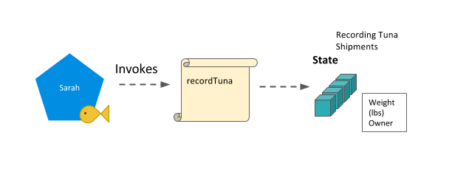
changeTunaHolder can be invoked by Miriam, the restaurateur, when she confirms receiving and passing on a particular tuna fish as it passes through the supply chain. queryTuna can be invoked by Miriam, the restaurateur, to view the state of a particular tuna.
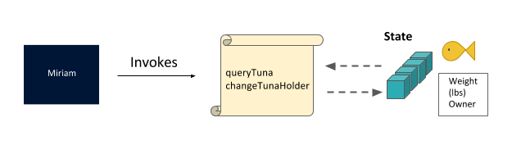
Regulators will invoke queryTuna and queryAllTuna based on their need to verify and check for sustainability of the supply chain.
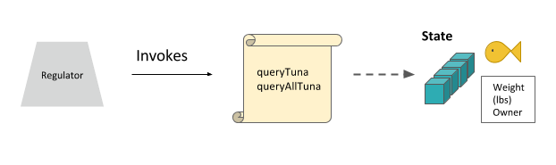

Invoke Method (Part II)
We’ll be getting into the different tuna chaincode methods in the following sections. But here is the Invoke method. As you can see, this method will look at the first parameter to determine which function should be called, and invoke the appropriate tuna chaincode method.
func (s *SmartContract) Invoke(APIstub shim.ChaincodeStubInterface) sc.Response {
// Retrieve the requested Smart Contract function and arguments
function, args := APIstub.GetFunctionAndParameters()
// Route to the appropriate handler function to interact with the ledger appropriately
if function == "queryTuna" {
return s.queryTuna(APIstub, args)
} else if function == "initLedger" {
return s.initLedger(APIstub)
} else if function == "recordTuna" {
return s.recordTuna(APIstub, args)
} else if function == "queryAllTuna" {
return s.queryAllTuna(APIstub)
} else if function == "changeTunaHolder" {
return s.changeTunaHolder(APIstub, args)
}
return shim.Error("Invalid Smart Contract function name.")
}

Chaincode Methods – queryTuna
The queryTuna method would be used by a fisherman, regulator, or restaurateur to view the record of one particular tuna. It takes one argument - the key for the tuna in question.
func (s *SmartContract) queryTuna(APIstub shim.ChaincodeStubInterface, args []string) sc.Response {
if len(args) != 1 {
return shim.Error("Incorrect number of arguments. Expecting 1")
}
tunaAsBytes, _ := APIstub.GetState(args[0])
if tunaAsBytes == nil {
return shim.Error(“Could not locate tuna”)
}
return shim.Success(tunaAsBytes)
}

Chaincode Methods – initLedger
The initLedger method will add test data to our network.
func (s *SmartContract) initLedger(APIstub shim.ChaincodeStubInterface) sc.Response {
tuna := []Tuna{
Tuna{Vessel: "923F", Location: "67.0006, -70.5476", Timestamp: "1504054225", Holder: "Miriam"},
Tuna{Vessel: "M83T", Location: "91.2395, -49.4594", Timestamp: "1504057825", Holder: "Dave"},
Tuna{Vessel: "T012", Location: "58.0148, 59.01391", Timestamp: "1493517025", Holder: "Igor"},
Tuna{Vessel: "P490", Location: "-45.0945, 0.7949", Timestamp: "1496105425", Holder: "Amalea"},
Tuna{Vessel: "S439", Location: "-107.6043, 19.5003", Timestamp: "1493512301", Holder: "Rafa"},
Tuna{Vessel: "J205", Location: "-155.2304, -15.8723", Timestamp: "1494117101", Holder: "Shen"},
Tuna{Vessel: "S22L", Location: "103.8842, 22.1277", Timestamp: "1496104301", Holder: "Leila"},
Tuna{Vessel: "EI89", Location: "-132.3207, -34.0983", Timestamp: "1485066691", Holder: "Yuan"},
Tuna{Vessel: "129R", Location: "153.0054, 12.6429", Timestamp: "1485153091", Holder: "Carlo"},
Tuna{Vessel: "49W4", Location: "51.9435, 8.2735", Timestamp: "1487745091", Holder: "Fatima"},
}
i := 0
for i < len(tuna) {
fmt.Println("i is ", i)
tunaAsBytes, _ := json.Marshal(tuna[i])
APIstub.PutState(strconv.Itoa(i+1), tunaAsBytes)
fmt.Println("Added", tuna[i])
i = i + 1
}
return shim.Success(nil)
}

Chaincode Methods – recordTuna
The recordTuna method is the method a fisherman like Sarah would use to record each of her tuna catches. This method takes in five arguments (attributes to be saved in the ledger).
func (s *SmartContract) recordTuna(APIstub shim.ChaincodeStubInterface, args []string) sc.Response {
if len(args) != 5 {
return shim.Error("Incorrect number of arguments. Expecting 5")
}
var tuna = Tuna{ Vessel: args[1], Location: args[2], Timestamp: args[3], Holder: args[4]}
tunaAsBytes, _ := json.Marshal(tuna)
err := APIstub.PutState(args[0], tunaAsBytes)
if err != nil {
return shim.Error(fmt.Sprintf("Failed to record tuna catch: %s", args[0]))
}
return shim.Success(nil)
}

Chaincode Methods – queryAllTuna
The queryAllTuna method allows for assessing all the records; in this case, all the Tuna records added to the ledger. This method does not take any arguments. It will return a JSON string containing the results.
func (s *SmartContract) queryAllTuna(APIstub shim.ChaincodeStubInterface) sc.Response {
startKey := "0"
endKey := "999"
resultsIterator, err := APIstub.GetStateByRange(startKey, endKey)
if err != nil {
return shim.Error(err.Error())
}
defer resultsIterator.Close()
// buffer is a JSON array containing QueryResults
var buffer bytes.Buffer
buffer.WriteString("[")
bArrayMemberAlreadyWritten := false
for resultsIterator.HasNext() {
queryResponse, err := resultsIterator.Next()
if err != nil {
return shim.Error(err.Error())
}
// Add a comma before array members, suppress it for the first array member
if bArrayMemberAlreadyWritten == true {
buffer.WriteString(",")
}
buffer.WriteString("{\"Key\":")
buffer.WriteString("\"")
buffer.WriteString(queryResponse.Key)
buffer.WriteString("\"")
buffer.WriteString(", \"Record\":")
// Record is a JSON object, so we write as-is
buffer.WriteString(string(queryResponse.Value))
buffer.WriteString("}")
bArrayMemberAlreadyWritten = true
}
buffer.WriteString("]")
fmt.Printf("- queryAllTuna:\n%s\n", buffer.String())
return shim.Success(buffer.Bytes())
}

Chaincode Methods – changeTunaHolder
As the tuna fish is passed to different parties in the supply chain, the data in the world state can be updated with who has possession. The changeTunaHolder method takes in 2 arguments, tuna id and new holder name.
func (s *SmartContract) changeTunaHolder(APIstub shim.ChaincodeStubInterface, args []string) sc.Response {
if len(args) != 2 {
return shim.Error("Incorrect number of arguments. Expecting 2")
}
tunaAsBytes, _ := APIstub.GetState(args[0])
if tunaAsBytes != nil {
return shim.Error("Could not locate tuna")
}
tuna := Tuna{}
json.Unmarshal(tunaAsBytes, &tuna)
// Normally check that the specified argument is a valid holder of tuna but here we are skipping this check for this example.
tuna.Holder = args[1]
tunaAsBytes, _ = json.Marshal(tuna)
err := APIstub.PutState(args[0], tunaAsBytes)
if err != nil {
return shim.Error(fmt.Sprintf("Failed to change tuna holder: %s", args[0]))
}
return shim.Success(nil)
}
We hope you now have a better idea of how chaincode is constructed and written, especially when applied to a simple example. To see all the code snippets, visit the educational GitHub repository: https://github.com/hyperledger/education/blob/master/LFS171x/fabric-material/chaincode/tuna-app/tuna-chaincode.go.

