Docker essentials: Extend your apps with containers

https://developer.ibm.com/courses/all/docker-essentials-extend-your-apps-with-containers/

Badge from IBM https://www.youracclaim.com/badges/bdf8db75-ca8a-4400-83a2-0a087dda6fe8/public_url

Table of Contents
Intro 2
Objectives 2
Labs 2
Prerequisites 3
Overview 3
Lab 1 4
1. Run your first container 4
2. Run multiple containers 6
3. Clean up 9
Summary 10
Checkpoint 10
Containers achieve isolation because of what feature in the Linux kernel? 10
What is the difference between a Docker container and a Docker image? 11
Lab 2 11
1. Create a Python app (without using Docker) 11
2. Create and build the Docker image 12
3. Run the Docker image 14
4. Push to a central registry 15
5. Deploy a change 16
6. Understand image layers 18
7. Clean up 20
Summary 21
Lab 3 21
Overview 21
Prerequisites 22
1. Create your first swarm 22
2. Deploy your first service 23
3. Scale your service 24
5. Reconciliation 27
How many nodes? 29
Summary 29
Checkpoint 30
What is one advantage of isolation that is provided by containers? 30
What is the best way to distribute a dockerized application to different environments? 30
Running containerized applications in production can come with a variety of problems. Which of the following items is not a problem of running a containerized application in production? 30
What is one advantage of using containers across different environments? 31
You need an SSH server to get a bash shell inside a container? 31
What technologies are behind Docker's image layering system? 31
What is the result of running docker run ubuntu:15.04 1000 times on your workstation? 31
Open-source container orchestration platforms, such as Docker Swarm and Kubernetes, provides what to their users? 32
Course summary 32

Intro
Containers are a standard way to package an application and all its dependencies so that the application can be moved between environments and run without changes. Containers work by isolating the application inside the container so that everything outside the container can be standardized.

Docker has provided a set of tools to simplify the use of containers. This has led to massive adoption of containers by developers and operators. In this course, you will focus mostly on Docker container technologies.

In this course, you’ll follow a series of hands-on labs that demonstrate how to use containers for your applications. You’ll start with the basics: creating and running your first Docker containers. By the end of the course, you’ll know how to run containers in production with the IBM Container service on IBM Cloud and solve problems of advanced orchestration such as high availability, service discovery, and reconciliation.

Objectives

When you finish this course, you should understand:

What containers are and their benefits
How to find and run Docker containers from the Docker Hub
How to create your first Docker container and understand the layering and union file system
The best practices when developing Dockerfiles
How to solve problems of orchestration: reconciliation, scaling, high availability, and service discovery
Some of the tools that can help you run highly available applications in production, such as the IBM Container service

Labs

Lab 1: Run your first container and learn how to inspect it. Explore the Docker Hub and discover common images ready to be run.
Lab 2: Create a custom Docker Image built from a Dockerfile and push it to a central registry where it can be pulled to be deployed on other environments. Learn about the union file system and copy-on-write, and how they help you deliver applications faster.
Lab 3: Deploy containers using Docker swarm and learn how Docker Swarm helps solve problems such as reconciliation, scaling, high availability and service discovery.

Prerequisites

You don’t need to know anything about containers to take this course, and no extensive programming experience is required. However, you must know how to run command-line tools from your workstation.

If you don’t have Docker already, you need install Docker Community Edition (CE) or use the use the Play-with-Docker website. Docker installations are available from store.docker.com for your Mac, Windows, or Linux machine.

The next section shows you how to install Docker.

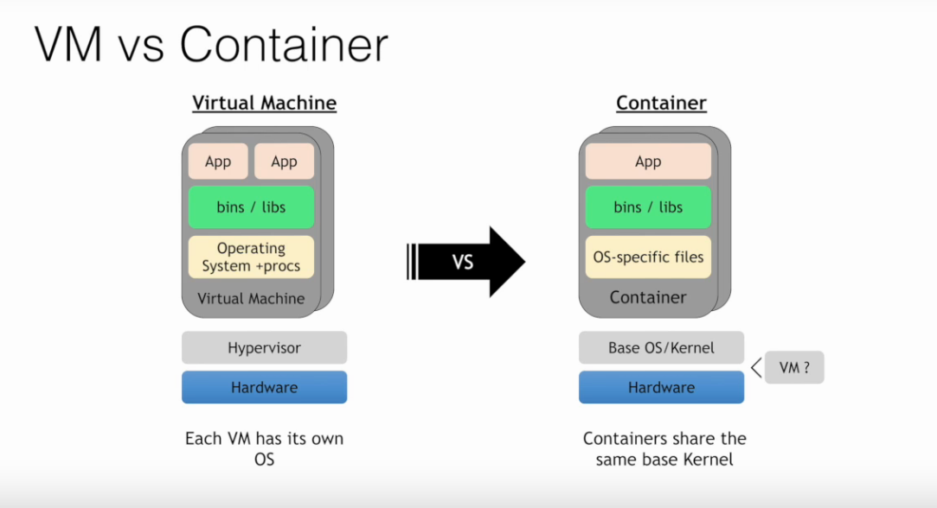

Overview

Containers are just a process (or a group of processes) running in isolation, which is achieved with Linux namespaces and control groups. Linux namespaces and control groups are features that are built into the Linux kernel. Other than the Linux kernel itself, there is nothing special about containers.

What makes containers useful is the tooling that surrounds them. The labs in this course use Docker, which has been the understood standard tool for using containers to build applications. Docker provides developers and operators with a friendly interface to build, ship, and run containers on any environment.

In the first part of this lab, run your first container, and learn how to inspect it. You will be able to witness the namespace isolation that you acquire from the Linux kernel.

After you run your first container, you can explore other uses of docker containers. You can find many examples of these on the Docker Store and can run several different types of containers on the same host, which allows you to see the benefit of isolation—where you can run multiple containers on the same host without conflicts.

You will use a few Docker commands in this lab. If interested, see the full documentation on available commands.
Prerequisites

You must have Docker installed or be using Play-with-Docker.

Lab 1

1. Run your first container

Use the Docker CLI to run our first container.

Open a terminal on your local computer.
Run docker container run -t ubuntu top.

Use the docker container run command to run a container with the ubuntu image, using the top command. The -t flag allocates a pseudo-TTY, which you need for the top to work correctly.

$ docker container run -it ubuntu top

The docker run command will result first in a docker pull to download the ubuntu image onto your host. Once it is downloaded, it will start the container.

top is a Linux utility that prints the processes on a system and orders them by resource consumption. Notice that there is only a single process in this output: it is the top process itself. We don’t see other processes from our host in this list because of the PID namespace isolation.

Containers use Linux namespaces to provide isolation of system resources from other containers or the host. The PID namespace provides isolation for process IDs. If you run top while inside the container, you will notice that it shows the processes within the PID namespace of the container, which is much different than what you can see if you ran top on the host.

Even though we are using the ubuntu image, it is important to note that our container does not have its own kernel. It uses the kernel of the host and the ubuntu image is used only to provide the file system and tools available on an ubuntu system.

Inspect the container with docker container exec.

The docker container exec command is a way to “enter” a running container’s namespaces with a new process.

In the new terminal, use the docker container ls command to get the ID of the running container you just created.

$ docker container ls

Then use that id to run bash inside that container using the docker container exec command. Since we are using bash and want to interact with this container from our terminal, use the -it flag to run using interactive mode while allocating a psuedo-terminal.

$ docker container exec -it f954e60569b6 bash
root@f954e60569b6:/#

We just used the docker container exec command to “enter” our container’s namespaces with our bash process. Using docker container exec with bash is a common pattern to inspect a docker container.

Notice the change in the prefix of your terminal. For example `root@b3ad2a23fab3:/`. This is an indication that we are running bash “inside” of our container.

Note: This is not the same as ssh’ing into a separate host or a VM. We don’t need an ssh server to connect with a bash process. Remember that containers use kernel-level features to achieve isolation and that containers run on top of the kernel. Our container is just a group of processes running in isolation on the same host, and we can use docker container exec to enter that isolation with the bash process. After running docker container exec, the group of processes running in isolation (in other words, our container) include top and bash.

From the same terminal, run ps -ef to inspect the running processes.

root@f954e60569b6:/# ps -ef

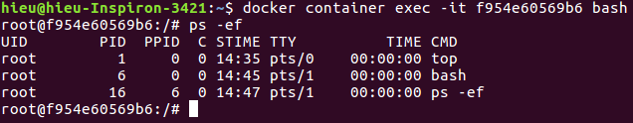
You should see only the top process, bash process, and our ps process.

For comparison, exit the container, and run ps -ef or top on the host. These commands will work on Linux or Mac. For Windows, you can inspect the running processes using tasklist.

root@f954e60569b6:/# exit
exit
$ ps -ef

Technical deep dive

PID is just one of the Linux namespaces that provides containers with isolation to system resources. Other Linux namespaces include:

MNT – Mount and unmount directories without affecting other namespaces.
NET – Containers have their own network stack.
IPC – Isolated interprocess communication mechanisms such as message queues.
User – Isolated view of users on the system.
UTC – Set hostname and domain name per container.

These namespaces together provide the isolation for containers that allow them to run together securely and without conflict with other containers running on the same system. Next we will demonstrate different uses of containers. and the benefit of isolation as we run multiple containers on the same host.

Note: Namespaces are a feature of the Linux kernel. But Docker allows you to run containers on Windows and Mac… how does that work? The secret is that embedded in the Docker product is a Linux subsystem. Docker open-sourced this Linux subsystem to a new project: LinuxKit. Being able to run containers on many different platforms is one advantage of using the Docker tooling with containers.

In addition to running Linux containers on Windows using a Linux subsystem, native Windows containers are now possible due the creation of container primitives on the Windows OS. Native Windows containers can be run on Windows 10 or Windows Server 2016 or later.

Clean up the container running the top processes by typing <ctrl>-c.

2. Run multiple containers
Explore the Docker Store.

The Docker Store is the public central registry for Docker images. Anyone can share images here publicly. The Docker Store contains community and official images that can also be found directly on the Docker Hub.

When searching for images you will find filters for “Store” vs “Community” images. “Store” images include content that has been verified and scanned for security vulnerabilities by Docker. Go one step further and search for “Certified” images, that are deemed enterprise-ready and are tested with Docker Enterprise Edition product. It is important to avoid using unverified content from the Docker Store when developing your own images that are intended to be deployed into the production environment. These unverified images may contain security vulnerabilities or possibly even malicious software.

In the next step of this lab, you will start a couple of containers using some verified images from the Docker Store: nginx web server, and mongo database.

Run an Nginx server.

Let’s run a container using the official Nginx image from the Docker Store.

$ docker container run --detach --publish 8080:80 --name nginx nginx

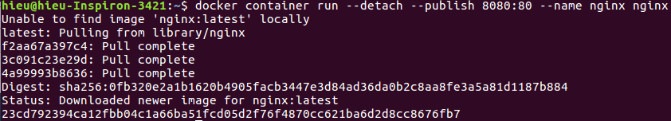
We are using a couple of new flags here. The --detach flag will run this container in the background. The publish flag publishes port 80 in the container (the default port for nginx), using port 8080 on our host. Remember that the NET namespace gives processes of the container their own network stack. The --publish flag is a feature that allows us to expose networking through the container onto the host.

How do you know port 80 is the default port for nginx? Because it is listed in the documentation on the Docker Store. In general, the documentation for the verified images is very good, and you will want to refer to them when running containers using those images.

We are also specifying the --name flag, which names the container. Every container has a name. If you don’t specify one, Docker will randomly assign one for you. Specifying your own name makes it easier to run subsequent commands on your container since you can reference the name instead of the id of the container. For example: docker container inspect nginx, instead of docker container inspect 5e1.

Since this is the first time you are running the nginx container, it will pull down the nginx image from the Docker Store. Subsequent containers created from the Nginx image will use the existing image located on your host.

Nginx is a lightweight web server. You can access it on port 8080 on your localhost.

Access the nginx server on http://localhost:8080.
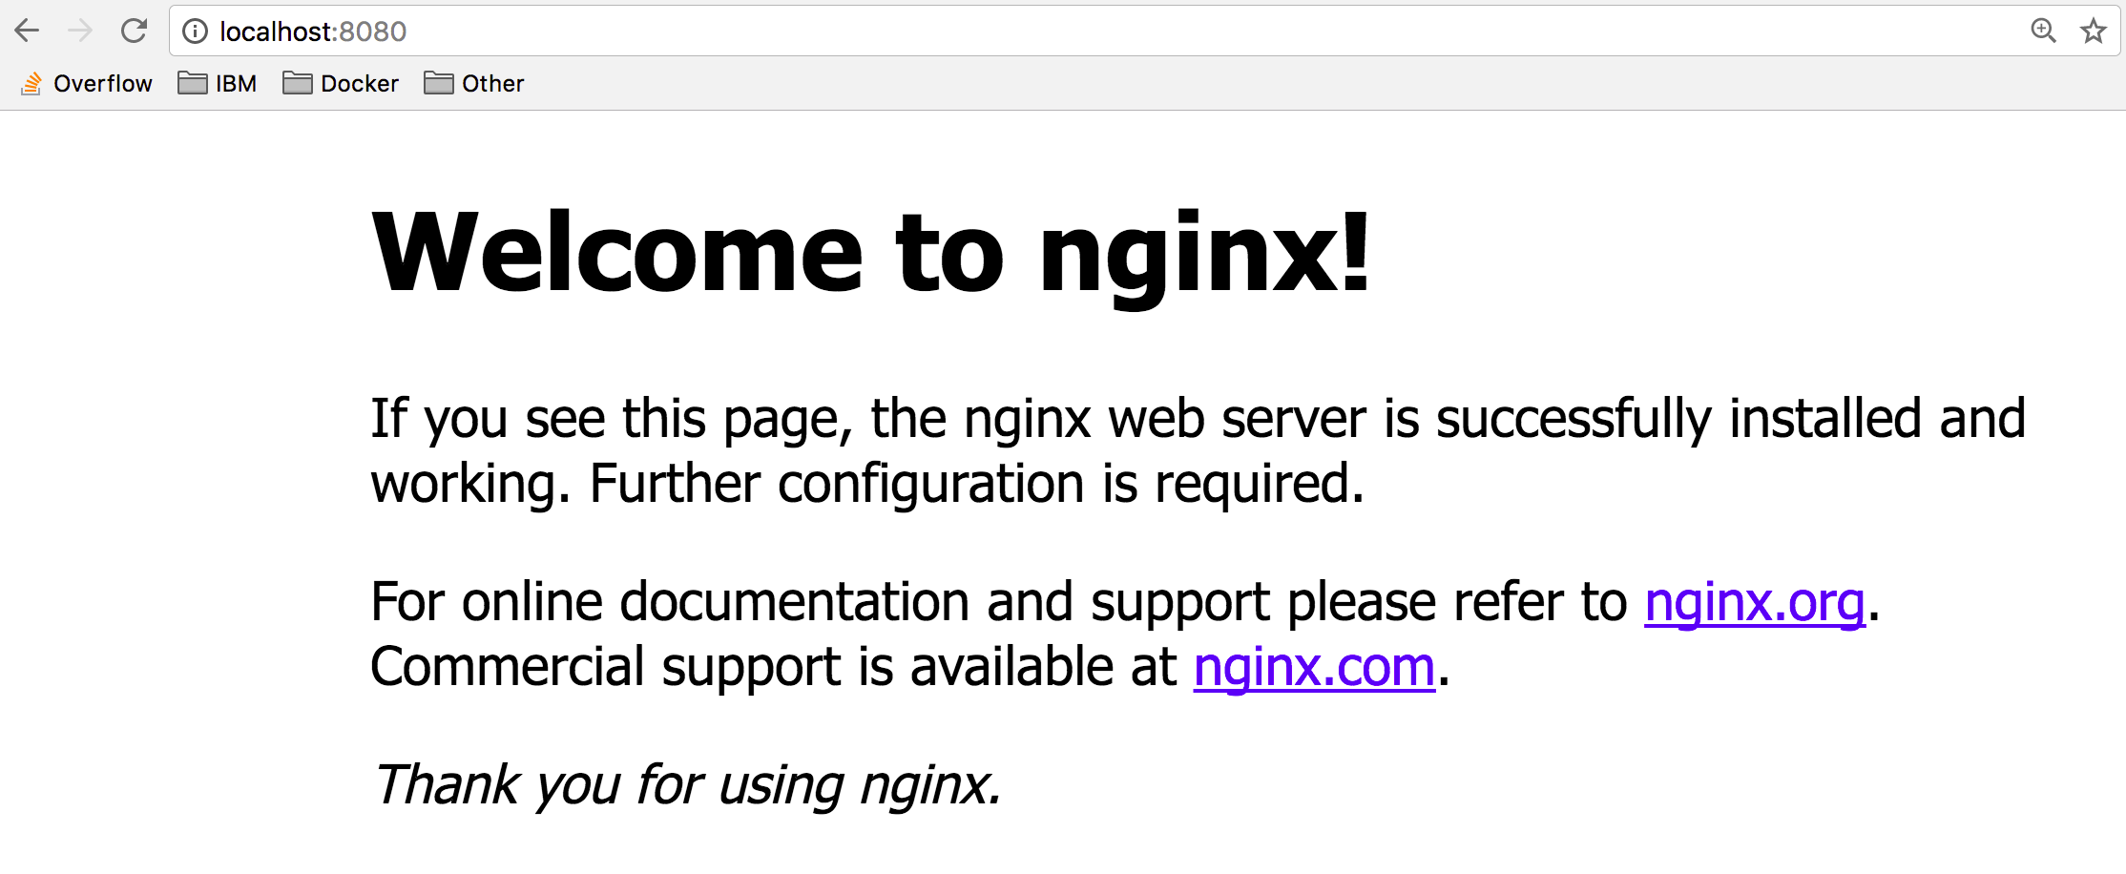
Now, run a mongoDB server.

We will use the official mongoDB image from the Docker Store. Instead of using the latest tag (which is the default if no tag is specified), we will use a specific version of the mongo image: 3.4.
$ docker container run --detach --publish 8081:27017 --name mongo mongo:3.4

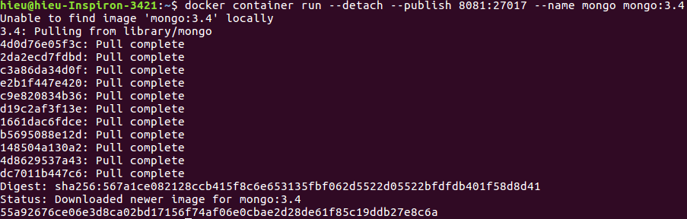
Again, since this is the first time we are running a mongo container, we will pull down the mongo image from the Docker Store. We are using the --publish flag to expose the 27017 mongo port on our host. We have to use a port other than 8080 for the host mapping, since that port is already exposed on our host. Again refer to the official docs on the Docker Store to get more details about using the mongo image.

Access http://localhost:8081 to see some output from mongo.

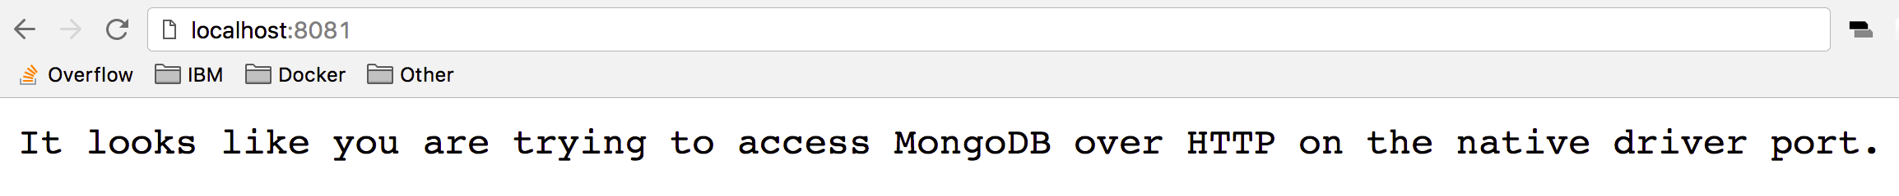
Check your running containers with docker container ls.

$ docker container ls

You should see that you have an Nginx web server container, and a MongoDB container running on your host. Note that we have not configured these containers to talk to each other.

You can see the “nginx” and “mongo” names that we gave to our containers, and the random name (in my case “priceless_kepler”) that was generated for the ubuntu container. You can also see that the port mappings that we specified with the --publish flag. For more details information on these running containers you can use the docker container inspect [container id command.

One thing you might notice is that the mongo container is running the docker-entrypoint command. This is the name of the executable that is run when the container is started. The mongo image requires some prior configuration before kicking off the DB process. You can see exactly what the script does by looking at it on GitHub. Typically, you can find the link to the github source from the image description page on the Docker Store website.

Containers are self-contained and isolated, which means we can avoid potential conflicts between containers with different system or runtime dependencies. For example: deploying an app that uses Java 7 and another app that uses Java 8 on the same host. Or running multiple nginx containers that all have port 80 as their default listening ports (if exposing on the host using the --publish flag, the ports selected for the host will need to be unique). Isolation benefits are possible because of Linux Namespaces.

Note: You didn’t have to install anything on your host (other than Docker) to run these processes! Each container includes the dependencies that it needs within the container, so you don’t need to install anything on your host directly.

Running multiple containers on the same host gives us the ability to fully utilize the resources (cpu, memory, etc) available on single host. This can result in huge cost savings for an enterprise.

While running images directly from the Docker Store can be useful at times, it is more useful to create custom images, and refer to official images as the starting point for these images. We will dive into building our own custom images in Lab 2.

3. Clean up
Completing this lab results in a bunch of running containers on your host. Let’s clean these up.

Get a list of the containers running using docker container ls.

Run docker container stop [container id] for each container in the list. You can also use the names of the containers that you specified before.

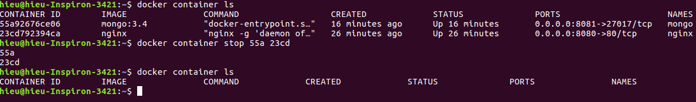
Note: You only have to reference enough digits of the ID to be unique. Three digits is almost always enough.

Remove the stopped containers.

docker system prune is a really handy command to clean up your system. It will remove any stopped containers, unused volumes and networks, and dangling images.

$ docker system prune

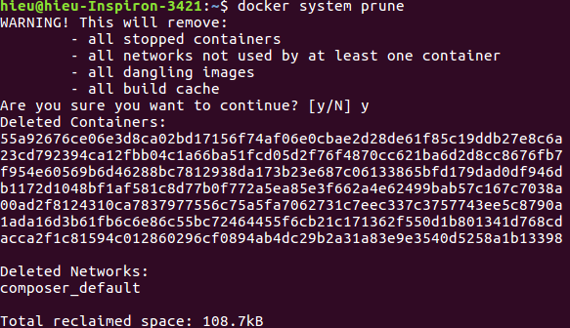

Summary
In this lab, you created your first Ubuntu, Nginx, and MongoDB containers.

Key takeaways

Containers are composed of Linux namespaces and control groups that provide isolation from other containers and the host.
Because of the isolation properties of containers, you can schedule many containers on a single host without worrying about conflicting dependencies. This makes it easier to run multiple containers on a single host: fully utilizing resources allocated to that host, and ultimately saving some money on server costs.
Avoid using unverified content from the Docker Store when developing your own images because these images might contain security vulnerabilities or possibly even malicious software.
Containers include everything they need to run the processes within them, so there is no need to install additional dependencies directly on your host.

Checkpoint

Containers achieve isolation because of what feature in the Linux kernel?

Namespaces

Linux namespaces provide processes an isolated view of system resources. There are different kinds of namespaces including PID, USER, MNT, IPC, UTS, and NET. Although Linux namespaces and containers have been a part of the Linux kernel for many years, Docker has created developer-friendly tooling to enable developers to easily integrate containers into their applications.

What is the difference between a Docker container and a Docker image?

An image is the blueprint for spinning up containers. Image is a TAR of a file system while a container is a file system plus a set of processes running in isolation.

Lab 2
Lab objective:

Create custom image using a Dockerfile
Build and run your image locally
Push your image to your account on DockerHub
Update image with a code change

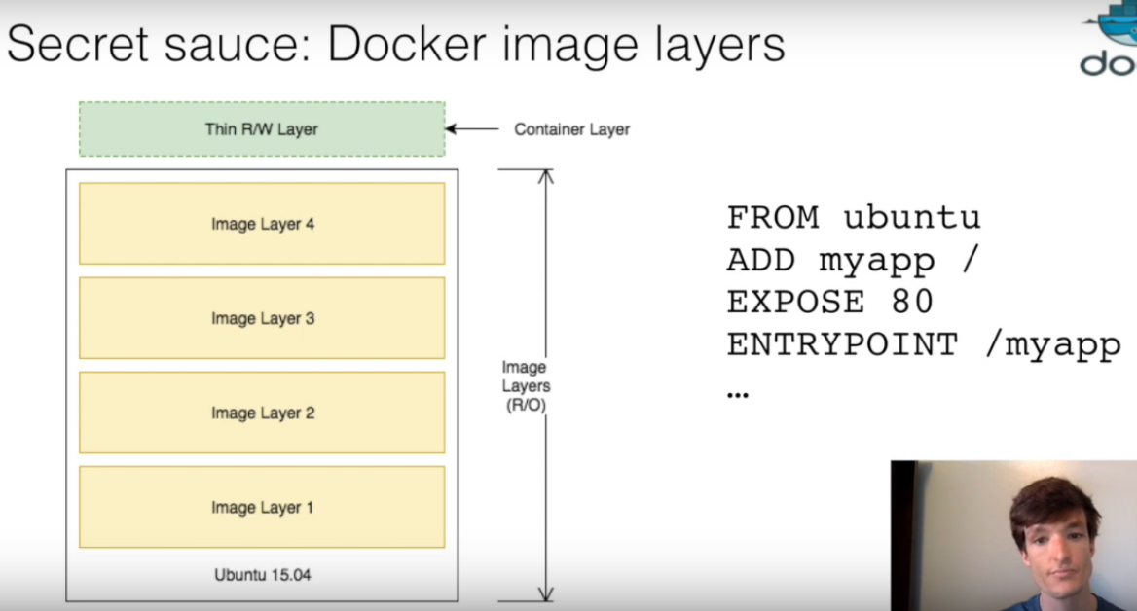

Overview

In this lab, build on your knowledge from Lab 1, where you used Docker commands to run containers. Create a custom Docker image built from a Dockerfile. Once you build the image, you will push it to a central registry, where it can be pulled to be deployed on other environments. Also, get a brief understanding of image layers, and how Docker incorporates “copy-on-write” and the union file system to efficiently store images and run containers. You will use a few Docker commands in this lab. See the official documentation on for information on available commands.

1. Create a Python app (without using Docker)

Create app.py with the following contents:

from flask import Flask

app = Flask(__name__)

@app.route("/")
def hello():
return "hello world!"

if __name__ == "__main__":
app.run(host='0.0.0.0')

This is a simple Python app that uses flask to expose a http web server on port 5000 (5000 is the default port for flask). Don’t worry if you are not too familiar with Python or Flask. These concepts can be applied to an application written in any language.

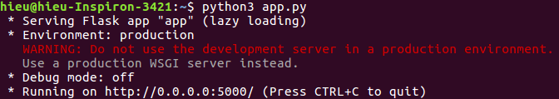

2. Create and build the Docker image

If you don’t have Python installed locally, don’t worry, because you don’t need it. One of the advantages of using Docker containers is that you can build Python into your containers without having Python installed on your host.

Create the Dockerfile with the following contents:

FROM python:3.6.1-alpine
RUN pip install flask
CMD ["python","app.py"]
COPY app.py /app.py

A Dockerfile lists the instructions needed to build a docker image. Let’s go through the above file line by line.
- FROM python:3.6.1-alpine
This is the starting point for your Dockerfile. Every Dockerfile must start with a FROM line that is the starting image to build your layers on top of. In this case, we are selecting the python:3.6.1-alpine base layer since it already has the version of python and pip that we need to run our application. The alpine version means that it uses the alpine distribution, which is significantly smaller than an alternative flavor of Linux. A smaller image means it will download (deploy) much faster, and it also has advantages for security because it has a smaller attack surface.
Here we are using the “3.6.1-alpine” tag for the python image. Take a look at the available tags for the official python image on the Docker Hub. It is best practice to use a specific tag when inheriting a parent image so that changes to the parent dependency are controlled. If no tag is specified, the “latest” tag takes into effect, which is acts as a dynamic pointer that points to the latest version of an image.
For security reasons, it is very important to understand the layers that you build your docker image on top of. For that reason, it is highly recommended to only use “official” images found in the docker hub, or non-community images found in the docker-store. These images are vetted to meet certain security requirements, and also have very good documentation for users to follow. You can find more information about this python base image, as well as all other images that you can use, on the docker store.
For a more complex application you may find the need to use a FROM image that is higher up the chain. For example, the parent Dockerfile for our python app starts with FROM alpine, then specifies a series of CMD and RUN commands for the image. If you needed more fine-grained control, you could start with FROM alpine (or a different distribution) and run those steps yourself. To start off though, I recommend using an official image that closely matches your needs.
- RUN pip install flask
The RUN command executes commands needed to set up your image for your application, such as installing packages, editing files, or changing file permissions. In this case we are installing flask. The RUN commands are executed at build time, and are added to the layers of your image.
- CMD ["python","app.py"]
CMD is the command that is executed when you start a container. Here we are using CMD to run our python app.
There can be only one CMD per Dockerfile. If you specify more thane one CMD, then the last CMD will take effect. The parent python:3.6.1-alpine also specifies a CMD (CMD python2). You can take a look at the Dockerfile for the official python:alpine image.
You can use the official python image directly to run python scripts without installing python on your host. But today, we are creating a custom image to include our source, so that we can build an image with our application and ship it around to other environments.
- COPY app.py /app.py
This copies the app.py in the local directory (where you will run docker image build) into a new layer of the image. This instruction is the last line in the Dockerfile. Layers that change frequently, such as copying source code into the image, should be placed near the bottom of the file to take full advantage of the Docker layer cache. This allows us to avoid rebuilding layers that could otherwise be cached. For instance, if there was a change in the FROM instruction, it would invalidate the cache for all subsequent layers of this image. We will demonstrate a this little later in this lab.
It seems counter-intuitive to put this after the CMD ["python","app.py"] line. Remember, the CMD line is executed only when the container is started, so we won’t get a file not found error here.
And there you have it: a very simple Dockerfile. See the full list of commands you can put into a Dockerfile. Now that we defined our Dockerfile, let’s use it to build our custom docker image.
Build the Docker image.
Pass in -t to name your image python-hello-world.
$ docker image build -t python-hello-world .
Run docker image ls to verify that your image shows up in your image list.
$ docker image ls
REPOSITORY TAG IMAGE ID CREATED SIZE
python-hello-world latest f1b2781b3111 26 seconds ago 99.3MB
python 3.6.1-alpine c86415c03c37 8 days ago 88.7MB
Notice that your base image, python:3.6.1-alpine, is also in your list.

3. Run the Docker image
Now that you have built the image, you can run it to see that it works.
- Run the Docker image.
$ docker run -p 5001:5000 -d python-hello-world
0b2ba61df37fb4038d9ae5d145740c63c2c211ae2729fc27dc01b82b5aaafa26
-p flag maps a port running inside the container to your host. In this case, you’re mapping the Python app running on port 5000 inside the container to port 5001 on your host. Note that if port 5001 is already in use by another application on your host, you may have to replace 5001 with another value, such as 5002.
- Navigate to http://localhost:5001 in a browser to see the results.
You should see “hello world!” on your browser.
- Check the log output of the container.
If you want to see logs from your application you can use the docker container logs command. By default, docker container logs prints out what is sent to standard out by your application. Use docker container ls to find the id for your running container.
$ docker container logs [container id]
* Running on http://0.0.0.0:5000/ (Press CTRL+C to quit)
172.17.0.1 - - [28/Jun/2017 19:35:33] "GET / HTTP/1.1" 200 -
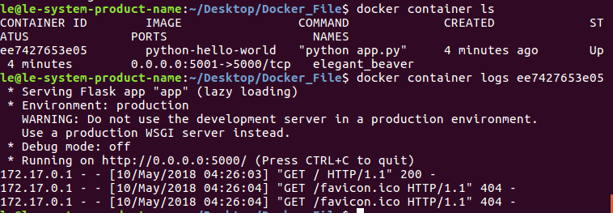
The Dockerfile is how you create reproducible builds for your application. A common workflow is to have your CI/CD automation run docker image build as part of its build process. Once images are built, they will be sent to a central registry, where they can be accessed by all environments (such as a test environment) that need to run instances of that application. In the next step, you will push your custom image to the public docker registry: the docker hub, where it can be consumed by other developers and operators.

4. Push to a central registry
- Navigate to Docker Hub and create a free account, if you haven’t already.
For this lab, you will use the Docker Hub as your central registry. Docker hub is a free service to publicly store available images, or you can pay to store private images.
Most organizations that heavily use Docker will set up their own registry internally. To simplify things, we will use the Docker Hub, but the following concepts apply to any registry.
- Log in to the Docker registry account by typing docker login on your terminal.
$ docker login
Login with your Docker ID to push and pull images from Docker Hub. If you don't have a Docker ID, head over to https://hub.docker.com to create one.
Username:
- Tag your image with your username.
The Docker Hub naming convention is to tag your image with [dockerhub username]/[image name]. To do this, tag your previously created image python-hello-world to fit that format.
$ docker tag python-hello-world [dockerhub username]/python-hello-world
- Once you have a properly tagged image, use the docker push command to push your image to the Docker Hub registry.
$ docker push jzaccone/python-hello-world
The push refers to a repository [docker.io/jzaccone/python-hello-world]
2bce026769ac: Pushed
64d445ecbe93: Pushed
18b27eac38a1: Mounted from library/python
3f6f25cd8b1e: Mounted from library/python
b7af9d602a0f: Mounted from library/python
ed06208397d5: Mounted from library/python
5accac14015f: Mounted from library/python
latest: digest: sha256:508238f264616bf7bf962019d1a3826f8487ed6a48b80bf41fd3996c7175fd0f size: 1786
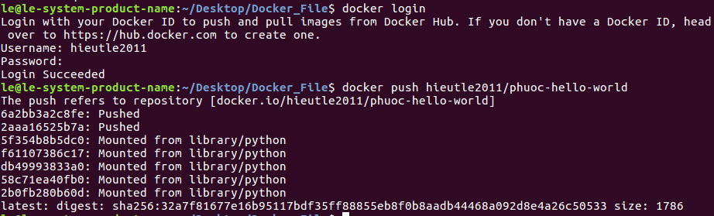
- Check out your image on docker hub in your browser.
Navigate to Docker Hub, and go to your profile to see your newly uploaded image.
Now that your image is on Docker Hub, other developers and operations can use the docker pull command to deploy your image to other environments.
Note: Docker images contain all the dependencies that they need to run an application within the image. This is useful because you no longer have deal with environment drift (version differences) when you rely on dependencies that are installed on every environment you deploy to. You also don’t have to go through additional steps to provision these environments. Just one step: install docker, and you’re good to go.

5. Deploy a change
- Update app.py by replacing the string “Hello World” with “Hello Beautiful World!” in app.py.
Your file should have the following contents:
from flask import Flask

app = Flask(__name__)

@app.route("/")
def hello():
return "Hello Beautiful World!"

if __name__ == "__main__":
app.run(host='0.0.0.0')
- Now that your app is updated, you need to rebuild your app and push it to the Docker Hub registry.
First rebuild, this time use your Docker Hub username in the build command.
$ docker image build -t jzaccone/python-hello-world .
Sending build context to Docker daemon 3.072kB
Step 1/4 : FROM python:3.6.1-alpine
---> c86415c03c37
Step 2/4 : RUN pip install flask
---> Using cache
---> ce41f2517c16
Step 3/4 : CMD python app.py
---> Using cache
---> 0ab91286958b
Step 4/4 : COPY app.py /app.py
---> 3e08b2eeace1
Removing intermediate container 23a955e881fc
Successfully built 3e08b2eeace1
Successfully tagged jzaccone/python-hello-world:latest

Notice the “Using cache” for Steps 1-3. These layers of the Docker image have already been built, and docker image build will use these layers from the cache, instead of rebuilding them.
$ docker push jzaccone/python-hello-world
The push refers to a repository [docker.io/jzaccone/python-hello-world]
94525867566e: Pushed
64d445ecbe93: Layer already exists
18b27eac38a1: Layer already exists
3f6f25cd8b1e: Layer already exists
b7af9d602a0f: Layer already exists
ed06208397d5: Layer already exists
5accac14015f: Layer already exists
latest: digest: sha256:91874e88c14f217b4cab1dd5510da307bf7d9364bd39860c9cc8688573ab1a3a size: 1786

There is a caching mechanism in place for pushing layers too. Docker Hub already has all but one of the layers from an earlier push, so it only pushes the one layer that has changed.
When you change a layer, every layer built on top of that will have to be rebuilt. Each line in a Dockerfile builds a new layer that is built on the layer created from the lines before it. This is why the order of the lines in your Dockerfile is important. We optimized our Dockerfile so that the layer that is most likely to change (COPY app.py /app.py) is the last line of the Dockerfile. Generally for an application, your code changes at the most frequent rate. This optimization is particularly important for CI/CD processes, where you want your automation to run as fast as possible.

6. Understand image layers
One of the major design properties of Docker is its use of the union file system.
Consider the Dockerfile that you created before:
FROM python:3.6.1-alpine
RUN pip install flask
CMD ["python","app.py"]
COPY app.py /app.py

Each of these lines is a layer. Each layer contains only the delta, or changes from the layers before it. To put these layers together into a single running container, Docker makes use of the union file system to overlay layers transparently into a single view.
Each layer of the image is read-only, except for the very top layer which is created for the container. The read/write container layer implements “copy-on-write” which means that files that are stored in lower image layers are pulled up to the read/write container layer only when edits are being made to those files. Those changes are then stored in the container layer. The “copy-on-write” function is very fast, and in almost all cases, does not have a noticeable effect on performance. You can inspect which files have been pulled up to the container level with the docker diff command. See more information about how to use docker diff.
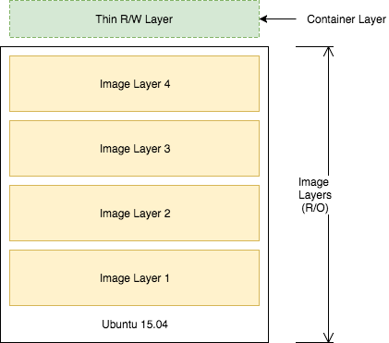
Since image layers are read-only, they can be shared by images and by running containers. For instance, creating a new python app with its own Dockerfile with similar base layers, would share all the layers that it had in common with the first python app.
FROM python:3.6.1-alpine
RUN pip install flask
CMD ["python","app2.py"]
COPY app2.py /app2.py
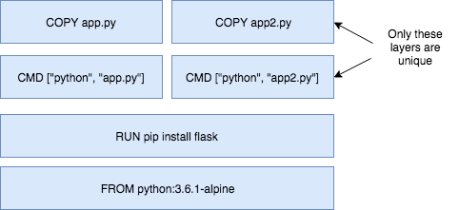
You can also experience the sharing of layers when you start multiple containers from the same image. Since the containers use the same read-only layers, you can imagine that starting up containers is very fast and has a very low footprint on the host.
You may notice that there are duplicate lines in this Dockerfile and the Dockerfile you created earlier in this lab. Although this is a very trivial example, you can pull common lines of both Dockerfiles into a “base” Dockerfile, that you can then point to with each of your child Dockerfiles using the FROM command.
Image layering enables the docker caching mechanism for builds and pushes. For example, the output for your last docker push shows that some of the layers of your image already exists on the Docker Hub.
$ docker push jzaccone/python-hello-world
The push refers to a repository [docker.io/jzaccone/python-hello-world]
94525867566e: Pushed
64d445ecbe93: Layer already exists
18b27eac38a1: Layer already exists
3f6f25cd8b1e: Layer already exists
b7af9d602a0f: Layer already exists
ed06208397d5: Layer already exists
5accac14015f: Layer already exists
latest: digest: sha256:91874e88c14f217b4cab1dd5510da307bf7d9364bd39860c9cc8688573ab1a3a size: 1786

To look more closely at layers, you can use the docker image history command of the python image we created.
$ docker image history python-hello-world
IMAGE CREATED CREATED BY SIZE COMMENT
f1b2781b3111 5 minutes ago /bin/sh -c #(nop) COPY file:0114358808a1bb... 159B
0ab91286958b 5 minutes ago /bin/sh -c #(nop) CMD ["python" "app.py"] 0B
ce41f2517c16 5 minutes ago /bin/sh -c pip install flask 10.6MB
c86415c03c37 8 days ago /bin/sh -c #(nop) CMD ["python3"] 0B
<missing> 8 days ago /bin/sh -c set -ex; apk add --no-cache -... 5.73MB
<missing> 8 days ago /bin/sh -c #(nop) ENV PYTHON_PIP_VERSION=... 0B
<missing> 8 days ago /bin/sh -c cd /usr/local/bin && ln -s idl... 32B
<missing> 8 days ago /bin/sh -c set -ex && apk add --no-cache ... 77.5MB
<missing> 8 days ago /bin/sh -c #(nop) ENV PYTHON_VERSION=3.6.1 0B
<missing> 8 days ago /bin/sh -c #(nop) ENV GPG_KEY=0D96DF4D411... 0B
<missing> 8 days ago /bin/sh -c apk add --no-cache ca-certificates 618kB
<missing> 8 days ago /bin/sh -c #(nop) ENV LANG=C.UTF-8 0B
<missing> 8 days ago /bin/sh -c #(nop) ENV PATH=/usr/local/bin... 0B
<missing> 9 days ago /bin/sh -c #(nop) CMD ["/bin/sh"] 0B
<missing> 9 days ago /bin/sh -c #(nop) ADD file:cf1b74f7af8abcf... 4.81MB

Each line represents a layer of the image. You’ll notice that the top lines match to your Dockerfile that you created, and the lines below are pulled from the parent python image. Don’t worry about the <missing> tags. These are still normal layers; they have just not been given an ID by the docker system.

7. Clean up
Completing this lab results in a lot of running containers on your host. Let’s clean these up.
- Get a list of the containers running using docker container ls.
$ docker container ls
CONTAINER ID IMAGE COMMAND CREATED STATUS PORTS NAMES
0b2ba61df37f python-hello-world "python app.py" 7 minutes ago Up 7 minutes 0.0.0.0:5001->5000/tcp practical_kirch
- Run docker container stop [container id] for each container in the list that is running.
$ docker container stop 0b2
0b2
- Remove the stopped containers.
docker system prune is a really handy command to clean up your system. It will remove any stopped containers, unused volumes and networks, and dangling images.
$ docker system prune
WARNING! This will remove:
- all stopped containers
- all volumes not used by at least one container
- all networks not used by at least one container
- all dangling images
Are you sure you want to continue? [y/N] y
Deleted Containers:
0b2ba61df37fb4038d9ae5d145740c63c2c211ae2729fc27dc01b82b5aaafa26

Total reclaimed space: 300.3kB

Summary
- The Dockerfile is how you create reproducible builds for your application and how you integrate your application with Docker into the CI/CD pipeline.
- Docker images can be made available to all of your environments through a central registry. The Docker Hub is one example of a registry, but you can deploy your own registry on servers you control.
- Docker images contain all the dependencies that it needs to run an application within the image. This is useful because we no longer have deal with environment drift (version differences) when we rely on dependencies that are install on every environment we deploy to.
- Docker makes use of the union file system and “copy on write” to reuse layers of images. This lowers the footprint of storing images and significantly increases the performance of starting containers.
- Image layers are cached by the Docker build and push system. No need to rebuild or repush image layers that are already present on the desired system.
- Each line in a Dockerfile creates a new layer, and because of the layer cache, the lines that change more frequently (for example, adding source code to an image) should be listed near the bottom of the file.

Lab 3

Overview
So far you have learned how to run applications using Docker on your local machine. But what about running dockerized applications in production? There are a number of problems that come with building an application for production: scheduling services across distributed nodes, maintaining high availability, implementing reconciliation, scaling, and logging… just to name a few.
There are several orchestration solutions out there that help you solve some of these problems. One example is the IBM Cloud Container Service, which uses Kubernetes to run containers in production.
Before introducing you to Kubernetes, you will learn how to orchestrate applications using Docker Swarm. Docker Swarm is the orchestration tool that comes built-in to the Docker Engine.
This lab uses a few Docker commands. For full documentation on available commands, check out the official documentation.

Prerequisites
In order to complete a lab about orchestrating an application that is deployed across multiple hosts, you need… well, multiple hosts. To make things easier, this lab uses the multi-node support provided by Play-with-Docker.com. This is the easiest way to test out Docker Swarm without having to deal with installing docker on multiple hosts yourself.

1. Create your first swarm
In this step, we will create our first swarm using play-with-docker.
- Navigate to Play-with-Docker.
- The first swarm cluster will have three nodes, so click add new instance on the left side three times to create three nodes.
- Initialize the swarm on node 1.
$ docker swarm init --advertise-addr eth0
Swarm initialized: current node (vq7xx5j4dpe04rgwwm5ur63ce) is now a manager.

To add a worker to this swarm, run the following command:

docker swarm join \
--token SWMTKN-1-50qba7hmo5exuapkmrj6jki8knfvinceo68xjmh322y7c8f0pj-87mjqjho30uue43oqbhhthjui \
10.0.120.3:2377

To add a manager to this swarm, run 'docker swarm join-token manager' and follow the instructions.
You can think of docker swarm as a special “mode” that is activated by the command: docker swarm init. The --advertise-addr specifies the address in which the other nodes will use to join the swarm.
This docker swarm init command generates a join token. The token makes sure that no malicious nodes join our swarm. We will need to use this token to join the other nodes to the swarm. For convenience, the output includes the full command docker swarm join, which you can just copy/paste to the other nodes.
- On both node2 and node3, copy and run the docker swarm join command that was outputted to your console by the last command.
You now have a three-node swarm!
- Back on node1, run docker node ls to verify your three-node cluster.
$ docker node ls
ID HOSTNAME STATUS AVAILABILITY MANAGER STATUS
7x9s8baa79l29zdsx95i1tfjp node3 Ready Active
x223z25t7y7o4np3uq45d49br node2 Ready Active
zdqbsoxa6x1bubg3jyjdmrnrn * node1 Ready Active Leader

This command outputs the three nodes in our swarm. The asterisk (*) next to the ID of the node represents the node that handled that specific command (docker node ls in this case).
Our node consists of one manager node and two workers nodes. Managers handle commands and manage the state of the swarm. Workers cannot handle commands and are simply used to run containers at scale. By default, managers are also used to run containers.
All docker service commands for the rest of this lab need to be executed on the manager node (Node1).
Note: While we will control the Swarm directly from the node in which its running, you can control a docker swarm remotely by connecting to the docker engine of the manager by using the remote API or by activating a remote host from your local docker installation (using the $DOCKER_HOST and $DOCKER_CERT_PATH environment variables). This will become useful when you want to remotely control production applications, instead of ssh-ing directly into production servers.

2. Deploy your first service
Now that we have our three-node Swarm cluster initialized, let’s deploy some containers. To run containers on a Docker Swarm, we want to create a service. A service is an abstraction that represents multiple containers of the same image deployed across a distributed cluster.
Let’s do a simple example using Nginx. For now we will create a service with just 1 running container, but we will scale up later.
- Deploy a service using Nginx.
$ docker service create --detach=true --name nginx1 --publish 80:80 --mount source=/etc/hostname,target=/usr/share/nginx/html/index.html,type=bind,ro nginx:1.12
pgqdxr41dpy8qwkn6qm7vke0q

This above statement is declarative, and docker swarm will actively try to maintain the state declared in this command unless explicitly changed via another docker service command. This behavior comes in handy when nodes go down, for example, and containers are automatically rescheduled on other nodes. We will see a demonstration of that a little later on in this lab.
The --mount flag is a neat trick to have nginx print out the hostname of the node it’s running on. This will come in handy later in this lab when we start load balancing between multiple containers of nginx that are distributed across different nodes in the cluster, and we want to see which node in the swarm is serving the request.
We are using nginx tag “1.12” in this command. We will demonstrate a rolling update with version 1.13 later in this lab.
The --publish command makes use of the swarm’s built in routing mesh. In this case port 80 is exposed on every node in the swarm. The routing mesh will route a request coming in on port 80 to one of the nodes running the container.
- Inspect the service.
You can use docker service ls to inspect the service you just created.
$ docker service ls
ID NAME MODE REPLICAS IMAGE PORTS
pgqdxr41dpy8 nginx1 replicated 1/1 nginx:1.12 *:80->80/tcp
- Check out the running container of the service.
To take a deeper look at the running tasks, you can use docker service ps. A task is yet another abstraction using in docker swarm that represents the running instances of a service. In this case, there is a 1-1 mapping between a task and a container.
$ docker service ps nginx1
ID NAME IMAGE NODE DESIRED STATE CURRENT STATE ERROR PORTS
iu3ksewv7qf9 nginx1.1 nginx:1.12 node1 Running Running 8 minutes ago

If you happen to know which node your container is running on (you can see which node based on the output from docker service ps), you can use docker container ls to see the container running on that specific node.
- Test the service.
Because of the routing mesh, we can send a request to any node of the swarm on port 80. This request will be automatically routed to the one node that is running our nginx container.
Try this on each node:
$ curl localhost:80
node1

Curling will output the hostname where the container is running. For this example, it is running on “node1”, but yours might be different.

3. Scale your service
In production we may need to handle large amounts of traffic to our application. So let’s scale!
- Update your service with an updated number of replicas.
We are going to use the docker service command to update the nginx service we created earlier to include 5 replicas. This is defining a new state for our service.
$ docker service update --replicas=5 --detach=true nginx1
nginx1

As soon as this command is run the following happens:
  - The state of the service is updated to 5 replicas (which is stored in the swarms internal storage).
  - Docker swarm recognizes that the number of replicas that is scheduled now does not match the declared state of 5.
  - Docker swarm schedules 5 more tasks (containers) in an attempt to meet the declared state for the service.
This swarm is actively checking to see if the desired state is equal to actual state, and will attempt to reconcile if needed.
- Check the running instances.
After a few seconds, you should see that the swarm did its job, and successfully started 9 more containers. Notice that the containers are scheduled across all three nodes of the cluster. The default placement strategy that is used to decide where new containers are to be run is “emptiest node”, but that can be changed based on your need.
$ docker service ps nginx1
ID NAME IMAGE NODE DESIRED STATE CURRENT STATE ERROR PORTS
iu3ksewv7qf9 nginx1.1 nginx:1.12 node1 Running Running 17 minutes ago
lfz1bhl6v77r nginx1.2 nginx:1.12 node2 Running Running 6 minutes ago
qururb043dwh nginx1.3 nginx:1.12 node3 Running Running 6 minutes ago
q53jgeeq7y1x nginx1.4 nginx:1.12 node3 Running Running 6 minutes ago
xj271k2829uz nginx1.5 nginx:1.12 node1 Running Running 7 minutes ago
- Send a lot of requests to http://localhost:80.
The --publish 80:80 is still in effect for this service, that was not changed when we ran docker service update. However, now when we send requests on port 80, the routing mesh has multiple containers in which to route requests to. The routing mesh acts as a load balancer for these containers, alternating where it routes requests to.
Let’s try it out by curling multiple times. Note, that it doesn’t matter which node you send the requests. There is no connection between the node that receives the request, and the node that that request is routed to.
$ curl localhost:80
node3
$ curl localhost:80
node3
$ curl localhost:80
node2
$ curl localhost:80
node1
$ curl localhost:80
node1

You should see which node is serving each request because of the nifty --mount command we used earlier.
Limits of the routing Mesh: The routing mesh can only publish one service on port 80. If you want multiple services exposed on port 80, then you can use an external application load balancer outside of the swarm to accomplish this.
- Check the aggregated logs for the service.
Another easy way to see which nodes those requests were routed to is to check the aggregated logs. We can get aggregated logs for the service using docker service logs [service name]. This aggregates the output from every running container, i.e. the output from docker container logs [container name].
$ docker service logs nginx1
nginx1.4.q53jgeeq7y1x@node3 | 10.255.0.2 - - [28/Jun/2017:18:59:39 +0000] "GET / HTTP/1.1" 200 6 "-" "curl/7.52.1" "-"
nginx1.2.lfz1bhl6v77r@node2 | 10.255.0.2 - - [28/Jun/2017:18:59:40 +0000] "GET / HTTP/1.1" 200 6 "-" "curl/7.52.1" "-"
nginx1.5.xj271k2829uz@node1 | 10.255.0.2 - - [28/Jun/2017:18:59:41 +0000] "GET / HTTP/1.1" 200 6 "-" "curl/7.52.1" "-"
nginx1.1.iu3ksewv7qf9@node1 | 10.255.0.2 - - [28/Jun/2017:18:50:23 +0000] "GET / HTTP/1.1" 200 6 "-" "curl/7.52.1" "-"
nginx1.1.iu3ksewv7qf9@node1 | 10.255.0.2 - - [28/Jun/2017:18:59:41 +0000] "GET / HTTP/1.1" 200 6 "-" "curl/7.52.1" "-"
nginx1.3.qururb043dwh@node3 | 10.255.0.2 - - [28/Jun/2017:18:59:38 +0000] "GET / HTTP/1.1" 200 6 "-" "curl/7.52.1" "-"

Based on these logs we can see that each request was served by a different container.
In addition to seeing whether the request was sent to node1, node2, or node3, you can also see which container on each node that it was sent to. For example nginx1.5 means that request was sent to container with that same name as indicated in the output of docker service ps nginx1.
4. Rolling updates

Now that we have our service deployed, let’s demonstrate a release of our application. We are going to update the version of Nginx to version “1.13”. To do this update we are going to use the docker service update command.
$ docker service update --image nginx:1.13 --detach=true nginx1
This will trigger a rolling update of the swarm. Quickly type in docker service ps nginx1 over and over to see the updates in real time.
You can fine tune the rolling update using these options: --update-parallelism will dictate the number of containers to update at once. (defaults to 1) --update-delay will dictate the delay between finishing updating a set of containers before moving on to the next set.
After a few seconds, run docker service ps nginx1 to see all the images have been updated to nginx:1.13.
$ docker service ps nginx1
ID NAME IMAGE NODE DESIRED STATE CURRENT STATE ERROR PORTS
di2hmdpw0j0z nginx1.1 nginx:1.13 node1 Running Running 50 seconds ago
iu3ksewv7qf9 \_ nginx1.1 nginx:1.12 node1 Shutdown Shutdown 52 seconds ago
qsk6gw43fgfr nginx1.2 nginx:1.13 node2 Running Running 47 seconds ago
lfz1bhl6v77r \_ nginx1.2 nginx:1.12 node2 Shutdown Shutdown 49 seconds ago
r4429oql42z9 nginx1.3 nginx:1.13 node3 Running Running 41 seconds ago
qururb043dwh \_ nginx1.3 nginx:1.12 node3 Shutdown Shutdown 43 seconds ago
jfkepz8tqy9g nginx1.4 nginx:1.13 node2 Running Running 44 seconds ago
q53jgeeq7y1x \_ nginx1.4 nginx:1.12 node3 Shutdown Shutdown 45 seconds ago
n15o01ouv2uf nginx1.5 nginx:1.13 node3 Running Running 39 seconds ago
xj271k2829uz \_ nginx1.5 nginx:1.12 node1 Shutdown Shutdown 40 seconds ago
You have successfully updated your app to the latest version of nginx!

5. Reconciliation
In the previous step, we updated the state of our service using docker service update. We saw Docker Swarm in action as it recognized the mismatch between desired state and actual state, and attempted to solve this issue.
The “inspect->adapt” model of docker swarm enables it to perform reconciliation when something goes wrong. For example, when a node in the swarm goes down it might take down running containers with it. The swarm will recognize this loss of containers, and will attempt to reschedule containers on available nodes in order to achieve the desired state for that service.
We are going to remove a node, and see tasks of our nginx1 service be rescheduled on other nodes automatically.
- For the sake of clean output, first create a brand new service by copying the line below. We will change the name, and the publish port to avoid conflicts with our existing service. We will also add the --replicas command to scale the service with five instances.
$ docker service create --detach=true --name nginx2 --replicas=5 --publish 81:80 --mount source=/etc/hostname,target=/usr/share/nginx/html/index.html,type=bind,ro nginx:1.12
aiqdh5n9fyacgvb2g82s412js
- On Node1, use watch to watch the update from the output of docker service ps.
Note: watch is a Linux utility and might not be available on other platforms.
$ watch -n 1 docker service ps nginx2

This should result in a window that looks like this:
Every 1s: docker service ps nginx1 2 2017-05-12 15:29:20

ID NAME IMAGE NODE DESIRED STATE CURRENT STATE ERROR PORTS
6koehbhsfbi7 nginx2.1 nginx:1.12 node3 Running Running 21 seconds ago
dou2brjfr6lt nginx2.2 nginx:1.12 node1 Running Running 26 seconds ago
8jc41tgwowph nginx2.3 nginx:1.12 node2 Running Running 27 seconds ago
n5n8zryzg6g6 nginx2.4 nginx:1.12 node1 Running Running 26 seconds ago
cnofhk1v5bd8 nginx2.5 nginx:1.12 node2 Running Running 27 seconds ago
[node1] (loc
- Click on Node3, and type the command to leave the swarm cluster.
$ docker swarm leave

This is the “nice” way to leave the swarm, but you can also kill the node and the following behavior will be the same.
- Click on Node1 to watch the reconciliation in action. You should see that the swarm will attempt to get back to the declared state by rescheduling the containers that were running on node3 to node1 and node2 automatically.
$ docker service ps nginx2
ID NAME IMAGE NODE DESIRED STATE CURRENT STATE ERROR PORTS
jeq4604k1v9k nginx2.1 nginx:1.12 node1 Running Running 5 seconds ago
6koehbhsfbi7 \_ nginx2.1 nginx:1.12 node3 Shutdown Running 21 seconds ago
dou2brjfr6lt nginx2.2 nginx:1.12 node1 Running Running 26 seconds ago
8jc41tgwowph nginx2.3 nginx:1.12 node2 Running Running 27 seconds ago
n5n8zryzg6g6 nginx2.4 nginx:1.12 node1 Running Running 26 seconds ago
cnofhk1v5bd8 nginx2.5 nginx:1.12 node2 Running Running 27 seconds ago
[node1] (loc

How many nodes?
In this lab, our Docker Swarm cluster consists of one master and two worker nodes. This configuration is not highly available. The manager node contains the necessary information to manage the cluster, so if this node goes down, the cluster will cease to function. For a production application, you will want to provision a cluster with multiple manager nodes to allow for manager node failures.
For manager nodes you want at least three, but typically no more than seven. Managers implement the raft consensus algorithm, which requires that more than 50% of the nodes agree on the state that is being stored for the cluster. If you don’t achieve more than 50%, the swarm will cease to operate correctly. For this reason, the following can be assumed about node failure tolerance:
- Three manager nodes tolerate one node failure
- Five manager nodes tolerate two node failures
- Seven manager nodes tolerate three node failures
It is possible to have an even number of manager nodes, but it adds no value in terms of the number of node failures. For example, four manager nodes would only tolerate one node failure, which is the same tolerance as a three-manager node cluster. The more manager nodes you have, the harder it is to achieve a consensus on the state of a cluster.
While you typically want to limit the number of manager nodes to no more than seven, you can scale the number of worker nodes much higher than that. Worker nodes can scale up into the 1000s of nodes. Worker nodes communicate using the gossip protocol, which is optimized to be highly performant under large traffic and a large number of nodes.
If you are using http://play-with-docker.com, you can easily deploy multiple manager node clusters using the built in templates. Click the templates icon in the upper left to see what templates are available.

Summary
In this lab, you got an introduction to problems that come with running container with production, such as scheduling services across distributed nodes, maintaining high availability, implementing reconciliation, scaling, and logging. We used the orchestration tool that comes built-in to the Docker Engine- Docker Swarm, to address some of these issues.
Key takeaways
- The Docker Swarm schedules services using a declarative language. You declare the state, and the swarm attempts to maintain and reconcile to make sure the actual state equals the desired state.
- Docker Swarm is composed of manager and worker nodes. Only managers can maintain the state of the swarm and accept commands to modify it. Workers have high scalability and are only used to run containers. By default, managers can run containers as well.
- The routing mesh built into swarm means that any port that is published at the service level will be exposed on every node in the swarm. Requests to a published service port will be automatically routed to a container of the service that is running in the swarm.
- Many tools exist to help solve problems with orchestration containerized applications in production, including Docker Swarm, and the IBM Cloud Container Service.

Checkpoint

What is one advantage of isolation that is provided by containers?

Containers running in isolation means that you don't have to deal with conflicting dependencies that are installed on the host or other containers.

Because containers are isolated, you can schedule many containers on a single host without worrying about conflicting dependencies. This makes it possible to make full use of the resources allocated to the host. Immutable infrastructure, while definitely an advantage of using containers, is not directly related to isolation.

What is the best way to distribute a dockerized application to different environments?

Docker registry

Docker images can be made available to all of your environments through a central registry. The Docker Hub is one example of a registry, but you can deploy your own registry on servers that you control. Using Docker can alleviate the need for a Maven Nexus repository. The Docker image becomes the immutable artifact that you build, test, and distribute to different environments.

What is a good starting point for the number of manager nodes in a cluster?

3

The ideal number of manager nodes is 3, 5, or 7. Manager nodes implement the raft consensus algorithm that requires greater than 50% of the nodes to agree on the state of the cluster. Three nodes would allow for one node to fail, which is a good starting point for a swarm.

One manager node does not allow for any node failures and does not allow for high availability. It doesn't make sense to use an even number of manager nodes because it adds no value in terms of tolerance of node failures. Anything more than 7 manager nodes decreases the performance of the swarm and its ability to achieve consensus.

Running containerized applications in production can come with a variety of problems. Which of the following items is not a problem of running a containerized application in production?

- High availability
.
- Scheduling containers across a distributed cluster
.
- "Works on my machine" syndrome
Because you are using containers, the one thing you can rely on is that your containers will run the same way in every environment. To solve the other problems, you can use a solution like Docker Swarm or the IBM Cloud Container service.
- Scaling

What is one advantage of using containers across different environments?

Avoiding environmental drift caused by maintaining multiple environments

Docker containers include all of the dependencies that your application needs to run. Containers are removed and created fresh from immutable images each time that they are redeployed, so there is only a small chance for environmental drift between different environments. The chance for environmental drift is minimized when containers are short-lived (replaced with a new version after a short period of time).

You need an SSH server to get a bash shell inside a container?

False

You don't need an SSH server to connect with a bash process. Remember that containers use kernel-level features to achieve isolation and that containers run on top of the kernel. A container is just a group of processes running in isolation on the same host, and you can use the command "docker container exec" to enter that isolation with a bash process.

What technologies are behind Docker's image layering system?

Union file system and copy-on-write

The union file system allows Docker to create images as layers. Each layer represents just the changes from the layer before it, and the union file system puts these layers together transparently into a single file system.

The copy-on-write is a method in which the container read/write layer (the top layer) copies up files from lower read-only image layers only when files are written to. This allows multiple containers of the same image to reuse all the lower image layers efficiently and only copy data as needed ("on-write").

What is the result of running docker run ubuntu:15.04 1000 times on your workstation?

Your workstation will run 1000 Ubuntu containers, and will likely handle this just fine.

Running 1000 containers from the same image will result in containers reusing the image layers from the Ubuntu:15.04 image. The only piece that is created that is unique for each running container is a very small R/W container layer that is placed on top of the image layers. This efficiency is made possible because of the union file system and copy-on-write.

Open-source container orchestration platforms, such as Docker Swarm and Kubernetes, provides what to their users?

A platform to help solve problems of running distributed containerized applications in production, such as high availability, scaling, fault tolerance, and scheduling

Open-source container orchestration platforms such as Docker Swarm or Kubernetes provide a platform to solve the set of problems dealing with running distributed applications in production. They don't provide an out-of-the-box GUI or a fully hosted solution, though there are a number of products and services built on top of container orchestration platforms that provide these features.

Course summary
Now that you’ve completed the course, you should understand:
- What containers are, their benefits, and when to use them
- How to find and run Docker containers from the Docker Hub
- How to create Docker containers and understand the layering and unionfile system
- The best practices when developing Dockerfiles
- How to solve problems of orchestration such as reconciliation, scaling, high availability, and service discovery
- Some of the tools that can help you run highly available applications in production, such as the IBM Container service

