**SerenityRestAssured Guideline**

1. 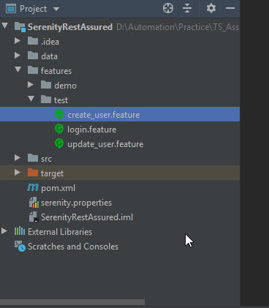Test suite for the assignment is in features/test
2. How to run framework and se report

* Run mvn command : **clean verify serenity:aggregate "-Dcucumber.options=--tags @Test"**

To run test suite for assignment

* Run mvn command : **clean verify serenity:aggregate "-Dcucumber.options=--tags @Demo"**

to run a sipmle rest api demo on <https://reqres.in/>.

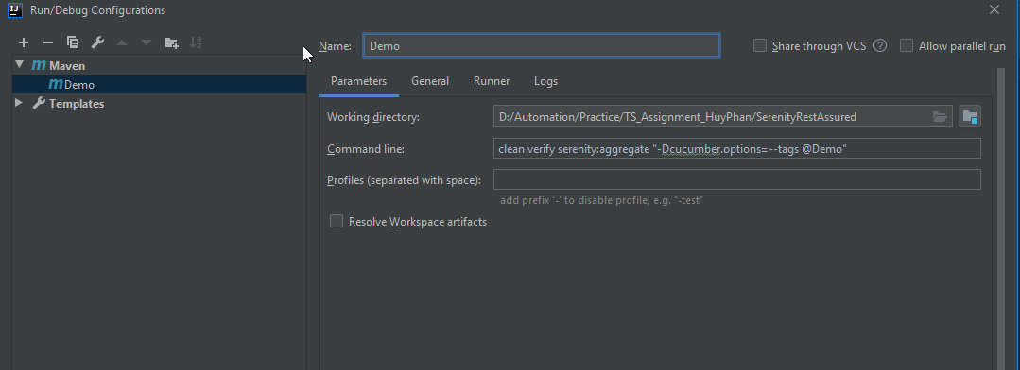

* Find the automation report in : target\site\reports\index.html

