HANOI UNIVERSITY OF SCIENCE AND TECHNOLOGY
SCHOOL OF INFORMATION AND COMMUNICATION TECHNOLOGY
________________________________________________

REPORT
OBJECT-ORIENTED PROGRAMMING MINI PROJECT
SMART FARM SIMULATOR
Instructor: | Nguyễn Thị Thu Trang
Class: | 166241 - IT3100E
Group: | 20
Students: | Nguyễn Lê Hiểu Văn 202417217  Nguyễn Duy Tân 202417194  Nguyễn Minh Trí 202417206  Phùng Đức Thịnh 202417200  Hồ Sỹ Hoàng Anh 202417092
Semester: 2025.2

CONTENTS
I. GROUP INFORMATION 4
Task Assignment and Contribution 4
Source claims 4
II. INTRODUCTION 5
1. System introduction 5
2. System operational overview 5
III. DESIGN 7
Use case diagram 7
General class diagram 9
IV. PACKAGE DESCRIPTION 13
1. Architecture 13
2. Package description 13
V. CLASS DESCRIPTION 22
1. Model classes 22
2. View classes 24
3. Controller classes 25
4. Class: Exception 26
5. Class: Constant 26
6. Main Application Class 27
VI. OBJECT-ORIENTED PROGRAMMING TECHNIQUES APPLIED 27
1. Encapsulation 27
2. Inheritance 27
3. Polymorphism 28
4. Abstraction 28
5. Exception handling 29
VII. LIMITATIONS & FUTURE WORK 30
VIII. CONCLUSION 30
IX. REFERENCES 30

I. GROUP INFORMATION
Project title: Smart Farm Simulator
Group: 20
Course: Object-Oriented Programming (IT3100E)
Class ID: 166241
Group members:
Name | GitHub | Student email
Nguyễn Lê Hiểu Văn | hieuvan153 | van.nlh2417217@sis.hust.edu.vn
Nguyễn Duy Tân | fixthat27 | tan.nd2417194@sis.hust.edu.vn
Nguyễn Minh Trí | TriNguyen3110 | tri.nm2417206@sis.hust.edu.vn
Phùng Đức Thịnh | phungthinh035-art | thinh.pd2417200@sis.hust.edu.vn
Hồ Sỹ Hoàng Anh | hohoanganh2605 | anh.hsh2417092@sis.hust.edu.vn

Task Assignment and Contribution:
Members | Task | Contribution
Nguyễn Lê Hiểu Văn | Use case diagram, Controller package; Controller class diagram; task assignment; report; slides | 20%
Nguyễn Duy Tân | Use case diagram, View (In-Game + Shop); General class diagram; crop logic; testing | 20%
Nguyễn Minh Trí | Use case diagram, Model (Player + Inventory + Game Item); exception handling; Main; player/inventory class diagram; demo video; slides | 20%
Hồ Sỹ Hoàng Anh | Use case diagram, View (Main Menu + Help + Seed Picker + Pause); View class diagram; slides | 20%
Phùng Đức Thịnh | Use case diagram, Model (Crop + Soil + Weather + Utils), crop logic; crop/soil/weather class diagram; report | 20%

Source claims
All source code in this project was written by the team. The only third-party dependency is JavaFX, used for the graphical user interface (bundled with the Liberica Full JDK 25 runtime). No other libraries or frameworks are used, the project uses no database, and no external source code was copied or adapted.

II. INTRODUCTION

1. System introduction
The Smart Farm Simulator is a Java-based desktop application, built with JavaFX, that simulates day-based farm management on a default 5×7 grid of soil cells. The player manages one farm and tries to grow and sell crops profitably while coping with weather and pests. With the main features, the player can:
- Plant and cultivate five crops: Corn, Potato, Sunflower, Tomato, and Water Rice.
- Monitor growth stages from seed to harvest: SEED → SEEDLING → MATURE → HARVEST (and the terminal states ROTTEN and DEAD).
- Use five tools: Hoe, Watering Can, Seed Bag, Fertilizer Bag, and Hand.
- Respond to three weather conditions: Sunny, Rainy, and Drought.
- Handle a Beetle pest that raises crop stress.
- Manage resources: starting money of $200, buying seeds and fertilizer in a Shop, and selling ripe crops.
The application features a graphical user interface (GUI) built with JavaFX (FXML layouts, a CSS style sheet, imported PNG icons and a color-rendered grid), kept fully separate from the game logic.

2. System operational overview
The Smart Farm Simulator operates through the following workflow:

2.1. Game initialization
- Player starts with initial capital of $200.
- The farm grid is created with empty (UNTILLED) soil cells.
- The controllers are created and the day-reacting ones register with the GameManager.
- The weather system is initialized to Sunny conditions, the day counter starts at 1, and the game status is set to RUNNING.

2.2. Core gameplay loop
- Player selects a tool from the toolbar.
- Player clicks on a farm cell to perform the tool's action (till, plant, water, fertilize, harvest, remove pest).
- Resource management: Player opens the Shop to buy seeds / fertilizer or sell ripe crops.
- Player progresses to the next day.

2.3. Daily update process
When the player advances a day, GameManager.advanceDay() notifies its day observers in registration order, then increments the day counter. The observers fire in the order they were created: FarmController (grow every crop) → EnvironmentController (roll the next day's weather and maybe spawn a pest) → GameOverController (evaluate the end-of-run condition last). Growing the crops before rolling the new weather means the crops resolve under the weather the player actually saw. Each cell then applies the weather effect, updates its crop (growth and stress), lets any pest attack, and loses some moisture to evaporation.

2.4. Win/loss conditions
The Smart Farm Simulator is an open-ended simulator: there is no win condition - the only terminal outcome is a loss by bankruptcy. The GameOverController checks a list of GameOverConditions at the end of every day. The implemented condition, BankruptcyCondition, declares the run lost only when all the following hold:
- the player's money is below the cheapest seed price, and
- the inventory holds no seeds, and
- no living crops remain on the farm.
To avoid ending the game on a brief cash dip, the loss is only announced after the condition has held for more than GAME_OVER_GRACE_DAYS (2) consecutive days. When it triggers, the Game Over screen shows the final day and money.

2.5 Scope
The simulation centers on core farming mechanics: five crop types each following a multi-stage growth system from seed to harvest, three weather types, one pest, a tile-based soil model (moisture, nutrient, sunlight), a simple shop economy, and a bankruptcy-based game-over check. It excludes save/load, seasons, multiplayer and animation.

III. DESIGN
Players can initiate the game by clicking the "New Farm" button on the main menu and reading the rules in the "Help" screen to better understand the game.
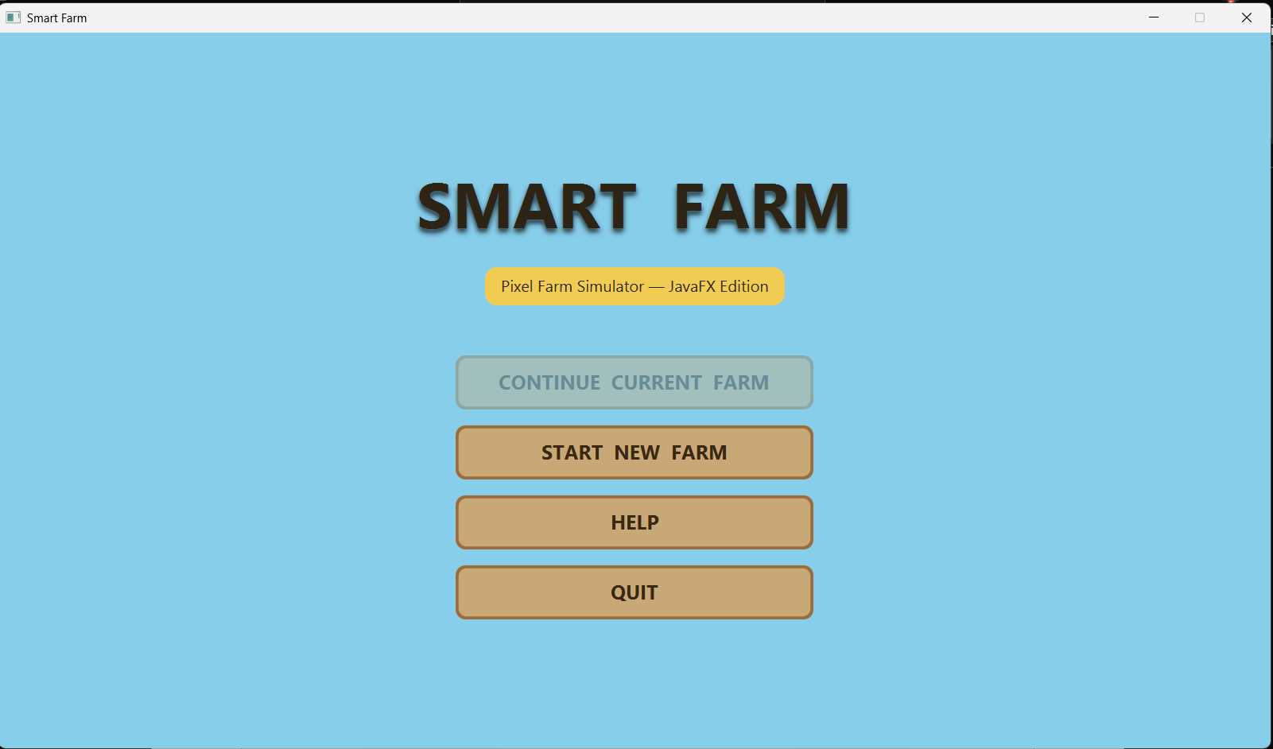
While playing, players can view resources and soil-cell information. Selecting a tool and clicking a cell performs actions such as Till, Plant, Water, Fertilize and Harvest. The Shop screen is used to buy seeds/fertilizer and sell ripe crops. If the farm goes bankrupt, a Game Over screen is shown.
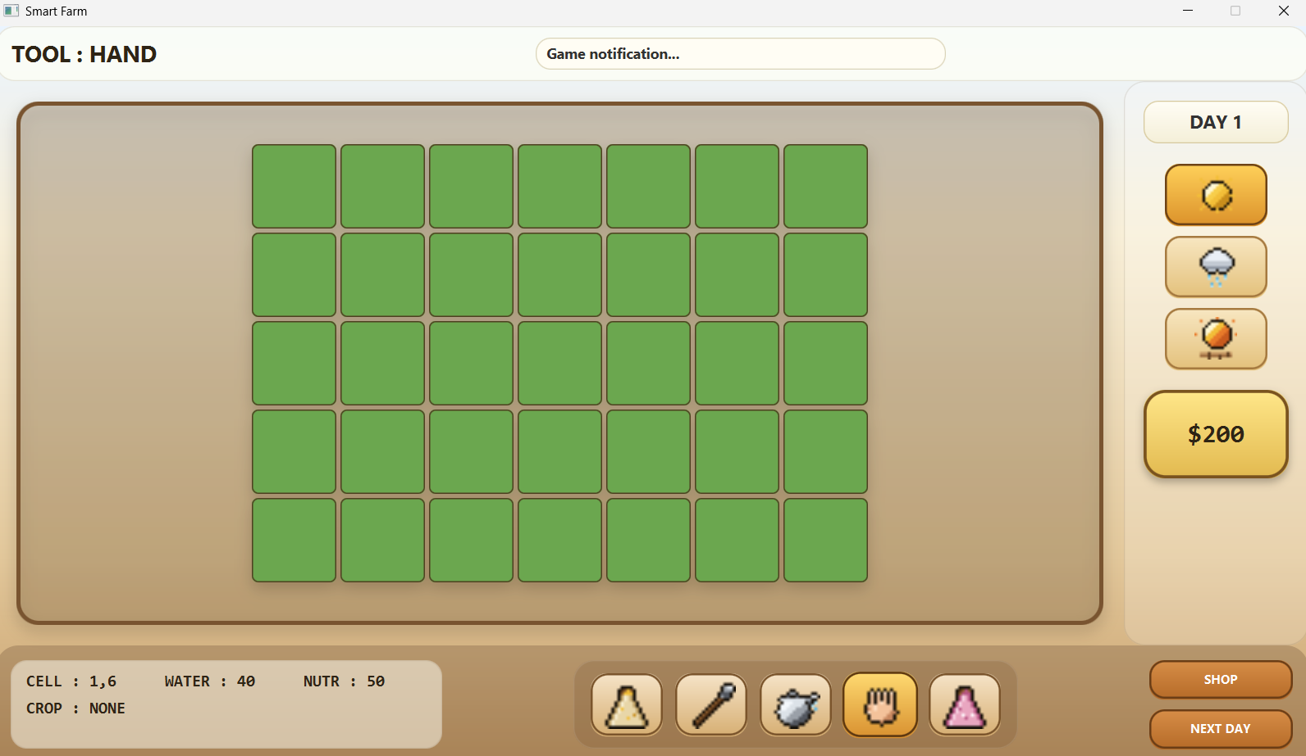
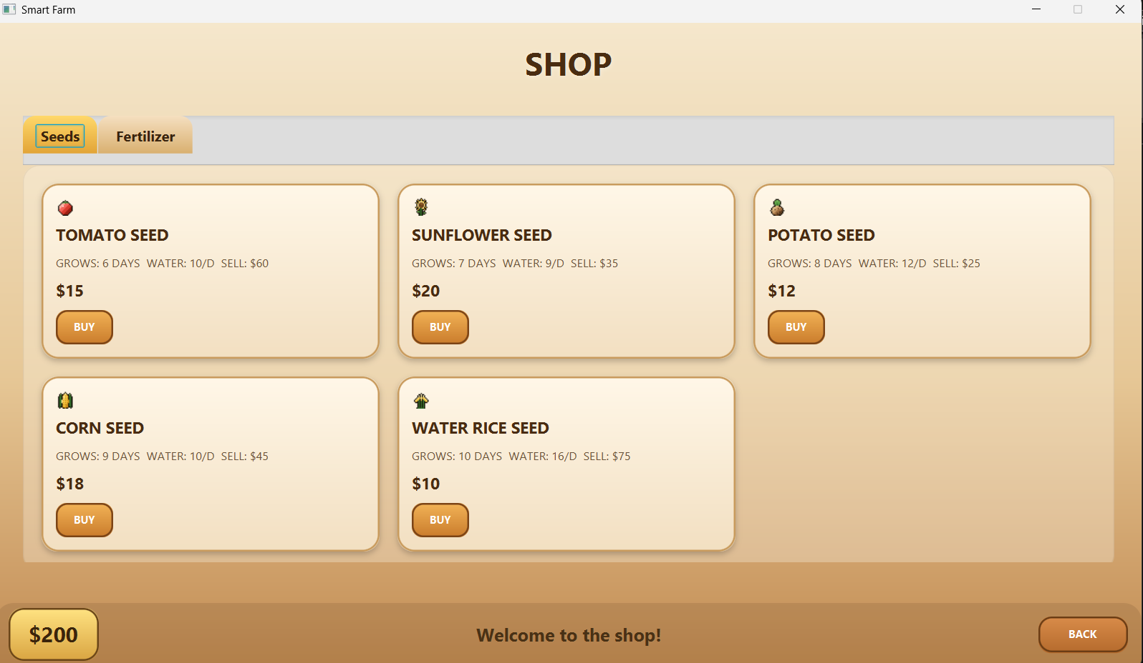
Quit: players can leave the current session through the Pause overlay (returning to the main menu) or by closing the window.
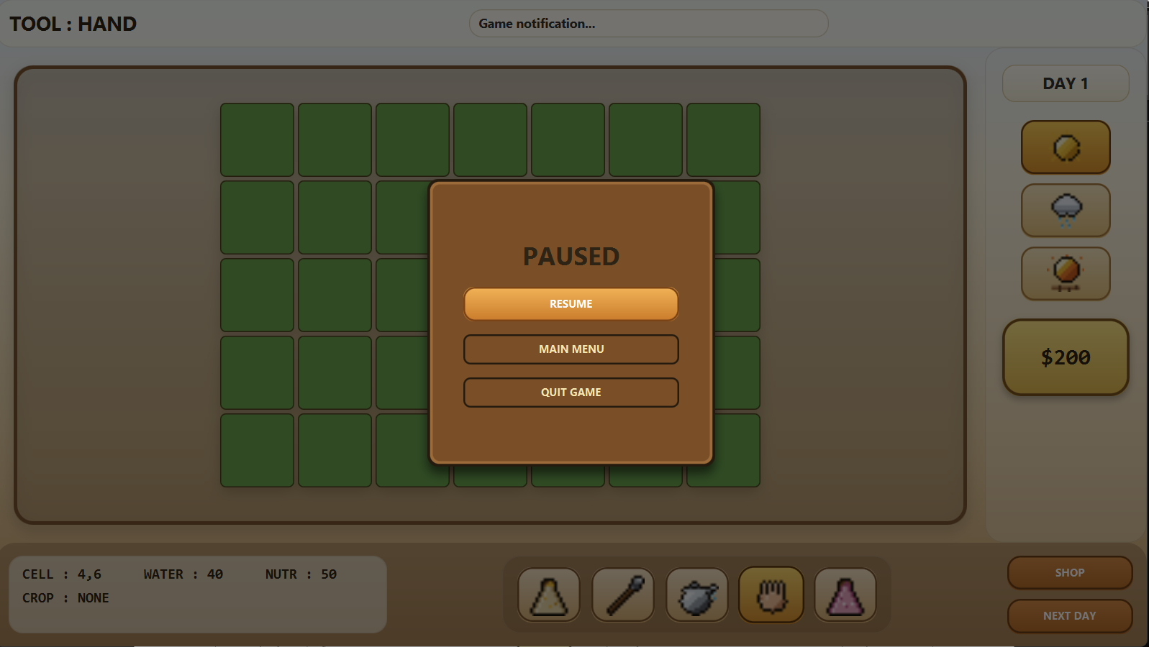

Use case diagram

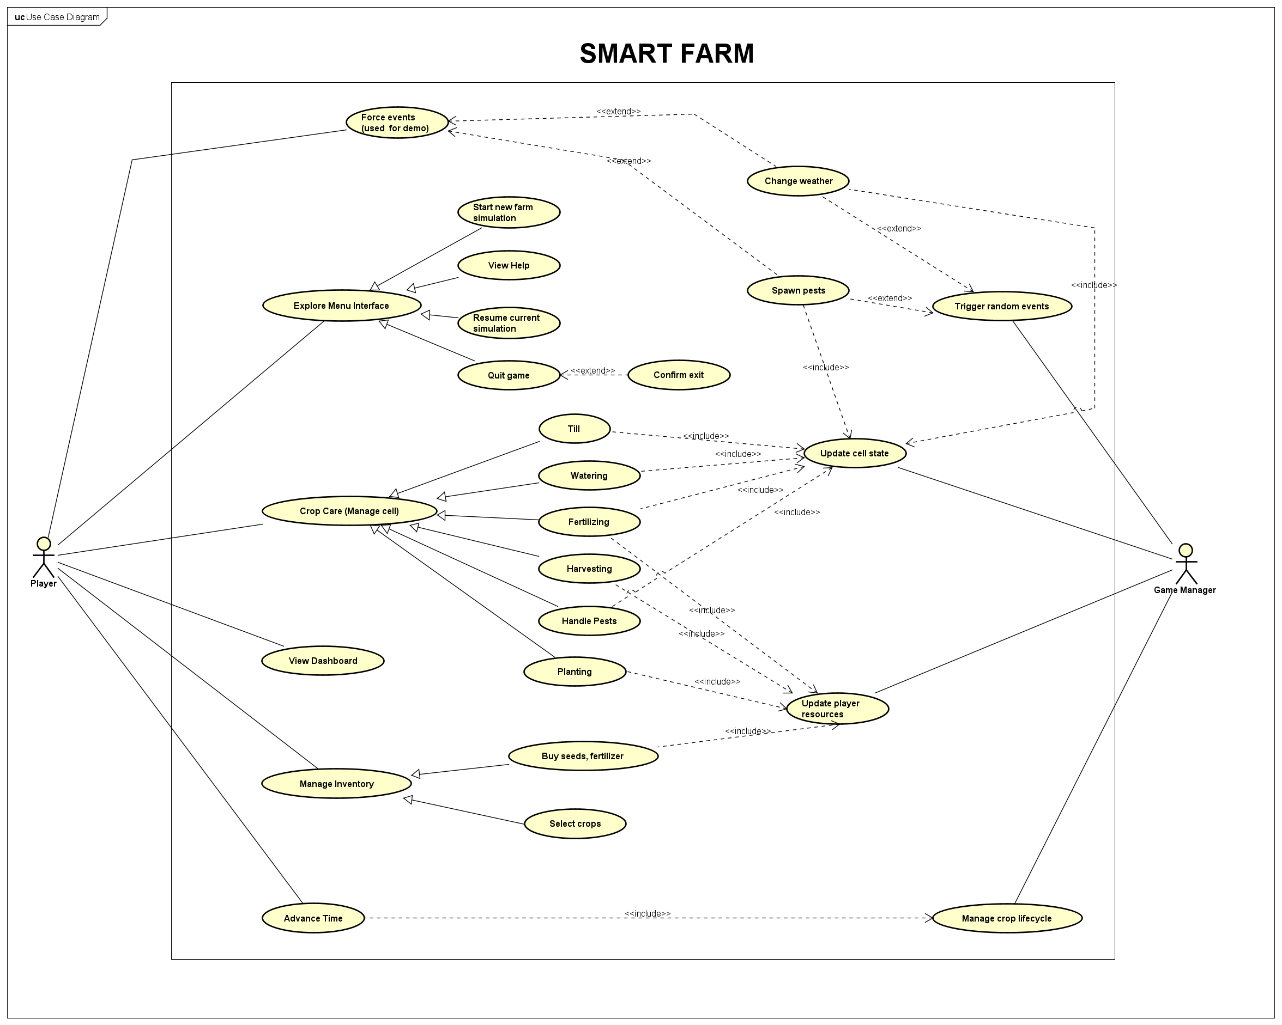
Use Case Diagram

There are two actors. The Player explores the menu (new farm, help, quit, resume current farm), cares for crops (plant, water, fertilize, harvest, handle pests), views the dashboard, force events (for demo simulation), manages the inventory (buy seeds & fertilizer, select crops), and advances time. The Game Manager represents the passing of a day: it changes the weather, spawns pests, manages crop cycle, including updating cell state and player’s resource.

General class diagram

General Class Diagram

The system follows the Model-View-Controller pattern: the View (top) holds the JavaFX screens, the Controller (middle) holds the game logic, and the Model (bottom) holds the domain classes.

Detailed Class Diagram

IV. PACKAGE DESCRIPTION

1. Architecture
The Smart Farm Simulator follows the Model-View-Controller (MVC) architectural pattern, which separates the application into three interconnected components:
- Model layer: business logic, data structures and game rules - crops, soil cells, weather, the player, inventory and shop items.
- View layer: the JavaFX user interface that displays information and captures user input.
- Controller layer: the intermediary that processes user actions, the day lifecycle and the end-of-run check, then lets the view refresh.
Additional layers:
- Exception layer: custom exceptions for game-specific errors.
- Utility layer: constants and configuration.
A key property is Dependency Inversion: the Model and Controller layers import no JavaFX type, so they compile on their own. Main is the only class that knows every concrete type and wires them together.

2. Package description

2.1. Package: (default) Main
Purpose: application entry point and composition root.
Classes: Main - the JavaFX Application that builds the model, builds the controllers, loads the FXML view and injects the dependencies.

2.2. Package: controller
Purpose: executes business logic on the model by processing user input, the end-of-day event and the end-of-run check, then lets the view refresh. It is split into sub-packages: lifecyclemanager (day lifecycle + game-over), actionmanager (tools), farmcontroller, environmentcontroller, shopmanager, and democontroller.
Classes: GameManager, DayObserver, BaseController, GameOverController, GameOverCondition, BankruptcyCondition, GameOverListener, GameStatus, PlayerController, ToolStrategy (+ Hoe, WateringCan, SeedBag, FertilizerBag, Hand), FarmController, EnvironmentController, ShopController, ItemManager (+ SeedItem, FertilizerItem), DemoController.

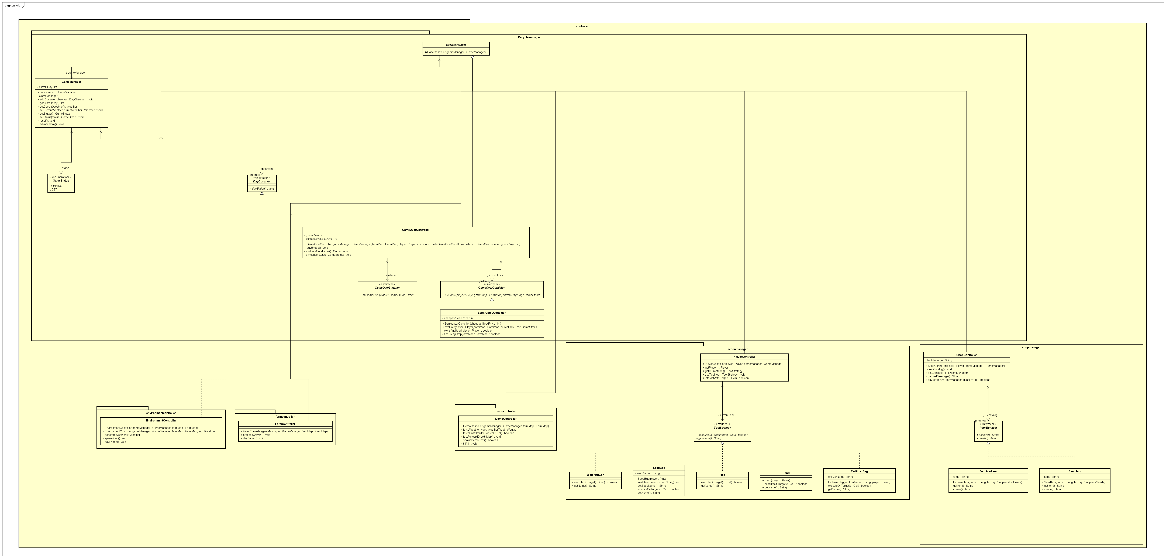
Controller package class diagram

2.3. Package: model
Purpose: contains the core business logic and domain entities, organized into the sub-packages crop, soil, weather, player_inventory and game_item.

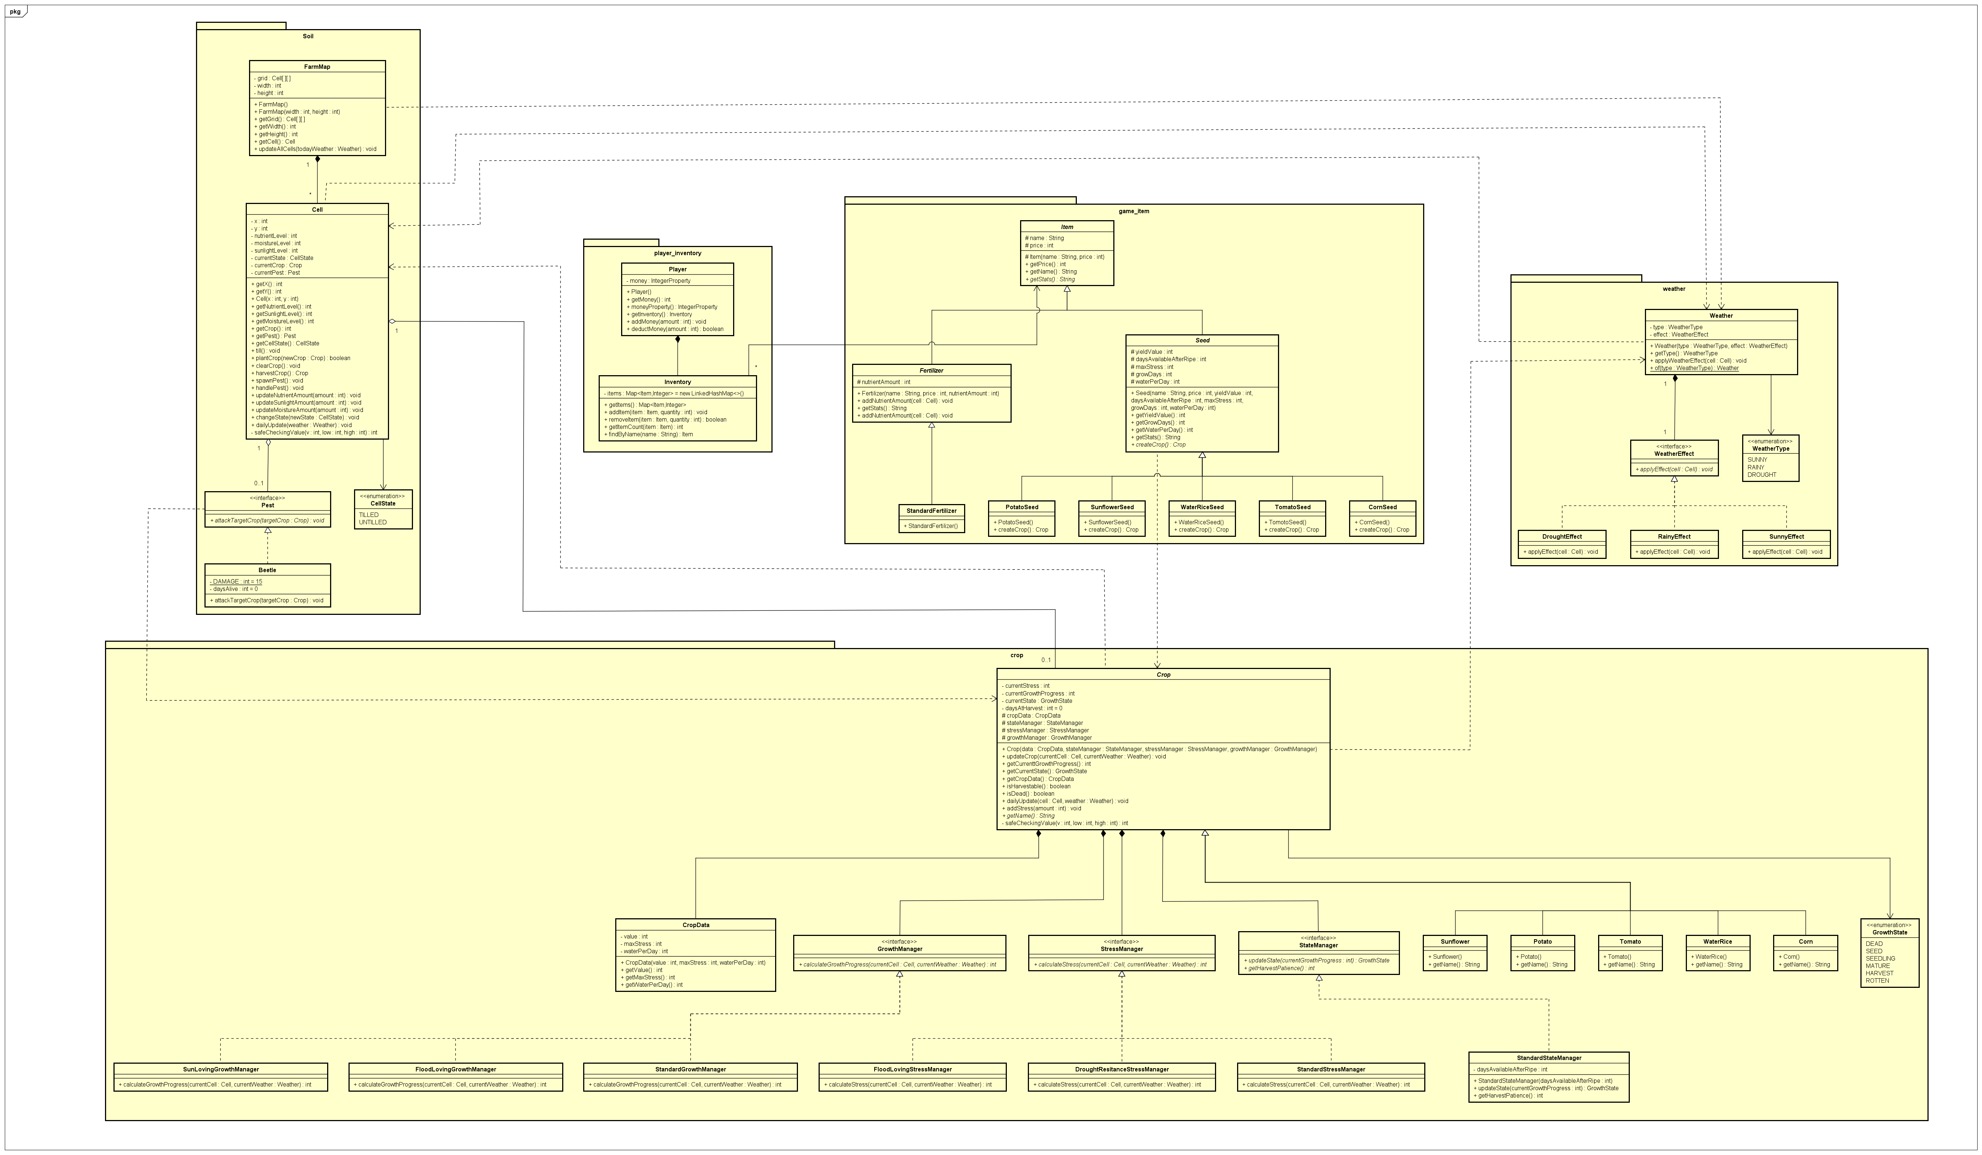
Model package class diagram

2.3.1. Package: model.crop
Purpose: the crop state machine and its species. A Crop delegates its daily behaviour to three pluggable strategies (growth, stress, lifecycle state).
Classes: Crop, CropData, GrowthState, the interfaces GrowthManager/StressManager/StateManager with their implementations (StandardGrowthManager, SunLovingGrowthManager, FloodLovingGrowthManager, StandardStressManager, DroughtResistanceStressManager, FloodLovingStressManager, StandardStateManager), and the species Corn, Potato, Sunflower, Tomato, WaterRice.

2.3.2 Package: model.soil
Purpose: the farm grid, individual cells and pests.
Classes: FarmMap (the Cell[][] grid), Cell, CellState (UNTILLED/TILLED), Pest and Beetle.

2.3.3. Package: model.weather
Purpose: implements the weather system whose effects influence the soil.
Classes: Weather, WeatherType (SUNNY/RAINY/DROUGHT), the WeatherEffect interface and its implementations SunnyEffect, RainyEffect, DroughtEffect.

2.3.4. Package: model.player_inventory and model.game_item
Purpose: the player and the item economy.
Classes: Player, Inventory; and the item hierarchy Item → Seed/Fertilizer → concrete seeds (CornSeed, PotatoSeed, SunflowerSeed, TomatoSeed, WaterRiceSeed) and StandardFertilizer.

2.4. Package: view
Purpose: all user-interface components using JavaFX, which recognise user input and display real-time game state. It is split into screen_controller (FXML controllers), screen_util (navigation) and assets (icons).
Classes: MainMenuController, HelpController, PauseController, InGameController, ShopViewController, SeedPickerController, GameOverViewController; SceneRouter, ScreensLoader, Screens, GameLauncher; Assets, CropAssetRegistry, ItemAssetRegistry.

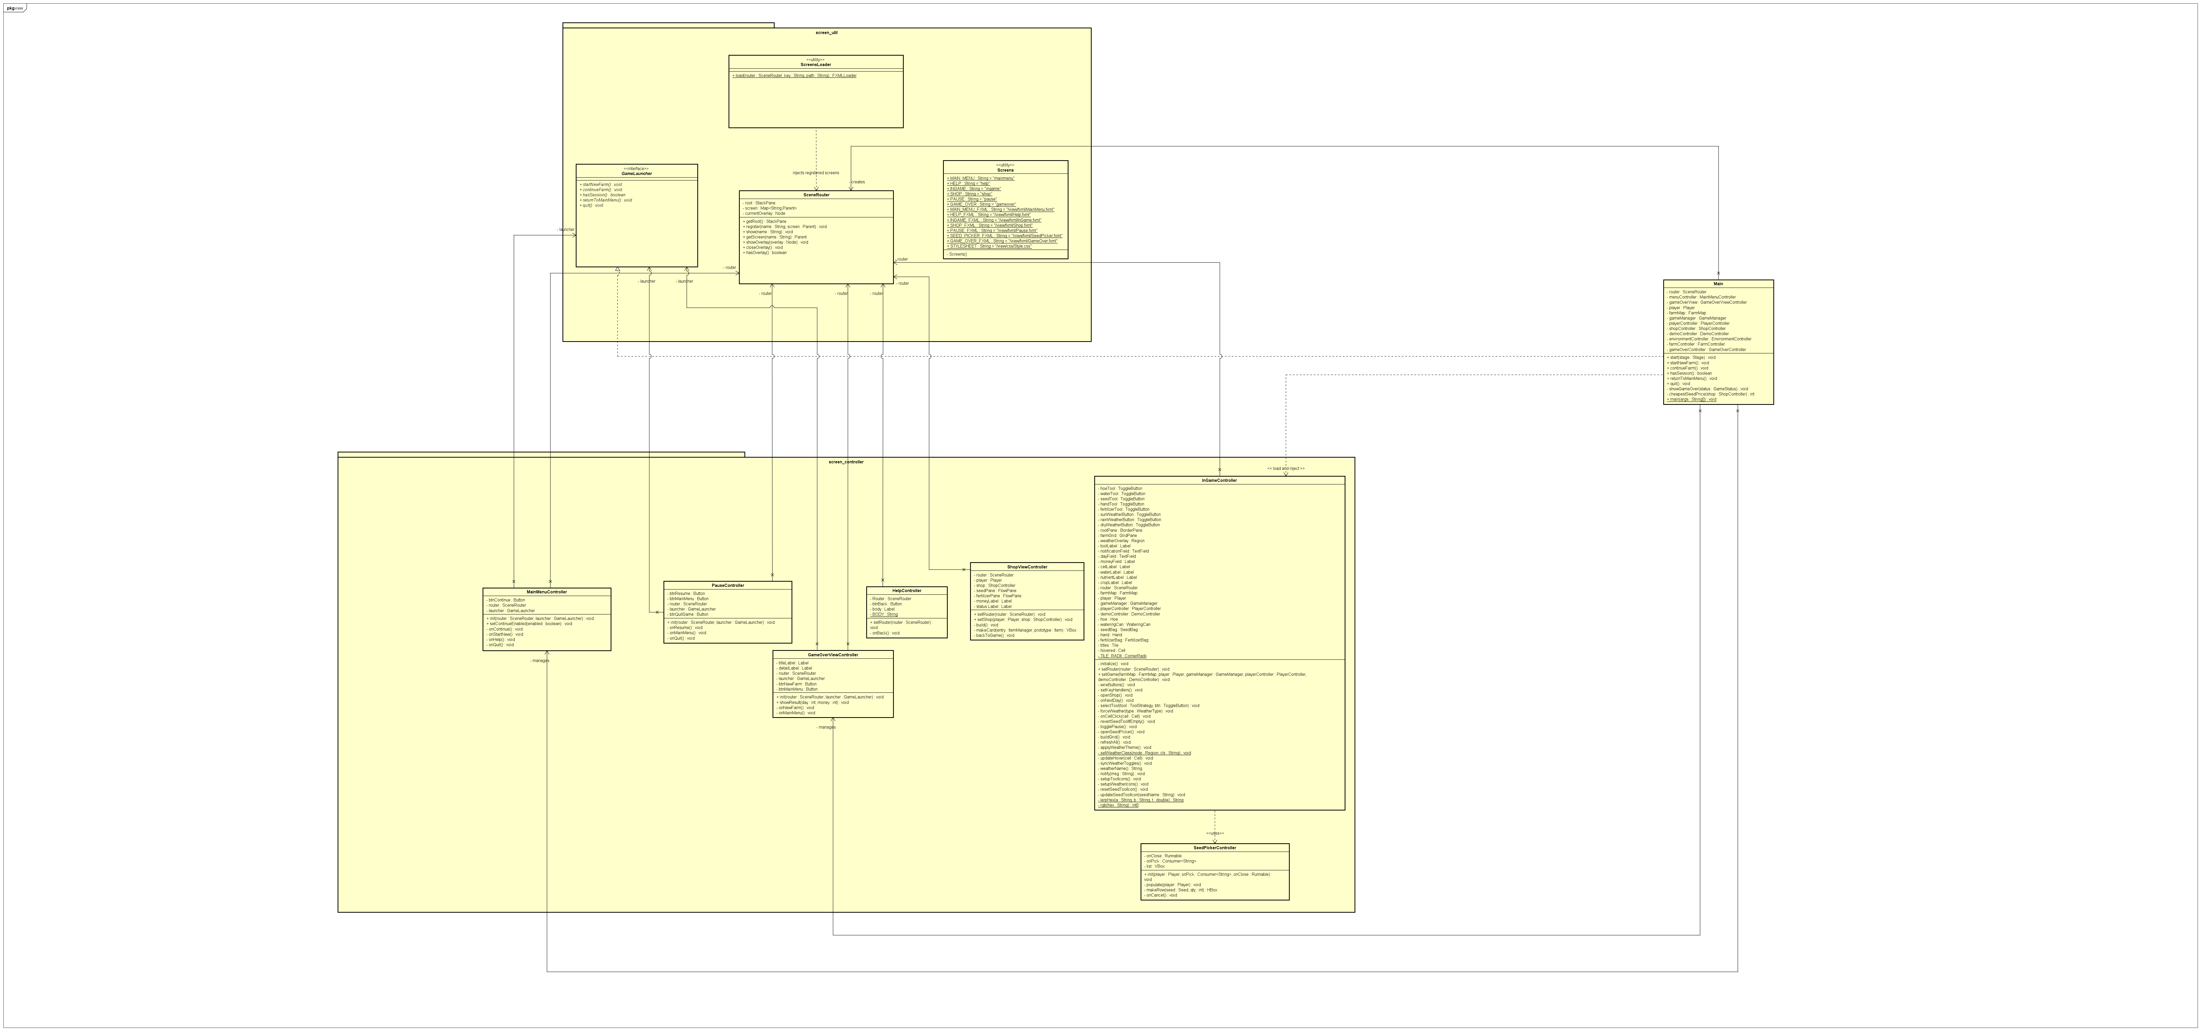
View package class diagram

2.5. Package: exception
Purpose: custom exception handling for game-specific errors.
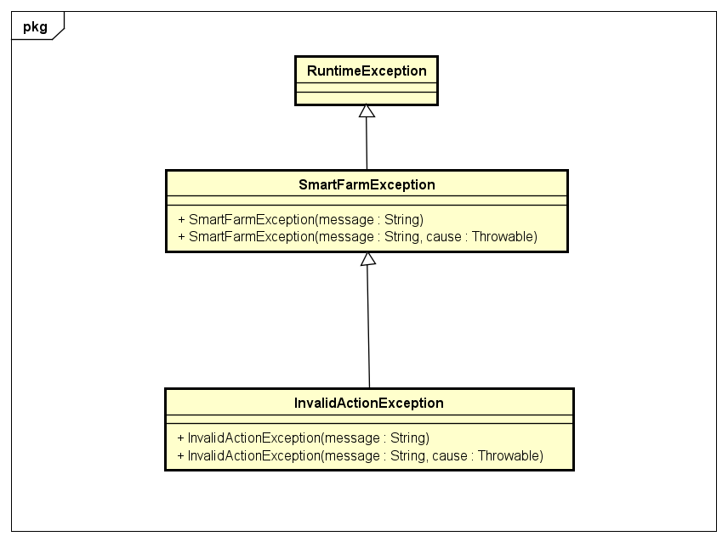
Classes: SmartFarmException (base, unchecked) and InvalidActionException (a violated precondition).

2.6. Package: utils
Purpose: stores constant definitions, enabling easy game tuning and avoiding magic numbers.
Classes: Constant — static final constants for game configuration.

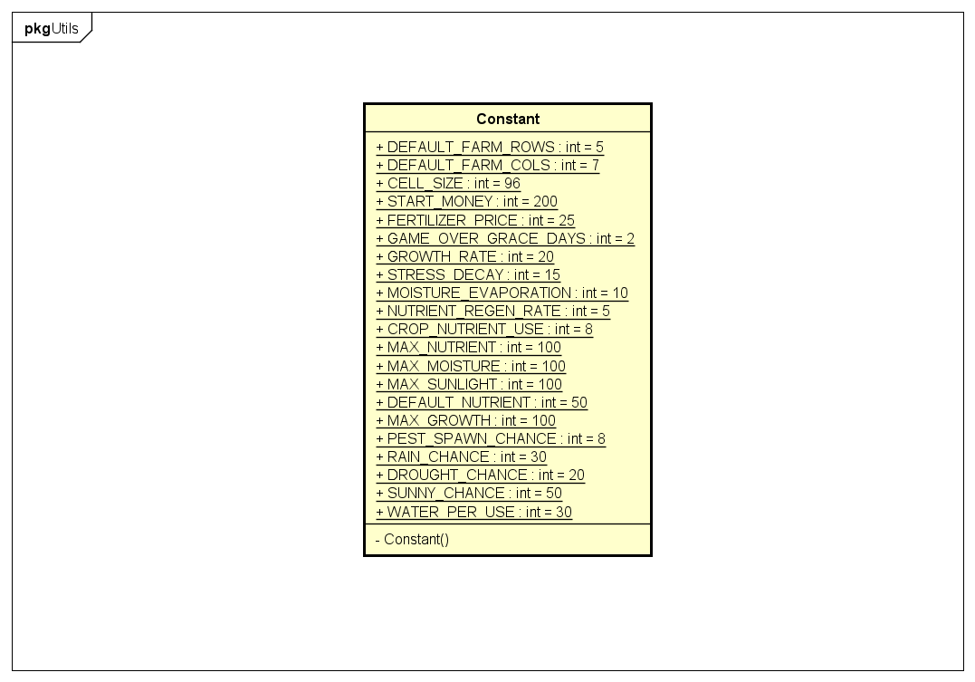
Utils package class diagram

V. CLASS DESCRIPTION
This section describes key classes in the Smart Farm Simulator, including their purpose, methods and relationships.

1. Model classes

1.1. Class: Crop
Purpose: a planted crop instance; a small state machine driven by three strategies.
Key Methods:
public void dailyUpdate(Cell hostCell, Weather weather) {
if (isDead()) return;
int stressDelta = stressManager.calculateStress(hostCell, weather);
currentStress = safeCheckingValue(currentStress + stressDelta, 0, cropData.getMaxStress());
if (currentStress >= cropData.getMaxStress()) { currentState = GrowthState.DEAD; return; }
if (currentState != GrowthState.HARVEST) {
int growthDelta = growthManager.calculateGrowthProgress(hostCell, weather);
double stressFactor = 1.0 - (currentStress / (double) cropData.getMaxStress());
growthDelta = (int) Math.round(growthDelta * stressFactor);
currentGrowthProgress = safeCheckingValue(currentGrowthProgress + growthDelta, 0, Constant.MAX_GROWTH);
currentState = stateManager.updateState(currentGrowthProgress);
}
hostCell.updateMoistureAmount(-cropData.getWaterPerDay());
hostCell.updateNutrientAmount(-Constant.CROP_NUTRIENT_USE);
if (currentState == GrowthState.HARVEST && ++daysAtHarvest > stateManager.getHarvestPatience())
currentState = GrowthState.ROTTEN;
}
Daily update algorithm:
- Skip if the crop is already dead.
- Accumulate stress; if stress reaches the maximum, the crop dies (DEAD).
- If not yet ripe, add growth progress (reduced by current stress) and update the growth state.
- Consume moisture (its own waterPerDay) and nutrient from the host cell.
- If left too long after ripening (beyond its harvest patience), the crop becomes ROTTEN.
Subclasses: each species extends Crop and supplies its own CropData(value, maxStress, waterPerDay), a StateManager (harvest patience), a StressManager and a GrowthManager.
Characteristics comparison:
Crop | Seed price | Harvest value | Max stress | Water/day | Growth strategy | Stress strategy
Corn | $18 | $45 | 85 | 10 | Standard | Standard
Potato | $12 | $25 | 90 | 12 | Standard | Drought-resistant
Sunflower | $20 | $35 | 70 | 9 | Sun-loving | Drought-resistant
Tomato | $15 | $60 | 80 | 10 | Sun-loving | Standard
Water Rice | $10 | $75 | 75 | 15 | Flood-loving | Flood-loving

1.2. Class: Cell and FarmMap
Purpose: Cell represents an individual soil plot (moisture, nutrient, sunlight, state, crop, pest); FarmMap owns the grid.
Key Methods:
public void dailyUpdate(Weather weather) {
if (weather != null) weather.applyWeatherEffect(this);
if (currentCrop != null) currentCrop.dailyUpdate(this, weather);
else if (nutrientLevel < Constant.DEFAULT_NUTRIENT)
updateNutrientAmount(Math.min(Constant.NUTRIENT_REGEN_RATE, Constant.DEFAULT_NUTRIENT - nutrientLevel));
if (currentPest != null && currentCrop != null && !currentCrop.isDead())
currentPest.attackTargetCrop(currentCrop);
updateMoistureAmount(-Constant.MOISTURE_EVAPORATION);
}
- Applies the weather effect, then grows the crop (or regenerates empty soil), then lets the pest attack, then evaporates moisture.
- plantCrop requires the cell to be TILLED and empty; harvestCrop returns the crop only if it is in HARVEST state.

1.3. Class: Weather
Purpose: couples a WeatherType and a WeatherEffect strategy.
public void applyWeatherEffect(Cell cell) {
if (cell == null) return;
effect.applyEffect(cell);
}
The three effects: SunnyEffect (+sunlight, −moisture), RainyEffect (+moisture, −sunlight), DroughtEffect (−moisture, +sunlight).

1.4. Class: Player and Inventory
Purpose: Player holds money and an Inventory; money math is overflow safe.
public void addMoney(int amount) {
if (amount <= 0) return;
try { money = Math.addExact(money, amount); }
catch (ArithmeticException overflow) { money = Integer.MAX_VALUE; }
}
Inventory wraps a LinkedHashMap<Item,Integer> and returns an unmodifiable view, with addItem, removeItem, getItemCount and findByName.

2. View classes

2.1. Class: InGameController
Purpose: the main gameplay screen — builds the cell grid, the toolbar, weather toggles and hover info, and handles Next Day.
private void onCellClick(Cell cell) {
boolean ok = playerController.interactWithCell(cell);
notify(ok ? "" : "Can't use this tool here");
refreshAll();
}
A cell click is sent to the controller through one API regardless of which tool is selected.

2.2. Classes: MainMenuController, HelpController and GameOverViewController
Purpose: MainMenuController handles New / Continue / Help / Quit; HelpController shows the guide text and a back button; GameOverViewController shows the bankruptcy result (final day and money) with New Farm / Main Menu buttons. All depends on the GameLauncher interface, not on Main.

2.3. Class: SceneRouter
Purpose: registers every screen and swaps the visible one inside a single StackPane, and manages a one-at-a-time overlay (pause / seed picker).
public void show(String name) {
Parent screen = screens.get(name);
if (screen == null) throw new SmartFarmException("Screen not registered: " + name);
closeOverlay();
root.getChildren().setAll(screen);
}

3. Controller classes

3.1. Class: GameManager
Purpose: a Singleton that owns the day, the current weather and the game status, and is the Subject of the Observer pattern.
public void advanceDay() {
if (status != GameStatus.RUNNING) return;
List<DayObserver> snapshot = new ArrayList<>(observers);
for (DayObserver obs : snapshot) obs.dayEnded();
currentDay++;
}
- Skips the update once the game is no longer RUNNING; otherwise notifies every observer's dayEnded() on a snapshot of the list (safe against re-registration), then advances the day.

3.2. Class: BaseController and the day observers
BaseController is the abstract parent that stores the shared GameManager:
public abstract class BaseController {
protected final GameManager gameManager;
protected BaseController(GameManager gameManager) {
this.gameManager = Objects.requireNonNull(gameManager, "gameManager must not be null");
}
}
Controllers that need the end-of-day event additionally implement `DayObserver` and register themselves in their constructor (FarmController, EnvironmentController, GameOverController):
public class FarmController extends BaseController implements DayObserver {
public FarmController(GameManager gameManager, FarmMap farmMap) {
super(gameManager);
this.farmMap = farmMap;
gameManager.addObserver(this); // self-register
}
@Override public void dayEnded() { processGrowth(); }
}

3.3. Class: PlayerController and ToolStrategy
Purpose: PlayerController is the Strategy context that holds the current tool.
public boolean interactWithCell(Cell cell) {
if (currentTool == null || cell == null) return false;
return currentTool.executeOnTarget(cell);
}
- The five tools (Hoe, WateringCan, SeedBag, FertilizerBag, Hand) each implement ToolStrategy; the tool can be swapped at runtime with no if/switch.

3.4. Classes: FarmController, EnvironmentController, ShopController
- FarmController.processGrowth() grows every crop each day.
- EnvironmentController.generateWeather() picks the weather by a weighted random roll, and spawnPest() may drop a Beetle on a random planted cell.
- ShopController.buyItem()/sellCrop() handle purchases and sales with overflow-safe money math; the catalog is an unmodifiable List<ItemManager>.

3.5. Game-over subsystem: GameOverController, GameOverCondition, GameStatus
GameOverController is a DayObserver that, at the end of each day, evaluates a list of GameOverConditions and ends the run after the loss has persisted past the grace period:
@Override public void dayEnded() {
if (gameManager.getStatus() != GameStatus.RUNNING) return;
GameStatus result = evaluateConditions();
if (result == GameStatus.LOST) {
consecutiveLostDays++;
if (consecutiveLostDays > graceDays) announce(GameStatus.LOST);
return;
}
consecutiveLostDays = 0;
}
GameOverCondition is the strategy interface (GameStatus evaluate(Player, FarmMap, int day)); BankruptcyCondition is the only implementation; GameStatus is the RUNNING/LOST enum; GameOverListener is the callback Main uses to show the Game Over screen.

4. Class: Exception
Purpose: a custom unchecked exception for invariant/programmer errors. InvalidActionException extends it for violated preconditions. They separate genuine errors from ordinary gameplay outcomes (which instead return false + a message).

5. Class: Constant
Purpose: centralized configuration constants (farm size 5×7, starting money $200, growth/stress rates, resource caps, weather chances, watering amount, game-over grace days). Benefits: easy balance tuning, better readability, simpler maintenance.

6. Main Application Class
Purpose: application entry point and composition root. It builds the model (FarmMap, Player), builds the controllers in order they must observe the day (FarmController → EnvironmentController → ... → GameOverController), assembles the game-over conditions (a BankruptcyCondition seeded with the cheapest seed price) plus the grace period, loads the FXML view and injects the controllers, then shows the main menu. Because it implements GameLauncher, the menu screens depend on the interface, not on Main. The runtime is the Liberica Full JDK 25, which bundles JavaFX.

VI. OBJECT-ORIENTED PROGRAMMING TECHNIQUES APPLIED
This section demonstrates how fundamental OOP principles are implemented throughout the project.

1. Encapsulation
Definition: encapsulation bundles data and methods within classes while restricting direct access to internal state.
Implementation: fields are private and changed only through guarded methods. Values that must stay in range are clamped:
private int safeCheckingValue(int v, int lo, int hi) {
if (v > hi) return hi;
if (v < lo) return lo;
return v;
}
Inventory.getItems() returns an unmodifiable view and ShopController.getCatalog() returns an unmodifiable list, so callers can read but never corrupt internal collections.
Benefits: internal state stays consistent; values cannot be set to invalid amounts.

2. Inheritance
Definition: inheritance lets classes reuse properties and methods from a parent class.
Implementation in the project:
public class Corn extends Crop {
public Corn() {
super(new CropData(45, 85, 10), new StandardStateManager(3),
new StandardStressManager(), new StandardGrowthManager());
}
}
- Crops: Crop → Corn, Potato, Sunflower, Tomato, WaterRice.
- Items: Item → Seed/Fertilizer → concrete seeds and StandardFertilizer.
- Controllers: BaseController → PlayerController, FarmController, EnvironmentController, ShopController, DemoController, GameOverController.
Benefits: eliminates duplication; all crops/controllers share common behaviour; new types are easy to add.

3. Polymorphism
Definition: polymorphism lets objects of different classes be used through a common interface (dynamic dispatch).

3.1. Strategy and Observer dispatch
// PlayerController — the current tool is called without knowing its concrete type
return currentTool.executeOnTarget(cell);
// GameManager — each observer runs its own dayEnded()
for (DayObserver obs : snapshot) obs.dayEnded();
- Moreover:
A Crop likewise calls its GrowthManager/StressManager/StateManager through interfaces, Weather calls WeatherEffect.applyEffect(cell), and GameOverController calls each GameOverCondition.evaluate(...).

3.2. Factory dispatch
ShopController iterates a List<ItemManager> and calls create() (each SeedItem/FertilizerItem wraps a Supplier<Seed>/Supplier<Fertilizer>), and Seed.createCrop() returns the right Crop subtype - with no instanceof checks.
Benefits: a single code path handles every tool/observer/effect/condition; new types can be added without modifying existing code.

4. Abstraction
Definition: abstraction hides implementation details behind simplified interfaces.

4.1. Abstract classes
Item, Seed, Fertilizer and BaseController are abstract: they define a common contract while leaving specifics to subclasses.

4.2. Interface abstraction and design patterns
Single-responsibility interfaces include DayObserver, ToolStrategy, ItemManager, GrowthManager, StressManager, StateManager, WeatherEffect, Pest, GameOverCondition, GameOverListener and GameLauncher. The project applies the design patterns:
- Singleton - GameManager (Holder idiom).
- Strategy - ToolStrategy, the crop growth/stress/state managers, and GameOverCondition.
- Observer - DayObserver (day lifecycle) and GameOverListener (end-of-run callback).
- Factory - Supplier<Seed>/Supplier<Fertilizer> inside SeedItem/FertilizerItem.
- State - GrowthState (crop lifecycle) and CellState (soil tilled/untilled).
- Dependency Inversion - Main implements GameLauncher.
Benefits: defines contracts without imposing implementations; adding a new crop, tool or game-over rule means writing one class - no controller or view change.

5. Exception handling
Definition: exception handling provides structured error management.

5.1. Custom exception class
public class SmartFarmException extends RuntimeException {
public SmartFarmException(String message) { super(message); }
public SmartFarmException(String message, Throwable cause) { super(message, cause); }
}
Invariant/programmer errors throw SmartFarmException/InvalidActionException (e.g. a null dependency in BaseController, an unregistered screen in SceneRouter.show()).

5.2. Expected outcomes and arithmetic safety
Ordinary situations (not enough money, can't plant here, nothing to harvest) do not throw, they return false and messages. Money/quantity math is overflow-checked:
try { totalCost = Math.multiplyExact(prototype.getPrice(), quantity); }
catch (ArithmeticException ex) { lastMessage = "That quantity is too large to purchase."; return false; }
Finally, Main installs one view-layer error boundary that turns any escaped exception into a friendly dialog.
- Benefits: clear error messages, no cryptic crashes, and a consistent game state.

VII. LIMITATIONS & FUTURE WORK
- No win condition: the only terminal outcome is bankruptcy.
- Future: add goals (target money / surviving N days) and a victory screen.
- No data persistence: progress is lost on close.
- Future: object serialization for save/load.
- Fixed scalability: the farm is the default 5×7 grid with no difficulty options.
- Future: adjustable grid sizes and difficulty levels.
- Limited variety: five crops, three weather types, one pest.
- Future: seasons, more crops/pests, livestock.
- Static economy: prices are constant.
- Future: a dynamic market where prices fluctuate.
- Basic visualization: static PNG icons, no animation or sound.
- Future: animated sprites and sound effects.

VIII. CONCLUSION
The Smart Farm Simulator successfully demonstrates the practical application of Object-Oriented Programming principles through an engaging JavaFX simulation game. A clean MVC split keeps the model and controller layers free of any GUI dependency, while several design patterns (Singleton, Observer, Strategy, Factory, State, Dependency Inversion) keep the system easy to extend. The four pillars of OOP - encapsulation, inheritance, polymorphism and abstraction - are applied throughout, and a two-tier error-handling strategy keeps ordinary gameplay outcomes separate from genuine programmer errors.

IX. REFERENCES
[1] Oracle, "Java Platform, Standard Edition API Specification," 2024. https://docs.oracle.com/en/java/
[2] OpenJFX, "JavaFX Documentation." https://openjfx.io/
[3] E. Gamma, R. Helm, R. Johnson, J. Vlissides, Design Patterns: Elements of Reusable Object-Oriented Software, Addison-Wesley, 1994.
[4] School of Information and Communication Technology - HUST, "Lecture Notes: IT3100 - Object-Oriented Programming," Semester 2025.2.
[5] Astah UML, "Astah Professional." https://astah.net/
[6] Smart Farm Simulator - demo video. https://www.youtube.com/watch?v=AhFmDBq2Wgg

