

Requirement & Design Specification

Spicy Noodle System

**Hệ Thống Quản Lý Nhà Hàng Bán Mì Cay**

– Ho Chi Minh Campus, July 2025 –

Contents

I. Overview 4

1. Team Members: 4

2. User Requirements 4

1.1 Actors 4

3. Overall Functionalities 4

3.1 Screens Flow 4

3.2: Functional requirement: 6

3.3: Non-Functional requirement: 7

II. ERD Diagram 7

III. Business Rules 10

**I**V. User Case Diagram 13

V. User Story 13

1. Customer 13

2. Staff 14

3. Administrator

VI. Project Source 15

# I. Overview

## 1. Team Members:

| **STT** | **Full name** | **Student code** | **Email** |
| --- | --- | --- | --- |
| 1 | Dương Minh Nhất | SE182236 | NhatDMSE182236@fpt.edu.vn |
| 2 | Phạm Đăng Khôi | SE170462 | KhoiPDSE170462@fpt.edu.vn |
| 3 | Vũ Ngọc Hoàn | SE170449 | HoanVNSE170449@fpt.edu.vn |
| 4 | Phạm Nguyễn Đan Thư | SE170446 | ThuPNDSE170446@fpt.edu.vn |
| 5 | Vũ Thanh Sơn | SE171604 | SonVTSE171604@fpt.edu.vn |

## 2. User Requirements

### 1.1 Actors

| **#** | **Actor** | **Description** |
| --- | --- | --- |
| 1 | Customer | End users who can browse meals, combos, and toppings, place orders, and make payments. |
| 2 | Staff | Employees who can view, update, and process orders, as well as update payment statuses. |
| 4 | Administrator | Users with elevated privileges to manage users, meals, combos, toppings, and view system revenue. |

## 3. Overall Functionalities

### 3.1 Screens Flow

Link:

### 3.2: Functional requirement:

#### 1. Customer

* Register and login to the system.
* Browse meals, combos, and available toppings.
* Add products (meals, combos, toppings) to cart.
* Place orders, including selecting delivery options and payment method.
* View order history and track current order status.
* Make payments for orders.
* View account information and update profile.

#### 2. Staff

* Login to the staff dashboard.
* View list of incoming, in-progress, and completed orders.
* Update order statuses (e.g., Confirmed, Preparing, Completed, Cancelled).
* Update payment status upon receipt of payment.
* View details of each order, including customer information and selected items.

#### 3. Administrator

* Login to the admin dashboard.
* Manage (create, update, delete) meals, combos, and toppings.
* Manage user accounts (view, edit, activate/deactivate users).
* View all orders and their statuses.
* View and manage staff accounts.
* View sales revenue and generate basic business reports.

### 3.3: Non-Functional requirement:

* **Security:**
* Secure registration, authentication, and data encryption.
* **Data integrity:**
* Ensure data accuracy and consistency, with regular backups and interaction logs.
* **Maintainability:**
* Well-structured, documented codebase for easy maintenance and updates.
* **Reliability:**
* Support session recovery and reliable appointment scheduling.

### II. ERD Diagram:

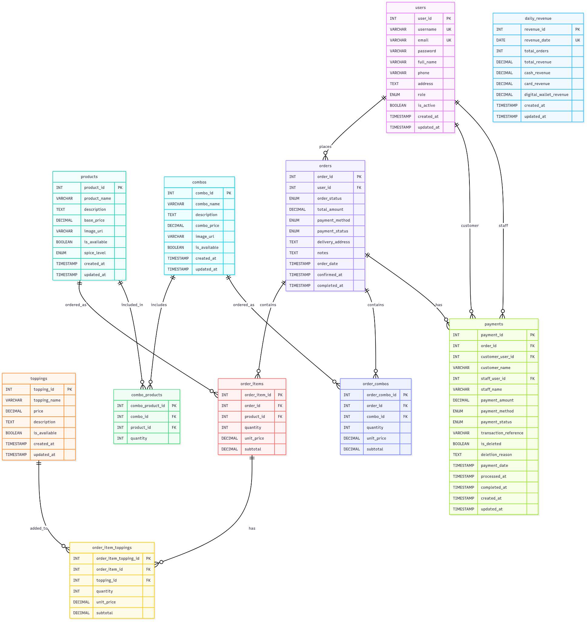

*Link:* [*ERD_Link*](https://drive.google.com/file/d/1u_4TT_WePjLk1B_b96mG2-CdDla1mEVv/view?usp=drive_link)

# III. Business Rules

| **ID** | **Rule Definition** |
| --- | --- |
| **BR-01** | **Each user is assigned exactly one role: Customer, Staff, or Admin.** |
| **BR-02** | **Only admins can change user roles.** |
| **BR-03** | **An order must contain at least one meal or combo.** |
| **BR-04** | **Toppings can only be added to applicable meal types.** |
| **BR-05** | **Orders progress through statuses: Pending → Confirmed → Preparing → Ready → Delivered.** |
| **BR-06** | **Staff can update order status except for completed/cancelled orders.** |
| **BR-07** | **Only Admin can create, update, or delete meals, combos, and toppings.** |
| **BR-08** | **Product names must be unique within each category.** |
| **BR-09** | **Customers can update their personal profile except for their role.** |
| **BR-10** | **Admin can deactivate or delete user accounts (except their own account).** |
| **BR-11** | **Order and payment history is retained for at least 12 months.** |
| **BR-12** | **Only Admin can access revenue reports.** |
| **BR-13** | **Reports are generated based on order payments marked as completed.** |

# IV. User Case Diagram:

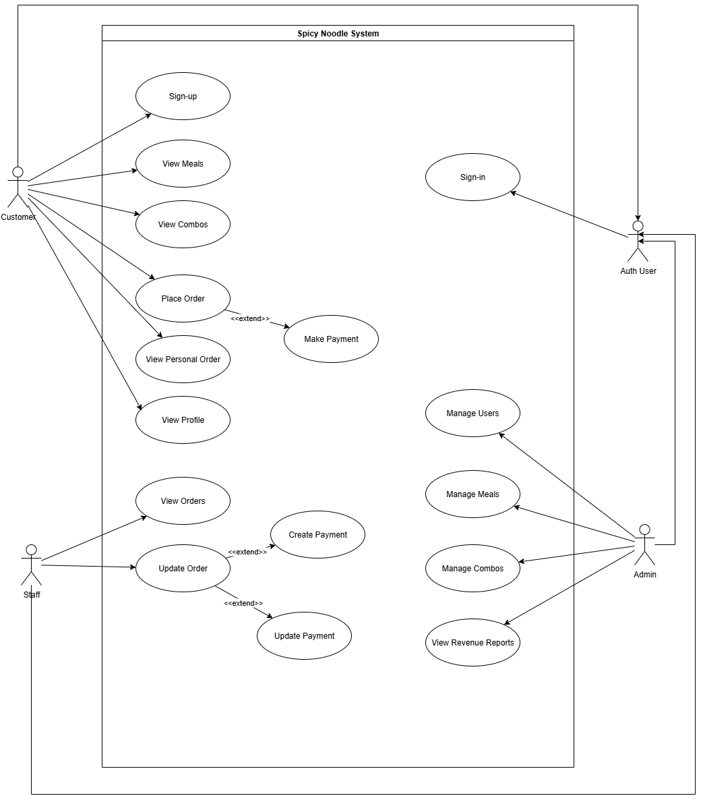

Link: [UCD_Link](https://drive.google.com/file/d/1jNaIZ0OP1GdzjBn4Cjew-E6Fs5Aju5kS/view?usp=drive_link)

# V. User Story:

### **1. Customer**

* **As a Customer**, I want to register and log in so that I can access my account and order spicy noodles.
* **As a Customer**, I want to browse available meals, combos, and toppings so I can choose what I like.
* **As a Customer**, I want to add items to my cart and place an order so that I can receive my meal.
* **As a Customer**, I want to choose my payment method and pay for my order easily and securely.
* **As a Customer**, I want to view my past orders and track the status of my current order for convenience.
* **As a Customer**, I want to edit my account information to keep my details up to date.

### **2. Staff**

* **As Staff**, I want to log in to the system so that I can manage orders.
* **As Staff**, I want to view all orders and their details so that I can process them efficiently.
* **As Staff**, I want to update the status of orders (e.g., confirmed, preparing, delivered, completed) to reflect the actual workflow.
* **As Staff**, I want to update payment status when customers pay offline so records are accurate.

### **3. Administrator**

* **As an Admin**, I want to log in to the admin dashboard to access management functions.
* **As an Admin**, I want to add, update, or remove meals, combos, and toppings to keep the menu current.
* **As an Admin**, I want to manage user accounts and staff roles to ensure proper access control.
* **As an Admin**, I want to view all orders and their statuses for business oversight.
* **As an Admin**, I want to generate and view revenue reports to monitor the business performance.

VI. Project Source

* API Project: [Github_API](https://github.com/hieuvau198/PRM-Noodle-BE)
* Web Application Project: [Github_Web](https://github.com/hieuvau198/PRM-Noodle-Web)
* Mobile Application Project: [Github_Mobile](https://github.com/hieuvau198/PRM-Noodle-Mobile)