

Requirement & Design Specification

**Jewelry Sales System At The Store**

**Phần mềm bán hàng trang sức tại cửa hàng**

– Ho Chi Minh, May 2024 –

# Record of Changes

| **Version** | **Date** | **A* M, D** | **In charge** | **Change Description** |
| --- | --- | --- | --- | --- |
| V1.0 |  | A |  |  |
|  |  |  |  |  |
|  |  |  |  |  |
|  |  |  |  |  |
|  |  |  |  |  |
|  |  |  |  |  |
|  |  |  |  |  |
|  |  |  |  |  |
|  |  |  |  |  |
|  |  |  |  |  |
|  |  |  |  |  |
|  |  |  |  |  |

*A - Added M - Modified D - Deleted

Contents

Record of Changes 2

I. Overview 4

1. User Requirements 4

1.1 Actors 4

1.2 Use Cases 4

2. Overall Functionalities 5

2.1 Screens Flow 5

2.2 Screen Descriptions 5

2.3 Screen Authorization 5

2.4 Non-UI Functions 6

3. System High Level Design 6

3.1 Database Design 6

3.2 Code Packages 7

II. Requirement Specifications 8

1. <<Feature Name>> 8

1.1 <<UseCaseCode_UC Name>> 8

2. Common Functions 11

2.1 UC-2_Login System 11

3. Patron Feature 12

3.1 UC-5_Order a Meal 12

3.2 UC-6_Register for Payroll Deduction 13

III. Design Specifications 14

1. <<Feature Name>> 14

1.1 <<SubFeature Name>> 14

1.2 System Access 15

IV. Appendix 19

1. Assumptions & Dependencies 19

2. Limitations & Exclusions 19

3. Business Rules 19

4. .. 19

# I. Overview

## 1. User Requirements

### 1.1 Actors

| **#** | **Actor** | **Description** |
| --- | --- | --- |
| 1 | Guest | Guest is a person who can buy jewelry products, enjoy promotions and discounts, and exchange or resell purchased jewelry. |
| 2 | Sales | Sales can assist customers in choosing products, and advise on promotions, discounts, and return policies. Apply promotions and discounts (when confirmed by management) and process jewelry buybacks from customers |
| 3 | Cashier | Cashier is responsible for creating orders and printing invoices, printing warranty cards and printing purchase invoices. |
| 4 | Admin | Admin is a person who has administrative privileges for the entire system |
| 5 | Manager | Manager has the right to confirm discounts for customers, set up and manage promotions. Manage staff and counter revenue, manage point accumulation for customers, and manage products in the Stall. |

### 1.2 Use Cases

#### a. Diagram(s)

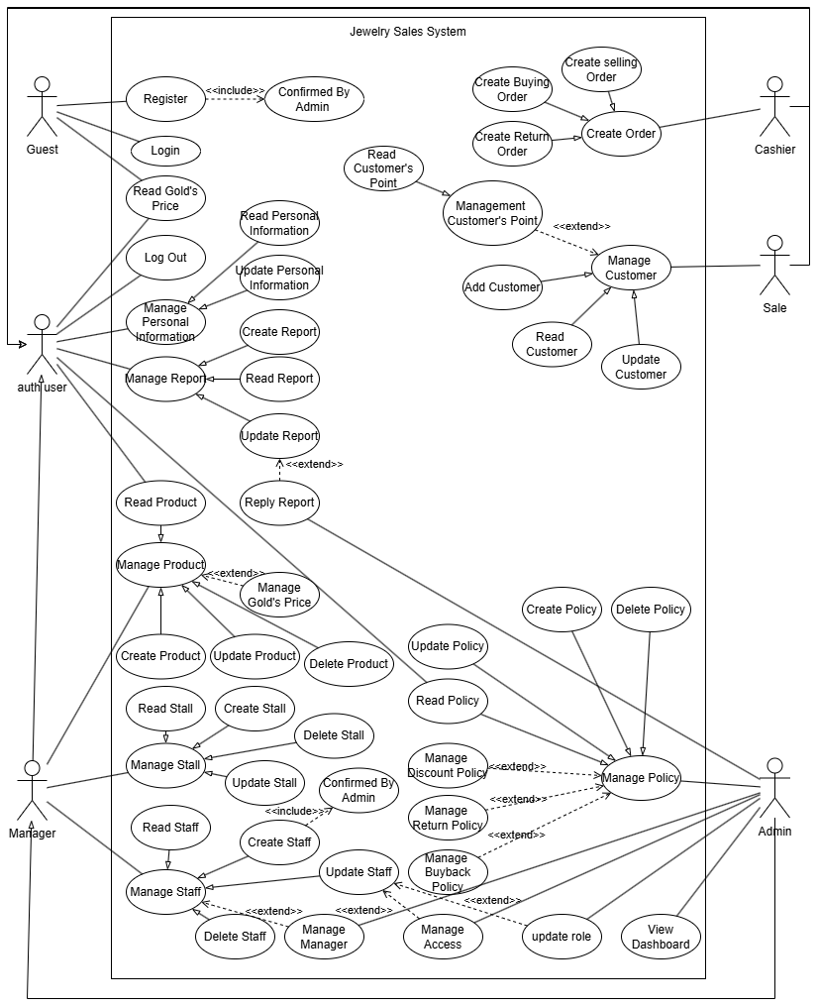

#### b. Descriptions

*This part describes the use cases, you can follow the table form as below]*

| **ID** | **Feature** | **Use Case** | **Use Case Description** |
| --- | --- | --- | --- |
| 01 | Register | Guest | Guest registers in the system and awaits admin confirmation |
| 02 | Login | Guest | Guest logs into the system |
| 03 | Read Gold’s Price | Guest | Guests can view the current price of gold |
| 04 | Create Order | Cashier | The cashier can create a buying, selling, or return order |
| 05 | Read Gold’s Price | Auth User | The Cashier can view the current price of gold |
| 06 | Logout | Auth User | The cashier logout into the system |
| 07 | Manage Report | Auth User | Have permission to read, create, and update reports of customers or store employees and can even reply to that report |
| 08 | Manage personal information | Auth User | Store employees or managers can manage their personal information as read and can update the information if anything changes and needs admin confirmation. |
| 09 | Read Product | Auth User | Store employees or managers can read or see detailed information about that product |
| 10 | Read Policy | Auth User | Store employees or managers can view detailed information about the policy |
| 11 | Manage Customer | Sales | Have permission to add, read customer information or update Customer information |
| 12 | Manage Customer’s Point | Sales | Have the right to view current point information to apply promotions for customers |
| 13 | Manage Policy | Admin | Admin has the right to manage the store's incentive policies such as read, create, delete, or even update those incentives. |
| 14 | Manage Discount Policy | Admin | Admin can manage discount policies such as creating new discount policies and reading, updating, or deleting those discount policies |
| 15 | Manage Return Policy | Admin | Admin can manage return policies such as creating new return policies and reading, updating, or deleting those return policies |
| 16 | Manage Buyback Policy | Admin | Admin can manage Buyback policies such as creating new Buyback policies and reading, updating, or deleting those Buyback policies |
| 17 | Manage Access | Admin | Admin can manage user and employee access rights such as create a new user and read, update, or delete that user from the system. |
| 18 | Update Role | Admin | Admin is the person who has the right to update an employee's role to sales or cashier according to that employee's abilities |
| 19 | View Dashboard | Admin | Admin is the only person who has the right to view the dashboard of sales statistics of the entire store and will then come up with appropriate plans to improve the store. |
| 20 | Manage Manager | Admin | Admin is the person with the highest authority who can manage the entire system, manger, and even the store's staff. |
| 21 | Manage Product | Manager | This use case describes the process of managing products within the jewelry sales management system for the Manager actor, including additional details for a more comprehensive understanding of the use case. |
| 22 | Manage Gold’s Price | Manager | The manager can manage gold price information including creating, reading, updating, and deleting gold's price on the system |
| 23 | Manage Stall | Manager | This use case describes the functionalities an Actor Manager can perform to manage individual stalls within the jewelry store. This includes managing product information, handling sales and returns, and potentially managing staff assigned to specific stalls (depending on system design). |
| 24 | Manage Staff | Manager | This use case describes the process of how an Actor Manager can manage their staff. This includes adding new staff members, updating the information of existing staff members, and deleting staff members. |

## 2. Overall Functionalities

### 2.1 Screens Flow

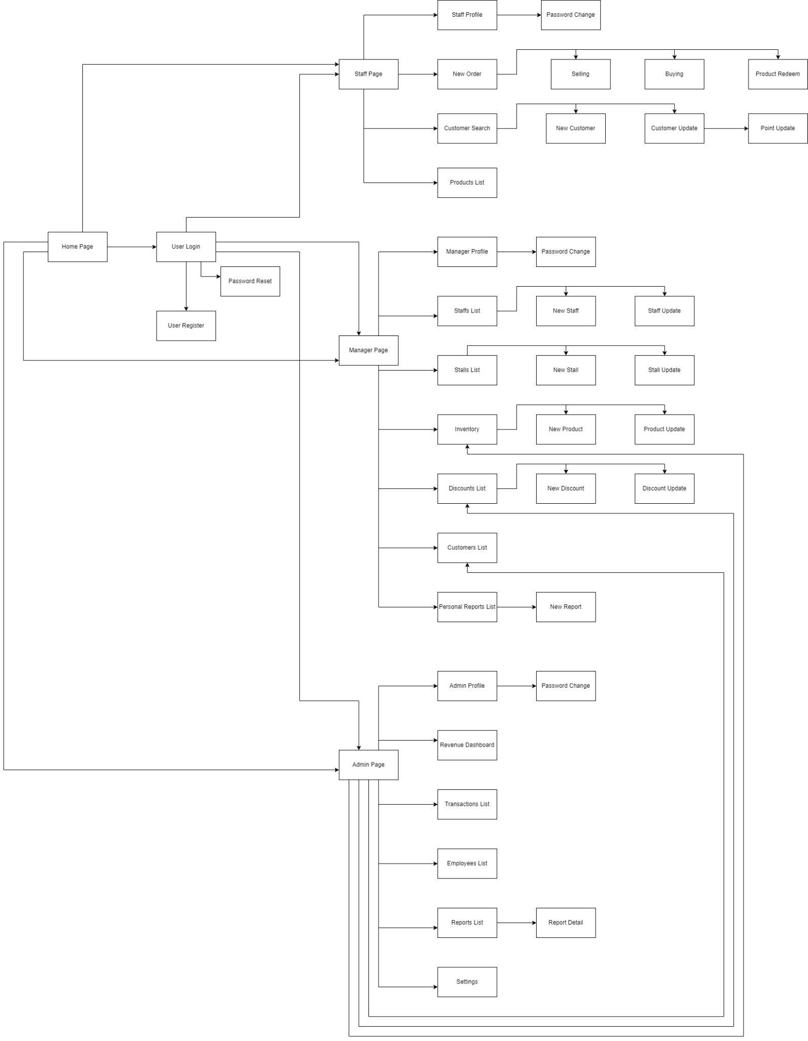

### 2.2 Screen Descriptions

| **#** | **Feature** | **Screen** | **Description** |
| --- | --- | --- | --- |
| 1 | Login | Login | Allows users to sign in to the application using their username and password. |
| 2 | Register | Register | Allows new users to create an account by providing their personal information, contact information, and employment information. |
| 3 | Manage Staff Profile | Staff Profile | Displays all information about the selected staff , including personal information, contact information, and employment information. |
| 4 | Create New Staff | Create Staff | Allows admins to create new staff accounts by providing their personal information, contact information, and employment information. |
| 5 | Update Staff | Update Staff | Allows Manager to update the profile information of existing staff. |
| 6 | Read Staff Profile | Read Staff | Allows Manager or managers to read the profile information of exiting staff. |
| 7 | Delete Staff Profile | Delete Staff | Allows Manager to delete the profile information of existing staff. |
| 8 | Individual Report | Individual Report | Displays the user's individual report, including job performance and compensation information. |
| 9 | New Report | New Report | Allows users to create new reports by selecting the desired report criteria. |
| 10 | Revenue Dashboard | Revenue Dashboard | Displays the company's sales performance over a specified time period. |
| 11 | Manage Roles | Manage Roles | Allows users to manage user roles, including assigning permissions to other users. |
|  | Change Password | Change Password | Allows users to change their password. |
|  | Create Customer Point | Create Customer Point | Allows sales staff to create cumulative scorecards for customers when purchasing products and must be approved by the admin |
|  | Update Customer Point | Update Customer Point | Allows sales staff to update cumulative scorecards for customers when purchasing products using loyalty coupons and must be approved by the admin. |
|  | Update Product | Update Product | Allows manager to update the quantity of products in the stall when the stall is out of stock |
|  | Create new product | Create new product | Allows managers to add new products to the stall |
|  | View Product List | Product List | Allows Staff , Manager, Admin view all product in the stall. |
|  | Create New Stall | Create Stall | Allows admins to create new Stall by providing stall infomation (Name, Id ,...) |
|  | Update Stall | Update Stall | Allows Manager to update the profile information of existing Stall. |
|  | Read Stall Profile | Read Stall | Allows Manager or managers to read the profile information of exiting Stall. |
|  | Delete Stall Profile | Delete Stall | Allows Manager to delete the profile information of existing Stall. |
|  |  |  |  |
|  |  |  |  |
|  |  |  |  |
|  |  |  |  |
|  |  |  |  |
|  |  |  |  |
|  |  |  |  |
|  |  |  |  |
|  |  |  |  |
|  |  |  |  |
|  |  |  |  |
|  |  |  |  |
|  |  |  |  |
|  |  |  |  |

### 2.3 Screen Authorization

| **Screen** | **Guest** | **Cashier** | **Sales** | **Manager** | **Admin** |
| --- | --- | --- | --- | --- | --- |
| Login | X | X | X | X | X |
| Register | X | X | X |  |  |
| Staff Profile |  | X | X | X | X |
| Create Staff |  |  |  | X | X |
| Update Staff |  |  |  | X |  |
| Read Staff |  | X | X | X |  |
| Delete Staff |  |  |  |  | X |
| Individual Report |  | X | X | X | X |
| New Report |  | X | X | X | X |
| Revenue Dashboard |  |  |  |  | X |
| Manage Roles |  |  |  | X | X |
| Change Password |  | X | X | X | X |
| Create Customer Point |  |  | X | X |  |
| Update Customer Point |  |  | X | X |  |
| Update Product |  |  |  | X | X |
| Create new product |  |  |  | X | X |
| Product List | X | X | X | X |  |
| Create Stall |  |  |  | X | X |
| Update Stall |  |  |  | X |  |
| Read Stall | X | X | X | X | X |
| Delete Stall |  |  |  | X | X |
|  |  |  |  |  |  |
|  |  |  |  |  |  |
|  |  |  |  |  |  |
|  |  |  |  |  |  |
|  |  |  |  |  |  |
|  |  |  |  |  |  |
|  |  |  |  |  |  |
|  |  |  |  |  |  |
|  |  |  |  |  |  |
|  |  |  |  |  |  |
|  |  |  |  |  |  |
|  |  |  |  |  |  |
|  |  |  |  |  |  |

### 2.4 Non-UI Functions

| **#** | **Feature** | **System Function** | **Description** |
| --- | --- | --- | --- |
| 1 | <<Feature Name>> | <<Function Name1>> | <<Function Name1 Description>> |
| 2 | … |  |  |

## 3. System High Level Design

### 3.1 Database Design

*[Provide the tables relationship like example below]*

#### a. Database Schema

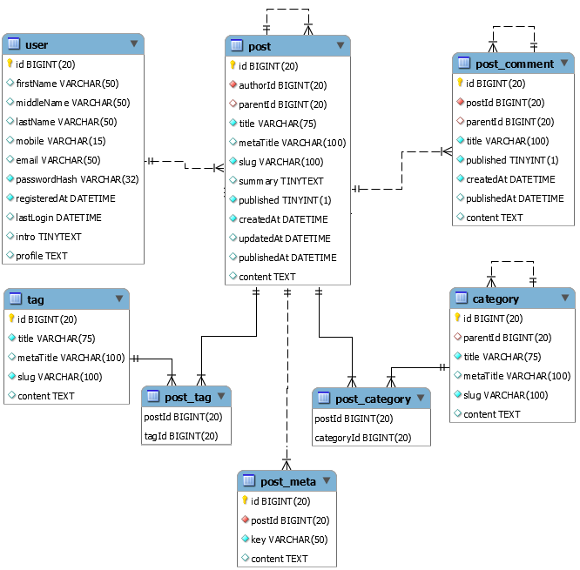

#### b. Table Descriptions

| **No** | **Table** | **Description** |
| --- | --- | --- |
| *01* | *<Table name>* | *<Description of the table>*  *- Primary keys: <<list of primary key fields>>*  *- Foreign keys: <<list of foreign key fields>>* |
| *02* | *<Table name2>* | *…* |

### 3.2 Code Packages

*[Provide the package diagram for each sub-system. The content of this section including the overall package diagram, the explanation, package and class naming conventions in each package. Please see the sample & description table format below]*

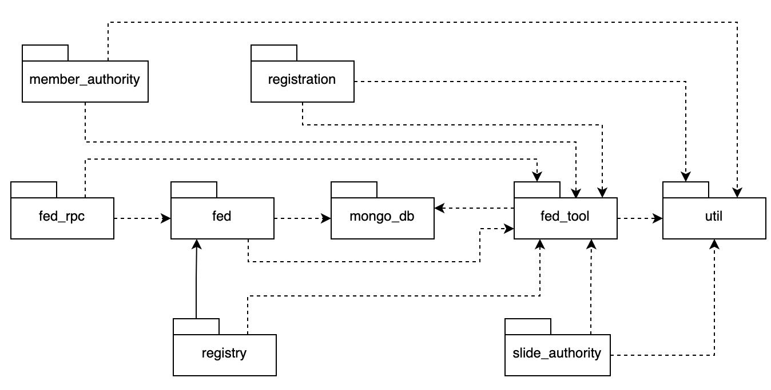

***Package descriptions***

| **No** | **Package** | **Description** |
| --- | --- | --- |
| *01* | *Member_authority* | *<Description of the package>* |
| *02* | *registration* | *<Description of the package>* |
| *03* | *…* |  |

# II. Requirement Specifications

## 1. <<Feature Name>>

### 1.1 <<UseCaseCode_UC Name>>

#### a. Functionalities

Provide the functional description for the use cases using the template/guides below

**Functional Description Template**

| UC ID and Name: | **G01-Register** | | |
| --- | --- | --- | --- |
|  |  | | |
| Created By: | Hoanv | Date Created: | None |
| Primary Actor: | Guest | Secondary Actors: |  |
| Trigger: | Customer wants to create a new account | | |
| Description: | The Register use case allows customers to create new accounts in the jewelry store sales management software. This enables customers to save their personal information, track purchase history, earn loyalty points, and receive personalized offers. | | |
| Preconditions: | -The customer must have a valid email address.  -The customer must create a unique password.  -The customer must agree to the terms and conditions of the software. | | |
| Postconditions: | -A new customer account is created in the system.  -The customer receives a confirmation email.  -The customer can log in to their account and start shopping. | | |
| Normal Flow: | -The customer clicks on the "Register" button on the login page.  -The customer enters their personal information, including name, email address, and password.  -The customer reviews and agrees to the terms and conditions of the software.  -The customer clicks on the "Create Account" button.  -The system validates the customer's information and creates a new account.  -The system sends a confirmation email to the customer.  -The customer clicks on the confirmation link in the email.  -The customer is logged in to their new account. | | |
| Alternative Flows: | -Invalid email address: If the customer enters an invalid email address, the system displays an error message.  -Password mismatch: If the customer's password does not match the confirmation password, the system displays an error message.  -Terms and conditions not accepted: If the customer does not agree to the terms and conditions, the system prevents them from creating an account.  -Email confirmation link not clicked: If the customer does not click on the confirmation link in the email, their account is not activated. | | |
| Exceptions: | -System error: If there is a system error, the customer is unable to create an account.  -Email delivery failure: If the system is unable to deliver the confirmation email, the customer is notified and instructed to contact customer support. | | |
| Priority: | Must Have | | |
| Frequency of Use: | High | | |
| Business Rules: | -Customer passwords must be at least 8 characters long and contain a mix of uppercase and lowercase letters, numbers, and symbols.  -Customer email addresses must be unique.  -Customers must agree to the terms and conditions of the software before creating an account. | | |
| Other Information: | -The system should store customer information securely.  -The system should comply with all applicable data privacy laws. | | |
| Assumptions: | -The customer has a basic understanding of how to use a computer and the internet.  -The customer has a valid email address.  -The customer has a password that meets the system's requirements. | | |

#### 

| UC ID and Name: | **G02_Login System** | | |
| --- | --- | --- | --- |
| Created By: | Hoanv | Date Created: |  |
| Primary Actor: | Guest | Secondary Actors: |  |
| Trigger: | Guest wants to browse the jewelry store's products and services | | |
| Description: | The Login - Guest use case allows guests to access the jewelry store's website without creating an account. This enables guests to view product information, browse categories, and use the search functionality. | | |
| Preconditions: | User account has been created & authorized | | |
| Postconditions: | * User logs in the system successfully * The system tracked successful login into the Activity Log | | |
| Normal Flow | **2.0 Login System**  1. User accesses the User Login screen  2. User types in the login details or choo other login options (see 2.1 and 2.2)  3. User clicks the Login button  4. System validates the login details (see 2.0.E1)  5. System allows user to access  6. System tracks user’s success login to the Activity Log  7. System accesses the Home Page (or the previous calling page if any) | | |
| Alternative Flows: | ***2.1 Google Login***  1. User chooses to login system using Google account  2. System redirects the user to the Google’s Login screen  3. User types in the Google account details and chooses to login  4. Google validates user’s login information successfully and redirect him/her back to the system  5. Return to step 5 of normal flow.  ***2.2 Username Login***  1. User chooses to login system using Username account  2. System redirects the user to the Username Login screen  3. User types in the Username account details and chooses to login  4. Username validates user’s login information successfully and redirect him/her back to the system  5. Return to step 5 of normal flow. | | |
| Exceptions: | ***2.0.E1 System can’t authenticate the user***  1. The Error Message screen is shown to the user  2. User cancels the logging in *=> UC stops, change to UC-1_View Home Page*  3. User clicks “Forgot Password?” link *=> change to UC-3_Reset Password*  4. User clicks “Register” link *=> change to UC-4_Register User Account* | | |
| Priority: | Must Have | | |
| Frequency of Use: | High | | |
| Business Rules: | -Guest users are not able to create or manage customer accounts.  -Guest users are not able to make purchases.  -Guest users are not able to save their shopping carts. | | |
| Other Information: | -The system should store guest login information securely.  -The system should comply with all applicable data privacy laws. | | |
| Assumptions: | -The guest has a basic understanding of how to use a computer and the internet. | | |

| UC ID and Name: | **G03-Read Gold’s Price** | | |
| --- | --- | --- | --- |
|  |  | | |
| Created By: | Hoanv | Date Created: |  |
| Primary Actor: | Varies (Guest, Cashier, Sales, Manager, Admin) | Secondary Actors: | System |
| Trigger: | Actor needs to know the current price of gold | | |
| Description: | This use case describes how various actors (Guest, Cashier, Sales, Manager, Admin) can access and view the current price of gold within the jewelry store sales management software. | | |
| Preconditions: | The system is operational and has access to a reliable gold price data source. | | |
| Postconditions: | The actor successfully retrieves and views the current price of gold. | | |
| Normal Flow: | 1. The actor navigates to the designated section within the software to view gold prices (may vary depending on actor role).   -Guest: May have a dedicated "Gold Price" section on the public website.  -Cashier, Sales, Manager, Admin: Likely have access through a dashboard or dedicated menu option.   1. The system retrieves the current gold price from the data source. 2. The system displays the current gold price to the actor. | | |
| Alternative Flows: | -Data source unavailable: If the system cannot access the gold price data source, an error message is displayed to the actor.  -Limited access: Guests may only see a basic gold price (e.g., per gram), while staff may have access to more detailed information (e.g., different karat varieties, price history). | | |
| Exceptions: | -System error: If there is a system error, the actor may not be able to view the gold price. | | |
| Priority: | -Must have | | |
| Frequency of Use: | -Guest: Occasional  -Cashier, Sales: Frequent  -Manager: Regular  -Admin: As needed | | |
| Business Rules: |  | | |
| Other Information: | -Required Access Levels:  +Guest: Read-only access to basic gold price information.  +Cashier: Read-only access to relevant gold price information for sales calculations.  +Sales: Read-only access to relevant gold price information for sales calculations.  +Manager: Read-only access to detailed gold price information for decision-making.  +Admin: Read-only and potentially write access (for managing data source configuration) to gold price information. | | |
| Assumptions: | -The system has a reliable mechanism for retrieving and updating gold prices.  Actors understand how to navigate the software to access the gold price information. | | |

| UC ID and Name: | **CA01-Create Order** | | |
| --- | --- | --- | --- |
|  |  | | |
| Created By: | Hoanv | Date Created: |  |
| Primary Actor: | Cashier | Secondary Actors: | None |
| Trigger: | Customer wants to purchase jewelry items | | |
| Description: | The Create Order - Cashier use case allows cashiers to create new sales orders for customers in the jewelry store sales management software. This involves selecting items, adding them to the cart, applying discounts, calculating totals, and processing payments. | | |
| Preconditions: | -The cashier is logged in to the software.  -The customer is present at the counter.  -The customer has selected the jewelry items they wish to purchase. | | |
| Postconditions: | -A new sales order is created in the system.  -The customer receives a sales invoice.  -The inventory levels are updated. | | |
| Normal Flow: | 1.The cashier scans or manually enters the product codes of the selected jewelry items.  2.The system retrieves the product information and displays it to the cashier.  3.The cashier verifies the product details and quantities.  4.The cashier applies any applicable discounts or promotions.  5.The system calculates the total order amount, including taxes and fees.  6.The cashier presents the total amount to the customer.  7.The customer makes the payment.  8.The system processes the payment.  9.The system generates a sales invoice and prints it for the customer.  10.The system updates the inventory levels for the sold items. | | |
| Alternative Flows: | -Out-of-stock items: If an item is out of stock, the system informs the cashier and allows them to adjust the quantity or suggest alternative items.  -Customer changes order: If the customer decides to add or remove items from the order, the cashier can modify the cart accordingly.  -Payment issues: If there are any payment issues, the cashier can retry the payment or offer alternative payment methods. | | |
| Exceptions: | -System error: If there is a system error, the cashier may not be able to complete the order.  -Inventory data discrepancy: If there is a discrepancy between the system's inventory data and the actual stock levels, the cashier may need to verify the inventory or consult with a manager. | | |
| Priority: | Must Have | | |
| Frequency of Use: | High | | |
| Business Rules: | -Cashiers must have the necessary permissions to create and manage sales orders.  -Sales orders must include accurate product information, quantities, and pricing.  -Discounts and promotions must be applied according to the defined rules and policies.  -Payments must be processed securely and in accordance with the store's payment policies.  -Sales invoices must be accurate and include all relevant information.  -Inventory updates must be reflected accurately in the system. | | |
| Other Information: | -The system should provide clear and user-friendly interfaces for cashiers to create and manage sales orders.  -The system should ensure data integrity and prevent unauthorized access or modifications.  -The system should generate detailed reports and analytics for sales data. | | |
| Assumptions: | -The cashier has been trained on the software and is familiar with the sales order process.  -The customer has a valid payment method.  -The network connection is stable. | | |

| UC ID and Name: | **AU-01: Logout** | | |
| --- | --- | --- | --- |
|  |  | | |
| Created By: | Hoanv | Date Created: |  |
| Primary Actor: | Varies (Cashier, Sales, Admin, Manager) | Secondary Actors: | None |
| Trigger: | Actor wants to end their current session and log out of the jewelry store sales management software | | |
| Description: | This use case describes how various actors (Cashier, Sales, Admin, Manager) can securely log out of their active sessions within the jewelry store sales management software. | | |
| Preconditions: | The actor is currently logged in to the software. | | |
| Postconditions: | -The actor is successfully logged out of the software.  -The actor's session is terminated.  -Any open or unfinished tasks are saved appropriately (if applicable). | | |
| Normal Flow: | 1.The actor initiates the logout process by clicking on the designated "Logout" button or option within the software.  2.The system prompts the actor to confirm their intention to log out.  3.The actor confirms the logout request.  4.The system invalidates the actor's active session token and clears any cached or temporary data associated with their session.  5.The system redirects the actor to the login page or a neutral exit point. | | |
| Alternative Flows: | -Accidental logout: If the actor accidentally clicks the logout button, they can cancel the logout by clicking on a "Cancel" or "Back" button (if available).  -Session timeout: If the actor's session expires due to inactivity, the system automatically logs them out and displays a notification. | | |
| Exceptions: | -System error: If there is a system error, the actor may not be able to log out properly.  -Network interruption: If the network connection is lost during the logout process, the actor may need to restart the software and attempt to log out again. | | |
| Priority: | Must Have | | |
| Frequency of Use: | -Cashier, Sales: Frequent throughout their work shifts.  -Admin, Manager: Depends on their usage patterns and session durations. | | |
| Business Rules: | -Data Security: During the logout process, the system should ensure that any sensitive user data or session information is properly cleared and not retained. | | |
| Other Information: | Required Access Levels:  -Cashier: Basic logout access to end their active sales session.  -Sales: Basic logout access to end their active sales session.  -Admin: Basic logout access to end their active administrative session.  -Manager: Basic logout access to end their active managerial session. | | |
| Assumptions: | -The system has a reliable mechanism for managing user sessions and implementing secure logout procedures.  -Actors understand how to initiate and complete the logout process. | | |

| UC ID and Name: | **AU02-Manage Report** | | |
| --- | --- | --- | --- |
|  |  | | |
| Created By: | Hoanv | Date Created: |  |
| Primary Actor: | Varies (Cashier, Sales, Admin, Manager) | Secondary Actors: | None |
| Trigger: | Actor needs to access, generate, view, and analyze reports related to sales, inventory, customer data, or other aspects of the jewelry store's business | | |
| Description: | This use case describes how various actors (Cashier, Sales, Admin, Manager) can utilize the reporting functionality within the jewelry store sales management software to gain insights into sales performance, inventory levels, customer trends, and other key business metrics. | | |
| Preconditions: | -The actor is logged in to the software with the appropriate access level.  -The software has generated and stored relevant data from sales transactions, inventory movements, customer interactions, and other sources. | | |
| Postconditions: | -The actor successfully accesses, generates, views, and analyzes the desired reports.  -The actor gains valuable insights from the report data.  -The actor can utilize the report findings to make informed business decisions or take corrective actions. | | |
| Normal Flow: | 1.The actor navigates to the designated reports section within the software.  2.The actor selects the type of report they want to view or generate (e.g., sales report, inventory report, customer report).  3.The actor specifies any relevant filters or parameters for the report (e.g., date range, product categories, customer segments).  4.The system generates the requested report.  5.The actor reviews the report data, which may be presented in tabular, graphical, or other formats.  6.The actor can export the report for further analysis or sharing. | | |
| Alternative Flows: | -Predefined reports: The software may provide a selection of predefined reports that cater to common use cases.  -Customizable reports: The software may allow for creating custom reports with user-defined filters and parameters.  -Scheduled reports: The software may offer options to schedule reports for automatic generation and delivery. | | |
| Exceptions: | -Data availability: If the required data is not available or has not been generated, the system may display an appropriate message.  -Report generation error: If there is an error during report generation, the system may notify the actor and provide error details.  -Access restrictions: Actors may only be able to access and generate reports within their authorized scope based on their user roles. | | |
| Priority: | Must Have | | |
| Frequency of Use: | -Cashier: Regularly to review daily or weekly sales performance.  -Sales: Regularly to track sales trends and performance within their department.  -Admin: Regularly to monitor overall sales performance, inventory levels, and customer data.  -Manager: Regularly to review reports for their specific managerial areas (e.g., sales, inventory, customer relations). | | |
| Business Rules: | -Data Visualization: The software should provide effective data visualization tools to enhance the presentation and comprehension of report data.  -Data Export: The software should allow for exporting reports in various formats (e.g., PDF, CSV, Excel) for further analysis or sharing. | | |
| Other Information: | Required Access Levels:  -Cashier: Basic access to view predefined sales reports for their assigned counter or period.  -Sales: Access to view and generate sales reports for their assigned department or period.  -Admin: Comprehensive access to view, generate, and customize reports across all departments and periods.  -Manager: Access to view, generate, and customize reports relevant to their managerial responsibilities. | | |
| Assumptions: | -The software has a robust reporting module capable of generating a variety of reports.  -The actor has a basic understanding of data analysis and interpretation.  -The actor is familiar with the software's reporting interface and functionalities. | | |

| UC ID and Name: | **AU-03:Manage Personal Information** | | |
| --- | --- | --- | --- |
|  |  | | |
| Created By: | Hoanv | Date Created: |  |
| Primary Actor: | Varies (Cashier, Sales, Admin, Manager) | Secondary Actors: | None |
| Trigger: | Actor needs to access, view, update, or manage their own personal information or the personal information of other users (within their authorized scope) | | |
| Description: | This use case describes how various actors (Cashier, Sales, Admin, Manager) can utilize the personal information management features within the jewelry store sales management software to maintain accurate and up-to-date employee and customer records. | | |
| Preconditions: | -The actor is logged in to the software with the appropriate access level.  -The software has a secure mechanism for storing and managing personal information. | | |
| Postconditions: | -The actor successfully accesses, views, updates, or manages the desired personal information.  -The personal information is accurate, complete, and up-to-date.  -Data privacy and security are maintained throughout the process. | | |
| Normal Flow For Cashier: | 1.The cashier navigates to the designated "My Profile" or "Personal Information" section within the software.  2.The cashier views their own personal information, including contact details, emergency contacts, and other relevant data.  3.The cashier can update their personal information if necessary.  4.The system saves the updated information securely. | | |
| Normal Flow For Sales: | 1.The sales associate navigates to the "Employee Management" section within the software.  2.The sales associate selects the employee whose personal information they need to access.  3.The sales associate views the employee's personal information, including contact details, emergency contacts, employment history, and other relevant data.  4.The sales associate can update the employee's personal information if necessary, subject to their access permissions.  5.The system saves the updated information securely. | | |
| Normal Flow For Admin: | 1.The administrator navigates to the "User Management" section within the software.  2.The administrator selects the user whose personal information they need to access.  3.The administrator views the user's personal information, including contact details, emergency contacts, user roles, and other relevant data.  4.The administrator can update the user's personal information if necessary.  5.The administrator can manage the user's access permissions and roles.  6.The system saves the updated information securely. | | |
| Normal Flow For Manager: | 1.The manager navigates to the "Employee Management" section within the software.  2.The manager selects the employee whose personal information they need to access.  3.The manager views the employee's personal information, including contact details, emergency contacts, employment history, and other relevant data.  4.The manager can update the employee's personal information if necessary, subject to their access permissions.  5.The manager can review the employee's performance history and other related data.  6.The system saves the updated information securely. | | |
| Alternative Flows: | -Customer personal information: Admin and Manager may also have access to manage customer personal information, adhering to data privacy regulations and customer consent.  -Data validation: The system should implement data validation checks to ensure the accuracy and completeness of personal information.  -Change history: The system should maintain a record of changes made to personal information, including who made the changes and when. | | |
| Exceptions: | -Access restrictions: Actors may only be able to access, view, update, or manage personal information within their authorized scope based on their user roles.  -Data privacy regulations: The software must comply with applicable data privacy regulations, such as GDPR, CCPA, and others.  -Data security: The software must implement appropriate security measures to protect sensitive personal information from unauthorized access, modification, or disclosure. | | |
| Priority: | Must Have | | |
| Frequency of Use: | -Cashier: Occasionally to update their personal information.  -Sales: Regularly to view and update employee personal information for various purposes (e.g., payroll, performance reviews).  -Admin: Regularly to manage user accounts, update personal information, and ensure data accuracy.  -Manager: Regularly to review employee personal information and performance data. | | |
| Business Rules: |  | | |
| Other Information: | Required Access Levels:  -Cashier: Basic access to view and update their own personal information.  -Sales: Access to view and update employee personal information within their department.  -Admin: Comprehensive access to view, update, and manage all user (employee and customer) personal information.  -Manager: Access to view, update, and manage employee personal information within their team or department. | | |
| Assumptions: | -The actor has a basic understanding of data privacy principles and the importance of protecting personal information.  -The actor is familiar with the software's personal information management features. | | |

| UC ID and Name: | **AU-04: Read Product** | | |
| --- | --- | --- | --- |
|  |  | | |
| Created By: | Hoanv | Date Created: |  |
| Primary Actor: | Varies (Cashier, Sales, Admin, Manager) | Secondary Actors: | None |
| Trigger: | Actor needs to access and view information about products in the jewelry store's inventory | | |
| Description: | This use case describes how various actors (Cashier, Sales, Manager, Admin) can utilize the product management features within the jewelry store sales management software to access, view, and understand detailed information about the products available for sale. | | |
| Preconditions: | -The actor is logged in to the software with the appropriate access level.  -The software has a comprehensive product database containing accurate and up-to-date product information. | | |
| Postconditions: | -The actor successfully accesses, views, and understands the desired product information.  -The actor can utilize the product information to make informed decisions, provide accurate customer information, or manage inventory effectively. | | |
| Normal Flow for Cashier: | 1.The cashier navigates to the "Products" or "Inventory" section within the software.  2.The cashier can browse the product catalog using various filters (e.g., category, brand, price range).  3.The cashier selects a specific product to view its detailed information, including:   * Product ID * Product Name * Product Description * Product Image(s) * Product Category * Product Brand * Product Price * Product Quantity in Stock * Other relevant product specifications (e.g., material, size, weight)   4.The cashier can use the product information to assist customers with inquiries, sales transactions, or product recommendations. | | |
| Normal Flow for Sales: | 1.The sales associate navigates to the "Products" or "Inventory" section within the software.  2.The sales associate can browse the product catalog using various filters (e.g., category, brand, price range, customer preferences).  3.The sales associate selects a specific product to view its detailed information, including:   * Product ID * Product Name * Product Description * Product Image(s) * Product Category * Product Brand * Product Price * Product Quantity in Stock * Other relevant product specifications (e.g., material, size, weight)   4.The sales associate can use the product information to provide customers with detailed product knowledge, answer their questions, and guide them towards informed purchasing decisions.  5.The sales associate can also utilize the product information to identify upselling or cross-selling opportunities. | | |
| Normal Flow for Manager: | 1.The manager navigates to the "Products" or "Inventory" section within the software.  2.The manager can browse the product catalog using various filters (e.g., category, brand, price range, sales performance).  3.The manager selects a specific product to view its detailed information, including:   * Product ID * Product Name * Product Description * Product Image(s) * Product Category * Product Brand * Product Price * Product Quantity in Stock * Sales History (e.g., units sold, revenue generated) * Profit Margin * Other relevant product metrics   4.The manager can use the comprehensive product information to:   * Analyze sales trends and identify popular or underperforming products. * Make informed decisions regarding product assortment, pricing, and promotions. * Optimize inventory levels to minimize stockouts and overstocking. * Identify opportunities for product improvement or new product development. | | |
| Normal Flow for Admin: | 1.The administrator navigates to the "Products" or "Inventory" section within the software.  2.The administrator has full access to all product information, including the ability to:   * Create new product entries * Edit existing product information * Upload product images * Manage product categories and brands * Set product prices and quantities * Track product sales history and performance metrics * Generate product reports for analysis and decision-making   3.The administrator can utilize their comprehensive product management capabilities to:   * Ensure the accuracy and completeness of product information in the system. * Maintain an organized and up-to-date product database. * Support the overall product strategy and profitability of the jewelry store. | | |
| Alternative Flows: | -AF1: If the user does not enter a product name or product code into the search box, the system will display a list of all products in the system.  -AF2: If the user enters a product name or product code that does not exist in the system, the system will display a product not found message. | | |
| Exceptions: | -E1: If the system encounters a technical error, the user will be notified of the error and asked to try again later. | | |
| Priority: | High | | |
| Frequency of Use: | Often | | |
| Business Rules: | -Only Cashier, Sales, Manager, and Admin actors are allowed to view product information.  -Users can only view product information, they cannot edit product information.  Product information displayed in the system must be accurate and up-to-date. | | |
| Other Information: | -This use case can be extended to support additional features such as viewing product price history, and comparing product prices, ... | | |
| Assumptions: | -System Access: Users have valid accounts and permissions to access product information within the jewelry sales management system.  -Product Data: All products are entered into the system with accurate and up-to-date information.  -Search Functionality: The system allows searching for products by name, code, or other relevant criteria.  -User Interface: Users can easily navigate and understand the product information displayed within the system. | | |

| UC ID and Name: | **AU-05: Read Policy** | | |
| --- | --- | --- | --- |
|  |  | | |
| Created By: |  | Date Created: |  |
| Primary Actor: | Varies (Cashier, Sales, Admin, Manager) | Secondary Actors: | None |
| Trigger: | -Users need to access and review company policies and procedures.  -New employees need to be informed of company policies during onboarding.  -Managers need to ensure employees are adhering to company policies.  -Admin may need to update or modify company policies. | | |
| Description: | -This use case describes the process of reading and accessing company policies and procedures for the Cashier, Sales, Manager, and Admin actors within the jewelry sales management system. | | |
| Preconditions: | -The jewelry sales management system must be started and running normally.  -The user must log in to the system with a valid account.  -Company policies and procedures must be uploaded and stored in the system. | | |
| Postconditions: | -Users can access and read the latest version of company policies and procedures.  -Users can search for specific policies by keyword or category.  -Users can understand and comply with company policies and procedures. | | |
| Normal Flow: | -Step 1: The user accesses the policy management module within the jewelry sales management system.  -Step 2: The system displays a list of available company policies and procedures.  -Step 3: The user selects the policy they want to read.  -Step 4: The system displays the selected policy in an easy-to-read format.  -Step 5: The user can print or save the policy for future reference. | | |
| Alternative Flows: | AF1: If the user does not have access to the policy management module, they will be notified and redirected to the appropriate authority.  AF2: If the user searches for a policy that does not exist in the system, they will be notified and provided with instructions on how to request the policy. | | |
| Exceptions: | E1: If the system encounters a technical error, the user will be notified and asked to try again later. | | |
| Priority: | High | | |
| Frequency of Use: | Often | | |
| Business Rules: | -All employees must be familiar with and comply with company policies and procedures.  -Company policies and procedures must be reviewed and updated regularly.  -New employees must be trained on company policies and procedures during onboarding.  -Managers are responsible for ensuring that their team members are adhering to company policies and procedures.  -Admin has the authority to create, update, and delete company policies and procedures. | | |
| Other Information: | -The system can be integrated with other HR modules, such as training and performance management, to ensure that policies are embedded within employee workflows.  -The system can be configured to send notifications to users when there are changes to company policies and procedures. | | |
| Assumptions: | -Policy Availability: All relevant company policies and procedures are uploaded and readily accessible within the jewelry sales management system.  -User Permissions: User accounts have appropriate permissions assigned to access and view company policies based on their roles (Cashier, Sales, Manager, Admin).  -User Knowledge: Users have basic computer literacy and understanding of navigating within the system to locate the policy management module. | | |

| UC ID and Name: | **SA-01:Manage Customer** | | |
| --- | --- | --- | --- |
|  |  | | |
| Created By: | Hoanv | Date Created: |  |
| Primary Actor: | Sales | Secondary Actors: | None |
| Trigger: | -Sales need to create, update, or view customer information.  -Sales need to track customer interactions and purchase history.  -Sales need to manage customer relationships and provide personalized service. | | |
| Description: | -This use case describes the process of managing customer information, interactions, and relationships for the Sales actor within the jewelry sales management system. | | |
| Preconditions: | -The jewelry sales management system must be started and running normally.  -The Sales user must log in to the system with a valid account.  -The customer profile must be created or already exist in the system. | | |
| Postconditions: | -Customer information is accurate, up-to-date, and accessible to authorized personnel.  -Customer interactions and purchase history are tracked and maintained within the system.  -Customer relationships are nurtured and strengthened through personalized interactions. | | |
| Normal Flow: | Step 1: The Sales user accesses the customer management module within the jewelry sales management system.  Step 2: The system displays a list of existing customer profiles.  Step 3: The Sales user can search for a specific customer by name, contact information, or other relevant criteria.  Step 4: If the customer profile does not exist, the Sales user can create a new customer profile.  Step 5: The Sales user can view and update customer information, including contact details, purchase history, preferences, and notes.  Step 6: The Sales user can record customer interactions, such as phone calls, emails, or in-person meetings.  Step 7: The Sales user can view and analyze customer purchase history to identify trends and preferences.  Step 8: The Sales user can utilize customer information and insights to provide personalized service and recommendations. | | |
| Alternative Flows: | AF1: If the Sales user does not have access to the customer management module, they will be notified and redirected to the appropriate authority.  AF2: If the Sales user searches for a customer that does not exist in the system, they will be notified and provided with instructions on how to create a new customer profile. | | |
| Exceptions: | E1: If the system encounters a technical error, the Sales user will be notified and asked to try again later. | | |
| Priority: | High | | |
| Frequency of Use: | Often | | |
| Business Rules: | -Customer information must be accurate, up-to-date, and secure.  -Customer interactions and purchase history must be tracked and maintained for future reference.  -Sales personnel must strive to build and maintain positive customer relationships.  -Customer information must be used ethically and in compliance with data privacy regulations. | | |
| Other Information: | -The system can be integrated with other CRM tools, such as marketing automation or customer support platforms, to provide a holistic view of customer interactions.  -The system can be customized to generate reports and insights on customer behavior, sales performance, and customer satisfaction. | | |
| Assumptions: | -System Access: Sales users have the necessary permissions to access and manage customer information within the jewelry sales management system.  -Data Accuracy: Sales personnel are responsible for entering and maintaining accurate and up-to-date customer information within the system.  -Integration Potential: The system can potentially integrate with other CRM tools for a more comprehensive customer relationship management experience. | | |

| UC ID and Name: | **SA-02: Manage Customer’s Point** | | |
| --- | --- | --- | --- |
|  |  | | |
| Created By: | Hoanv | Date Created: |  |
| Primary Actor: | Sales | Secondary Actors: | None |
| Trigger: | -Sales need to add, redeem, or track customer loyalty points.  -Sales need to provide information about the loyalty program to customers. | | |
| Description: | -This use case describes the process of managing customer loyalty points for the Sales actor within the jewelry sales management system. | | |
| Preconditions: | -The jewelry sales management system must be started and running normally.  -The Sales user must log in to the system with a valid account.  -The customer must be enrolled in the loyalty program and have an active account.  -The loyalty program rules and point values are defined and configured within the system. | | |
| Postconditions: | -Customer loyalty points are accurately tracked and updated in the system.  -Customer loyalty points are redeemed in accordance with program rules.  -Customers are informed about their point balance and loyalty program benefits. | | |
| Normal Flow: | Step 1: The Sales user accesses the customer's profile within the jewelry sales management system.  Step 2: The system displays the customer's loyalty point balance and transaction history.  Step 3: The Sales user can add loyalty points to the customer's account based on eligible purchases or promotions.  Step 4: The Sales user can redeem loyalty points for the customer according to the program rules, such as discounts or rewards.  Step 5: The system automatically updates the customer's point balance and transaction history.  Step 6: The Sales user can provide information about the loyalty program to the customer, such as benefits, earning opportunities, and redemption options. | | |
| Alternative Flows: | AF1: If the customer is not enrolled in the loyalty program, the Sales user can guide them through the enrollment process.  AF2: If the system encounters an error during point transactions, the Sales user will be notified and provided with instructions on how to proceed. | | |
| Exceptions: | E1: If the loyalty program rules or point values change, the system will automatically update the customer's account accordingly.  E2: If the customer's loyalty account is inactive or expired, the Sales user will be notified and provided with instructions on how to reactivate the account. | | |
| Priority: | Medium | | |
| Frequency of Use: | Often | | |
| Business Rules: | -Customer loyalty points must be awarded and redeemed in accordance with program rules.  -Customer loyalty point balances must be accurate and up-to-date.  -Customers must be informed about their point balance and loyalty program benefits.  -Loyalty program rules and point values may be subject to change at the discretion of the Loyalty Program Administrator. | | |
| Other Information: | -The system can be integrated with point-of-sale (POS) systems to automate point accrual based on transactions.  -The system can generate reports on customer point balances, redemption trends, and program performance. | | |
| Assumptions: | -Customer Point Awareness: Customers are aware of their loyalty point balance and the benefits of the program.  -Loyalty Program Communication: Sales personnel are informed about loyalty program updates, rules, and promotional opportunities.  -System Reliability: The jewelry sales management system reliably processes point transactions and maintains accurate point balances. | | |

| UC ID and Name: | **AD-01: Manage Policy** | | |
| --- | --- | --- | --- |
|  |  | | |
| Created By: | Hoanv | Date Created: |  |
| Primary Actor: | Admin | Secondary Actors: | None |
| Trigger: | -Admin needs to create, update, or delete company policies and procedures.  -Admin needs to manage policy access permissions.  -Admin needs to ensure policy compliance across the organization. | | |
| Description: | -This use case describes the process of managing company policies and procedures for the Admin actor within the jewelry sales management system. | | |
| Preconditions: | -The jewelry sales management system must be started and running normally.  -The Admin user must log in to the system with a valid account with administrative privileges. | | |
| Postconditions: | -Company policies and procedures are comprehensive, up-to-date, and accessible to authorized personnel.  -Policy access permissions are aligned with user roles and responsibilities.  -Policy compliance is monitored and enforced within the organization. | | |
| Normal Flow: | Step 1: The Admin user accesses the policy management module within the jewelry sales management system.  Step 2: The system displays a list of existing company policies and procedures.  Step 3: The Admin user can create a new policy by defining its content, category, and effective date.  Step 4: The Admin user can update an existing policy by modifying its content or attributes.  Step 5: The Admin user can delete a policy if it is no longer applicable or relevant.  Step 6: The Admin user can manage policy access permissions by assigning policies to specific user roles or groups.  Step 7: The Admin user can monitor policy compliance by generating reports on policy acknowledgments, violations, and training completion. | | |
| Alternative Flows: | AF1: If the Admin user attempts to create, update, or delete a policy without the necessary permissions, they will be notified and redirected to the appropriate authority.  AF2: If the Admin user searches for a policy that does not exist in the system, they will be notified and provided with instructions on how to create the policy. | | |
| Exceptions: | E1: If the system encounters a technical error, the Admin user will be notified and asked to try again later. | | |
| Priority: | High | | |
| Frequency of Use: | Often | | |
| Business Rules: | -Company policies and procedures must be clear, concise, and aligned with organizational goals and legal requirements.  -Policy access permissions must be granted based on the principle of least privilege.  -Policy compliance is mandatory for all employees, and non-compliance may result in disciplinary action.  -Admin has the authority to review, revise, and enforce company policies and procedures. | | |
| Other Information: | -The system can be integrated with e-learning platforms to provide policy training and track employee acknowledgments.  -The system can generate alerts and notifications to remind employees of upcoming policy changes or compliance req.rements. | | |
| Assumptions: | -Policy Authority: Admin has the authority to establish, modify, and interpret company policies and procedures.  -System Security: The system is secure and protects sensitive policy information from unauthorized access or modification. | | |

| UC ID and Name: | **AD-02:Manage Discount Policy** | | |
| --- | --- | --- | --- |
|  |  | | |
| Created By: | Hoanv | Date Created: |  |
| Primary Actor: | Admin | Secondary Actors: | None |
| Trigger: | -Admin needs to create, update, or delete discount policies.  -Admin needs to manage discount policy eligibility and application rules.  -Admin needs to monitor the impact of discount policies on sales and revenue. | | |
| Description: | This use case describes the process of managing discount policies for the Admin actor within the jewelry sales management system. | | |
| Preconditions: | -The jewelry sales management system must be started and running normally.  -The Admin user must log in to the system with a valid account with administrative privileges. | | |
| Postconditions: | -Discount policies are well-defined, strategically aligned, and effectively communicated.  -Discount policy eligibility and application rules are clear and transparent.  -The impact of discount policies on sales and revenue is monitored and evaluated. | | |
| Normal Flow: | Step 1: The Admin user accesses the discount policy management module within the jewelry sales management system.  Step 2: The system displays a list of existing discount policies.  Step 3: The Admin user can create a new discount policy by defining its name, type (e.g., percentage, fixed amount), eligibility criteria, application rules (e.g., product groups, customer segments), and duration.  Step 4: The Admin user can update an existing discount policy by modifying its details, eligibility criteria, application rules, or duration.  Step 5: The Admin user can delete a discount policy if it is no longer applicable or relevant.  Step 6: The Admin user can monitor the impact of discount policies by generating reports on sales performance, revenue generated, and customer redemption rates. | | |
| Alternative Flows: | AF1: If the Admin user attempts to create, update, or delete a discount policy without the necessary permissions, they will be notified and redirected to the appropriate authority.  AF2: If the Admin user encounters an error while defining or modifying a discount policy, they will be notified and provided with instructions on how to proceed. | | |
| Exceptions: | E1: If the system encounters a technical error, the Admin user will be notified and asked to try again later. | | |
| Priority: | High | | |
| Frequency of Use: | Often | | |
| Business Rules: | -Discount policies must be aligned with overall business strategies and marketing objectives.  -Discount policy eligibility and application rules must be fair, transparent, and consistent with customer expectations.  -The impact of discount policies on sales, revenue, and profitability must be carefully evaluated.  -Admin has the authority to create, manage, and monitor discount policies across the organization. | | |
| Other Information: | -The system can be integrated with marketing automation tools to automate discount communication and customer targeting.  -The system can generate alerts and notifications to inform Admin of potential issues or opportunities related to discount policies. | | |
| Assumptions: | -Policy Optimization: Admin uses data and insights to optimize discount policies for maximum effectiveness and profitability.  -System Security: The system is secure and protects sensitive discount policy information from unauthorized access or modification. | | |

| UC ID and Name: | **AD-03:Manage Return Policy** | | |
| --- | --- | --- | --- |
|  |  | | |
| Created By: | Hoanv | Date Created: |  |
| Primary Actor: | Admin | Secondary Actors: | None |
| Trigger: | -Admin needs to create, update, or delete return policies.  -Admin needs to manage return policy eligibility and application rules.  -Admin needs to monitor the impact of return policies on customer satisfaction and operational efficiency. | | |
| Description: | -This use case describes the process of managing return policies for the Admin actor within the jewelry sales management system. | | |
| Preconditions: | -The jewelry sales management system must be started and running normally.  -The Admin user must log in to the system with a valid account with administrative privileges. | | |
| Postconditions: | -Return policies are well-defined, customer-friendly, and aligned with industry standards.  -Return policy eligibility and application rules are clear, transparent, and consistently enforced.  -The impact of return policies on customer satisfaction and operational efficiency is monitored and evaluated. | | |
| Normal Flow: | Step 1: The Admin user accesses the return policy management module within the jewelry sales management system.  Step 2: The system displays a list of existing return policies.  Step 3: The Admin user can create a new return policy by defining its name, eligibility criteria (e.g., purchase date, product categories), return window duration, return methods (e.g., in-store, mail), restocking fees, and refund options.  Step 4: The Admin user can update an existing return policy by modifying its details, eligibility criteria, application rules, or other parameters.  Step 5: The Admin user can delete a return policy if it is no longer applicable or relevant.  Step 6: The Admin user can monitor the impact of return policies by generating reports on return rates, reasons for return, customer satisfaction feedback, and operational costs associated with returns. | | |
| Alternative Flows: | AF1: If the Admin user attempts to create, update, or delete a return policy without the necessary permissions, they will be notified and redirected to the appropriate authority.  AF2: If the Admin user encounters an error while defining or modifying a return policy, they will be notified and provided with instructions on how to proceed. | | |
| Exceptions: | E1: If the system encounters a technical error, the Admin user will be notified and asked to try again later. | | |
| Priority: | Medium | | |
| Frequency of Use: | Often | | |
| Business Rules: | -Return policies must be customer-centric, fair, and consistent with the company's brand image.  -Return policy eligibility and application rules must be clearly communicated to customers at the point of purchase and on the company's website.  -The impact of return policies on customer satisfaction, operational efficiency, and profitability must be carefully evaluated.  -Admin has the authority to create, manage, and monitor return policies across the organization. | | |
| Other Information: | -The system can be integrated with customer relationship management (CRM) tools to track customer return history and identify trends.  -The system can generate alerts and notifications to inform Admin of potential issues or opportunities related to return policies. | | |
| Assumptions: | -Impact Analysis: The system has the capability to track and analyze the impact of return policies on customer satisfaction, operational costs, and profitability.  -Policy Optimization: Admin uses data and insights to optimize return policies for a balance between customer satisfaction and operational efficiency.  -System Security: The system is secure and protects sensitive return policy information from unauthorized access or modification. | | |

| UC ID and Name: | **AD-04: Manage Buyback Policy** | | |
| --- | --- | --- | --- |
|  |  | | |
| Created By: | Hoanv | Date Created: |  |
| Primary Actor: | Admin | Secondary Actors: | None |
| Trigger: | -Admin needs to create, update, or delete buyback policies.  -Admin needs to manage buyback policy eligibility and evaluation criteria.  -Admin needs to monitor the impact of buyback policies on inventory management and customer satisfaction. | | |
| Description: | -This use case describes the process of managing buyback policies for the Admin actor within the jewelry sales management system. | | |
| Preconditions: | -The jewelry sales management system must be started and running normally.  -The Admin user must log in to the system with a valid account with administrative privileges. | | |
| Postconditions: | -Buyback policies are well-defined, strategically aligned, and effectively communicated.  -Buyback policy eligibility and evaluation criteria are clear, transparent, and consistently applied.  -The impact of buyback policies on inventory management, customer satisfaction, and profitability is monitored and evaluated. | | |
| Normal Flow: | Step 1: The Admin user accesses the buyback policy management module within the jewelry sales management system.  Step 2: The system displays a list of existing buyback policies.  Step 3: The Admin user can create a new buyback policy by defining its name, eligibility criteria (e.g., product categories, purchase date range), evaluation criteria (e.g., condition, original purchase price), buyback pricing formula, and communication strategies.  Step 4: The Admin user can update an existing buyback policy by modifying its details, eligibility criteria, evaluation criteria, pricing formula, or communication strategies.  Step 5: The Admin user can delete a buyback policy if it is no longer applicable or relevant.  Step 6: The Admin user can monitor the impact of buyback policies by generating reports on buyback volume, inventory turnover, customer feedback, and profitability metrics. | | |
| Alternative Flows: | AF1: If the Admin user attempts to create, update, or delete a buyback policy without the necessary permissions, they will be notified and redirected to the appropriate authority.  AF2: If the Admin user encounters an error while defining or modifying a buyback policy, they will be notified and provided with instructions on how to proceed. | | |
| Exceptions: | E1: If the system encounters a technical error, the Admin user will be notified and asked to try again later. | | |
| Priority: | Medium | | |
| Frequency of Use: | Often | | |
| Business Rules: | -Buyback policies must be aligned with overall business strategies and inventory management goals.  -Buyback policy eligibility and evaluation criteria must be fair, transparent, and consistently applied across all customers.  -The impact of buyback policies on inventory levels, customer satisfaction, and profitability must be carefully evaluated.  -Admin has the authority to create, manage, and monitor buyback policies across the organization. | | |
| Other Information: | -The system can be integrated with inventory management tools to track buyback transactions and update inventory levels accordingly.  -The system can generate alerts and notifications to inform Admin of potential issues or opportunities related to buyback policies. | | |
| Assumptions: | -Impact Analysis: The system has the capability to track and analyze the impact of buyback policies on inventory levels, customer satisfaction, and profitability.  -Policy Optimization: Admin uses data and insights to optimize buyback policies for a balance between inventory management, customer satisfaction, and profitability.  -System Security: The system is secure and protects sensitive buyback policy information from unauthorized access or modification. | | |

| UC ID and Name: | **AD-05:Manage Access** | | |
| --- | --- | --- | --- |
|  |  | | |
| Created By: | Hoanv | Date Created: |  |
| Primary Actor: | Admin | Secondary Actors: | None |
| Trigger: | -Admin needs to create, update, or delete user accounts.  -Admin needs to assign or revoke user roles and permissions.  -Admin needs to manage user access to system resources and functionalities.  -Admin needs to monitor and audit user access activities. | | |
| Description: | This use case describes the process of managing user access within the jewelry sales management system for the Admin actor. | | |
| Preconditions: | -The jewelry sales management system must be started and running normally.  -The Admin user must log in to the system with a valid account with administrative privileges. | | |
| Postconditions: | -User accounts are created, updated, or deleted as required.  -User roles and permissions are aligned with job responsibilities and security principles.  -User access activities are monitored and audited to ensure compliance and prevent unauthorized access. | | |
| Normal Flow: | Step 1: The Admin user accesses the user management module within the jewelry sales management system.  Step 2: The system displays a list of existing user accounts.  Step 3: The Admin user can create a new user account by entering the user's name, email address, password, and assigning an initial role.  Step 4: The Admin user can update an existing user account by modifying the user's details, role, or permissions.  Step 5: The Admin user can delete a user account if it is no longer needed.  Step 6: The Admin user can assign or revoke user roles and permissions by selecting the user account and modifying their access privileges.  Step 7: The Admin user can monitor user access activities by generating reports on login attempts, system usage, and potential security breaches.  Step 8: The Admin user can audit user access logs to investigate suspicious activities and ensure compliance with security policies. | | |
| Alternative Flows: | AF1: If the Admin user attempts to create, update, or delete a user account without the necessary permissions, they will be notified and redirected to the appropriate authority.  AF2: If the Admin user encounters an error while creating, updating, or managing user accounts, they will be notified and provided with instructions on how to proceed. | | |
| Exceptions: | E1: If the system encounters a technical error, the Admin user will be notified and asked to try again later. | | |
| Priority: | High | | |
| Frequency of Use: | Often | | |
| Business Rules: | -User accounts must be created and managed in accordance with the organization's security policies and access control principles.  -User roles and permissions must be assigned based on the principle of least privilege, granting only the necessary access for each user's job responsibilities.  -User access activities must be monitored and audited to detect and prevent unauthorized access, data breaches, and security violations.  -Admin has the authority to create, manage, and audit user access within the jewelry sales management system. | | |
| Other Information: | -The system can be integrated with identity and access management (IAM) tools to automate user provisioning, role assignment, and access control policies.  -The system can generate alerts and notifications to inform Admin of potential security risks or unauthorized access attempts. | | |
| Assumptions: | -System Security: The system is secure and protects user information, passwords, and access credentials from unauthorized access or modification.  -Administrative Authority: Admin has the authority to manage all user accounts, roles, and permissions within the system. | | |

| UC ID and Name: | **AD-06:Update Role** | | |
| --- | --- | --- | --- |
|  |  | | |
| Created By: | Hoanv | Date Created: |  |
| Primary Actor: | Admin | Secondary Actors: | None |
| Trigger: | Admin needs to modify the roles and permissions associated with a user account. | | |
| Description: | This use case describes the process of updating user roles and permissions within the jewelry sales management system for the Admin actor. | | |
| Preconditions: | -The jewelry sales management system must be started and running normally.  -The Admin user must log in to the system with a valid account with administrative privileges.  -The user account for which roles and permissions are to be updated must exist within the system. | | |
| Postconditions: | -The user account's roles and permissions are updated as specified by the Admin user.  -The updated roles and permissions are aligned with the user's job responsibilities and security principles.  -The system reflects the updated roles and permissions for the user account. | | |
| Normal Flow: | Step 1: The Admin user accesses the user management module within the jewelry sales management system.  Step 2: The system displays a list of existing user accounts.  Step 3: The Admin user selects the user account for which they want to update roles and permissions.  Step 4: The system displays the user's current roles and permissions.  Step 5: The Admin user selects the desired roles and permissions for the user by checking or unchecking the corresponding options.  Step 6: The Admin user clicks the "Update" button to save the changes.  Step 7: The system confirms the role and permission updates and reflects the changes in the user account. | | |
| Alternative Flows: | AF1: If the Admin user attempts to update the roles and permissions of a user account without the necessary permissions, they will be notified and redirected to the appropriate authority.  AF2: If the Admin user encounters an error while updating roles and permissions, they will be notified and provided with instructions on how to proceed. | | |
| Exceptions: | E1: If the system encounters a technical error, the Admin user will be notified and asked to try again later. | | |
| Priority: | Medium | | |
| Frequency of Use: | Often | | |
| Business Rules: | -User roles and permissions must be aligned with the user's job responsibilities and the organization's security policies.  -Role and permission updates should be made in a timely manner to reflect changes in job duties or security requirements.  -Admin has the authority to update user roles and permissions within the jewelry sales management system. | | |
| Other Information: | -The system can be integrated with identity and access management (IAM) tools to automate role and permission updates based on job changes or organizational policies.  -The system can generate notifications to inform the affected user of role and permission changes. | | |
| Assumptions: | -Change Management: Role and permission updates are managed in a controlled manner to minimize disruption and maintain system integrity.  -System Security: The system is secure and protects user information, roles, and permissions from unauthorized access or modification. | | |

| UC ID and Name: | **AD-07:View Dashboard** | | |
| --- | --- | --- | --- |
|  |  | | |
| Created By: | Hoanv | Date Created: |  |
| Primary Actor: | Admin | Secondary Actors: | None |
| Trigger: | Admin needs to access and review system-generated reports, metrics, and visualizations related to various aspects of the jewelry sales business. | | |
| Description: | This use case describes the process of viewing dashboards within the jewelry sales management system for the Admin actor. | | |
| Preconditions: | -The jewelry sales management system must be started and running normally.  -The Admin user must log in to the system with a valid account with administrative privileges. | | |
| Postconditions: | -The Admin user has accessed and reviewed the desired dashboards.  -The Admin user has gained insights into key performance indicators (KPIs) and business trends related to jewelry sales.  -The Admin user is able to make informed decisions based on the data and insights presented in the dashboards. | | |
| Normal Flow: | Step 1: The Admin user accesses the dashboard module within the jewelry sales management system.  Step 2: The system displays a list of available dashboards, categorized by business area or function.  Step 3: The Admin user selects the desired dashboard to view.  Step 4: The system displays the selected dashboard, presenting relevant data, metrics, and visualizations in an interactive format.  Step 5: The Admin user can drill down into the data by clicking on specific data points or chart elements.  Step 6: The Admin user can filter the data by applying date ranges, product categories, or other relevant criteria.  Step 7: The Admin user can export the dashboard data in various formats (e.g., CSV, PDF) for further analysis or sharing. | | |
| Alternative Flows: | AF1: If the Admin user attempts to access a dashboard without the necessary permissions, they will be notified and redirected to the appropriate dashboard or view.  AF2: If the system encounters an error while loading or displaying a dashboard, the Admin user will be notified and asked to try again later. | | |
| Exceptions: | E1: If the system encounters a technical error, the Admin user will be notified and asked to try again later. | | |
| Priority: | High | | |
| Frequency of Use: | Often | | |
| Business Rules: | -Dashboards must provide clear, concise, and visually appealing representations of key business metrics and trends.  -Dashboards must be tailored to the specific needs and information requirements of the Admin user.  -Data presented in dashboards must be accurate, up-to-date, and reliable.  -Admin has the authority to access and view all dashboards within the jewelry sales management system. | | |
| Other Information: | -The system can be integrated with business intelligence (BI) tools to provide advanced data analysis and visualization capabilities.  -The system can generate alerts and notifications to inform Admin of potential issues or opportunities identified from the dashboards. | | |
| Assumptions: | -Dashboard Availability: The system provides a comprehensive suite of dashboards covering various aspects of the jewelry sales business.  -Decision-Making Support: Dashboards enable Admin to make informed decisions based on data-driven insights.  -System Security: The system protects sensitive data and dashboard access from unauthorized users. | | |

| UC ID and Name: | **AD-08:Manage Manager** | | |
| --- | --- | --- | --- |
|  |  | | |
| Created By: | Hoanv | Date Created: |  |
| Primary Actor: | Admin | Secondary Actors: | None |
| Trigger: | -Admin needs to create, update, or delete manager accounts.  -Admin needs to assign or revoke manager roles and permissions.  -Admin needs to monitor and audit manager activities. | | |
| Description: | -This use case describes the process of managing manager accounts within the jewelry sales management system for the Admin actor. | | |
| Preconditions: | -The jewelry sales management system must be started and running normally.  -The Admin user must log in to the system with a valid account with administrative privileges. | | |
| Postconditions: | -Manager accounts are created, updated, or deleted as required.  -Manager roles and permissions are aligned with job responsibilities and security principles.  -Manager activities are monitored and audited to ensure compliance and prevent unauthorized access. | | |
| Normal Flow: | Step 1: The Admin user accesses the user management module within the jewelry sales management system.  Step 2: The system displays a list of existing user accounts, including manager accounts.  Step 3: The Admin user selects the manager account they want to manage.  Step 4: The system displays the manager's profile, including their name, email address, role, and permissions.  Step 5: The Admin user can update the manager's profile by modifying their details, role, or permissions.  Step 6: The Admin user can create a new manager account by entering the manager's name, email address, password, and assigning an initial role.  Step 7: The Admin user can delete a manager account if it is no longer needed.  Step 8: The Admin user can monitor manager activities by generating reports on login attempts, system usage, and potential security breaches.  Step 9: The Admin user can audit manager access logs to investigate suspicious activities and ensure compliance with security policies. | | |
| Alternative Flows: | AF1: If the Admin user attempts to create, update, or delete a manager account without the necessary permissions, they will be notified and redirected to the appropriate authority.  AF2: If the Admin user encounters an error while creating, updating, or managing manager accounts, they will be notified and provided with instructions on how to proceed. | | |
| Exceptions: | E1: If the system encounters a technical error, the Admin user will be notified and asked to try again later. | | |
| Priority: | High | | |
| Frequency of Use: | Often | | |
| Business Rules: | -Manager accounts must be created and managed in accordance with the organization's security policies and access control principles.  -Manager roles and permissions must be assigned based on the principle of least privilege, granting only the necessary access for each manager's job responsibilities.  -Manager activities must be monitored and audited to detect and prevent unauthorized access, data breaches, and security violations.  -Admin has the authority to create, manage, and audit manager accounts within the jewelry sales management system. | | |
| Other Information: | -The system can be integrated with identity and access management (IAM) tools to automate manager provisioning, role assignment, and access control policies.  -The system can generate alerts and notifications to inform Admin of potential security risks or unauthorized access attempts by managers. | | |
| Assumptions: | -Administrative Authority: Admin has the authority to manage all manager accounts, roles, and permissions within the system.  -Security Awareness: Admin is responsible for ensuring that all managers are aware of and adhere to security policies and best practices.  -System Security: The system is secure and protects user information, passwords, and access credentials from unauthorized access or modification. | | |

| UC ID and Name: | **MA-01:Manage Product** | | |
| --- | --- | --- | --- |
|  |  | | |
| Created By: | Hoanv | Date Created: |  |
| Primary Actor: | Manager | Secondary Actors: | None |
| Trigger: | -Manager needs to add, edit, or remove products from the system.  -Manager needs to manage product information, including descriptions, pricing, and availability.  -Manager needs to upload product images and videos.  -Manager needs to assign products to categories and subcategories. | | |
| Description: | This use case describes the process of managing products within the jewelry sales management system for the Manager actor. | | |
| Preconditions: | -The jewelry sales management system must be started and running normally.  -The Manager user must log in to the system with a valid account with manager privileges. | | |
| Postconditions: | -Products are added, edited, or removed as specified by the Manager.  -Product information is accurate, up-to-date, and consistent across all channels.  -Product images and videos are high-quality and visually appealing.  -Products are assigned to appropriate categories and subcategories for easy navigation. | | |
| Normal Flow: | Step 1: The Manager user accesses the product management module within the jewelry sales management system.  Step 2: The system displays a list of existing products.  Step 3: The Manager user can add a new product by entering the product name, description, price, availability, and other relevant details.  Step 4: The Manager user can upload product images and videos by selecting them from their local computer or by providing URLs.  Step 5: The Manager user can assign the product to one or more categories and subcategories.  Step 6: The Manager user can edit an existing product by modifying its details, images, videos, or category assignments.  Step 7: The Manager user can remove a product from the system if it is no longer available or relevant. | | |
| Alternative Flows: | AF1: If the Manager user attempts to add, edit, or remove a product without the necessary permissions, they will be notified and redirected to the appropriate authority.  AF2: If the Manager user encounters an error while adding, editing, or managing products, they will be notified and provided with instructions on how to proceed. | | |
| Exceptions: | E1: If the system encounters a technical error, the Manager user will be notified and asked to try again later. | | |
| Priority: | High | | |
| Frequency of Use: | Often | | |
| Business Rules: | -Product information must be accurate, complete, and consistent with the actual product.  -Product images and videos must be high-quality, visually appealing, and represent the product accurately.  -Products must be categorized and subcategorized in a way that is logical and user-friendly.  -Manager has the authority to manage products within the jewelry sales management system. | | |
| Other Information: | -The system can be integrated with product information management (PIM) tools to automate product data enrichment and syndication.  -The system can generate product feeds for various e-commerce platforms and marketplaces. | | |
| Assumptions: | -Managerial Authority: Managers have the authority to add, edit, and remove products within their assigned product categories.  -System Security: The system is secure and protects product information and images from unauthorized access or modification. | | |

| UC ID and Name: | **MA-02:Manage Product** | | |
| --- | --- | --- | --- |
|  |  | | |
| Created By: | Hoanv | Date Created: |  |
| Primary Actor: | Manager | Secondary Actors: | None |
| Trigger: | -Manager needs to add, edit, or remove products from the system.  -Manager needs to manage product information, including descriptions, pricing, and availability.  -Manager needs to upload product images and videos.  -Manager needs to assign products to categories and subcategories.  -Manager needs to manage product variants, such as colors, sizes, and materials.  -Manager needs to set product promotions and discounts.  -Manager needs to track product inventory levels. | | |
| Description: | This use case describes the process of managing products within the jewelry sales management system for the Manager actor, including additional details for a more comprehensive understanding of the use case. | | |
| Preconditions: | -The jewelry sales management system must be started and running normally.  -The Manager user must log in to the system with a valid account with manager privileges. | | |
| Postconditions: | -Products are added, edited, or removed as specified by the Manager.  -Product information is accurate, up-to-date, consistent across all channels, and optimized for search engines.  -Product images and videos are high-quality, visually appealing, and represent the product accurately from various angles and in use.  -Products are assigned to appropriate categories and subcategories for easy navigation and filtering.  -Product variants are defined and managed accurately, reflecting the different options available to customers.  -Product promotions and discounts are set correctly, ensuring that customers receive the intended savings.  -Product inventory levels are tracked accurately, preventing stockouts and overstocking. | | |
| Normal Flow: | Step 1: The Manager user accesses the product management module within the jewelry sales management system.  Step 2: The system displays a list of existing products.  Step 3: The Manager user can add a new product by entering the product name, description, price, availability, and other relevant details.  Step 4: The Manager user can upload product images and videos by selecting them from their local computer or by providing URLs.  Step 5: The Manager user can assign the product to one or more categories and subcategories.  Step 6: The Manager user can manage product variants by defining the different options available (e.g., colors, sizes, materials) and setting prices and inventory levels for each variant.  Step 7: The Manager user can set product promotions and discounts by specifying the discount percentage, start and end dates, and applicable product variants or categories.  Step 8: The Manager user can track product inventory levels by viewing real-time stock quantities, setting reorder points, and receiving alerts for low stock levels.  Step 9: The Manager user can edit an existing product by modifying its details, images, videos, category assignments, variants, promotions, or inventory levels.  Step 10: The Manager user can remove a product from the system if it is no longer available or relevant. | | |
| Alternative Flows: | AF1: If the Manager user attempts to add, edit, or remove a product without the necessary permissions, they will be notified and redirected to the appropriate authority.  AF2: If the Manager user encounters an error while adding, editing, or managing products, they will be notified and provided with instructions on how to proceed.  AF3: If a product variant becomes unavailable, the Manager user can mark it as "out of stock" or "discontinued" to prevent customers from purchasing it.  AF4: If a product promotion or discount is no longer applicable, the Manager user can end it or modify its parameters. | | |
| Exceptions: | E1: If the system encounters a technical error, the Manager user will be notified and asked to try again later.  E2: If a product inventory level drops below the reorder point, the Manager user will receive an alert to replenish stock. | | |
| Priority: | High | | |
| Frequency of Use: | Often | | |
| Business Rules: | -Product information must be accurate, complete, consistent with the actual product, and optimized for search engines.  -Product images and videos must be high-quality, visually appealing, represent the product accurately, and comply with copyright laws.  -Products must be categorized and subcategorized in a way that is logical, user-friendly, and aligned with the organization's product structure. | | |
| Other Information: |  | | |
| Assumptions: | -Product Knowledge: Managers possess a deep understanding of the products they manage, including their features, benefits, target audience, and competitive landscape.  -Data Accuracy: Managers are responsible for ensuring the accuracy and completeness of product information within their assigned categories. | | |

| UC ID and Name: | **MA-03:Manage Stall** | | |
| --- | --- | --- | --- |
|  |  | | |
| Created By: | Hoanv | Date Created: |  |
| Primary Actor: | Manager | Secondary Actors: | None |
| Trigger: | The Actor Manager needs to manage operations related to individual stalls within the store. | | |
| Description: | This use case describes the functionalities an Actor Manager can perform to manage individual stalls within the jewelry store. This includes managing product information, handling sales and returns, and potentially managing staff assigned to specific stalls (depending on system design). | | |
| Preconditions: | -The Actor Manager must be logged in to the system.  -The Actor Manager must have the necessary permissions to manage stalls. | | |
| Postconditions: | The desired action related to stall management has been completed (e.g., product information updated, sale processed, return processed). | | |
| Normal Flow: | 1.The Actor Manager navigates to the Stall Management module.  2.The Actor Manager selects the specific stall they want to manage.  3.The Actor Manager chooses the action they want to perform from available options (may include):   * **Manage Products:**   + Add new products to the stall.   + Update existing product information (e.g., price, stock level).   + View product details and reports. * **Manage Sales:**   + Process sales transactions for customers at the stall (using barcode scanning or manual entry).   + Apply relevant discounts or promotions during sales.   + Print receipts and warranty certificates (if applicable). * **Manage Returns:**   + Initiate return process for customer purchases at the stall.   + Calculate return value based on company policy (e.g., full refund, partial refund based on wear and tear).   + Print return receipts. * **Manage Assigned Staff (Optional):**   + Assign staff members to the specific stall (if the system manages staff by stall).   + View assigned staff details and performance reports (if applicable).   4. The Actor Manager completes the chosen action by entering required information and submitting the request.  5.The system processes the request and displays a confirmation message. | | |
| Alternative Flows: | -If the Actor Manager does not have the necessary permissions, they will be denied access to specific functionalities within Stall Management.  -If the Actor Manager enters invalid information, they will be prompted to correct the error.  -If the system encounters issues with product stock levels or promotions during sales processing, the Actor Manager will be notified and may need to take corrective actions. | | |
| Exceptions: | E1: If the system encounters a technical error, the Manager user will be notified and asked to try again later.  E2: If a product stall level drops below the reorder point, the Manager user will receive an alert to replenish the stall. | | |
| Priority: | High | | |
| Frequency of Use: | Varies depending on store operations (potentially high during peak periods). | | |
| Business Rules: | -The Actor Manager must have the authority to manage products and sales within their assigned stalls.  -Product information (price, stock) must be accurate and updated regularly.  -Sales transactions must comply with company policies and regulations.  -Returns must be processed in accordance with company return policy. | | |
| Other Information: | -The Actor Manager might be able to view reports on stall performance (e.g., sales figures, popular products).  -The system might integrate with a central inventory management system for real-time stock tracking. | | |
| Assumptions: | -The Actor Manager is familiar with the system and stall operations.  -Products are properly categorized and assigned to specific stalls within the system. | | |

| UC ID and Name: | **MA-04:Manage Staff** | | |
| --- | --- | --- | --- |
|  |  | | |
| Created By: | Hoanv | Date Created: |  |
| Primary Actor: | Manager | Secondary Actors: | None |
| Trigger: | -The Actor Manager needs to add a new staff member.  -The Actor Manager needs to update the information of an existing staff member.  -The Actor Manager needs to delete a staff member. | | |
| Description: | -This use case describes the process of how an Actor Manager can manage their staff. This includes adding new staff members, updating the information of existing staff members, and deleting staff members. | | |
| Preconditions: | -The Actor Manager must be logged in to the system.  -The Actor Manager must have the necessary permissions to manage staff. | | |
| Postconditions: | -The new staff member has been added to the system.  -The information of the existing staff member has been updated.  -The staff member has been deleted from the system. | | |
| Normal Flow: | 1.The Actor Manager navigates to the Staff Management module.  2.The Actor Manager selects the action they want to perform (add, update, or delete).  3.The Actor Manager enters the required information.  4.The Actor Manager submits the form.  5.The system processes the request and displays a confirmation message. | | |
| Alternative Flows: | -If the Actor Manager does not have the necessary permissions, they will be denied access to the Staff Management module.  -If the Actor Manager enters invalid information, they will be prompted to correct the error. | | |
| Exceptions: | If the system is unavailable, the Actor Manager will be unable to manage staff. | | |
| Priority: | High | | |
| Frequency of Use: | Medium | | |
| Business Rules: | -The Actor Manager must be authorized to manage the staff member.  -The staff member's information must be accurate and up-to-date.  -The staff member's termination must be processed in accordance with company policy. | | |
| Other Information: | -The Actor Manager can also view a list of all staff members, their contact information, and their roles.  -The Actor Manager can generate reports on staff performance. | | |
| Assumptions: | -The Actor Manager is familiar with the system.  -The staff member has a valid user account. | | |

**Functional Description Contents**

***Use Case ID and Name***

Give each use case a unique integer sequence number identifier. State a concise name for the use case that indicates the value the use case would provide to some user. Begin with an action verb, followed by an object.

***Author and Date Created***

Enter the name of the person who initially wrote this use case and the date it was written.

***Primary and Secondary Actors***

An actor is a person or other entity external to the software system being specified who interacts with the system and performs use cases to accomplish tasks. Different actors often correspond to different user classes, or roles, identified from the customer community that will use the product. Name the primary actor that will be initiating this use case and any other secondary actors who will participate in completing execution of the use case.

***Trigger***

Identify the business event, system event, or user action that initiates the use case. This trigger alerts the system that it should begin testing the preconditions for the use case so it can judge whether to proceed with execution.

***Description***

Provide a brief description of the reason for and outcome of this use case, or a high-level description of the sequence of actions and the outcome of executing the use case.

***Preconditions***

List any activities that must take place, or any conditions that must be true, before the use case can be started. The system must be able to test each precondition. Number each precondition. Example: PRE-1: User’s identity has been authenticated.

***Postconditions***

Describe the state of the system at the successful conclusion of the use case execution. Label each postcondition in the form POST-X, where X is a sequence number. Example: POST-1: Price of item in the database has been updated with the new value.

***Normal Flow***

Provide a description of the user actions and corresponding system responses that will take place during execution of the use case under normal, expected conditions. This dialog sequence will ultimately lead to accomplishing the goal stated in the use case name and description. Show a numbered list of actions performed by the actor, alternating with responses provided by the system. The normal flow is numbered “X.0”, where “X” is the Use Case ID.

***Alternative Flows***

Document other successful usage scenarios that can take place within this use case. State the alternative flow, and describe any differences in the sequence of steps that take place. Number each alternative flow in the form “X.Y”, where “X” is the Use Case ID and Y is a sequence number for the alternative flow. For example, “5.3” would indicate the third alternative flow for use case number 5. Indicate where each alternative flow would branch off from the normal flow, and if pertinent, where it would rejoin the normal flow.

***Exceptions***

Describe any anticipated error conditions that could occur during execution of the use case and how the system is to respond to those conditions. Number each alternative flow in the form “X.Y.EZ”, where “X” is the Use Case ID, Y indicates the normal (0) or alternative (>0) flow during which this exception could take place, “E” indicates an exception, and “Z” is a sequence number for the exceptions. For example “5.0.E2” would indicate the second exception for the normal flow for use case number 5. Indicate where in the normal (or an alternative) flow each exception could occur.

***Priority***

Indicate the relative priority of implementing the functionality required to allow this use case to be executed. Use the same priority scheme as that used for the functional requirements.

***Frequency of Use***

Estimate the number of times this use case will be performed per some appropriate unit of time. This gives an early indicator of throughput, concurrent usage loads, and transaction capacity.

***Business Rules***

List any business rules that influence this use case. Don’t include the business rule text here, just its identifier so the reader can find it in another repository when needed.

***Other Information***

Identify any additional requirements, such as quality attributes, for the use case that may need to be addressed during design or implementation. Also list any associated functional requirements that aren’t a direct part of the use case flows but which a developer needs to know about. Describe what should happen if the use case execution fails for some unanticipated or systemic reason (e.g., loss of network connectivity, timeout). If the use case results in a durable state change in a database or the outside world, state whether the change is rolled back, completed correctly, partially completed with a known state, or left in an undetermined state as a result of the exception.

***Assumptions***

List any assumptions that were made regarding this use case or how it might execute.

#### b. Business Rules

Provide the business rules those are applied only to the use case

| **ID** | **Business Rule** | **Business Rule Description** |
| --- | --- | --- |
| FR1 | Password Encoding | User’s password must be encoded with MD5 hashing |

## 2. Common Functions

### 2.1 UC-2_Login System

#### a. Functional Description

| UC ID and Name: | **UC-2_Login System** | | |
| --- | --- | --- | --- |
| Created By: | MinhNNT | Date Created: | 16/Jun/2023 |
| Primary Actor: | Customer | Secondary Actors: | None |
| Trigger: | User clicks Login button from the page header, or  User accesses an authenticated feature (from a link or type the page URL directly into the address bar) | | |
| Description: | As a user, I want to be able to log into the system so that I can use the system’s authenticated features and access my personalized account. | | |
| Preconditions: | User account has been created & authorized | | |
| Postconditions: | * User logs in the system successfully * The system tracked successful login into the Activity Log | | |
| Normal Flow | **2.0 Login System**  1. User accesses the User Login screen  2. User types in the login details or choo other login options (see 2.1 and 2.2)  3. User clicks the Login button  4. System validates the login details (see 2.0.E1)  5. System allows user to access  6. System tracks user’s success login to the Activity Log  7. System accesses the Home Page (or the previous calling page if any) | | |
| Alternative Flows: | ***2.1 Google Login***  1. User chooses to login system using Google account  2. System redirects the user to the Google’s Login screen  3. User types in the Google account details and chooses to login  4. Google validates user’s login information successfully and redirect him/her back to the system  5. Return to step 5 of normal flow.  ***2.2 Facebook Login***  1. User chooses to login system using Facebook account  2. System redirects the user to the Facebook’s Login screen  3. User types in the Facebook account details and chooses to login  4. Facebook validates user’s login information successfully and redirect him/her back to the system  5. Return to step 5 of normal flow. | | |
| Exceptions: | ***2.0.E1 System can’t authenticate the user***  1. The Error Message screen is shown to the user  2. User cancels the logging in *=> UC stops, change to UC-1_View Home Page*  3. User clicks “Forgot Password?” link *=> change to UC-3_Reset Password*  4. User clicks “Register” link *=> change to UC-4_Register User Account* | | |
| Priority: | Must Have | | |
| Frequency of Use: |  | | |
| Business Rules: | FR1, FR2, FR3 | | |
| Other Information: |  | | |
| Assumptions: |  | | |

#### b. Business Rules

| **ID** | **Business Rule** | **Business Rule Description** |
| --- | --- | --- |
| FR1 | Password Encoding | User’s password must be encoded with MD5 hashing |
| FR2 | Invalid Logging In | User can’t be authenticated to login the system if below cases   * His/her logging-in details are incorrect * His/her account has not been verified * His/her account has been locked or blocked |
| FR3 | Account Locking | If user inputs wrong logging-in details 6 times continuously, his/her account would be locked in 30 minutes |

## 3. Patron Feature

### 3.1 UC-5_Order a Meal

#### a. Functional Description

| ID and Name: | **UC-5 Order a Meal** | | |
| --- | --- | --- | --- |
| Created By: | Prithvi Raj | Date Created: | 10/4/13 |
| Primary Actor: | Patron | Secondary Actors: | Cafeteria Inventory System |
| Description: | A Patron accesses the Cafeteria Ordering System from the corporate intranet or from home, views the menu for a specific date if desired, selects food items, and places an order for a meal to be delivered to a specified location within a specified 15-minute time window. | | |
| Trigger: | A Patron indicates that he wants to order a meal | | |
| Preconditions: | PRE-1. Patron is logged into COS.  PRE-2. Patron is registered for meal payments by payroll deduction. | | |
| Postconditions: | POST-1. Meal order is stored in COS with a status of “Accepted”.  POST-2. Inventory of available food items is updated to reflect items in this order.  POST-3. Remaining delivery capacity for the requested time window is updated. | | |
| Normal Flow: | **5.0 Order a Single Meal**   1. Patron asks to view menu for a specific date. (see 5.0.E1, 5.0.E2) 2. COS displays menu of available food items and the daily special. 3. Patron selects one or more food items from menu. (see 5.1) 4. Patron indicates that meal order is complete. (see 5.2) 5. COS displays ordered menu items, individual prices, and total price, including taxes and delivery charge. 6. Patron either confirms meal order (continue normal flow) or requests to modify meal order (return to step 2). 7. COS displays available delivery times for the delivery date. 8. Patron selects a delivery time and specifies the delivery location. 9. Patron specifies payment method. 10. COS confirms acceptance of the order. 11. COS sends Patron an email message confirming order details, price, and delivery instructions. 12. COS stores order, sends food item information to Cafeteria Inventory System, and updates available delivery times. | | |
| Alternative Flows: | **5.1 Order multiple identical meals**   1. Patron requests a specified number of identical meals. (see 5.1.E1) 2. Return to step 4 of normal flow.   **5.2 Order multiple meals**   1. Patron asks to order another meal. 2. Return to step 1 of normal flow. | | |
| Exceptions: | **5.0.E1 Requested date is today and current time is after today’s order cutoff time**  1. COS informs Patron that it’s too late to place an order for today.  2a. If Patron cancels the meal ordering process, then COS terminates use case.  2b. Else if Patron requests another date, then COS restarts use case.  **5.0.E2 No delivery times left**  1. COS informs Patron that no delivery times are available for the meal date.  2a. If Patron cancels the meal ordering process, then COS terminates use case.  2b. Else if Patron requests to pick the order up at the cafeteria, then continue with normal flow, but skip steps 7 and 8.  **5.1.E1 Insufficient inventory to fulfill multiple meal order**  1. COS informs Patron of the maximum number of identical meals he can order, based on current available inventory.  2a. If Patron modifies number of meals ordered, then Return to step 4 of normal flow.  2b. Else if Patron cancels the meal ordering process, then COS terminates use case. | | |
| Priority: | High | | |
| Frequency of Use: | Approximately 300 users, average of one usage per day. Peak usage load for this use case is between 9:00 A.M. and 10:00 A.M. local time. | | |
| Business Rules: | BR-1, BR-2, BR-3, BR-4, BR-11, BR-12, BR-33 | | |
| Other Information: | 1. Patron shall be able to cancel the meal ordering process at any time prior to confirming it. 2. Patron shall be able to view all meals he ordered within the previous six months and repeat one of those meals as the new order, provided that all food items are available on the menu for the requested delivery date. (Priority = M) 3. The default date is the current date if the Patron is using the system before today’s order cutoff time. Otherwise, the default date is the next day that the cafeteria is open. | | |
| Assumptions: | Assume that 15 percent of Patrons will order the daily special (source: previous 6 months of cafeteria data). | | |

#### b. Business Rules

None

### 3.2 UC-6_Register for Payroll Deduction

#### a. Functional Description

| ID and Name: | **UC-6 Register for Payroll Deduction** | | |
| --- | --- | --- | --- |
| Created By: | Nancy Anderson | Date Created: | 9/15/13 |
| Primary Actor: | Patron | Secondary Actors: | Payroll System |
| Description: | Cafeteria patrons who use the COS and have meals delivered must be registered for payroll deduction. For noncash purchases made through the COS, the cafeteria will issue a payment request to the Payroll System, which will deduct the meal costs from the next scheduled employee payday direct deposit. | | |
| Trigger: | Patron requests to register for payroll deduction, or Patron says yes when COS asks if he wants to register | | |
| Preconditions: | PRE-1. Patron is logged into COS. | | |
| Postconditions: | POST-2. Patron is registered for payroll deduction. | | |
| Normal Flow: | **6.0 Register for Payroll Deduction**   1. COS asks Payroll System if Patron is eligible to register for payroll deduction. 2. Payroll System confirms that Patron is eligible to register for payroll deduction. 3. COS asks Patron to confirm his desire to register for payroll deduction. 4. If so, COS asks Payroll System to establish payroll deduction for Patron. 5. Payroll System confirms that payroll deduction is established. 6. COS informs Patron that payroll deduction is established. | | |
| Alternative Flows: | None | | |
| Exceptions: | 6.0.E1 Patron is not eligible for payroll deduction  6.0.E2 Patron is already enrolled for payroll deduction | | |
| Priority: | High | | |
| Business Rules: | BR-86 and BR-88 govern an employee’s eligibility to enroll for payroll deduction. | | |
| Other Information: | Expect high frequency of executing this use case within first 2 weeks after system is released. | | |

#### b. Business Rules

None

# III. Design Specifications

## 1. <<Feature Name>>

### 1.1 <<SubFeature Name>>

#### a. <<Screen/Function Name>>

*[Provide brief description of the screen/function + related UC here and other details as in the sub-sections]*

##### UI Design

*[This is to describe the UI layout (Mockup prototype) & descriptions for screen fields/components]*

<<Mockup prototype>>

| **Field Name** | **Field Type** | **Description** |
| --- | --- | --- |
| ***Field Group Name*** | | |
| <<Field-Name>> | <<Field type>> | <<Field description & data initializing design>> |

##### Database Access

*[Provide the design description for the screen/function to access the database here: what table the screen/function would access, which transactions does it make (C-Create, R-Read, U-Update, or D-Delete), and how/purpose of the access (by providing Description and SQL commands)]*

| **Table** | **CRUD** | **Description** |
| --- | --- | --- |
| <<Table Name>> | <<transaction(s)>> | <<Table access description: purpose, how,…>> |
| .. |  |  |

***SQL Commands***

*[Provide the detailed SQL (select, insert, update...) which are used in implementing the screen/function]*

### 1.2 System Access

#### a. User Login

This screen allows user to be authenticated to the system screens/functionalities.

Related use cases:

* UC02_Login System

##### UI Design

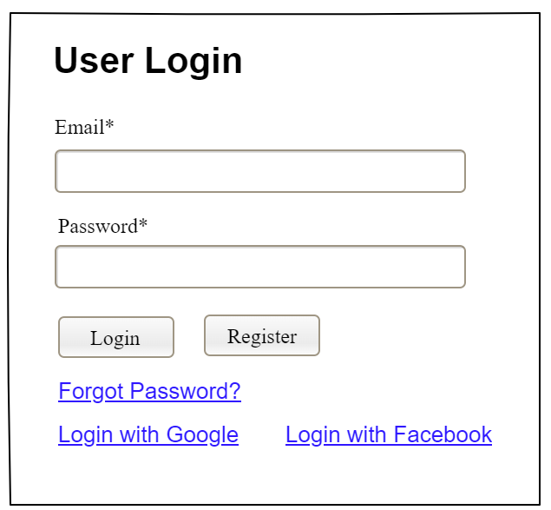

| **Field Name** | **Field Type** | **Description** |
| --- | --- | --- |
| Email* | Text Box | This is for user to input valid email address for logging in |
| Password* | Password Box | This is for user to input password for logging in |
| Login | Button | User clicks to authenticate him/herself into the system with provided email & password |
| Register | Button | User clicks to redirect to the User Register page for registering new user account to access the system |
| Forgot Password? | Hyperlink | User clicks to redirect to the Password Reset page for resetting his/her forgot password |
| Login with Google | Hyperlink | Allow user to login with his/her Google account |
| Login with Facebook | Hyperlink | Allow user to login with his/her Facebook account |

##### Database Access

| **Table** | **CRUD** | **Description** |
| --- | --- | --- |
| User | R | Verify UserName & Password information |
| Setting, User | R | Specify the authorizations of the logged-in user |

***SQL Commands:***

1/ Verify UserName & Password information

SELECT user_id, full_name, email, image_url, status

FROM user WHERE user_name = ? AND password = ?

2/ Specify the authorizations of the logged-in user

SELECT mapped_values FROM setting WHERE setting_id = ?

SELECT setting_name, mapped_values FROM setting WHERE setting_id IN (?)

#### b. Setting List

##### UI Design

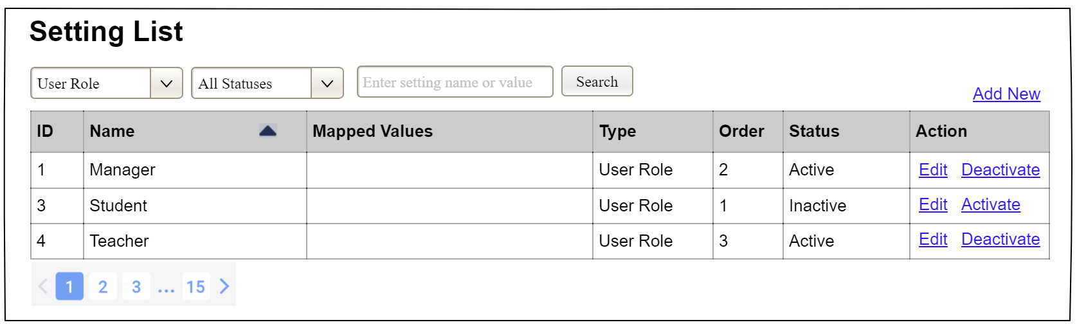

| **Field Name** | **Field Type** | **Description** |
| --- | --- | --- |
| ***Search Fields*** | | |
| Setting Type | Combo Box  Single-Choice | Filled with the list of current active setting types  Allow to filter the list by setting type;  Default value is “All Types” |
| Setting Status | Combo Box  Single-Choice | Values: All Statuses (default), Active, and Inactive  Allow to filter the list by status  Default value: “All Statuses” |
| Search Phase | Text Box  String (30) | Allow to search using the name or map values  Default value: blank |
| Search | Button | Click to refresh the list with the defined filter(s) and search phrase. |
| Add New | Hyperlink | Click to open the Setting Details page for adding new setting (master data) |
| ***Data Table*** | | |
| ID | Integer | Auto-increased identifier of the setting |
| Name | Text | Name of the setting |
| Mapped Values | Text | Supplementary information for the setting |
| Type | Text | Type of the setting |
| Order | Integer | Display order of the setting: the order of the setting type, displayed among the list of settings with the same type |
| ***Data Actions*** | | |
| Edit | icon | Click to open the Setting Details page for updating the relevant setting (master data) |
| Activate | icon | Shown when the data status is inactive. This is to activate the relevant setting (master data) |
| Deactivate | Ion | Shown when the data status is active. This is to deactivate the relevant setting (master data) |

##### Database Access

| **Table** | **CRUD** | **Description** |
| --- | --- | --- |
| Setting | RU | Query the list of current settings from the database  Update status of a specific setting |

***SQL Commands:***

1/ Query the list of current settings from the database

SELECT setting_id, setting_name, mapped_values, type_id, display_order, status

FROM setting WHERE (setting_type = ?) AND (status = ?) AND (setting_name LIKE ?)

2/ Update status of a specific setting

UPDATE setting SET status = ? WHERE setting_id = ?

#### c. Setting Details

##### UI Design

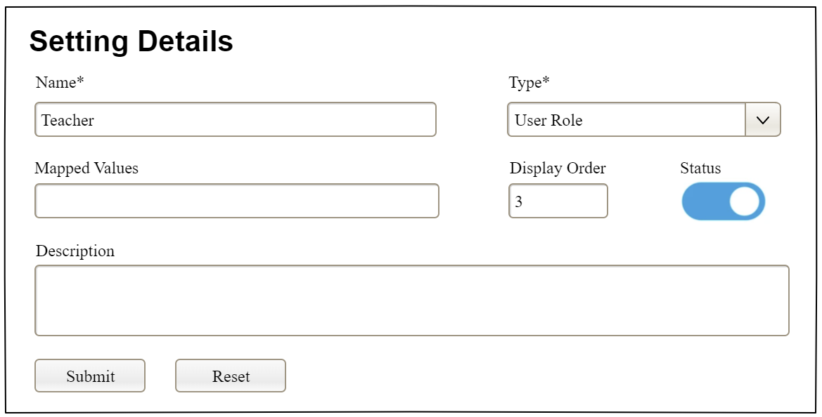

| **Field Name** | **Field Type** | **Description** |
| --- | --- | --- |
| Name* | Text Box  String (20) | Name of the setting |
| Type* | Combo Box  (Single Choice) | Type of the setting, filled with the list of setting types  Default value: the first type in the list |
| Mapped Values | Text Box  String (50) | Supplementary information for the setting (if any) |
| Order | Text Box  Integer (>=0) | Display order of the setting: the order of the setting type, displayed among the list of settings with the same type |
| Status | On/Off button | Status of the setting: Active or Inactive  Default value: Active |
| Description | Text Area  String (200) | Description of the setting |
| Submit | Button | Click to store new or updated setting details |
| Reset | Button | Click to reset the changes use has made on the screen fields back to the initial values when the screen is loaded |

##### Database Access

…

# IV. Appendix

## 1. Assumptions & Dependencies

*[Record any assumptions that were made when conceiving the project and writing this vision and scope document. Note any major dependencies the project must rely upon for success, such as specific technologies, third-party vendors, development partners, or other business relationships.]*

<<Sample:

AS-1: Systems with appropriate user interfaces will be available for cafeteria employees to process the expected volume of meals ordered.

AS-2: Cafeteria staff and vehicles will be available to deliver all meals for specified delivery time slots within 15 minutes of the requested delivery time.

DE-1: If a restaurant has its own on-line ordering system, the Cafeteria Ordering System must be able to communicate with it bi-directionally.

>>

## 2. Limitations & Exclusions

*[Identify any product features or characteristics that a stakeholder might anticipate, but which are not planned to be included in the new product]*

## 3. Business Rules

*[Provide common business rules that you must follow. The information can be provided in the table format as the sample below]*

<<Sample

| **ID** | **Category** | **Rule Definition** |
| --- | --- | --- |
| BR-01 | Constraints | Delivery time windows are 15 minutes, beginning on each quarter hour. |
| BR-02 | Constraints | Deliveries must be completed between 10:00 A.M. and 2:00 P.M. local time, inclusive. |
| BR-03 | Facts | All meals in a single order must be delivered to the same location. |
| BR-04 | Facts | All meals in a single order must be paid for by using the same payment method. |
| BR-11 | Constraints | If an order is to be delivered, the patron must pay by payroll deduction. |
| BR-12 | Computations | Order price is calculated as the sum of each food item price times the quantity of that food item ordered, plus applicable sales tax, plus a delivery charge if a meal is delivered outside the free delivery zone. |
|  |  |  |

>>

## 4. ..