PE_PRN222_SP25_TrialTest
SPRING 2025
Subject: PRN222
Duration: 85 minutes

INSTRUCTIONS
Please read the instructions carefully before doing the questions.
- You are NOT allowed to use any other materials. You are NOT allowed to use any device to share data with others.
- You must use Visual Studio 2019 or above, MSSQL Server 2008 or above for your development tools.
IMPORTANT – before you start doing your solution, MUST do the following steps:
- Create Solution in Visual Studio named PE_PRN222_SP25_TrialTest_StudentName. Inside your Solution, the Project ASP.NET Core Razor Page must be named: PharmaceuticalManagement_StudentName.
- To do your program, you must use ASP.NET Core Web App (Razor Pages), apply 3-Layer architecture (Presentation Layer, Business Logic Layer, Data Access Layer), there are at least 2 Projects for the Solution. The database connection string must get from the appsettings.json file.
In the case your code connects direct to the database from ASP.NET Core Web App (Razor Pages) or hard coded the connection string, you will get 0 point.
- Create your MS SQL database named Sp25PharmaceuticalDB by running code in script Sp25PharmaceuticalDB.sql.
- Set the default user interface for your project as a Login page.
- If there are syntax errors or compilation errors in your PE program, you will not pass the PE requirements, the mark will be 0.
- Your work will be considered invalid (0 point) if your code inserts stuff that is unrelated to the test.

Create an application using ASP.NET Core Razor Pages with .NET Core (.NET 8/.NET 9), C#, and Entity Framework Core. A MS SQL Server database will be created to persist the data and it will be used for reading and managing data.
A part of Sp25PharmaceuticalDB database.
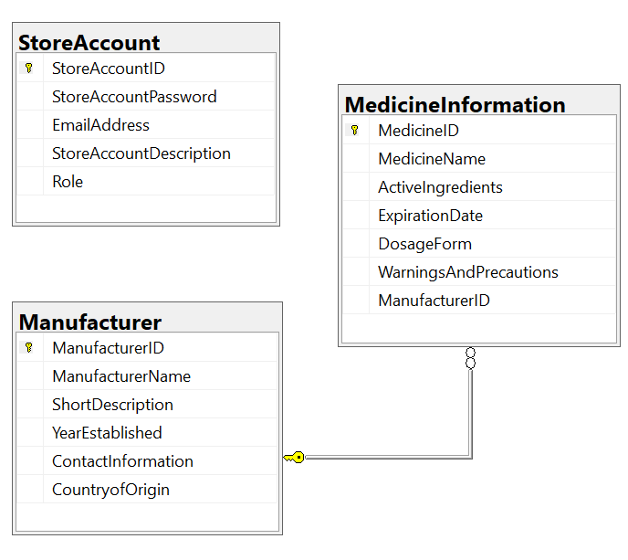
Store account role: Administrator = 1; Manager = 2; Staff = 3; Member = 4

- (1.00 point) Authentication function. Using EmailAddress and StoreAccountPassword for the authentication/authorization process.
If the user with a Manager Role or Staff Role logs in successfully, save this information to a temporary parameter. In case the login is unsuccessful, display the message “You do not have permission to do this function!”.
- No permissions for the function: List all of items.
- All Create-Update-Delete and Search functions are required with Manager role,
- Staff role is required for Search actions.

- (1.5 points) List all of items in MedicineInformation table (each record includes information of MedicineInformation and ManufacturerName). Paging is required for this function, 3 records/1page. (Note that, No permissions for this function).

- (2.5 points) If a user with a Manager role logs in successfully, add a new item with the requirements:
- The new item will display at the top of the list.
- All fields are required.
- Value for ActiveIngredients is greater than 10 characters. Each word of the ActiveIngredients must begin with the capital letter or a number (0, 1, 2 →9). The value of ActiveIngredients is not allowed with special characters such as #, @, &, (, ).
- The ManufacturerID/ManufacturerName will come from the Manufacturer table (you can use ComboBox UI control in this case)

- (2.0 points) If a user with Manger role logs in successfully, update the selected existing item.
- With update function, the same validation requirements with Add function.

- (1.50 points) If a user with Manager role logs in successfully, search all items with 3 conditions: ActiveIngredients, ExpirationDate, WarningsAndPrecautions (OR option for this case and using relative search). Search results need to be grouped by ActiveIngredients, ExpirationDate, WarningsAndPrecautions.

- (1.50 points) Using realtime communication with SignalR for delete function. If a user with Manager role logs in successfully, delete the selected item with the confirmation then update the list of items for all connected clients.

