Requirement & Design Specification
Apartment Building Management (CondoCare)

Version: 1.1
--- Hanoi, April 2026 ---

Record of Changes
Version | Date | A/M/D | In charge | Change Description
V1.0 | 20/01 | A | Team | Use-case Diagram, Entity Relationship Diagram, Initial Template
V1.1 | 07/04 | M | Team | Added System Context Diagram, Use Case Diagrams, Screens Flow Diagram, Package Diagram, Overall Architecture Diagram, Demonstration section, complete Functional Requirements, Database Design, Appendix

*A – Added M – Modified D – Deleted

I. Overview

1. System Context
CondoCare is a web-based Apartment Building Management system designed to digitize and streamline all operational activities within a residential condominium. The system replaces traditional manual management by providing an integrated platform for managing apartments, residents, staff, service requests, invoices, vehicle registrations, and resident notifications.
The system serves two main user groups: Staff (Admin, Manager, Accountant, Technician, Receptionist) who manage internal operations through a dedicated dashboard, and Residents (Owner, Tenant, Guest) who interact via a personal resident portal. CondoCare integrates with two external services — MoMo Payment Gateway for online invoice payments and Gmail (SMTP) for automated email notifications.
The context diagram below illustrates the system boundary and its interactions with external entities.
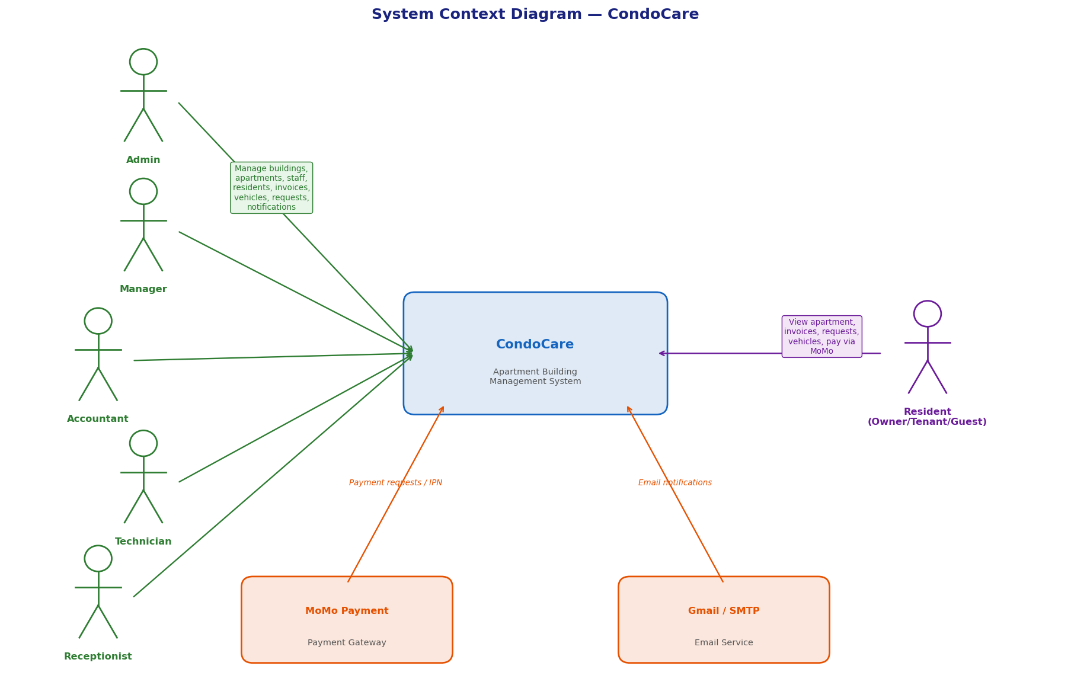
Figure 1. System Context Diagram — CondoCare

2. External Entities
No | Entity | Description
1 | Admin (Staff) | System administrator with full access. Manages all staff accounts, resident accounts, building/apartment data, fee templates, and system configuration.
2 | Manager (Staff) | Building management head. Approves resident registrations, manages staff assignments, oversees apartments, issues access cards, sends notifications, and views all reports.
3 | Accountant (Staff) | Handles all financial operations: creates monthly invoices, manages fee templates per building, views invoice reports, and tracks payment statuses (UNPAID / PAID / OVERDUE).
4 | Technician (Staff) | Handles assigned service requests. Can view only their assigned requests, add notes, upload completion images, and mark requests as DONE.
5 | Receptionist (Staff) | Front-desk staff. Manages resident accounts, approves/rejects vehicle registrations, issues access cards, and sends targeted notifications.
6 | Resident (Owner / Tenant / Guest) | Residents of the condominium. Can register accounts, view apartment info, submit and track service requests, view/pay invoices via MoMo, register vehicles, and receive notifications.
7 | MoMo Payment Gateway | External payment processor. Receives payment requests and returns transaction results via IPN callback to update invoice status to PAID.
8 | Email Service (Gmail/SMTP) | External email service for: account approval, password reset links, invoice overdue reminders, and service request status updates.

3. Business Processes
CondoCare supports the following core business processes:

3.1 User Registration and Authentication
- Registration (Resident): Resident fills in the registration form. System creates account with status = PENDING. Manager or Admin approves (status → ACTIVE). System sends approval email.
- Registration (Staff): Only Admin/Manager can create staff accounts directly in the Staff Management dashboard.
- Login: All users log in via username + password. System generates a JWT token (24-hour expiry). Frontend stores token and uses it in Authorization headers.
- Forgot/Reset Password: User requests reset by entering email. System generates a UUID token (15-min expiry) and sends a reset link. User sets new password.

3.2 Invoice & Payment Process
- Invoice Creation: Accountant/Manager selects building and month/year. System auto-calculates total from active FeeTemplates (PER_APT, PER_M2, FIXED). Invoice saved with status = UNPAID.
- Automated Overdue Detection: Scheduled job runs daily at 00:30. Finds all UNPAID invoices past due_date and marks them OVERDUE. Sends notifications and emails to affected residents.
- Payment via MoMo: Resident selects an UNPAID/OVERDUE invoice. System creates MoMo payment session and returns deep-link URL. After payment, MoMo sends IPN callback. System verifies signature, marks invoice PAID, records payment.

3.3 Service Request Process
- Submission (Resident): Resident submits request with title, description, category (ELECTRIC/WATER/INTERNET/HVAC/STRUCTURE/OTHER), and priority (LOW/MEDIUM/HIGH). Status = PENDING.
- Assignment (Staff): Manager/Receptionist assigns to Technician. Status → IN_PROGRESS. Resident notified.
- Resolution (Technician): Marks DONE, optionally uploads completion image. Resident receives notification.
- Confirmation (Resident): Resident confirms satisfactory resolution. residentConfirmed flag set to true.
- Cancellation: Resident can cancel only while status = PENDING. Rejection: Admin/Manager can reject with reason.

3.4 Vehicle Registration Process
- Resident submits registration request (type, license plate, brand, model, color, duration: MONTHLY/QUARTERLY/YEARLY). Saved with pendingStatus = PENDING.
- Staff reviews: If approved, system calculates expiry date and notifies resident. If rejected, resident receives rejection notification with reason.

3.5 Notification Process
- Staff can send: (1) Broadcast — all residents of a building; (2) Apartment — all residents of a specific unit; (3) Personal — one specific resident.
- System-generated notifications (created_by = NULL) are created automatically for: invoice overdue, account approval, access card issuance, service request updates, vehicle approval/rejection.

3.6 Resident Account Lifecycle
- Register (PENDING) → Admin/Manager approves (ACTIVE) → Assigned to apartment → Access all features. When resident leaves → Staff deactivates (INACTIVE) → Access revoked.

4. User Requirements
ID | Use Case | Feature | Main Actor | Description
UC01 | Register Account | Authentication | Resident | Allows a new resident to self-register. Account created with PENDING status pending staff approval.
UC02 | Login | Authentication | All | Authenticates users (Staff and Residents) and returns a JWT token for session management.
UC03 | Logout | Authentication | All | Allows users to end their active session by clearing the stored JWT token.
UC04 | Forgot / Reset Password | Authentication | All | Enables users to request a password reset link via email, then set a new password through a time-limited token.
UC05 | View Profile | Profile Management | All | Displays the personal information of the currently logged-in user.
UC06 | Update Profile | Profile Management | All | Allows users to update personal details such as phone number, email.
UC07 | Change Password | Profile Management | All | Allows logged-in users to change their account password after verifying the current password.
UC08 | View Dashboard Overview | Dashboard | Staff | Summary statistics: total apartments, residents, staff, invoices by status, pending service requests.
UC09 | Manage Staff Accounts | Staff Management | Admin / Manager | Create, view, update, and deactivate staff accounts. Assign roles.
UC10 | Manage Resident Accounts | Resident Management | Admin / Manager | View, approve, and deactivate resident accounts. Assign residents to apartments.
UC11 | Manage Buildings & Apartments | Building Management | Admin / Manager | Create and manage buildings and apartment units. Track apartment and rental status.
UC12 | Manage Fee Templates | Fee Management | Admin / Manager | Define monthly fee templates per building with amount, unit (PER_APT/PER_M2/FIXED), and effective period.
UC13 | Create Invoice | Invoice Management | Admin / Manager / Accountant | Generate monthly invoices by auto-calculating fees from active FeeTemplates.
UC14 | View & Search Invoices | Invoice Management | Admin / Manager / Accountant | View invoice list with filters. View line-item fee details.
UC15 | Update Invoice Status | Invoice Management | Admin / Manager | Manually update invoice status (e.g., mark PAID for cash transactions).
UC16 | View Invoices (Resident) | Invoice Management | Resident | View personal invoice list with filters. See fee breakdown.
UC17 | Pay Invoice via MoMo | Payment | Resident | Initiate online payment through MoMo. System handles IPN callback to mark invoice PAID.
UC18 | Submit Service Request | Service Request | Resident | Submit a support request with title, description, category, and priority level.
UC19 | Cancel Service Request | Service Request | Resident | Cancel a PENDING service request not yet assigned to staff.
UC20 | View & Track Service Requests | Service Request | Resident | View own requests with filters and see status/notes/completion images.
UC21 | Confirm Request Completion | Service Request | Resident | Confirm that a DONE request has been satisfactorily resolved.
UC22 | Manage Service Requests (Staff) | Service Request | Staff | View, search, filter all requests. Assign, reject, or mark DONE with completion image.
UC23 | Register Vehicle | Vehicle Management | Resident | Submit a vehicle registration request. Pending staff approval.
UC24 | View My Vehicles | Vehicle Management | Resident | View registered vehicles with status and approval state.
UC25 | Approve / Reject Vehicle | Vehicle Management | Admin/Manager/Receptionist | Review pending vehicle registrations. Approve (sets expiry) or reject with reason.
UC26 | Manage Access Cards | Access Card Management | Admin / Manager | Issue access cards with expiry. Block or mark as lost.
UC27 | Send Notification | Notification Management | Admin/Manager/Receptionist | Send broadcast, apartment-level, or personal notifications.
UC28 | View Notifications (Resident) | Notification | Resident | View received notifications. Mark individual or all as read.
UC29 | View Apartment Info | Resident Portal | Resident | View assigned apartment details, active fee charges, approved vehicles, and access cards.

4.1 Use Case Diagram — All Actors
The following diagram illustrates all 29 use cases and their associations with system actors.
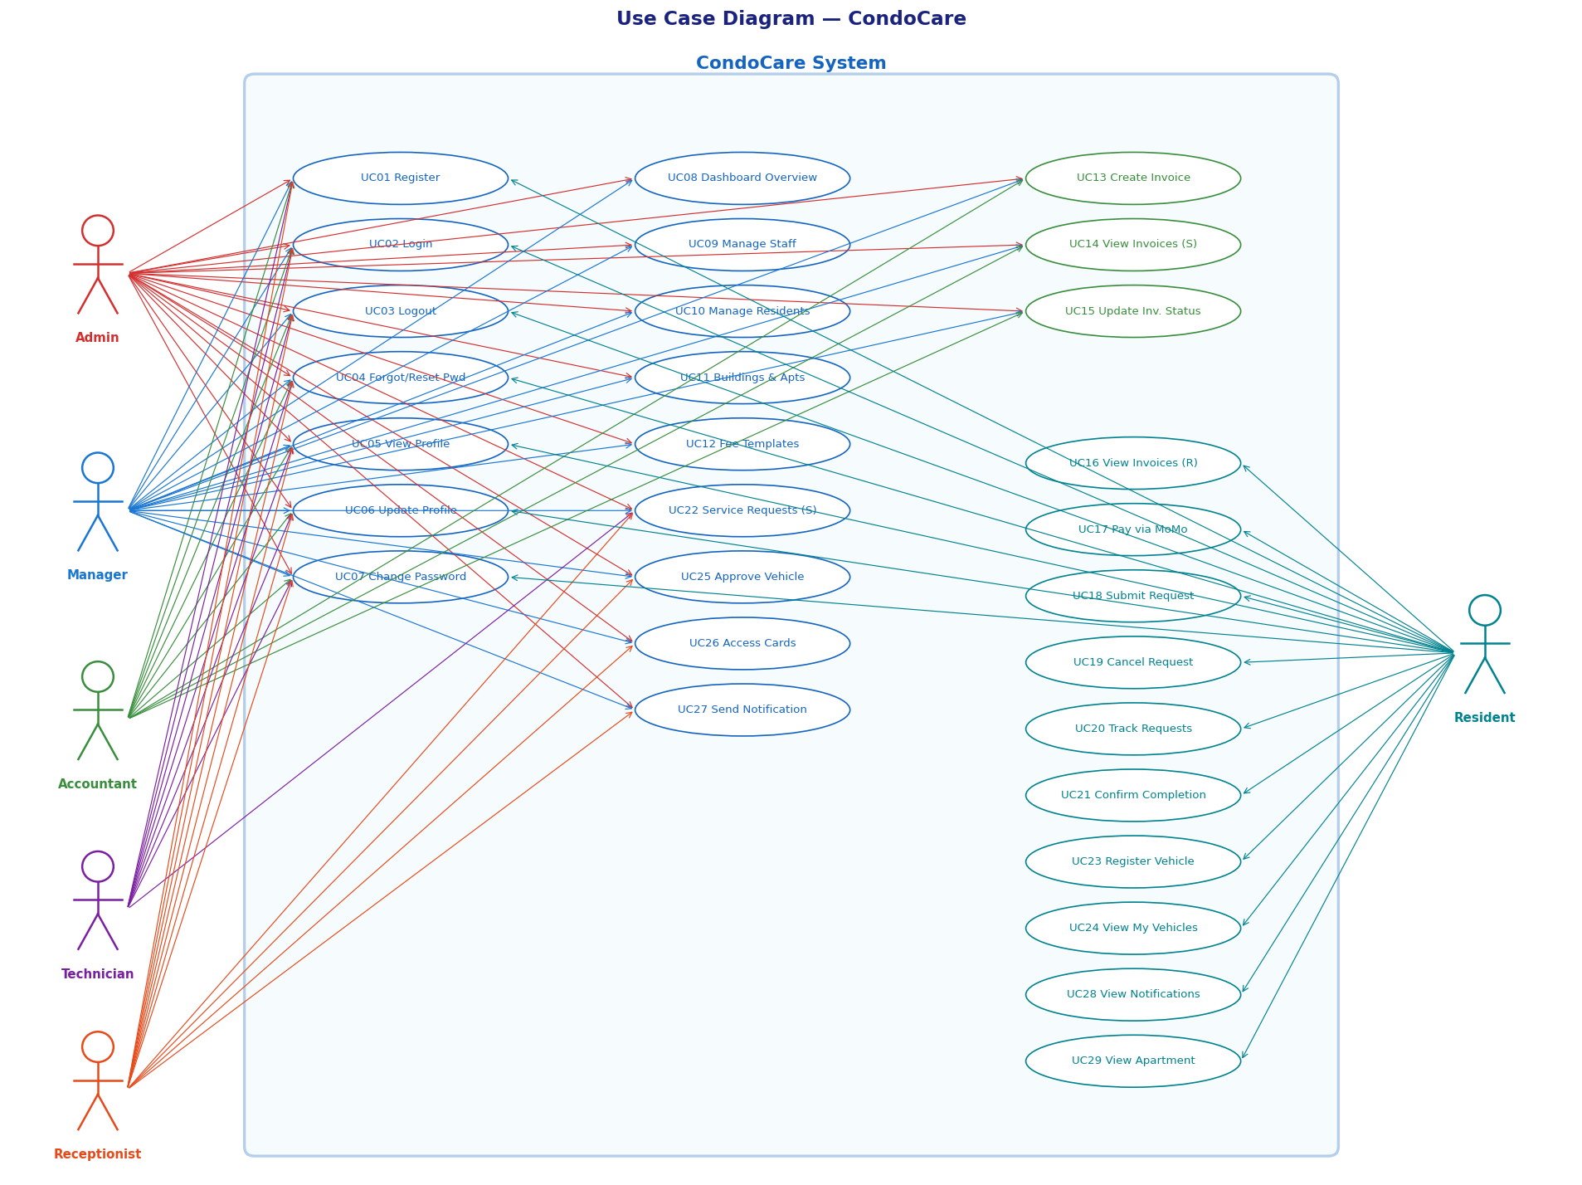
Figure 2. Use Case Diagram — CondoCare

5. System Functionalities

5.1 Screens Flow
The system has two distinct navigation areas: the Staff Dashboard (accessible after staff login) and the Resident Portal (accessible after resident login). Both areas share the Login, Register, Forgot Password, and Reset Password screens.
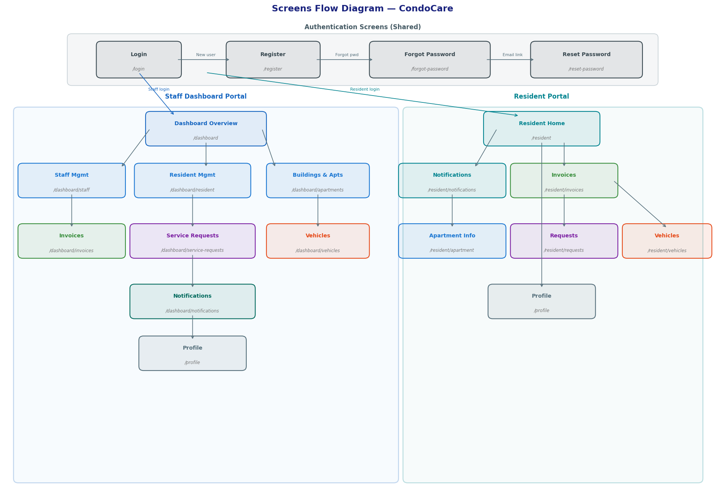
Figure 3. Screens Flow Diagram — CondoCare
# | Area | Screen / URL | Description
1 | Authentication | /login | Login screen for all users. Links to Register and Forgot Password.
2 | Authentication | /register | Resident self-registration form.
3 | Authentication | /forgot-password | Email entry for password reset request.
4 | Authentication | /reset-password | New password entry after clicking reset link from email.
5 | Common | /profile | View and update personal profile information.
6 | Staff – Overview | /dashboard | Staff home: summary stats for apartments, residents, invoices, requests.
7 | Staff – Management | /dashboard/staff | Staff account list with create/edit/deactivate actions.
8 | Staff – Management | /dashboard/resident | Resident account list with approve/assign-apartment actions.
9 | Staff – Management | /dashboard/apartments | Apartment and building management with fee template configuration.
10 | Staff – Finance | /dashboard/invoices | Invoice list with create, filter, and status update. Preview fee breakdown.
11 | Staff – Operations | /dashboard/service-requests | Service request list with assign, reject, mark-done, search/filter.
12 | Staff – Operations | /dashboard/vehicles | Pending and approved vehicle registration management.
13 | Staff – Operations | /dashboard/notifications | Send broadcast, apartment, or personal notifications. View sent history.
14 | Resident Portal | /resident | Resident home: quick stats for unpaid invoices, pending requests, vehicles.
15 | Resident Portal | /resident/notifications | Personal notification list with unread badge.
16 | Resident Portal | /resident/invoices | Invoice list with filter and MoMo pay button.
17 | Resident Portal | /resident/apartment | Apartment details, active fee charges, approved vehicles.
18 | Resident Portal | /resident/requests | Service request list with submit, cancel, and confirm actions.
19 | Resident Portal | /resident/vehicles | Vehicle registration form and list of own vehicles.

5.2 Screen Authorization
Screen / Feature | Admin | Manager | Accountant | Technician | Receptionist | Resident
Login / Register / Forgot & Reset Password | ✓ | ✓ | ✓ | ✓ | ✓ | ✓
Profile (View / Edit / Change Password) | ✓ | ✓ | ✓ | ✓ | ✓ | ✓
Dashboard Overview (/dashboard) | ✓ | ✓ | ✓ | ✓ | ✓ | –
Staff Management (/dashboard/staff) | ✓ | ✓ | – | – | – | –
Resident Management (/dashboard/resident) | ✓ | ✓ | – | – | ✓ | –
Buildings & Apartments (/dashboard/apartments) | ✓ | ✓ | ✓ (read) | – | – | –
Fee Templates (apartments tab) | ✓ | ✓ | ✓ (read) | – | – | –
Invoice Management (/dashboard/invoices) | ✓ | ✓ | ✓ | – | – | –
Service Requests Staff (/dashboard/service-requests) | ✓ | ✓ | – | ✓ (own) | ✓ | –
Vehicle Management (/dashboard/vehicles) | ✓ | ✓ | – | – | ✓ | –
Notifications Staff (/dashboard/notifications) | ✓ | ✓ | ✓ (read) | ✓ (read) | ✓ | –
Resident Home (/resident) | – | – | – | – | – | ✓
Resident Invoices / Pay MoMo | – | – | – | – | – | ✓
Resident Apartment Info | – | – | – | – | – | ✓
Resident Requests / Vehicles / Notifications | – | – | – | – | – | ✓

5.3 Non-UI Functions
Function | Description
JWT Authentication Filter | Intercepts every HTTP request, extracts Bearer token, validates it, and sets the authenticated principal in Spring Security context.
Invoice Overdue Scheduler | CRON job (0 30 0 * * *) running daily at 00:30. Marks all UNPAID invoices past due_date as OVERDUE. Sends notifications and emails to affected residents.
MoMo IPN Callback | POST /api/momo/ipn. Receives IPN from MoMo, verifies HMAC-SHA256 signature, updates invoice to PAID, creates Payments record.
Email Notification Service | Sends HTML emails via Gmail SMTP for: account approval, password reset, invoice overdue, service request updates, vehicle approval/rejection.
Password Reset Token Expiry | Reset tokens have 15-minute validity. Expired tokens are rejected; users must request a new link.
Vehicle Expiry Calculation | On approval, auto-calculates expiry: MONTHLY → +1 month, QUARTERLY → +3 months, YEARLY → +12 months.
System Notification Generator | Auto-creates Notification records (created_by = NULL, shown as "Hệ thống") for all lifecycle events.

II. Functional Requirements

1. Authentication & Common Features

1.1 UC02 – Login
Field | Value
Use Case ID | UC02
Use Case Name | Login
Actor | All Users (Staff & Residents)
Pre-condition | User must have a registered and active account
Post-condition | JWT token issued; user redirected to respective dashboard
Main Flow | 1. User submits POST /api/auth/login with {username, password}.  2. System loads user from Staff or Residents table.  3. System validates BCrypt password hash.  4. System generates JWT token (HS512, 24h expiry).  5. Returns {token, role, userType, fullName}.  6. Frontend stores token in sessionStorage/localStorage.  7. Staff → /dashboard; Resident → /resident.
Alternative Flow | A1 (Invalid credentials): HTTP 401.  A2 (Inactive/PENDING account): HTTP 403 with message.

1.2 UC04 – Forgot / Reset Password
Field | Value
Use Case ID | UC04
Use Case Name | Forgot / Reset Password
Actor | All Users
Pre-condition | User must have a registered email address
Post-condition | User password updated; reset token invalidated
Main Flow | 1. User submits POST /api/auth/forgot-password with {email}.  2. System generates UUID token, saves with 15-min expiry.  3. System sends reset link email via Gmail SMTP.  4. User clicks link; frontend shows /reset-password.  5. User submits POST /api/auth/reset-password with {token, newPassword}.  6. System validates token, checks expiry, updates BCrypt password.
Alternative Flow | A1 (Email not found): 404 error.  A2 (Token expired): 400 Bad Request.

1.3 UC01 – Register Account
Field | Value
Use Case ID | UC01
Use Case Name | Register Account
Actor | Resident
Pre-condition | User is not registered in the system
Post-condition | Account created with status = PENDING
Main Flow | 1. Resident submits POST /api/auth/register with {username, password, fullName, phone, email, gender, dob, idNumber}.  2. System validates uniqueness (username, phone).  3. System creates Residents record (status = PENDING).  4. Account awaits approval by Admin or Manager.
Alternative Flow | A1 (Duplicate username or phone): 400 error.  A2 (Weak password): Validation error.

2. Staff Management Features

2.1 UC11 – Manage Buildings & Apartments
Field | Value
Use Case ID | UC11
Use Case Name | Manage Buildings & Apartments
Actor | Admin / Manager
Pre-condition | Admin or Manager is logged in
Post-condition | Building or Apartment created/updated; data persisted
Main Flow | 1. Staff navigates to /dashboard/apartments.  2. CREATE BUILDING: POST /api/buildings with {name, address, totalFloors, totalApartments, managerId}.  3. CREATE APARTMENT: POST /api/apartments with {buildingId, number, floor, area, description}.  4. EDIT APARTMENT: PUT /api/apartments/{id} with {floor, area, status, rentalStatus, description}.  5. System checks for duplicate apartment number within same building.
Alternative Flow | A1 (Duplicate apartment number): 409 conflict.  A2 (Invalid buildingId): 404 Not Found.

2.2 UC12 – Manage Fee Templates
Field | Value
Use Case ID | UC12
Use Case Name | Manage Fee Templates
Actor | Admin / Manager
Pre-condition | Building must exist
Post-condition | FeeTemplate created/updated; affects future invoice generation
Main Flow | 1. Staff selects building in Fee Templates tab.  2. POST /api/fee-templates with {buildingId, name, type(SERVICE/PARKING), unit(PER_M2/PER_APT/FIXED), amount, effectiveFrom, effectiveTo?, minArea?, maxArea?, hasElevator?}.  3. For PER_M2 SERVICE fees: system validates against QĐ 33/2025 range (elevator: 1,200–16,500 đ/m², non-elevator: 700–5,000 đ/m²).  4. To deactivate: DELETE /api/fee-templates/{id} (soft delete → INACTIVE).
Alternative Flow | A1 (Amount out of decree range): Warning logged, save proceeds.  A2 (Missing required fields): 400 validation error.

2.3 UC13 – Create Invoice
Field | Value
Use Case ID | UC13
Use Case Name | Create Invoice
Actor | Admin / Manager / Accountant
Pre-condition | Active FeeTemplates exist for the building. No duplicate invoice for same apartment/month/year.
Post-condition | Invoice created (status = UNPAID); InvoiceFeeDetails snapshot recorded.
Main Flow | 1. Staff submits POST /api/invoice-management with {buildingId, apartmentId?, month, year, dueDate}.  2. System loads active FeeTemplates for the building.  3. SERVICE/PER_M2: checks area in [minArea, maxArea]; calculates amount = rate × area.  4. SERVICE/PER_APT: uses flat amount.  5. PARKING/FIXED: counts APPROVED+ACTIVE vehicles matching the fee type; amount = rate × vehicleCount.  6. Creates Invoice record; saves InvoiceFeeDetail lines as snapshot.  7. Returns invoice summary.
Alternative Flow | A1 (Duplicate invoice): 409 conflict.  A2 (No fee templates): Invoice created with 0 amount and warning.

2.4 UC22 – Manage Service Requests (Staff)
Field | Value
Use Case ID | UC22
Use Case Name | Manage Service Requests (Staff)
Actor | Staff
Pre-condition | Service requests exist in the system
Post-condition | Request status updated; resident notified
Main Flow | 1. Staff views request list with filters (status, category, priority, keyword).  2. ASSIGN: PUT /api/staff-service-requests/{id}/assign with {staffId}. Status → IN_PROGRESS.  3. DONE: PUT /api/staff-service-requests/{id}/done with {note?, completionImage?}.  4. REJECT: PUT /api/staff-service-requests/{id}/reject with {rejectReason}.  5. System sends in-app notification and email to resident at each step.
Alternative Flow | A1 (Technician): Can only see/act on requests assigned to them.  A2 (Already DONE/REJECTED): Cannot re-assign.

2.5 UC25 – Approve / Reject Vehicle Registration
Field | Value
Use Case ID | UC25
Use Case Name | Approve / Reject Vehicle Registration
Actor | Admin / Manager / Receptionist
Pre-condition | Vehicle registration with pendingStatus = PENDING exists
Post-condition | Vehicle approved (expiry calculated) or rejected; resident notified
Main Flow | 1. Staff views pending vehicle list at /dashboard/vehicles.  2. APPROVE: PUT /api/vehicles/{id}/approve. System calculates expiredAt based on durationType. pendingStatus → APPROVED. Notification sent to resident.  3. REJECT: PUT /api/vehicles/{id}/reject with {rejectReason}. pendingStatus → REJECTED. Notification sent.
Alternative Flow | A1 (Vehicle already processed): 400 error.

3. Resident Portal Features

3.1 UC17 – Pay Invoice via MoMo
Field | Value
Use Case ID | UC17
Use Case Name | Pay Invoice via MoMo
Actor | Resident
Pre-condition | Invoice status = UNPAID or OVERDUE; MoMo credentials configured in application.properties
Post-condition | Invoice status = PAID; Payment record created in Payments table
Main Flow | 1. Resident selects invoice and clicks "Pay via MoMo".  2. System calls POST /api/momo/create-payment → receives payUrl.  3. Resident redirected to MoMo deep-link.  4. Resident completes payment on MoMo app.  5. MoMo calls POST /api/momo/ipn with transaction result.  6. System verifies HMAC-SHA256 signature.  7. System marks Invoice PAID; creates Payments record with transactionId.
Alternative Flow | A1 (Signature invalid): IPN rejected; invoice unchanged.  A2 (Payment cancelled by user): Invoice remains UNPAID.

3.2 UC18–UC21 – Service Request Lifecycle (Resident)
Field | Value
Use Case IDs | UC18, UC19, UC20, UC21
Use Case Names | Submit / Cancel / Track / Confirm Service Request
Actor | Resident
Pre-condition | Resident must be ACTIVE and assigned to an apartment
Post-condition | Request status updated accordingly
Main Flow | SUBMIT (UC18): POST /api/resident/requests with {title, description, category, priority}. Status = PENDING.  TRACK (UC20): GET /api/resident/requests with optional filters (filterType, month, quarter, year, status, keyword).  CANCEL (UC19): PUT /api/resident/requests/{id}/cancel — only if status = PENDING.  CONFIRM (UC21): PUT /api/resident/requests/{id}/confirm — only if status = DONE.
Alternative Flow | A1 (Cancel non-PENDING): 400 error.  A2 (Confirm non-DONE): 400 error.

3.3 UC23–UC24 – Vehicle Registration (Resident)
Field | Value
Use Case IDs | UC23, UC24
Use Case Names | Register Vehicle / View My Vehicles
Actor | Resident
Pre-condition | Resident must be ACTIVE
Post-condition | Vehicle record created with pendingStatus = PENDING
Main Flow | REGISTER: POST /api/resident/vehicles with {type, licensePlate?, brand?, model?, color?, durationType}. Creates Vehicle record; pendingStatus = PENDING.  VIEW: GET /api/resident/vehicles — returns list of own vehicles with type, license, status, expiry.
Alternative Flow | A1 (Duplicate license plate): 400 error.  A2 (Same type already active): System warns but allows registration.

3.4 UC29 – View Apartment Info
Field | Value
Use Case ID | UC29
Use Case Name | View Apartment Info (Resident)
Actor | Resident
Pre-condition | Resident must be ACTIVE and assigned to an apartment
Post-condition | Apartment information displayed including active fee charges
Main Flow | 1. Resident navigates to /resident/apartment.  2. GET /api/resident/apartment returns: apartment info (number, floor, area, status), building info (name, address, floors), access cards, active fee charges (activeFees + totalEstimatedMonthly), access cards.  3. Resident views fee breakdown and monthly estimated cost.  4. GET /api/resident/vehicles — displays registered vehicles.
Alternative Flow | A1 (No apartment assigned): Page shows "Chưa được gán căn hộ" message.

III. System Design

1. Software Architecture

1.1 Overall Architecture Diagram
CondoCare uses a Monolithic MVC Architecture built on Spring Boot 3 (Java 17). The frontend is served as Thymeleaf HTML templates with vanilla JavaScript for AJAX interactions. Authentication is stateless, using JWT tokens. The database is MySQL 8.
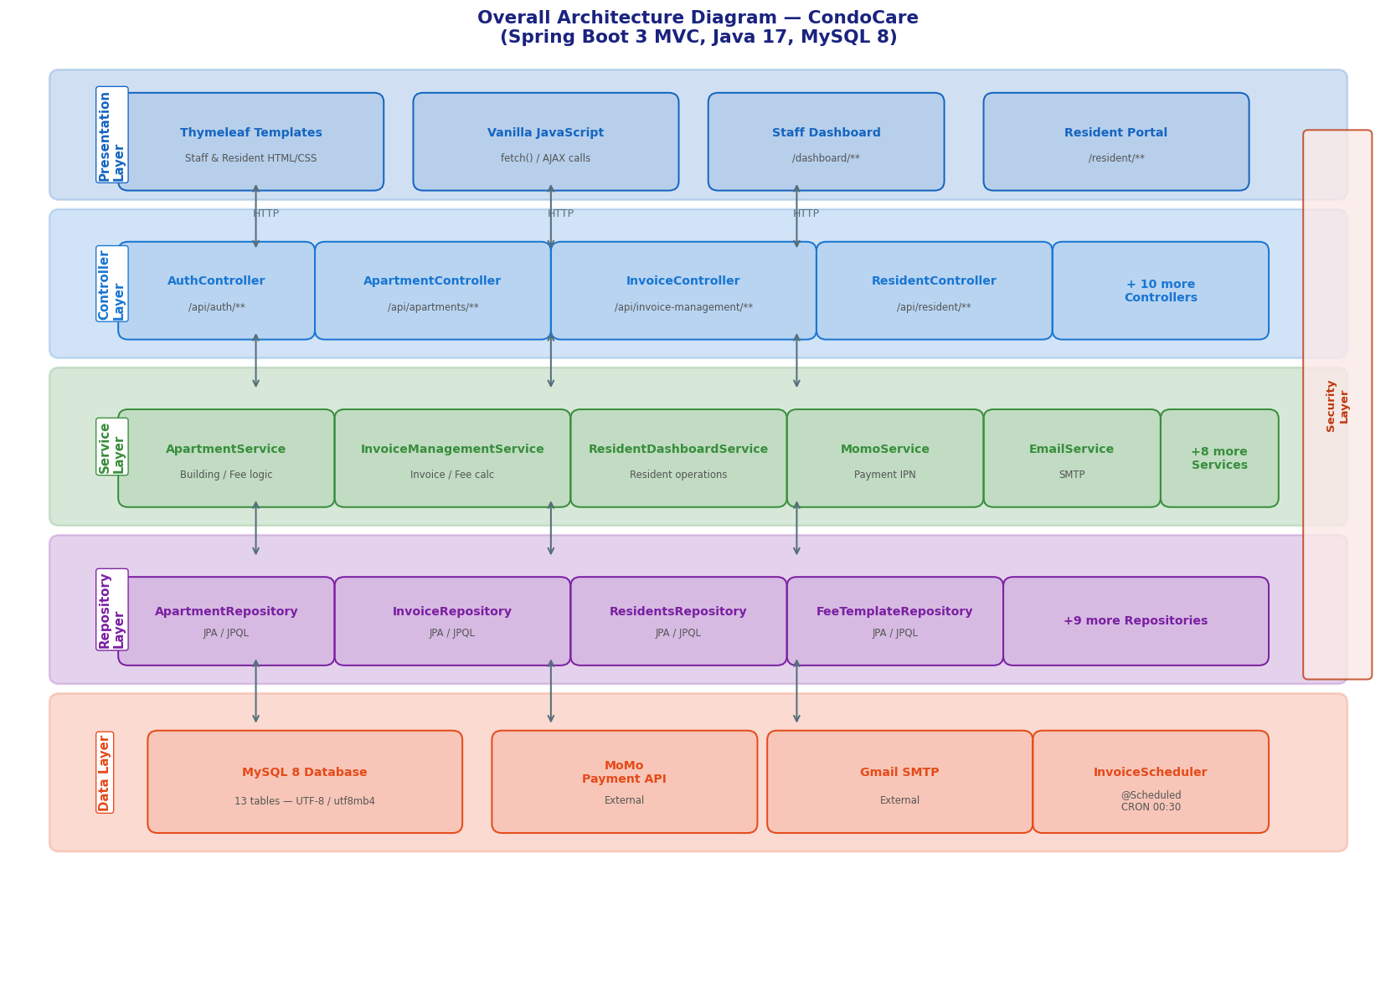
Figure 4. Overall Architecture Diagram — CondoCare (Spring Boot 3 MVC, Java 17, MySQL 8)
Architecture layers:
- Presentation Layer: Thymeleaf HTML templates + JavaScript (fetch API). Two portals: Staff Dashboard (/dashboard/**) and Resident Portal (/resident/**).
- Controller Layer: Spring MVC REST Controllers — receive HTTP requests, validate inputs, delegate to services.
- Service Layer: Business logic classes — orchestrate entity operations, enforce business rules, call repositories.
- Repository Layer: Spring Data JPA interfaces with custom JPQL queries for complex filtering and aggregation.
- Security Layer: JWT Authentication Filter, CustomUserDetailsService, Spring Security with role-based access control.
- Scheduler: Spring @Scheduled component (CRON 0 30 0 * * *) for automatic invoice overdue detection.

1.2 Component Descriptions
Component | Description
SecurityConfig | Defines all HTTP security rules: public endpoints (login, register, momo IPN), JWT filter placement, and role-based URL access control.
JwtTokenProvider | Generates and validates JWT tokens using HS512 algorithm. Extracts username and role claims. Handles 24h token expiry.
JwtAuthenticationFilter | Spring OncePerRequestFilter. Extracts Bearer token from Authorization header, validates it, sets authenticated principal in Spring Security context.
CustomUserDetailsService | Implements UserDetailsService. Searches both Staff and Residents tables. Assigns GrantedAuthority based on role name (ROLE_ADMIN, ROLE_RESIDENT, etc.).
InvoiceScheduler | Scheduled task (CRON 0 30 0 * * *). Finds all UNPAID invoices past their due date, marks them OVERDUE, and triggers notifications for each affected resident.
EmailService | Wraps Spring JavaMailSender. Builds HTML email bodies for each notification type and sends via configured Gmail SMTP.
MomoService | Handles MoMo payment integration: builds HMAC-SHA256 signed request, calls MoMo API, processes IPN callback to update invoice payment status.
SecurityUtils | Utility bean that retrieves the currently authenticated Staff or Resident from Spring Security context. Used across all services to avoid duplicating SecurityContextHolder access code.

2. Code Package Design

2.1 Package Diagram
Base package: com.swp391.condocare_swp
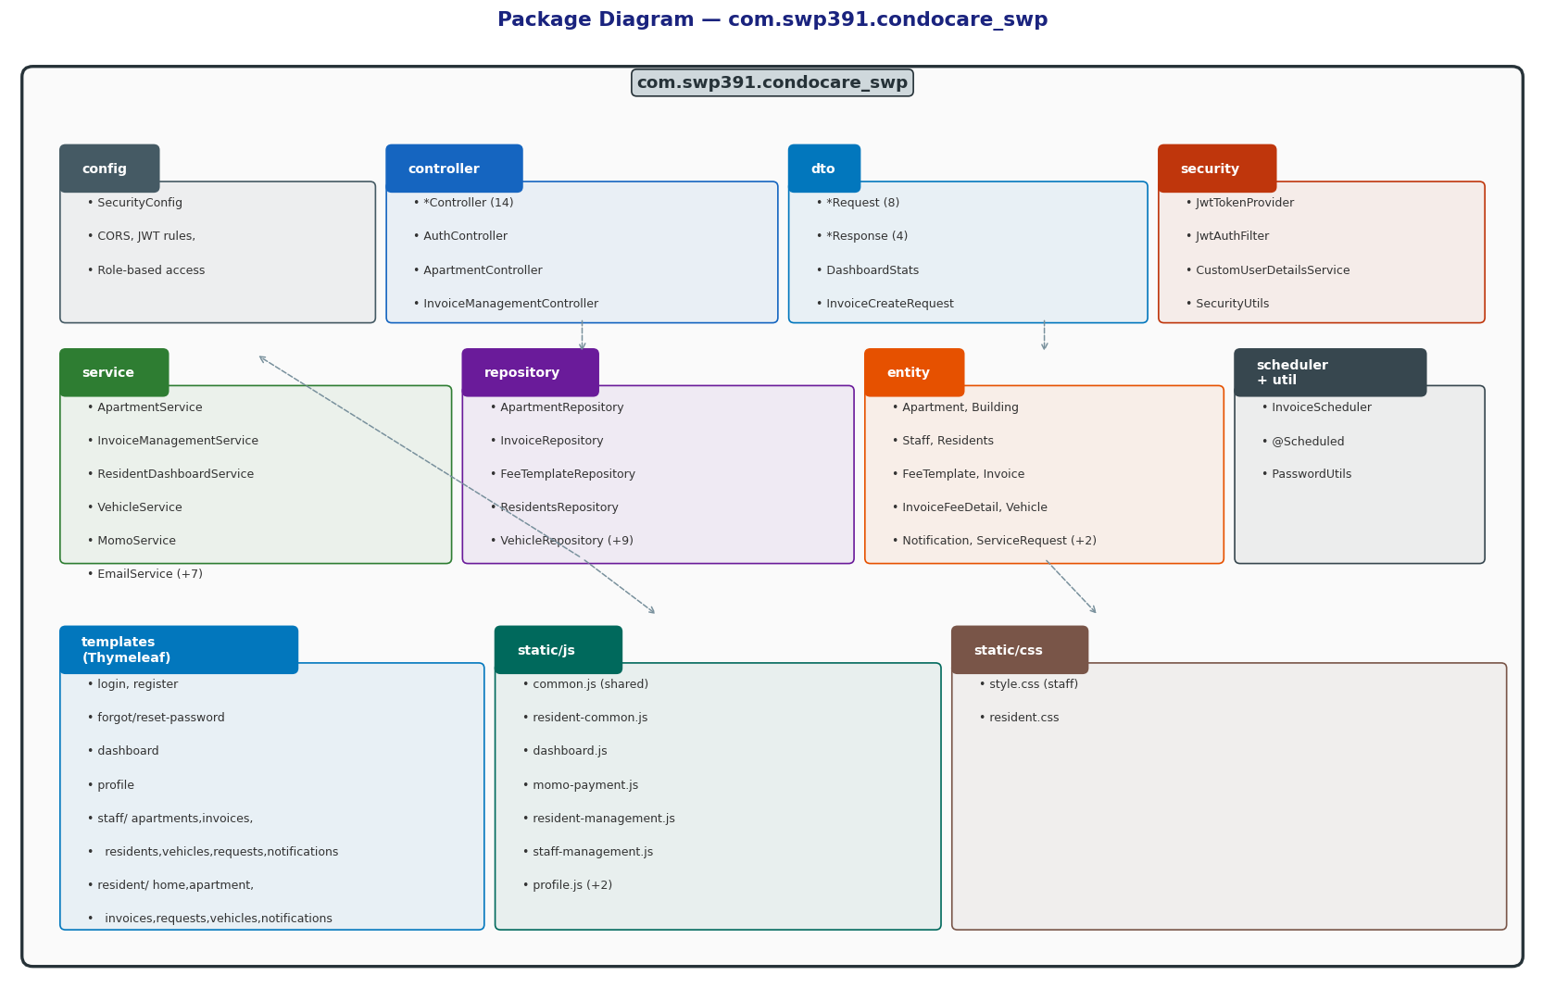
Figure 5. Package Diagram — com.swp391.condocare_swp

2.2 Package Descriptions
Package | Key Classes | Responsibility
config | SecurityConfig | Spring Security configuration, CORS, JWT filter registration, role-based access rules
controller | *Controller (14 files) | REST API endpoint handlers. Organized by feature: Auth, Profile, Dashboard, Apartment, Invoice, ServiceRequest, Vehicle, Notification, Resident, Momo
dto | *Request, *Response, DashboardStats | Data Transfer Objects for API input/output, decoupled from JPA entities
entity | *Entity (13 entity classes) | JPA entity classes mapping to database tables: Apartment, Building, Staff, Residents, FeeTemplate, Invoice, InvoiceFeeDetail, Vehicle, Notification, ServiceRequest, Payments, AccessCard, Role
repository | *Repository (14 interfaces) | Spring Data JPA interfaces with custom JPQL queries for filtering, aggregation, and status-based lookups
security | JwtTokenProvider, JwtAuthFilter, CustomUserDetailsService, SecurityUtils | JWT generation/validation, authentication filter, user loading, security context utility
service | *Service (13 classes) | Business logic: AuthService, NotificationService, InvoiceManagementService, StaffServiceRequestService, ResidentDashboardService, VehicleService, MomoService, EmailService, ApartmentService, ProfileService, StaffManagementService, ResidentManagementService, DashboardService
scheduler | InvoiceScheduler | Scheduled CRON task for automated invoice overdue detection and notification dispatch
util | PasswordUtils | Password strength validation utility

3. Database Design

3.1 Database Schema
Database: MySQL 8. Character set: utf8mb4_unicode_ci. 13 tables with foreign key constraints. All primary keys use string IDs (char(10) or varchar(15)) generated by the application layer. Key relationships:
- Building → (1:N) → Apartment → (1:N) → Residents
- Building → (1:N) → FeeTemplate
- Apartment → (1:N) → Invoice → (1:N) → InvoiceFeeDetail → Payments
- Residents → (1:N) → Vehicle, Notification, ServiceRequest, AccessCard
- Staff → (1:N) → Building (as manager), FeeTemplate (created_by), ServiceRequest (assigned_to)

3.2 Table Descriptions
Table | Key Columns | Description
Building | id, name, address, total_floors, total_apartments, manager_id | Stores condominium building information. manager_id references Staff responsible for the building.
Apartment | id, number, floor, area, building_id, status, rental_status, total_residents, total_vehicles, description | Individual apartment units. Status: EMPTY / OCCUPIED / MAINTENANCE. Rental: AVAILABLE / RENTED / OWNER_OCCUPIED.
Role | id, name, description | Lookup table for staff roles: ADMIN, MANAGER, ACCOUNTANT, TECHNICIAN, RECEPTIONIST.
Staff | id, username, password, full_name, email, phone, position, department, dob, gender, status, role_id, hired_at, last_login, created_at | Staff accounts. Password as BCrypt hash. Status: ACTIVE / RESIGNED / ON_LEAVE.
Residents | id, username, password, full_name, type, dob, gender, id_number, phone, email, status, apartment_id, verified_by, verified_at, last_login, created_at | Resident accounts. Type: OWNER/TENANT/GUEST. Status: PENDING/ACTIVE/INACTIVE.
FeeTemplate | id, building_id, name, type, amount, unit, min_area, max_area, effective_from, effective_to, status, created_by | Fee templates per building. Type: SERVICE/PARKING. Unit: PER_APT/PER_M2/FIXED. Area-range rules supported.
Invoice | id, apartment_id, month, year, total_amount, status, issued_at, due_date, paid_at, created_by, created_at | Monthly invoice per apartment. Unique (apartment_id, month, year). Status: UNPAID/PAID/OVERDUE.
invoice_fee_detail | id, invoice_id, fee_template_id, fee_name, fee_type, unit_amount, quantity, amount | Line items (snapshot) per invoice. Cascade-deleted with parent invoice.
Payments | id, invoice_id, amount, paid_at, method, momo_trans_id, momo_order_id, note, paid_by | Payment transactions from MoMo IPN. method=MOMO.
ServiceRequest | id, title, description, category, status, priority, resident_id, apartment_id, assigned_to, note, completion_image, resident_confirmed, confirmed_at, reject_reason, created_at, updated_at | Support request table. Status flow: PENDING → IN_PROGRESS → DONE/REJECTED/CANCELLED.
Vehicle | id, type, license_plate, brand, model, color, resident_id, apartment_id, duration_type, registered_at, expired_at, pending_status, approved_by, approved_at, reject_reason, status, revoked_at, created_at | Vehicle records. pending_status: PENDING/APPROVED/REJECTED. status: ACTIVE/INACTIVE/LOST/REVOKED.
Notification | id, title, content, type, resident_id, apartment_id, building_id, is_read, created_by, created_at | Notification records. created_by nullable (NULL=system-generated). Supports broadcast, apartment-level, and personal targeting.
access_cards | id, card_number, resident_id, issued_by, issued_at, expired_at, status | Physical access card records. status: ACTIVE/BLOCKED/LOST.

IV. Demonstration
This section provides a walkthrough of key CondoCare features as demonstrated during system testing. All features listed below have been implemented and verified against the requirements.

1. Authentication & Registration
ID | Feature | URL / Trigger | Description
D01 | Resident Registration | /register | Guest registers a new account by providing username, full name, phone, email, gender, and password. Account created with status = PENDING. A confirmation message is displayed.
D02 | Staff & Resident Login | /login | All users log in with username + password. JWT token issued. Staff → /dashboard; Resident → /resident. Role-based sidebar rendered automatically.
D03 | Forgot Password | /forgot-password → email → /reset-password | User enters registered email. System sends a reset link. User sets new password. Token expires after 15 minutes. Expired tokens are rejected.

2. Staff Dashboard Features
ID | Feature | URL / Trigger | Description
D04 | Dashboard Overview | /dashboard | Admin/Manager sees summary cards: total apartments, total residents, total staff, invoices by status (UNPAID/PAID/OVERDUE), pending service requests, and recent activity chart.
D05 | Building & Apartment Management | /dashboard/apartments | Admin/Manager creates buildings and apartment units. Tracks status (EMPTY/OCCUPIED/MAINTENANCE) and rental status. Configures fee templates with area-range rules. Views estimated monthly fee per apartment.
D06 | Resident Account Management | /dashboard/resident | Staff approves PENDING resident registrations (status → ACTIVE), assigns residents to apartments, deactivates accounts. Search and filter by name, status, apartment.
D07 | Invoice Creation | /dashboard/invoices | Accountant selects building and month/year. System auto-calculates fees from active FeeTemplates (PER_M2 × area, PER_APT flat, PARKING × vehicle count). Invoice created with line-item breakdown.
D08 | Service Request Management | /dashboard/service-requests | Manager assigns PENDING requests to Technicians. Technician marks DONE and uploads completion image. Residents notified at each step. Filter by status, category, priority.
D09 | Vehicle Registration Approval | /dashboard/vehicles | Receptionist reviews PENDING vehicle requests. Approves (auto-calculates expiry date by duration type) or rejects with reason. Resident receives notification.
D10 | Notification Broadcast | /dashboard/notifications | Manager sends broadcast notifications to all residents of a building, or targeted to a specific apartment or individual. View history of sent notifications.

3. Resident Portal Features
ID | Feature | URL / Trigger | Description
D11 | Resident Home Dashboard | /resident | Quick stats: unpaid invoice count, pending service requests, registered vehicles, latest notifications. Direct links to key actions.
D12 | Invoice View & MoMo Payment | /resident/invoices | Resident views all invoices with fee line-item breakdown. Clicks "Pay via MoMo" on UNPAID invoice. System redirects to MoMo payment page. After successful payment, status changes to PAID automatically via IPN.
D13 | Apartment Info & Active Fees | /resident/apartment | Resident views assigned apartment details, current active fee charges with monthly cost estimate (per QĐ 33/2025), registered vehicles, and access card information.
D14 | Service Request Lifecycle | /resident/requests | Resident submits requests, tracks status updates (PENDING → IN_PROGRESS → DONE), views completion images and notes, confirms completion, or cancels PENDING requests.
D15 | Vehicle Registration | /resident/vehicles | Resident registers vehicle (type, license plate, duration). Views registration status (PENDING/APPROVED/REJECTED) with calculated expiry date for approved vehicles.

4. Automated Background Functions
ID | Feature | URL / Trigger | Description
D16 | Invoice Overdue Detection | Scheduled CRON (00:30 daily) | Every day at 00:30, all UNPAID invoices past their due date are marked OVERDUE. In-app notification and email sent to all ACTIVE residents of affected apartments.
D17 | MoMo IPN Processing | POST /api/momo/ipn | After resident pays via MoMo, the MoMo server sends IPN callback. System verifies HMAC-SHA256 signature and updates invoice to PAID without any user action.
D18 | System Notifications | Automated (various triggers) | Notifications with system sender ("Hệ thống") are auto-created for: account approval, access card issuance, invoice overdue, service request status changes, vehicle approval/rejection.

V. Appendix

1. Assumptions & Dependencies
- The system assumes a single condominium complex with one or more buildings managed under one deployment instance.
- MoMo payment integration requires valid Partner credentials (partnerCode, accessKey, secretKey) configured in application.properties.
- Email sending requires a valid Gmail account with App Password configured for SMTP access.
- All dates and times are stored in server local time (Vietnam, UTC+7).
- JWT token expiry is 24 hours. Refresh token mechanism is not implemented; users must re-login after expiry.
- The system does not support multi-language. All UI and business messages are in Vietnamese.
- Fee management follows Quyết định 33/2025/QĐ-UBND Hà Nội (effective 01/05/2025): elevator buildings 1,200–16,500 đ/m²/month, non-elevator 700–5,000 đ/m²/month.

2. Limitations & Exclusions
- No mobile native application — web-only (responsive design for mobile browser use).
- No real-time WebSocket notifications — residents must refresh the page to see new notifications.
- Report/export features (PDF, Excel) are not included in the current version.
- Access card NFC/RFID hardware integration is not in scope — only digital record management.
- Multi-tenancy (multiple companies managing separate building clusters) is not supported.

3. Business Rules
- An invoice is unique per (apartment, month, year) — duplicate invoice creation is rejected.
- A service request can only be CANCELLED by the resident while status = PENDING.
- A service request can only be DONE by a Technician or Manager/Admin assigned to it (Technician: only their own; Manager/Admin: any).
- Vehicle registration can only be approved by Admin, Manager, or Receptionist. Approval auto-calculates expiry.
- Invoice status changes UNPAID → PAID only via MoMo IPN callback or manual Admin/Manager action. Residents cannot self-mark as PAID.
- Notifications with created_by = NULL are system-generated and displayed as "Hệ thống".
- Staff TECHNICIAN role can only view and act on service requests assigned to them.
- Resident accounts must be ACTIVE before they can access any portal features.
- Fee templates with min_area/max_area are only applied to apartments with area in [min_area, max_area].

4. Recommended External Tools for Diagrams
For creating/editing professional diagrams similar to those in this document, the following tools are recommended:
Tool | Best For | URL / Notes
draw.io (diagrams.net) | System context, architecture, flowcharts, UML. Free, web-based and desktop. | https://app.diagrams.net — exports to PNG, SVG, XML
PlantUML | Use case, sequence, package, component diagrams from text/code. IDE plugins available. | https://plantuml.com — integrates with VS Code, IntelliJ
Lucidchart | UML use case, BPMN process flows, ER diagrams. Collaborative, cloud-based. | https://lucidchart.com — Google Drive integration
Figma | Screens flow mockups, wireframes, UI navigation maps. Free tier available. | https://figma.com — best for UI/UX flows
StarUML | Full UML suite: class, package, component, deployment diagrams. | https://staruml.io — desktop application

