Table of Contents

What is the Unix operating system? 2

How is linux used in smartphones, servers, supercomputers, and embedded systems? 3

Distros: Ubuntu, Debian, and Red Hat 4

What are the basic concepts of a Linux operating system? 5

What are Unix executable files? 9

What are binary executables? 10

What is the structure of a command? 10

Combining Commands 13

What is #!/bin/bash? 14

Why is #!/bin/bash needed? 14

Why do I need to run chmod +x file-name.sh to make it run? 14

What are the Linux operators? 15

# What is the Unix operating system?

Unix is a family of multi-tasking, multi-user computer operating systems originally developed in the 1970s by AT&T Bell Labs. Unix was designed to be portable, meaning it could run on different types of hardware from different vendors, and to be highly customizable.

Unix introduced many innovative concepts that have since become standard features of modern operating systems, including the file system hierarchy, the use of a shell for command-line interaction, and the idea of small, single-purpose utilities that can be combined to perform complex tasks.

Over time, Unix evolved into different versions, including commercial versions such as SunOS, HP-UX, and AIX, as well as free and open-source versions such as FreeBSD, OpenBSD, and NetBSD.

Today, Unix is still used in many applications, particularly in the enterprise and server markets. It has influenced the development of many other operating systems, including Linux and macOS, and its concepts and ideas continue to shape the way that we interact with computers and other digital devices.

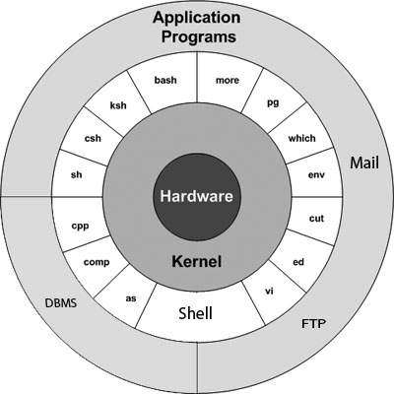

https://www.tutorialspoint.com/unix/unix-getting-started.htm

# How is linux used in smartphones, servers, supercomputers, and embedded systems?

Linux is a versatile operating system that can be used in a wide range of applications. Here are some examples of how Linux is used in different types of systems:

* Smartphones: Linux is used as the operating system in many smartphones, particularly those based on the Android platform. Android is a modified version of Linux that is designed for use on mobile devices.
* Servers: Linux is a popular choice for server operating systems, particularly in enterprise and cloud computing environments. Linux-based servers are known for their stability, security, and flexibility.
* Supercomputers: Linux is widely used in supercomputing clusters due to its scalability and high-performance capabilities. Some of the world's fastest supercomputers, such as the Tianhe-2 in China, run Linux.
* Embedded Systems: Linux is often used in embedded systems, which are computer systems that are integrated into other devices such as cars, appliances, and industrial machinery. Linux's flexibility and open-source nature make it well-suited for use in embedded systems.

In each of these applications, Linux provides a reliable and customizable operating system that can be tailored to meet the specific needs of the system. Its open-source nature allows developers to modify and enhance the system to improve performance, security, and functionality.

# Distros: Ubuntu, Debian, and Red Hat

Ubuntu, Debian, and Red Hat are all popular distributions (distros) of the Linux operating system. Each has its own unique characteristics, but they share many common features.

1. Ubuntu: Ubuntu is a free and open-source distribution of Linux that is based on Debian. It is designed to be easy to use and user-friendly, making it a popular choice for desktop and laptop computers. Ubuntu is known for its regular releases, which include the latest software updates and security patches.
2. Debian: Debian is one of the oldest and most popular distributions of Linux. It is known for its stability and security, making it a popular choice for servers and other mission-critical systems. Debian also has a large and active community of developers who maintain and update the software packages that make up the distribution.
3. Red Hat: Red Hat is a commercial distribution of Linux that is popular in enterprise environments. It is known for its stability, security, and support, and is often used in mission-critical applications. Red Hat is backed by a large company (Red Hat Inc.), which provides support and services to customers.

All three distributions share a common ancestry, as they are all based on the original Unix operating system and are developed as open-source software. They also share many common features, such as the use of the Linux kernel, the Bash shell, and the GNU utilities. However, they differ in their package management systems, release schedules, and target audiences.

https://distrowatch.com/dwres.php?resource=family-tree

# What are the basic concepts of a Linux operating system?

The basic concepts of a Linux operating system include:

1. Kernel: The kernel is the core component of the Linux operating system that manages the system's resources, such as the CPU, memory, and input/output devices.
2. Shell: The shell is a command-line interface that allows users to interact with the operating system. It interprets user commands and executes them.
3. File System: The file system is the way that Linux organizes and stores files and directories. Linux uses a hierarchical file system with a root directory (/) at the top.
4. Processes: A process is a running instance of a program. Linux can run multiple processes simultaneously, and each process has its own unique identifier (PID).
5. Users and Groups: Linux is a multi-user operating system, which means that multiple users can use the system at the same time. Each user has their own account, which provides access to the system's resources. Users can be organized into groups, which allows for easier management of permissions and access control.
6. Permissions: Linux has a sophisticated system of permissions that determines who can access files and directories, and what actions they can perform on them. Each file and directory has an owner and a group, and there are three levels of permissions: read, write, and execute.
7. Services and Daemons: Linux can run background processes known as daemons, which provide services such as web servers, email servers, and database servers.

Understanding these basic concepts is essential for using and administering a Linux system. They provide a foundation for working with the command line interface, managing files and directories, controlling access to system resources, and configuring services and daemons.

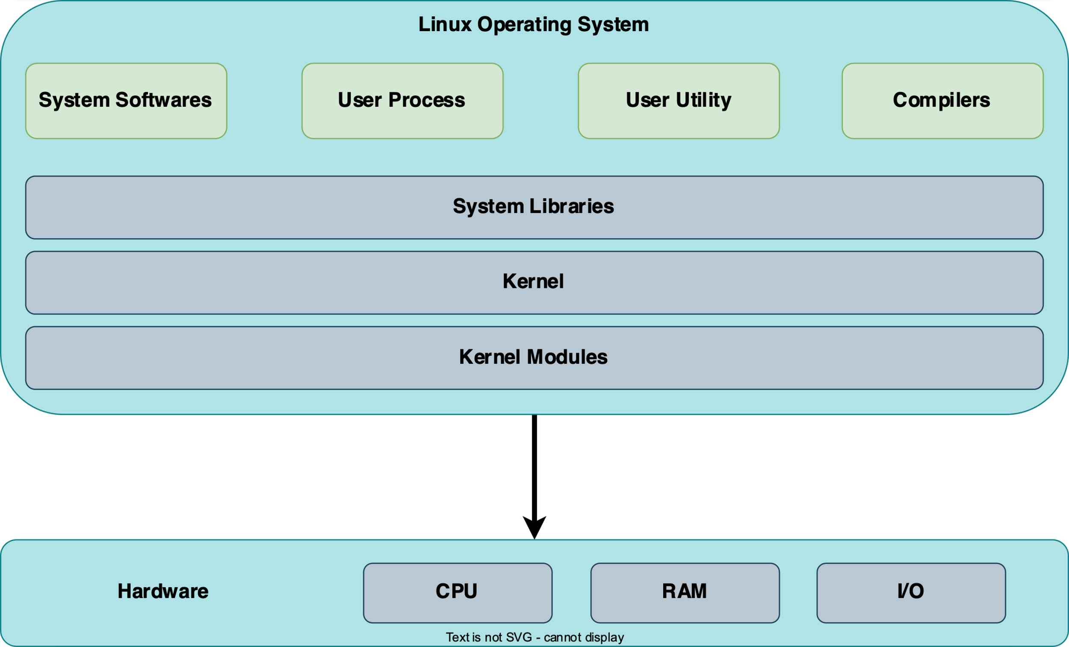

Here's what each directory represents:

* /bin: contains essential command binaries that are needed by all users (e.g. ls, cp, rm, etc.)
* /boot: contains files used during the boot process, such as the kernel and bootloader configuration files
* /dev: contains device files that represent hardware devices (e.g. hard drives, USB devices, etc.)
* /etc: contains system-wide configuration files
* /home: contains the home directories for regular users
* /lib: contains shared library files that are used by the system and applications
* /media: contains mount points for removable media devices (e.g. CD-ROMs, USB drives, etc.)
* /mnt: contains mount points for file systems that are mounted temporarily
* /opt: contains optional software packages that are not installed by default
* /proc: contains a virtual file system that provides information about running processes and system resources
* /root: the home directory for the root user
* /run: contains run-time variable data for the system and applications
* /sbin: contains essential system binaries that are needed by the system administrator (e.g. fdisk, mount, ifconfig, etc.)
* /srv: contains data for services provided by the system (e.g. HTTP server, FTP server, etc.)
* /sys: contains a virtual file system that provides information about the system's hardware devices
* /tmp: contains temporary files that are created by the system and applications
* /usr: contains the majority of the system's non-essential files, including executables, libraries, documentation, etc.
* /var: contains variable data that changes frequently, including log files, mail files, spool files, etc.

This file system hierarchy is just an example, and different distributions of Linux may have slightly different layouts. However, the basic principles and directory structures are similar across most Linux systems.

https://www.geeksforgeeks.org/linux-file-hierarchy-structure/

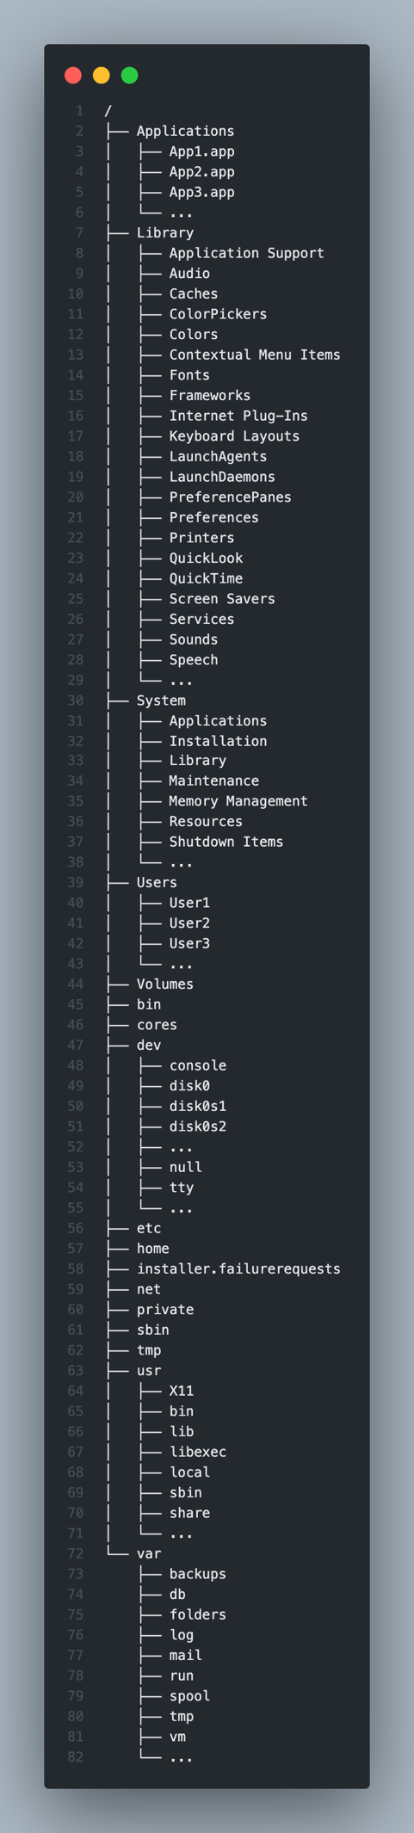

Here's a brief explanation of each directory in the macOS file system hierarchy:

* /: The root directory of the file system hierarchy.
* /Applications: Contains applications that are installed on the system.
* /Library: Contains system-wide libraries and files used by applications and the operating system.
* /System: Contains system-level files and libraries used by the operating system.
* /Users: Contains the home directories of all user accounts on the system.
* /Volumes: Contains mounted volumes, such as external hard drives and disk images.
* /bin: Contains essential command-line utilities that are required for system maintenance.
* /dev: Contains device files that represent hardware devices on the system.
* /etc: Contains configuration files for the operating system and installed applications.
* /private: Contains system-level files and directories that are hidden from regular users.
* /sbin: Contains system-level command-line utilities that are required for system maintenance.
* /tmp: Contains temporary files created by applications and the system.
* /usr: Contains user-level programs, libraries, documentation, and other files.
* /var: Contains variable files that change frequently, such as log files and spool directories.

Note that this is just a high-level overview of the directories in the macOS file system hierarchy, and there are many subdirectories and files within each directory that serve specific purposes.

# What are Unix executable files?

Unix executable files, also known as binary files, are files that contain machine code that can be executed directly by the Unix operating system. They are typically compiled from high-level programming languages such as C or C++, and can be used to perform a wide range of tasks on a Unix system.

When an executable file is run, the Unix kernel reads the file from disk and loads it into memory, where it can be executed. Executable files can be run by any user who has permission to do so, and can perform a wide variety of tasks, from simple command-line utilities to complex graphical applications.

Executable files are an important part of the Unix ecosystem, as they enable developers to create powerful, efficient, and portable software that can run on a wide variety of Unix-based systems. They are also used extensively by system administrators to automate tasks and manage system resources.

In order to create an executable file, developers typically write their code in a high-level programming language, such as C or C++, and then use a compiler to translate the code into machine code that can be executed directly by the Unix operating system. The resulting binary file can then be distributed and run on any Unix system that supports the same architecture and operating system version.

## What are binary executables?

Binary executables are files that contain machine code that can be executed directly by a computer's operating system. They are typically compiled from high-level programming languages like C, C++, or Java, using a compiler that translates the source code into machine code that the computer can understand and execute.

Binary executables can take many forms, including:

* Standalone programs: These are executable files that can be run independently of any other software. Examples include text editors, media players, and web browsers.
* Libraries: These are collections of pre-compiled code that can be linked to other programs at compile time or runtime. They are often used to provide common functionality to multiple programs, such as networking, graphics, or database access.
* Plugins: These are executable modules that can be loaded into other programs to extend their functionality. Examples include browser plugins that add support for specific media formats or web technologies.
* Drivers: These are executable files that provide low-level access to hardware devices, such as printers, network cards, or graphics cards.

Binary executables are an essential part of modern computing, as they allow developers to create efficient, portable, and powerful software that can run on a wide range of systems. However, they also pose security risks, as malicious actors can use them to distribute viruses, trojans, and other malware. As a result, it is important to only run binary executables from trusted sources and to use anti-virus software to protect your system.

# What is the structure of a command?

In Linux, a command typically has the following structure:

command [options] [arguments]

* command: The name of the command you want to execute.
* [options]: Optional flags or switches that modify the behavior of the command. These typically begin with a single dash (-) or a double dash (--), and can be combined into a single string. For example, the ls command has an option -l that displays output in long format, and an option -a that shows hidden files. You can use these options individually (ls -l or ls -a) or together (ls -la).
* [arguments]: Additional data that the command needs to perform its function. These can be filenames, directories, search terms, or any other type of input that the command requires. For example, the cp command requires two arguments: the source file or directory, and the destination file or directory.

Here's an example of how you might use these components to execute the ls command:

bash

ls -l /home/user/Documents

In this example, ls is the command, -l is an option that tells ls to display output in long format, and /home/user/Documents is an argument that specifies the directory you want to list.

By combining commands, options, and arguments, you can perform a wide range of tasks in Linux, from simple file management to complex system administration.

Here are 10 basic Linux commands, along with some common options and arguments:

1. ls: Lists the contents of a directory.
   * -l: Shows output in long format.
   * -a: Shows hidden files and directories.
   * Example: ls -la /home/user
2. cd: Changes the current working directory.
   * directory: Specifies the directory you want to change to.
   * Example: cd /var/log
3. mkdir: Creates a new directory.
   * directory: Specifies the name of the directory you want to create.
   * Example: mkdir new_directory
4. rm: Removes a file or directory.
   * -r: Removes a directory and its contents recursively.
   * -f: Forces the removal of files without prompting for confirmation.
   * Example: rm -rf old_directory
5. cp: Copies a file or directory.
   * -r: Copies a directory and its contents recursively.
   * Example: cp -r /home/user/docs /home/user/backups
6. mv: Moves or renames a file or directory.
   * source: Specifies the source file or directory.
   * destination: Specifies the destination file or directory.
   * Example: mv old_name new_name
7. touch: Creates a new empty file.
   * Example: touch new_file.txt
8. cat: Displays the contents of a file.
   * Example: cat file.txt
9. grep: Searches for a pattern in a file or output.
   * -i: Ignores case sensitivity.
   * -r: Searches recursively in subdirectories.
   * Example: grep -i "error" /var/log/syslog
10. sudo: Executes a command with superuser privileges.
    * Example: sudo apt-get update

Note that this is just a small sampling of the many commands, options, and arguments available in Linux. I encourage you to explore further and experiment with different commands to learn more about how they work.

ls: Lists the contents of the current directory.

cd: Changes the current working directory.

pwd: Displays the current working directory.

mkdir: Creates a new directory.

rmdir: Removes an empty directory.

cp: Copies a file or directory.

mv: Moves or renames a file or directory.

rm: Removes a file or directory.

touch: Creates a new empty file.

cat: Displays the contents of a file.

less: Displays the contents of a file one page at a time.

head: Displays the first few lines of a file.

tail: Displays the last few lines of a file.

grep: Searches for a pattern in a file.

find: Searches for files and directories that match specified criteria.

man: Displays the manual page for a command.

whoami: Displays the current user.

sudo: Executes a command with superuser privileges.

chown: Changes the owner of a file or directory.

chmod: Changes the permissions of a file or directory.

tar: Archives files and directories into a compressed file.

gzip: Compresses a file.

gunzip: Decompresses a file.

wget: Downloads files from the internet.

curl: Sends HTTP requests and displays responses.

ps: Displays information about running processes.

kill: Terminates a process.

clear: Clears the terminal screen.

date: Displays the current date and time.

echo: Prints a message to the terminal.

These commands are simple and easy to use, and can help you get started with everyday tasks in Linux. As you become more comfortable with the command line, you can start to explore more advanced commands and techniques.

## Combining Commands

Combining commands in Linux can be a powerful way to save time and perform complex tasks with ease. Here are some tips on how to effectively combine commands:

1. Use pipes (|) to pass output from one command as input to another command. For example, you can use the grep command to search for a pattern in a file, and then pipe the output to the sort command to sort the results alphabetically.
2. Use command substitution ($(...)) to insert the output of a command into another command. For example, you can use the date command to get the current date and time, and then use command substitution to insert the result into a filename when creating a new file.
3. Use semicolons (;) to execute multiple commands in a single line. For example, you can use the cd command to change to a directory, and then use the ls command to list the contents of that directory, all in a single line.
4. Use backticks or grave accents ()) to execute a command and use its output as an argument to another command. For example, you can use the echo command to print the output of a command, and then use backticks to execute a command and insert its output into the echo command.
5. Use command chaining (&& and ||) to execute commands conditionally based on the success or failure of previous commands. For example, you can use the grep command to search for a pattern in a file, and then use command chaining to execute a second command only if the first command succeeds.

Remember to always test your command combinations before using them in production, and to be careful when using commands that can modify or delete files or directories. With practice and experimentation, you can become more comfortable with combining commands and using the full power of the Linux command line.

# What is #!/bin/bash?

#!/bin/bash is called a shebang or a hashbang. It is a special sequence of characters that appears on the first line of a shell script and is used to specify the interpreter that should be used to run the script. In this case, #!/bin/bash specifies that the Bash shell should be used to execute the commands in the script.

When the script is run, the operating system reads the shebang line and uses the interpreter specified in the line to execute the commands in the script. In other words, it tells the shell which program to use to interpret and execute the script.

Note that the shebang is not specific to Bash; it can be used to specify any interpreter. For example, #!/usr/bin/python would specify that the Python interpreter should be used to run the script.

## Why is #!/bin/bash needed?

The #!/bin/bash shebang is needed in a Bash script because it specifies the path to the Bash interpreter, which is the program that will be used to execute the script.

When you run a script, the operating system needs to know which interpreter to use to execute the commands in the script. The shebang line tells the operating system which interpreter to use. In this case, #!/bin/bash specifies that the Bash shell should be used to execute the commands in the script.

Without the shebang line, the operating system would not know which interpreter to use and would not be able to run the script.

In summary, the #!/bin/bash shebang is necessary to specify the interpreter for a Bash script and to enable the operating system to run the script properly.

## Why do I need to run chmod +x file-name.sh to make it run?

You need to run chmod +x file-name.sh to make a Bash script executable.

The chmod command is used to change the permissions of a file or directory. In this case, the +x option is used to add executable permission to the script.

By default, when you create a new file in Linux, it does not have the executable permission. This means that you cannot run the file as a program.

When you run chmod +x file-name.sh, you are giving the file permission to be executed as a program. This makes it possible to run the script by typing ./file-name.sh in the terminal.

Note that the ./ in front of the filename is necessary to specify that the file should be executed from the current directory. Without it, the terminal may not be able to find the file and execute it properly.

# What are the Linux operators?

In Linux, operators are special symbols or characters that are used to perform various operations or tasks on the command line. Here are some common operators used in Linux:

1. | (pipe) - Used to redirect the output of one command to the input of another command.
2. > (redirect) - Used to redirect the output of a command to a file. This will overwrite any existing data in the file.
3. >> (append) - Used to append the output of a command to a file.
4. ; (semicolon) - Used to separate multiple commands on the same line.
5. && (and) - Used to execute the second command only if the first command was successful.
6. || (or) - Used to execute the second command only if the first command was unsuccessful.
7. * (wildcard) - Used to match any character or group of characters in a file or directory name.
8. ? (question mark) - Used to match a single character in a file or directory name.
9. [] (brackets) - Used to match a range of characters in a file or directory name.
10. () (parentheses) - Used to group commands together and execute them as a single unit.

These are just a few examples of the many operators available in Linux.