**Basics**

Three types of multiplications

Vector-vector multiplication

* Inner product = dot product. Result is scalar
* Outer product results in matrix. Why is it useful?

Matrix-vector multiplication

A (m x n) x(n x 1) = vector (m x1)

Matrix-matrix multiplication

A (m x n) x B (n x p) = C (m x p)

**Symmetric** AT =A has important properties: their Eigen values are real and their eigenvectors are orthogonal

**Matrix trace** Sum of all elements in the diagonal of matrix. Only defined for square nxn matrix. It is used to [measure complexity](https://www.quora.com/What-is-a-trace-as-in-trace-of-a-matrix-and-why-is-it-used) of any linear machine learning model 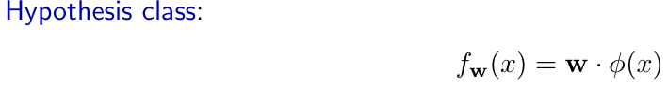

**Gradient** is a subset of a jacobian. The gradient is a vector field (a tangent vector at each pont).



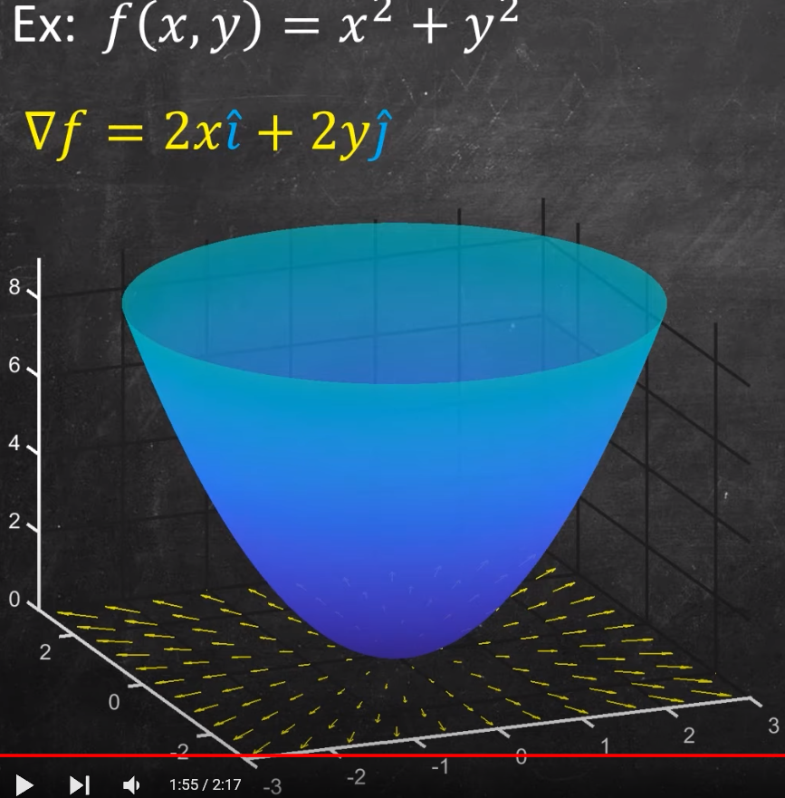

**Calculus**

Chain rule

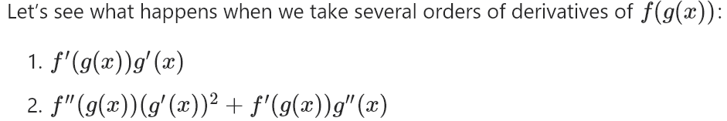

**Chain rule in vector form[1]**

Dot product between gradient of v and vector derivative v. Interpret as the directional derivative

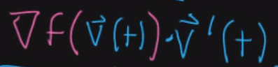

When to use nabla? <https://www.youtube.com/watch?v=m2mW2FQJgEE>

Hessian

Positive Definite Hessian = Local Minimum

Negative Definite Hessian = Local Maximum

Indefinite Hessian = Saddle point

Other definiteness = Test is inconclusive

1. <https://www.youtube.com/watch?v=qZlBjnC3iro>