CS 2033
Multimedia and Communications

Lab 01: Learning how to transfer files between your Computer and a Server
- File Transfer and Website “Publishing” -

REMEMBER TO BRING YOUR MEMORY STICK TO EVERY LAB!

INTRODUCTION TO THE COMPUTING ENVIRONMENT:

You will either be doing the labs for this course in MC Room 230 or in North Campus Building Room 105b. You will use your UWO User ID for BOTH of these labs BUT the password is different depending which room you working in. If you are doing your lab in NCB 105b you will be using your regular UWO password BUT if you are doing your lab in MC230 you will be using a password for the GAUL network that was emailed to you at the beginning of term from the Computer Science Department.

PLEASE NOTE: even if you are doing your labs in NCB105b, do NOT delete the email send to from the Computer Science with the GAUL password as you may want to use lab MC230 when this room is free to work on your assignments and for this room you will ALWAYS need to use the GAUL password.

A computer network is a group of computers that are connected to each other. In this course, you will be using two different computer networks: GAUL and UWO. Accessing a computer on one of these networks requires two things:

- User ID
- Password

Each of these networks will have the same username (everything before the @uwo.ca in your email address), but the passwords will be different. Read below for an overview of each network, and details on how to get your passwords – you need this information to complete the labs!

GAUL

The computers found in some of the lab room (MC-230) are connected to the Computer Science Department’s network, and the network itself called GAUL. These computers contain all the software that you will use in this course, and the rooms themselves are accessed by swiping your student cards in the doorway. These computer labs are accessible 24 hours a day (when the lab room is not in use for course instruction), and after hours access to Middlesex College is available by swiping your student card at the North entrance to Middlesex College (the door closest to the Western Science building).

To access these computers, you must login using the GAUL username and password that was sent to your @uwo.ca e-mail when you registered for this course. If you did not receive an e-mail, wait till 2 weeks after the last add date (use the dummy account for this lab and next lab) and then if at the beginning of lab 3, you have still not received the email with your GAUL password, go to the I/O Counter on the 3rd floor in Middlesex College and ask for Bruce Richards; he will assist you in this matter. For further help, please consult your TA.

ITS/UWO/”Panther”

The second network that we will be using is the UWO network, which is the general network used by all students in the University and maintained by ITS (ITS is located in Support Services building on Western Road, near Huron College). This network is connected to all library computers and the General Computing labs (“Genlabs”) scattered throughout the University. The username and password for this network is the same as what you use to check your @uwo.ca e-mail account. For this course, you can also use the machines in the North Campus Building Genlab located in NCB 105. This lab contains all the software we need for this course.

INTRODUCTION TO FTP:

FTP (File transfer protocol) enables a user to transfer files between his/her local computer (the computer you are sitting working at) and a remote server. Some terminology:
  - hosting – placing website files on a computer that is set up to allow access to those files from the Internet
  - server – a computer that is set up to host websites. In this course, we will be hosting our websites on a server in ITS called “panther”
  - downloading - copying files from a remote server (such as ‘panther’) to the local PC computer (the computer you are using right now)
  - uploading - copying files from the local PC to the remote server
A common use for an ftp (file transfer protocol) package is to obtain files from archive sites, which are servers used to store files. A wide variety of files are available from these sites - applications, games, utilities, documentation - some of which include audio, video, and/or graphics. Western is now using WinSCP to allow students to perform ftp operations.

- “How To” documents on WinSCP available at: http://winscp.net/eng/docs/faq
- WinSCP Software can be obtained from: http://www.uwo.ca/its/sitelicense/WinSCP/index.html

FTP allows you to move files (such as .jpg files or .html files) between the machine you are sitting at and working on (your local machine) and the web server (we will be using a web server called panther.uwo.ca)
Your local machine
panther.uwo.ca
Upload
Download

GETTING STARTED AND CREATING A “Publish Area” ON THE SERVER PANTHER:
It creates a folder that will hold the items you want to put on the World Wide Web.
THIS STEP ONLY NEEDS TO BE DONE ONCE.

- Make sure all your passwords are in sync by open an Internet browser going to the following site: http://idm.uwo.ca and go to the profile tab, click on sync password and click on the sync button.

- If you are in MC230 over the next 13 weeks and you have any problems such as the monitor flickering, the software not working, the internet not working, please report it at this site: http://www.csd.uwo.ca/prob_report.html

- If you are in NCB105b over the next 13 weeks and have any problems such as the monitor flickering, the software not working, the internet not working, please report it to ITS at this site: http://www.uwo.ca/its/about-its/contact.html

- Start the browser → Internet Explorer and go to the following website: http://www.uwo.ca/its/accounting/ActivatePublish.html You should then see this:
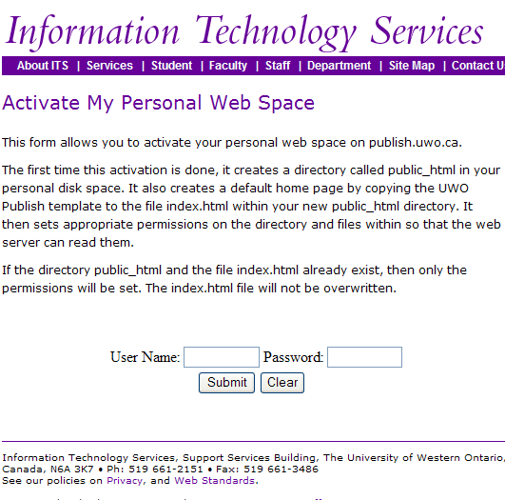
- Enter your UWO username/user id and your UWO password and hit the Submit button. In a few minutes a special area (really just a folder) will be created. Anything contained in this folder will now appear on the World Wide Web. Thus you can put files into this folder and then see them using IE or Firefox. The name of this folder will be public_html

UNDERSTANDING HOW TO REFER TO (ACCESS) YOUR MEMORY STICK (IT WILL LIKELY BE CALLED THE F: DRIVE):

NOTE: For the remaining labs in CS2033 remember that folder and directory mean the same thing. Because the set up in MC230 is slightly differ than the set up in NCB105, we have to do a bit of setup so that your memory stick is pointing to the same place in both lab rooms. Normally the memory stick will map to the F: drive, so this lab will ALWAYS refer to the F: drive but just in case, perform the steps below to figure out which drive your memory stick was mapped to. Then we will save everything to the F: drive (i.e. your stick)

- Put your memory stick into the USB slot

- Open up the Explorer Window (Simply, just click on Computer from the Start menu, two columns will appear about the Start menu. Computer will be in the right column above the Shutdown button).
- Look and see which drive your memory stick was mapped to. It will likely be under an area labeled “Devices with removable storage”. Make sure you remember the drive letter and substitute it every time you see F: if your memory stick was mapped to a different drive. It will look like this:
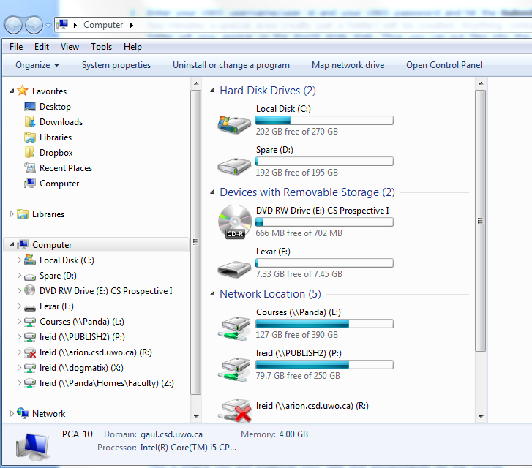
- Double click on the F:\ drive (memory stick) to get into this area.
- Once you have gone into your F:\ drive, create a folder(i.e. directory) called cs2033.
This is where you will organize your labs and assignments for the course.

LOADING THE LAB 1 FILES ONTO YOUR MEMORY STICK:

This is where the instructors provide you with the material needed to complete the labs. For each lab we will place files containing images, documents, video clips, etc that you will need to complete the lab a server. You will need to move them from the server (called publish.gaul.csd.uwo.ca) to your F: drive in the cs2033 folder (directory) every week for each lab.

- On your memory stick, create a folder called cs2033 (it will likely be put on the F: drive)
- Move to the cs2033 folder and create a folder called lab01.
NOTE: it is VERY important you name your files and folders carefully and use the exact same spelling and exact same case (usually make every file/folder name lowercase with no spaces in the folder name or file names
- Move to the cs2033/lab01 folder and create a file called images
- Move to the cs2033/lab01/images folder.
- Using IE or Firefox open the following website: http://www.csd.uwo.ca/courses/CS2033/labs/lab01/

- Right click on the file called middlesexcollege.jpg and select Save target as…(or Save picture as…) and save this file to the folder on your memory stick called cs2033/lab01/images
- Right click on the file called thegradclub.jpg and select Save target as… (or Save picture as…)and save this file to the folder on your memory stick called cs2033/lab01/images
- Using IE or Firefox, open the following website: http://www.csd.uwo.ca/courses/CS2033/labs/lab01/
- Right click on the file called: picturepage.html and save it to your memory stick to the folder called cs2033/lab01
- Right click on the file called: lab01.doc and save it to your memory stick to the folder called cs2033/lab01
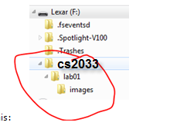
- Right click on the file called: lab01.pdf and save it to your memory stick to the folder called cs2033/lab01
- You memory stick should now look sort of like this:

WORKING ON PANTHER:

We are now going to learn how to use WinSCP to work with panther (the remote server that will store your completed webpages). The next few pages will describe the essential parts:
Connecting with WinSCP and Creating a Folder
Since panther is a remote server, you must use a FTP program such as WinSCP (or Fugu for Mac users) to connect and move files onto panther. Above, by doing the “Activate my Personal Web Site, you created a “publish area” – this is where you will put a copy of your completed websites/files/assignment work so that they are viewable on the Internet (in other words, “publishing” your websites).

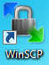
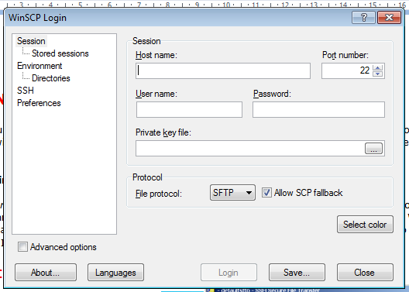
Connecting with WinSCP and Creating a Folder:
- Open WinSCP click on this icon →
and select the Quick Connect button. You will then see the screen to the right.
  - Enter panther.uwo.ca in the Host Name: box
  - Enter your UWO userid in the User name: box
  - Enter your UWO password in the Password: box
  - Make sure the Port Number: is 22
  - Click on the Login button

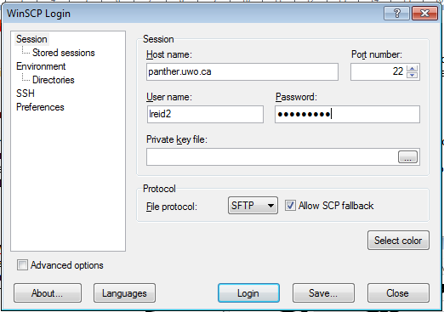
- Your screen should look similar to this:

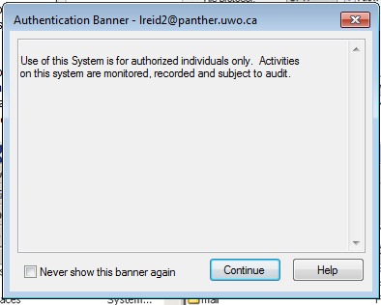
- You may then see this window, just click on Continue

- You will then see something like this window with a folder called public_html on the right side: (Note that your own computer files are on the left side panel. We call this the Local Side. In the right panel is the panther server files and we call this the Remote side. Some files stored on the remote side can be viewed on the Internet)

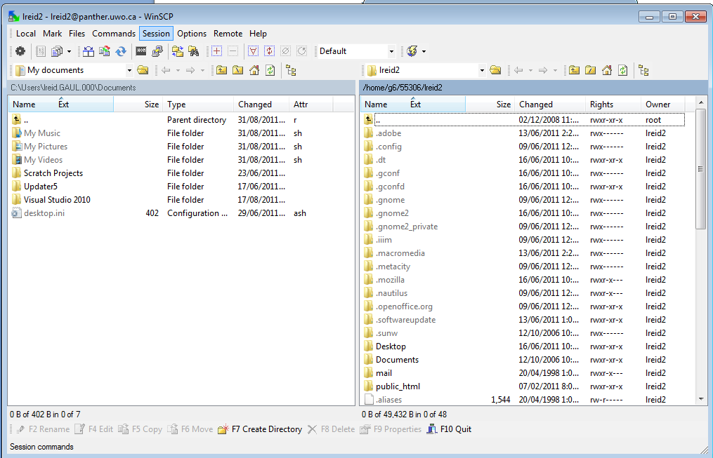

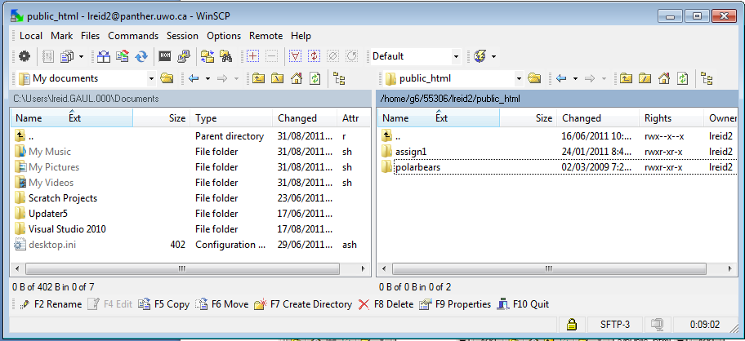
- Once you see your remote files on File Transfer window, double-click the public_html folder (This is your directory called your “publish area”). Note: your public_html folder (directory) might contain other things as well – ignore these for now.

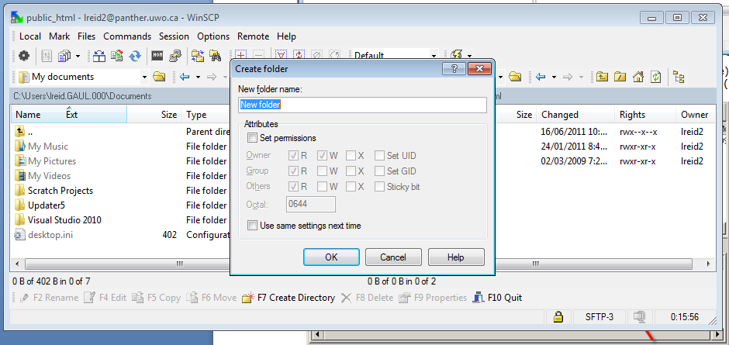
- Make sure you have clicked on the right side panel (the bar will be a darker blue), then click on the F7 Create Directory button (or just press F7) and create a new directory (folder). You should then see this screen:

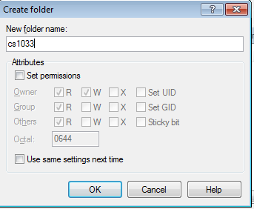
- Type cs2033 for the name of the new folder ALL IN LOWER-CASE AND WITH NO SPACES.

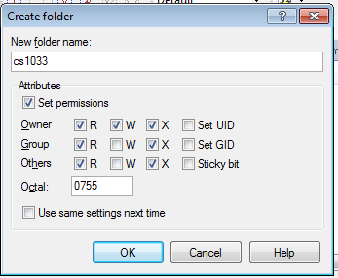
- Click on the Set Permissions box just under attributes and make sure your permissions checkboxes are identical to this →
The Octal box should say 0755
IT IS IMPORTANT TO KNOW THAT ANYTIME YOU CREATE A FOLDER IT MUST HAVE PERMISSIONS OF 0755, otherwise your files inside this folder will not be viewable from the Internet. If you try to view it from the browser you would get an error message saying “You are not authorized to view this page”

- You are now going to upload (transfer) files from your local computer to the Remote side (panther server).
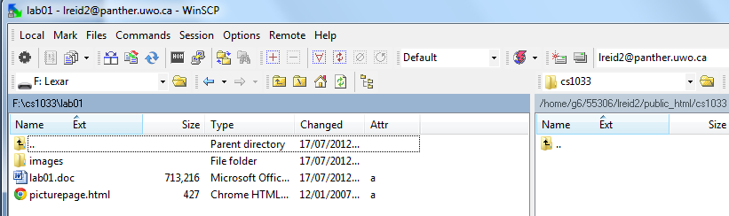
Double click on the cs2033 folder in the right hand panel that you just created so that you are positioned IN the folder. Move your mouse over to the drop down box in the left hand panel near the top of the screen, click on the drop down button and select the memory stick (the F: drive). Then on this left side, find the cs2033 folder you created and click into the lab01 folder that is inside the cs2033 folder. You should then see something like this: (Pay attention to the directory names in the red boxes, instead of lreid2 it will use your username)

When you want to copy a file from your local machine to the server, just click on the file and then press the F5 (copy) button, or drag it from the left side panel over to the right side panel and dropping it there. For example, you could copy the file called lab01.doc by dragging it from the left side panel to the right side panel. You will then see something like this, (just click on the Copy button):
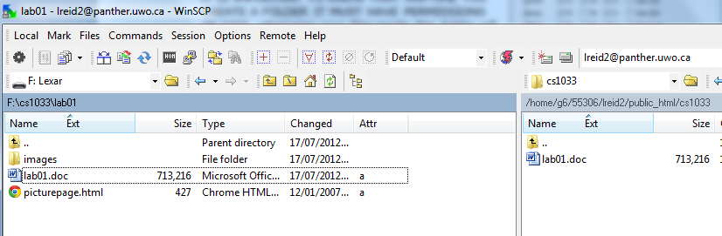
Now we want to see if our file is really on the internet by opening a brower (like IE or Chrome or Firefox) and viewing it.

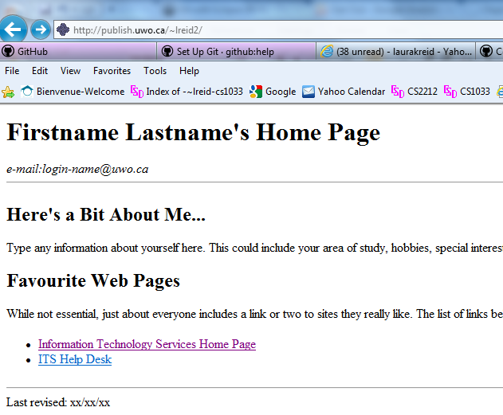
- Open up IE and go to your personal web area that is provided to every Western student. Your personal web area will be at: http://publish.uwo.ca/~youruwouserid You should see something at first like this: (Notice that Western gives every student a default template for a home page).

- Now try to see the page you just uploaded by going into the directory called cs2033. So add /cs2033 to the end of the above webaddress. Thus, the new webaddress will be: http://publish.uwo.ca/~youruserid/cs2033

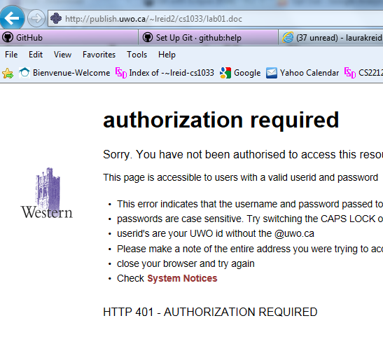
- Then try to click on the lab01.doc file. Unfortunately we still won’t be able to see this file. You should see something like this →
Notice that you get a message “Authorization Required”

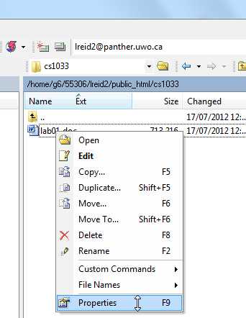
- To fix it so that we can view the files from the browser, we need to ALWAYS set the permission right of files on the remote side in WinSCP. Go back into WinSCP and right click on the folder lab01.doc in the right hand panel. Select Properties.

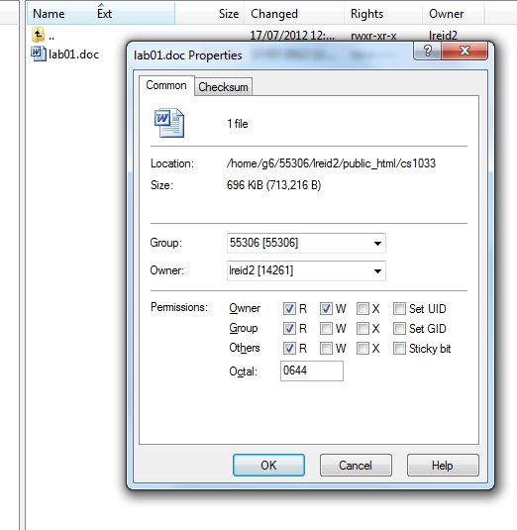
- Make sure that the permissions for the file are checked so that Owner, Group and Others have R (read) access. It should give you Octal value of 0644.

- Now, using IE, go back to your webpage and click on the lab01.doc file again. This time you should be able to open it in IE.
Congratulations! You have posted your first item on the web (from now on, we will post web (html) pages and pictures) but you can really post anything on the internet, even a MS Word .doc document, as we just did ☺
Always remember to set your permissions and remember that the Octal permissions for:
- folders/directory must be 0755
- files must be 0644
Note on Permissions → Whenever you create a file/folder on panther, or copy a file to panther, it will automatically assume that you do NOT want to share that file/folder on the Internet. So anyone who tries to access it on the Internet will get the “You are not authorized to view this page” error. Remember to ALWAYS check the permissions the permissions have been set correctly on your folders (i.e. directories) and files.

EXERCISE:
- Make a folder called lab01 on panther INSIDE the cs2033 folder(directory), i.e. make lab01 a subdirectory (folder inside another folder) of cs2033.
- From the files that you copied onto your memory stick, inside the lab01 folder, there should be a file called picturepage.html and a folder called images/.
- Rename picturepage.html to index.html.
- Upload index.html as well as the images/ folder into the lab01 subfolder of cs2033
- Set up the permissions for the files and folders that you uploaded. DOUBLE CHECK → DID YOU SET THE PERMISSIONS ON THE FOLDER(S) TOO?? Always remember to check the file permissions (set to 644) AND the FOLDER PERMISSIONS (set to 755).

- Go to your website to preview the page.
http://publish.uwo.ca/~username/cs2033/lab01
- Call your TA to check your work and receive your mark for this lab.

- REMEMBER TO REMOVE YOUR MEMORY STICK FROM YOUR MACHINE AND PUT IT IN YOUR BACKPACK! (don’t forget it in our lab machines)! ☺

