
University of the Punjab
SAVE&SERVE

Submitted by:
Hareem Fatima (BCSF24M045)
Hifza Malook (BCSF24M038)
Submitted to:
Sir Noman
Date:
15 October 2026

1. Overview
A web application that connects people who have surplus food (restaurants, wedding halls, households) with NGOs and volunteers who can collect it and distribute it to people in need. Donors post available food with quantity and pickup time, and verified NGOs or volunteers claim it. Every post moves through a clear status: available → claimed → collected.

2. Problem Statement
Restaurants and wedding events often throw away large amounts of edible food, while many people go hungry. The donors and the organisations that could use the food have no simple, reliable way to find each other in time, because cooked food is only safe for a short window. This platform provides one place to list surplus food, find it, claim it, and track it until pickup.

3. Objectives
- Reduce food waste by making surplus food visible quickly.
- Let NGOs and volunteers find nearby food and claim it with no double claims.
- Allow only verified NGOs to claim on behalf of an organisation, and only verified volunteers to claim independently, to build trust.
- Keep a clear record of every donation and who handled it.

4. Technology Stack
HTML, CSS and JavaScript for the frontend. PHP (with PDO) for the backend and authentication. MySQL for the database (LAMP stack).

5. User Roles
Role | What they do
Donor | Registers, posts surplus food, views their donations, confirms collection
NGO | Registers an organisation, browses and claims food, manages volunteers
Volunteer | Registers and is verified by the admin, then browses and claims food, independently or as part of an NGO
Admin | Verifies NGOs and volunteers, oversees the platform

6. Functional Requirements (Modules)
- Authentication: signup, login and logout with hashed passwords and session handling. After login, users are redirected to a home page based on their role.
- Role-based access: each page checks the session and role before allowing access.
- NGO management: NGO registration, admin verification, and adding members (managers and volunteers).
- Volunteer verification: new volunteers start as unverified (users.is_verified = 0) and the admin approves them. Only verified volunteers can claim food on their own.
- Food posting: donors create posts with category, quantity, unit, description, pickup window and pickup address.
- Browse and filter: NGOs and volunteers see available posts, filtered by city, area or category.
- Claiming: a verified volunteer or a verified NGO claims a post. A post can only be claimed once.
- Collection tracking: the post is marked collected after pickup, with a timestamp.
- Cancellation: a claimer can cancel, and the post returns to available.
- Status history: every status change is logged with who made it and when.
- Dashboards: donors see their donations, NGOs see their claims, admins see NGOs and volunteers awaiting verification.

7. Database Schema

7.1 Entities Overview
The database has 8 tables:
Table | Purpose
locations | Shared addresses for users, NGOs and pickup points
users | All people who log in, with their role and (for volunteers) verification status
ngos | Registered organisations and their verification status
ngo_members | Links users to the NGOs they belong to
food_categories | Types of food (cooked meals, bakery, etc.)
food_posts | The food listings offered by donors
claims | Records who claimed which post
post_status_logs | History of every status change

7.2 ERD
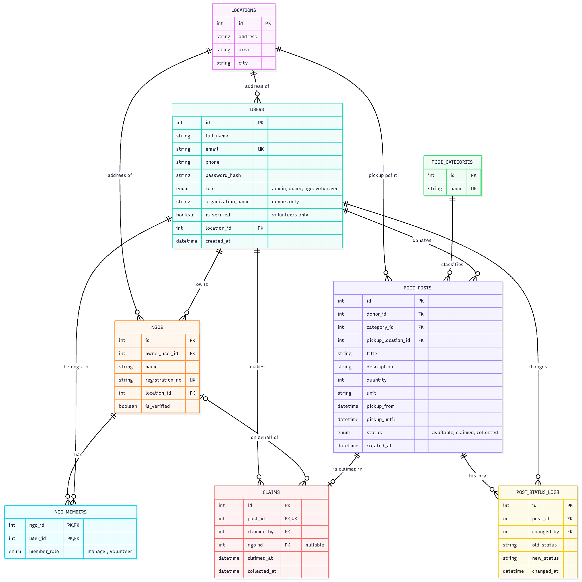
Figure 1: Entity Relationship Diagram of SAVE&SERVE

8. System Workflow
- Setup: admin account and food categories are added.
- Signup and login: user registers with a role, logs in, and lands on a role-based home page. Volunteers start as unverified until the admin approves them.
- Volunteer verification: the admin reviews unverified volunteers and approves them by setting is_verified to 1.
- NGO registration: an NGO user registers the organisation (unverified), the admin approves it, and the owner adds members.
- Post food: the donor submits a post with status available, and a log entry is written.
- Browse: NGOs and volunteers see only available, unexpired posts and can filter them.
- Claim: the system first checks that the claimer is a verified volunteer or a member of a verified NGO. A transaction then creates the claim, sets the post to claimed, and logs it. A second simultaneous claim fails.
- Collect: after pickup, collected_at is set, the post becomes collected, and a log entry is written.
- Exceptions: a claim can be cancelled (post returns to available). Expired and withdrawn posts leave the browse page.
Status lifecycle: available → claimed → collected, with claimed → available on cancellation.

9. Conclusion
The schema supports every feature of SAVE&SERVE directly. The users table and its role field drive authentication and role-based access, and its is_verified field lets the admin approve individual volunteers, while ngos and ngo_members support organisation registration, admin verification and team management. The locations table gives donors, NGOs and pickup points one shared address structure, which makes filtering by city and area simple. The food_posts table holds each listing and its status, and the unique post_id in claims guarantees that a post can only be claimed once. Finally, post_status_logs keeps a complete history of who changed what and when, so every donation can be traced from posting to collection.
The system can be extended later with notifications (for example SMS or email when food is posted or claimed), map integration to show nearby pickup points, and a rating system so donors and NGOs can build trust through feedback.

