

FATIMA JINNAH WOMEN UNIVERSITY

DEPARTMENT OF SOFTWARE ENGINEERING
Course: Cloud Computing (BSE-410)
Program: BS(SE)-V
Assignment No.: 01
Assignment Title: Git, Gitea, GitHub, Git LFS, and GitHub Pages
Student Name: Hifza Shakeel
Registration Number: fa24b1-se-052
GitHub Username: hifzashakeel52
Submission Date: 10 October 2026
Total Marks: 10

1. Assignment Objective
The objective of this assignment is to install and run Gitea on an Ubuntu server, create and manage a Git repository, push the same repository to Gitea and GitHub, track three large files using Git Large File Storage (Git LFS), and publish a personal portfolio or CV using GitHub Pages.
By completing this assignment, I will learn how to:
- Install and run Gitea on an Ubuntu server.
- Create and manage Git repositories.
- Work with multiple Git remotes.
- Authenticate safely without exposing credentials.
- Track and push large files using Git LFS.
- Create and publish a portfolio website using GitHub Pages.

2. Required Environment
The following environments are required to complete this assignment:
- Ubuntu Server: Gitea installation and Git terminal operations for Tasks 1, 2, and 3.
- Web Browser: Accessing Gitea, GitHub, and GitHub Pages.
- GitHub Repository: Storing the assignment evidence in the existing public repository named CC.
The required Ubuntu terminal prompt is:
hifzashakeel52@ubuntu:~$

3. Getting Started
First, open the existing CC repository on the Ubuntu server and create the required assignment directory:
mkdir -p Assignments/Assignment01/screenshots
Ensure that Git and Git LFS are installed. Docker and Docker Compose will be installed during Task 1.
The assignment directory must contain:
- Assignment01.md
- Assignment01_Solution.docx
- Assignment01_Solution.pdf
- screenshots/
The screenshots folder must contain all 12 screenshots specified in this report.

4. Task 1: Install Gitea and Push a Repository from the Ubuntu Server

4.1 Install and Run Gitea
Step 1: Update Ubuntu packages and install Docker and curl.
sudo apt update -y
sudo apt install -y docker.io curl
Step 2: Install the Docker Compose plugin.
sudo mkdir -p /usr/local/lib/docker/cli-plugins
sudo curl -SL https://github.com/docker/compose/releases/latest/download/docker-compose-linux-x86_64 -o /usr/local/lib/docker/cli-plugins/docker-compose
sudo chmod +x /usr/local/lib/docker/cli-plugins/docker-compose
Step 3: Start Docker and configure permissions.
sudo systemctl start docker
sudo usermod -aG docker $USER
exit
Completely sign out of the Ubuntu server and reconnect so the updated group membership takes effect.
Step 4: Verify the installations.
git --version
docker --version
docker compose version
All three commands should display their installed versions.
Step 5: Download the instructor-provided Gitea setup repository.
cd ~
git clone https://github.com/WaqasSaleem97/Gitea.git
cd Gitea
Step 6: Start Gitea and PostgreSQL.
docker compose up -d
Step 7: Check the running containers.
docker compose ps
Both Gitea and PostgreSQL should be running.
Step 8: Check the Gitea HTTP response.
curl -sS -o /dev/null -w "Gitea HTTP status: %{http_code}\n" http://127.0.0.1:3000/
Step 9: Find the Ubuntu server IP address.
ip addr
Open the following address in a browser, replacing the placeholder with the actual server IP:
http://<ubuntu-server-ip>:3000/
Complete the initial Gitea installation using these database settings:
Setting | Required Value
Database type | PostgreSQL
Database host | db:5432
Database username | gitea
Database password | gitea
Database name | gitea
Server domain | Ubuntu server IP
Gitea base URL | http://<ubuntu-server-ip>:3000/
Create the Gitea administrator account and finish the installation. Do not show passwords or tokens in screenshots.
Screenshot 1: Gitea Running
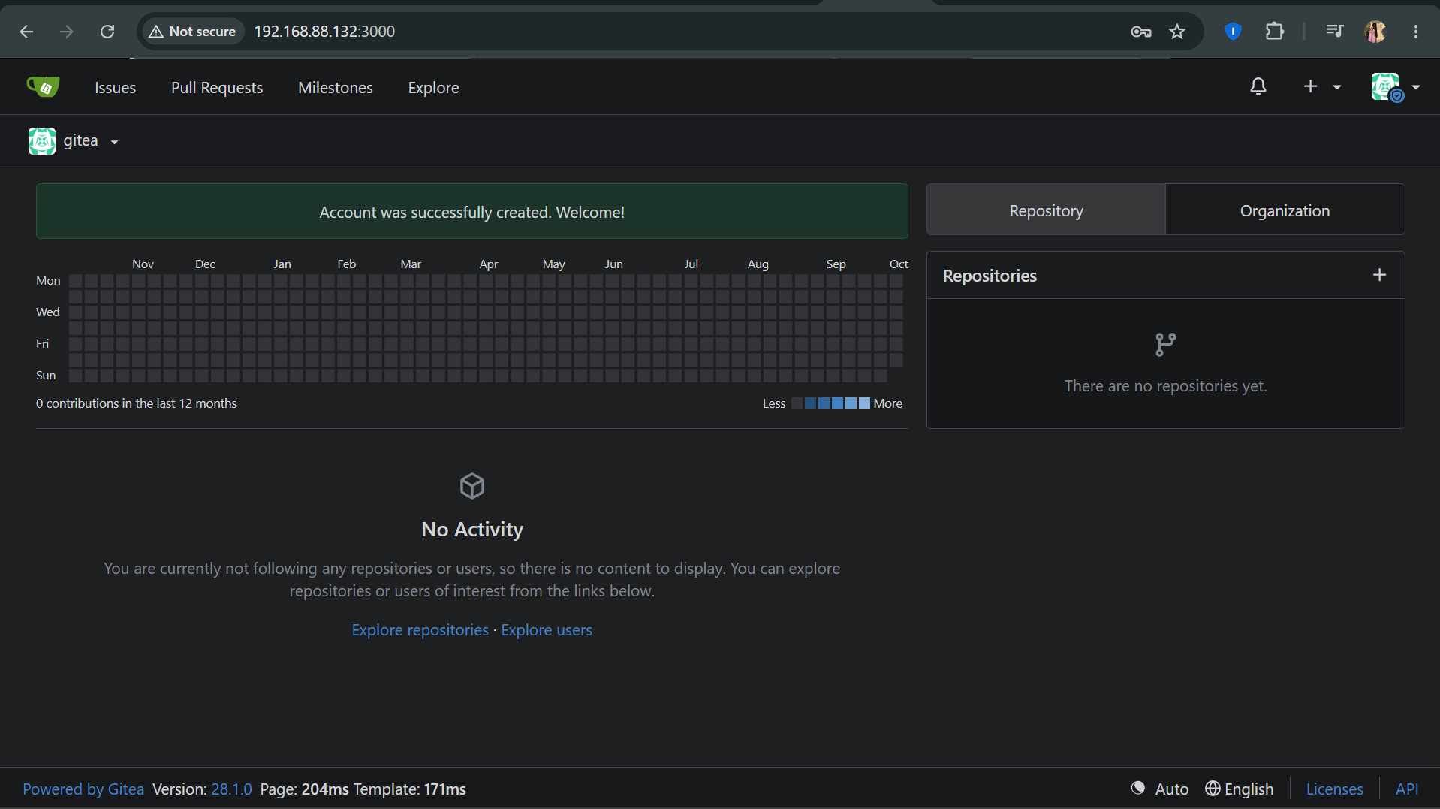
Filename: task1_gitea_running.png
The screenshot should show the Ubuntu prompt, docker compose ps, both containers running, and the successful Gitea HTTP status.

4.2 Create and Push the Initial Repository
Step 1: Create an empty public repository in Gitea named exactly Assignment01. Do not initialize it with a README, .gitignore, or license.
Step 2: Create a separate local repository on the Ubuntu server.
cd ~
mkdir Assignment01
cd Assignment01
git init
git branch -M main
Step 3: Create the README file.
printf "# Hifza Shakeel\n\nRegistration Number: fa24b1-se-052\n" > README.md
Step 4: Add and commit the README.
git add README.md
git commit -m "Add student information"
Step 5: Create a Gitea personal access token with repository read/write permission (write:repository). Use ubuntu-server-token as its name.
Step 6: Add the Gitea remote.
Replace <gitea-username> with your actual Gitea account username.
git remote add gitea http://<gitea-username>@127.0.0.1:3000/<gitea-username>/Assignment01.git
Step 7: Verify the remote.
git remote -v
Step 8: Push the repository to Gitea.
git push -u gitea main
Enter the personal access token only when Git asks for the password. Never place it in the remote URL or command.
Screenshot 2: Push to Gitea
Filename: task1_gitea_push.png
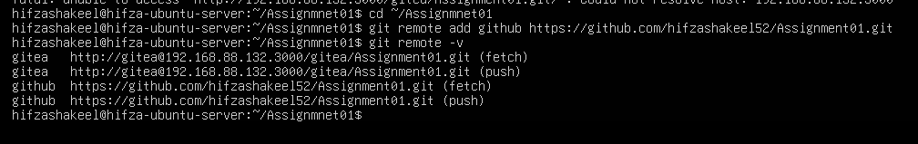

The screenshot should show the remote, push command, successful result, and Ubuntu prompt. The token must not be visible.

4.3 Verify the Gitea Repository
Open the Assignment01 repository in Gitea.
Verify that:
- The repository owner and name are visible.
- The repository is public.
- The README displays your full name and registration number.
- The Gitea URL is visible.
Screenshot 3: Gitea Repository

Filename: task1_gitea_repository.png
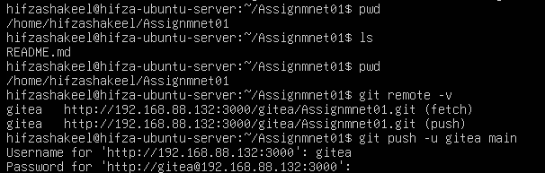
Task 1 Result: After successful completion, the repository will be stored in Gitea and accessible through the Ubuntu server's Gitea service.

5. Task 2: Push the Same Repository to GitHub

5.1 Create the GitHub Repository and Configure Remotes
Create an empty public GitHub repository named exactly Assignment01. Do not initialize it with a README, .gitignore, or license.
Open the same local repository on Ubuntu:
cd ~/Assignment01
Add GitHub as the second remote:
git remote add github https://github.com/hifzashakeel52/Assignment01.git
Verify both remotes:
git remote -v
The output should show both gitea and github, including their fetch and push URLs. Neither URL should contain a password or token.
Screenshot 4: Both Git Remotes
Filename: task2_remotes.png
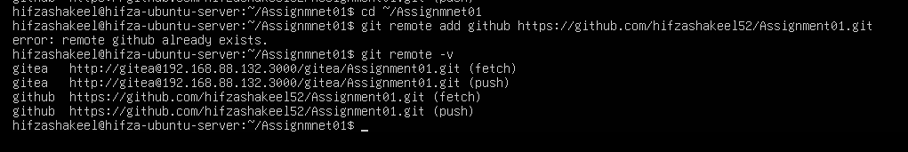

5.2 Push the Repository to GitHub
Run:
git push -u github main
Authenticate safely if prompted. Confirm that the push completes successfully.
Screenshot 5: GitHub Push
Filename: task2_github_push.png

5.3 Verify the GitHub Repository
Open:
https://github.com/hifzashakeel52/Assignment01
Verify that:
- The repository owner is hifzashakeel52.
- The repository name is Assignment01.
- The repository is public.
- The rendered README displays your name and registration number.
Screenshot 6: GitHub Repository
Filename: task2_github_repository.png
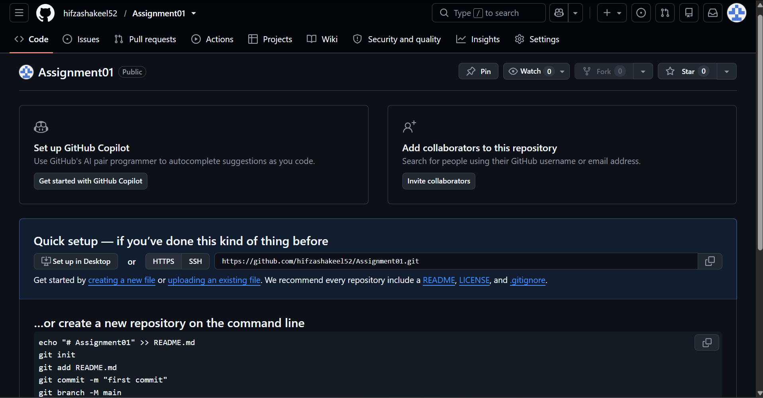
Task 2 Result: After successful completion, the same local repository will be connected to Gitea and GitHub and available on GitHub.

6. Task 3: Track Three Large Files with Git LFS

6.1 Configure Git LFS
Open the local repository:
cd ~/Assignment01
Initialize Git LFS:
git lfs install
Check the Git LFS version:
git lfs version
Configure Git LFS to track .bin files:
git lfs track "*.bin"
Display the tracking rule:
cat .gitattributes
The output should contain the *.bin tracking rule.
Screenshot 7: Git LFS Setup
Filename: task3_lfs_setup.png
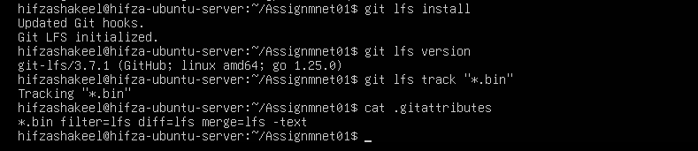

6.2 Create and Verify Three Large Files
Create three files larger than 100 MiB each:
truncate -s 101M large-file-1.bin
truncate -s 102M large-file-2.bin
truncate -s 103M large-file-3.bin
Add the files and the Git LFS configuration:
git add .gitattributes large-file-1.bin large-file-2.bin large-file-3.bin
Verify the tracked files and their sizes:
git lfs ls-files --size
Confirm that all three files are listed and each is larger than 100 MiB.
Screenshot 8: Three LFS Files
Filename: task3_lfs_files.png
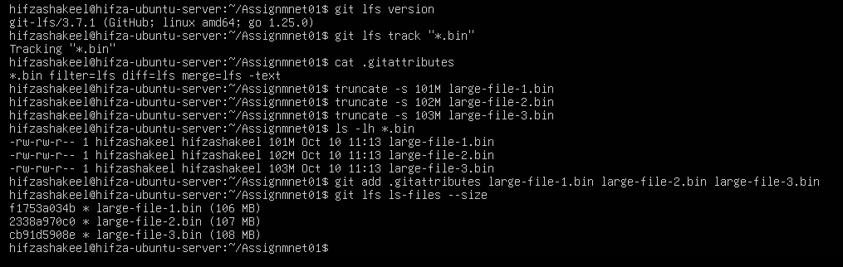

6.3 Commit and Push the LFS Files
Commit the files:
git commit -m "Add three files using Git LFS"
Push them to GitHub:
git push github main
Wait for the actual upload to finish successfully. The assignment asks you to capture the successful LFS upload, preferably showing 100% (3/3).
Screenshot 9: Git LFS Push
Filename: task3_lfs_push.png
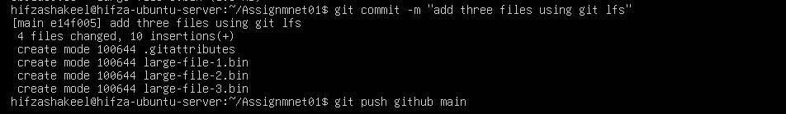
Task 3 Result: After successful completion, three files larger than 100 MiB will be tracked using Git LFS and pushed to GitHub.

7. Task 4: Create a Portfolio or CV with GitHub Pages

7.1 Create the Portfolio Repository
Create a new public GitHub repository named:
hifzashakeel52.github.io
Create a personal portfolio using HTML and CSS. It must contain these files:
- index.html
- styles.css
The portfolio must include the following sections:
- About Me
- Education
- Skills
- Projects
Replace any sample text with accurate information about yourself before publishing.
If you create the website locally, initialize the repository and push it to GitHub:
git init
git branch -M main
git add index.html styles.css
git commit -m "Create personal portfolio"
git remote add origin https://github.com/hifzashakeel52/hifzashakeel52.github.io.git
git push -u origin main
Run these commands in the portfolio project directory, not inside the Assignment01 repository. If the repository already exists locally or has already been initialized, do not repeat the initialization or remote-add commands unnecessarily.
Open the portfolio repository on GitHub and verify that index.html and styles.css are visible.
Screenshot 10: Portfolio Repository
Filename: task4_pages_repository.png
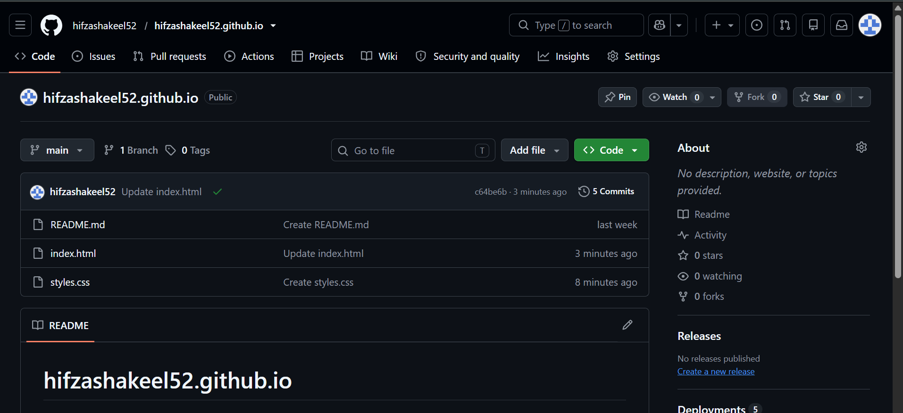

7.2 Publish the Portfolio with GitHub Pages
Open the portfolio repository on GitHub.
- Select Settings.
- Open Pages.
- Under Build and deployment, select Deploy from a branch.
- Select the main branch.
- Select the / (root) folder.
- Click Save.
- Wait until GitHub reports that the website is published or live.
The deployment screen should show the GitHub Pages status and website URL.
Screenshot 11: GitHub Pages Deployment
Filename: task4_pages_deployment.png
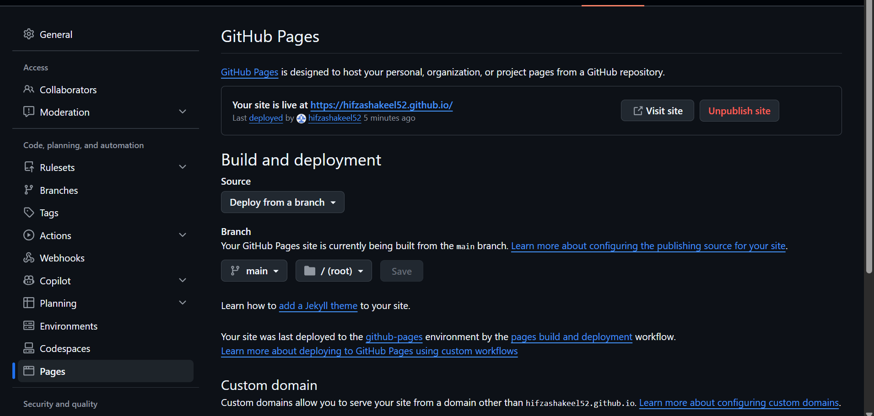

7.3 Verify the Live Portfolio
Open:
https://hifzashakeel52.github.io/
Confirm that:
- The website loads successfully.
- The full GitHub Pages URL is visible.
- At least one required section, such as About Me, Education, Skills, or Projects, is visible.
Screenshot 12: Live Portfolio
Filename:
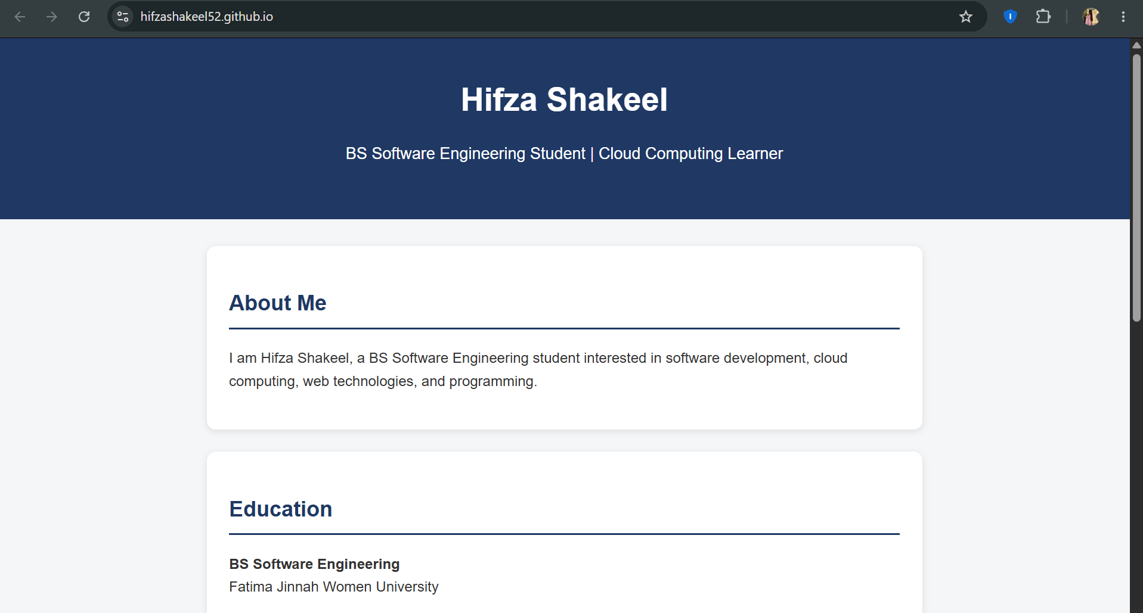
Task 4 Result: After successful completion, the portfolio will be stored in a public GitHub repository and published through GitHub Pages.

8. Assignment Summary
This assignment demonstrates practical skills in Git, Gitea, GitHub, Git LFS, and GitHub Pages.
The completed work should demonstrate that:
- Gitea was installed and run on an Ubuntu server.
- A local repository was pushed to Gitea.
- The same repository was pushed to GitHub using a second remote.
- Three files larger than 100 MiB were tracked with Git LFS and pushed.
- A personal portfolio was created and published using GitHub Pages.
- The required assignment files and screenshots were prepared for submission.
Record only results that you have actually verified.

9. Final Submission Checklist
Before submitting, confirm the following:
- 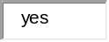
Assignment01.md is inside CC/Assignments/Assignment01/.
Assignment01_Solution.docx opens correctly.
Assignment01_Solution.pdf matches the Word document.
The screenshots/ directory contains all 12 readable screenshots.
Each screenshot was captured from my own practical work.
My GitHub username is visible in every Ubuntu terminal screenshot.
No screenshot contains a password, token, or private key.
My CC repository is public.
My GitHub Assignment01 repository is public.
My hifzashakeel52.github.io repository is public.
My Gitea repository was created and pushed from the Ubuntu server.
All repositories use the main branch.
The complete Assignments/Assignment01 directory was pushed to CC.
All three required assignment files were uploaded to Google Classroom.
The three required links were submitted on Google Classroom.
End of Assignment 01

