CHARLIE PARKER’S “KO KO”

By: Uriel Navarro

Charlie Parker is said to be one of bebop era’s greatest player. He was an influential and talented musician who contributed so much to jazz. He was an amazing saxophonist who gained wide recognition for his brilliant solos and innovative improvisations. “Ko Ko” comes to mind when thinking about a famous Charlie Parker song. This 1945 bebop song was a perfect choice to analyze, considering this is a favorite of mine.

“Ko Ko” is not like most songs, in that the beginning gives an elaborate intro but there does not seem to be an established tune. Once the song hits 0:06 seconds, Gillespie comes in with a trumpet solo followed by Parker’s solo at 0:13 seconds. But even then there is no chord progression, it just seems to be a little abstract. Once you hit 0:20 the introduction seems to come to an end, and at 0:25 seconds Parker starts his solo. Accompanying him is a drummer who plays primarily on the ride cymbal and the bass playing a walking bass line. His solo is mostly a string of fast eighth notes and from time to time there being a dramatic outburst.

His unique style of play is demonstrated by his accenting. The rhythms are disorienting not because this tempo goes really quick but because of accents constantly changing. The swooping upbeats also give you a sense of his tricky rhythm; the speed that Parker plays at is almost mind-boggling. When the song hits 1:41, there seems to be many shifts in his thoughts as many different spills of notes are played. This is typical for Parker as it is shown throughout much of his solo.

As the song progresses, around 2:07 Max Roach comes up as the next soloist. Most of his solo consists of drum licks and bass drum drops in a quick fashion. His solo overall seems to get increasingly more complicated as he plays each of his notes. Roach finishes his solo at 2:29, with the different soloist coming in and playing all their improvised pieces to bring the song to an end.

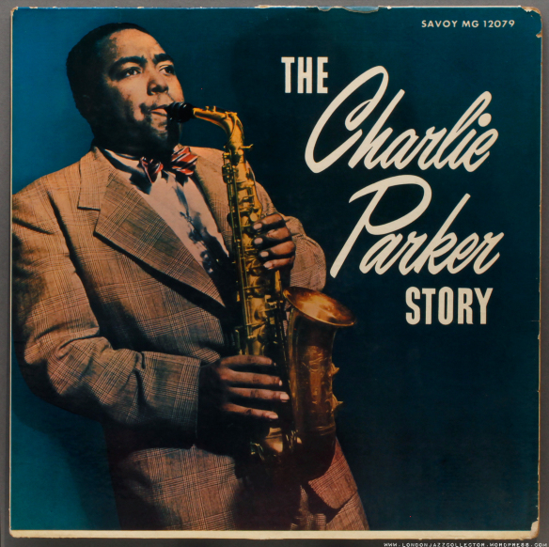

Charlie Parker

|  |  |  |  |
| --- | --- | --- | --- |
| Charlie Parker Songs | Year of Song | Length | Era |
| ‘KO KO’ | 1945 | 2:30 | Bebop |
| ‘Salt Peanuts’ | 1942 | 3:09 | Bebop |
| ‘Hot House’ | 1945 | 4:23 | Bebop |