Cross-stage technology convergence as knowledge integration in semiconductor hybrid bonding: A patent-based longitudinal analysis

Abstract
Front-end fabrication and back-end assembly have long been separate knowledge domains in semiconductor manufacturing. Hybrid bonding, a back-end technology, depends on front-end fabrication knowledge for its performance, driving convergence, or knowledge integration, across process stages. Using hybrid bonding patent applications from the European Patent Office’s PATSTAT, this study examines the level and forms of cross-stage knowledge integration, its change over time, and shifts in its locus. Applications were classified as bonding-only, process-only, or integrated by Cooperative Patent Classification co-classification, a trace of this integration, and analyzed with multinomial and binary logit models and technology cluster and network analyses. First, integrated applications formed the largest group and remained substantial under a narrower definition excluding packaging-stage processes, indicating cross-stage convergence was not exceptional; they included more diverse technical elements. Second, integration evolved through three phases (formation, when process-only applications dominated; diffusion, when the integrated share peaked; and reconfiguration, when it fell as bonding-only applications increased) as the center of gravity of filings shifted from fabrication processes toward bonding. Third, bonding applications containing the core technologies were far more likely than others to carry fabrication-process classifications in the formation phase, but this gap became nonsignificant by the reconfiguration phase, and the center of the fabrication processes combined with bonding shifted from wafer fabrication to processing apparatus and packaging-stage processes. Cross-stage convergence is not a linear expansion but a dynamic process whose content and center are reorganized across phases; as the core design became entrenched, knowledge integration appears to have relocated rather than disappeared.
Keywords: technology convergence; cross-stage convergence; hybrid bonding; advanced packaging; knowledge integration; knowledge boundaries
JEL classification: L63; O32; O33; O34

1. Introduction
For more than half a century, the semiconductor industry has maintained a division of labor between the front end, which forms transistors on the wafer, and the back end, which dices finished wafers and assembles and packages the resulting dies. Front-end fabrication became concentrated in the large fabs of integrated device manufacturers and foundries, whereas packaging and testing were contracted out to specialized assembly and test firms (outsourced semiconductor assembly and test, OSAT) (Brown & Linden, 2009; Kapoor, 2013; Macher & Mowery, 2004). This division of labor was possible because the interface between the two stages was stable. Stable interfaces allow production stages to specialize while maintaining distinct knowledge domains (Brusoni et al., 2001; Henderson & Clark, 1990), but when technological change destabilizes such an interface, innovation increasingly requires integrating specialized knowledge from both sides of the boundary (Grant, 1996).
Advanced packaging has brought precisely this kind of change. As scaling ran into a slowdown in density gains and a steep rise in costs, the semiconductor industry began to seek new opportunities for performance gains in how dies are partitioned, stacked, and connected (Arden et al., 2010; Khan et al., 2018). Hybrid bonding, the technology at the center of this shift, directly bonds copper pads and the surrounding oxide without solder bumps and achieves interconnect pitches below 10 µm (Lau, 2021, 2022). The nanometer-scale surface planarization, surface activation, and precise alignment that determine its success are front-end fabrication capabilities rather than capabilities that the back end has traditionally accumulated. Moves by leading foundries to internalize advanced packaging capabilities are also related to this deepening interdependence (KnowMade, 2024; Lau, 2022).
Research on technology convergence has long examined how previously distinct technological domains come to overlap and combine (Curran & Leker, 2011; Kodama, 1992; Rosenberg, 1963; Sick & Bröring, 2022). As the cases of information and communication technology and consumer electronics (Hacklin et al., 2009), food and pharmaceuticals (Bröring et al., 2006), and nanotechnology and biotechnology (No & Park, 2010) show, however, its main interest has been in overlaps between different industries or technological fields. The closest precedent, the study by Karvonen and Kässi (2012), analyzed patent citations between upstream and downstream firms in a value chain, but it did not test at the patent level whether an invention crosses the boundary between process stages. Moreover, although convergence has been theorized as a staged process (Hacklin et al., 2010), empirical studies of how the content of convergence changes over time are scarce. This gap matters because inventions that cross the boundary between process stages can be a technological starting point for changing the industry architecture that defines who produces what and how value is distributed (Jacobides et al., 2006). From a knowledge perspective, the question is not only whether the knowledge domains of the two stages combine but also how the locus of their integration changes as a technological architecture evolves.
This study analyzes cross-stage technology convergence, that is, the integration of knowledge from the two stages within an invention, at the level of individual patents. The data are 928 patent applications related to hybrid bonding extracted from the Worldwide Patent Statistical Database (PATSTAT) of the European Patent Office (EPO), together with the Cooperative Patent Classification (CPC) symbols assigned to each application. An application to which both a symbol of the bonding and interconnect classification (H01L24) and a symbol of the fabrication-process classification (H01L21) are assigned is defined as integrated, that is, as a patent that crosses the boundary between process stages; an application with symbols of only one of the two classes is defined as bonding-only or process-only. Because an invention is a new combination of existing knowledge (Fleming, 2001), the co-classification of an application provides an observable, albeit imperfect, trace of the integration of knowledge from two process domains within an invention. Capturing convergence through co-classification is a standard method (Curran & Leker, 2011; Kwon et al., 2020), but this study applies it to the boundary between process stages within a single industry and recasts co-classification as types of individual patents instead of field-level indices.
The study addresses three research questions. First (RQ1), to what extent and in what forms is knowledge from the fabrication-process and bonding domains integrated within hybrid bonding inventions? Second (RQ2), how has cross-stage knowledge integration changed over time? Third (RQ3), how has the locus of cross-stage knowledge integration shifted between core and peripheral technologies over time?
The study makes three contributions. First, it broadens the scope of technology convergence research to convergence between manufacturing process stages within the same industry and extends the study of knowledge boundaries, which has centered on firm boundaries, to vertically separated process domains. Second, it analyzes convergence as a dynamic process in which the composition of types changes through phases of formation, diffusion, and reconfiguration, and it shows that cross-stage knowledge integration is reorganized nonlinearly. Third, by tracing how the relationship between core bonding technologies and fabrication-process technologies varies over time, it provides empirical grounds for the argument that, as the core design becomes entrenched, knowledge integration does not disappear but relocates from the core bonding interface to peripheral processes.

2. Theoretical background

2.1 Technology convergence and knowledge integration
Analyzing the emergence of the nineteenth-century machine tool industry, Rosenberg (1963) used the term “technological convergence” for the process by which machining techniques developed for firearms or sewing machines came to be applied to other products. In his account, the unit of convergence was not the final product but common production processes, and the machine tool industry, which accumulated this process knowledge, emerged as an independent specialized industry. Kodama (1992) conceptualized technology fusion as the process of combining previously separate technological fields to create capabilities that none of them possessed alone. From a knowledge-based perspective, such a combination amounts to the integration of previously separate bodies of specialized knowledge (Grant, 1996), and each invention can be seen as a new combination of existing knowledge components (Fleming, 2001).
From case studies of 26 information and communication technology firms, Hacklin et al. (2010) derived a stage model in which convergence starts from knowledge convergence, when previously separate knowledge bases begin to overlap, and proceeds through technological convergence and applicational convergence to industrial convergence, and Hacklin et al. (2009) argued that these stages form coevolutionary cycles through mutual feedback. Because convergence proceeds nonlinearly, not every instance of convergence passes through all four stages in sequence, but the stage of technological convergence, in which technologies from different fields are combined within a single invention, is well suited to observation with patents (Curran et al., 2010; Curran & Leker, 2011). Technology convergence research has since become established as a distinct research stream in technology and innovation management that examines, among other topics, the drivers of convergence and the fields in which it is likely to occur (Caviggioli, 2016; Geum et al., 2016; Hwang, 2020; Sick & Bröring, 2022; Whang, 2018).
This prior research, however, shares three features. First, its focus lies on overlaps between different industries or technological fields (Bröring et al., 2006; Gambardella & Torrisi, 1998; No & Park, 2010). Second, convergence is generally measured with field-level indicators that aggregate co-classifications or citations between two fields (Cho & Kim, 2014; Choi et al., 2022; Curran et al., 2010; Song et al., 2017). Such indicators show whether and when two fields converge, but because differences among individual patents are hidden in the average, they cannot readily explain which inventions embody convergence. Third, whereas theory views convergence as a staged process, empirical studies have largely been confined to confirming, as a trend, whether the degree of convergence has increased; how the content and center of convergence change as convergence proceeds has received little attention. Sick and Bröring (2022) likewise noted that research treating convergence as a process has developed relatively independently of its theoretical foundations.

2.2 Cross-stage technology convergence and knowledge boundaries within the value chain
The boundaries at which convergence occurs do not exist only between industries. In the semiconductor industry, the boundaries that separate the stages of the value chain have long been an object of research on vertical specialization. As design was separated from fabrication and fabrication from assembly, fabless firms, foundries, and specialized assembly and test firms emerged, and this structure was reshaped through successive crises (Brown & Linden, 2009; Langlois & Steinmueller, 1999; Macher & Mowery, 2004), but the choices of firms that retained capabilities spanning multiple stages shaped the architecture of the industry (Kapoor, 2013). Analyzing 12 product generations of the worldwide DRAM industry from 1974 to 2005, Kapoor and Adner (2012) showed that nonintegrated firms whose knowledge extended to the outsourced components gained performance advantages in technological transitions. The boundaries of production and of knowledge do not coincide, and in periods of technological change the gap between them determines how well firms can respond (Brusoni et al., 2001).
Industry architecture is the template that defines who does what and how value is distributed, and this template can itself be reshaped as technology and firm strategy change (Jacobides et al., 2006). The division of labor between process stages persists as long as the interfaces between them are stable. Studying the semiconductor photolithographic alignment equipment industry, Henderson and Clark (1990) distinguished knowledge of components from architectural knowledge of how components are linked and showed that changes in these linkages erode the value of established architectural knowledge. When a new technology makes the performance of one stage depend on the knowledge of another, the interface becomes unstable, and firms must acquire or integrate knowledge from the other side of the boundary. Such a combination of knowledge can appear at the level of invention before organizations and industry structure change, in the form of single inventions that incorporate the technologies of both stages.
Hybrid bonding is precisely a technology that makes the performance of one stage depend on the knowledge of another. Because its yield depends on front-end capabilities such as planarization, surface chemistry, and alignment, the interface between fabrication and packaging is no longer stable. This phenomenon was anticipated in research on the limits of scaling (Arden et al., 2010; Iyer, 2016; Khan et al., 2018) and has been documented technically in packaging engineering research (Lau, 2021, 2022), but few studies have observed it in the record of invention. In terms of the stage model, knowledge convergence in hybrid bonding corresponds to the stage at which fabrication-process knowledge such as planarization and surface activation begins to be applied to the problem of chip-to-chip connection; technological convergence, to the stage at which this knowledge is combined with bonded structures within a single invention; applicational convergence, to the stage at which the combined technology is implemented in products such as image sensors, 3D NAND, HBM, and chiplets; and industrial convergence, to the stage at which the division of labor itself is reorganized, as when leading foundries internalize advanced packaging (KnowMade, 2024; Lau, 2022). Of these, only technological convergence can be observed directly through patent co-classification; applicational convergence is addressed only indirectly, through shifts in the locus of knowledge integration, and industrial convergence lies outside the scope of the analysis. If the interface has become unstable, inventions incorporating knowledge from both stages should not be exceptional, and inventions spanning the two domains should combine more diverse technical elements than inventions confined to one domain.

2.3 The dynamic unfolding of technology convergence and the locus of knowledge integration
According to the technology cycle model (Anderson & Tushman, 1990), technological change follows a cycle of technological discontinuity, an era of ferment in which multiple designs compete, the emergence of a dominant design, and incremental change, and once a dominant design has been established, incremental innovation that refines the established design becomes central. Whereas the stage model shows the sequence of levels through which convergence passes, the technology cycle model shows the temporal process by which competing designs within a single technology converge, and Hacklin et al. (2009) also explained convergence on the basis of an innovation cycle model. When the two perspectives are combined, process inventions that make direct bonding possible can be expected to predominate while the technology is forming (knowledge convergence), cases in which process knowledge is combined with bonding inventions should increase as the technology diffuses (technological convergence), and once a single design has become established as the dominant design, the combination of the two technologies should shift toward the peripheral processes required for applications (applicational convergence). Indeed, many early hybrid bonding inventions concerned processes such as surface preparation, low-temperature annealing, and planarization, but as the use of the technology expanded from wafer-level bonding to die-level bonding for HBM and logic, the focus of invention shifted to bonded structures and stacking (Lau, 2021). Patent-based studies of convergence dynamics have focused on how the degree of convergence between pairs of fields changes (Jeong et al., 2015; Yun & Geum, 2019) and have paid relatively little attention to how the composition of convergence by form changes within a single technology.
Changes in convergence may also appear in the relationships among the elements that make up a technology. A complex technology consists of core elements that are closely linked to other elements and peripheral elements that are not, and Murmann and Frenken (2006) defined a dominant design as the stabilized design of the core elements that serve as stable interfaces with the other elements. Once the design of the core elements has stabilized, subsequent technological change can continue in the peripheral elements, taking those interfaces as given. The core element of hybrid bonding is a connection scheme in which bonding pads are bonded directly to one another without bumps or solder (Lau, 2021), and inventing it in an era of ferment, when the interfaces are not yet settled, requires dealing with fabrication-process knowledge such as surface planarization and wafer bonding. Once a dominant design has been established, however, the architectural knowledge that links components becomes embedded in an organization’s problem-solving routines and is taken for granted (Henderson & Clark, 1990), and as interdependencies among components become predictable, the need to handle knowledge from the other side of the boundary decreases (Brusoni et al., 2001). Because hybrid bonding was first commercialized in wafer-level bonding and its use was later extended to die-level bonding (Lau, 2021, 2022), later filings are more likely to belong to a stage in which the design of the core technologies has become entrenched.
Inventions containing the core technologies can therefore be expected to incorporate fabrication-process knowledge more often than other bonding inventions while the technology is forming, but this difference should diminish over time, and new combinations should occur in peripheral processes that take the interface of the core technologies as given. In terms of the stage model, this is a movement from technological convergence to applicational convergence, that is, a relocation of the locus of knowledge integration from the core bonding interface to peripheral processes. Furthermore, just as the convergence of process knowledge in Rosenberg’s (1963) case spread through machine tools, an equipment industry, processing apparatus can serve as an intermediary that connects the two stages in cross-stage convergence. This is why this study divides fabrication processes into wafer fabrication, processing apparatus, and packaging-stage processes and compares the coupling of each domain with bonding technologies. These theoretical expectations are not tested as statistical hypotheses; they serve as benchmarks for interpreting the results.

2.4 Patent-based measurement of convergence as knowledge integration
Patents are widely used to measure convergence because classification symbols place each invention in one or more technological fields (Curran & Leker, 2011). Just as Fleming (2001) treated classification symbols as the technical components of an invention and their joint assignment as the recombination of components, the joint assignment of symbols from different domains to a single patent is a trace of the combination of knowledge from the two domains within an invention. In this sense, co-classification is an observable trace of invention-level knowledge integration, not a measure of knowledge transfer between organizations. Prior studies have generally aggregated co-classification into field-level indices (Cho & Kim, 2014; Jeong et al., 2015; Kwon et al., 2020; Lee et al., 2015; Yun & Geum, 2019), and others have used patent text to compensate for the limitation that classification reflects inventions only after the fact (Preschitschek et al., 2013; Zhu & Motohashi, 2022).
This study classifies individual patents into three types: bonding-only, process-only, and integrated. The process-only type represents a state in which the fabrication-process knowledge required for bonding develops separately from bonding technology, and the integrated type a state in which knowledge from the two domains is combined within a single invention. A bonding-only application may be a bonding invention not yet combined with fabrication-process knowledge or one in which, the interface having become entrenched, fabrication-process knowledge is taken as given; the share of each type should therefore be interpreted together with changes in composition over filing periods. Because the types are defined at the level of the individual patent, they can be analyzed with discrete choice models, and differences between patents are preserved.
The core technologies are identified with technology cluster and network analyses (Section 4.4). If classification symbols are treated as nodes and pairs of jointly assigned symbols as links, the structure of combinations among technical elements can be represented as a network (Sternitzke et al., 2008), and the frequency with which two symbols are assigned together reflects the knowledge relatedness between the two technologies (Breschi et al., 2003). Treating the symbols most strongly linked to the others as core technologies approximates, within the combination structure of classifications, Murmann and Frenken’s (2006) concept of core elements, and period-to-period changes in the symbols that link different symbols indicate the locus of knowledge integration. Finally, technological scope applies Lerner’s (1994) approach of measuring patent scope by the number of classification symbols, restricted to the number of subgroups within the two classes (Hall & Ziedonis, 2001; Ziedonis, 2004), and indicates the diversity of the elements that an invention combines across the two domains. Because an integrated application by definition carries at least one symbol of each class, however, the relationship between technological scope and type has a mechanical aspect, which is addressed in Sections 4.3 and 5.4.

3. Research context: Hybrid bonding technology and industry

3.1 Technical characteristics of hybrid bonding
In hybrid bonding, two planar surfaces with copper pads embedded in a dielectric are brought together; the dielectric is bonded first at room temperature, and the copper pads are then joined by low-temperature annealing to form permanent electrical connections. Because no solder bumps are used, the interconnect pitch can be reduced below 10 µm, which is difficult to achieve with microbump flip-chip methods, and has been reduced below 1 µm in research settings (Lau, 2021, 2022). Wafer-to-wafer (W2W) bonding, which bonds entire wafers, was commercialized first in CMOS image sensors and 3D NAND, whereas die-to-wafer (D2W) bonding, which bonds individual dies to a wafer, is required to implement chiplets, HBM, and 3D logic. Figure 1 organizes hybrid bonding into four layers: enabling processes, bonding configurations, device structures, and applications.
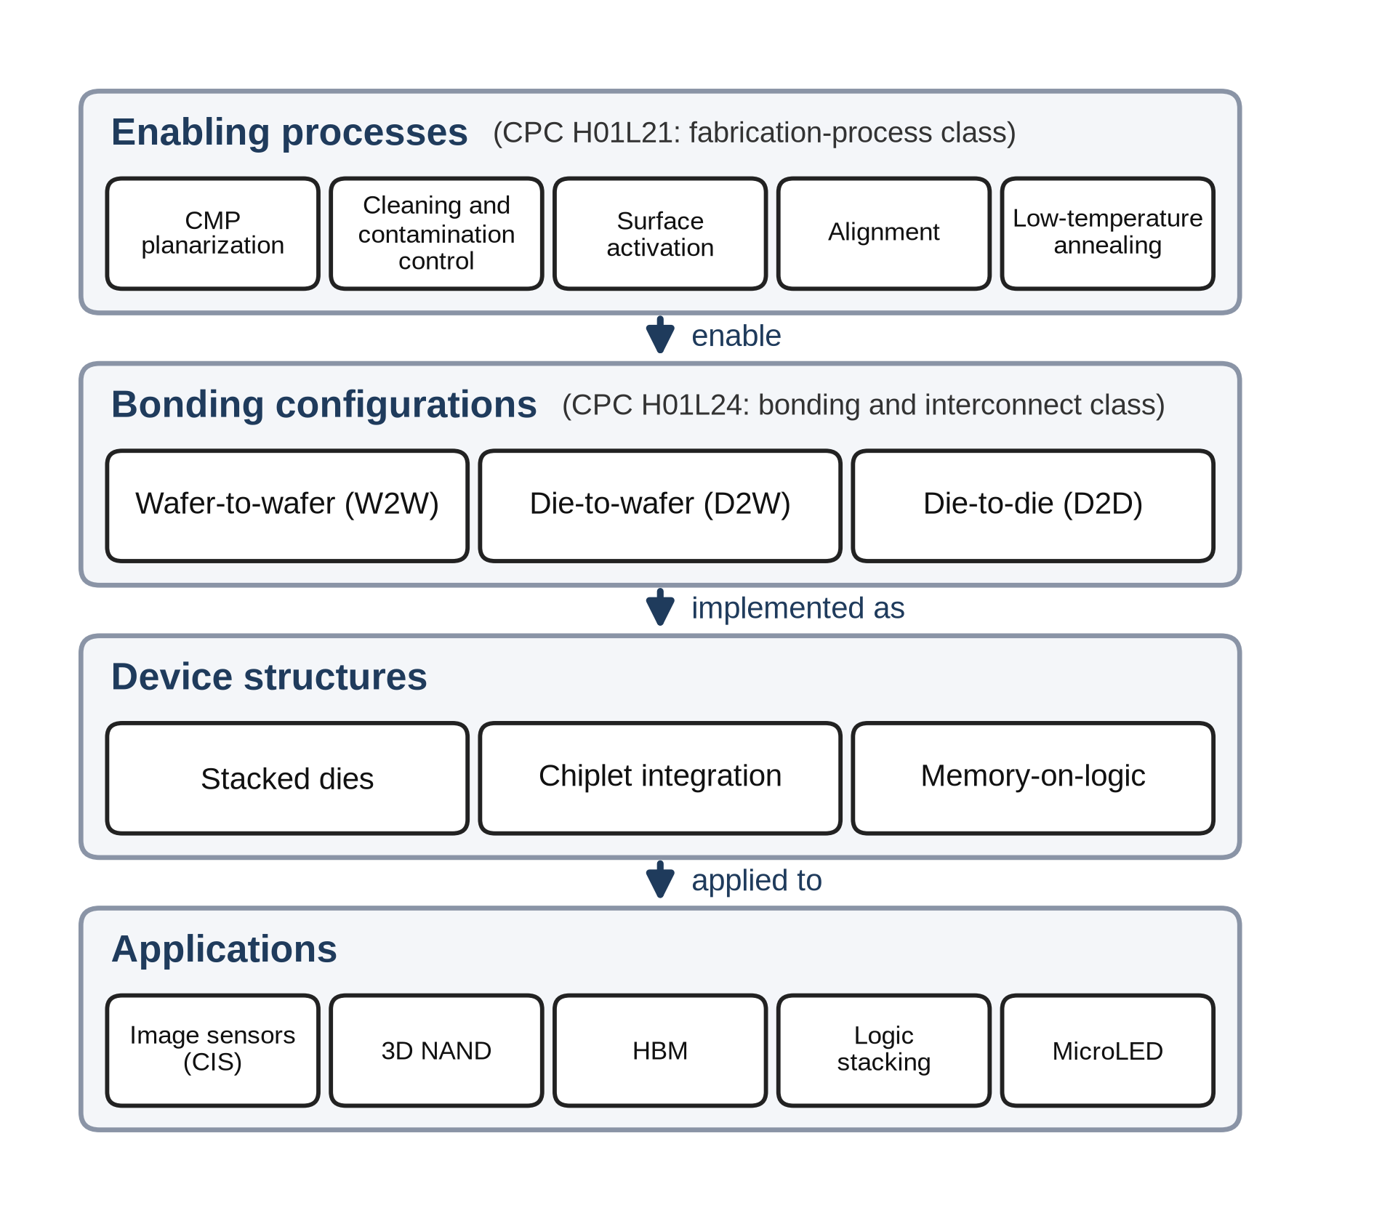
Figure 1. Enabling processes, bonding configurations, device structures, and applications of hybrid bonding (prepared by the authors on the basis of the technical descriptions in Lau (2021, 2022)).

3.2 Interdependence between fabrication processes and bonding technologies
The steps that determine the yield of hybrid bonding—chemical mechanical polishing (CMP), which polishes surfaces to sub-nanometer roughness, plasma surface activation, particle control, and precise alignment—all belong to the semiconductor fabrication-process class (H01L21) of the CPC. The enabling processes in Figure 1 correspond mainly to H01L21, and the bonding configurations and interconnect structures mainly to the bonding and interconnect class (H01L24). In the actual D2W process flow as well, interlayer dielectric deposition, damascene etching, copper barrier and seed deposition, copper plating, and chemical mechanical polishing proceed in sequence before the dies are singulated and bonded, and all of these are processes and equipment used in the front end (Applied Materials, 2025). Hybrid bonding inventions must therefore combine front-end knowledge of planarization, surface chemistry, and alignment with back-end knowledge of die handling, stacking, and packaging, knowledge that has long been divided among different production stages and often among different firms.
The industry landscape shows the same interdependence. According to the industry analysis of KnowMade (2024), the applicants leading patent activity in hybrid bonding are TSMC, Adeia, YMTC, Intel, and Samsung, a group that includes a licensing firm holding foundational technology together with foundries and memory manufacturers that operate advanced packaging directly. The knowledge this technology requires is thus distributed across organizations that were separated by the vertical division of labor, which makes hybrid bonding a suitable case for observing cross-stage knowledge integration.

4. Data and methods

4.1 Data collection
The data were extracted from the 2025 edition of PATSTAT Global of the EPO (European Patent Office, 2025). The search proceeded in two steps (Table A.1 in Appendix A). Applications carrying at least one symbol of the CPC H01L21 (semiconductor fabrication processes) or H01L24 (semiconductor bonding and interconnect technology) classes were first retrieved, and only those whose titles contained at least one keyword related to hybrid bonding (hybrid bonding, direct bonding, Cu–Cu, copper to copper, or metal-oxide bond) were then selected. The final sample consists of 928 applications filed between 1968 and 2024, or 5,277 application–subgroup pairs within H01L21 and H01L24. The sample is not the universe of hybrid bonding patents but the set of related applications identified by this search query, and it was designed broadly to capture not only contemporary hybrid bonding but also the early direct bonding precursor technologies on which it builds. Because symbols outside the two classes were not retained at the extraction stage, the regression data contain 262 subgroup symbols, 202 of the H01L21 class and 60 of the H01L24 class, whereas the technology cluster and network tables in Section 4.4 are based on a separate tabulation of all CPC symbols assigned to the same 928 applications (including the bonding indexing codes H01L2224 and the device assembly class H01L25). The unit of analysis is the individual patent application.
Three characteristics of these data are examined in the robustness analyses (Section 5.4). First, because direct bonding has a broader range of meanings than hybrid bonding, the models were re-estimated on the 467 applications whose titles contain hybrid bonding (hereafter the hybrid bonding sample). Second, the models were re-estimated without 68 applications whose titles use a search term in a different sense (63 for direct bonding and 5 for hybrid bonding), such as direct bonded copper (DBC) substrates, in which copper is bonded to a ceramic substrate, and power modules (Appendix A). Third, because the extracted records do not include patent family identifiers, the same invention filed at several offices is counted as several applications; this was checked with a sample that keeps only the earliest application among those sharing the same title and with standard errors clustered by title. The 928 applications comprise 473 unique titles, of which 149 were filed at two or more offices.

4.2 Operational definitions and measurement
In this study, the theoretical concept is cross-stage technology convergence, that is, the integration of knowledge from two process domains; the observed phenomenon is the inclusion of fabrication-process technology and bonding and interconnect technology in a single application; and the operational indicator is the co-classification of H01L21 and H01L24. From a knowledge perspective, the two classes represent distinct knowledge domains, fabrication-process knowledge and bonding and interconnect knowledge, and an integrated application is an invention that integrates knowledge from both. The two classes are not, however, regarded as the front end and the back end themselves: in addition to wafer fabrication, H01L21 covers packaging-stage fabrication processes such as mounting, encapsulation, and dicing as well as processing apparatus, and H01L24 does not coincide with the boundary of the back-end industry in the organizational sense. The co-classification of the two classes can nevertheless serve as a proxy because many of the wafer preparation, surface treatment, and planarization processes that determine the performance of hybrid bonding are included in H01L21, whereas bonding and interconnect technologies are concentrated in H01L24. The 1,636 H01L21 symbol records in the sample consist of 905 for wafer fabrication (55.3%), 328 for processing apparatus (20.0%), and 403 for packaging-stage processes (24.6%), and the models were also re-estimated under a narrow definition that excludes packaging-stage processes (Section 5.4). Because CPC symbols are assigned by examiners, statements below that an application “contains” a technology mean that a symbol of the corresponding class has been assigned to it; they are not statements about the legal scope of the claims.

4.3 Definition of variables
The variables are defined in Table 1. Technological scope (breadth) represents the diversity of the technical elements assigned to an application within the two classes; it measures neither the extent to which the application extends into fields beyond semiconductors nor the legal scope of its claims. Because the co-classification type and technological scope are derived from the same CPC information, the minimum breadth of an integrated application is two by definition, whereas that of a single-class type is one. To mitigate this difference in mechanical minimums, a type-minimum-adjusted CPC scope was constructed by subtracting one symbol for each class that an application carries (breadth_adj = breadth − I[has H01L21] − I[has H01L24]); because this indicator also uses type information, it is used only as an exploratory robustness indicator. Filing period (period) groups 1968–2014, when filings were sparse, into a single period and divides the subsequent years into five-year periods. Because filing periods and technological composition differ across filing offices, filing office (ccode) is included as a control variable in all models, but its coefficients are not interpreted. Technological scope averages 5.69 symbols (standard deviation 4.07): 7.89 for integrated, 4.16 for bonding-only, and 3.15 for process-only applications. By filing office, there are 382 applications at the US office, 175 at the Chinese office, 113 through the Patent Cooperation Treaty (PCT) route, 83 at the EPO, 75 at the Taiwanese office, 58 at the Korean office, 26 at the Japanese office, and 16 at other offices. Applications were rare before 2010 but surged in the late 2010s and peaked around 2022 (Figure 2).
Table 1. Variable definitions.
Variable | Definition | Type | Interpretive caveat
tech_cat | Co-classification type: bonding-only (H01L24 only) / integrated (both) / process-only (H01L21 only) | Categorical, 3 | Combination of classifications
has_process | 1 if the application carries at least one H01L21 symbol (fabrication-process classification), 0 otherwise | Binary | Classification related to fabrication processes, not the front end itself
breadth | Number of distinct CPC subgroups of the H01L21 and H01L24 classes assigned to an application (within-class CPC scope) | Count, 1–21 | Technological diversity within the two classes, not total CPC scope or the legal scope of the claims
breadth_adj | Type-minimum-adjusted CPC scope: breadth − 1 for single-class types and breadth − 2 for the integrated type | Count, 0–19 | Exploratory indicator that mitigates the mechanical difference in the minimum number of CPC symbols by type
yc | Filing year, measured as years since 1968 (1968 = 0); sample mean 49.7 (2017.7) | Integer, 0–56 | Not a direct measure of technological maturity
period | Filing period: 1968–2014 (reference), 2015–2019, 2020–2024 | Categorical, 3 | The first period is longer than the two later periods
core | 1 if the application carries at least one core bonding symbol (24/03, 24/05, 24/08, 24/80), 0 otherwise (Section 4.4) | Binary | Defined only for applications with H01L24 symbols (N = 763)
ccode | Filing office or route: US (reference), CN, KR, TW, JP, EP, WO (PCT), other | Categorical, 8 | Control variable (not interpreted)
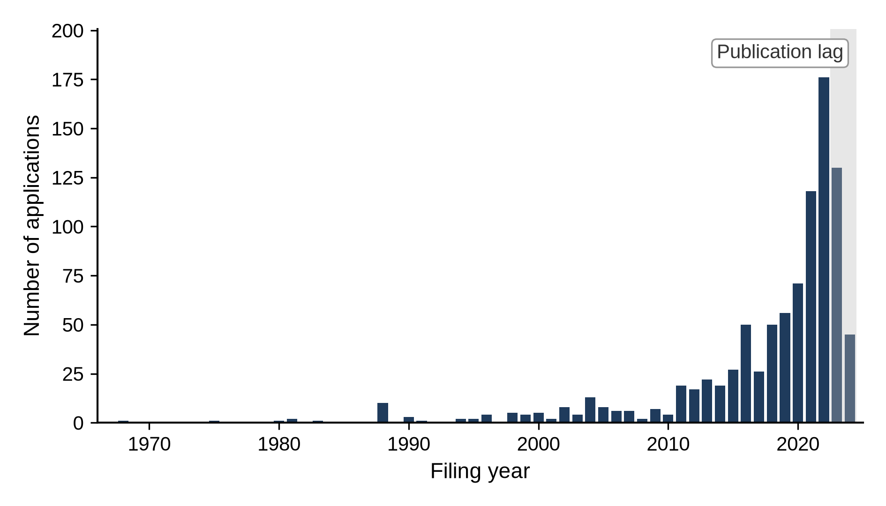
Figure 2. Number of applications related to hybrid bonding by filing year, 1968–2024 (N = 928). The decline in 2023–2024 is likely to have been affected by the lag between filing and publication.

4.4 Identification of core technologies: Technology cluster and technology network
The core technologies were identified with two methods: the technology cluster method, which looks for the symbols that many applications share, and the technology network method, which treats pairs of symbols assigned to the same application as links to capture how the elements combine (Breschi et al., 2003; Sternitzke et al., 2008). In knowledge terms, the core technologies are the core knowledge elements of the hybrid bonding architecture, and the network shows how knowledge elements are combined.
Table 2 lists the 11 CPC symbols assigned to 200 or more of the 928 applications. The symbols assigned to the most applications are 24/80, connection methods using bonding pads (“bonding areas” in CPC terminology; 529 applications, 57.0%), and 24/08, the structure of bonding pads after connection (513 applications, 55.3%), followed by 2224/80895, direct bonding between electrically conductive surfaces (504 applications), and 2224/80896, direct bonding between electrically insulating surfaces (488 applications). Read together, these symbols define hybrid bonding within the classification system as a technology that forms copper-based bonding pads (2224/05647) flush with the surface (2224/80357) and directly bonds the metal (2224/80895) and the dielectric (2224/80896) together (24/08, 24/80) to stack chips vertically without bumps (2224/08145, 25/0657). In the network of all CPC symbols as well, the strongest link is the pair formed by the direct bonding of conductive surfaces and the direct bonding of insulating surfaces (460 applications), and all of the ten strongest pairs are combinations of two of the five symbols 24/08, 24/80, 2224/80895, 2224/80896, and 2224/08145 (Appendix B). The core technologies of hybrid bonding are thus concentrated in a small number of closely linked bonding symbols.
Table 2. Technology cluster: CPC symbols assigned to 200 or more applications (N = 928; shares are relative to the 928 applications).
Rank | CPC symbol | Official definition (summary) | Applications | Share (%) | In regression data
1 | H01L 24/80 | Connection methods using bonding pads | 529 | 57.0 | Yes
2 | H01L 24/08 | Structure, shape, material, or disposition of an individual bonding pad after connection | 513 | 55.3 | Yes
3 | H01L 2224/80895 | Direct bonding between electrically conductive surfaces (e.g., copper–copper) | 504 | 54.3 | No
4 | H01L 2224/80896 | Direct bonding between electrically insulating surfaces (e.g., oxide or nitride layers) | 488 | 52.6 | No
5 | H01L 2224/08145 | Bonding between stacked chips whose bonding pads are connected directly (bumpless) | 436 | 47.0 | No
6 | H01L 25/50 | Multistep manufacturing processes of device assemblies | 363 | 39.1 | No
7 | H01L 24/05 | Structure, shape, material, or disposition of an individual bonding pad before connection | 350 | 37.7 | Yes
8 | H01L 25/0657 | Stacked arrangements of devices | 274 | 29.5 | No
9 | H01L 2224/05647 | Bonding pads with copper as the principal constituent | 239 | 25.8 | No
10 | H01L 24/03 | Manufacturing methods of bonding pads | 222 | 23.9 | Yes
11 | H01L 2224/80357 | Bonding interface flush with the surface | 205 | 22.1 | No
Note: The descriptions summarize the official CPC definitions. “Yes” in the last column marks symbols included in the H01L21 and H01L24 symbol records used in the regression analyses. “No” marks indexing codes (H01L2224) and the device assembly class (H01L25), whose counts come from a separate tabulation of all CPC symbols of the same applications.
Because indexing codes are not included in the regression data, the core technologies used in the analysis were selected from among the H01L24 symbols in the regression data. The four H01L24 symbols assigned to 200 or more applications in Table 2 (24/80, 24/08, 24/05, and 24/03) are also the four symbols with the greatest connection strength (the sum of the numbers of applications in which a symbol is assigned together with other symbols) in the network of the regression data (Figure 3; 3,235, 3,140, 2,518, and 1,778), and the six pairs formed by these four symbols (186–439 applications) are the six strongest links in the entire network. In the CPC scheme, all four symbols belong to the groups concerning bonding pads: 24/03 and 24/05 cover the manufacture of bonding pads and their structure before connection, and 24/08 and 24/80 cover the structure after bonding pads have been connected to one another without separate connectors such as bumps, layers, or wires, and the corresponding connection methods. This study therefore defines these four symbols as the core technologies of hybrid bonding. Connection using layer connectors (24/83), the fifth most frequent H01L24 symbol by number of applications, is assigned to 164 applications and thus falls short of the 200-application threshold. Of the 763 applications carrying H01L24 symbols (hereafter bonding applications), 620 (81.3%) contain the core technologies.
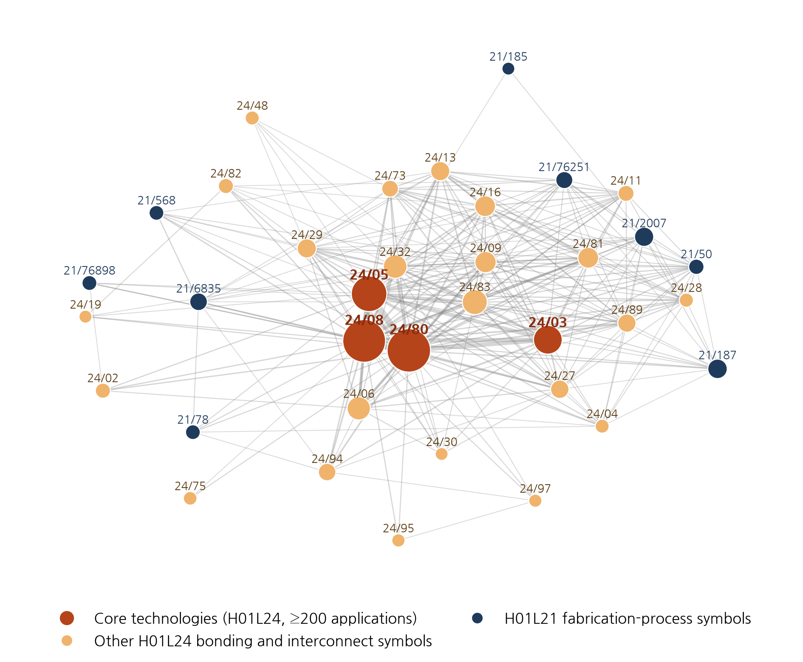
Figure 3. Technology network in the regression data (H01L21 and H01L24 symbols assigned to 30 or more applications; node size indicates the number of applications, and line width indicates the number of applications to which both symbols are assigned, with only links of 10 or more applications shown; the prefix H01L is omitted).

4.5 Analytical methods
This study uses three models, all of which include filing office dummies as control variables. The main model, the co-classification type model, is a multinomial logit (McFadden, 1974) with tech_cat as the dependent variable (N = 928). A multinomial logit is used because the three categories represent different CPC configurations rather than ordered categories, and the results are reported as relative risk ratios (RRRs) of the integrated and process-only types, with bonding-only as the base category. The supplementary fabrication-process classification model is a binary logit with has_process as the dependent variable, and its results are reported as odds ratios (ORs). The explanatory variables of both models are technological scope and filing year. Because ORs and RRRs are not rates of change in probability, average predicted probabilities, obtained by varying only the explanatory variable of interest while holding the other variables at each application’s observed values, are also presented for the multinomial logit.
The core technology model is a binary logit estimated on the 763 bonding applications (425 integrated and 338 bonding-only) with integrated status as the dependent variable (process-only applications cannot, by definition, contain the core technologies). The model is log[P/(1 − P)] = β₀ + β₁·core + Σδ_{t}·period_{t} + Σθ_{t}·(core × period_{t}) + Σγ_{k}·ccode_{k}. The odds ratio of the core technologies is exp(β₁) for applications filed in 1968–2014 and exp(β₁ + θ_{t}) for 2015–2019 and 2020–2024, and exp(θ_{t}) is the ratio of the odds ratio in each period to that in 1968–2014. If the integrated-type advantage of applications containing the core technologies diminished, the odds ratio for 1968–2014 would exceed 1 and θ_{t} would be negative. Filing year is divided into three periods in order to approximate the stages of the technology cycle (Lee et al., 2017), and the standard errors are robust to heteroskedasticity.
The shift in the locus of knowledge integration is examined with two supplementary indicators calculated by period. The first is the Jaccard coefficient (Jaccard, 1912), which measures how often symbols of each of the three fabrication-process domains (wafer fabrication, processing apparatus, and packaging-stage processes) are assigned to the same application as bonding symbols. The second is the period-specific technology network, in which symbols with a large connection strength are regarded as hubs and symbols with high betweenness centrality (Freeman, 1977) as linking symbols that connect different symbols; betweenness centrality is calculated without considering link weights. In knowledge terms, the Jaccard coefficient indicates how strongly each fabrication-process knowledge domain is integrated with bonding knowledge, and betweenness centrality indicates which knowledge domains link the two sides, that is, the locus of integration.
Robustness is examined with the alternative samples and definitions of Sections 4.1–4.3 and with standard errors clustered by title; for the core technology model, a model that controls for the number of bonding symbols other than the core symbols and a definition that restricts the core technologies to the most strongly linked pair of core symbols (24/08 and 24/80) are added. The independence of irrelevant alternatives (IIA) assumed by the multinomial logit is checked with an alternative-exclusion sensitivity analysis (Appendix C). The results are interpreted at the 5% significance level, but the consistency of the direction, magnitude, and significance of the coefficients across the baseline model and the alternative samples and definitions is considered jointly, and all coefficients are interpreted not as causal effects but as conditional associations that control for the observed variables.

5. Results

5.1 Level and forms of knowledge integration (RQ1)
Of all 928 applications, the integrated type accounted for the largest share (425 applications, 45.8%), followed by bonding-only (338, 36.4%) and process-only (165, 17.8%) applications. Under the narrow definition that excludes packaging-stage processes, the integrated share was still 37.2% (Section 5.4). Nearly half of the applications thus integrated knowledge from both process domains within a single invention, so cross-stage convergence was not an exceptional phenomenon.
Table 3 presents the results of the binary logit of fabrication-process classification and the multinomial logit of the co-classification type. In the binary logit, technological scope showed a strong positive association with carrying fabrication-process symbols: each additional CPC subgroup was associated with about 27% higher odds of carrying a fabrication-process symbol (OR 1.267, p < 0.01). The area under the receiver operating characteristic curve (AUC), an indicator of the model’s discriminatory power, is 0.707, at the lower end of the acceptable range according to the criteria of Hosmer et al. (2013). In the main analysis, the multinomial logit, applications that include more diverse technical elements in the fabrication-process and bonding domains were also more likely to be integrated. With each additional CPC subgroup, the relative risk of being integrated rather than bonding-only was 40% higher (RRR 1.403, p < 0.01), and that of being process-only about 10% lower (RRR 0.905, p < 0.05). As the left panel of Figure 4 shows, the predicted probabilities for an application with a technological scope of 3 are 0.26 for integrated, 0.50 for bonding-only, and 0.24 for process-only, whereas those for an application with a technological scope of 8 are 0.68, 0.24, and 0.08, respectively. Applications with a broad scope tend to span the two domains, and those with a narrow scope tend to remain within one domain, which reflects a compositional characteristic: integrated applications include more diverse technical elements.
Table 3. Binary logit of fabrication-process classification and multinomial logit of the co-classification type (N = 928; seven filing office dummies included (coefficients omitted); standard errors of the logit coefficients in parentheses; * p < 0.10, ** p < 0.05, *** p < 0.01).
 | Binary logit: fabrication-process classification (OR) | Multinomial logit: integrated (RRR) | Multinomial logit: process-only (RRR)
Technological scope (breadth) | 1.267*** (0.027) | 1.403*** (0.031) | 0.905** (0.048)
Filing year (yc) | 0.946*** (0.011) | 0.993 (0.015) | 0.913*** (0.015)
Note: The dependent variable of the binary logit is has_process; log-likelihood −547.6, likelihood ratio χ²(9) = 122.0 (p < 0.001), McFadden pseudo-R² = 0.100, Akaike information criterion (AIC) 1,115.1, and AUC 0.707. The base category of the multinomial logit is bonding-only; log-likelihood −774.5, likelihood ratio χ²(18) = 367.4 (p < 0.001), McFadden pseudo-R² = 0.192, and AIC 1,589.0.
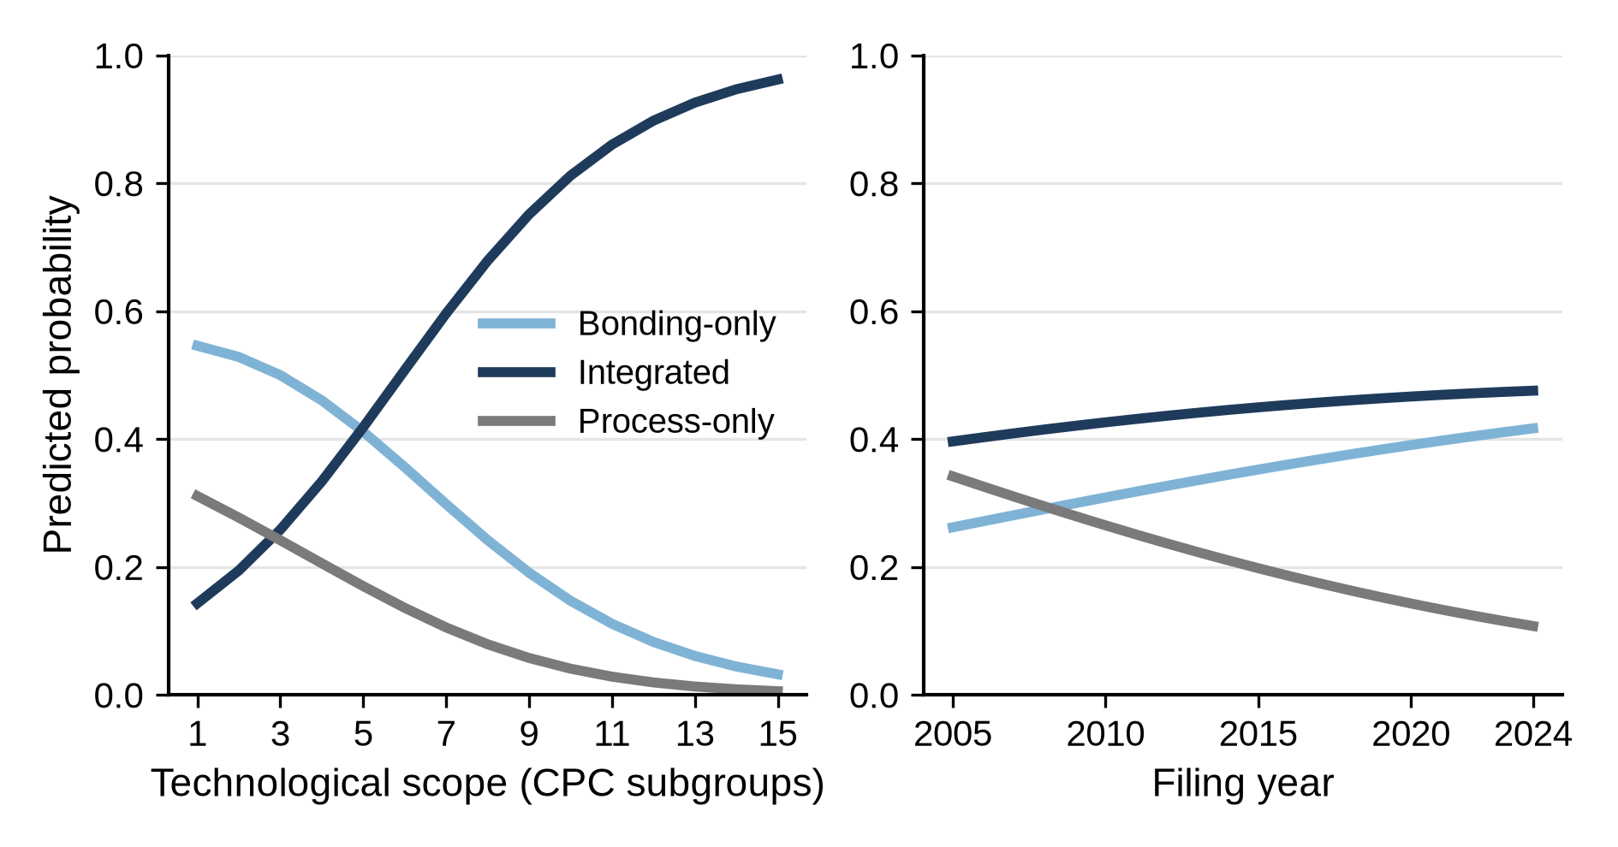
Figure 4. Predicted probabilities of the co-classification types by technological scope (left) and filing year (right) (multinomial logit; other variables held at each application’s observed values and then averaged).

5.2 Temporal change in knowledge integration (RQ2)
The level of knowledge integration differed considerably over time. The years 1968–2014 were grouped into a single period because filings were so sparse that the 47 years produced fewer applications (179) than the following five years (209). As Figure 5 shows, the share of process-only applications declined steadily from 43.6% in 1968–2014 to 14.8% in 2015–2019 and 10.4% in 2020–2024. The integrated share rose sharply from 31.3% to 62.2% and then fell to 44.3%, whereas the bonding-only share, 25.1% and 23.0% in the first two periods, rose to 45.4%. This evolution can be divided into three phases: 1968–2014, when process-only applications were the most common; 2015–2019, when the integrated share peaked; and 2020–2024, when the integrated share declined and the bonding-only share rose to a level similar to that of the integrated type. Hereafter, the three phases are referred to as the formation, diffusion, and reconfiguration phases, respectively. The integration of knowledge from the two process stages thus intensified and then receded rather than accumulating steadily.
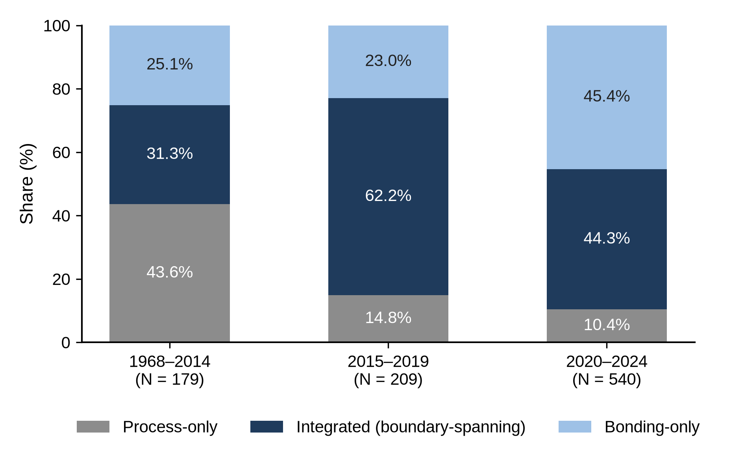
Figure 5. Composition of co-classification types in the three filing periods (N = 928; the first period, 1968–2014, is longer than the two later periods).
The more recent the filing year, the more likely applications were to be classified as bonding-only rather than process-only. In the multinomial logit of Table 3, the relative risk of the process-only type decreased by about 8.7% per year (RRR 0.913, p < 0.01), whereas the relative risk of the integrated type showed no significant linear trend over the entire period (RRR 0.993). The predicted probability of being process-only was 0.27 for applications filed in 2010 but 0.12 for those filed in 2022; over the same period, that of being bonding-only increased from 0.31 to 0.40, whereas that of being integrated barely changed, from 0.43 to 0.47 (Figure 4, right). In the binary logit as well, more recent applications had lower odds of carrying fabrication-process symbols (annual OR 0.946, p < 0.01), mainly because of the decline of the process-only type. In a multinomial logit that includes period dummies instead of a linear year term, the RRR of the process-only type relative to 1968–2014 was likewise 0.273 in 2015–2019 and 0.101 in 2020–2024 (both p < 0.01), whereas that of the integrated type was 1.707 (p = 0.09) and then 0.762 (not significant). In the sample of applications filed in 2010 or later (N = 830), the year coefficient was significantly less than 1 for the integrated type as well (RRR 0.934, p < 0.05). The year coefficient for the integrated type was also significantly less than 1 under the narrow fabrication-process definition (0.967) and in the sample excluding irrelevant uses (0.949) (Table C.1 in Appendix C). The center of gravity of filings thus shifted from fabrication processes toward bonding.
Meanwhile, the association between technological scope and the integrated type persisted in all three phases. When the model was estimated separately for each period, the RRR of technological scope for the integrated type was 1.179 in the formation phase, 1.513 in the diffusion phase, and 1.414 in the reconfiguration phase, all significant at the 1% level (for the first period, filing office dummies were excluded because many filing office cells were empty). Although the integrated share and the center of gravity of filings changed from phase to phase, the characteristic that boundary-spanning patents include more diverse technical elements persisted.

5.3 Shift in the locus of knowledge integration (RQ3)
To determine where in the technological architecture knowledge from the two stages was integrated in each phase, this study analyzed the core technology model (Table 4) and the coupling indicators by fabrication-process domain (Table 5).
Bonding applications containing the core technologies were initially far more likely to be integrated than those without them, but this difference diminished among more recent filings. In the formation phase (1968–2014), 79.6% of the bonding applications containing the core technologies were integrated, compared with only 27.7% of those without them, and the odds ratio of the core technologies, controlling for filing office, was 11.071 (p < 0.01). In the diffusion phase (2015–2019), applications containing the core technologies were still more often classified as integrated (77.1% vs. 57.9%; OR 2.452, p < 0.05), but the odds ratio decreased to 0.221 times that of 1968–2014 (p < 0.05). In the reconfiguration phase (2020–2024), the integrated share of applications containing the core technologies fell to 48.4% and did not differ significantly from that of applications without them (56.9%; OR 0.658, p = 0.15); the odds ratio in this period was 0.059 times that of 1968–2014 (p < 0.01).
Table 4. Core technologies and the integrated type: Shares by filing period and binary logit (applications with H01L24 symbols, N = 763; dependent variable = integrated or not; filing office dummies included; heteroskedasticity-robust standard errors; * p < 0.10, ** p < 0.05, *** p < 0.01).
Filing period | With core technologies: integrated/N (%) | Without core technologies: integrated/N (%) | Odds ratio of core technologies | 95% CI | p
1968–2014 | 43/54 (79.6) | 13/47 (27.7) | 11.071*** | 4.211–29.107 | <0.001
2015–2019 | 108/140 (77.1) | 22/38 (57.9) | 2.452** | 1.158–5.194 | 0.019
2020–2024 | 206/426 (48.4) | 33/58 (56.9) | 0.658 | 0.374–1.160 | 0.148
Note: The odds ratio compares the odds of being integrated for applications with the core technologies with those for applications without them in the same period (the exponentiated sum of the main effect of the core technologies and the interaction for that period). The interactions (multiples relative to 1968–2014) are 0.221 for 2015–2019 (p = 0.016) and 0.059 for 2020–2024 (p < 0.001); the joint Wald test of the two interactions gives χ²(2) = 26.43 (p < 0.001), and the McFadden pseudo-R² is 0.069.
This change originated in the applications containing the core technologies. The integrated share of bonding applications without the core technologies actually rose, whereas that of applications containing them fell. Over the same periods, the share of applications containing the core technologies among bonding applications rose from 53.5% to 78.7% and 88.0%, which suggests that inventive activity converged on a single core design. The fabrication-process symbols assigned together with the core technologies also differed across periods. In integrated applications containing the core technologies, the most frequent H01L21 symbols in 2015–2019 were the joining of semiconductor bodies (21/187; 22 applications) and through-substrate vias (21/76898; 21 applications), whereas those in 2020–2024 were support using temporary substrates (21/6835; 48 applications) and temporary substrates used as encapsulation process aids (21/568; 43 applications). The latter two symbols concern processes for supporting dies and completing them as packages rather than the bonding principle itself.
This shift is also evident in the fabrication-process domains as a whole and in the structure of the technology network (Table 5). The Jaccard coefficient of wafer fabrication with bonding symbols peaked at 0.598 in the diffusion phase and then dropped sharply to 0.159 in the reconfiguration phase, whereas those of processing apparatus and packaging-stage processes rose steadily. From the diffusion phase to the reconfiguration phase, the number of applications in which a domain’s symbols were assigned together with bonding symbols decreased from 119 to 82 for wafer fabrication but increased from 11 to 89 for processing apparatus and from 43 to 139 for packaging-stage processes, so the fabrication-process domain most strongly coupled with bonding changed from wafer fabrication to packaging-stage processes. In the technology network, the three symbols with the greatest connection strength were core symbols (24/80, 24/08, and 24/05) in all three periods, so the core technologies retained their position as hubs. By contrast, the share of total betweenness centrality accounted for by wafer fabrication symbols fell from 53.6% in the formation phase and 42.5% in the diffusion phase to 9.0% in the reconfiguration phase, when processing apparatus symbols accounted for 26.1%. In the reconfiguration phase, the five fabrication-process symbols with the highest betweenness centrality were four processing apparatus symbols (21/67121, apparatus for making assemblies; 21/67766, mechanical parts of transfer devices; 21/67092, apparatus for mechanical treatment; and 21/6835, support using temporary substrates) and one packaging-stage process symbol (21/50), and the direction was the same when betweenness centrality was recalculated with the reciprocals of the link weights as distances. While the core technologies remained hubs, the locus of knowledge integration moved from wafer fabrication to processing apparatus and packaging-stage processes.
Table 5. Coupling strength between the fabrication-process domains and bonding symbols, and hubs and linking symbols of the technology network, by period (N = 928; the numbers in parentheses after the Jaccard coefficients are the numbers of applications carrying both the domain’s symbols and bonding symbols).
Indicator | Formation (1968–2014) | Diffusion (2015–2019) | Reconfiguration (2020–2024)
Jaccard with bonding symbols: wafer fabrication | 0.306 (52) | 0.598 (119) | 0.159 (82)
Jaccard with bonding symbols: processing apparatus | 0.046 (5) | 0.059 (11) | 0.176 (89)
Jaccard with bonding symbols: packaging-stage processes | 0.194 (21) | 0.234 (43) | 0.268 (139)
Share of betweenness centrality (%): wafer fabrication | 53.6 | 42.5 | 9.0
Share of betweenness centrality (%): processing apparatus | 0.0 | 1.8 | 26.1
Share of betweenness centrality (%): packaging-stage processes | 0.3 | 0.6 | 7.3
Share of betweenness centrality (%): bonding symbols (H01L24) | 46.1 | 55.1 | 57.6
Hubs: top three symbols by connection strength | 24/80, 24/05, 24/08 | 24/80, 24/05, 24/08 | 24/08, 24/80, 24/05
Linking symbols: fabrication-process symbols with the highest betweenness centrality | 21/187, 21/76251 | 21/187, 21/2007 | 21/67121, 21/67766
Note: The Jaccard coefficient is the number of applications carrying both the domain’s symbols and bonding symbols divided by the number of applications carrying either. The share of betweenness centrality is the sum of the betweenness centralities of each domain’s symbols as a percentage of the network total in each period-specific technology network, calculated without considering link weights. The linking symbols row lists the two fabrication-process symbols with the highest betweenness centrality in each period; those of the formation and diffusion phases belong to wafer fabrication, and those of the reconfiguration phase to processing apparatus. The prefix H01L is omitted from the symbols.

5.4 Robustness checks
Tables 6 and 7 present the results re-estimated with alternative samples and variable definitions, and the full coefficients of the multinomial logit are presented in Appendix C.
Table 6. Comparison of the re-estimation results of the multinomial logit (RRRs, base category = bonding-only; filing office dummies included; * p < 0.10, ** p < 0.05, *** p < 0.01).
Sample or variable | N | Scope → integrated | Year → process-only
Baseline (Table 3) | 928 | 1.403*** | 0.913***
Baseline + standard errors clustered by title | 928 | 1.403*** | 0.913***
Same-title deduplication (one application per title) | 473 | 1.295*** | 0.935***
Narrow fabrication-process definition (packaging-stage processes excluded) | 908 | 1.352*** | 0.898***
Irrelevant uses excluded (68 applications) | 860 | 1.384*** | 0.820***
hybrid bonding sample (title-based) | 467 | 1.485*** | 1.029
Note: In the clustered standard error row, the point estimates are identical to the baseline, and only the significance is based on clustering by title. The standard errors of the unclustered estimations, the remaining coefficients, and the results for the type-minimum-adjusted CPC scope (breadth_adj) are presented in Appendix C.
In Table 6, the two key coefficients of the multinomial logit were significant at the 1% level in all re-estimations except for the year coefficient in the hybrid bonding sample. With standard errors clustered by title, the only multinomial logit coefficient that lost significance was that of scope for the process-only type (RRR 0.905, p = 0.29), which is not shown in the table. When the model was re-estimated with the type-minimum-adjusted CPC scope (breadth_adj), the RRR for the integrated type decreased from 1.403 to 1.262 but kept its direction, so CPC diversity beyond the minimum composition of each type is also associated with the integrated type. Under the narrow fabrication-process definition (excluding 20 applications for which no symbol remains, N = 908), the type distribution becomes 46.8% bonding-only, 37.2% integrated, and 16.0% process-only, so bonding-only becomes the largest type. The descriptive finding that the integrated type is the largest therefore depends on the definition of fabrication processes. Even under this definition, however, more than one-third of the applications carried symbols of both domains, and the signs and significance of the two key coefficients were unchanged. In the hybrid bonding sample (N = 467), the integrated share was 49.5% and the RRR of technological scope for the integrated type (1.485) was significant, but the year coefficient for the process-only type was not (1.029). The sample contains only 30 applications filed in 1968–2014, and the decline of the process-only type appears largely to reflect a transition from wafer bonding process applications filed when the term direct bonding prevailed to structural applications of the hybrid bonding era, which this sample cannot adequately observe.
Table 7. Comparison of the re-estimation results of the core technology model (applications with H01L24 symbols; period-specific odds ratios of the core technologies; the last column is the 2020–2024 interaction, i.e., the multiple relative to 1968–2014; filing office dummies included; * p < 0.10, ** p < 0.05, *** p < 0.01).
Sample or variable | N | 1968–2014 | 2015–2019 | 2020–2024 | 2020–2024 interaction
Baseline (Table 4) | 763 | 11.071*** | 2.452** | 0.658 | 0.059***
Number of non-core bonding symbols controlled | 763 | 8.768*** | 2.377** | 0.684 | 0.078***
Baseline + standard errors clustered by title | 763 | 11.071*** | 2.452 | 0.658 | 0.059***
Same-title deduplication (one application per title) | 361 | 6.191*** | 4.433*** | 0.814 | 0.131***
Narrow fabrication-process definition (packaging-stage processes excluded) | 763 | 15.334*** | 3.185*** | 0.771 | 0.050***
Irrelevant uses excluded | 712 | 3.981** | 1.817 | 0.738 | 0.185**
Core technologies restricted to 24/08 and 24/80 | 763 | 14.474*** | 3.445*** | 0.732 | 0.051***
Note: Under the narrow fabrication-process definition, integrated applications whose only fabrication-process symbols are packaging-stage process symbols are reclassified as bonding-only, so the sample size is unchanged and the number of integrated applications becomes 338. The hybrid bonding sample was not used for estimation because it contains only 12 bonding applications without the core technologies up to 2019.
In the core technology model, the findings that the odds ratio for 1968–2014 exceeds 1, that the odds ratio for 2020–2024 does not differ significantly from 1, and that the ratio between them (last column) is significantly less than 1 held in all seven estimations (Table 7). Controlling for the number of bonding symbols other than the core symbols (whose own odds ratio is 1.100, p < 0.01) left the direction and significance of the period-specific odds ratios unchanged (from 11.071 to 8.768 for 1968–2014), so the association of the core technologies does not simply reflect applications carrying many bonding symbols. In the sample excluding irrelevant uses, where the results are weakest, the odds ratio for 1968–2014 falls to 3.981, because 28 of the 51 irrelevant applications with bonding symbols were filed in 1968–2014 and lacked the core technologies, and 25 of these were bonding-only. Even in this sample, the odds ratio for 1968–2014 (p < 0.05) and the 2020–2024 interaction (0.185, p < 0.05) were significant. The odds ratio for 2015–2019, however, loses significance with clustered standard errors and in the sample excluding irrelevant uses, so whether the advantage of the core technologies became nonsignificant in the diffusion phase or in the reconfiguration phase is left undetermined. Overall, the key regression result for RQ1 (scope → integrated) and the key results for RQ3 held in all re-estimations, and the temporal trend for RQ2 held in all re-estimations except the hybrid bonding sample, which contains few applications filed in 1968–2014.

6. Discussion

6.1 Theoretical implications
First, knowledge integration occurs not only between different industries but also between process stages within a single industry (RQ1). The literature has treated convergence mainly as a phenomenon between industries or between technological fields (Curran & Leker, 2011; Hacklin et al., 2010; Zhang & Zhang, 2025). The finding that 45.8% of the applications related to hybrid bonding (37.2% under the narrow definition) carry symbols of both domains shows that the technological convergence stage of the stage model also appears in individual inventions at the boundary between process stages of a single industry, where knowledge from vertically separated domains is integrated within inventions. In knowledge terms, this extends the study of knowledge boundaries, which has centered on firm boundaries (Brusoni et al., 2001; Kapoor & Adner, 2012), to vertically separated process domains within an industry. Whereas Kapoor (2013) showed that organizational integration persisted amid the division of labor, this study shows the technological basis of that integration at the level of invention. Such inventions represent an expansion of technological interdependence that may precede the reorganization of the industry architecture (Jacobides et al., 2006), and the hypothesis that the distribution of boundary-spanning patents may serve as a leading indicator of changes in organizational boundaries is left for future research. In addition, boundary-spanning patents included more diverse technical elements, and this association persisted in all three phases, which offers one answer to the question of which inventions embody convergence, a question that field-level indicators could not readily address. This finding is consistent with work on the economic value of patent scope (Lerner, 1994) and on portfolio strategies in fragmented markets for technology (Zhao et al., 2023; Ziedonis, 2004), but it is a compositional association partly built into the definition of the types, not evidence that diversity causes integration (Section 5.4).
Second, cross-stage knowledge integration did not expand linearly but unfolded through three phases of formation, diffusion, and reconfiguration (RQ2). Table 8 summarizes the results in chronological order. If convergence were a simple process of expansion, the share of boundary-spanning patents would be expected to increase over time; instead, process-only applications were the most common in the formation phase and integrated applications in the diffusion phase, and in the reconfiguration phase bonding-only applications increased to a level similar to that of integrated applications. The number of symbols per application followed the same pattern: bonding (H01L24) symbols increased from 3.03 in 1968–2014 to 4.73 in 2015–2019 and then decreased to 3.91 in 2020–2024, whereas fabrication-process (H01L21) symbols, at 2.12 and 2.23 in the first two periods, decreased to 1.46. In terms of the expectations of Section 2.3, the formation phase corresponds to the knowledge convergence stage, in which the fabrication-process knowledge required for bonding accumulates; the diffusion phase to the technological convergence stage, in which knowledge from the two domains is combined within single inventions; and the reconfiguration phase, in which the fabrication processes combined with the core technologies shifted to die support and encapsulation, to a transition toward the applicational convergence stage. The intensity and form of cross-stage knowledge integration were thus reorganized nonlinearly as the technological architecture evolved, which reveals the temporal change in the content of convergence that the stage model (Hacklin et al., 2010) proposed but that had received little empirical attention.
Table 8. Three phases of cross-stage knowledge integration in hybrid bonding (type shares from Figure 5, odds ratios from Table 4, and the share of core technologies and the main fabrication processes from Section 5.3).
Phase (period) | Integrated (%) | Process-only (%) | Bonding-only (%) | Share with core technologies (bonding applications, %) | Odds ratio of core technologies | Main fabrication processes combined with core technologies
Formation (1968–2014) | 31.3 | 43.6 | 25.1 | 53.5 | 11.071*** | —
Diffusion (2015–2019) | 62.2 | 14.8 | 23.0 | 78.7 | 2.452** | Joining of semiconductor bodies (21/187), through-substrate vias (21/76898)
Reconfiguration (2020–2024) | 44.3 | 10.4 | 45.4 | 88.0 | 0.658 | Support using temporary substrates (21/6835), temporary substrates as encapsulation process aids (21/568)
Note: The odds ratio of the core technologies compares the odds of being integrated for bonding applications containing the core technologies with those for bonding applications not containing them (** p < 0.05, *** p < 0.01). The main fabrication processes are the most frequent H01L21 symbols in integrated applications containing the core technologies. For the formation phase, no representative symbol is given because the 43 relevant applications are concentrated in a few groups of applications sharing the same title (even the most frequent symbol appears in only 5 titles).
Third, as the core design became entrenched, the locus of knowledge integration shifted from the core technologies to peripheral processes (RQ3). The finding that the integrated-type advantage of applications containing the core technologies was pronounced in the formation phase but not observed in the reconfiguration phase is consistent with the technology cycle model, according to which, once a dominant design is established, interfaces become entrenched and subsequent innovation shifts to incremental improvement within the established design (Anderson & Tushman, 1990). The finding that inventions dealing with the core no longer incorporated fabrication-process knowledge more often than other bonding inventions, while the share of bonding applications containing the core technologies rose from 53.5% to 88.0%, is in line with Murmann and Frenken’s (2006) argument that once the design of a core element is entrenched, the need to change the elements linked to it diminishes. In light of Henderson and Clark’s (1990) argument that architectural knowledge comes to be taken for granted once a dominant design has been established, the reduced visibility of knowledge integration at the core bonding interface in individual inventions may indicate not that this integration disappeared but that it became embedded in the established design. Indeed, the core symbols remained hubs serving as stable interfaces throughout the three periods, whereas the center of the fabrication processes combined with bonding, and the links between the two, shifted from wafer fabrication to processing apparatus and packaging-stage processes (Table 5). The replacement of wafer fabrication symbols by processing apparatus symbols among the fabrication-process symbols with the highest betweenness centrality in the reconfiguration phase also echoes Rosenberg’s (1963) observation that the convergence of production processes spread through machine tools as production equipment. Here, “peripheral” has the structural meaning of lying outside the core bonding symbols; it does not imply that these processes are less important in volume manufacturing. These results suggest that the maturation of a technological architecture does not eliminate knowledge integration across domains but relocates it from the core bonding interface to the peripheral processes that implement the architecture in new applications, and they show that the coevolutionary logic of Hacklin et al. (2009) also operates within a single technology.

6.2 Practical and policy implications
The finding that many applications contain both fabrication-process and bonding technologies implies that bonding capabilities alone are not sufficient in hybrid bonding and that knowledge of adjacent processes, spanning surface planarization, contamination control, surface chemistry, and alignment, may become increasingly important. Because the boundaries of production and of knowledge do not necessarily coincide (Brusoni et al., 2001; Kapoor & Adner, 2012), firms need to maintain knowledge of adjacent process stages that they do not perform themselves. Moreover, in the reconfiguration phase, inventions containing the core technologies did not carry fabrication-process symbols more often than other bonding inventions, and the most frequent fabrication processes combined with the core technologies were processes for supporting dies and completing them as packages. This suggests that the focus of competition may be shifting from inventing the core bonding principle to inventing applications that combine this principle with die-level processes. For the Korean memory industry, which seeks to introduce hybrid bonding in next-generation HBM stacking, this implies that packaging competitiveness may not depend on the bonding principle alone and that, in addition to fabrication capabilities such as planarization, surface chemistry, and alignment metrology, capabilities in processes for handling and stacking thin dies may be required.

6.3 Limitations and future research
This study has several limitations. First, the H01L21–H01L24 co-classification was used as an observable trace of the integration of knowledge from two process domains within an invention; it does not measure knowledge transfer between organizations, firms’ absorptive capacity, or innovation performance. H01L21 includes packaging-stage fabrication processes, and technological scope is derived from the same CPC information as the types; although the regression results held under the narrow definition, descriptive statistics such as the integrated share depend on the definition. Given that the CPC is revised periodically and earlier applications may be reclassified retroactively, part of the observed temporal change may also reflect changes in the classification system and examination practices. Second, the title keyword search has clear criteria but cannot capture applications whose titles lack relevant terms, and because the data lack patent family identifiers, duplicates were approximated with identical titles, so the independence of observations is not fully guaranteed. Third, the regression data do not include applicants, firm types, nationalities, end-use areas, the distinction between wafer-level and die-level bonding, or CPC symbols outside the two classes. Fourth, this study does not claim causality. Diversity and type are likely to be jointly determined, no suitable instrumental variable is available, and the period division of the core technology analysis approximates the timing of the emergence of a dominant design with filing periods rather than measuring it directly. Because patent applications are generally published 18 months after their priority date, applications from the most recent years are not yet fully observed (Figure 2). In addition, the boundaries of the three periods were set in light of the concentration of filings rather than estimated from the data. The results for the reconfiguration phase should therefore be interpreted with the truncation of recent filings in mind, and examination under alternative period divisions is left for future work. Fifth, CPC co-classification is reproducible but is assigned later than the invention itself. Text-based methods (Lei et al., 2019; Preschitschek et al., 2013; Zhu & Motohashi, 2022) allow earlier detection but depend on trained models, so this study, in which the boundary between H01L21 and H01L24 is institutionally clear, prioritized reproducibility.
Future research could apply the same two-class rule and discrete choice models to other process technologies in which downstream stages have begun to depend on upstream capabilities, such as advanced lithography in displays, cell-to-pack integration in batteries, and additive manufacturing in aerospace assembly, to test whether the formation–diffusion–reconfiguration pattern is general. Representations that preserve higher-order co-occurrence, or generality indices (Petralia, 2020), could also be used to test directly the general-purpose character of hybrid bonding as it diffuses into logic, memory, and image sensors.

7. Conclusion
Technology convergence has been studied mainly as the combination of industries and as a question of whether the degree of convergence has increased. If convergence is understood as the integration of knowledge from previously separate domains, however, it can also occur between the stages of the value chain within a single industry. This study classified 928 applications related to hybrid bonding into three types according to their CPC co-classification and analyzed the level and forms of cross-stage knowledge integration, its temporal change, and shifts in its locus at the level of individual applications.
The integrated type accounted for the largest share, 45.8%, and still accounted for 37.2% under the narrow definition, and applications including more diverse technical elements were more likely to cross the boundary (RQ1). Knowledge integration changed through a formation phase dominated by process-only applications, a diffusion phase in which the integrated share peaked, and a reconfiguration phase in which the integrated share declined and the bonding-only share increased, and the center of gravity of filings shifted from fabrication processes toward bonding (RQ2). The odds that applications containing the core technologies also carried fabrication-process classifications were 11.1 times those of other bonding applications in the formation phase, but the difference was not significant in the reconfiguration phase, and the center of the fabrication processes combined with bonding shifted from wafer fabrication to processing apparatus and packaging-stage processes (RQ3). As the technological architecture matured, the integration of knowledge from the two process stages did not disappear but relocated from the core bonding interface to the peripheral processes that implement the architecture.
This study extends the scope of technology convergence research to convergence between process stages within the same industry and recasts co-classification as types of individual patents, linking patent-level heterogeneity and its temporal change to core technologies identified through technology cluster and network analyses. By tracing how knowledge from vertically separated process domains is integrated in inventions and where this integration takes place as a technology matures, it links research on technological innovation with research on knowledge integration across knowledge boundaries.

Data availability
The patent data were extracted from PATSTAT Global, a licensed database of the European Patent Office, and cannot be redistributed. The application identifiers and the analysis code are available from the corresponding author upon reasonable request.

Declaration of generative AI and AI-assisted technologies in the manuscript preparation process
During the preparation of this work, the authors used Claude (Anthropic) to condense the thesis manuscript into journal length, to translate the manuscript from Korean into English, and to edit the language. After using this tool, the authors reviewed and edited the content as needed and take full responsibility for the content of the published article.

References
Anderson, P., & Tushman, M. L. (1990). Technological discontinuities and dominant designs: A cyclical model of technological change. Administrative Science Quarterly, 35(4), 604–633. https://doi.org/10.2307/2393511
Applied Materials. (2025). Kinex integrated die-to-wafer hybrid bonding system [Press release, in Korean; written by J. Kim]. Retrieved October 12, 2026, from https://www.appliedmaterials.com/kr/ko/newsroom/press-releases/251126-next-gen-semi-equipment-ko.html
Arden, W., Brillouët, M., Cogez, P., Graef, M., Huizing, B., & Mahnkopf, R. (2010). “More-than-Moore” white paper. International Technology Roadmap for Semiconductors (ITRS).
Breschi, S., Lissoni, F., & Malerba, F. (2003). Knowledge-relatedness in firm technological diversification. Research Policy, 32(1), 69–87. https://doi.org/10.1016/S0048-7333(02)00004-5
Bröring, S., Cloutier, L. M., & Leker, J. (2006). The front end of innovation in an era of industry convergence: Evidence from nutraceuticals and functional foods. R&D Management, 36(5), 487–498. https://doi.org/10.1111/j.1467-9310.2006.00449.x
Brown, C., & Linden, G. (2009). Chips and change: How crisis reshapes the semiconductor industry. MIT Press.
Brusoni, S., Prencipe, A., & Pavitt, K. (2001). Knowledge specialization, organizational coupling, and the boundaries of the firm: Why do firms know more than they make? Administrative Science Quarterly, 46(4), 597–621. https://doi.org/10.2307/3094825
Caviggioli, F. (2016). Technology fusion: Identification and analysis of the drivers of technology convergence using patent data. Technovation, 55–56, 22–32. https://doi.org/10.1016/j.technovation.2016.04.003
Cho, Y., & Kim, M. (2014). Entropy and gravity concepts as new methodological indexes to investigate technological convergence: Patent network-based approach. PLOS ONE, 9(6), e98009. https://doi.org/10.1371/journal.pone.0098009
Choi, S., Afifuddin, M., & Seo, W. (2022). A supervised learning-based approach to anticipating potential technology convergence. IEEE Access, 10, 19284–19300. https://doi.org/10.1109/ACCESS.2022.3151870
Curran, C.-S., Bröring, S., & Leker, J. (2010). Anticipating converging industries using publicly available data. Technological Forecasting and Social Change, 77(3), 385–395. https://doi.org/10.1016/j.techfore.2009.10.002
Curran, C.-S., & Leker, J. (2011). Patent indicators for monitoring convergence – Examples from NFF and ICT. Technological Forecasting and Social Change, 78(2), 256–273. https://doi.org/10.1016/j.techfore.2010.06.021
European Patent Office. (2025). PATSTAT Global (2025 edition) [Database]. EPO.
Fleming, L. (2001). Recombinant uncertainty in technological search. Management Science, 47(1), 117–132. https://doi.org/10.1287/mnsc.47.1.117.10671
Freeman, L. C. (1977). A set of measures of centrality based on betweenness. Sociometry, 40(1), 35–41. https://doi.org/10.2307/3033543
Gambardella, A., & Torrisi, S. (1998). Does technological convergence imply convergence in markets? Evidence from the electronics industry. Research Policy, 27(5), 445–463. https://doi.org/10.1016/S0048-7333(98)00062-6
Geum, Y., Kim, M.-S., & Lee, S. (2016). How industrial convergence happens: A taxonomical approach based on empirical evidences. Technological Forecasting and Social Change, 107, 112–120. https://doi.org/10.1016/j.techfore.2016.03.020
Grant, R. M. (1996). Toward a knowledge-based theory of the firm. Strategic Management Journal, 17(S2), 109–122. https://doi.org/10.1002/smj.4250171110
Hacklin, F., Marxt, C., & Fahrni, F. (2009). Coevolutionary cycles of convergence: An extrapolation from the ICT industry. Technological Forecasting and Social Change, 76(6), 723–736. https://doi.org/10.1016/j.techfore.2009.03.003
Hacklin, F., Marxt, C., & Fahrni, F. (2010). An evolutionary perspective on convergence: Inducing a stage model of inter-industry innovation. International Journal of Technology Management, 49(1–3), 220–249. https://doi.org/10.1504/IJTM.2010.029419
Hall, B. H., & Ziedonis, R. H. (2001). The patent paradox revisited: An empirical study of patenting in the U.S. semiconductor industry, 1979–1995. RAND Journal of Economics, 32(1), 101–128. https://doi.org/10.2307/2696400
Henderson, R. M., & Clark, K. B. (1990). Architectural innovation: The reconfiguration of existing product technologies and the failure of established firms. Administrative Science Quarterly, 35(1), 9–30. https://doi.org/10.2307/2393549
Hosmer, D. W., Lemeshow, S., & Sturdivant, R. X. (2013). Applied logistic regression (3rd ed.). Wiley.
Hwang, I. (2020). The effect of collaborative innovation on ICT-based technological convergence: A patent-based analysis. PLOS ONE, 15(2), e0228616. https://doi.org/10.1371/journal.pone.0228616
Iyer, S. S. (2016). Heterogeneous integration for performance and scaling. IEEE Transactions on Components, Packaging and Manufacturing Technology, 6(7), 973–982. https://doi.org/10.1109/TCPMT.2015.2511626
Jaccard, P. (1912). The distribution of the flora in the alpine zone. New Phytologist, 11(2), 37–50. https://doi.org/10.1111/j.1469-8137.1912.tb05611.x
Jacobides, M. G., Knudsen, T., & Augier, M. (2006). Benefiting from innovation: Value creation, value appropriation and the role of industry architectures. Research Policy, 35(8), 1200–1221. https://doi.org/10.1016/j.respol.2006.09.005
Jeong, S., Kim, J.-C., & Choi, J. Y. (2015). Technology convergence: What developmental stage are we in? Scientometrics, 104(3), 841–871. https://doi.org/10.1007/s11192-015-1606-6
Kapoor, R. (2013). Persistence of integration in the face of specialization: How firms navigated the winds of disintegration and shaped the architecture of the semiconductor industry. Organization Science, 24(4), 1195–1213. https://doi.org/10.1287/orsc.1120.0802
Kapoor, R., & Adner, R. (2012). What firms make vs. what they know: How firms’ production and knowledge boundaries affect competitive advantage in the face of technological change. Organization Science, 23(5), 1227–1248. https://doi.org/10.1287/orsc.1110.0686
Karvonen, M., & Kässi, T. (2012). Industry convergence analysis with patent citations in changing value systems. International Journal of Business and Systems Research, 6(2), 150–175. https://doi.org/10.1504/IJBSR.2012.046353
Khan, H. N., Hounshell, D. A., & Fuchs, E. R. H. (2018). Science and research policy at the end of Moore’s law. Nature Electronics, 1(1), 14–21. https://doi.org/10.1038/s41928-017-0005-9
KnowMade. (2024). Hybrid bonding patent landscape analysis 2024 [Industry report]. KnowMade (Yole Group). https://www.knowmade.com/patent-analytics-services/patent-report/semiconductor-patent-landscape/semiconductor-advanced-packaging-patent-landscape/hybrid-bonding-patent-landscape-analysis-2024/
Kodama, F. (1992). Technology fusion and the new R&D. Harvard Business Review, 70(4), 70–78.
Kwon, O., An, Y., Kim, M., & Lee, C. (2020). Anticipating technology-driven industry convergence: Evidence from large-scale patent analysis. Technology Analysis & Strategic Management, 32(4), 363–378. https://doi.org/10.1080/09537325.2019.1661374
Langlois, R. N., & Steinmueller, W. E. (1999). The evolution of competitive advantage in the worldwide semiconductor industry, 1947–1996. In D. C. Mowery & R. R. Nelson (Eds.), Sources of industrial leadership: Studies of seven industries (pp. 19–78). Cambridge University Press.
Lau, J. H. (2021). State-of-the-art and outlooks of chiplets heterogeneous integration and hybrid bonding. Journal of Microelectronics and Electronic Packaging, 18(4), 145–160. https://doi.org/10.4071/imaps.1542066
Lau, J. H. (2022). Recent advances and trends in advanced packaging. IEEE Transactions on Components, Packaging and Manufacturing Technology, 12(2), 228–252. https://doi.org/10.1109/TCPMT.2022.3144461
Lee, C., Kim, J., Noh, M., Woo, H., & Gang, K. (2017). Patterns of technology life cycles: Stochastic analysis based on patent citations. Technology Analysis & Strategic Management, 29(1), 53–67. https://doi.org/10.1080/09537325.2016.1194974
Lee, W. S., Han, E. J., & Sohn, S. Y. (2015). Predicting the pattern of technology convergence using big-data technology on large-scale triadic patents. Technological Forecasting and Social Change, 100, 317–329. https://doi.org/10.1016/j.techfore.2015.07.022
Lei, L., Qi, J., & Zheng, K. (2019). Patent analytics based on feature vector space model: A case of IoT. IEEE Access, 7, 45705–45715. https://doi.org/10.1109/ACCESS.2019.2909123
Lerner, J. (1994). The importance of patent scope: An empirical analysis. RAND Journal of Economics, 25(2), 319–333. https://doi.org/10.2307/2555833
Macher, J. T., & Mowery, D. C. (2004). Vertical specialization and industry structure in high technology industries. In J. A. C. Baum & A. M. McGahan (Eds.), Business strategy over the industry lifecycle (Advances in Strategic Management, Vol. 21, pp. 317–355). Emerald. https://doi.org/10.1016/S0742-3322(04)21011-7
McFadden, D. (1974). Conditional logit analysis of qualitative choice behavior. In P. Zarembka (Ed.), Frontiers in econometrics (pp. 105–142). Academic Press.
Murmann, J. P., & Frenken, K. (2006). Toward a systematic framework for research on dominant designs, technological innovations, and industrial change. Research Policy, 35(7), 925–952. https://doi.org/10.1016/j.respol.2006.04.011
No, H. J., & Park, Y. (2010). Trajectory patterns of technology fusion: Trend analysis and taxonomical grouping in nanobiotechnology. Technological Forecasting and Social Change, 77(1), 63–75. https://doi.org/10.1016/j.techfore.2009.06.006
Petralia, S. (2020). Mapping general purpose technologies with patent data. Research Policy, 49(7), 104013. https://doi.org/10.1016/j.respol.2020.104013
Preschitschek, N., Niemann, H., Leker, J., & Moehrle, M. G. (2013). Anticipating industry convergence: Semantic analyses vs IPC co-classification analyses of patents. Foresight, 15(6), 446–464. https://doi.org/10.1108/FS-10-2012-0075
Rosenberg, N. (1963). Technological change in the machine tool industry, 1840–1910. Journal of Economic History, 23(4), 414–443. https://doi.org/10.1017/S0022050700109155
Sick, N., & Bröring, S. (2022). Exploring the research landscape of convergence from a TIM perspective: A review and research agenda. Technological Forecasting and Social Change, 175, 121321. https://doi.org/10.1016/j.techfore.2021.121321
Song, C. H., Elvers, D., & Leker, J. (2017). Anticipation of converging technology areas – A refined approach for the identification of attractive fields of innovation. Technological Forecasting and Social Change, 116, 98–115. https://doi.org/10.1016/j.techfore.2016.11.001
Sternitzke, C., Bartkowski, A., & Schramm, R. (2008). Visualizing patent statistics by means of social network analysis tools. World Patent Information, 30(2), 115–131. https://doi.org/10.1016/j.wpi.2007.08.003
Whang, Y.-K. (2018). Convergence processes in the mobile communication processor. Technology Analysis & Strategic Management, 30(11), 1338–1350. https://doi.org/10.1080/09537325.2018.1461206
Yun, J., & Geum, Y. (2019). Analysing the dynamics of technological convergence using a co-classification approach: A case of healthcare services. Technology Analysis & Strategic Management, 31(12), 1412–1429. https://doi.org/10.1080/09537325.2019.1616082
Zhang, Z., & Zhang, Q. (2025). Bridging the digital and green divide: Technology convergence and productivity in innovative manufacturing. Journal of Innovation & Knowledge, 10(6), 100848. https://doi.org/10.1016/j.jik.2025.100848
Zhao, X., Guo, Y., & Mi, J. (2023). Value creation and value capture from patents: Theory and implications for patent strategies. Journal of Innovation & Knowledge, 8(3), 100397. https://doi.org/10.1016/j.jik.2023.100397
Zhu, C., & Motohashi, K. (2022). Identifying the technology convergence using patent text information: A graph convolutional networks (GCN)-based approach. Technological Forecasting and Social Change, 176, 121477. https://doi.org/10.1016/j.techfore.2022.121477
Ziedonis, R. H. (2004). Don’t fence me in: Fragmented markets for technology and the patent acquisition strategies of firms. Management Science, 50(6), 804–820. https://doi.org/10.1287/mnsc.1040.0208

Appendix

Appendix A. Sample construction: Search strategy and irrelevant uses of the search terms
Table A.1 presents the search strategy for patents related to hybrid bonding.
Table A.1. Search strategy for patents related to hybrid bonding.
Step | Condition | Content
Step 1: CPC | H01L21 | Semiconductor fabrication-process technology, including direct wafer bonding (21/18, 21/20), device isolation, interconnects, and through-substrate vias (21/76), substrate and insulating-layer treatment (21/02), and chemical mechanical polishing (21/30–21/32); also includes packaging-stage fabrication processes (21/48, 21/50–21/58, 21/60, 21/78) and processing apparatus (21/67–21/68)
Step 1: CPC | H01L24 | Connector structures for connecting or disconnecting semiconductor or solid-state bodies, bump, layer, and wire connections, and related connecting methods and apparatus
Step 2: Keyword | Title | At least one of hybrid bonding, direct bonding, Cu–Cu, copper to copper, and metal-oxide bond
Note: Step 1 requires at least one of the two classes, and Step 2 at least one of the keywords; both conditions must be met. The indexing codes of the two classes (e.g., H01L2224) were also used in the search, but because only the symbols of the classes proper were retained in the extracted records, indexing codes are not included in the calculation of technological scope.
The search terms of the keyword filter are also used in senses unrelated to hybrid bonding. Most such cases use direct bonding in a different sense, and a few use hybrid bonding in the sense of chemical bonding or bonding sheets for power modules. Applications whose titles contain the following terms were judged to be irrelevant uses: ceramic, DBC (direct bonded copper), alumina, zirconia, and aluminum nitride substrates; copper alloys; diamond–molybdenum bonding; laser precursors; electrostatic chucks; power module and power device substrates; heat spreaders; direct bonded metal substrates; direct bonded circuit assemblies; and sp3–sp2 hybrid bonds (in the sense of chemical bonding). These applications number 68 (63 for direct bonding and 5 for hybrid bonding), and their distribution is shown in Table A.2. Many of the applications filed before 2010 that remain after the irrelevant uses are excluded concern direct bonding of silicon wafers (e.g., for manufacturing silicon-on-insulator wafers); they were retained in the sample because they are precursor technologies of the dielectric bonding that forms part of hybrid bonding. The list of the titles of the 68 applications is available from the authors upon request.
Table A.2. Distribution of the 68 applications judged to be irrelevant uses.
Category | Applications
Type: bonding-only | 34
Type: integrated | 17
Type: process-only | 17
Filing period: 1968–2014 | 36
Filing period: 2015–2024 | 32

Appendix B. Strongest links of the technology network
Table B.1 lists the ten symbol pairs most frequently assigned together in the network of all CPC symbols assigned to the 928 applications. The network consists of CPC symbols as nodes and of undirected links between any two different symbols assigned to the same application, and the weight of a link is the number of applications to which both symbols are assigned. The strongest link, between the direct bonding of conductive surfaces and the direct bonding of insulating surfaces, directly reflects the principle of hybrid bonding, which bonds both the metal and the dielectric.
Table B.1. Technology network: Symbol pairs most frequently assigned together (N = 928; top 10 pairs).
Rank | Symbol pair | Content | Applications
1 | 2224/80895 – 2224/80896 | Direct bonding of conductive surfaces – direct bonding of insulating surfaces | 460
2 | 24/08 – 24/80 | Bonding pad after connection – connection methods using bonding pads | 439
3 | 24/80 – 2224/80895 | Connection methods using bonding pads – direct bonding of conductive surfaces | 434
4 | 24/08 – 2224/80895 | Bonding pad after connection – direct bonding of conductive surfaces | 420
5 | 24/80 – 2224/80896 | Connection methods using bonding pads – direct bonding of insulating surfaces | 418
6 | 24/08 – 2224/80896 | Bonding pad after connection – direct bonding of insulating surfaces | 395
7 | 24/08 – 2224/08145 | Bonding pad after connection – bumpless bonding of stacked chips | 392
8 | 24/80 – 2224/08145 | Connection methods using bonding pads – bumpless bonding of stacked chips | 392
9 | 2224/08145 – 2224/80895 | Bumpless bonding of stacked chips – direct bonding of conductive surfaces | 379
10 | 2224/08145 – 2224/80896 | Bumpless bonding of stacked chips – direct bonding of insulating surfaces | 368
Note: The prefix H01L is omitted from the symbols. The application count for the second-ranked pair (24/08 – 24/80) is identical when recounted from the regression data.

Appendix C. Full re-estimation results
Tables C.1 and C.2 present the full coefficients of the re-estimations summarized in Table 6 (except the clustered-standard-error row, whose point estimates equal the baseline), with the adjusted-scope specification and the 2010–2024 sample added. Each column is a multinomial logit in which one sample or variable definition is changed, and the baseline column is identical to the multinomial logit of Table 3. Filing office dummies are included as control variables in all columns, but their coefficients are omitted. Adjusted scope refers to the type-minimum-adjusted CPC scope (breadth_adj), which subtracts one symbol for each class an application carries; same-title deduplication to the sample that keeps only the earliest application among those with the same title; the narrow fabrication-process definition to the variable that excludes the packaging-stage process symbols of H01L21 from fabrication processes; irrelevant uses excluded to the sample without the 68 applications of Appendix A; and the hybrid bonding sample to the sample that keeps only applications whose titles contain hybrid bonding. The 2010–2024 sample is the sample of applications filed in 2010 or later mentioned in Section 5.2.
Table C.1. Integrated-type equation of the multinomial logit: Relative risk ratios by sample and variable (base category = bonding-only; filing office dummies included; standard errors of the logit coefficients in parentheses; * p < 0.10, ** p < 0.05, *** p < 0.01).
 | Baseline | Adjusted scope | Same-title deduplication | Narrow fabrication-process definition | Irrelevant uses excluded | hybrid bonding sample | 2010–2024
Technological scope | 1.403*** (0.031) | 1.262*** (0.027) | 1.295*** (0.039) | 1.352*** (0.028) | 1.384*** (0.031) | 1.485*** (0.044) | 1.385*** (0.032)
Filing year (yc) | 0.993 (0.015) | 1.002 (0.014) | 0.997 (0.018) | 0.967** (0.015) | 0.949** (0.022) | 0.965 (0.033) | 0.934** (0.027)
N | 928 | 928 | 473 | 908 | 860 | 467 | 830
Log-likelihood | −774.5 | −829.4 | −425.3 | −755.9 | −682.7 | −364.0 | −683.0
Table C.2. Process-only-type equation of the multinomial logit: Relative risk ratios by sample and variable (base category = bonding-only; filing office dummies included; standard errors of the logit coefficients in parentheses; * p < 0.10, ** p < 0.05, *** p < 0.01).
 | Baseline | Adjusted scope | Same-title deduplication | Narrow fabrication-process definition | Irrelevant uses excluded | hybrid bonding sample | 2010–2024
Technological scope | 0.905** (0.048) | 0.915** (0.044) | 0.826*** (0.061) | 0.923* (0.045) | 0.916* (0.050) | 1.129* (0.062) | 0.910* (0.051)
Filing year (yc) | 0.913*** (0.015) | 0.911*** (0.015) | 0.935*** (0.016) | 0.898*** (0.015) | 0.820*** (0.023) | 1.029 (0.057) | 0.862*** (0.033)
N | 928 | 928 | 473 | 908 | 860 | 467 | 830
Log-likelihood | −774.5 | −829.4 | −425.3 | −755.9 | −682.7 | −364.0 | −683.0
Alternative-exclusion sensitivity analysis. To examine indirectly the sensitivity to the IIA assumption, a binary logit of integrated versus bonding-only was estimated on the sample excluding the process-only type (N = 763). The odds ratio of technological scope was 1.463 and that of filing year 0.987, similar in direction and relative magnitude to the values in the integrated-type equation of the multinomial logit (1.403 and 0.993). The substantive interpretation of the results for the integrated type can thus be regarded as largely unchanged when the process-only type is excluded, although this analysis does not replace a formal IIA test (Hausman–McFadden or Small–Hsiao). The core technology model in the main text also uses this sample.

