Supplementary material
Front-end/back-end technological convergence in semiconductor hybrid bonding patents: Determinants of boundary-spanning patents and jurisdictional strategy differentiation
Source of the robustness analyses in Section 5.4 of the main text. Raw data: 5,277 application–CPC records (928 applications) extracted from EPO PATSTAT. Estimation: Python statsmodels (NegativeBinomial, Logit, MNLogit; identical specifications to Stata nbreg/logit/mlogit). The baseline estimates (main-text Tables 4–6) match the original Stata analysis to three decimal places. Standard errors in the tables below are those of the log-scale coefficients (the parentheses in main-text Tables 5 and 6 are delta-method standard errors on the ratio scale), and significance is from z tests on the log scale. * p < 0.10, ** p < 0.05, *** p < 0.01. The office reference is the US office, and the outcome base category of the multinomial logit is assembly-only.

S0. Period distribution and diagnostic figures
Table S1. Strategy-type distribution by period (N = 928; row shares in parentheses).
Filing period | Assembly-only | Integrated (boundary-spanning) | Process-only | N | Front-end oriented (%)
to 2014 | 45 (25.1%) | 56 (31.3%) | 78 (43.6%) | 179 | 74.9
2015–2019 | 48 (23.0%) | 130 (62.2%) | 31 (14.8%) | 209 | 77.0
2020–2024 | 245 (45.4%) | 239 (44.3%) | 56 (10.4%) | 540 | 54.6
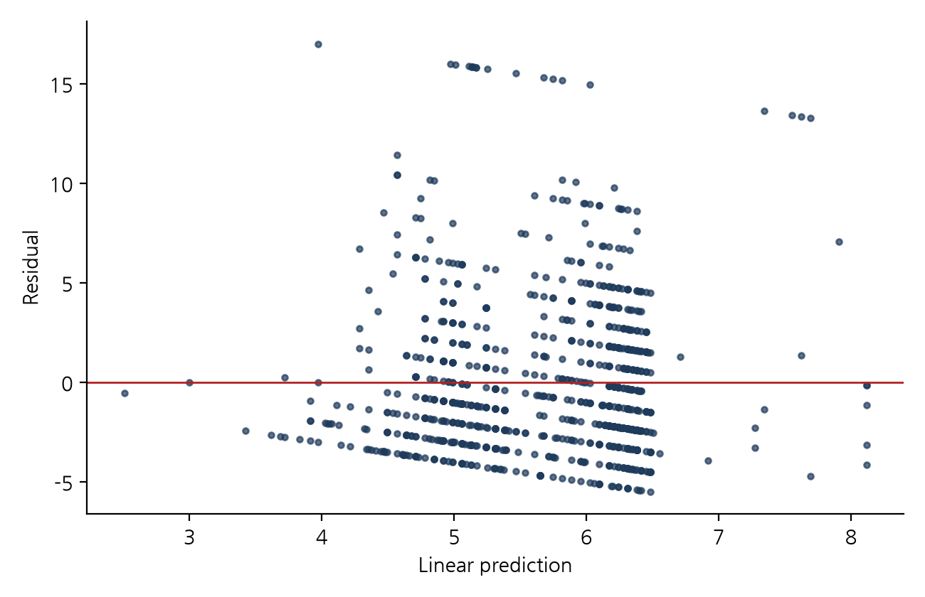
Figure S1. OLS residuals versus fitted values (N = 928).
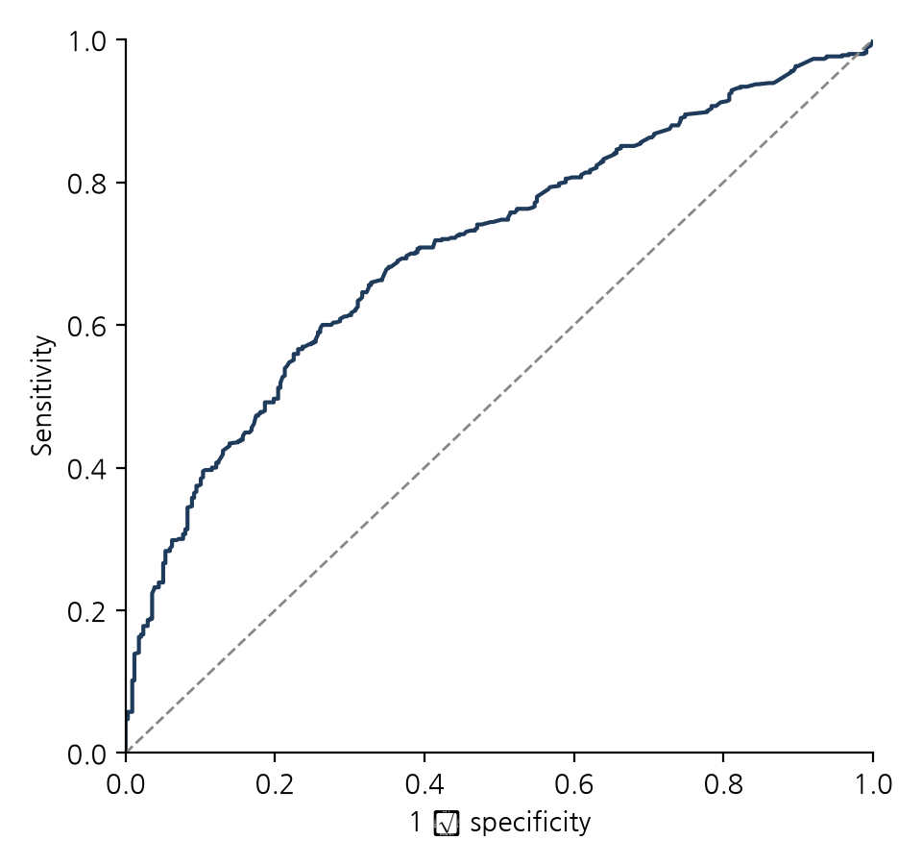
Figure S2. ROC curve of the front-end-orientation logit (AUC = 0.707).

S1. Full robustness estimates

S1.0 Data structure and diagnostics
- The CPC symbols in the extracted file belong to two classes only, H01L21/* and H01L24/* (262 unique symbols). Other classes (for example the H01L2224 indexing codes) were not retained at extraction, so technological scope is the number of unique subgroups within the two classes.
- Main-group composition of the 1,636 H01L21 records: wafer-fabrication groups 905, equipment and handling groups (21/67–21/68) 328, assembly-stage groups (21/48, 21/50–21/58, 21/60, 21/78) 403.
- OLS residual heteroskedasticity: Breusch–Pagan (all regressors) χ²(8) = 99.6, p < 0.001; Koenker version LM = 39.7, p < 0.001. The auxiliary regression on fitted values only (Stata estat hettest default) does not reject (χ²(1) = 0.90, p = 0.34).
- Poisson versus negative binomial: boundary likelihood-ratio test χ̄²(01) = 596.3, p < 0.001; Poisson Pearson χ²/df = 2.92.
- Heteroskedasticity-robust (HC1) standard errors: OLS Japan coefficient p = 0.040 → 0.191; Poisson robust standard errors China 0.063, Japan 0.190.

S1.1 Baseline models (identical to main-text Tables 4–6)
Table S2. Negative binomial (technological scope) (N = 928; α = 0.268 (SE 0.020); log-likelihood = -2431.5; AIC = 4883.0)
 | IRR | SE (log) | p
Filing year (yc) | 1.015*** | (0.003) | 0.000
China (CN) | 0.785*** | (0.062) | 0.000
Korea (KR) | 1.018 | (0.094) | 0.853
Taiwan (TW) | 1.021 | (0.083) | 0.801
Japan (JP) | 1.270* | (0.133) | 0.073
EPO (EP) | 0.993 | (0.080) | 0.933
PCT (WO) | 0.826*** | (0.073) | 0.009
Other | 1.057 | (0.171) | 0.745
Table S3. Binary logit (dependent variable has_process (front-end orientation); N = 928; log-likelihood = -547.6; AIC = 1115.1; AUC = 0.707)
 | Odds ratio | SE (log) | p
Filing year (yc) | 0.946*** | (0.011) | 0.000
Technological scope | 1.267*** | (0.027) | 0.000
China (CN) | 1.650** | (0.205) | 0.015
Korea (KR) | 1.430 | (0.327) | 0.274
Taiwan (TW) | 1.555 | (0.290) | 0.128
Japan (JP) | 0.483 | (0.482) | 0.131
EPO (EP) | 1.170 | (0.267) | 0.555
PCT (WO) | 1.398 | (0.235) | 0.155
Other | 2.132 | (0.613) | 0.217
Table S4. Multinomial logit (N = 928; log-likelihood = -774.5; AIC = 1589.0)
 | Integrated RRR | SE (log) | p | Process-only RRR | SE (log) | p
Filing year (yc) | 0.993 | (0.015) | 0.654 | 0.913*** | (0.015) | 0.000
Technological scope | 1.403*** | (0.031) | 0.000 | 0.905** | (0.048) | 0.039
China (CN) | 1.205 | (0.233) | 0.423 | 2.687*** | (0.276) | 0.000
Korea (KR) | 1.166 | (0.381) | 0.687 | 1.906 | (0.419) | 0.124
Taiwan (TW) | 1.312 | (0.322) | 0.399 | 2.102* | (0.407) | 0.068
Japan (JP) | 1.046 | (0.557) | 0.935 | 0.086*** | (0.816) | 0.003
EPO (EP) | 1.307 | (0.291) | 0.358 | 0.858 | (0.438) | 0.726
PCT (WO) | 1.126 | (0.268) | 0.659 | 1.997** | (0.323) | 0.032
Other | 2.326 | (0.681) | 0.215 | 1.901 | (0.779) | 0.409

S1.2 Heteroskedasticity-robust and family (title) clustered standard errors
Table S5. Negative binomial, HC1 robust standard errors (N = 928; α = 0.268 (SE 0.020); log-likelihood = -2431.5; AIC = 4883.0)
 | IRR | SE (log) | p
Filing year (yc) | 1.015*** | (0.005) | 0.002
China (CN) | 0.785*** | (0.064) | 0.000
Korea (KR) | 1.018 | (0.111) | 0.875
Taiwan (TW) | 1.021 | (0.090) | 0.816
Japan (JP) | 1.270 | (0.185) | 0.197
EPO (EP) | 0.993 | (0.079) | 0.932
PCT (WO) | 0.826** | (0.079) | 0.015
Other | 1.057 | (0.284) | 0.845
Table S6. Negative binomial, title-clustered standard errors (N = 928; α = 0.268 (SE 0.056); log-likelihood = -2431.5; AIC = 4883.0)
 | IRR | SE (log) | p
Filing year (yc) | 1.015 | (0.010) | 0.129
China (CN) | 0.785*** | (0.065) | 0.000
Korea (KR) | 1.018 | (0.083) | 0.833
Taiwan (TW) | 1.021 | (0.067) | 0.755
Japan (JP) | 1.270 | (0.207) | 0.249
EPO (EP) | 0.993 | (0.087) | 0.939
PCT (WO) | 0.826*** | (0.058) | 0.001
Other | 1.057 | (0.304) | 0.855
Table S7. Binary logit, title-clustered standard errors (dependent variable has_process (front-end orientation); N = 928; log-likelihood = -547.6; AIC = 1115.1; AUC = 0.707)
 | Odds ratio | SE (log) | p
Filing year (yc) | 0.946*** | (0.016) | 0.000
Technological scope | 1.267*** | (0.041) | 0.000
China (CN) | 1.650** | (0.213) | 0.019
Korea (KR) | 1.430 | (0.316) | 0.258
Taiwan (TW) | 1.555* | (0.236) | 0.061
Japan (JP) | 0.483 | (0.665) | 0.274
EPO (EP) | 1.170 | (0.247) | 0.524
PCT (WO) | 1.398* | (0.197) | 0.090
Other | 2.132 | (0.623) | 0.224
Table S8. Multinomial logit, title-clustered standard errors (N = 928; log-likelihood = -774.5; AIC = 1589.0)
 | Integrated RRR | SE (log) | p | Process-only RRR | SE (log) | p
Filing year (yc) | 0.993 | (0.021) | 0.737 | 0.913*** | (0.022) | 0.000
Technological scope | 1.403*** | (0.050) | 0.000 | 0.905 | (0.094) | 0.292
China (CN) | 1.205 | (0.244) | 0.445 | 2.687*** | (0.265) | 0.000
Korea (KR) | 1.166 | (0.427) | 0.720 | 1.906* | (0.372) | 0.083
Taiwan (TW) | 1.312 | (0.263) | 0.303 | 2.102** | (0.349) | 0.033
Japan (JP) | 1.046 | (0.581) | 0.938 | 0.086* | (1.301) | 0.059
EPO (EP) | 1.307 | (0.275) | 0.331 | 0.858 | (0.420) | 0.715
PCT (WO) | 1.126 | (0.221) | 0.591 | 1.997*** | (0.262) | 0.008
Other | 2.326 | (0.749) | 0.260 | 1.901 | (0.619) | 0.299
Note: Point estimates equal the baseline. Number of title clusters = 473.

S1.3 Adjusted scope (breadth_adj = breadth − has_process − has_assembly)
Table S9. Binary logit, adjusted scope (dependent variable has_process (front-end orientation); N = 928; log-likelihood = -573.7; AIC = 1167.4; AUC = 0.652)
 | Odds ratio | SE (log) | p
Filing year (yc) | 0.956*** | (0.011) | 0.000
Technological scope | 1.179*** | (0.025) | 0.000
China (CN) | 1.467* | (0.198) | 0.054
Korea (KR) | 1.398 | (0.319) | 0.293
Taiwan (TW) | 1.493 | (0.280) | 0.153
Japan (JP) | 0.540 | (0.468) | 0.188
EPO (EP) | 1.183 | (0.261) | 0.519
PCT (WO) | 1.271 | (0.229) | 0.295
Other | 1.954 | (0.607) | 0.270
Table S10. Multinomial logit, adjusted scope (N = 928; log-likelihood = -829.4; AIC = 1698.7)
 | Integrated RRR | SE (log) | p | Process-only RRR | SE (log) | p
Filing year (yc) | 1.002 | (0.014) | 0.871 | 0.911*** | (0.015) | 0.000
Technological scope | 1.262*** | (0.027) | 0.000 | 0.915** | (0.044) | 0.043
China (CN) | 1.096 | (0.220) | 0.677 | 2.720*** | (0.274) | 0.000
Korea (KR) | 1.161 | (0.360) | 0.677 | 1.913 | (0.419) | 0.122
Taiwan (TW) | 1.297 | (0.302) | 0.388 | 2.131* | (0.406) | 0.063
Japan (JP) | 1.053 | (0.526) | 0.922 | 0.087*** | (0.817) | 0.003
EPO (EP) | 1.302 | (0.278) | 0.342 | 0.868 | (0.435) | 0.745
PCT (WO) | 1.031 | (0.254) | 0.904 | 2.016** | (0.322) | 0.029
Other | 2.021 | (0.664) | 0.289 | 1.923 | (0.775) | 0.399

S1.4 Post-2010 subsample
Table S11. Negative binomial, 2010 onwards (N = 830; α = 0.183 (SE 0.017); log-likelihood = -2131.7; AIC = 4283.5)
 | IRR | SE (log) | p
Filing year (yc) | 0.970*** | (0.006) | 0.000
China (CN) | 0.794*** | (0.057) | 0.000
Korea (KR) | 0.999 | (0.096) | 0.989
Taiwan (TW) | 1.021 | (0.076) | 0.790
Japan (JP) | 1.577*** | (0.141) | 0.001
EPO (EP) | 1.014 | (0.076) | 0.858
PCT (WO) | 0.842** | (0.068) | 0.012
Other | 0.716 | (0.204) | 0.101
Table S12. Negative binomial, 2010 onwards excluding the four Japanese-office filings with scope 21 (N = 826; α = 0.178 (SE 0.017); log-likelihood = -2112.2; AIC = 4244.5)
 | IRR | SE (log) | p
Filing year (yc) | 0.972*** | (0.006) | 0.000
China (CN) | 0.793*** | (0.057) | 0.000
Korea (KR) | 0.999 | (0.095) | 0.993
Taiwan (TW) | 1.019 | (0.076) | 0.804
Japan (JP) | 1.057 | (0.176) | 0.751
EPO (EP) | 1.013 | (0.075) | 0.860
PCT (WO) | 0.841** | (0.068) | 0.011
Other | 0.716* | (0.203) | 0.099
Table S13. Binary logit, 2010 onwards (dependent variable has_process (front-end orientation); N = 830; log-likelihood = -487.3; AIC = 994.6; AUC = 0.723)
 | Odds ratio | SE (log) | p
Filing year (yc) | 0.905*** | (0.025) | 0.000
Technological scope | 1.269*** | (0.028) | 0.000
China (CN) | 1.676** | (0.210) | 0.014
Korea (KR) | 1.005 | (0.362) | 0.989
Taiwan (TW) | 1.588 | (0.296) | 0.119
Japan (JP) | 5.858* | (1.073) | 0.100
EPO (EP) | 1.263 | (0.288) | 0.416
PCT (WO) | 1.321 | (0.246) | 0.257
Other | 1.319 | (0.678) | 0.683
Table S14. Multinomial logit, 2010 onwards (N = 830; log-likelihood = -683.0; AIC = 1406.0)
 | Integrated RRR | SE (log) | p | Process-only RRR | SE (log) | p
Filing year (yc) | 0.934** | (0.027) | 0.013 | 0.862*** | (0.033) | 0.000
Technological scope | 1.385*** | (0.032) | 0.000 | 0.910* | (0.051) | 0.063
China (CN) | 1.240 | (0.234) | 0.358 | 2.701*** | (0.290) | 0.001
Korea (KR) | 0.958 | (0.394) | 0.914 | 1.131 | (0.560) | 0.825
Taiwan (TW) | 1.400 | (0.323) | 0.299 | 2.088* | (0.434) | 0.090
Japan (JP) | 6.795* | (1.085) | 0.078 | 3.240 | (1.456) | 0.419
EPO (EP) | 1.447 | (0.302) | 0.221 | 0.709 | (0.578) | 0.553
PCT (WO) | 1.184 | (0.271) | 0.533 | 1.694 | (0.364) | 0.148
Other | 1.940 | (0.684) | 0.332 | 0.000 | (58079.484) | 1.000
Note: The 15 Japanese-office applications from 2010 onwards comprise one assembly-only, 13 integrated and one process-only application; the 10 “other” applications contain no process-only filing, so the Other → process-only coefficient is not identified (quasi-complete separation; the value shown is meaningless).

S1.5 Period-dummy specification and boundary sensitivity
Table S15. Multinomial logit, period dummies (to 2014 / 2015–2019 / 2020–2024) (N = 928; log-likelihood = -751.3)
 | Integrated RRR | p | Process-only RRR | p
Technological scope | 1.397*** | 0.000 | 0.897** | 0.023
Second period (vs first) | 1.707* | 0.092 | 0.273*** | 0.000
Third period (vs first) | 0.762 | 0.319 | 0.101*** | 0.000
China (CN) | 1.172 | 0.500 | 2.898*** | 0.000
Korea (KR) | 1.124 | 0.758 | 1.802 | 0.170
Taiwan (TW) | 1.358 | 0.346 | 2.340** | 0.044
Japan (JP) | 1.114 | 0.843 | 0.239** | 0.044
EPO (EP) | 1.306 | 0.365 | 0.856 | 0.726
PCT (WO) | 1.145 | 0.617 | 2.034** | 0.037
Other | 2.612 | 0.159 | 1.666 | 0.530
Note: Wald test of the difference between the two period coefficients in the integrated equation: χ²(1) = 13.9, p = 0.0002.
Table S16. Boundaries one year earlier (to 2013 / 2014–2018 / 2019–2024) (N = 928; log-likelihood = -754.4)
 | Integrated RRR | p | Process-only RRR | p
Technological scope | 1.398*** | 0.000 | 0.896** | 0.023
Second period (vs first) | 1.913* | 0.061 | 0.367*** | 0.003
Third period (vs first) | 0.820 | 0.497 | 0.108*** | 0.000
China (CN) | 1.208 | 0.419 | 2.752*** | 0.000
Korea (KR) | 1.136 | 0.737 | 1.689 | 0.220
Taiwan (TW) | 1.416 | 0.284 | 2.390** | 0.039
Japan (JP) | 1.126 | 0.830 | 0.230** | 0.038
EPO (EP) | 1.274 | 0.410 | 0.889 | 0.790
PCT (WO) | 1.152 | 0.600 | 1.997** | 0.039
Other | 2.587 | 0.163 | 1.576 | 0.575
Note: Wald test of the difference between the two period coefficients in the integrated equation: χ²(1) = 12.7, p = 0.0004.
Table S17. Boundaries one year later (to 2015 / 2016–2020 / 2021–2024) (N = 928; log-likelihood = -758.8)
 | Integrated RRR | p | Process-only RRR | p
Technological scope | 1.395*** | 0.000 | 0.888** | 0.013
Second period (vs first) | 1.258 | 0.412 | 0.216*** | 0.000
Third period (vs first) | 0.639* | 0.078 | 0.128*** | 0.000
China (CN) | 1.243 | 0.354 | 2.718*** | 0.000
Korea (KR) | 1.161 | 0.695 | 1.832 | 0.152
Taiwan (TW) | 1.457 | 0.249 | 2.359** | 0.040
Japan (JP) | 1.096 | 0.865 | 0.272* | 0.066
EPO (EP) | 1.367 | 0.287 | 0.903 | 0.814
PCT (WO) | 1.209 | 0.484 | 1.996** | 0.039
Other | 2.587 | 0.166 | 1.784 | 0.469
Note: Wald test of the difference between the two period coefficients in the integrated equation: χ²(1) = 12.0, p = 0.0005.

S1.6 Exclusion of 2023–2024 (publication-lag truncation)
Table S18. Negative binomial, filings up to 2022 (N = 753; α = 0.289 (SE 0.024); log-likelihood = -2006.9; AIC = 4033.7)
 | IRR | SE (log) | p
Filing year (yc) | 1.022*** | (0.004) | 0.000
China (CN) | 0.808*** | (0.071) | 0.003
Korea (KR) | 1.017 | (0.099) | 0.865
Taiwan (TW) | 1.108 | (0.095) | 0.281
Japan (JP) | 1.388** | (0.153) | 0.032
EPO (EP) | 0.988 | (0.087) | 0.886
PCT (WO) | 0.912 | (0.087) | 0.289
Other | 1.106 | (0.181) | 0.578
Table S19. Binary logit, filings up to 2022 (dependent variable has_process (front-end orientation); N = 753; log-likelihood = -426.1; AIC = 872.3; AUC = 0.733)
 | Odds ratio | SE (log) | p
Filing year (yc) | 0.936*** | (0.013) | 0.000
Technological scope | 1.288*** | (0.030) | 0.000
China (CN) | 1.389 | (0.231) | 0.155
Korea (KR) | 1.360 | (0.340) | 0.366
Taiwan (TW) | 1.671 | (0.349) | 0.141
Japan (JP) | 0.186*** | (0.573) | 0.003
EPO (EP) | 1.004 | (0.285) | 0.988
PCT (WO) | 1.703* | (0.297) | 0.073
Other | 2.650 | (0.684) | 0.154
Table S20. Multinomial logit, filings up to 2022 (N = 753; log-likelihood = -607.4; AIC = 1254.7)
 | Integrated RRR | SE (log) | p | Process-only RRR | SE (log) | p
Filing year (yc) | 0.989 | (0.018) | 0.543 | 0.909*** | (0.016) | 0.000
Technological scope | 1.418*** | (0.034) | 0.000 | 0.908* | (0.054) | 0.077
China (CN) | 1.231 | (0.258) | 0.420 | 1.651 | (0.319) | 0.116
Korea (KR) | 1.095 | (0.396) | 0.818 | 1.808 | (0.430) | 0.169
Taiwan (TW) | 1.480 | (0.381) | 0.304 | 1.876 | (0.492) | 0.201
Japan (JP) | 0.400 | (0.748) | 0.220 | 0.061*** | (0.836) | 0.001
EPO (EP) | 1.078 | (0.313) | 0.810 | 0.804 | (0.449) | 0.628
PCT (WO) | 1.387 | (0.335) | 0.330 | 2.167** | (0.385) | 0.045
Other | 2.979 | (0.747) | 0.144 | 2.172 | (0.837) | 0.354
Among 2023–2024 filings, 18 of the 39 Chinese-office applications and 3 of the 65 US-office applications are process-only. Mean scope by filing year: 2019: 6.36, 2020: 6.42, 2021: 5.64, 2022: 5.40, 2023: 4.72, 2024: 4.78.

S1.7 Family de-duplication (earliest filing per normalised title, N = 473)
Type distribution: assembly-only 187 (39.5%), integrated 173 (36.6%), process-only 113 (23.9%). Among the 37 US–China pairs with the same title, scope is identical in 34 pairs and strategy type in 36; the Chinese filing is narrower in 3 pairs.
Table S21. Negative binomial, de-duplicated (N = 473; α = 0.234 (SE 0.028); log-likelihood = -1172.0; AIC = 2364.0)
 | IRR | SE (log) | p
Filing year (yc) | 1.022*** | (0.004) | 0.000
China (CN) | 0.792*** | (0.077) | 0.003
Korea (KR) | 0.919 | (0.127) | 0.506
Taiwan (TW) | 1.111 | (0.149) | 0.479
Japan (JP) | 1.302 | (0.183) | 0.150
EPO (EP) | 1.435*** | (0.119) | 0.002
PCT (WO) | 0.751** | (0.131) | 0.029
Other | 1.342 | (0.272) | 0.279
Table S22. Binary logit, de-duplicated (dependent variable has_process (front-end orientation); N = 473; log-likelihood = -301.7; AIC = 623.3; AUC = 0.645)
 | Odds ratio | SE (log) | p
Filing year (yc) | 0.959*** | (0.013) | 0.002
Technological scope | 1.141*** | (0.033) | 0.000
China (CN) | 1.870** | (0.246) | 0.011
Korea (KR) | 1.563 | (0.405) | 0.270
Taiwan (TW) | 2.069 | (0.526) | 0.167
Japan (JP) | 0.626 | (0.602) | 0.436
EPO (EP) | 1.791 | (0.445) | 0.190
PCT (WO) | 1.308 | (0.393) | 0.495
Other | 1.243 | (0.926) | 0.814
Table S23. Multinomial logit, de-duplicated (N = 473; log-likelihood = -425.3; AIC = 890.6)
 | Integrated RRR | SE (log) | p | Process-only RRR | SE (log) | p
Filing year (yc) | 0.997 | (0.018) | 0.858 | 0.935*** | (0.016) | 0.000
Technological scope | 1.295*** | (0.039) | 0.000 | 0.826*** | (0.061) | 0.002
China (CN) | 1.366 | (0.288) | 0.280 | 2.721*** | (0.320) | 0.002
Korea (KR) | 1.429 | (0.485) | 0.462 | 1.807 | (0.499) | 0.236
Taiwan (TW) | 1.267 | (0.633) | 0.708 | 3.485** | (0.636) | 0.050
Japan (JP) | 1.572 | (0.673) | 0.501 | 0.061** | (1.222) | 0.022
EPO (EP) | 2.412* | (0.480) | 0.067 | 0.699 | (0.764) | 0.640
PCT (WO) | 1.042 | (0.489) | 0.933 | 1.636 | (0.496) | 0.321
Other | 0.167 | (2.128) | 0.400 | 1.847 | (1.010) | 0.543

S1.8 Strict front-end definition (assembly-stage main groups excluded, N = 908)
Type distribution: assembly-only 425, integrated 338, process-only 145 (20 applications with no symbol left in either class excluded). Front-end orientation 52.0%. Period shares (assembly/integrated/process): to 2014 27.2/31.2/41.6; 2015–2019 25.5/61.8/12.8; 2020–2024 61.4/29.8/8.8.
Table S24. Binary logit, strict definition (dependent variable has_process (strict definition); N = 908; log-likelihood = -557.7; AIC = 1135.3; AUC = 0.710)
 | Odds ratio | SE (log) | p
Filing year (yc) | 0.928*** | (0.012) | 0.000
Technological scope | 1.235*** | (0.024) | 0.000
China (CN) | 1.963*** | (0.202) | 0.001
Korea (KR) | 2.027** | (0.320) | 0.027
Taiwan (TW) | 2.040** | (0.282) | 0.011
Japan (JP) | 0.666 | (0.490) | 0.406
EPO (EP) | 1.140 | (0.260) | 0.615
PCT (WO) | 1.486* | (0.235) | 0.092
Other | 2.523 | (0.585) | 0.114
Table S25. Multinomial logit, strict definition (N = 908; log-likelihood = -755.9; AIC = 1551.8)
 | Integrated RRR | SE (log) | p | Process-only RRR | SE (log) | p
Filing year (yc) | 0.967** | (0.015) | 0.025 | 0.898*** | (0.015) | 0.000
Technological scope | 1.352*** | (0.028) | 0.000 | 0.923* | (0.045) | 0.076
China (CN) | 1.401 | (0.235) | 0.151 | 3.299*** | (0.285) | 0.000
Korea (KR) | 1.684 | (0.371) | 0.161 | 2.636** | (0.422) | 0.022
Taiwan (TW) | 1.763* | (0.315) | 0.071 | 2.683** | (0.416) | 0.018
Japan (JP) | 1.401 | (0.536) | 0.530 | 0.103*** | (0.833) | 0.006
EPO (EP) | 1.215 | (0.288) | 0.500 | 0.956 | (0.443) | 0.918
PCT (WO) | 1.193 | (0.274) | 0.518 | 2.170** | (0.339) | 0.022
Other | 2.631 | (0.663) | 0.145 | 2.385 | (0.758) | 0.251

S1.9 Exclusion of irrelevant uses of the search terms (N = 860; list in Section S2)
Table S26. Negative binomial, irrelevant uses excluded (N = 860; α = 0.254 (SE 0.020); log-likelihood = -2270.0; AIC = 4560.0)
 | IRR | SE (log) | p
Filing year (yc) | 1.001 | (0.004) | 0.730
China (CN) | 0.785*** | (0.063) | 0.000
Korea (KR) | 0.961 | (0.094) | 0.675
Taiwan (TW) | 1.012 | (0.082) | 0.885
Japan (JP) | 1.397** | (0.145) | 0.021
EPO (EP) | 0.989 | (0.082) | 0.892
PCT (WO) | 0.820*** | (0.073) | 0.007
Other | 0.938 | (0.169) | 0.705
Table S27. Binary logit, irrelevant uses excluded (dependent variable has_process (front-end orientation); N = 860; log-likelihood = -482.8; AIC = 985.6; AUC = 0.752)
 | Odds ratio | SE (log) | p
Filing year (yc) | 0.883*** | (0.018) | 0.000
Technological scope | 1.266*** | (0.028) | 0.000
China (CN) | 1.831*** | (0.218) | 0.005
Korea (KR) | 1.169 | (0.349) | 0.656
Taiwan (TW) | 1.630 | (0.297) | 0.100
Japan (JP) | 1.006 | (0.656) | 0.993
EPO (EP) | 1.400 | (0.290) | 0.246
PCT (WO) | 1.377 | (0.248) | 0.197
Other | 1.698 | (0.640) | 0.408
Table S28. Multinomial logit, irrelevant uses excluded (N = 860; log-likelihood = -682.7; AIC = 1405.4)
 | Integrated RRR | SE (log) | p | Process-only RRR | SE (log) | p
Filing year (yc) | 0.949** | (0.022) | 0.015 | 0.820*** | (0.023) | 0.000
Technological scope | 1.384*** | (0.031) | 0.000 | 0.916* | (0.050) | 0.078
China (CN) | 1.350 | (0.241) | 0.214 | 3.235*** | (0.303) | 0.000
Korea (KR) | 1.128 | (0.385) | 0.754 | 1.175 | (0.510) | 0.752
Taiwan (TW) | 1.402 | (0.323) | 0.296 | 2.294* | (0.445) | 0.062
Japan (JP) | 1.643 | (0.654) | 0.448 | 0.015*** | (1.466) | 0.004
EPO (EP) | 1.522 | (0.306) | 0.170 | 1.089 | (0.494) | 0.863
PCT (WO) | 1.145 | (0.274) | 0.622 | 2.046* | (0.366) | 0.050
Other | 2.051 | (0.680) | 0.291 | 0.996 | (0.914) | 0.997

S1.10 Indirect check of the independence of irrelevant alternatives
Binary logit of integrated against assembly-only in the sample without process-only applications (N = 763): technological scope OR 1.463, filing year 0.987, China 1.177, Korea 1.206, Taiwan 1.440, Japan 1.243, EPO 1.316, PCT 1.150, other 2.162. These are close to the integrated equation of main-text Table 6 (1.403, 0.993, 1.205, 1.166, 1.312, 1.046, 1.307, 1.126, 2.326).

S1.11 Counts used in the classification-practice check
- Of the 60 H01L24 subgroups, 28 are assigned to applications filed before 2010. Of the 662 applications with bonding symbols filed from 2015 onwards, 97.6% carry at least one pre-existing symbol; 76.7% of the H01L24 records in that period are assigned to pre-existing symbols.
- H01L24 symbols per application: –2014 3.03, 2015–2019 4.73, 2020–2024 3.91; H01L21 symbols per application: –2014 2.12, 2015–2019 2.23, 2020–2024 1.46; share of applications with a bonding symbol: –2014 56.4%, 2015–2019 85.2%, 2020–2024 89.6%.

S1.12 Predicted values behind main-text Figures 3 and 4
- Figure 3 (negative binomial, filing year fixed at the sample mean yc = 49.7): US 5.98 [5.59, 6.39], CN 4.69 [4.23, 5.20], KR 6.08 [5.12, 7.22], TW 6.10 [5.26, 7.08], JP 7.59 [5.90, 9.77], EP 5.94 [5.15, 6.85], WO 4.94 [4.35, 5.60], Other 6.32 [4.55, 8.77].
- Figure 4 (multinomial logit, average predicted probabilities): US 0.143 [0.113, 0.177], CN 0.255 [0.202, 0.312], KR 0.209 [0.133, 0.311], TW 0.216 [0.142, 0.318], JP 0.021 [0.006, 0.069], EP 0.120 [0.069, 0.194], WO 0.217 [0.156, 0.284], Other 0.170 [0.069, 0.352]. Predictions with covariates fixed at their means (for reference): US 0.102, CN 0.216, KR 0.166, TW 0.170, JP 0.009, EP 0.078, WO 0.176, Other 0.113.

S2. Applications excluded as irrelevant uses of the search terms
Basis of Section 4.1 and the eighth robustness item of Section 5.4 in the main text. Applications whose titles contain the following terms were judged irrelevant uses of “direct bonding”: ceramic, DBC (direct bonded copper), alumina, zirconia and aluminium nitride substrates; copper alloys (“copper alloy having … direct bonding property”); diamond-to-molybdenum bonding; laser precursors; electrostatic chucks; power-module and power-device substrates; heat spreaders; direct bonded metal or copper substrates; direct bond circuit assemblies; and sp3–sp2 “hybrid bonding” in the chemical sense. Total 68 applications (36 filed before 2015). By office: US 35, CN 11, JP 7, EP 7, WO 5, KR 2, TW 1, Other 0. By type: Assembly 34, Integrated 17, Process 17, None 0.
Filing year | Office | Scope | Strategy type | Title
1968 | US | 2 | Integrated | DIRECT BONDING OF DIAMOND TO MOLYBDENUM
1975 | US | 3 | Assembly | Direct bonding of metals to ceramics and metals
1981 | US | 1 | Process | Blister-free direct bonding of metals to ceramics and metals
1988 | JP | 1 | Assembly | COPPER ALLOY HAVING GOOD DIRECT BONDING PROPERTIES
1988 | JP | 1 | Assembly | COPPER ALLOY HAVING SUPERIOR DIRECT BONDING PROPERTY
1988 | JP | 1 | Assembly | COPPER ALLOY HAVING SUPERIOR DIRECT BONDING PROPERTY
1988 | JP | 1 | Assembly | COPPER ALLOY HAVING GOOD DIRECT BONDING PROPERTIES
1988 | JP | 1 | Assembly | COPPER ALLOY HAVING SUPERIOR DIRECT BONDING PROPERTY
1988 | US | 1 | Assembly | Direct bond circuit assembly with crimped lead frame
1988 | US | 2 | Assembly | Direct bond circuit assembly with ground plane
1988 | US | 3 | Integrated | Hermetic direct bond circuit assembly
1988 | JP | 1 | Assembly | COPPER ALLOY HAVING GOOD DIRECT BONDING PROPERTIES
1990 | EP | 2 | Process | Direct bonded metal-substrate structures.
1990 | US | 2 | Integrated | Circuit assembly and method with direct bonded terminal pin
1994 | US | 2 | Assembly | Direct bonded heat spreader
1995 | EP | 1 | Assembly | Zirconia-added alumina substrate with direct bonding of copper
1996 | US | 1 | Assembly | Zirconia-added alumina substrate with direct bonding of copper
1996 | EP | 1 | Assembly | Zirconia-added alumina substrate with direct bonding of copper
2001 | US | 3 | Assembly | High frequency power device with a plastic molded package and direct bonded substrate
2002 | US | 8 | Process | System and method for fabricating efficient semiconductor lasers via use of precursors having a direct bond between a group III atom and a nitrogen atom
2002 | US | 3 | Assembly | Method for manufacturing a power semiconductor device and direct bonded substrate thereof
2002 | US | 2 | Assembly | Power device with a plastic molded package and direct bonded substrate
2002 | KR | 2 | Assembly | POWER DEVICE WITH A PLASTIC MOLDED PACKAGE AND DIRECT BONDED SUBSTRATE
2002 | EP | 2 | Assembly | Power device with a plastic molded package and direct bonded substrate
2003 | EP | 3 | Assembly | Direct bonded substrate for a power semiconductor device.
2003 | JP | 8 | Process | HIGHLY EFFICIENT SEMICONDUCTOR LASER MANUFACTURING SYSTEM AND METHOD USING PRECURSOR HAVING DIRECT BONDING BETWEEN GROUP III ATOM AND NITROGEN ATOM
2007 | US | 3 | Assembly | Method for direct bonding of metallic conductors to a ceramic substrate
2010 | US | 3 | Assembly | NON-DIRECT BOND COPPER ISOLATED LATERAL WIDE BAND GAP SEMICONDUCTOR DEVICE
2011 | WO | 1 | Process | ELECTRONICS SUBSTRATE WITH ENHANCED DIRECT BONDED METAL
2011 | CN | 1 | Assembly | Microchannel direct bonded copper substrate and packaging structure and process of power device thereof
2011 | CN | 3 | Assembly | Non-direct bond copper isolated lateral wide band gap semiconductor device
2011 | US | 1 | Process | ELECTRONICS SUBSTRATE WITH ENHANCED DIRECT BONDED METAL
2011 | WO | 1 | Assembly | MICROCHANNEL DIRECT BONDED COPPER SUBSTRATE AND PACKAGING STRUCTURE AND PROCESS OF POWER DEVICE THEREOF
2013 | KR | 2 | Process | CERAMIC ELECTROSTATIC CHUCK FOR APPLICATIONS OF CO-FIRED BY DIRECT BONDING AND METHOD FOR MANUFACTURING THE SAME
2014 | US | 5 | Assembly | Package structure with direct bond copper substrate
2014 | US | 1 | Process | Method of producing electronics substrate with enhanced direct bonded metal
2015 | US | 6 | Integrated | Direct bonded copper semiconductor packages and related methods
2017 | US | 6 | Integrated | Direct bonded copper semiconductor packages and related methods
2017 | US | 5 | Assembly | Electronic assembly with a direct bonded copper substrate
2018 | US | 6 | Integrated | Direct bonded copper semiconductor packages and related methods
2018 | WO | 1 | Process | LOW TEMPERATURE DIRECT BONDING OF ALUMINUM NITRIDE TO ALSIC SUBSTRATES
2018 | CN | 1 | Assembly | Method for uniformizing temperature field of current assisted sintered nano-silver soldering paste on basis of DBC (Direct Bonded Copper) ceramic substrate
2018 | EP | 5 | Assembly | ELECTRONIC ASSEMBLY WITH A DIRECT BONDED COPPER SUBSTRATE
2018 | US | 3 | Assembly | Direct bonded copper power module with elevated common source inductance
2018 | US | 1 | Process | Low temperature direct bonding of aluminum nitride to AlSiC substrates
2018 | CN | 5 | Assembly | ELECTRONIC ASSEMBLY WITH A DIRECT BONDED COPPER SUBSTRATE
2019 | CN | 3 | Assembly | Direct bonded copper power module with elevated common source inductance
2019 | US | 1 | Process | Direct bonded metal substrates with encapsulated phase change materials and electronic assemblies incorporating the same
2019 | TW | 1 | Process | DIRECT BONDED COPPER CERAMIC SUBSTRATE
2019 | US | 1 | Process | Direct bonded copper ceramic substrate
2020 | US | 6 | Integrated | DIRECT BONDED COPPER SEMICONDUCTOR PACKAGES AND RELATED METHODS
2020 | CN | 4 | Integrated | DIRECT BONDED COPPER SUBSTRATES FABRICATED USING SILVER SINTERING
2020 | US | 4 | Integrated | Direct bonded copper substrates fabricated using silver sintering
2020 | US | 2 | Assembly | Automotive power devices on direct bond copper embedded in PCB driver boards
2022 | US | 8 | Integrated | DIRECT BOND COPPER SUBSTRATE WITH METAL FILLED CERAMIC SUBSTRATE INDENTATIONS
2022 | WO | 9 | Integrated | HYBRID BOND SHEET AND COOLED SEMICONDUCTOR POWER MODULE
2022 | US | 5 | Integrated | POWER MODULE PACKAGE WITH STACKED DIRECT BONDED METAL SUBSTRATES
2022 | EP | 9 | Integrated | HYBRID BOND SHEET AND COOLED SEMICONDUCTOR POWER MODULE
2022 | US | 4 | Assembly | DUAL SIDE COOLED POWER MODULE WITH THREE-DIMENSIONAL DIRECT BONDED METAL SUBSTRATES
2022 | CN | 9 | Integrated | Hybrid bonding sheet and cooling semiconductor power module
2023 | US | 4 | Integrated | Direct bonded copper substrates fabricated using silver sintering
2023 | CN | 1 | Process | Method for forming sharp corner pattern on DBC (Direct Bonding Copper) substrate
2023 | CN | 4 | Assembly | Two-sided cooling power module employing three-dimensional direct bonding metal substrates
2023 | CN | 4 | Process | Preparation method and application of sp3-sp2 hybrid bonding network layer of diamond substrate
2023 | US | 1 | Process | THICK FILM PRINTED COOLER FOR IMPROVED THERMAL MANAGEMENT OF DIRECT BONDED POWER DEVICES
2023 | CN | 4 | Process | Method for fragmenting DBC (Direct Bonding Copper) substrate
2024 | WO | 3 | Integrated | PACKAGE COMPRISING A DIRECT BONDED METAL SUBSTRATE AND A COOLING JACKET, METHOD OF FORMING THE PACKAGE AND A DIRECT BONDED METAL SUBSTRATE
2024 | US | 9 | Integrated | HYBRID BOND SHEET AND COOLED SEMICONDUCTOR POWER MODULE

