PARP Analysis of ABT-263 Anti-Fibrotic Therapy

Stephen G. Collins and Peter Higgins

### Read in data

### Plot the PARP data for powerpoint

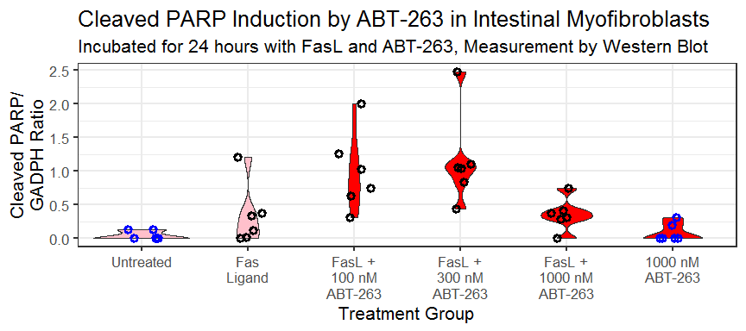

ABT-263 Cleaved PARP

## Saving 9 x 4 in image