ABT263 Effects on Gene Expression in CCDs Treated with TGFbeta.Rmd

Peter Higgins

5/18/2019

### Read in data

### Plot the Gene Expression data for powerpoint

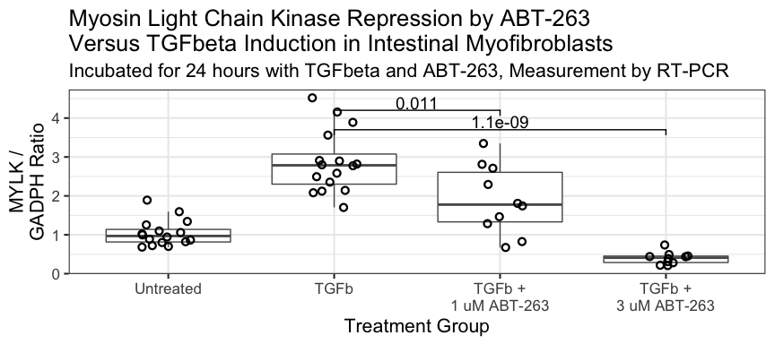

ABT-263 Gene Expr vs TGFb

## Saving 9 x 4 in image

## Make a cool table

ccdgenedata %>%   
 filter(Category == "TGFb") %>%   
 mutate(max_col = mean(Col1A1))

## # A tibble: 16 x 6  
## Category Col1A1 MYLK FN1 ACTA2 max_col  
## <ord> <dbl> <dbl> <dbl> <dbl> <dbl>  
## 1 TGFb 5.18 3.56 5.20 3.40 2.48  
## 2 TGFb 3.61 2.77 4.67 3.39 2.48  
## 3 TGFb 2.02 2.14 3.87 2.99 2.48  
## 4 TGFb 2.27 3.89 9.56 2.51 2.48  
## 5 TGFb 2.51 2.49 5.90 1.99 2.48  
## 6 TGFb 1.42 4.52 6.94 1.61 2.48  
## 7 TGFb 2.11 2.12 3.90 1.66 2.48  
## 8 TGFb 1.77 1.70 3.34 1.27 2.48  
## 9 TGFb 1.89 2.91 5.39 1.85 2.48  
## 10 TGFb 2.79 4.15 7.33 2.66 2.48  
## 11 TGFb 2.23 2.82 4.46 1.62 2.48  
## 12 TGFb 1.90 2.80 3.82 1.60 2.48  
## 13 TGFb 2.03 2.35 4.85 1.44 2.48  
## 14 TGFb 2.81 2.58 3.17 0.757 2.48  
## 15 TGFb 3.30 2.90 4.47 1.43 2.48  
## 16 TGFb 1.86 2.08 4.12 1.25 2.48

ccdgenedata %>%   
 filter(Category == "Untreated") %>%   
 mutate(min_col = mean(Col1A1)) %>%   
 summarize(col_base = mean(min_col))

## # A tibble: 1 x 1  
## col_base  
## <dbl>  
## 1 1.06