Analysis of MST-41 Anti-Fibrotic Therapy

Peter Higgins

# Anti-fibrotic Therapy Data

## Background

* Intestinal Fibrosis leads to surgery in 70% of Crohn’s disease
* Intestinal Myofibroblasts are stimulated to generate scar by:
  + injury/ wounding
  + matrix stiffness

## Background 2

* Matrix Stiffness Activates Myofibroblasts
* Activated Myofibroblasts Synthesize Stiff Matrix
* Positive Feedback Loop –> **More Fibrosis**
  + This is Bad
    - It gets worse
      * It can get *even* worse

## Hypothesis and Aims

### Hypothesis

* Determine whether Anti-fibrotic drug can reverse fibrosis

### Aims

* Determine whether Colon Weight is reduced by AFD
* Determine whether Gene Expression of Collagen 1, TGFb, CTGF is reduced by AFD
* Determine whether Protein expression of Collagen 1, aSMA, FN is reduced by AFD

# Experimental Design

## Experimental Design 1

* Get mice
* Strep cleanout

## Experimental Design 2

1. Infect with Salmonella
2. Wait 8 days
3. Levo x 5 days in the water
4. Rest Day
5. Anti-fibrotic drug x 10 days
6. Image

* Ultrasound + SWV + Strain
* Photoacoustic

1. Sac

## Experimental Design Diagram

# Results

## Weight Result

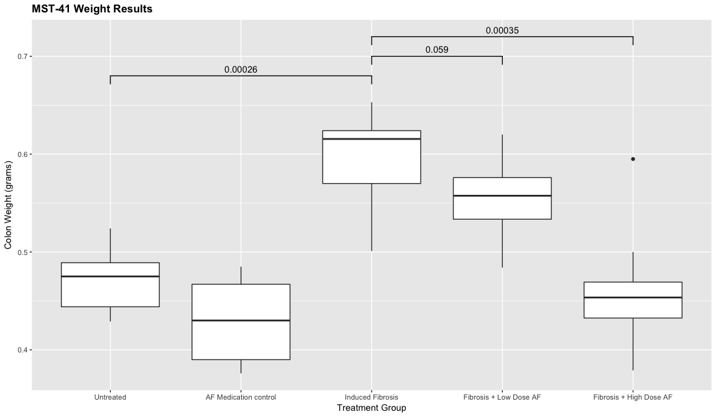

## TGFb Result

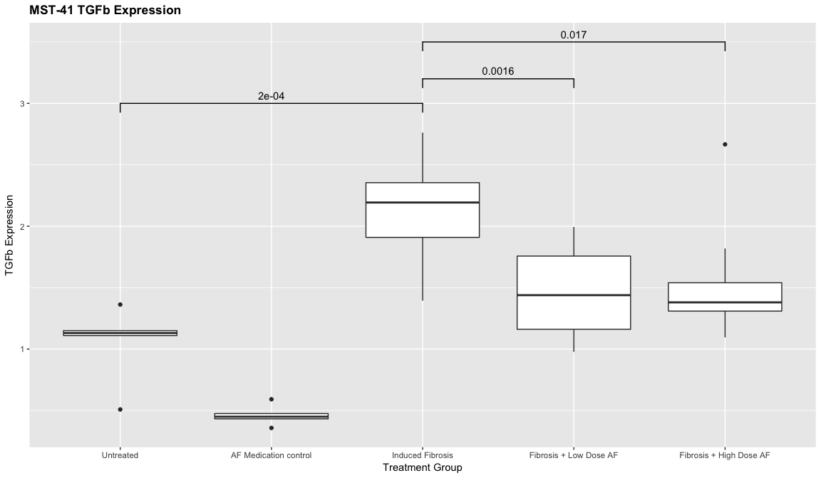

## CTGF Result

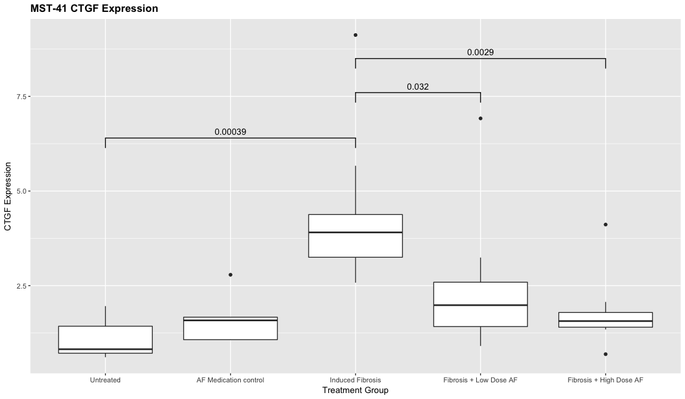

## IGF-1 Result

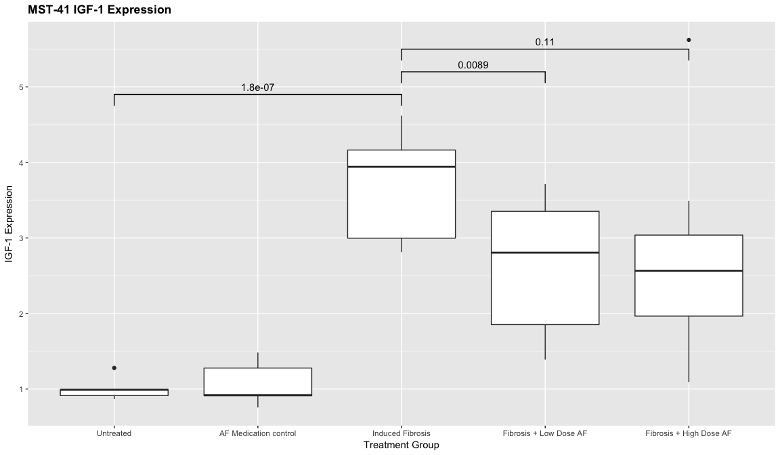

## Collagen 1 Result

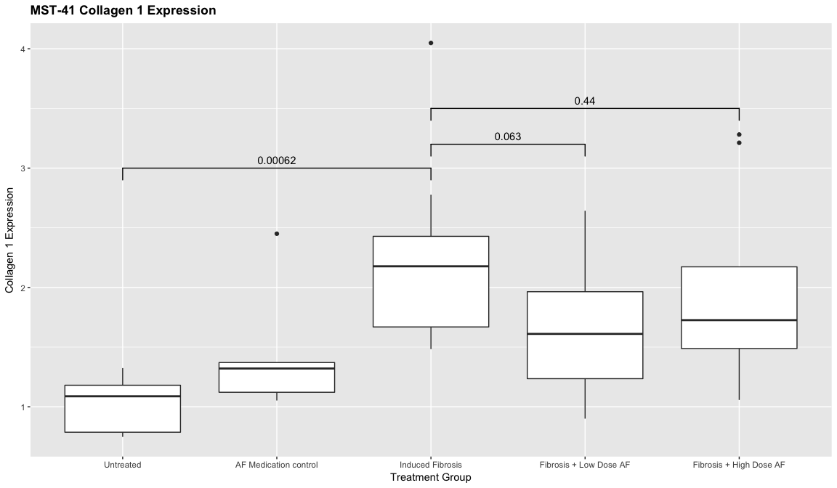

## Collagen 3 Result

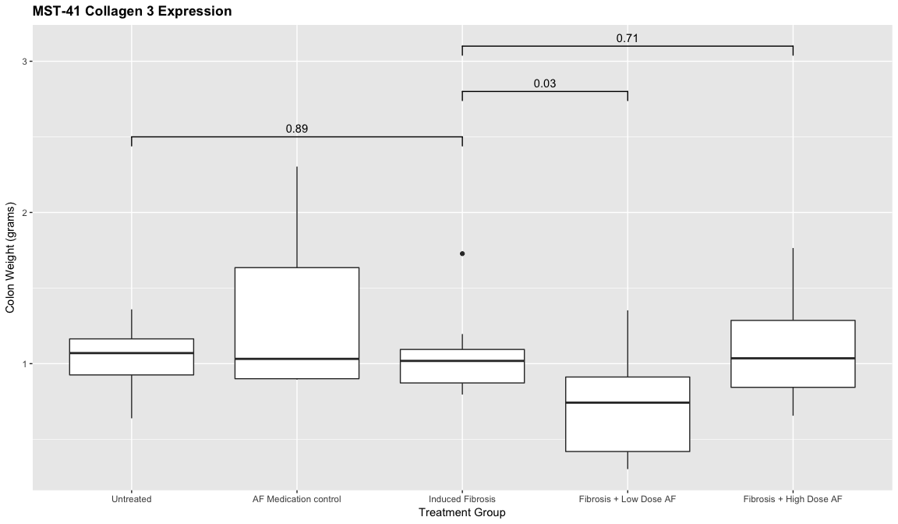

# Conclusions

## Conclusions

* Antifibrotic Drug Works in Human Intestinal Organoids
* Antifibrotic Drug Works in Salmonella Mouse Model
* Antifibrotic Drug Works in TNBS Rat Model
  + This is Amazing
    - Clinical Trials to Follow
      * Sure Hope the Ultrasound Works

# Examples of other stuff you can do with Rmd

## R Markdown

* This is an R Markdown document. Markdown is a simple formatting syntax for authoring HTML, PDF, MS Word, and now **PowerPoint** documents. For more details on using R Markdown see
* When you click the *Knit* button a document will be generated that includes both content as well as the output of any embedded R code chunks within the document.

## Block Quotes

A friend once said:

It’s always better to give than to receive. Totes magotes, my friend, he said. I don’t know why he said this.

## You can embed an R code chunk like this:

summary(cars)

## speed dist   
## Min. : 4.0 Min. : 2.00   
## 1st Qu.:12.0 1st Qu.: 26.00   
## Median :15.0 Median : 36.00   
## Mean :15.4 Mean : 42.98   
## 3rd Qu.:19.0 3rd Qu.: 56.00   
## Max. :25.0 Max. :120.00

## Including Plots

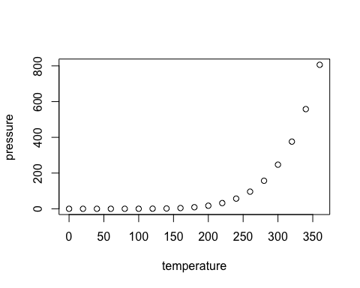

## And Tables

|  |  |
| --- | --- |
| Treatment Arm | Colon Weight (gm) |
| Control | 17.2 |
| S.typhi | 23.7 |
| S.typhi+ AFD | 17.9 |

## Inline R code

Inline R Code

There were 50 cars studied

## R Code Chunks

summary(cars$dist)

## Min. 1st Qu. Median Mean 3rd Qu. Max.   
## 2.00 26.00 36.00 42.98 56.00 120.00

summary(cars$speed)

## Min. 1st Qu. Median Mean 3rd Qu. Max.   
## 4.0 12.0 15.0 15.4 19.0 25.0

## Add Links

Links

Use a plain http address or add a link to a phrase:

## Miscellaneous

* Manual Line breaks,  
  end line with 2 or more spaces  
  Roses are red,  
  Violets are blue.

superscript2

~~strikethrough~~

## Horizontal Line break

Horizontal Rule / Page Break

Three or more asterisks or dashes:

and continue

## Use of the echo parameter

* Note that the echo = FALSE parameter was added to the previous plotting code chunk to prevent printing of the R code that generated the plot.
* If you want to see the R code **and** the output, like in the previous summary table, then set the parameter to echo=TRUE