Bcl Inhibitors vs. Stiffness Analysis

Peter Higgins

2/19/2017

## R Markdown for Reproducible Data Analysis

This is a reproducible analysis of data generated by Eva Rodansky in the Higgins Lab on several inhibitors of bcl provided by the Shaomeng Wang lab. These inhibitors were tested for their *anti-fibrotic activity* in the stiffness model of induction of fibrogenesis in *CCD-18co* human intestinal myofibroblasts on stiff plastic culture plates. For more details on using R Markdown see <http://rmarkdown.rstudio.com>.

Three compounds were tested, BM1197, BM1244, and BM1252.

Each compound was tested at concentrations of 0.5, 1, 5, and 10 micromolar concentrations.

Each compound x dose was evaluated for mRNA gene expression on 4 genes:

* Collagen (col1A1)
* Fibronectin (FN)
* Myosin light chain kinase (MYLK)
* Alpha smooth muscle actin (ACTA2)

Each compound x dose x gene analysis was perfomed in triplicate

Will hide read in and clean up of data, renaming of variables

# Exploratory Data Analysis

## What is the effect by gene x dose for BM1197?

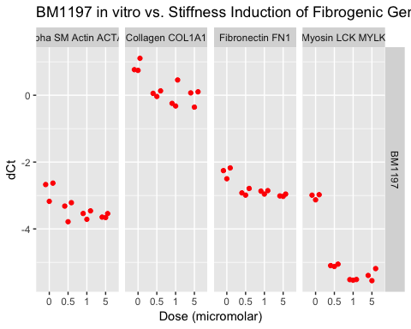

#### It appears that BM1197 has significant anti-fibrotic effects on all 4 genes

## What is effect by gene x dose for BM1244?

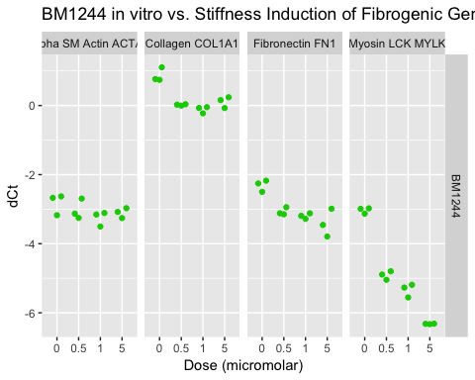

#### It appears that BM1244 has significant anti-fibrotic effects on collagen, FN, and MYLK, but less on aSMA

## What is effect x gene x dose for BM1252?

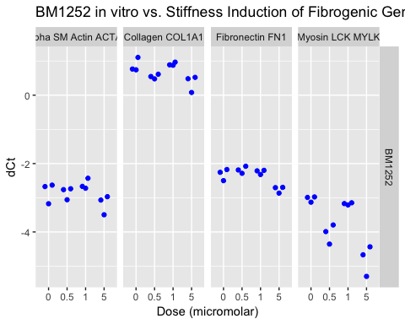

#### It appears that BM1252 has minimal anti-fibrotic effects on all 4 genes at only the highest dose

# Put it all together

## What is effect by gene, by drug, by dose - All drugs?

ggplot(data= stf, aes(x=micromolar, y=dct, color=rx)) +  
 facet_grid(rx ~ gene) +  
 geom_quasirandom(dodge.width = 1) +   
 ggtitle("Bcl inhibitors in vitro vs. Stiffness Induction of Fibrogenic Genes") +  
 labs(x="Dose (micromolar)") + labs(y="dCt") +  
 guides(color=guide_legend(title="Drug")) +  
 theme(legend.position = "top")

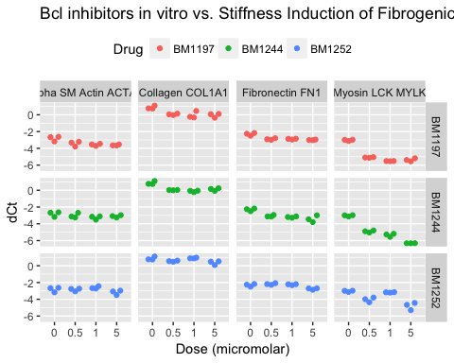

#### It appears that 1197 and 1244 are the best candidates.

#### Since 1197 is not available for commercial reasons, we should proceed with BM1244 as our candidate drug in mice if the pK looks reasonably gut-specific.