fulldata

Autogenerated data summary from dataMaid

2017-10-31

# Data cleaning summary

The dataset examined has the following dimensions:

|  |  |
| --- | --- |
| Feature | Result |
| Number of rows | 5434 |
| Number of variables | 6 |

### Checks performed

The following variable checks were performed, depending on the data type of each variable:

|  |  |  |  |  |  |  |  |
| --- | --- | --- | --- | --- | --- | --- | --- |
|  | character | factor | labelled | numeric | integer | logical | Date |
| Identify miscoded missing values | $×$ | $×$ | $×$ | $×$ | $×$ |  |  |
| Identify prefixed and suffixed whitespace | $×$ | $×$ | $×$ |  |  |  |  |
| Identify levels with < 6 obs. | $×$ | $×$ | $×$ |  |  |  |  |
| Identify case issues | $×$ | $×$ | $×$ |  |  |  |  |
| Identify misclassified numeric or integer variables | $×$ | $×$ | $×$ |  |  |  |  |
| Identify outliers |  |  |  | $×$ | $×$ |  | $×$ |

Please note that all numerical values in the following have been rounded to 2 decimals.

# Variable list

## **sampid**

|  |  |
| --- | --- |
| Feature | Result |
| Variable type | numeric |
| Number of missing obs. | 0 (0 %) |
| Number of unique values | 247 |
| Median | 430 |
| 1st and 3rd quartiles | 248; 603 |
| Min. and max. | 101; 3113 |

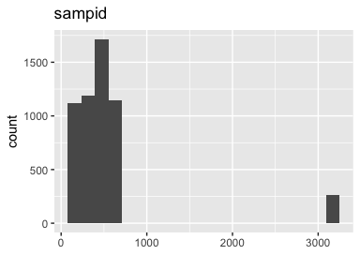

* Note that the following possible outlier values were detected: "3100", "3101", "3103", "3104", "3105", "3107", "3108", "3109", "3110", "3111", "3112", "3113".

## **rundate**

|  |  |
| --- | --- |
| Feature | Result |
| Variable type | Date |
| Number of missing obs. | 0 (0 %) |
| Number of unique values | 32 |
| Mode | “2017-07-20” |
| Min. and max. | 2017-06-27; 2017-08-09 |
| 1st and 3rd quartiles | 2017-07-12; 2017-07-31 |

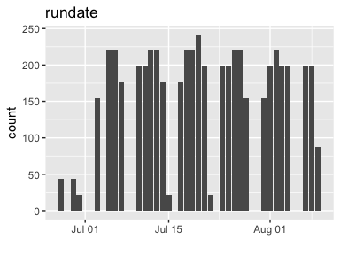

## **pathogen**

|  |  |
| --- | --- |
| Feature | Result |
| Variable type | character |
| Number of missing obs. | 0 (0 %) |
| Number of unique values | 22 |
| Mode | “E. coli O157” |

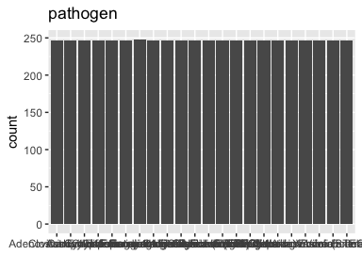

## **result**

|  |  |
| --- | --- |
| Feature | Result |
| Variable type | logical |
| Number of missing obs. | 0 (0 %) |
| Number of unique values | 2 |
| Mode | “FALSE” |

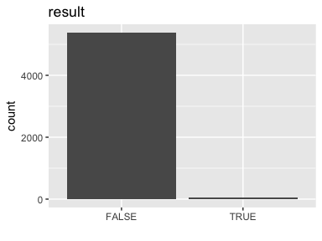

## **detect**

|  |  |
| --- | --- |
| Feature | Result |
| Variable type | character |
| Number of missing obs. | 0 (0 %) |
| Number of unique values | 2 |
| Mode | “Not Detected” |

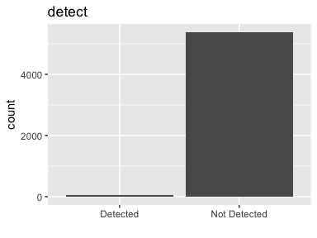

## **group**

|  |  |
| --- | --- |
| Feature | Result |
| Variable type | numeric |
| Number of missing obs. | 0 (0 %) |
| Number of unique values | 7 |
| Median | 4 |
| 1st and 3rd quartiles | 2; 5 |
| Min. and max. | 1; 7 |

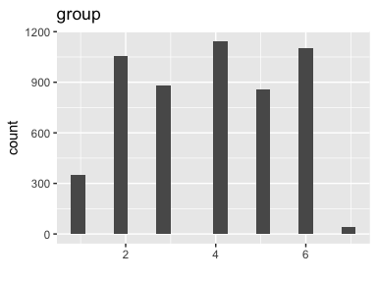

This report was created by dataMaid v0.9.2.