**A Survey of Inflammatory Bowel Disease Patients on Health Insurance Satisfaction**

1. Identify Health insurance type within state, within US

Exclude if Q530 != 1

Extract value for Q560 (state), exclude if >56

Based on state, ask

|  |  |  |
| --- | --- | --- |
| Number | 1 |  |
| Question | What type of health Insurance do you have? |  |
| Responses | 1. Medicaid 2. Medicare 3. Commercial |  |
| Variable Name | instype |  |

2. Identify Health insurance plan

Based on Q1 and lookup table (provided)

|  |  |  |
| --- | --- | --- |
| Number | 2 |  |
| Question | Which is your current primary health insurance plan? |  |
| Responses | List selected from lookup table based on Q530 and instype |  |
| Variable Name | insplan |  |

3. Insurance Plan Turnover

|  |  |  |
| --- | --- | --- |
| Number | 3 |  |
| Question | How many times have you changed your primary health insurance plan in the past 3 years? |  |
| Responses | 1. No change  2. Once  3. Twice  4. Three times  5. Four times  6. Five times  7. Six or more times |  |
| Variable Name | inschange |  |

4. Insurance Plan Durability

|  |  |  |
| --- | --- | --- |
| Number | 4 |  |
| Question | How many years have you kept your current primary health insurance plan |  |
| Responses | Numeric |  |
| Variable Name | insdur |  |

5. LOGIC – if Q4 is <3,  
 Prior Insurance Plan (loop through process for Q1 and Q2)

Note: will need Q to check if lived in different state at time of prior insurance plan

|  |  |  |
| --- | --- | --- |
| Number | 5 |  |
| Question | Which was your previous primary health insurance plan? |  |
| Responses | List selected from lookup table based on Q530 and instype |  |
| Variable Name | priorinsplan |  |

5a. LOGIC – if Q3 is <3,  
 Q to check if lived in different state at time of prior insurance plan

|  |  |  |
| --- | --- | --- |
| Number | 5a |  |
| Question | Did you live in a different state when you had your previous primary health insurance plan? |  |
| Responses | 1. Yes  2. No |  |
| Variable Name | diffstate |  |

LOGIC – if yes, re-ask state Q as “priorstate” variable

Use priorstate to loop through Q1 and Q2 to get priorinsplan

6. Policyholder

|  |  |  |
| --- | --- | --- |
| Number | 6 |  |
| Question | Are you the policy holder of your health insurance? |  |
| Responses | 1. Yes  2. No  3. Don’t know |  |
| Variable Name | policyholder |  |

6A.. Biologic Gap Antibodies: LOGIC If age >16, skip

|  |  |  |
| --- | --- | --- |
| Number | 6A. |  |
| Question | Are you covered by your parents’ health insurance ? |  |
| Responses | 1. Yes  2. No |  |
| Variable Name | parentins |  |

7. Number of people covered

|  |  |  |
| --- | --- | --- |
| Number | 7 |  |
| Question | How many people (usually your family members) are covered by your health insurance (include spouse, partner, or children if they are also covered by the same policy)? |  |
| Responses | Numeric |  |
| Variable Name | numcovered |  |

8. Premium

|  |  |  |
| --- | --- | --- |
| Number | 8 |  |
| Question | The ***premium*** is the amount of money charged by your insurance company for the plan you’ve chosen. It is usually paid on a monthly basis, but can be billed a number of ways. You must pay your premium to keep your coverage active, regardless of whether you use it or not.  How much do you pay each month to your health insurance company as your premium in dollars (please do not enter a dollar sign, just numbers)? | Example: You’ve researched rates and the health plan you’ve chosen costs $325 per month, which is your premium. In order to keep your benefits active and the plan in force, you’ll need to pay your premium on time every month. |
| Responses | Numeric |  |
| Variable Name | premium |  |

9. Deductible

|  |  |  |
| --- | --- | --- |
| Number | 9 |  |
| Question | The ***deductible*** is a set amount that you have to pay every year toward your medical bills ***before*** your insurance company starts covering your bills. It varies by plan and some plans don’t have a deductible.  How much is your deductible each year (enter zero if you don’t have a deductible)? | Example: Your plan has a $1,000 deductible. That means you pay your own medical bills up to $1,000 for the year. Then, your insurance coverage kicks in. At the beginning of each year, you’ll have to meet the deductible again. |
| Responses | Numeric |  |
| Variable Name | deductible |  |

10. Deductible met (LOGIC – if Q9 is >0 – if Q9=0, skip)

|  |  |  |
| --- | --- | --- |
| Number | 10 |  |
| Question | Did your total medical expenses meet or exceed your deductible in the past year? |  |
| Responses | 1. Yes  2. No  3. Don’t know |  |
| Variable Name | deductiblemet |  |

11. Coinsurance

|  |  |  |
| --- | --- | --- |
| Number | 11 |  |
| Question | Your ***coinsurance*** is the ***percentage*** of your medical bill you share with your insurance company ***after*** you’ve paid your deductible. Unless you have a policy with 100 percent coverage for everything, you have to pay a coinsurance amount.  How much is your coinsurance percentage each year (enter zero if you don’t have coinsurance)? | Example: You have an “80/20” plan. That means your insurance company pays for 80 percent of your costs after you’ve met your deductible. You pay for 20 percent.  Coinsurance is different and separate from any copayment. |
| Responses | Numeric |  |
| Variable Name | coinsurance |  |

12. Coinsurance Paid (LOGIC – if Q11 is >0 – if Q11=0, skip)

|  |  |  |
| --- | --- | --- |
| Number | 12 |  |
| Question | How much did you have to pay as coinsurance (your percentage) in the past year? | Example: You have had a total of $25,000 in medical expenses in the past year. You have an “80/20” plan with a $10,000 deductible. You paid the first $10,000, then exceeded the deductible in April. Since April you have had another $15,000 in medical expenses. Your share of that has been 20%, or $3,000.  If this were the case, your answer to this question would be 3000. |
| Responses | Numeric |  |
| Variable Name | coinsurancepaid |  |

13. Copayment

|  |  |  |
| --- | --- | --- |
| Number | 13 |  |
| Question | Your copayment, or ***copay***, is the flat fee you pay every time you go to the doctor or fill a prescription. It’s usually a relatively small dollar amount. Copays do ***not*** count toward your deductible.  How much is your copay for doctor visits? | Example: Let’s say your plan has a $20 copayment for routine doctor’s visits. That means you have to pay $20 each time you go. Copayments are different from coinsurance. |
| Responses | Numeric |  |
| Variable Name | copay |  |

14. Copayment Paid (LOGIC – if Q13 is >0 – if Q13=0, skip)

|  |  |  |
| --- | --- | --- |
| Number | 14 |  |
| Question | How much did you have to pay as copays in the past year? | Example: You have had three doctor visits with copays of $20 each, and one ER visit, with a copay of $50.  If this were the case, your answer to this question would be 110. |
| Responses | Numeric |  |
| Variable Name | copayamt |  |

15. Surgeries in Past Year

|  |  |  |
| --- | --- | --- |
| Number | 15 |  |
| Question | How many times have you had surgery in the past year? |  |
| Responses | Numeric |  |
| Variable Name | surgerynum |  |

16. Emergency and Urgent visits in Past Year

|  |  |  |
| --- | --- | --- |
| Number | 16 |  |
| Question | How many times have you visited an emergency room or an urgent care clinic (for your health) in the past year? |  |
| Responses | Numeric |  |
| Variable Name | emergencynum |  |

17. Hospitalizations in Past Year

|  |  |  |
| --- | --- | --- |
| Number | 17 |  |
| Question | How many times have you been hospitalized in the past year? |  |
| Responses | Numeric |  |
| Variable Name | hospnum |  |

18. Scopes in Past Year

|  |  |  |
| --- | --- | --- |
| Number | 18 |  |
| Question | How many times have you had an endoscopy (upper endoscopy, lower endoscopy, or through a stoma) in the past year? |  |
| Responses | Numeric |  |
| Variable Name | scopenum |  |

19. Hospitalization Coverage

|  |  |  |
| --- | --- | --- |
| Number | 19 |  |
| Question | Have you ever had trouble getting coverage for a hospitalization from your current health insurer? |  |
| Responses | 1. Yes  2. No  3. I don’t know |  |
| Variable Name | hospcoverage |  |

.

20. Urgent Care Coverage

|  |  |  |
| --- | --- | --- |
| Number | 20 |  |
| Question | Have you ever had trouble getting coverage for a urgent care or emergency room visit from your current health insurer? |  |
| Responses | 1. Yes  2. No  3. I don’t know |  |
| Variable Name | hospcoverage |  |

21. Medication Coverage

|  |  |  |
| --- | --- | --- |
| Number | 21 |  |
| Question | Have you ever had trouble getting coverage from your current health insurer for an IBD medication prescribed by your doctor ? |  |
| Responses | 1. Yes  2. No  3. I don’t know |  |
| Variable Name | hospcoverage |  |

22. Insurance Barrier for Medications

|  |  |  |
| --- | --- | --- |
| Number | 22 |  |
| Question | Has your current health insurer made it more difficult for you to use a medication that your doctor has prescribed with any of the following actions? |  |
| Responses | 19A. Denied coverage of a new medication  19B. Denied renewal of coverage of a medication that you were already taking when the prescription was renewed  19C. Denied renewal of coverage of a medication that you were already taking on January 1 of a new year.  19D. Required a prior authorization before coverage of a medication  19E. Denied coverage and required an appeal letter from your doctor.  19F. Denied coverage, required an appeal phone call from your doctor.  19G. Denied coverage, required you to try another medication with a different mechanism (for example, Imuran before Remicade, Humira before Entyvio) first  19H. Denied coverage, required you to try another medication with the same mechanism (for example, Humira before Cimzia) first. | 1. Yes  2. No |
| Variable Name | insbarrier |  |

23A. LOGIC – if 22G yes, which medicine denied?

23B. LOGIC – if 22G yes, which medicine used instead?

24A. LOGIC – if 22H yes, which medicine denied?

24B. LOGIC – if 22H yes, which medicine denied?

25. Insurance Forced switch

|  |  |  |
| --- | --- | --- |
| Number | 25 |  |
| Question | Has your current health insurer forced you to switch from one IBD medication (that was working) to a different IBD medication? |  |
| Responses | 1. Yes  2. No |  |
| Variable Name | insswitch |  |

26. Insurance Biologics

|  |  |  |
| --- | --- | --- |
| Number | 26 |  |
| Question | Does your current health insurer cover biologic medications? |  |
| Responses | 1. Yes  2. No  3. I don’t know |  |
| Variable Name | insbiolcover |  |

27. Patient Assistance

|  |  |  |
| --- | --- | --- |
| Number | 27 |  |
| Question | Have you ever used a drug company-funded patient assistance program or copay assistance program? | Examples include Remistart, Abbvie Patient Assistance Foundation, Lialda Pharmacy Savings Card |
| Responses | 1. Yes  2. No  3. I don’t know |  |
| Variable Name | insptassist |  |

.

28. Coverage of antiTNF

|  |  |  |
| --- | --- | --- |
| Number | 28 |  |
| Question | Please rate your difficulty in getting anti-TNF biologic medications (these include Remicade, Humira, Cimzia, Simponi) covered by your current health insurer? |  |
| Responses | 1. No difficulty at all  2. Minor Difficulty  3. Major Difficulty  4. Not able to get coverage  5. Not applicable |  |
| Variable Name | tnfcover |  |

.

29. Coverage of Entyvio

|  |  |  |
| --- | --- | --- |
| Number | 28 |  |
| Question | Please rate your difficulty in getting anti-adhesion biologic medications (Entyvio) covered by your current health insurer? |  |
| Responses | 1. No difficulty at all  2. Minor Difficulty  3. Major Difficulty  4. Not able to get coverage  5. Not applicable |  |
| Variable Name | tnfcover |  |

.

30. Coverage of Entyvio

|  |  |  |
| --- | --- | --- |
| Number | 30 |  |
| Question | Please rate your difficulty in getting anti-IL12/23 biologic medications (Stelara) covered by your current health insurer? |  |
| Responses | 1. No difficulty at all  2. Minor Difficulty  3. Major Difficulty  4. Not able to get coverage  5. Not applicable |  |
| Variable Name | Il23cover |  |

31. Coverage of other IBD Meds

|  |  |  |
| --- | --- | --- |
| Number | 31 |  |
| Question | Please rate your difficulty in getting non-biologic medications (these include Imuran, methotrexate, asacol, lialda, apriso, etc.) covered by your current health insurer? |  |
| Responses | 1. No difficulty at all  2. Minor Difficulty  3. Major Difficulty  4. Not able to get coverage  5. Not applicable |  |
| Variable Name | othermedcover |  |

32. Coverage of other IBD Meds

|  |  |  |
| --- | --- | --- |
| Number | 32 |  |
| Question | Please rate your difficulty in getting non-biologic medications (these include Imuran, methotrexate, asacol, lialda, apriso, etc.) covered by your current health insurer? |  |
| Responses | 1. No difficulty at all  2. Minor Difficulty  3. Major Difficulty  4. Not able to get coverage  5. Not applicable |  |
| Variable Name | othermedcover |  |

33. Coverage of other IBD Meds

|  |  |  |
| --- | --- | --- |
| Number | 33 |  |
| Question | If you have ever been on a biologic, have you ever had a gap in your treatment ***because*** of insurance? |  |
| Responses | 1. Yes  2. No  3. Not sure  4. Not applicable (I have never been on a biologic) |  |
| Variable Name | insbiolgap |  |

34. Biologic Gap Length: LOGIC If 33 yes, if not- SKIP

|  |  |  |
| --- | --- | --- |
| Number | 34 |  |
| Question | How long in weeks was the longest gap you have had in biologic therapy due to insurance? |  |
| Responses | Numeric |  |
| Variable Name | biolgaplength |  |

35. Biologic Gap Length: LOGIC If 33 yes, if not- SKIP

|  |  |  |
| --- | --- | --- |
| Number | 35 |  |
| Question | How many times have you had a gap in biologic therapy due to insurance? |  |
| Responses | Numeric |  |
| Variable Name | biolgapnum |  |

36. Biologic Gap Length: LOGIC If 33 yes, if not- SKIP

|  |  |  |
| --- | --- | --- |
| Number | 36 |  |
| Question | During treatment with which of the following biologics have you hada gap in therapy due to insurance? |  |
| Responses | 1. Remicade  2. Humira  3. Cimzia  4. Simponi  5. Entyvio  6. Stelara |  |
| Variable Name | whichbiolgap |  |

37. Biologic Gap Why: LOGIC If 33 yes, if not- SKIP

|  |  |  |
| --- | --- | --- |
| Number | 37 |  |
| Question | Why did you have a gap in biologic therapy due to insurance reasons? |  |
| Responses | 1. Denial by same insurer (after previous approval) at renewal  2. Denial by same insurer (after previous approval) on January 1 of new year  3. Slow re-approval / prior authorization / appeals  4. Gap when I changed insurance  5. Lost insurance for a while |  |
| Variable Name | whylostbiolcover |  |

38. Biologic Gap Antibodies: LOGIC If 33 yes, if not- SKIP

|  |  |  |
| --- | --- | --- |
| Number | 38 |  |
| Question | Did you develop antibodies to the biologic medication after this gap in coverage? |  |
| Responses | 1. Yes  2. No |  |
| Variable Name | gapantibody |  |

39. Biologic Gap Antibodies: LOGIC If 33 yes, if not- SKIP

|  |  |  |
| --- | --- | --- |
| Number | 39 |  |
| Question | During the gap in coverage were you on an immunomodulator like Imuran, azathioprine, 6-MP, or methotrexate? |  |
| Responses | 1. Yes  2. No |  |
| Variable Name | gapimm |  |

40. Biologic Gap Antibodies: LOGIC If 33 yes, if not- SKIP

|  |  |  |
| --- | --- | --- |
| Number | 40 |  |
| Question | During the gap in coverage were you on an immunomodulator like Imuran, azathioprine, 6-MP, or methotrexate? |  |
| Responses | 1. Yes  2. No |  |
| Variable Name | gapimm |  |

41. Average yearly household income

|  |  |  |
| --- | --- | --- |
| Number | 41 |  |
| Question | What is your average yearly household income? |  |
| Responses | 1. Less than $25,000  2. $25,000 - $34,000  3. $35,000 - $49,999  4. $50,000 - $79,999  5. $80,000 - $100,000  6. Over $100,000 |  |
| Variable Name | hshldincome |  |

42. Satisfaction

|  |  |  |
| --- | --- | --- |
| Number | 42 |  |
| Question | How would your rate your satisfaction with your current health insurance? |  |
| Responses | 1. Highly Unsatisfactory  1.5. Mostly Unsatisfactory  2. Moderately Unsatisfactory  2.5. Somewhat Unsatisfactory  3. Neutral  3.5. Somewhat Satisfactory  4. Moderately Satisfactory  4.5. Mostly Satisfactory  5. Highly Satisfactory | * note this 9 point Likert scale is set up to match NCQA scale for consumer satisfaction |
| Variable Name | inssat |  |

43. Recommend

|  |  |  |
| --- | --- | --- |
| Number | 43 |  |
| Question | Would you recommend this health insurance plan to someone else with IBD? |  |
| Responses | 1. Yes  2. No  3. I am not sure |  |
| Variable Name | insrec |  |

44. Recommend

|  |  |  |
| --- | --- | --- |
| Number | 44 |  |
| Question | What is your current work status? |  |
| Responses | 1. Currently working  2. Not working by choice  3. Disabled  4. Unable to find work |  |
| Variable Name | workstatus |  |

**Data to Be Extracted from Existing Questions**

|  |  |  |
| --- | --- | --- |
| Number | Q120 |  |
| Question | What is Your Diagnosis? |  |
| Responses | 1. Crohn's Disease  2. Ulcerative Colitis  3. Indeterminate Colitis  5. I don’t have IBD |  |
| Variable Name | Q120 |  |

|  |  |  |
| --- | --- | --- |
| Number | Q320 |  |
| Question | Age on last birthday |  |
| Responses | Numeric |  |
| Variable Name | Q320 |  |

|  |  |  |
| --- | --- | --- |
| Number | Q360 |  |
| Question | Gender |  |
| Responses | 1. Male  2. Female |  |
| Variable Name | Q360 |  |

|  |  |  |
| --- | --- | --- |
| Number | Q520, Qu520 |  |
| Question | Weight, units |  |
| Responses | Numeric, 1=lbs, 2=kilos |  |
| Variable Name | Q520, Qu520 |  |

|  |  |  |
| --- | --- | --- |
| Number | Q530 |  |
| Question | Do you live in US |  |
| Responses | 1. Yes  2. No | * exclude if NO |
| Variable Name | Q530 |  |

|  |  |  |
| --- | --- | --- |
| Number | Q560 |  |
| Question | Which State |  |
| Responses | Values 1-78 | * exclude if >56 |
| Variable Name | Q560 |  |
| Logic | To select health plan |  |

1 = ALABAMA 2 = ALASKA 60 = AMERICAN SAMOA 4 = ARIZONA 5 = ARKANSAS 6 = CALIFORNIA 8 = COLORADO 9 = CONNECTICUT 10 = DELAWARE 11 = DISTRICT OF COLUMBIA 12 = FLORIDA 13 = GEORGIA 66 = GUAM 15 = HAWAII 16 = IDAHO 17 = ILLINOIS 18 = INDIANA 19 = IOWA 20 = KANSAS 21 = KENTUCKY 22 = LOUISIANA 23 = MAINE 24 = MARYLAND 25 = MASSACHUSETTS 26 = MICHIGAN 27 = MINNESOTA 28 = MISSISSIPPI 29 = MISSOURI 30 = MONTANA 31 = NEBRASKA 32 = NEVADA 33 = NEW HAMPSHIRE 34 = NEW JERSEY 35 = NEW MEXICO 36 = NEW YORK 37 = NORTH CAROLINA 38 = NORTH DAKOTA 39 = OHIO 40 = OKLAHOMA 41 = OREGON 42 = PENNSYLVANIA 72 = PUERTO RICO 44 = RHODE ISLAND 45 = SOUTH CAROLINA 46 = SOUTH DAKOTA 47 = TENNESSEE 48 = TEXAS 49 = UTAH 50 = VERMONT 78 = VIRGIN ISLANDS 51 = VIRGINIA 53 = WASHINGTON 54 = WEST VIRGINIA 55 = WISCONSIN 56 = WYOMING

|  |  |  |
| --- | --- | --- |
| Number | Q26690 |  |
| Question | Jewish Ancestry |  |
| Responses | 1. Yes  2. No  3. Don’t know |  |
| Variable Name | Q26690 |  |

|  |  |  |
| --- | --- | --- |
| Number | Q2320 |  |
| Question | Family Hx of IBD |  |
| Responses | 1. Yes  2. No  3. Don’t know |  |
| Variable Name | Q2320 |  |

Race

Ethnicity (Hispanic/NonHispanic)

|  |  |  |
| --- | --- | --- |
| Number | Q720 |  |
| Question | Have a PCP? |  |
| Responses | 1. Yes  2. No  3. Don’t know |  |
| Variable Name | Q720 |  |

|  |  |  |
| --- | --- | --- |
| Number | Q760 |  |
| Question | Use of PCP |  |
| Responses | 1. Never  2. 1 or 2 times  3. 3 or 4 times  4. 5 or more times  5. Don’t know |  |
| Variable Name | Q760 |  |

|  |  |  |
| --- | --- | --- |
| Number | Q800 |  |
| Question | Have a GI? |  |
| Responses | 1. Yes  2. No  3. Don’t know |  |
| Variable Name | Q800 |  |

|  |  |  |
| --- | --- | --- |
| Number | Q840 |  |
| Question | Use of GI |  |
| Responses | 1. Never  2. 1 or 2 times  3. 3 or 4 times  4. 5 or more times  5. Don’t know |  |
| Variable Name | Q840 |  |

|  |  |  |
| --- | --- | --- |
| Number | Q880 |  |
| Question | Where see GI? |  |
| Responses | 1. Academic  2. Private  3. VA  4. Other  5. Don’t know |  |
| Variable Name | Q760 |  |

Q890, 900

Q30630

Q1000

Q4440

Section 4. IBD Characteristics

Q1080-19050 (not the rest on cancer)

Location of disease

Section 21. Surgeries

Q37510

Section 22. Pouch

If applicable

Section 17. EIMs

Q2805-Q3005

Section 9 Colitis History

Q2520-2710

Section 10 Crohn’s History

Q3070-10140

Section 11. Crohn’s Activity

Q3520-3650

Section 5 IBD Meds

Q1410-30168

Section 6 Use of IBD Meds

Q41521-42049

Section 19 Depression, Anxiety, Sleep

Q33000-Q33295

Section 13 Exercise and Daily Activity

Q10110-30620

Section 15 Quality of Life

Q8720-Q2280

Patient Activation Measure

Questions 36410-36500, responses on 1-4 scale, 5 = NA

Social Support Inventory

Questions 32010-32440, responses on 1-5 scale

GI Symptoms

Section 4. Diarrhea

Section 5. Nausea and Vomiting

Section 6. Belly Pain

Section 7. Gas/Bloat/Flatulence

Section 8. Bowel Incontinence/Soilage

Care for Chronic Conditions

Questions 15010-15200, responses on 1-5 scale

|  |
| --- |
|  |

Results

*Respondent Characteristics*

The sample of 48 respondent included 23 with self-reported Crohn’s disease, 21 with ulcerative colitis, and 4 with indeterminate colitis. Respondents from 24 states were represented, with the most frequent being California and Ohio (4), followed by Illinois, North Carolina, Pennsylvania, and Washington (3).The average age of respondents was 35.82. In terms of gender, 77.1% were female. In terms of race, 93.8% were white, with 2.1% black. In terms of household income, the most common income brackets were $50,000-79,999 and >$100,000 per year, both with 29.2%. Eighteen patients reported that they were under 26, and 50% of these were on their parents’ insurance. Two-thirds of respondents are currently working, 16% disabled, and 12.5% not working by choice. Of the 48 respondents, 39 (81.25%) have been on a biologic at some point in their lives. The respondents averaged 1.8 ER visits, 1.28 hospitalizations, and 0.8 surgeries per year.

*Insurer Characteristics*

Twenty-eight different insurers were represented, with the most common being Aetna(4), Anthem BCBS (3), BCBS of Illinois(3), Highmark (3), and United Health Group (3). Of the insurers, 47.9% were some form of BlueCross coverage, and 43.8% had deductibles greater than $1000. Among respondents, 70.8% were the policyholder, with an average of 2.23 people covered. Of the respondents, 43.75% reported that their health insurer had denied payment for a medication that their physician had prescribed for IBD. All 39 respondents to whom it was relevant reported that their health insurer covered biologics; for 9 this was not applicable. On a 1 (easy) - 10 (difficult) scale, respondents rated the difficulty of getting medications covered for IBD (mean 3.9), difficulty of getting anti-TNF biologics covered (mean 5.1), and difficulty of getting Entyvio covered (mean 4.6). Thirteen patients (27.1%) have experienced a gap in biologic therapy due to insurance problems. Of these, 7/13 were due to slow approval processes, 3 after a change in health insurance, 2 annual denials after previous approval, 1 due to denial of the particular dose, and 1 due to miscommunication with a pharmacy. Of these thirteen, 3 developed antibodies to the biologic therapy due to the gap in therapy. The average monthly insurance payment was $329.80, the average deductible was $1772, and the average annual out of pocket spend was $3636. Ninety-seven percent of IBD patients had out of pocket health care expenditures that exceeded their deductible. Overall satisfaction with service provided by their healthcare insurance on a 1-10 scale averaged a 7.13 (SD 2.18).

|  |  |  |  |
| --- | --- | --- | --- |
| Characteristic | Percent | Mean(SD) | Median(IQR) (min-max) |
| Crohn’s Disease/ Ulcerative Colitis/ Indeterminate Colitis | 47.9  43.8  8.3 |  |  |
| Age |  | 35.82 (10.19) | 34.39 (27.6-39.1) |
| Gender  Male  Female | 20.9  77.1 |  |  |
| Race  White  Black  Refused to Answer | 93.8  2.1  4.2 |  |  |
| Ethnicity  Hispanic or Latino  Other  Refused to Answer | 4.2  81.3  14.6 |  |  |
| Income Category  <$25,000  $25,000-34,999  $35,000-49,999  $50,000-79,999  $80,000-100,000  > $100,000  Refused to Answer | 8.3  8.3  8.3  29.2  14.6  29.2  2.1 |  |  |
| If <26, on parents’ insurance  Yes  No | 50  50 |  |  |
| Work Status  Working  Disabled  Not working by choice  Refused to Answer | 66.7  16.7  12.5  4.2 |  |  |
| Number of ER visits |  | 1.826 (2.56) | 1 (0-2.75)  (0-12) |
| Number of Hospitalizations |  | 1.283 (1.80) | 1 (0-1.75)  (0-6) |
| Number of Surgeries |  | 0.8043 (1.31) | 0 (0-1)  (0-5) |
| **Health Insurance** Policyholder  Yes  No | 70.8  29.2 |  |  |
| Number of people covered |  | 2.277 (1.25) | 2 (1-3)  (1-5) |
| Denied Payment for Medications  Yes  No | 43.8  56.2 |  |  |
| Difficulty of IBD Medication Coverage (1-10) |  | 3.891 (2.68) | 3 (1.25-6)  (1-10) |
| Difficulty of anti-TNF Coverage (1-10) |  | 5.135 (3.04) | 5 (3-7)  (1-10) |
| Difficulty of Entyvio Coverage (1-10) |  | 4.6 (3.204) | 4 (2.5-5)  (1-10) |
| Gap in Biologic Therapy Due to Insurance  Yes  No  Not Relevant  Not Sure | 27.1  45.8  18.8  8.3 |  |  |
| Why Gap Occurred  Slow Approval  Change in Insurance  Annual renewal denied  Pharmacy Problem | 7 (50%)  3 (21%)  3 (21%)  1 (7%) |  |  |
| Antibodies to Biologic Due to Gap in Coverage  Yes  No | 3 (21%)  11 (79%) |  |  |
| Monthly Payment |  | 329.80 (286.99) | 300 (142.5-400)  (0-1400) |
| Annual Deductible |  | 1772 (1872.86) | 1000 (500-3000)  (0-6500) |
| Annual Out of Pocket Spent on Healthcare |  | 3636 (4010.99) | 2500 (1000-5000)  (0-20,000) |
| Overall Satisfaction with Health Insurance |  | 7.13 (2.18) | 8 (6-9)  (1-10) |

*Patient Predictors of Overall Satisfaction*

Eleven patient characteristics were tested for their association with overall satisfaction with health insurance in bivariate models. The estimates of effect and P values are listed below. Only disabled status was significant, with a strong negative effect on overall satisfaction. Trending positively were the number of hospitalizations and high income, which were weakly associated (NS) with increased satisfaction.

|  |  |  |
| --- | --- | --- |
| Predictor | Estimate | p value |
| IBD type (vs. CD)  Ulcerative colitis  Indeterminate colitis | 0  0.9239  0.5423 | 0.443  0.431 |
| Age (per year) | 0.0195 | 0.768 |
| Gender (vs. female)  Male | 0  0.4722 | 0.550 |
| Race (vs. black)  White | 0  -2.932 | 0.191 |
| Ethnicity (vs. Not Hispanic)  Hispanic or Latino | -0.500 | 0.784 |
| Income >$80,000 | 0.9867 | 0.127 |
| Disabled status | -2.5789 | 0.00153 |
| Number of ER visits | 0.1350 | 0.277 |
| Number of Hospitalizations | 0.2968 | 0.0901 |
| Number of Surgeries | 0.1799 | 0.462 |

*Insurance Predictors of Overall Satisfaction*

Thirteen insurance characteristics were tested for their association with overall satisfaction with health insurance in bivariate models. The estimates of effect and P values are listed below. “Denied payment for a medication in the past year”, “Coverage difficulty for any IBD medications”, “Coverage difficulty for anti-TNF therapy” and presence of “Gap in biologic therapy” were significant, with a strong negative effect on overall satisfaction. Trending positively was the coverage by Blue Cross insurance, which was weakly associated (NS) with increased satisfaction.

|  |  |  |
| --- | --- | --- |
| Predictor | Estimate | p value |
| Blue Cross vs.  Not Blue Cross | 1.0435 | 0.105 |
| Monthly Payment | 0.01 | 0.965 |
| Annual Deductible | -0.01 | 0.517 |
| High Deductible | -0.6706 | 0.309 |
| Out of pocket spend | -0.01 | 0.289 |
| Policyholder | -0.1399 | 0.847 |
| Number of persons covered | -0.1627 | 0.551 |
| Denied Payment for a Medication in the Past Year | -2.4423 | <0.0001 |
| Coverage for Biologics | -0.2961 | 0.731 |
| Coverage Difficulty for any IBD medication | -0.3713 | 0.00216 |
| Coverage Difficulty for anti-TNF therapy | -0.2668 | 0.0215 |
| Coverage Difficulty for Entyvio | -0.4719 | 0.131 |
| Gap in Biologic Therapy | -1.2817 | 0.0683 |

*Graphs of potentially important Covariates for Overall Satisfaction*

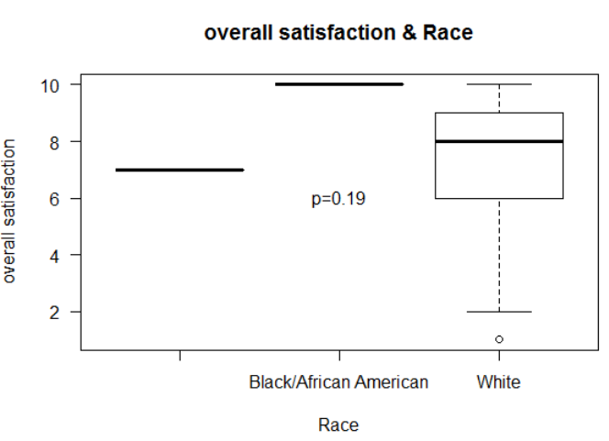

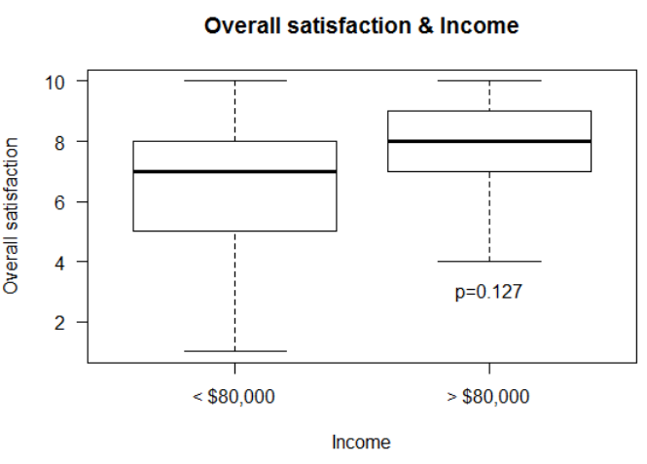

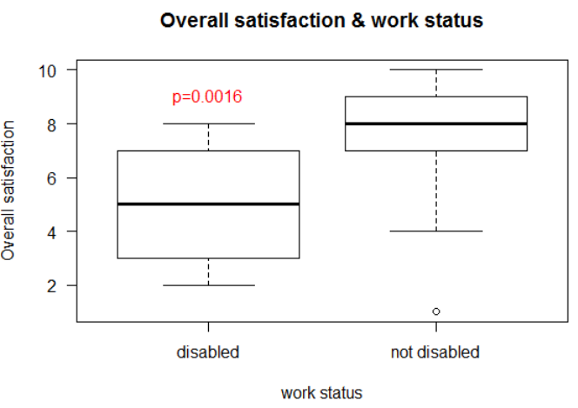

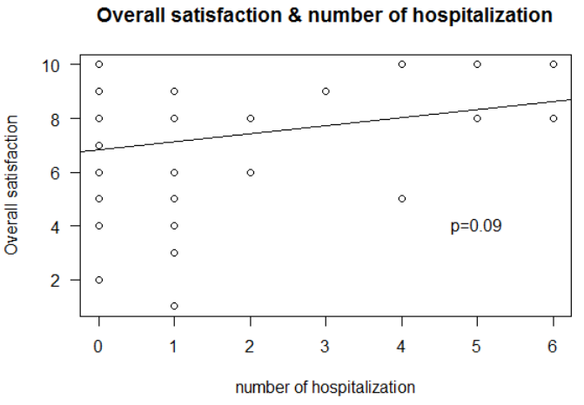

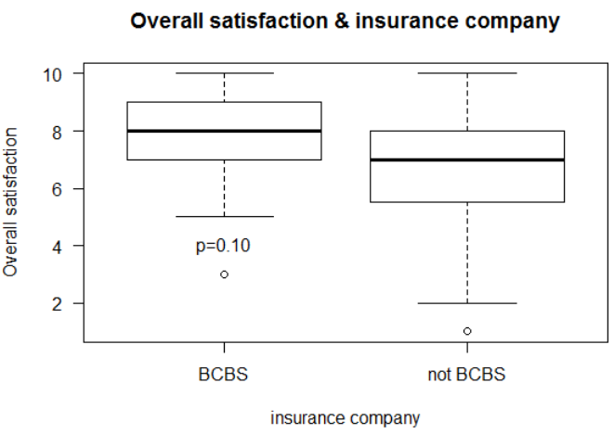

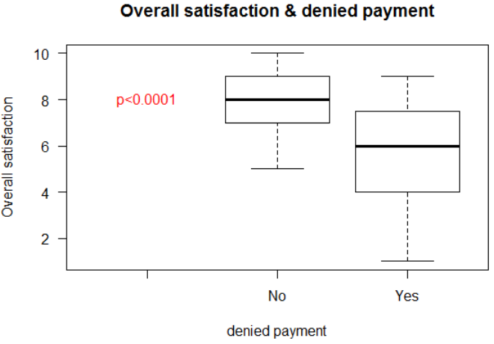

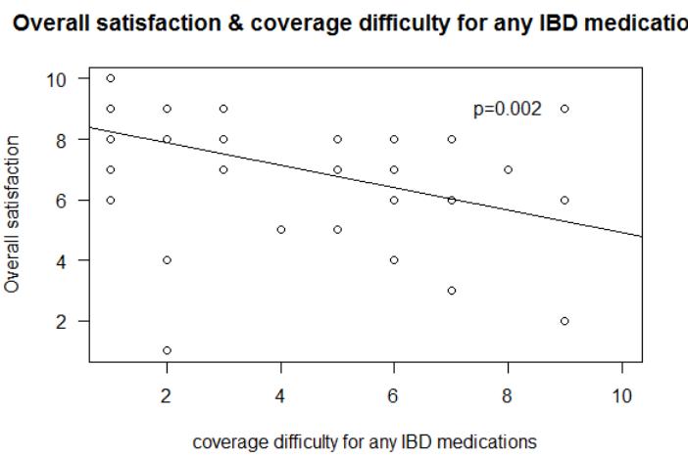

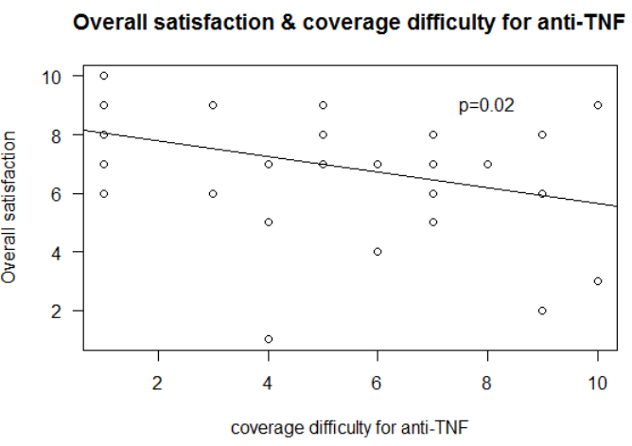

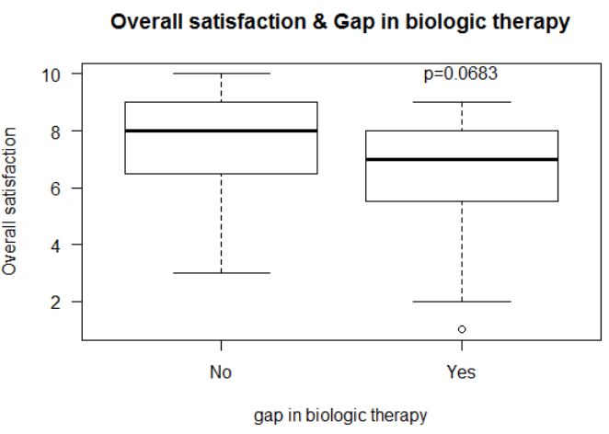

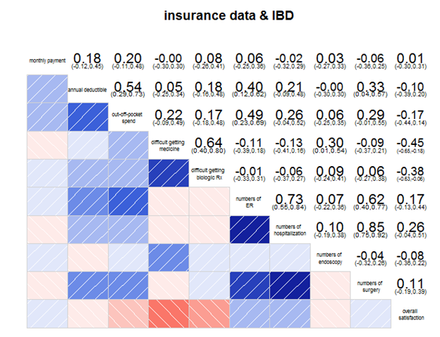

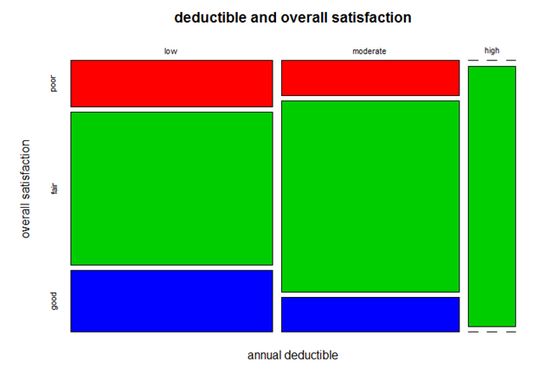

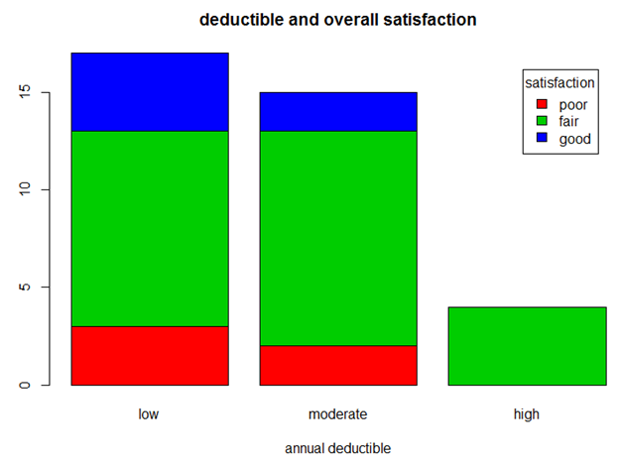

Overall satisfaction

- 0-4 = poor

- 5-8 = fair

- 9-10 = good

Annual deductible

- 0-1000 = low

- 1001-5000 = moderate

- 5001-10000 = high

*Data Issues*

* There was enormous variation in inputting the name of insurance company. Many insurance companies were identified by different names (i.e. Blue Cross/Blue Shield of Illinois as “BCBSIL”, BlueCross IL”, Blue cross Illinois”)
* There was significant variation in inputting the data associated with cost such as “income”, “deductible”, “out-of-pocket” as follows;
  + input in separate categories, for example “$200, employer $380” → should note your contribution. Question should be clearer.
  + input as a range, for example “$2500-$5000” → should note “maximal value”
  + input as “don’t know or I don’t know” → should note “leave it blank if you don’t know” - should have a selection for IDK
  + input as “no deductible” → should note “input 0 if you have no deductible”
  + Need to have clearer explanation of deductible - some patients did not understand.
  + Need to have clearer explanation of out of pocket spending - some patients included deductible, some did not.
* For “number of endoscopy”, some patients answered “one per each”
* Some had more than one insurance
* “Race is a social construct” response
* “Gender norming is oppression” response
* You could also ask if the insurance company has preferred biologics. Mine does. I have to use Humira and Remicade before they'll pay for anything else. Even if my doc wants me on something else like Cimzia.

*Additional Potential Questions*

1. How to capture all possible insurers - certainly BCBS by state, but many options - how to include all reasonable options? VA, Tricare, etc. - perhaps a branching question - state first, then a pick list of all health insurers for that state
2. Ask about pharma programs for copay assistance - does that affect satisfaction?
3. Make sure patients understand what is meant by deductible, out of pocket, etc.
4. Any information on forced switch of biologics by insurers?
5. Data on how long with current insurer?
6. Data on how many times in the last N years that they have changed insurance?
7. If they could get lower rates, or free preventive care, would they sign up for longer than 1 year with an insurer? How much lower would they have to be/how much benefit?
8. Add "Would you recommend this type of health insurance to other IBD patients?" Yes/No
9. Clarify if you have 2 types of insurance. Focus on insurance for meds
10. specify how long you have had this insurance
11. How many times have you switched insurers
12. gender and race issues -
13. if covered by current insurer for less than one year, evaluate your previous insurer.
14. Explain deductible
15. explain out of pocket, how to calculate (include deductible or not).
16. explain monthly payment - patient part vs. employer part.
17. How long was the gap in biologic therapy?
18. Which biologic therapy did you have a gap for?
19. Before or During the gap were you on an immunomodulator like imuran or methotrexate?
20. How many times have you been prescribed a biologic, of those, how many times initially denied?
21. How long did it take to get approval from your insurance for a biologic. I've had it take a few weeks to get prior authorizations to get through
22. Did you use a company assistance program/copay program?
23. Another thing you could ask is how much each patients co-payment is for their biologic. You could ask how much it is with insurance and then how much it is after they have the manufacture's copayment card applied. Like my Humira would be $120 a month but I only pay $5 because of Abbvie's copayment card.
24. I don't know if you guys want to distinguish between PPO, HMO, ect plans. Because depending on which one you have depends on how things work with copayments, deductibles, ect.
25. You could also ask if the insurance company has preferred biologics. Mine does. I have to use Humira and Remicade before they'll pay for anything else. Even if my doc wants me on something else like Cimzia.

*Future Plans*

1. Improve questions - monthly payment - how much do you pay? separate from employer - can say dont know.
2. Explain that respondents may have to look up information like deductible, monthly payment, OOP spend. For children, ask parents?
3. Get feedback from patients
4. Add questions
5. Apply CCFA partners
6. Do N=1000 pilot with CCFAP. Test, develop clean code to analyze, revise.
7. With Final version, do N=13,000 version with CCFAP