Early Career Faculty in GI & Hepatology

Peter Higgins, RAC Chair

11/23/2020

## Tracking Junior Faculty and Their Supported Effort

It can become complicated to track which faculty are in the career development phase, and what supported effort they have for research, along the the source for that support, and the timeline for when it runs out. These are important pieces of information for planning and supporting future faculty development and grant applications.

In the Gantt chart below, we will track junior research faculty timelines, with support indicated in:

* red, for Department Support
* gray, for foundation CDAs
* light blue, for internal KL2s
* blue for NIH K awards
* black for NIH R01s

The vertical lines mark:

* red - today - funding should extend past this line - if not, this is an **urgent** problem
* black - 2 years from now - stable funding extends past this line

Anyone whose funding runs out between the 2 lines should actively be **writing and submitting** grants.

## Current Funding

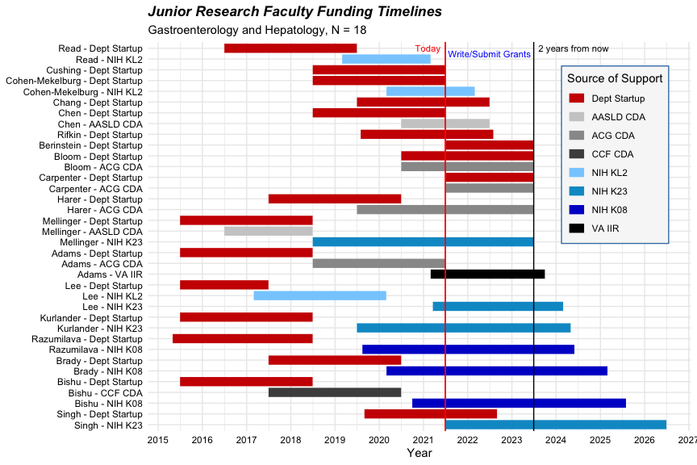

## Planned Grant Proposals

