thiomon_report

Peter Higgins

4/25/2018

## Use of Thiomon

Thiomon is an algorithmic test that assesses the immunosuppression by thiopurine medications using data from CBCPD, COMP, and date of birth. It produces an immunosuppression score, which, if greater than 100, indicates effective immunosuppression by thiopurines.

This test is highly accurate, with 86% accuracy for clinical remission, and 80% accurate for biologic remission. It replaces a metabolite test, which is only 59% accurate for clinical remission, and 50% accurate for biologic remission (effectively, a coin flip). The metabolite test costs $210, while the thiomon test is currently free. However, many clinicians are familiar with the highly marketed metabolite test, and few are familiar with the thiomon test. Usage of the thiomon test is lower than it should be, and usage of the metabolite test is too high. Below is the usage of the thiomon and metabolite tests by year

knitr::include_graphics(here::here("counts_byyear.png"))

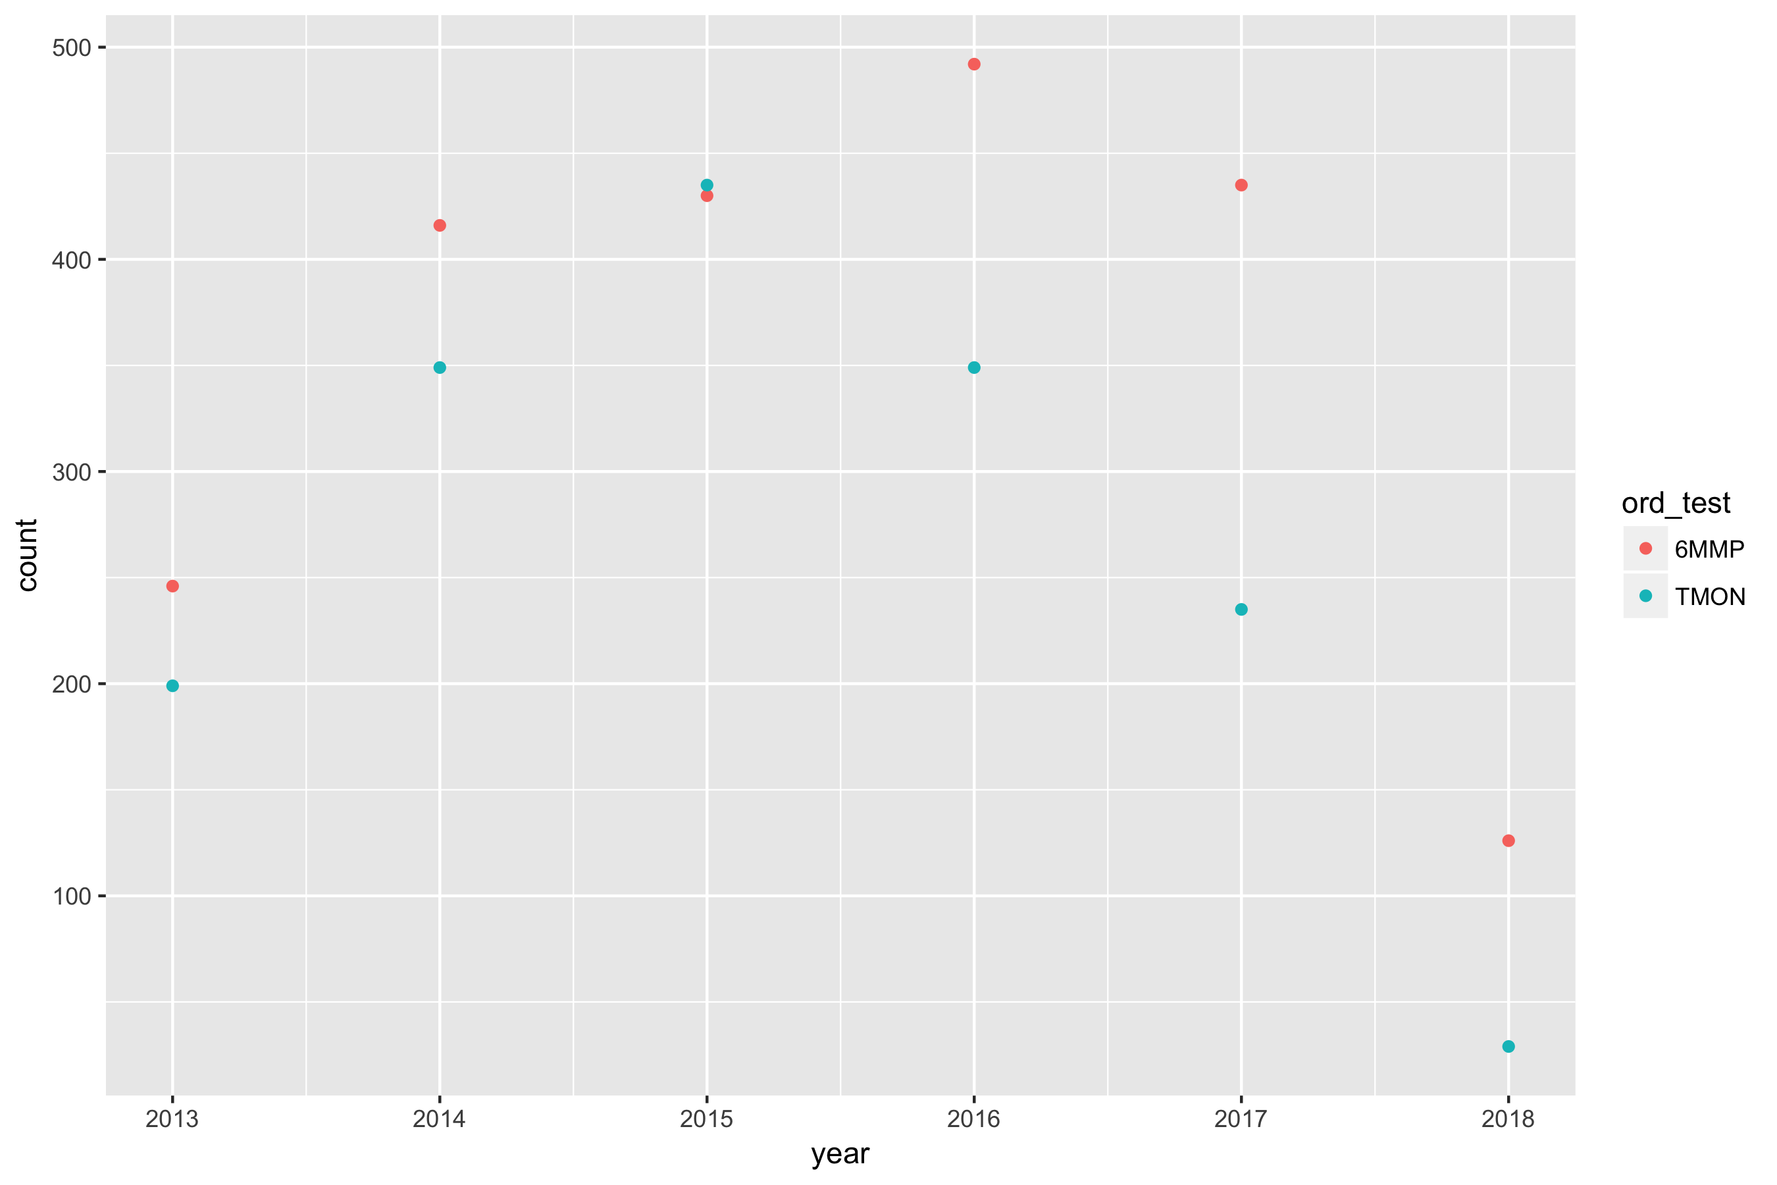

## ThioMon by doctor

Below is the usage of the thiomon and metabolite tests by doctor

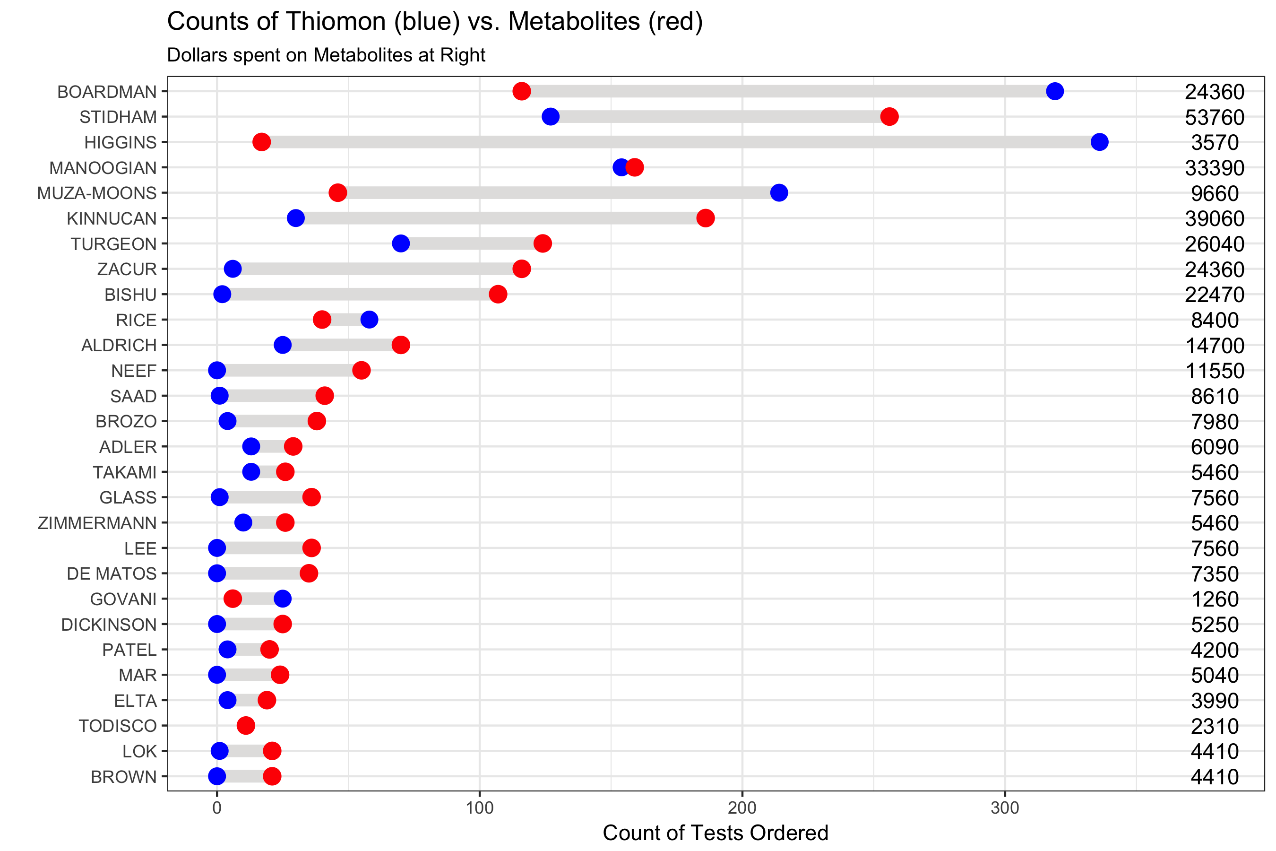

Note that the echo = FALSE parameter was added to the code chunk to prevent printing of the R code that generated the plot.