DSS Mouse Experiment 2 with Upa and Vada

library(tidyverse)

── Attaching core tidyverse packages ──────────────────────── tidyverse 2.0.0 ──  
✔ dplyr 1.1.4 ✔ readr 2.1.5  
✔ forcats 1.0.1 ✔ stringr 1.5.2  
✔ ggplot2 4.0.0 ✔ tibble 3.3.0  
✔ lubridate 1.9.4 ✔ tidyr 1.3.1  
✔ purrr 1.1.0   
── Conflicts ────────────────────────────────────────── tidyverse_conflicts() ──  
✖ dplyr::filter() masks stats::filter()  
✖ dplyr::lag() masks stats::lag()  
ℹ Use the conflicted package (<http://conflicted.r-lib.org/>) to force all conflicts to become errors

library(readxl)  
library(janitor)

Attaching package: 'janitor'  
  
The following objects are masked from 'package:stats':  
  
 chisq.test, fisher.test

library(ggbeeswarm)

## DSS Mouse Experiment 2

This experiment was to test Upa/Vada vs Upa alone vs. DSS colitis.

This experiment used DSS in water at 3% for 8 days, rather than the planned 7, because the mice were slow to develop rectal bleeding. This led to only only one day of rest on regular drinking water.

Each arm of the study included C57BL6 male mice, 5 or 10 per group.

The groups were:

1. Negative controls (no DSS, vehicle gavage) - 5 mice - one lost
2. Drug controls (no DSS, Upa 30 mpk, Vada 3 mpk) - 5 mice
3. DSS positive controls (DSS, vehicle) - 10 mice
4. DSS + Upa 30 mpk - group 5 - 10 mice (anti-inf rx)
5. DSS + Upa 30 mpk + vada 3 mpk - 10 mice (anti-inf + BET)

## Read in Data

Final data are from day 10 (sac day).

dat <- readxl::read_xlsx("tidy data for vada-upa experiment2.xlsx") |>   
 clean_names() |>   
 mutate(rx = factor(rx, ordered = TRUE,  
 levels = c("water+vehicle", "water+Vada/Upa",  
 "DSS+vehicle", "DSS+Upa",  
 "DSS+Vada/Upa")))

Need a body weight comparison here

Graph BW by day

Graph blood by day

Graph DAI by Day

Let’s compare the colon weights by group

dat |>   
 ggplot(aes(y= colon_weight, x = rx)) +  
 geom_boxplot() +   
 geom_beeswarm() +  
 labs( x = "Treatment Group",  
 y = "Colon Weight in grams",  
 caption = "Comparisons with Student's t test",   
 title = "Colon Weight by Treatment Group")+   
 ggsignif::geom_signif(comparisons = list(  
 c(1,2), c(1,3), c(2,3), c(3,4), c(4,5), c(1,4),  
 c(1,5)),  
 test = "t.test",  
 step_increase = 0.1)

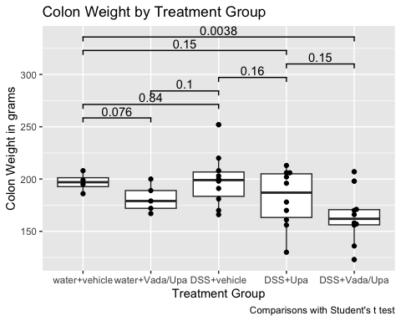

Issues:

* not much colon weight gain in DSS
* colon wt loss in drug treated/ drug control
* NS more colon wt loss in upa treated
* signif more colon wt loss in double treated
* May need to normalize to body weight

Now compare the colon lengths by group

dat |>   
 ggplot(aes(y= colon_length, x = rx)) +  
 geom_boxplot() +   
 geom_beeswarm() +  
 labs( x = "Treatment Group",  
 y = "Colon Length in cm",  
 caption = "Comparisons with Student's t test",  
 title = "Colon Length by Treatment Group")+  
 ggsignif::geom_signif(comparisons = list(  
 c(1,2), c(1,3), c(2,3), c(3,4), c(4,5), c(1,4),  
 c(1,5)),  
 test = "t.test",  
 step_increase = 0.1)

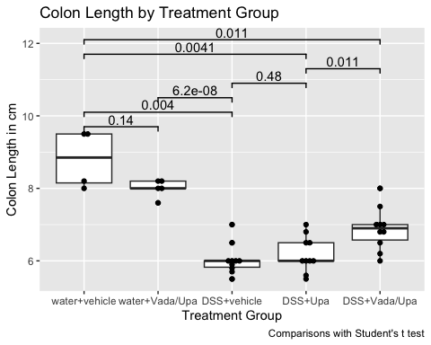

Issues:

* some loss of length with drug control
* big loss of length with DSS
* partial restoration with Upa
* More length restoration with Vada/Upa, but a ways from normal colon - colon ends up shorter, less heavy
* May need to normalize to body weight

Now compare the colon ‘density’ (grams/cm) by group

dat |>   
 ggplot(aes(y= colon_density, x = rx)) +  
 geom_boxplot() +   
 geom_beeswarm() +  
 labs( x = "Treatment Group",  
 y = "Colon 'Density' in grams/cm",  
 caption = "Comparisons with Student's t test",  
 title = "Colon 'Density' by Treatment Group")+  
 ggsignif::geom_signif(comparisons = list(  
 c(1,2), c(1,3), c(2,3), c(3,4), c(4,5), c(1,4),  
 c(1,5)),  
 test = "t.test",  
 step_increase = 0.1)

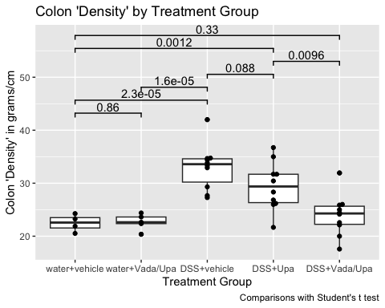

This makes sense - no difference with drug control, big spleen in DSS, partial recovery with Upa, more recovery with vada/upa - to nearly normal.

Now compare the spleen weight to body mass ratio by group

dat |>   
 ggplot(aes(y= spleen_wt_bw, x = rx)) +  
 geom_boxplot() +   
 geom_beeswarm() +  
 labs( x = "Treatment Group",  
 y = "Spleen to Body Weight Ratio",  
 caption = "Comparisons with Student's t test",  
 title = "Spleen to Body Weight Ratio by Treatment Group") +  
 ggsignif::geom_signif(comparisons = list(  
 c(1,2), c(1,3), c(2,3), c(3,4), c(4,5), c(1,4),  
 c(1,5)),  
 test = "t.test",  
 step_increase = 0.1)

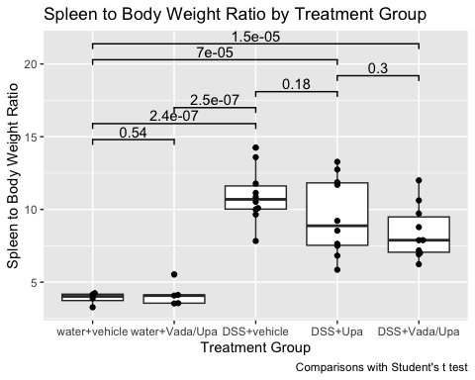

This makes sense - no difference with drug control, big spleen in DSS, partial recovery with Upa, more recovery with vada/upa - still not entirely normal.

Now compare the day 10 Disease Activity Index

dat |>   
 ggplot(aes(y= day10_dia, x = rx)) +  
 geom_boxplot() +   
 geom_beeswarm() +  
 labs( x = "Treatment Group",  
 y = "Day 10 Disease Activity Index",  
 caption = "Comparisons with Student's t test",  
 title = "Day 10 DAI by Treatment Group") +  
 ggsignif::geom_signif(comparisons = list(  
 c(1,3), c(2,3), c(3,4), c(3,5), c(1,4),  
 c(1,5)),  
 test = "t.test",  
 step_increase = 0.1)

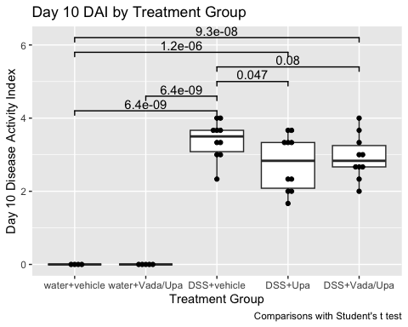

May need more recovery time - 4 days on water plus drugs?

Now compare the day 7 stool bleeding score

dat |>   
 ggplot(aes(y= day7_stool_bleeding, x = rx)) +  
 geom_boxplot() +   
 geom_beeswarm() +  
 labs( x = "Treatment Group",  
 y = "Day 7 Stool Bleeding Score",  
 caption = "Too many ties to calculate several p values",  
 title = "Day 7 Stool Bleeding Score by Treatment Group")+  
 ggsignif::geom_signif(comparisons = list(  
 c(1,3), c(2,3), c(3,4), c(3,5)),  
 test = "t.test",  
 step_increase = 0.1)

Warning: Removed 1 row containing non-finite outside the scale range  
(`stat_boxplot()`).

Warning: Removed 1 row containing non-finite outside the scale range  
(`stat_signif()`).

Warning: Removed 1 row containing missing values or values outside the scale range  
(`geom_point()`).

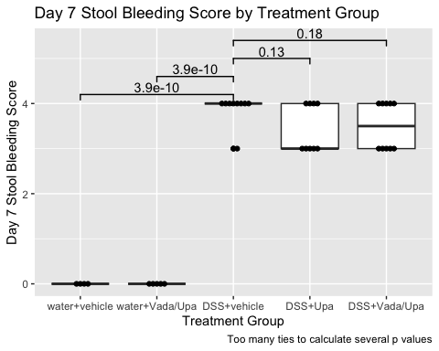

Possibly need more recovery time - 4 days on water?