**CURRICULUM VITAE**

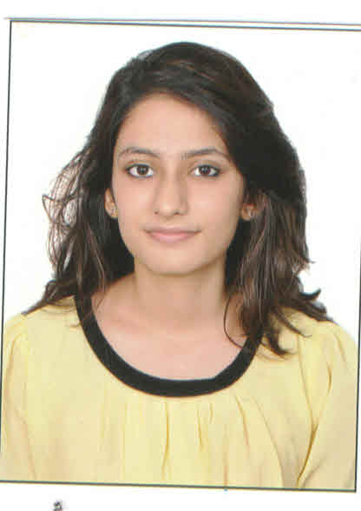

**NAME:**

MS. ASMA KHOPEKAR.

**ADDRESS:**

A-WING, 1303, PEARL HEIGHTS, YARI ROAD, VERSOVA, ANDHERI (W), MUMBAI 400 061.

**MOB NO**:

+91-8879434170

**EMAIL ID:**

[khopekarasma@gmail.com](mailto:khopekarasma@gmail.com)

* Date of Birth:

03 April 1996.

* Languages Known:
* English, Hindi, Marathi, Learning Spanish, can read and write Arabic.

* Education Qualification:

|  |  |
| --- | --- |
| **COLLEGE/SCHOOL** | **QUALIFICATION** |
| * Rizvi Law College, Bandra, Mumbai. | Pursuing 4th year of the B.L.S/LL.B Course; |
| * Rizvi Law College, Bandra, Mumbai. | Passed T.Y.B.L.S/LL.B- 2015-2016 at 53%, Mumbai University. |
| * Rizvi Law College, Bandra, Mumbai. | Passed S.Y.B.L.S/LL.B- 2014-2015 at 60% |
| * Rizvi Law College, Bandra, Mumbai. | Passed F.Y.B.L.S/LL.B- 2013-2014 at 57.16% |
| * Asian School of Law, Pune | Pursuing Cyber Law Course, 2016-17; |
| * Mithibai Motiram Kundnani (M.M.K) College of Commerce and Economics, Bandra, Mumbai. | Passed (12th Grade) H.S.C. Examination-May 2013 at 78.16%, Maharashtra Board; |
| * St. Louis Convent High School, Andheri (W), Mumbai. | Passed (10th Grade) S.S.C Examination May 2011 at 86.55%, Maharashtra Board; |

* Work Experience:
* I have interned at the Runwal Group, Sion, Mumbai under Ms. Dhruti Dholakia for a period of 3.5 months as a legal trainee and have learnt a lot of legal and back-office work (from June to October 2015). I have dealt with various legal works of Runwal as it had 19 companies.viz;
* Drafting of Legal notices, Drafting of Legal letters, Drafting of property agreements, Sale Deeds, Allotment letters, Preparation of Affidavits,Power of Attorney.
* I have assisted on a few cases before Kamgar Bhavan (Labor Dispute Court-Mumbai).
* Organizational Experience:
* Vice President of the Cultural-Committee of the Student’s Bar Forum of the College 2015-2016.
* Designated as the Vice-President of the Rotoract Club of Rizvi Law College, District 3140.
* Headed the organization of TEDx Mumbai by Rizvi Law College in Association with the Rotoract Club of Mumbai in the year 2015.
* Headed and organized Umang 2015- A Show for the Senior Citizens-All over Mumbai in Association with the Rotoract Club of Mumbai.
* Cultural Achievements:
* Have participated and won for various University level Street Plays and Dances.
* Hobbies:
* Article Writing, Dancing, Photography, Tennis, Team Sports, Bicycling, Travelling and exploring.