Observabilidade de ponta a ponta no Azure
Jornada de um Pedido de Compra: APIM → Azure Functions → Service Bus → Storage + Cosmos DB, com Application Insights, trace distribuído e correlação de negócio
Resource Group: ai-expert • Runtime: .NET 8 isolated (Functions v4) • Auth: Managed Identity + RBAC
Passo a passo de construção reproduzível via Azure CLL + func core tools

1. Visão geral e arquitetura
O objetivo é enxergar a jornada completa de uma mensagem de negócio (um pedido de compra) atravessando vários serviços, com rastreabilidade ponta a ponta no Application Insights. Um cliente envia o pedido via APIM; a primeira Function publica no Service Bus; a segunda Function consome a mensagem e persiste em DOIS destinos (Blob para auditoria e Cosmos DB para consulta).
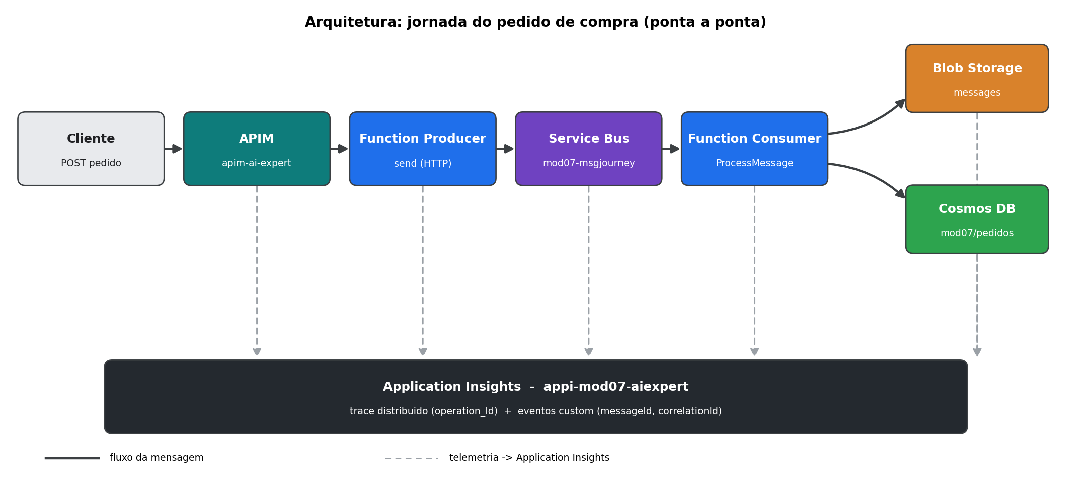
Figura 1 — Arquitetura ponta a ponta. Linha sólida = fluxo da mensagem; tracejado = telemetria para o Application Insights.
Dois eixos de correlação:
- messageId — ID técnico, único por mensagem (um GUID por POST).
- correlationId — ID de negócio, igual ao orderId do pedido (ex.: PO-2026-0004). Amarra TODOS os componentes e eventos do mesmo pedido. Vai no campo nativo ServiceBusMessage.CorrelationId, em ApplicationProperties e nos eventos custom.
Além disso, o trace distribuído W3C (traceparent) propaga automaticamente do Producer, pela mensagem do Service Bus, até o Consumer — conectando tudo sob um único operation_Id.
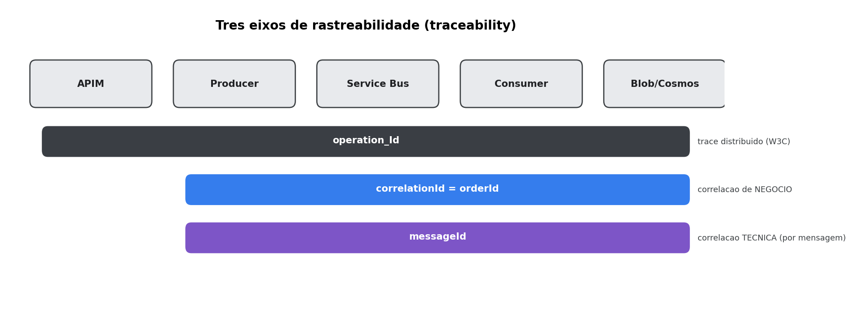
Figura 2 — Os três eixos de rastreabilidade e o alcance de cada um na jornada.

2. Pré-requisitos
- Azure CLI (az) autenticado na subscription (az login).
- Azure Functions Core Tools v4 (comando func).
- .NET SDK 8.
- Permissão para criar recursos e atribuir RBAC no RG ai-expert.
Ambiente usado: Windows 11 + PowerShell/Git Bash. Subscription “Visual Studio Enterprise MSDN” (f0b99507-d9cd-4a31-93f8-ce27b88b7969).

3. Recursos da solução
Reutilizados (já existiam):
Recurso | Nome | Região
API Management | apim-ai-expert | -
Service Bus (namespace) | sbaiexpert | canadacentral
Storage Account | stamod03lab03dev001 | eastus
Criados neste passo a passo:
Recurso | Nome | Detalhe
Log Analytics workspace | log-mod07-aiexpert | eastus
Application Insights | appi-mod07-aiexpert | workspace-based, eastus
Function App (Producer) | func-mod07-producer-aiexpert | Y1 Consumption, Linux, .NET 8 isolated
Function App (Consumer) | func-mod07-consumer-aiexpert | Y1 Consumption, Linux, .NET 8 isolated
Fila Service Bus | mod07-msgjourney | no namespace sbaiexpert
Container Blob | messages | no storage stamod03lab03dev001
Cosmos DB (conta) | cosmos-mod07-aiexpert | SQL API, serverless, eastus2
Cosmos DB database | mod07 | -
Cosmos DB container | pedidos | partition key /correlationId

4. Código das Functions (.NET 8 isolated)
Crie a pasta da solução com dois projetos: producer\ e consumer\. Abaixo o código de cada arquivo.

4.1. Producer — recebe o pedido por HTTP e publica no Service Bus
producer\producer.csproj
<Project Sdk="Microsoft.NET.Sdk">
<PropertyGroup>
<TargetFramework>net8.0</TargetFramework>
<AzureFunctionsVersion>v4</AzureFunctionsVersion>
<OutputType>Exe</OutputType>
<ImplicitUsings>enable</ImplicitUsings>
<Nullable>enable</Nullable>
<RootNamespace>Mod07.Producer</RootNamespace>
</PropertyGroup>
<ItemGroup>
<PackageReference Include="Microsoft.Azure.Functions.Worker" Version="1.23.0" />
<PackageReference Include="Microsoft.Azure.Functions.Worker.Sdk" Version="1.18.1" />
<PackageReference Include="Microsoft.Azure.Functions.Worker.Extensions.Http" Version="3.2.0" />
<PackageReference Include="Microsoft.Azure.Functions.Worker.ApplicationInsights" Version="1.4.0" />
<PackageReference Include="Microsoft.ApplicationInsights.WorkerService" Version="2.22.0" />
<PackageReference Include="Azure.Identity" Version="1.13.1" />
<PackageReference Include="Azure.Messaging.ServiceBus" Version="7.18.2" />
</ItemGroup>
<ItemGroup>
<None Update="host.json">
<CopyToOutputDirectory>PreserveNewest</CopyToOutputDirectory>
</None>
<None Update="local.settings.json">
<CopyToOutputDirectory>PreserveNewest</CopyToOutputDirectory>
<CopyToPublishDirectory>Never</CopyToPublishDirectory>
</None>
</ItemGroup>
</Project>
producer\Program.cs — registra o ServiceBusClient via Managed Identity (sem connection string).
using Azure.Identity;
using Azure.Messaging.ServiceBus;
using Microsoft.Azure.Functions.Worker;
using Microsoft.Extensions.DependencyInjection;
using Microsoft.Extensions.Hosting;
var host = new HostBuilder()
.ConfigureFunctionsWorkerDefaults()
.ConfigureServices(services =>
{
// Telemetria: App Insights no worker isolado (traces, dependencias, eventos custom)
services.AddApplicationInsightsTelemetryWorkerService();
services.ConfigureFunctionsApplicationInsights();
// ServiceBusClient autenticado via Managed Identity (sem connection string)
var fqns = Environment.GetEnvironmentVariable("ServiceBusConnection__fullyQualifiedNamespace")
?? throw new InvalidOperationException("ServiceBusConnection__fullyQualifiedNamespace nao configurado.");
services.AddSingleton(_ => new ServiceBusClient(fqns, new DefaultAzureCredential()));
})
.Build();
host.Run();
producer\PurchaseOrder.cs — modelo do pedido de compra.
using System.Text.Json.Serialization;
namespace Mod07.Producer;
/// <summary>
/// Item de um pedido de compra (ex.: caneta, papel sulfite, teclado, mouse, caneca).
/// </summary>
public record PurchaseOrderItem
{
public string Sku { get; init; } = "";
public string Name { get; init; } = "";
public int Quantity { get; init; }
public decimal UnitPrice { get; init; }
[JsonIgnore]
public decimal LineTotal => Quantity * UnitPrice;
}
/// <summary>
/// Pedido de compra recebido via HTTP. O <see cref="OrderId"/> vira o
/// correlationId de negocio que amarra toda a jornada (Producer -> Service Bus
/// -> Consumer -> Blob + Cosmos) no Application Insights.
/// </summary>
public record PurchaseOrder
{
public string? OrderId { get; init; }
public string? Requester { get; init; }
public string? CostCenter { get; init; }
public string Currency { get; init; } = "BRL";
public List<PurchaseOrderItem> Items { get; init; } = new();
}
producer\SendMessageFunction.cs — gera messageId, define correlationId = orderId e publica.
using System.Net;
using System.Text.Json;
using Azure.Messaging.ServiceBus;
using Microsoft.ApplicationInsights;
using Microsoft.ApplicationInsights.DataContracts;
using Microsoft.Azure.Functions.Worker;
using Microsoft.Azure.Functions.Worker.Http;
using Microsoft.Extensions.Logging;
namespace Mod07.Producer;
/// <summary>
/// Function A (Producer): exposta via APIM. Recebe um PEDIDO DE COMPRA via HTTP POST
/// e publica na fila do Service Bus. Emite telemetria correlacionada por:
/// - messageId -> ID tecnico de CADA mensagem
/// - correlationId -> ID de NEGOCIO do pedido (orderId), que amarra a jornada inteira
/// para que o pedido possa ser seguido ponta-a-ponta no Application Insights.
/// </summary>
public class SendMessageFunction
{
private static readonly JsonSerializerOptions JsonOpts = new()
{
PropertyNameCaseInsensitive = true,
PropertyNamingPolicy = JsonNamingPolicy.CamelCase
};
private readonly ServiceBusClient _sbClient;
private readonly TelemetryClient _telemetry;
private readonly ILogger<SendMessageFunction> _logger;
private readonly string _queueName;
public SendMessageFunction(ServiceBusClient sbClient, TelemetryClient telemetry, ILogger<SendMessageFunction> logger)
{
_sbClient = sbClient;
_telemetry = telemetry;
_logger = logger;
_queueName = Environment.GetEnvironmentVariable("QUEUE_NAME") ?? "mod07-msgjourney";
}
[Function("SendMessage")]
public async Task<HttpResponseData> Run(
[HttpTrigger(AuthorizationLevel.Function, "post", Route = "send")] HttpRequestData req)
{
var messageId = Guid.NewGuid().ToString("N");
// ---- Le e valida o pedido de compra ----------------------------------
string requestBody;
using (var reader = new StreamReader(req.Body))
{
requestBody = await reader.ReadToEndAsync();
}
PurchaseOrder order;
try
{
order = string.IsNullOrWhiteSpace(requestBody)
? BuildSampleOrder()
: JsonSerializer.Deserialize<PurchaseOrder>(requestBody, JsonOpts) ?? BuildSampleOrder();
}
catch (JsonException)
{
var bad = req.CreateResponse(HttpStatusCode.BadRequest);
await bad.WriteAsJsonAsync(new { status = "invalid", error = "JSON do pedido de compra invalido." });
return bad;
}
if (order.Items.Count == 0)
{
order = order with { Items = BuildSampleOrder().Items };
}
// correlationId de negocio = orderId (gera um se nao vier no payload)
var correlationId = string.IsNullOrWhiteSpace(order.OrderId)
? $"PO-{DateTimeOffset.UtcNow:yyyyMMdd}-{messageId[..8]}"
: order.OrderId!.Trim();
order = order with { OrderId = correlationId };
var totalAmount = order.Items.Sum(i => i.LineTotal);
var itemCount = order.Items.Sum(i => i.Quantity);
// Operacao do App Insights carimbada com os dois eixos de correlacao
using var op = _telemetry.StartOperation<RequestTelemetry>("SendMessage");
op.Telemetry.Properties["messageId"] = messageId;
op.Telemetry.Properties["correlationId"] = correlationId;
var envelope = JsonSerializer.Serialize(new
{
messageId,
correlationId,
createdUtc = DateTimeOffset.UtcNow,
source = "func-mod07-producer",
kind = "purchase-order",
totalAmount,
currency = order.Currency,
itemCount,
order
}, JsonOpts);
var message = new ServiceBusMessage(envelope)
{
MessageId = messageId,
CorrelationId = correlationId, // campo nativo do Service Bus -> aparece na dependencia
ContentType = "application/json",
Subject = "purchase-order"
};
// App properties para correlacao simples em KQL (alem do traceparent W3C,
// injetado automaticamente para o trace distribuido).
message.ApplicationProperties["messageId"] = messageId;
message.ApplicationProperties["correlationId"] = correlationId;
message.ApplicationProperties["source"] = "func-mod07-producer";
var sender = _sbClient.CreateSender(_queueName);
try
{
await sender.SendMessageAsync(message);
_telemetry.TrackEvent("MessageSent", new Dictionary<string, string>
{
["messageId"] = messageId,
["correlationId"] = correlationId,
["queue"] = _queueName,
["stage"] = "producer",
["itemCount"] = itemCount.ToString(),
["totalAmount"] = totalAmount.ToString("F2")
});
_logger.LogInformation(
"Pedido {CorrelationId} (msg {MessageId}) enviado para {Queue}: {Items} itens, total {Total} {Currency}.",
correlationId, messageId, _queueName, itemCount, totalAmount, order.Currency);
var ok = req.CreateResponse(HttpStatusCode.Accepted);
await ok.WriteAsJsonAsync(new
{
status = "accepted",
messageId,
correlationId,
orderId = correlationId,
itemCount,
totalAmount,
currency = order.Currency,
queue = _queueName
});
return ok;
}
catch (Exception ex)
{
op.Telemetry.Success = false;
_telemetry.TrackException(ex, new Dictionary<string, string>
{
["messageId"] = messageId,
["correlationId"] = correlationId,
["stage"] = "producer"
});
_logger.LogError(ex, "Falha ao enviar pedido {CorrelationId} (msg {MessageId}).", correlationId, messageId);
var fail = req.CreateResponse(HttpStatusCode.InternalServerError);
await fail.WriteAsJsonAsync(new { status = "error", messageId, correlationId, error = ex.Message });
return fail;
}
finally
{
await sender.DisposeAsync();
}
}
/// <summary>Pedido de exemplo (caneta, papel sulfite, teclado, mouse, caneca).</summary>
private static PurchaseOrder BuildSampleOrder() => new()
{
Requester = "Compras - TI",
CostCenter = "TI-Infra",
Currency = "BRL",
Items = new()
{
new PurchaseOrderItem { Sku = "CAN-AZ-001", Name = "Caneta esferografica azul", Quantity = 50, UnitPrice = 1.50m },
new PurchaseOrderItem { Sku = "PAP-A4-500", Name = "Papel sulfite A4 (resma 500fl)", Quantity = 20, UnitPrice = 24.90m },
new PurchaseOrderItem { Sku = "TEC-ABNT2", Name = "Teclado USB ABNT2", Quantity = 5, UnitPrice = 89.90m },
new PurchaseOrderItem { Sku = "MOU-OPT-USB", Name = "Mouse optico USB", Quantity = 5, UnitPrice = 39.90m },
new PurchaseOrderItem { Sku = "CCA-CER-350", Name = "Caneca ceramica 350ml", Quantity = 10, UnitPrice = 19.90m }
}
};
}
producer\host.json
{
"version": "2.0",
"logging": {
"applicationInsights": {
"samplingSettings": {
"isEnabled": true,
"excludedTypes": "Request;Exception"
},
"enableLiveMetricsFilters": true
}
}
}

4.2. Consumer — consome a fila e grava em Blob + Cosmos
consumer\consumer.csproj — note a referência EXPLÍCITA a Newtonsoft.Json exigida pelo SDK do Cosmos.
<Project Sdk="Microsoft.NET.Sdk">
<PropertyGroup>
<TargetFramework>net8.0</TargetFramework>
<AzureFunctionsVersion>v4</AzureFunctionsVersion>
<OutputType>Exe</OutputType>
<ImplicitUsings>enable</ImplicitUsings>
<Nullable>enable</Nullable>
<RootNamespace>Mod07.Consumer</RootNamespace>
</PropertyGroup>
<ItemGroup>
<PackageReference Include="Microsoft.Azure.Functions.Worker" Version="1.23.0" />
<PackageReference Include="Microsoft.Azure.Functions.Worker.Sdk" Version="1.18.1" />
<PackageReference Include="Microsoft.Azure.Functions.Worker.Extensions.ServiceBus" Version="5.22.0" />
<PackageReference Include="Microsoft.Azure.Functions.Worker.ApplicationInsights" Version="1.4.0" />
<PackageReference Include="Microsoft.ApplicationInsights.WorkerService" Version="2.22.0" />
<PackageReference Include="Azure.Identity" Version="1.13.1" />
<PackageReference Include="Azure.Storage.Blobs" Version="12.23.0" />
<PackageReference Include="Microsoft.Azure.Cosmos" Version="3.46.0" />
<PackageReference Include="Newtonsoft.Json" Version="13.0.3" />
</ItemGroup>
<ItemGroup>
<None Update="host.json">
<CopyToOutputDirectory>PreserveNewest</CopyToOutputDirectory>
</None>
<None Update="local.settings.json">
<CopyToOutputDirectory>PreserveNewest</CopyToOutputDirectory>
<CopyToPublishDirectory>Never</CopyToPublishDirectory>
</None>
</ItemGroup>
</Project>
consumer\Program.cs — registra BlobServiceClient e CosmosClient, ambos via Managed Identity.
using Azure.Identity;
using Azure.Storage.Blobs;
using Microsoft.Azure.Cosmos;
using Microsoft.Azure.Functions.Worker;
using Microsoft.Extensions.DependencyInjection;
using Microsoft.Extensions.Hosting;
var host = new HostBuilder()
.ConfigureFunctionsWorkerDefaults()
.ConfigureServices(services =>
{
// Telemetria: App Insights no worker isolado
services.AddApplicationInsightsTelemetryWorkerService();
services.ConfigureFunctionsApplicationInsights();
var credential = new DefaultAzureCredential();
// BlobServiceClient autenticado via Managed Identity (sem connection string)
var blobUri = Environment.GetEnvironmentVariable("STORAGE_BLOB_URI")
?? throw new InvalidOperationException("STORAGE_BLOB_URI nao configurado.");
services.AddSingleton(_ => new BlobServiceClient(new Uri(blobUri), credential));
// CosmosClient autenticado via Managed Identity + RBAC de dados do Cosmos
var cosmosEndpoint = Environment.GetEnvironmentVariable("COSMOS_ENDPOINT")
?? throw new InvalidOperationException("COSMOS_ENDPOINT nao configurado.");
services.AddSingleton(_ => new CosmosClient(cosmosEndpoint, credential, new CosmosClientOptions
{
ApplicationName = "func-mod07-consumer",
// SDK ja instrumenta dependencias no App Insights quando a telemetria esta ligada
}));
})
.Build();
host.Run();
consumer\PurchaseOrder.cs — modelo do envelope recebido.
namespace Mod07.Consumer;
/// <summary>Item do pedido de compra (espelha o modelo do Producer).</summary>
public record PurchaseOrderItem
{
public string Sku { get; init; } = "";
public string Name { get; init; } = "";
public int Quantity { get; init; }
public decimal UnitPrice { get; init; }
}
/// <summary>Pedido de compra carregado do envelope da mensagem.</summary>
public record PurchaseOrder
{
public string? OrderId { get; init; }
public string? Requester { get; init; }
public string? CostCenter { get; init; }
public string Currency { get; init; } = "BRL";
public List<PurchaseOrderItem> Items { get; init; } = new();
}
/// <summary>Envelope publicado pelo Producer no Service Bus.</summary>
public record OrderEnvelope
{
public string? MessageId { get; init; }
public string? CorrelationId { get; init; }
public DateTimeOffset CreatedUtc { get; init; }
public string? Source { get; init; }
public string? Kind { get; init; }
public decimal TotalAmount { get; init; }
public string Currency { get; init; } = "BRL";
public int ItemCount { get; init; }
public PurchaseOrder? Order { get; init; }
}
consumer\ProcessMessageFunction.cs — grava nos dois destinos e emite a telemetria.
using System.Text.Json;
using Azure.Messaging.ServiceBus;
using Azure.Storage.Blobs;
using Microsoft.ApplicationInsights;
using Microsoft.Azure.Cosmos;
using Microsoft.Azure.Functions.Worker;
using Microsoft.Extensions.Logging;
namespace Mod07.Consumer;
/// <summary>
/// Function B (Consumer): disparada pela fila do Service Bus. Persiste o pedido de
/// compra em DOIS destinos:
/// 1) Blob (Storage Account) -> arquivo/auditoria do envelope completo;
/// 2) Cosmos DB SQL serverless -> documento consultavel do pedido (upsert).
/// Emite telemetria correlacionada por messageId (tecnico) e correlationId (negocio).
/// O trace distribuido (W3C traceparent) propaga do Producer ate aqui, fechando a
/// jornada no Application Insights (APIM -> Producer -> Service Bus -> Consumer -> Blob + Cosmos).
/// </summary>
public class ProcessMessageFunction
{
private static readonly JsonSerializerOptions JsonOpts = new()
{
PropertyNameCaseInsensitive = true,
PropertyNamingPolicy = JsonNamingPolicy.CamelCase
};
private readonly BlobServiceClient _blobService;
private readonly CosmosClient _cosmos;
private readonly TelemetryClient _telemetry;
private readonly ILogger<ProcessMessageFunction> _logger;
private readonly string _containerName;
private readonly string _cosmosDb;
private readonly string _cosmosContainer;
public ProcessMessageFunction(
BlobServiceClient blobService,
CosmosClient cosmos,
TelemetryClient telemetry,
ILogger<ProcessMessageFunction> logger)
{
_blobService = blobService;
_cosmos = cosmos;
_telemetry = telemetry;
_logger = logger;
_containerName = Environment.GetEnvironmentVariable("BLOB_CONTAINER") ?? "messages";
_cosmosDb = Environment.GetEnvironmentVariable("COSMOS_DATABASE") ?? "mod07";
_cosmosContainer = Environment.GetEnvironmentVariable("COSMOS_CONTAINER") ?? "pedidos";
}
[Function("ProcessMessage")]
public async Task Run(
[ServiceBusTrigger("%QUEUE_NAME%", Connection = "ServiceBusConnection")] ServiceBusReceivedMessage message)
{
var messageId = message.ApplicationProperties.TryGetValue("messageId", out var mid) && mid is not null
? mid.ToString()!
: message.MessageId;
// correlationId de negocio: app property -> campo nativo -> fallback messageId
var correlationId =
(message.ApplicationProperties.TryGetValue("correlationId", out var cid) && cid is not null ? cid.ToString() : null)
?? (string.IsNullOrWhiteSpace(message.CorrelationId) ? null : message.CorrelationId)
?? messageId;
var body = message.Body.ToString();
OrderEnvelope? envelope = null;
try { envelope = JsonSerializer.Deserialize<OrderEnvelope>(body, JsonOpts); }
catch (JsonException ex) { _logger.LogWarning(ex, "Envelope nao-JSON para msg {MessageId}; segue como texto.", messageId); }
var itemCount = envelope?.ItemCount ?? envelope?.Order?.Items.Sum(i => i.Quantity) ?? 0;
var totalAmount = envelope?.TotalAmount ?? 0m;
var props = new Dictionary<string, string>
{
["messageId"] = messageId,
["correlationId"] = correlationId,
["stage"] = "consumer",
["enqueuedUtc"] = message.EnqueuedTime.ToString("o"),
["deliveryCount"] = message.DeliveryCount.ToString(),
["itemCount"] = itemCount.ToString(),
["totalAmount"] = totalAmount.ToString("F2")
};
_telemetry.TrackEvent("MessageReceived", props);
_logger.LogInformation(
"Pedido {CorrelationId} (msg {MessageId}) recebido da fila (delivery #{Count}).",
correlationId, messageId, message.DeliveryCount);
try
{
var processedUtc = DateTimeOffset.UtcNow;
// ---- Destino 1: Blob (envelope completo) ---------------------------
var container = _blobService.GetBlobContainerClient(_containerName);
await container.CreateIfNotExistsAsync();
var blobName = $"{processedUtc:yyyy/MM/dd}/{correlationId}/{messageId}.json";
var blob = container.GetBlobClient(blobName);
var record = JsonSerializer.Serialize(new
{
messageId,
correlationId,
processedUtc,
enqueuedUtc = message.EnqueuedTime,
deliveryCount = message.DeliveryCount,
envelope
}, JsonOpts);
await blob.UploadAsync(BinaryData.FromString(record), overwrite: true);
_telemetry.TrackEvent("BlobWritten", new Dictionary<string, string>
{
["messageId"] = messageId,
["correlationId"] = correlationId,
["stage"] = "consumer",
["container"] = _containerName,
["blob"] = blobName
});
_logger.LogInformation("Pedido {CorrelationId} persistido em blob {Container}/{Blob}.", correlationId, _containerName, blobName);
// ---- Destino 2: Cosmos DB SQL serverless (upsert do pedido) --------
var cosmosContainer = _cosmos.GetContainer(_cosmosDb, _cosmosContainer);
var doc = new
{
id = messageId, // chave do documento (Cosmos exige "id")
correlationId, // partition key (/correlationId) = orderId
orderId = correlationId,
kind = envelope?.Kind ?? "purchase-order",
status = "Received",
requester = envelope?.Order?.Requester,
costCenter = envelope?.Order?.CostCenter,
currency = envelope?.Currency ?? "BRL",
itemCount,
totalAmount,
items = envelope?.Order?.Items?
.Select(i => new { sku = i.Sku, name = i.Name, quantity = i.Quantity, unitPrice = i.UnitPrice })
.ToList(),
source = envelope?.Source ?? "func-mod07-consumer",
messageId,
createdUtc = envelope?.CreatedUtc,
enqueuedUtc = message.EnqueuedTime,
processedUtc,
deliveryCount = message.DeliveryCount
};
var resp = await cosmosContainer.UpsertItemAsync(doc, new PartitionKey(correlationId));
_telemetry.TrackEvent("CosmosDocWritten", new Dictionary<string, string>
{
["messageId"] = messageId,
["correlationId"] = correlationId,
["stage"] = "consumer",
["database"] = _cosmosDb,
["container"] = _cosmosContainer,
["requestCharge"] = resp.RequestCharge.ToString("F2")
});
_logger.LogInformation(
"Pedido {CorrelationId} gravado no Cosmos {Db}/{Container} (id={MessageId}, RU={RU}).",
correlationId, _cosmosDb, _cosmosContainer, messageId, resp.RequestCharge);
}
catch (Exception ex)
{
_telemetry.TrackException(ex, new Dictionary<string, string>
{
["messageId"] = messageId,
["correlationId"] = correlationId,
["stage"] = "consumer"
});
_logger.LogError(ex, "Falha ao persistir pedido {CorrelationId} (msg {MessageId}).", correlationId, messageId);
throw; // re-lanca para abandonar a mensagem e exercitar retry/dead-letter
}
}
}
consumer\host.json
{
"version": "2.0",
"logging": {
"applicationInsights": {
"samplingSettings": {
"isEnabled": true,
"excludedTypes": "Request;Exception"
},
"enableLiveMetricsFilters": true
}
},
"extensions": {
"serviceBus": {
"maxConcurrentCalls": 16,
"autoCompleteMessages": true
}
}
}

5. Provisionamento no Azure (CLI)
Variáveis comuns:
RG=ai-expert
LOC=eastus
SB=sbaiexpert
STG=stamod03lab03dev001
# Git Bash: evite que argumentos iniciados por / sejam convertidos em caminho
export MSYS_NO_PATHCONV=1

5.1. Application Insights (workspace-based)
az monitor log-analytics workspace create -g $RG -n log-mod07-aiexpert -l $LOC
WSID=$(az monitor log-analytics workspace show -g $RG -n log-mod07-aiexpert --query id -o tsv)
az monitor app-insights component create \
--app appi-mod07-aiexpert -g $RG -l $LOC \
--workspace $WSID
AICS=$(az monitor app-insights component show --app appi-mod07-aiexpert -g $RG \
--query connectionString -o tsv)

5.2. Function Apps (Consumption, Linux, .NET 8 isolated) + Managed Identity
for APP in func-mod07-producer-aiexpert func-mod07-consumer-aiexpert; do
az functionapp create -g $RG -n $APP \
--storage-account $STG \
--consumption-plan-location $LOC \
--os-type Linux \
--runtime dotnet-isolated --runtime-version 8 --functions-version 4
# Identidade gerenciada atribuida pelo sistema
az functionapp identity assign -g $RG -n $APP
# Liga o App Insights
az functionapp config appsettings set -g $RG -n $APP \
--settings "APPLICATIONINSIGHTS_CONNECTION_STRING=$AICS"
done

5.3. Fila no Service Bus
az servicebus queue create -g $RG --namespace-name $SB -n mod07-msgjourney

5.4. Container no Storage
az storage container create --name messages \
--account-name $STG --auth-mode login

5.5. Cosmos DB SQL serverless + database + container
Observação: criamos em eastus2 porque East US retornou ServiceUnavailable (falta de capacidade) no momento da criação.
az cosmosdb create -n cosmos-mod07-aiexpert -g $RG \
--kind GlobalDocumentDB \
--capabilities EnableServerless \
--default-consistency-level Session \
--locations regionName=eastus2 failoverPriority=0 isZoneRedundant=false
az cosmosdb sql database create -a cosmos-mod07-aiexpert -g $RG -n mod07
az cosmosdb sql container create -a cosmos-mod07-aiexpert -g $RG \
-d mod07 -n pedidos --partition-key-path "/correlationId"

6. Permissões (Managed Identity + RBAC) — sem connection string de dados
Princípio: cada Function só recebe o papel mínimo necessário, no menor escopo possível.
Identidade | Papel | Escopo
MI do Producer | Azure Service Bus Data Sender | fila mod07-msgjourney
MI do Consumer | Azure Service Bus Data Receiver | fila mod07-msgjourney
MI do Consumer | Storage Blob Data Contributor | storage stamod03lab03dev001
MI do Consumer | Cosmos DB Built-in Data Contributor | conta cosmos-mod07-aiexpert
PROD_MI=$(az functionapp identity show -g $RG -n func-mod07-producer-aiexpert --query principalId -o tsv)
CONS_MI=$(az functionapp identity show -g $RG -n func-mod07-consumer-aiexpert --query principalId -o tsv)
QUEUE_ID=$(az servicebus queue show -g $RG --namespace-name $SB -n mod07-msgjourney --query id -o tsv)
STG_ID=$(az storage account show -g $RG -n $STG --query id -o tsv)
COSMOS_ID=$(az cosmosdb show -n cosmos-mod07-aiexpert -g $RG --query id -o tsv)
# Service Bus (control plane RBAC)
az role assignment create --assignee $PROD_MI \
--role "Azure Service Bus Data Sender" --scope $QUEUE_ID
az role assignment create --assignee $CONS_MI \
--role "Azure Service Bus Data Receiver" --scope $QUEUE_ID
# Storage Blob
az role assignment create --assignee $CONS_MI \
--role "Storage Blob Data Contributor" --scope $STG_ID
# Cosmos DB (data plane - role definition built-in 00000000-0000-0000-0000-000000000002)
az cosmosdb sql role assignment create -a cosmos-mod07-aiexpert -g $RG \
--role-definition-id "00000000-0000-0000-0000-000000000002" \
--principal-id $CONS_MI \
--scope $COSMOS_ID

7. Configurações (App Settings) dos Function Apps
As Functions leem endpoints por variável de ambiente. Para Service Bus, o binding usa a convenção ServiceBusConnection__fullyQualifiedNamespace (conexão baseada em identidade).
Producer:
az functionapp config appsettings set -g $RG -n func-mod07-producer-aiexpert --settings \
"ServiceBusConnection__fullyQualifiedNamespace=sbaiexpert.servicebus.windows.net" \
"QUEUE_NAME=mod07-msgjourney"
Consumer:
az functionapp config appsettings set -g $RG -n func-mod07-consumer-aiexpert --settings \
"ServiceBusConnection__fullyQualifiedNamespace=sbaiexpert.servicebus.windows.net" \
"QUEUE_NAME=mod07-msgjourney" \
"STORAGE_BLOB_URI=https://stamod03lab03dev001.blob.core.windows.net" \
"BLOB_CONTAINER=messages" \
"COSMOS_ENDPOINT=https://cosmos-mod07-aiexpert.documents.azure.com:443/" \
"COSMOS_DATABASE=mod07" \
"COSMOS_CONTAINER=pedidos"

8. Publicar as Functions
cd producer
func azure functionapp publish func-mod07-producer-aiexpert --dotnet-isolated
cd ../consumer
func azure functionapp publish func-mod07-consumer-aiexpert --dotnet-isolated
Após publicar, se uma instância “quente” ainda processar com o código antigo por alguns segundos, force o swap com: az functionapp restart -g $RG -n func-mod07-consumer-aiexpert.

9. Expor o Producer no API Management
Crie a API apontando para o Function App, com uma policy que injeta a function key, e uma subscription para o consumo.
9.1. API e operação:
FUNC_URL=https://func-mod07-producer-aiexpert.azurewebsites.net/api
az apim api create --service-name apim-ai-expert -g $RG \
--api-id mod07-producer --display-name "Mod07 Producer" \
--path mod07 --protocols https --service-url $FUNC_URL
az apim api operation create --service-name apim-ai-expert -g $RG \
--api-id mod07-producer --operation-id send \
--display-name "SendMessage" --method POST --url-template "/send"
9.2. Function key como Named Value (secreto) e policy de inbound:
Obtenha a chave de host da Function (portação via management API / portal) e crie o named value func-mod07-producer-key. A policy abaixo injeta o header x-functions-key e um id de correlação:
<policies>
<inbound>
<base />
<set-header name="x-functions-key" exists-action="override">
<value>{{func-mod07-producer-key}}</value>
</set-header>
<set-header name="x-apim-correlation-id" exists-action="override">
<value>@(context.RequestId.ToString())</value>
</set-header>
</inbound>
<backend><base /></backend>
<outbound><base /></outbound>
<on-error><base /></on-error>
</policies>
9.3. Subscription para chamar a API:
az apim product api add --service-name apim-ai-expert -g $RG \
--product-id unlimited --api-id mod07-producer
# Crie a subscription 'mod07-sub' (portal ou management API) e copie a primaryKey.
Endpoint final: POST https://apim-ai-expert.azure-api.net/mod07/send com header Ocp-Apim-Subscription-Key.

10. Payloads e teste de ponta a ponta
Exemplo de pedido de compra (payloads\pedido-004-kit-completo.json):
{
"orderId": "PO-2026-0004",
"requester": "Henrique Souza",
"costCenter": "TI-Infra",
"currency": "BRL",
"items": [
{ "sku": "CAN-AZ-001", "name": "Caneta esferografica azul", "quantity": 50, "unitPrice": 1.50 },
{ "sku": "PAP-A4-500", "name": "Papel sulfite A4 (resma 500fl)", "quantity": 20, "unitPrice": 24.90 },
{ "sku": "TEC-ABNT2", "name": "Teclado USB ABNT2", "quantity": 5, "unitPrice": 89.90 },
{ "sku": "MOU-OPT-USB", "name": "Mouse optico USB", "quantity": 5, "unitPrice": 39.90 },
{ "sku": "CCA-CER-350", "name": "Caneca ceramica 350ml", "quantity": 10, "unitPrice": 19.90 }
]
}
Disparo via APIM (PowerShell):
$key = "<SUA_SUBSCRIPTION_KEY>"
$resp = Invoke-RestMethod -Method Post `
-Uri "https://apim-ai-expert.azure-api.net/mod07/send" `
-Headers @{ "Ocp-Apim-Subscription-Key" = $key } `
-ContentType "application/json" `
-InFile ".\payloads\pedido-004-kit-completo.json"
$resp # status, messageId, correlationId/orderId, itemCount, totalAmount
A resposta traz messageId (técnico) e correlationId/orderId (negócio). Os eventos custom emitidos, todos com ambos os IDs, são: MessageSent → MessageReceived → BlobWritten → CosmosDocWritten.
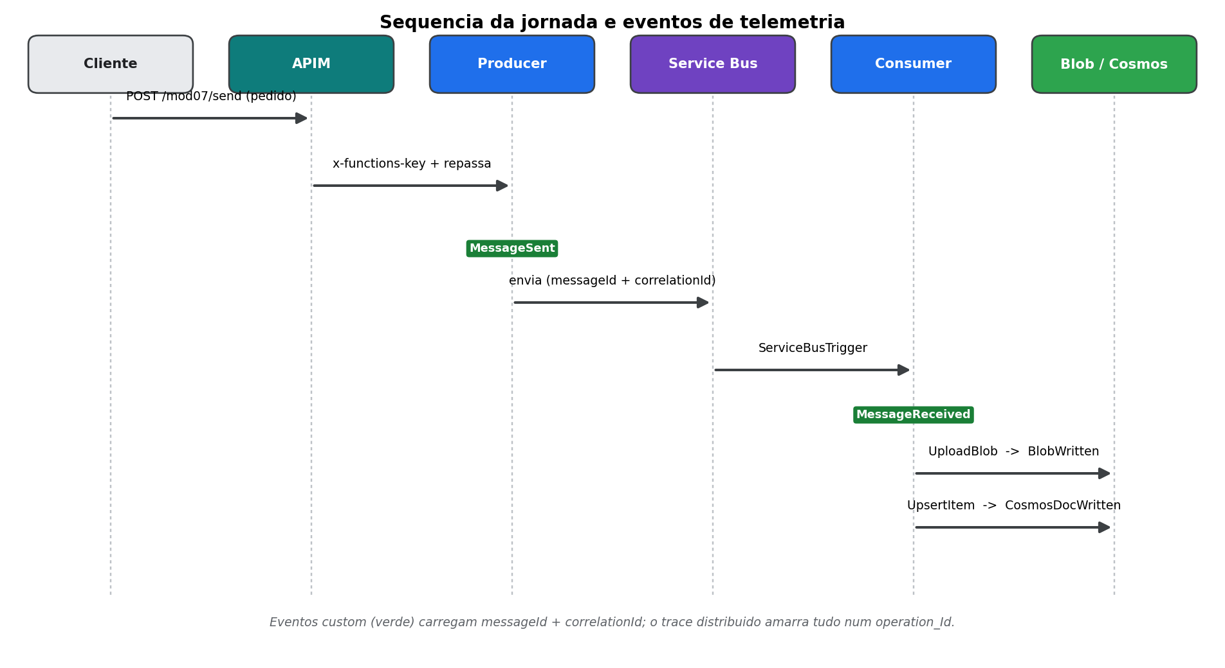
Figura 3 — Sequência da jornada e os quatro eventos de telemetria emitidos.

11. Observabilidade no Application Insights (KQL)
Abra o Application Insights appi-mod07-aiexpert → blade Logs e rode as consultas. As principais:
Consulta | Para quê serve
01 - jornada por messageId | Linha do tempo de UMA mensagem.
02 - transação distribuída | Trace completo por operation_Id (inclui APIM e dependências).
03 - latência produtor-consumidor | Tempo entre envio e recebimento.
06 - dependências | Latência/erros de Service Bus, Storage e Cosmos.
08 - funil da jornada | Quantos pedidos chegam em cada um dos 4 estágios.
09 - jornada por pedido | Linha do tempo de UM pedido inteiro (por correlationId).
Funil da jornada (08):
// =====================================================================
// 08 - Funil da jornada (quantas mensagens chegam em cada estagio)
// =====================================================================
// Conta mensagens DISTINTAS em cada estagio nas ultimas 24h. O ideal e
// MessageSent == MessageReceived == BlobWritten. Qualquer queda revela
// onde a mensagem se perdeu.
// ---------------------------------------------------------------------
let janela = 24h;
customEvents
| where timestamp > ago(janela)
| where name in ("MessageSent", "MessageReceived", "BlobWritten", "CosmosDocWritten")
| extend messageId = tostring(customDimensions.messageId)
| summarize mensagens = dcount(messageId) by estagio = name
// ordem logica da jornada (em vez de so por contagem)
| extend ordem = case(estagio == "MessageSent", 1,
estagio == "MessageReceived", 2,
estagio == "BlobWritten", 3,
estagio == "CosmosDocWritten", 4, 9)
| order by ordem asc
// Para detectar mensagens "presas" (enviadas mas nao gravadas):
// customEvents
// | where timestamp > ago(24h) and name in ("MessageSent","BlobWritten")
// | extend messageId = tostring(customDimensions.messageId)
// | summarize estagios = make_set(name) by messageId
// | where not(set_has_element(estagios, "BlobWritten"))
Jornada por pedido / correlationId (09):
// =====================================================================
// 09 - Jornada de UM PEDIDO de compra (correlacao por correlationId)
// =====================================================================
// Visao de NEGOCIO: segue um pedido inteiro (orderId = correlationId)
// por todos os estagios e por TODAS as suas mensagens. Diferente da 01
// (que e por messageId tecnico), aqui um mesmo pedido reenviado aparece
// agrupado. Troque o valor por um orderId (ex.: "PO-2026-0004").
// Executar em: Application Insights 'appi-mod07-aiexpert' > Logs
// ---------------------------------------------------------------------
let pedido = "PO-2026-0004";
union withsource=Tabela customEvents, requests, dependencies, traces, exceptions
| extend correlationId = tostring(customDimensions.correlationId)
| extend messageId = tostring(customDimensions.messageId)
| where correlationId == pedido
| project
timestamp,
Tabela,
sinal = coalesce(name, type, message),
componente = cloud_RoleName,
correlationId,
messageId,
itemCount = tostring(customDimensions.itemCount),
totalAmount = tostring(customDimensions.totalAmount),
operation_Id,
duracaoMs = duration,
sucesso = success
| order by timestamp asc
// ---------------------------------------------------------------------
// Resumo do funil DESTE pedido (descomente):
// customEvents
// | extend correlationId = tostring(customDimensions.correlationId)
// | where correlationId == pedido
// | summarize estagios = make_set(name), mensagens = dcount(tostring(customDimensions.messageId))
Dica: a ingestão do Application Insights tem latência típica de 1–3 minutos.

12. Pegadinhas do ambiente (Windows) e lições aprendidas
- Git Bash converte argumentos iniciados por / em caminho de arquivo. Exporte MSYS_NO_PATHCONV=1 antes de comandos az com IDs/escopos (ex.: role-definition-id, scope).
- az rest --body @arquivo pode quebrar com UnicodeEncodeError (cp1252) mesmo sem BOM. Contorne usando Invoke-RestMethod no PowerShell com token de az account get-access-token.
- O pacote Microsoft.Azure.Cosmos exige referência EXPLÍCITA a Newtonsoft.Json (>= 13) no .csproj, senão o build falha.
- O serializer padrão do Cosmos é Newtonsoft. Para o documento sair em camelCase, projete os itens em objeto anônimo (new { sku = ..., name = ... }) em vez de passar o record direto (sai PascalCase). O campo id (minúsculo) é obrigatório.
- Cosmos serverless é single-region; se a região desejada estiver sem capacidade (ServiceUnavailable), delete a conta em estado 'failed' e recrie em outra região (ex.: eastus2).
- Após func publish, uma instância quente pode rodar código antigo por alguns segundos; az functionapp restart força o swap antes de revalidar.

Resultado: cada pedido de compra é rastreável de ponta a ponta — por mensagem (messageId), por pedido (correlationId) e por trace distribuído (operation_Id) — e persistido tanto em Blob (auditoria) quanto em Cosmos DB (consulta), tudo autenticado por Managed Identity.

