ComSci Project - MyTime
Max Stupple

Analysis

Overview of the problem
Many students struggle to manage their time. The workload of A-levels alone is enough to make it difficult to balance between small pieces that are due in soon, and longer project that need a little bit of work here and there, let alone extra-curricular activities and sports that take up more time after school and on weekends. One solution is to manually plan how you will use all your free time, but this has two drawbacks:
- Many people struggle to estimate how long a task will take them and hence struggle to allocate a reasonable amount of time to each task
- This process takes time, a resource which has already been established to be finite and valuable
My stakeholder (henceforth referred to as SH) is a Year 12 Sixth Form student studying Maths, Further Maths, Physics and Chemistry. He struggles to fit in all his work around his various extra-curricular activities, so he needs an app that will not only help him keep track of what he needs to do, but timetable when to do each task and prioritise those which are most urgent. SH represents the needs of my target user group.

Limitations of current system
To organise his tasks, SH currently uses the Apple Reminders app on his iPhone. However, he finds this lacking for a number of reasons. Although the app helps him keep track of the tasks he needs complete and when they are due, it does not help him prioritise these tasks or inform him of the relationship between the amount of time he needs to do those tasks and the amount of time he has before they are due. He also doesn’t find the app very engaging, as he lacks a sense of accomplishment after completing a task and ticking it off his list. Furthermore, the app only provides the ability to sync between Apple devices, which he finds limiting as he cannot access his tasks on his Windows computer. SH also finds the light theme of the app abhorrent, and desires a solution with a darker, more attractive colour scheme.

Initial ideas
This initial feature list will help me research existing software which may partially solve the problem. It will also give an idea of how complex the final solution will be.
To satisfy the needs of SH, I anticipate a solution will need to fulfil the following functions:
- Keep a list of the users tasks which contain a description of the task, a due date and time estimate
- Schedule tasks in user’s free time according to a calendar and school/work schedule
- Record and track the actual time taken to complete a task, including breaks
- Provide feedback on the accuracy of the user’s time estimates and productivity levels
- Adapt to the user’s preference in terms of length of work sessions
- Display these tasks to the user is an organised manner using a Graphical User Interface
The program will be created as a web app using the Django web framework. The reason for creating it as a web app is so that it is available as widely as possible, as it will be possible to access it on any device with a modern web browser. Django will allow me to deploy my solution in a modern and efficient way, so that I can focus on the underlying data structures, while Django mostly handles the interface. The data structures will also be implemented using Python in an object-oriented way, which I think is sensible and are tools I’m familiar with working with.

User group
My target users are students, in particular Sixth Form and University. As the program is targeted at individuals who struggle to manage their time and avoid procrastination, the program will need to be engaging and provide incentives for the user to complete tasks early rather than delaying them. Thus the user will avoid situations in which they find themselves with insufficient time to complete all their tasks before they are due.
The UI must also be simple and intuitive to use: there’s no point in using an app to organise your time if you waste more time trying to get the app to work than doing the work you need to do.

Computational methods
This problem lends itself to a computational solution in particular due to the need for automation and interactivity to ensure engagement. One potential non-computational solution could be a physical calendar or to-do list, however this would not be able to provide the features required by my client. Such a solution could not automatically allocate time for the user to complete their tasks in, and could not remind the user of their tasks - it would require the user to check and plan the time for themselves.

Abstraction
Data will be stored with an object-oriented approach. Tasks, events, routine events, and allocated time slots will all be objects with appropriate relationships so that the data can be viewed from a number of perspectives.

Reusability
There are a number of functions which my program will need to perform where it wouldn’t make sense to write them myself from scratch, so I will use libraries that have already solved the problem. I will need to be able to get the current date and time, to associate with each task, and a SQL database to store my data in.

Visualisation
My program will need to be able to present data to the user in a way that is visually appealing and easy to understand. For example, data about the number of tasks completed can be presented on a histogram.

Concurrency
The program will need to be able to perform certain tasks in the background without interrupting the user, for example allocating time slots to tasks and analysing data to create graphs and provide feedback to the user.

Data Mining
Albeit on a small scale, my program will use the concept of data mining to analyse trends in the user’s completion of tasks, such as how much time they spend and how accurate their time estimates are, in order to give feedback and help the user improve their efficiency.

Logic
The program will need to be able to intelligently allocate time slots to tasks based on the user’s schedule and the time needed to complete the task. It will also need to be able to adapt the user’s habits and preferences regarding their work schedule.

Research
I identified a number of candidates for solutions to SH’s problem. The candidate programs are:
- Forest
- Evernote
- Todoist
- Remember the Milk
- Ike
- Google Keep
- Trello
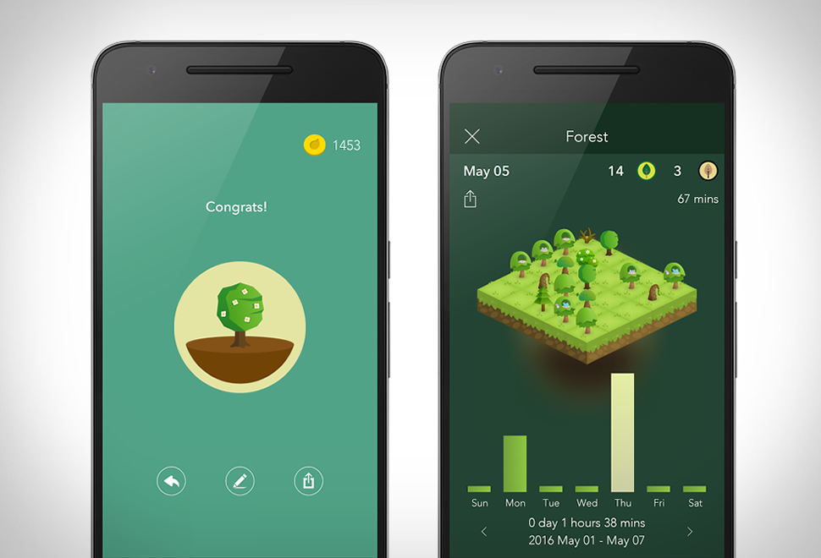
Figure 1: Forest
Forest is the only candidate dedicated to helping the user focus on their tasks and get stuff done as quickly as possible by avoiding distractions. It’s primary feature is an animated forest which grows as you work, but dies if you leave the app. This encourages the user to avoid ’quickly’ having a look at Facebook, sending a text or otherwise breaking their workflow. Forest shows you how much time you spent each day growing your forest, so you can see which days you were most productive on. The primary drawback of Forest is that it lacks any means of tracking tasks from within the app. In my view this is significantly problematic as the app which is going to help you focus the most is one which never needs you to leave while working. Integrated task management is an absolute must for my solution.
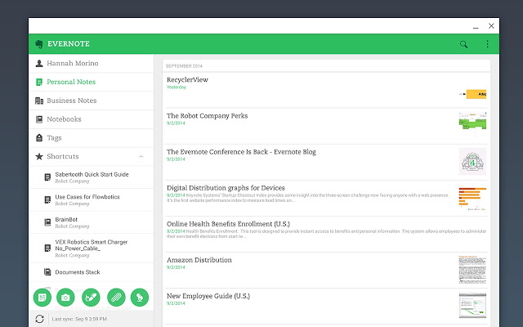
Figure 2: Evernote
Evernote is primarily focused on note-taking, organisation and task-management. The power of it’s note-taking is remarkable, and can include voice memos, handwritten notes and embedded web pages. However, most of these features are superfluous for my product, and would needlessly add complexity.
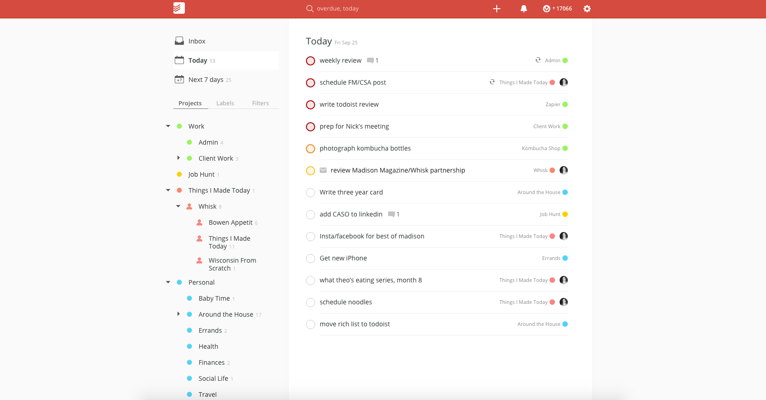
Figure 3: Todoist
Todoist is the only of these apps which is laser-focused on to-dos. One of its prominent features is the ability to write tasks in natural language, which it then understands when they are due, if they are recurring etc. This is beyond the scope of my product, however I am interested in the tools they have for tracking your productivity. Todoist can display graphs of total number of tasks done per day/week, the distribution between different types of tasks e.g. whether you did more tasks tagged with “Study” or “Chores”. I definitely want to have similar visualisations of how productive the user is being.
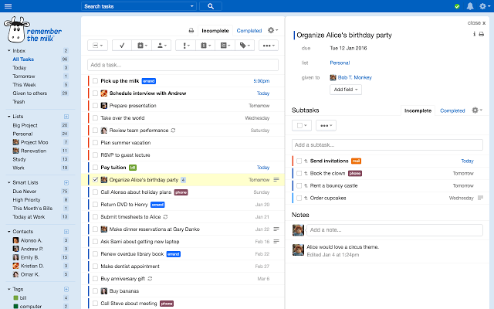
Figure 4: Remember The Milk
Similar to Todoist, Remember the Milk has a lot of advanced tools for intelligently adding, sorting and searching through tasks. However I’m particularly interested in the ability to divide tasks into sub-tasks. I personally have used to-do apps with such a feature and have found it rather useful, so I’ll be interested to get my stakeholder’s opinion on this feature specifically when I talk to them.
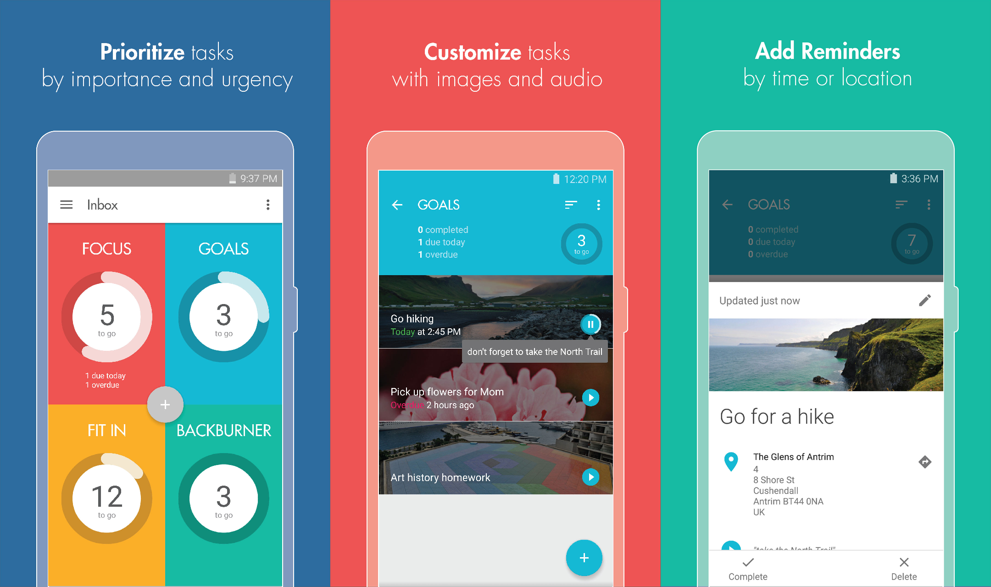
Figure 5: Ike
Ike is in fact the to-do app which I currently use. I can’t say that I’m entirely satisfied with it, but I like the system of organising tasks into “Urgent and Important”, “Urgent but not Important”, “Important but not Urgent” and “Neither Urgent nor Important”. I think this is a useful system and could perhaps be preset in my product, but I find it limiting that Ike forces you to organise by those categories. I definitely want my product to allow the user to organise their tasks into whatever folders and sub-folders they please. I think any limitation on how the tasks are organised will always be counterproductive in some degree to some users.
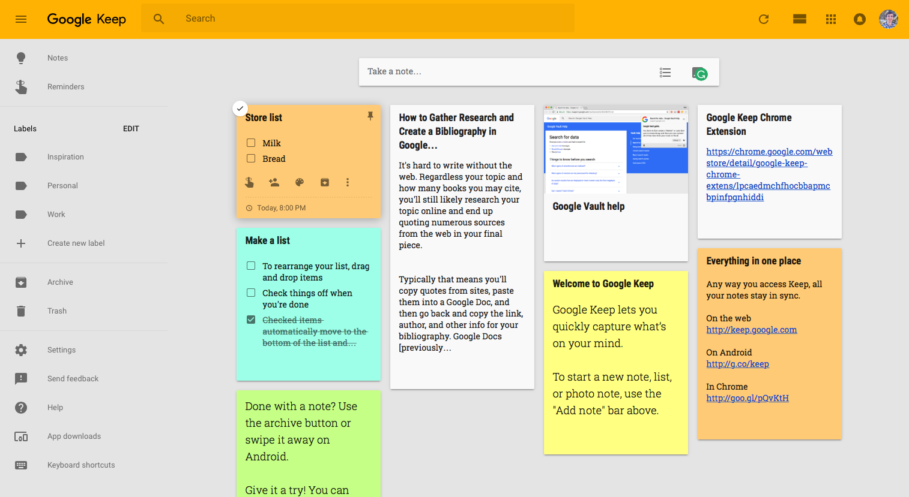
Figure 6: Google Keep
Keep is quite a good, basic to-do app. Keep’s main interesting feature is its integration with the rest of Google’s ecosystem, however this isn’t really something that my project is too concerned with. I’m also not a fan of Keep’s visual metaphor of tasks being “cards” on the screen - a common visual metaphor in Google’s design language. I think this creates confusion as there is not simply a vertical list. I also dislike that you need to create different types of tasks for simple text, lists, voice memos etc.
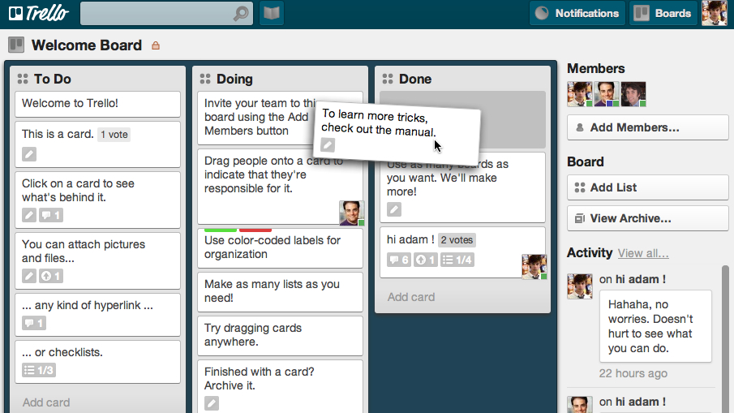
Figure 7: Trello
Trello is more focused on managing multi-person projects than an individual’s todo list. It’s most prominent feature is the ability to work collaboratively on creating tasks, marking them complete, adding comments and so on. However I think this sort of feature is beyond the scope of my solution. However I do like that each “card” can - unlike Keep - have text, checklists, and attachments. I think it will be useful for my users to be able to attach a reasonable amount of information to their tasks.
I think these programs all offer partial solutions to the problem, but none of them offer a solution to the exact problem SH has described. Forest is excellent for helping you focus on a task, but can’t keep track of your to-dos. Todoist offers excellent functionality for keeping track of and organising your tasks, but doesn’t do anything with regard to helping you timetable everything that you need to do. Keep is better in this regard as it integrates with GCal to display tasks in your calendar, but can’t allocate them those time slots automatically. Ike has a very appealing UI and a good system for organising into four overarching categories, but you can’t create your own categories like Todoist. Remember the Milk is probably the most intelligent of the programs, with a “Smart Add” feature that makes adding tasks very simple, and a powerful search for filtering through your tasks, in addition to integrating with a number of other services such as email and social media for reminders, and cloud storage services for adding attachments to tasks, however this is probably beyond the scope of the problem I’m trying to solve. Evernote is in my opinion the least effective of these programs, as it is mainly focused on note taking, with reminders as a side-feature. Trello offers the most features oriented towards time management and prioritising tasks, but is more focused around team collaboration on big projects than individual to-do management.
I showed the candidates to SH to get his opinion and he gave me the following comments:
Forest: “This is my favourite. The UI is excellent and the metaphor of growing trees is very appealing. Out of all the programs this does the best job of helping me manage my time, however tt’s unfortunate that is doesn’t include integrated task management. I like that you can see your past progress as this is very motivational, and it stops the timer if you leave the app, which helps you avoid idly switching to Facebook or Twitter for a ’quick check’.”
Evernote: “Good for note taking, but that’s not really what I’m looking for. It has too many extraneous features, which are unnecessary and make it feel bloated - I want a more streamlined experience. I also dislike the subscription model.”
Todoist: “Great for managing tasks, with graphs and data to track your statistics. I love the categorisation and colour coding for different tasks, and being able to give them different levels of priority. I also like that you can export your tasks to your calendar. The lack of a dark mode harms the UX.”
Remember the Milk: “There’s too much task segregation which makes the UI confusing. It also has a weird notes system. Not a fan.”
Ike: “The idea behind it is admirable, but ultimately the categories feel a bit arbitrary, and that’s made worse by the lack of an ’all tasks’ view. The UI is very clean however, and the animations are really nice.”
Keep: “It’s good for lists, but otherwise nothing special.”
Trello: “Good for project development, but not well-suited to personal task management.”
He also commented in general that he liked the ability to sync tasks between devices, and a feature which he wanted but none of the programs offered was the ability to have “subtasks” nestled inside other tasks.
From this I have assembled the following list of features which my program will need:
- Main view displays all uncompleted tasks and recently completed but not-deleted tasks
- Archive containing completed tasks, and allows tasks to be un-marked as complete
- Tasks grouped in categories, can be colour coded
- Tasks can be filtered by category
- Ordered by time needed or due date
- Tasks can be marked as done or deleted
- New tasks can be added, with a brief title, optional additional notes, an estimate of time needed and a due date
- Graphs showing number of tasks completed, amount of time taken, and whether tasks were completed on time
- Show upcoming tasks in their automatically allocated time slots
- User can enter the schedule and other commitments that the program will schedule tasks around
- The program will give a warning if there is not enough free time to complete a given task before it’s due date
- Current task displayed at top of screen
- Time spent working and time to next break
- Buttons to manually pause timer and take a break or mark task as done
- Graphic showing a town/city building up over time as you work
I showed this list to SH, and he added that tasks should be given a priority level, so that high priority tasks can be scheduled before low priority ones. He also elaborated on the city-building mechanic, resulting in the following:
- The city builds over time as you work
- Taking a break which has been allocated by the app simply pauses development
- Taking an unallocated break sets the development back - perhaps there is a level system and you can be set back one or two levels
- If you quit a task before you finished - and taking an excessively long break automatically quits - the city is destroyed
- If you take too long to complete a task, development is slowed down
- When you finish a task, you can either stop, which doesn’t destroy your city but it degrades over time, or go straight to the next task, in which case progress continues
- If you finish a task early and go straight on to another task, your city gets a boost
SH said he “agrees with all of this” and called it “good design”. He also emphasised his desire to access his tasks across different devices. I have concluded that the best way to facilitate this would be to build the program as a web app. This is the easiest way to make it available cross-platform, as it should be accessible on any device with a modern web browser.
SH also suggested that there were psychological benefits to offering the user a choice in what task they do. Studies have shown that individuals are more motivated to complete a task which they have chosen to do from a set of options, rather than only one. Therefore I will endeavour to implement a system which, rather than forcing, or heavily encouraging, the user to complete one particular task in a certain time slot, will instead give them the option to choose between tasks with similar levels of priority.

System requirements
As the program will be web-based, it will require a system capable of running a modern internet browser, such as Firefox. The system requirements for Firefox 66.0 are as follows:

Windows

Operating Systems (32-bit and 64-bit)
- Windows 7
- Windows 8
- Windows 10

Recommended Hardware
- Pentium 4 or newer processor that supports SSE2
- 512MB of RAM / 2GB of RAM for the 64-bit version
- 200MB of hard drive space

Mac

Operating Systems
- macOS 10.9
- macOS 10.10
- macOS 10.11
- macOS 10.12
- macOS 10.13
- macOS 10.14

Recommended Hardware
- Macintosh computer with an Intel x86 processor
- 512 MB of RAM
- 200 MB hard drive space

GNU/Linux

Software Requirements
Please note that GNU/Linux distributors may provide packages for your distribution which have different requirements.
- Firefox will not run at all without the following libraries or packages:
  - GTK+ 3.4 or higher
  - GLib 2.22 or higher
  - Pango 1.22 or higher
  - X.Org 1.0 or higher (1.7 or higher is recommended)
  - libstdc++ 4.6.1 or higher
- For optimal functionality, we recommend the following libraries or packages:
  - NetworkManager 0.7 or higher
  - DBus 1.0 or higher
  - GNOME 2.16 or higher
  - PulseAudio
Any system which meets these requirements will be able to run the program.

Success Criteria

General objectives
To create a program which stores tasks and arranges them around the user’s schedule. The program should engage the user through the use of a game-like progression system and help the user complete their tasks in a timely manner through the use of reminders.

Specific objectives
The program should:
- Store a list of the user’s tasks
- Store the due date, priority, expected time needed, and other information about each task
- Add and remove tasks from the list
- Allow the user to group tasks into categories of their choosing, and colour code categories
- Record the successful completion of each task, time taken, and number of breaks taken and display this information to the user in a useful manner
- Schedule time for the user to complete their tasks, according to the user’s schedule, task due date, task priority, and the user’s preferences
- Display the tasks in their allocated time slots in a calendar view, and allow the user to manually alter time allocations
- Have a focus mode, which helps the user concentrate on the task at hand, and incentivise the user to complete the task in a timely manner without procrastination using game-like aspects
- Be available on multiple platforms and devices
- Sync tasks between devices
- Remind the user of upcoming tasks

Design

Breaking down the problem
The first step to solving the problem is to decompose it into modules, which will comprise the overall solution. This is a higher-level description than the product specification, but low enough that each component is a manageable individual problem. I have identified the key functions that my solution will need to perform as:
- Basic calendaring:
My solution needs to keep track of the user’s regular commitments, and particular events, so that tasks can be scheduled around them.
- Task management:
The user should be able to add tasks, mark them as done, and delete them. These tasks should be able to hold a reasonable amount of information, but in particular a due date and time estimate will be essential to the scheduler.
- Track time spent on tasks:
The user should be able to log they are working on a task, and for how long, so that they can see overall statistics, on the accuracy of their time estimates, and on how good they are at sticking to their schedule.
- Calculate and display statistics:
The aforementioned statistics should be presented to the user in a helpful way.
- Scheduling the user’s tasks:
The program will need to allocate time for each of the user’s tasks, according to their priority, due date, and time estimate. It will also need to take into account the user’s other commitments.
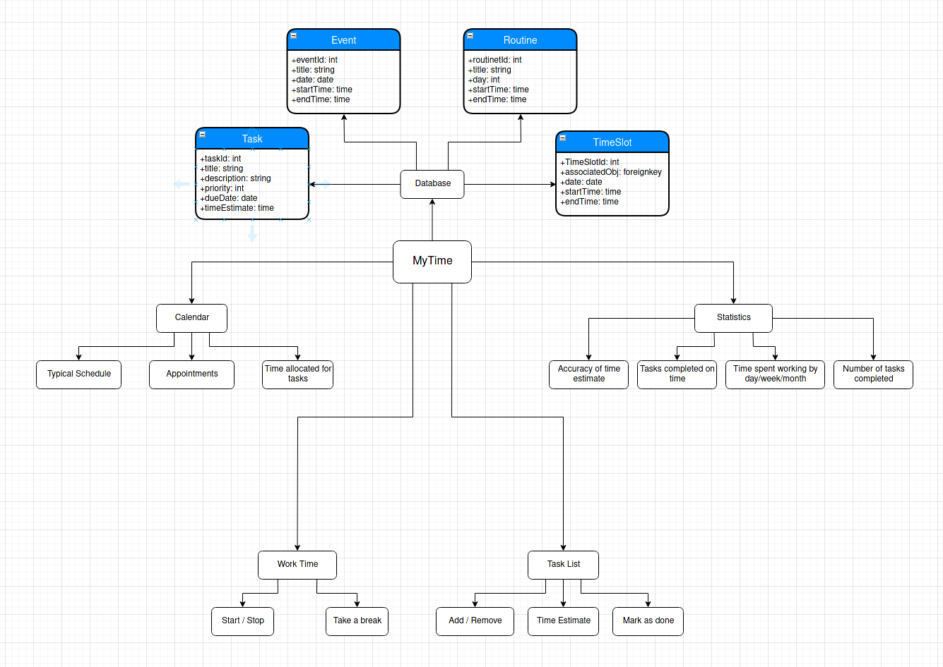
Figure 8: Combination of top-down design analysis and class diagrams

Explanation of design
The solution naturally breaks down into four parts: a task manager, a basic calendar, a tracker for time spent working, and a statistics viewer. The relevant data that each component will need to use is also quite obvious: the task manager, time tracker and statistics tracker will only be concerned with tasks, whereas the calendar will additionally need the user’s routine, daily commitments, and any particular events that tasks will need to be scheduled around.
The data, then, will consist of four types. Tasks will have a title and description, so the user can record a reasonable amount of information alongside them, and a due date, time estimate and priority level, so that they can be scheduled. Events and routines are similar, however differ in that whereas events have a concrete date, routines have a weekday on which they reoccur. Both have a title, start and end time. The TimeSlot exists for the purposes of unifying data into a single type for the purposes of scheduling. They have a data, start and end time as expected, and additionally an associated object, being the task, event or routine which occupies that slice of time. It might be possible to remove the need for this additional data structure, by instead converting tasks and routines into events for the purpose of scheduling, however it makes sense to logically distinguish between tasks, events and routines, which represent user intentions - what the user wants to do with their time - and time slots, which represent a concrete allocation of time to be used for a specific purpose. Of course events and routines are already concrete, as the program will never override them since this would not be helpful for the user, but it is a nice logical separation to make in the database, which wouldn’t be possible if I instead used the approach of converting everything into events for scheduling.

