Kuruv (U23ai052), Aryan (U23ai042), Jaya (U23ai043)

Lab 1
Epsilon greedy v epsilon greedy
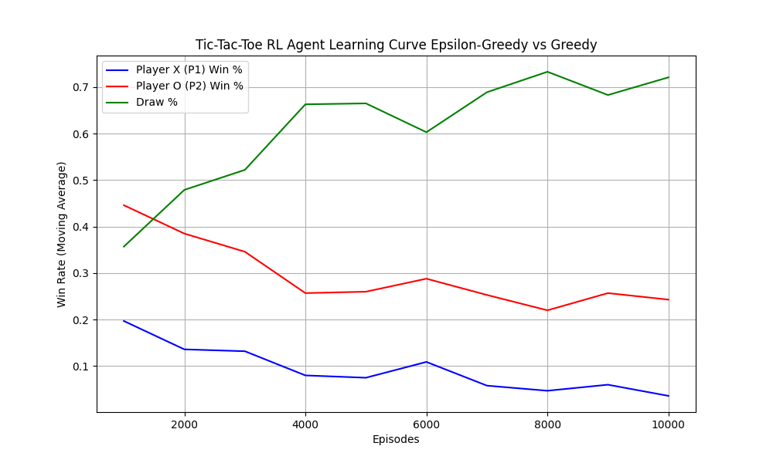
Epsilon greedy v greedy
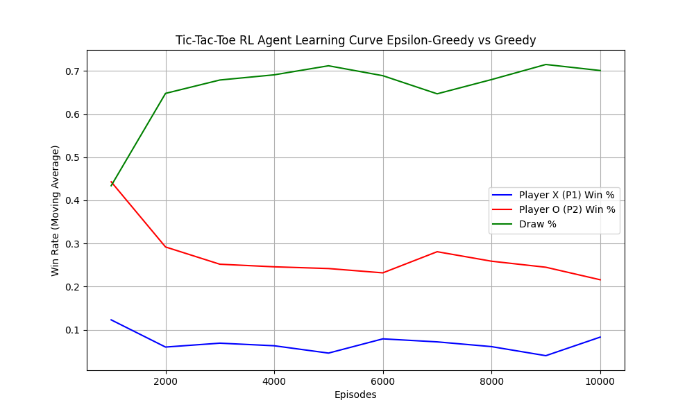
Greedy v epsilon greedy
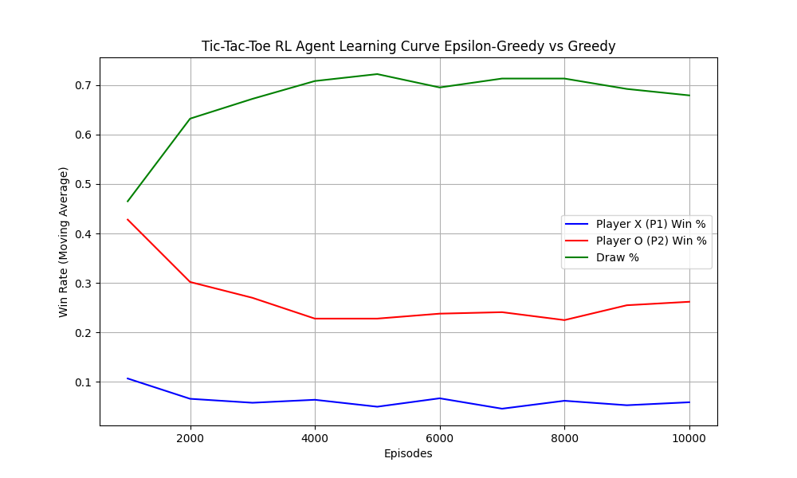
greedy v greedy
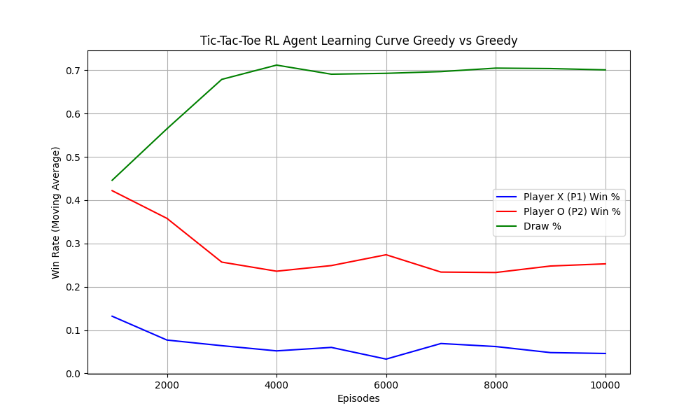

Code Flowchart:
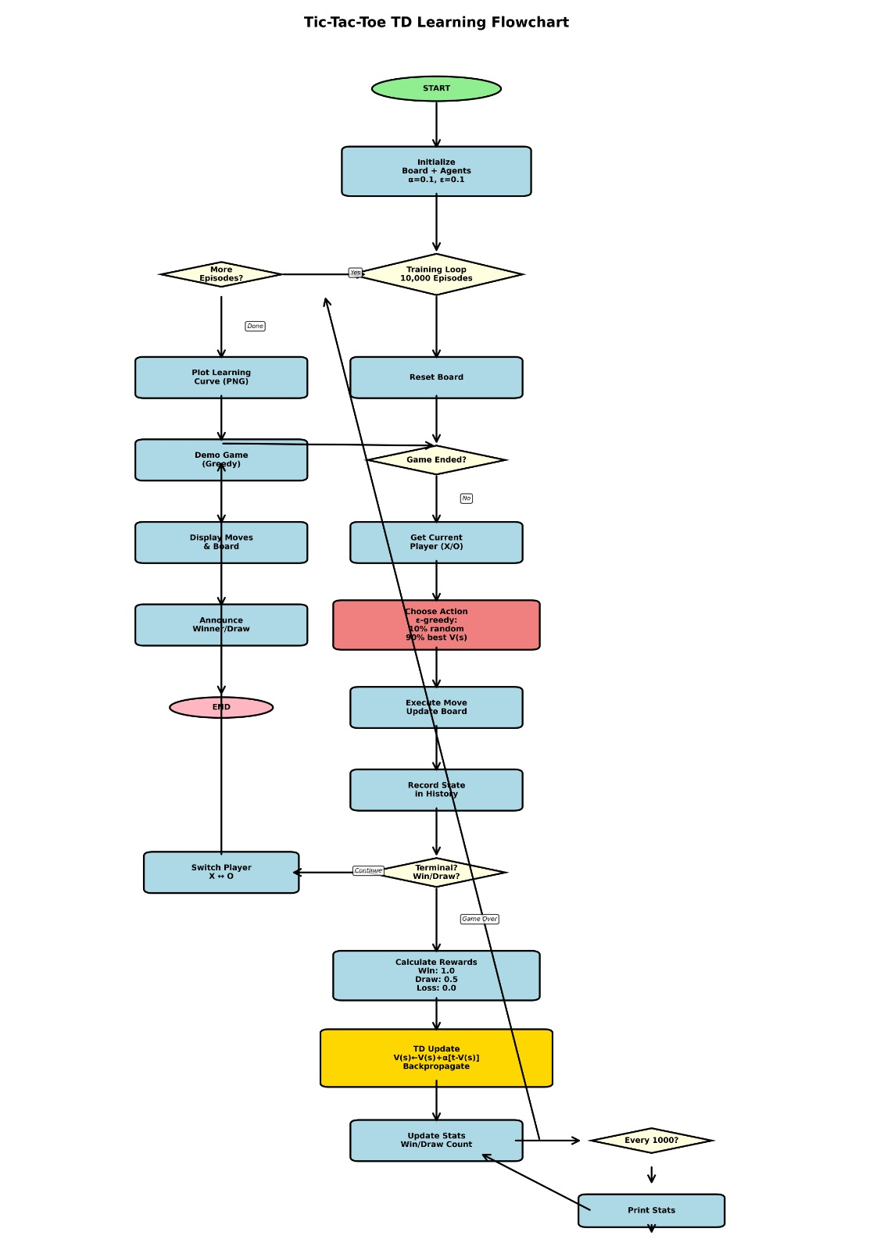

Lab 2
