I used wire shark. <http://www.wireshark.org/>

1. Download and install wire shark from above link.

2. It should be the default application to open .pcap file now. Double click on a .pcap file.

3. Sort by the “Protocol” column and find the Keyword MMSE.

4. For sent MMS, click on the “Info” MMS m-send-req. 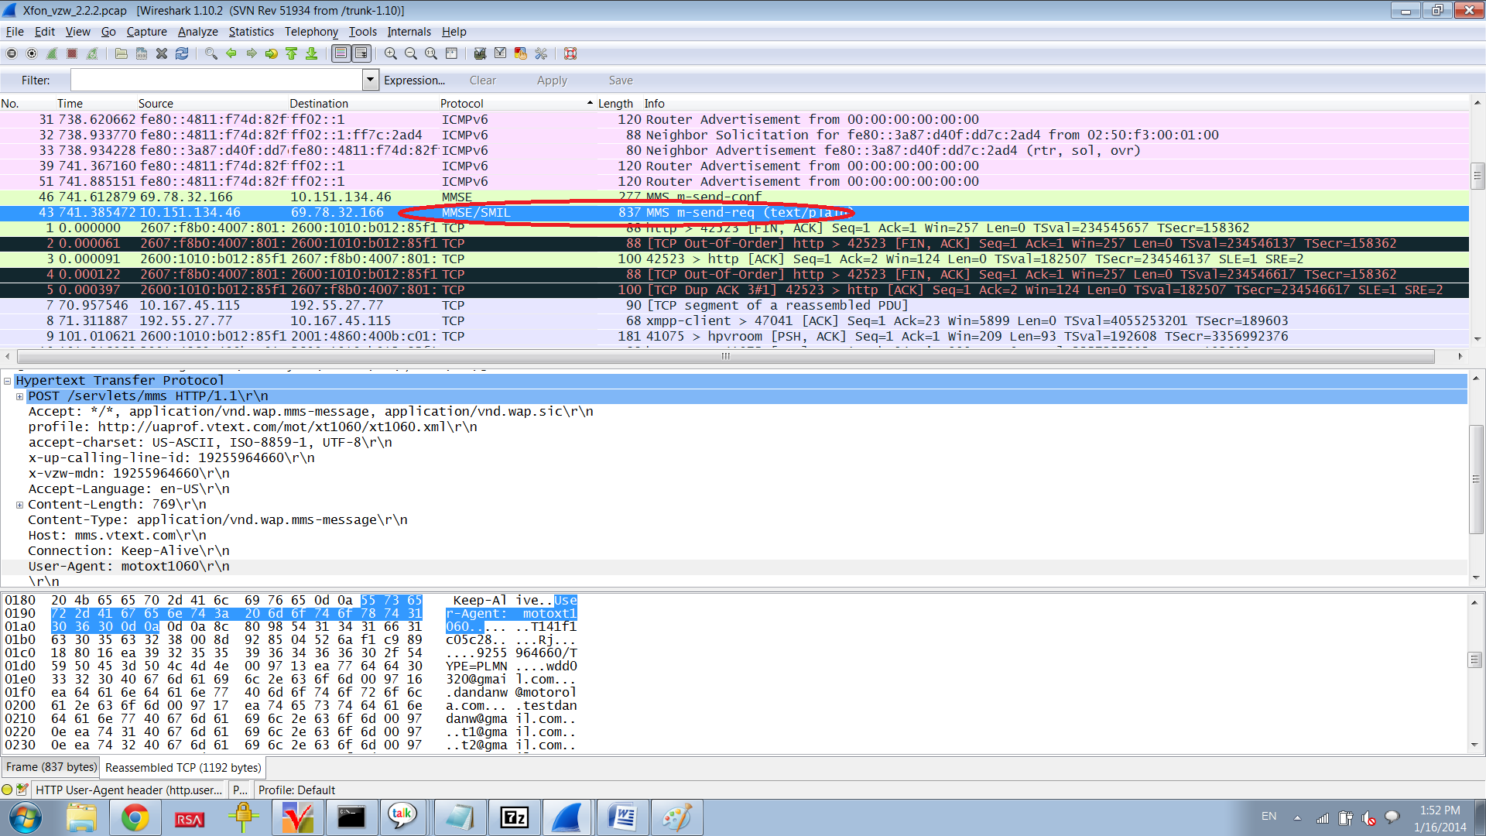

For received MMS, click on MMS m-notifyresp-ind.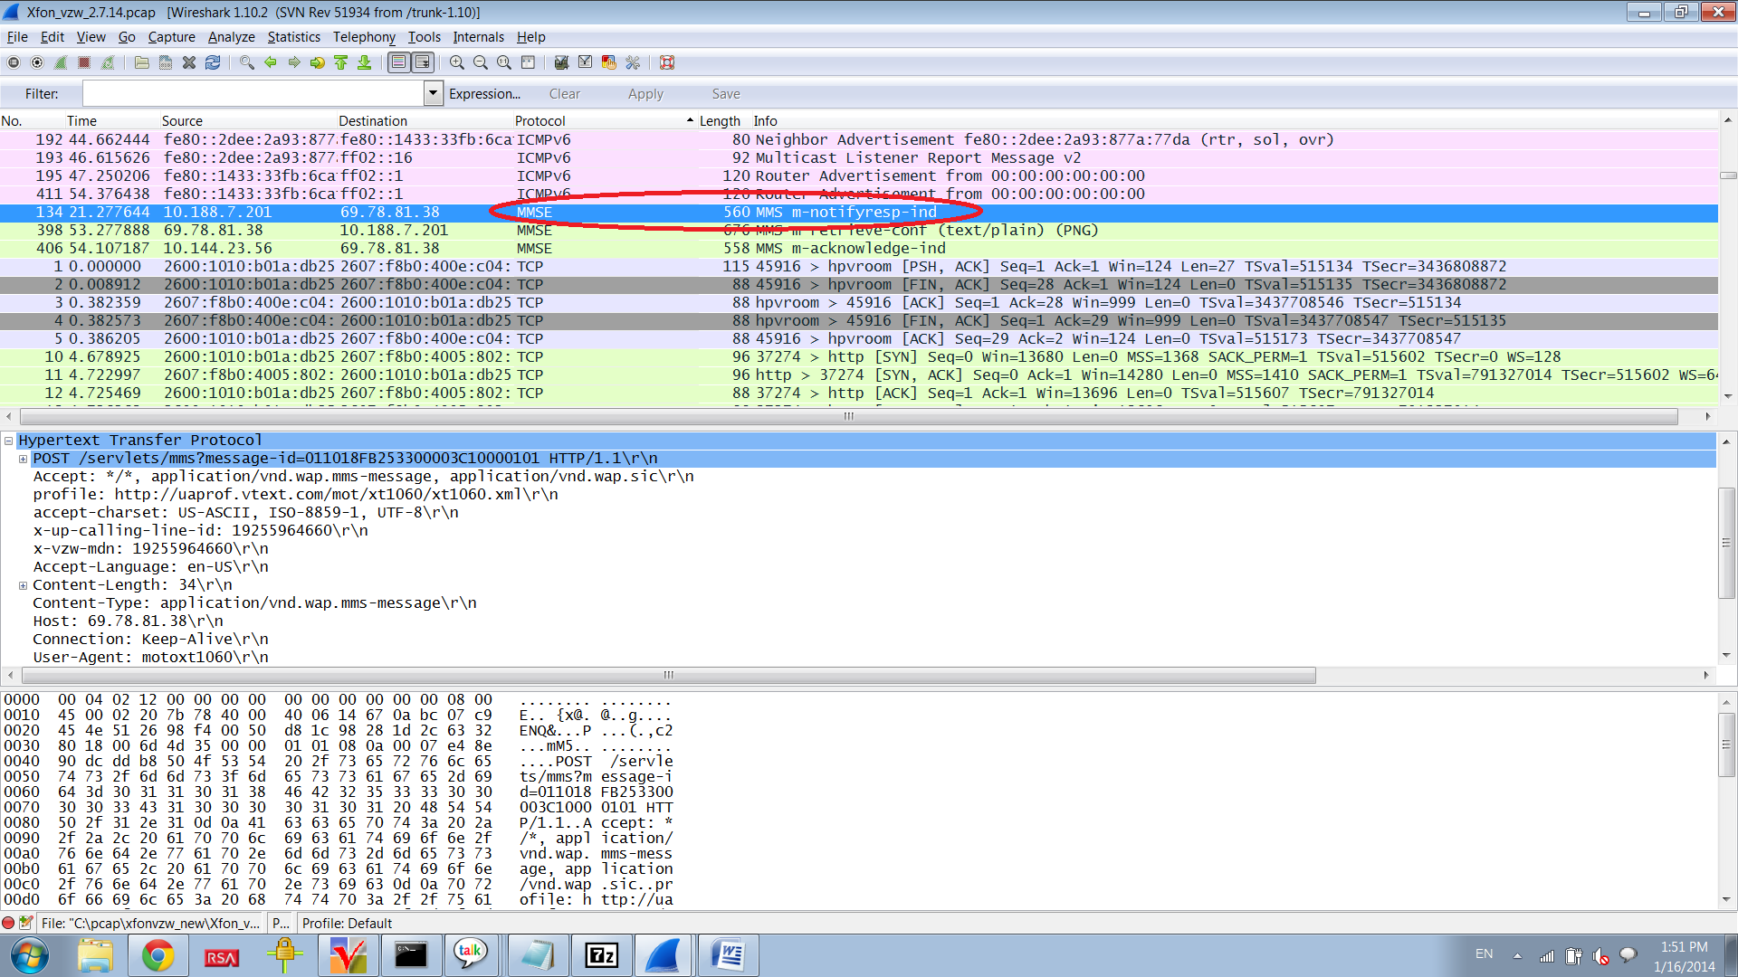

5. Expand “Hypertext Transfer Protocol”

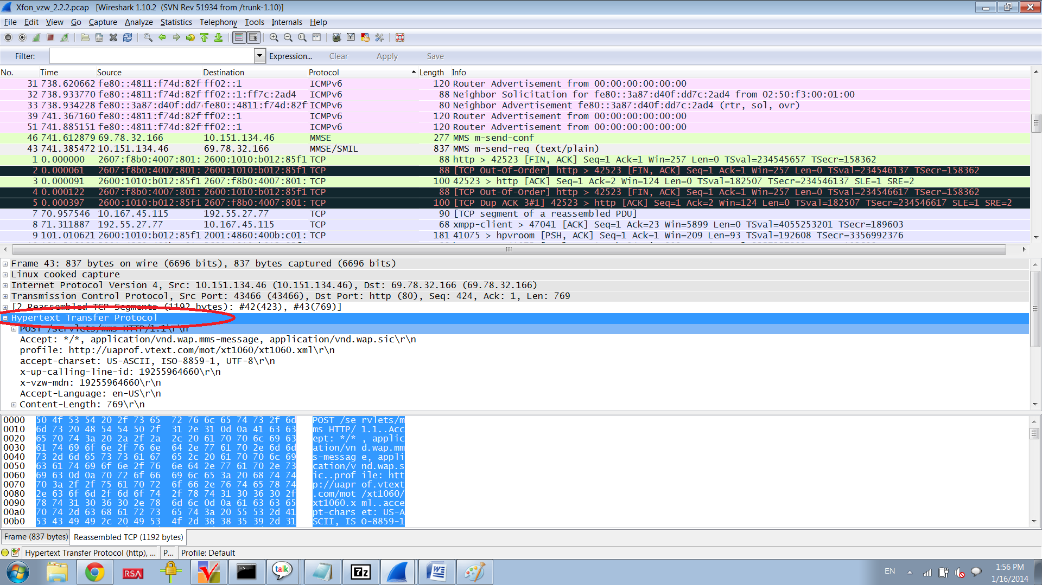

6. UaProf and User Agent should be listed.

