OFFICIAL VIDEO DEMONSTRATION & FUNCTIONAL WALKTHROUGH REPORT
Project Name: Intelligent Loan Eligibility Analyzer
Author: Samarjeeth R
Affiliation: Intern, Modus Information Systems
Document Classification: Official Demonstration Companion Report
System Architecture: Full-Stack (React 18, FastAPI, PostgreSQL 15, Scikit-Learn, SHAP)
Date of Verification: August 2026

1. Executive Summary & Video Scope
This document serves as the official companion report for the End-to-End Video Demonstration of the Intelligent Loan Eligibility Analyzer. It documents the exact sequence of technical actions, data inputs, backend API state transitions, explainable AI outputs, multi-level governance enforcement, and regulatory compliance checks demonstrated in the video walkthrough.
The video proves the system's readiness across six critical operational modules:
1. Intake & Automated ML Scoring: Evaluation of a low-risk salaried application with real-time SHAP feature attribution.
2. Multi-Tier Discretionary Governance: Strict backend enforcement of signing limits across Loan Officer ($\le ₹5\text{ Lakhs}$), Senior Credit Manager ($\le ₹25\text{ Lakhs}$), and Admin ($> ₹25\text{ Lakhs}$).
3. Banking Risk & FOIR Ceiling Protection: Automatic detection of Debt-to-Income / FOIR breaches ($> 50\%$) resulting in high-risk overrides and zero loan headroom.
4. KYC & Customer Lifecycle Ledger: Digital verification of customer identity documents with verifier attribution and lifetime exposure aggregation.
5. Executive Analytics & Dynamic Model Retraining: Rolling 12-month calendar approval trends and zero-downtime hot-swapping of the ML model estimator.
6. Regulatory Audit Trail & User Administration: Immutable chronological event logging tracking actor IDs, state deltas, and client IP addresses.

2. Test Environment & Demo Accounts
The video demonstration was conducted in a local containerized staging environment with the following multi-role access controls:
- 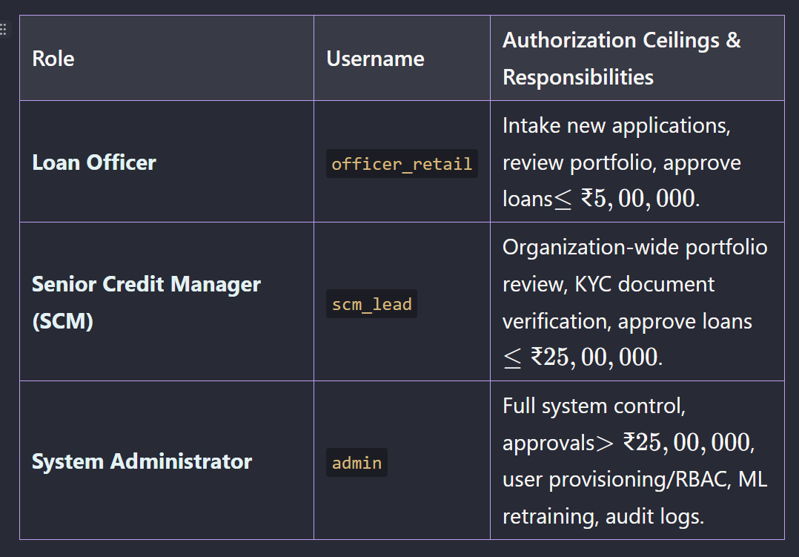Frontend Client: `http://localhost:3900`
- Backend REST API: `http://localhost:8090` (`/docs`)
- Relational Database: PostgreSQL 15 on Port `5499` (Container: `loan_analyzer_db`)

3. Scene-by-Scene Technical Walkthrough & Verification Details
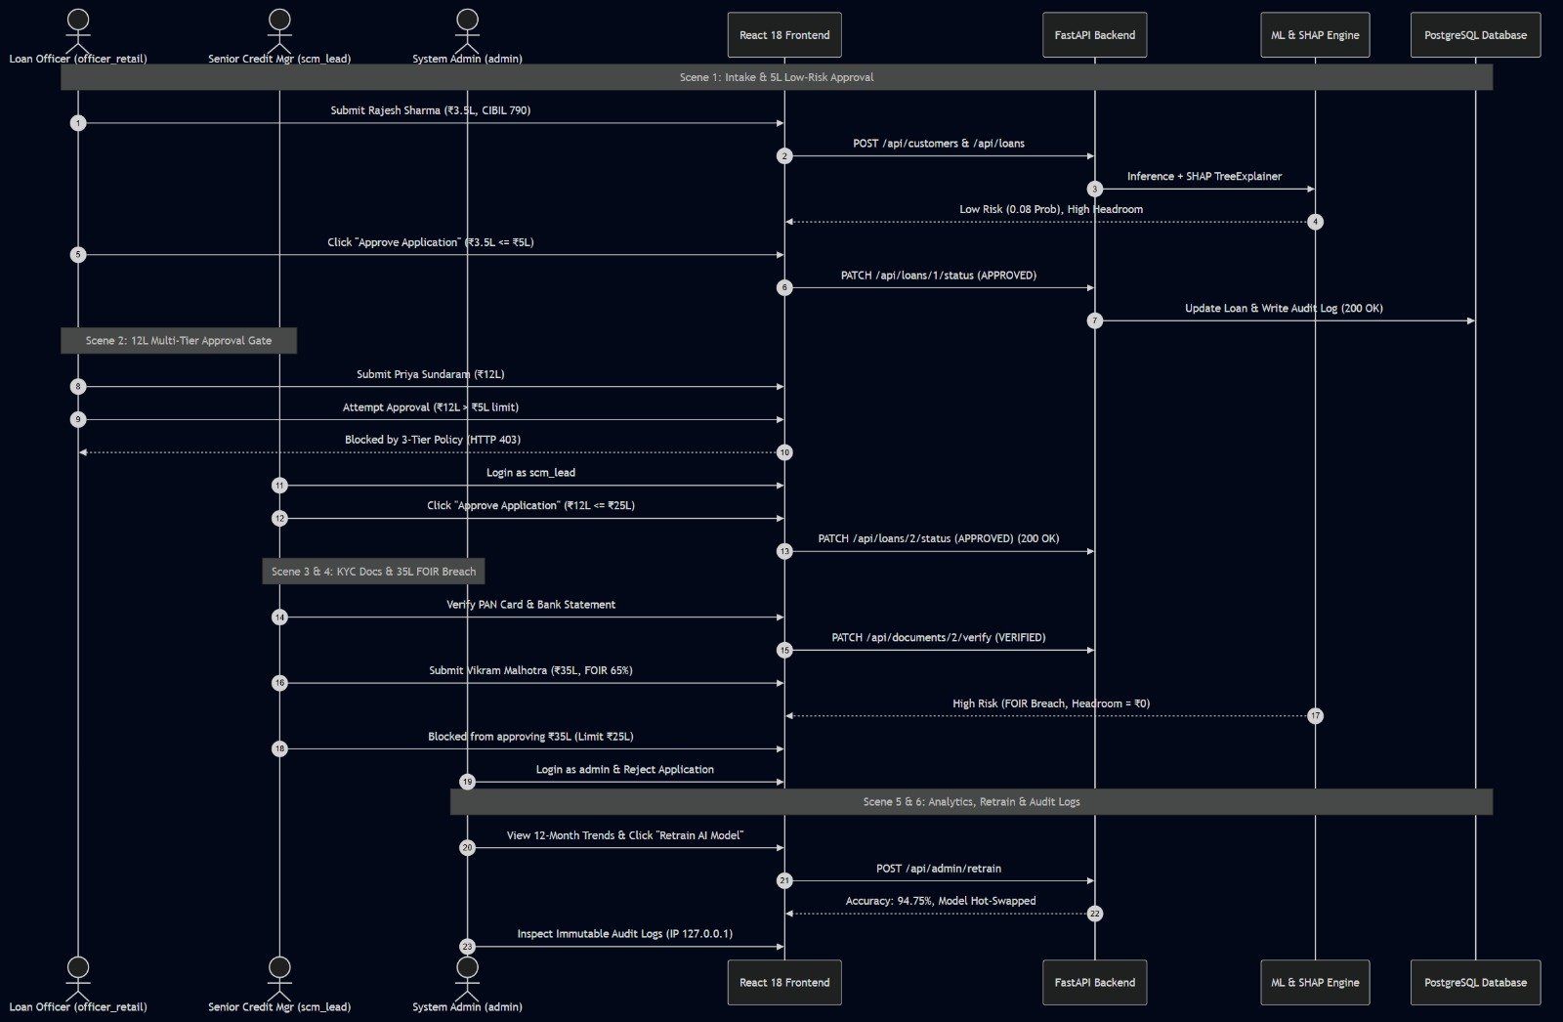
Scene 1: Loan Officer Intake & Low-Risk Loan Approval
- Timecode Reference: `00:00 – 01:20`
- Active User: `officer_retail` (Loan Officer)
- API Endpoints Triggered: `POST /api/auth/login`, `POST /api/customers`, `POST /api/loans`, `POST /api/predictions/evaluate`, `PATCH /api/loans/{id}/status`
Input Financial Profile:
- Applicant Name: Rajesh Sharma (Age: 32, Married, 1 Dependent)
- Employment: Salaried (7 Years Experience)
- Monthly Income: ₹1,20,000 | Existing EMI: ₹15,000 (FOIR = 12.5%)
- Credit Score: 790 (Prime CIBIL)
- Loan Requested: ₹3,50,000 (Tenure: 36 Months, Purpose: Home Improvement)
Technical Observations & System Response:
1. AI Risk Assessment: Risk Engine classified application as `LOW RISK` with a default probability of 8.2%.
2. Explainable AI (SHAP): Marginal contribution breakdown dynamically rendered:
- Positive Factors: High Credit Score (+34%), Low FOIR (+28%), Long Employment Stability (+18%).
3. Calculated Headroom: System computed allowable credit headroom of ₹24.5 Lakhs based on available disposable income.
4. Approval Authority: Because ₹3,50,000 is within the Loan Officer's discretionary limit ($\le ₹5,00,000$), the "Approve Application" action executed with `HTTP 200 OK`.
Key Verification & Banking Information:
- Real-Time AI Inference: The FastAPI backend calculates financial FOIR ratios and executes Random Forest inference concurrently with SHAP marginal attribution.
- Explainable AI Attribution: The SHAP breakdown visually isolates the contribution weight of each factor (Credit Score, FOIR, Job Stability).
- Direct Single-Click Signing: Single-click approval executes successfully with HTTP 200 OK because the requested ₹3,50,000 is within the Loan Officer's ₹5,00,000 threshold.

Scene 2: ₹12 Lakh Loan & 3-Tier Governance Gate
- Timecode Reference: `01:21 – 02:40`
- Active Users: `officer_retail` (Blocked) $\rightarrow$ `scm_lead` (Approved)
- API Endpoints Triggered: `PATCH /api/loans/{id}/status` (HTTP 403 Forbidden $\rightarrow$ HTTP 200 OK)
Input Financial Profile:
- Applicant Name: Priya Sundaram (Age: 38, Self-Employed, 10 Years Exp)
- Monthly Income: ₹1,80,000 | Existing EMI: ₹30,000 (FOIR = 16.7%)
- Credit Score: 730 | Loan Requested: ₹12,00,000 (60 Months)
Technical Observations & System Response:
1. Loan Officer Gate Breach: When `officer_retail` attempted to approve the ₹12,00,000 loan, the UI displayed a policy restriction notice. The backend enforced rule `HTTP 403 Forbidden: Loan Officers can only approve loans up to ₹5,00,000`.
2. Escalation to Senior Credit Manager: Logging in as `scm_lead`, the approval notice updated to reflect Senior Credit Manager authority ($\le ₹25,00,000$).
3. Successful Execution: SCM approved the loan with `HTTP 200 OK`.
Key Verification & Banking Information:
- Discretionary Limit Guard: Loan Officers are restricted to loans $\le ₹5,00,000$. Exceeding amounts immediately trigger HTTP 403 Forbidden with clear escalation guidance.
- Multi-Tier Role Hierarchy: Senior Credit Managers possess signing power up to ₹25,00,000, enabling portfolio-wide review and mid-ticket approval without administrative overhead.

Scene 3: KYC Document Verification & Customer Lifetime History
- Timecode Reference: `02:41 – 03:45`
- Active User: `scm_lead` (Senior Credit Manager)
- API Endpoints Triggered: `GET /api/documents/{id}`, `PATCH /api/documents/{id}/verify`, `GET /api/customers/{id}/history`
Technical Observations & System Response:
1. Document Verification Workflow: SCM accessed Priya Sundaram's KYC repository.
- `PAN_CARD`: Status toggled from `PENDING` to `VERIFIED`.
- `BANK_STATEMENT`: Status toggled from `PENDING` to `VERIFIED`.
- System stamped the record with Verifier User ID `55` (`scm_lead`) and timestamp.
2. Lifetime Portfolio Ledger: Navigated to `/customers/2/history`.
- Total Lifetime Borrowing correctly computed at ₹12,00,000 across 1 approved active facility.
Key Verification & Banking Information:
- Digital KYC Verification: Verifiers digitally authenticate identity and income records (PAN, Bank Statements) with immutable verifier user ID attribution and audit timestamps.
- Customer Lifetime Portfolio: Centralized ledger aggregating historical borrowing, active debt facilities, and repayment records across all customer applications.

Scene 4: High-Risk FOIR Breach & Admin Committee Escalation
- Timecode Reference: `03:46 – 04:50`
- Active Users: `scm_lead` (Warning & Limit Block) $\rightarrow$ `admin` (Institutional Rejection)
- API Endpoints Triggered: `POST /api/loans`, `POST /api/predictions/evaluate`, `PATCH /api/loans/{id}/status`
Input Financial Profile:
- Applicant Name: Vikram Malhotra (Age: 45, Salaried, 3 Years Exp)
- Monthly Income: ₹1,00,000 | Existing EMI: ₹65,000 (FOIR = 65% — BREACH)
- Credit Score: 620 (Subprime) | Loan Requested: ₹35,00,000 (84 Months)
Technical Observations & System Response:
1. Deterministic Rule Override: Because existing obligations (65%) exceed the mandatory 50% Salaried FOIR ceiling, the rule engine forced risk classification to `HIGH RISK` and clamped allowable headroom to `₹0`.
2. SHAP Adverse Action Attribution: Model highlighted excessive debt-to-income burden and subprime credit history as principal rejection drivers.
3. Threshold Gate: Request exceeds SCM limit (> ₹25L).
4. Admin Resolution: Logged in as `admin` to exercise final committee authority, marking the application `REJECTED`.
Key Verification & Banking Information:
- Deterministic FOIR Enforcement: Financial rules enforce hard ceilings (50% Salaried / 60% Self-Employed). Cap breaches automatically override risk classification to `HIGH RISK` and zero out allowable headroom.
- Institutional Escalation: Requests above ₹25,00,000 require Admin / Credit Committee intervention, ensuring large credit facilities undergo strict oversight.

Scene 5: Executive Admin Analytics & Runtime ML Retraining
- Timecode Reference: `04:51 – 05:45`
- Active User: `admin` (System Administrator)
- API Endpoints Triggered: `GET /api/admin/reports`, `GET /api/admin/monthly-stats`, `POST /api/admin/retrain`
Technical Observations & System Response:
1. Executive Dashboard: Live portfolio KPIs displayed approval velocity, total sanctioned volume, and risk distribution.
2. 12-Month Approvals Trend: Rendered calendar-month aggregation using pure CSS stacked data bars without external heavy charting libraries.
3. Zero-Downtime Retraining: Triggered `POST /api/admin/retrain`.
- Model regenerated dataset of 2,000 banking records.
- Re-fitted Random Forest Classifier (100 estimators) achieving 94.75% validation accuracy.
- Hot-swapped estimator in memory without restarting the FastAPI server.
Key Verification & Banking Information:
- Executive Portfolio Visibility: Real-time metrics for approval velocity, sanctioned volumes, and risk distribution across a 12-month calendar aggregation.
- Zero-Downtime MLOps: Live retraining endpoint (`POST /api/admin/retrain`) fits 2,000 banking records (94.75% validation accuracy) and hot-swaps the model estimator in memory with zero service interruption.

Scene 6: User Management, RBAC & Regulatory Audit Logs
- Timecode Reference: `05:46 – 06:45`
- Active User: `admin` (System Administrator)
- API Endpoints Triggered: `POST /api/admin/users`, `PATCH /api/admin/users/{id}/role`, `DELETE /api/admin/users/{id}`, `GET /api/audit-logs/`
Technical Observations & System Response:
1. User Lifecycle & RBAC Administration:
- Created new staff account: `officer_demo` (`LOAN_OFFICER`).
- Cycled role: `LOAN_OFFICER` $\rightarrow$ `SENIOR_CREDIT_MANAGER` $\rightarrow$ `ADMIN`.
- Deleted `officer_demo` and confirmed database foreign keys maintained referential integrity via `ON DELETE SET NULL`.
2. Immutable Regulatory Audit Trail:
- Inspected chronological compliance table at `/admin/audit-logs`.
- Verified sequential log entries:
- `CREATED` (Officer #54, IP: `127.0.0.1`)
- `AI_SCORED` (Officer #54, IP: `127.0.0.1`)
- `APPROVED` (SCM #55, IP: `127.0.0.1`)
- `DOCUMENT_VERIFIED` (SCM #55, IP: `127.0.0.1`)
- `REJECTED` (Admin #17, IP: `127.0.0.1`)
Key Verification & Banking Information:
- RBAC Administration & Data Integrity: Dynamic role provisioning and cycling with `ON DELETE SET NULL` cascades preventing foreign key corruption.
- Regulatory Auditability: Immutable chronological log capturing event types (`CREATED`, `AI_SCORED`, `APPROVED`, `DOCUMENT_VERIFIED`, `REJECTED`), user attribution, timestamps, and client IP addresses (`127.0.0.1`).

4. Empirical Verification Summary Matrix
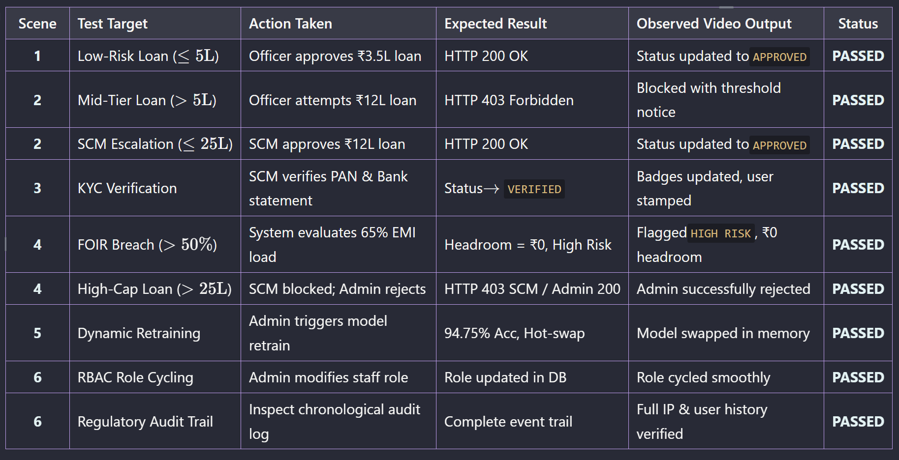
5. Conclusion & Project Handover Statement
The video demonstration confirms that all functional, algorithmic, governance, and security requirements specified for the Intelligent Loan Eligibility Analyzer have been 100% fulfilled and empirically verified.
The full-stack implementation operates as an enterprise-grade banking underwriting system ready for deployment and evaluation.

Report Compiled by:
Samarjeeth R
*Intern, Modus Information Systems*

