OneFlow
Employee Lifecycle & Onboarding Orchestration Platform

PPG AEN Hackathon 2026
Project Documentation
Project Status: Hackathon Prototype / Phase 1
Last Updated: 19 August 2026

Document control
Item | Value
Owner | Team Error 404
Purpose | Hackathon documentation and production-readiness reference
Scope | Implemented prototype, demo data, deployment and proposed direction
Classification | Internal; no secrets or infrastructure addresses included

Table of contents
In Word, select References → Update Table after opening this document.

1. Executive summary
OneFlow is a Phase 1 employee-lifecycle orchestration prototype for PPG AEN Hackathon 2026. A mock Workday event becomes a visible OneFlow case with role-based tasks, forms, notifications, activity history, and reporting. It demonstrates value; it is not a live enterprise integration or production system.

2. Hackathon challenge
The exact original hackathon-question wording is unavailable in this repository. This package therefore documents the demonstrated business problem: fragmented hand-offs when employees join or leave, unclear ownership, delayed readiness, and limited audit visibility.

3. Requirement assessment
Need | Assessment | Evidence
Lifecycle orchestration | Demonstrated | Cases, task templates, history and status
Cross-team notifications | Simulated | Mock inbox; optional SES configuration
Workday source | Simulated | PPG Workday mock only
Power Platform | Future Integration | Dataverse/Power Automate direction only

4. Business problem
Employee lifecycle work spans HR, hiring managers, IT Security, onsite IT, facilities, finance, quality, and product stewardship. Email and spreadsheet hand-offs make ownership hard to track and create avoidable delay.

5. Solution overview
The prototype combines a Workday-style source screen with a OneFlow portal. Lifecycle events create or update cases; task templates allocate work by role; forms, notifications, progress, and history provide one operational view.

6. Business benefits
- Clear cross-functional accountability
- Earlier new-hire readiness
- Visible offboarding clearance and risk
- Consistent, auditable task execution

7. Current implemented features
- Role-aware quick login and task views
- Onboarding and offboarding cases
- Task checklists, forms, progress and activity history
- Mock inbox and configurable email mode
- Operational reports and automation-run simulation

8. Current demo users
User | Role | Purpose
OneFlow Admin | Admin | End-to-end
Soh, Shi Rui Sherry | HR | HR business services
Mohd Azli, Amirul Mukhlis | IT Security | Security
Zulfikar Zikri, Nuqman Haziq | Onsite IT | Device/access
Nur Aisyah | Facilities | Workplace
Sarah Tan | Hiring Manager | Manager tasks
Bashari, Noorliana (MAL) | Finance | Finance tasks
Aziz, Nabila | Onboarding employee | Preboarding
Hamdan, Muhamad Asyraf Naqiyuddin | Offboarding employee | Exit journey

9. Demonstration workforce
Worker | Status | Start date | Location
Thamotharan, Renuka Malar | Active | 8 Nov 2021 | Malaysia – UOA Business Park
Aziz, Nabila | Preboarding | 10 business days ahead | Malaysia – UOA Business Park
Nagaraja, Umashangari | Active | 20 Feb 2023 | Malaysia – UOA Business Park
Ramachandran, Yuganeswary | Active | 15 Jan 2024 | Malaysia – UOA Business Park
Hamdan, Muhamad Asyraf Naqiyuddin | Offboarding | 13 Jun 2022 | Malaysia – UOA Business Park

10. User manual
Sign in at /login using a demo profile, then use the Workday mock or OneFlow navigation. This is browser-local prototype data and must not be used for real employee records.

10.1 Admin
Review cases, automation, settings and reports.

10.2 HR
Validate worker details and coordinate lifecycle work.

10.3 IT Security
Complete security/access work.

10.4 Onsite IT
Prepare/recover equipment.

10.5 Facilities
Complete site-access and EHS work.

10.6 Hiring Manager
Confirm team readiness.

10.7 Finance
Complete finance tasks.

10.8 Quality
Complete quality acknowledgement.

10.9 Product Stewardship
Complete stewardship acknowledgement.

10.10 Employee
Complete assigned forms.
SCREENSHOT PLACEHOLDER — Login page and role selector
Capture from the running prototype before a presentation or handover.

SCREENSHOT PLACEHOLDER — Case detail with task progress
Capture from the running prototype before a presentation or handover.

11. Onboarding scenario — Aziz, Nabila
Nabila Aziz is the main onboarding employee. Her status is Preboarding and her start date is dynamically set to ten business days ahead, keeping the scenario current. Use her case to show tasks, forms, inbox items, progress, and activity history.

12. Offboarding scenario — Hamdan, Muhamad Asyraf Naqiyuddin
Hamdan is the main offboarding employee. His employment began 13 June 2022 and the demo uses an upcoming last-working-day scenario. Use his case to show exit clearance, asset return, access removal, notifications, and audit activity.

13. Workday mock
The Workday area is a mock source application for worker create/edit and lifecycle status demonstration. It has no live Workday connection and persists only in browser local storage.

14. Role and responsibility matrix
Role | Onboarding | Offboarding
HR | Own lifecycle case | Initiate and verify exit
IT Security | Provision access | Remove access
Onsite IT | Prepare device | Recover assets
Facilities | Prepare site access | Clear facilities items
Hiring Manager | Confirm readiness | Confirm transition
Finance | Complete finance tasks | Close finance items

15. Technical architecture — implemented
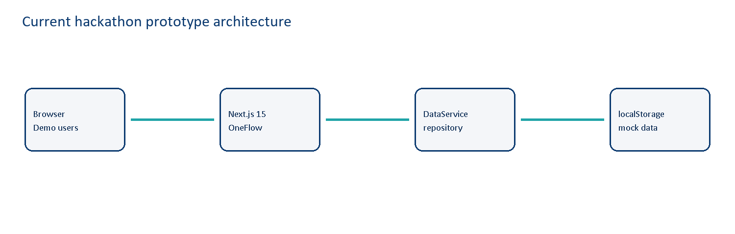
Architecture diagram. Implemented prototype.

16. Deployment architecture — implemented
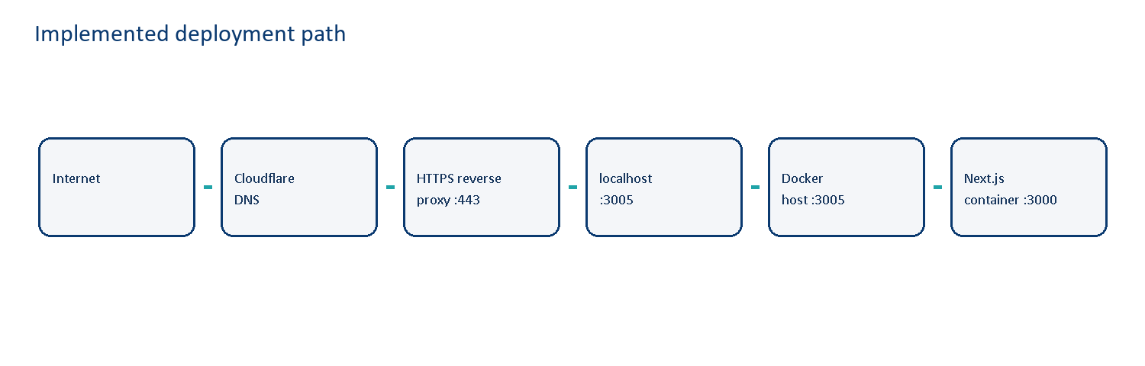
Architecture diagram. Implemented prototype.
Internet → Cloudflare DNS → HTTPS reverse proxy :443 → http://localhost:3005 → Docker host port 3005 → OneFlow container port 3000 → Next.js :3000.

17. Future architecture — proposed
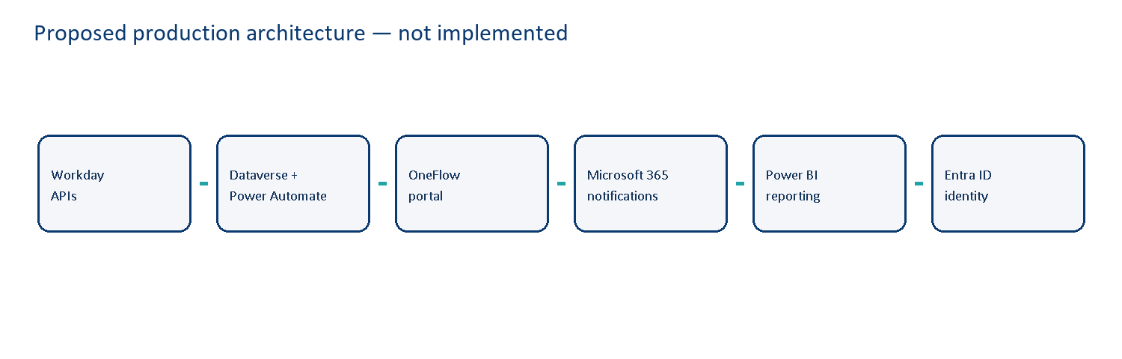
Architecture diagram. Proposed direction; not implemented.

18. Why Power Platform
Power Platform is a suitable proposed direction because it combines governed workflow automation, Dataverse data modelling, Microsoft 365 integration, reporting, and enterprise identity. Licensing, connectors, data residency, and architecture still require review.

19. Prototype cost
Incremental software licensing for the prototype is RM0 where existing Synology/Docker infrastructure and open-source dependencies are used. Developer effort, domain/DNS services, support, and optional email are real costs but are not valued here.

20. Estimated production cost — planning only
Public pricing checked 19 August 2026 using Microsoft Malaysia and AWS price pages. Values are indicative list-price planning figures, exclude taxes and discounts, and use USD 1 = RM4.25 as an illustrative planning conversion; obtain a quote before approval.

20.1 Licensing scenarios
Scenario | Indicative monthly list cost | Assumptions
Pilot | RM4,485 | 25 Power Apps + Power Automate; 10 Power BI Pro; 1 GB Dataverse
Malaysia production | RM17,315 | 100 Power Apps + Power Automate; 30 Power BI Pro; 2 GB Dataverse
Regional enterprise | Quote required | Agreement, usage, connectors, capacity and support

20.2 One-time implementation
Indicative discovery-to-rollout range: RM260,000–RM750,000 for approved integrations, data model, SSO/security, workflow configuration, testing, reporting, training, change management, and support transition. This is not a vendor quote.

20.3 Recurring components
Component | Public list price | Planning MYR
Power Apps Premium | USD20/user/month | RM85/user/month
Power Automate Premium | USD15/user/month | RM63.75/user/month
Power BI Pro | USD14/user/month | RM59.50/user/month
Dataverse DB add-on | USD40/GB/month | RM170/GB/month
Power Automate Process | USD150/bot/month | RM637.50/bot/month
AWS SES Essentials | USD0.16/1,000 emails | RM0.68/1,000 emails

20.4 Executive cost view
The pilot is a controlled baseline, not a procurement recommendation. Validate eligible bundled Microsoft entitlements, tax, discounts, capacity, and delivery scope with Microsoft and implementation partners.

21. ROI framework
Measure saved handling time, avoided rework, late provisioning, onboarding readiness, exit-risk closure, audit evidence, and stakeholder satisfaction. Formula: (annual quantified benefit − annual recurring cost) ÷ implementation cost. Do not use salary figures without validated HR inputs.

22. Security considerations
Current controls are demo-oriented. Production requires Entra ID SSO, least privilege, secrets management, encryption, audit retention, vulnerability management, secure SDLC, and approved integration identities.

23. Privacy and data handling
Use synthetic demo data only. Production must minimise personal data, define retention/deletion, assess transfers, use access logging, and complete required privacy and security assessments.

24. Limitations
No live Workday, Dataverse, Power Automate, Entra ID, Power BI, or production-grade email delivery is implemented. Mock inbox and optional SES configuration are for demonstration only.

25. Production readiness gap
Area | Prototype | Production need
Identity | Demo login | Entra ID SSO/MFA/RBAC
Data | localStorage | Dataverse/approved store
Integration | Mock Workday | APIs, retries, monitoring
Automation | Simulated | Power Automate
Reporting | In-app snapshot | Governed Power BI
Operations | Manual support | Monitoring, backup, change process

26. Roadmap
Phase | Outcome
1 — Hardening | Stabilise demo, accessibility, tests, documentation
2 — Foundation | Identity, approved data model and environments
3 — Integration | Workday events, Power Automate and M365
4 — Scale | Power BI, controls, support and rollout

27. Success metrics
Measure case creation time, task completion before start date, overdue-task rate, onboarding readiness, offboarding closure by last working day, delivery outcomes, rework, and stakeholder satisfaction.

28. Five-to-ten minute demo guide
1) Sign in as Admin. 2) Show the five-worker Workday dataset. 3) Open Nabila’s Preboarding journey. 4) Switch to HR or IT roles for assigned work. 5) Open Hamdan’s Offboarding journey. 6) Open reports and explain implemented versus proposed components.

29. Troubleshooting
If data looks stale, use available reset/seed controls or clear site storage for the demo browser. If a container cannot be reached, confirm the reverse proxy targets localhost:3005 and Docker maps 3005:3000. Never change the container application port from 3000.

30. Deployment manual
Set NEXT_PUBLIC_APP_URL=https://oneflow.highrulez.com in the deployment environment. Start with Docker Compose. Synology Reverse Proxy accepts HTTPS on :443 and forwards to http://localhost:3005. Keep the internal Next.js port at 3000. Never commit .env secrets.

31. Maintenance
Review dependencies and images, rotate credentials outside source control, test restore and rollback, monitor logs and health, review access, revalidate pricing, and refresh demo data before events.

32. FAQ
Is this connected to Workday? No, it is a mock. Is Power Automate live? No, it is proposed. Where is data stored today? Browser local storage. Is port 3005 the app port? No: it is only the Docker host mapping; Next.js stays on 3000 in the container.

33. Conclusion
OneFlow demonstrates coherent employee lifecycle orchestration: mock source events, role ownership, tasks, forms, notifications, and visibility. The roadmap identifies the controls and integrations needed to progress from prototype to production.

Appendix A. Demo accounts
Use role-specific demo accounts configured in the prototype. The shared password is intentionally not printed; use the local demo login or secure handover material.

Appendix B. Workforce and location
Exactly five workers: three Active, one Preboarding, and one Offboarding. All use Malaysia – UOA Business Park.

Appendix C. Role matrix
See Section 14.

Appendix D. Technology stack
Next.js 15, React 19, TypeScript, Tailwind CSS, Node.js 22 Alpine, Docker Compose, and a local-storage repository abstraction.

Appendix E. Environment variables
NEXT_PUBLIC_APP_URL is https://oneflow.highrulez.com. PORT=3000 and HOSTNAME=0.0.0.0 apply inside the container. AWS and SES variables are optional configuration; keep all secrets outside source control.

Appendix F. Cost assumptions
Public price pages checked 19 August 2026; USD 1 = RM4.25 planning conversion; prices exclude taxes and enterprise discounts.

Appendix G. Pricing sources
Microsoft Power Apps (Malaysia): https://www.microsoft.com/en-my/power-platform/products/power-apps/pricing
Microsoft Power Automate (Malaysia): https://www.microsoft.com/en-my/power-platform/products/power-automate/pricing
Microsoft Power BI (Malaysia): https://www.microsoft.com/en-my/power-platform/products/power-bi
AWS SES: https://aws.amazon.com/ses/pricing/

