Development Progress for Laravel backpack-based DUX

Date: 27-03-2022
- Setup laravel 8 and configured .ENV file for database
- Created Database and run initial migration
- Installed Core Back pack packages
# require Backpack using Composer
composer require backpack/crud:"^5.0"
composer require --dev backpack/generators

# run the installation command
php artisan backpack:install

- created a user from Register page and logged in to admin panel

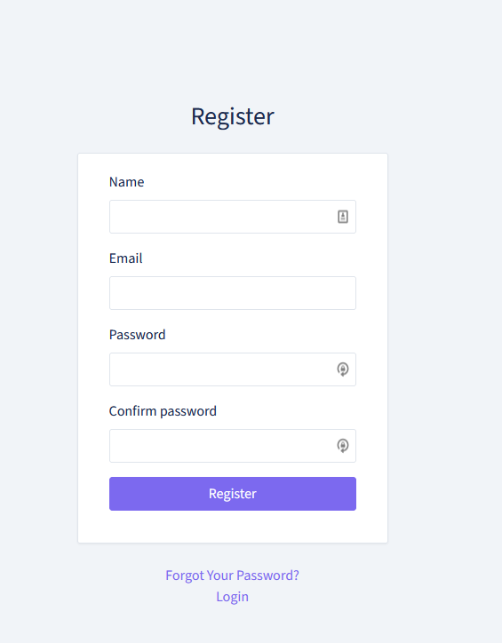

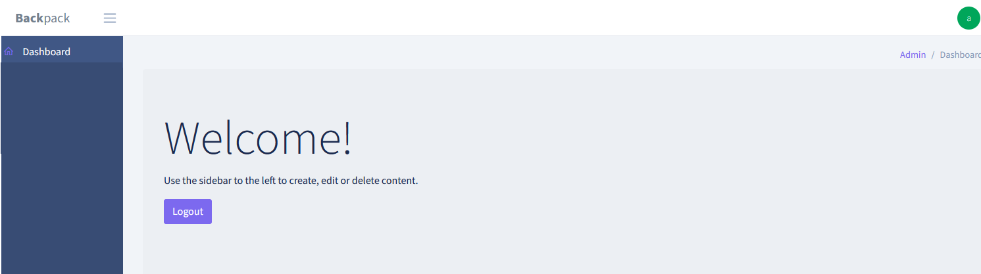

- added additional columns in user table as per dux db
business_address
your_position
city state_name
zip_code
country
phone
business_name
business_logo
is_active
profile_image
last_login
login_ip_address

- installed PermissionManager add-on
composer require backpack/permissionmanager

- published PermissionServiceProvider and migrated permissionmanager tables
php artisan vendor:publish --provider="Spatie\Permission\PermissionServiceProvider" --tag="migrations"
php artisan migrate
php artisan vendor:publish --provider="Spatie\Permission\PermissionServiceProvider" --tag="config"

- added the Spatie\Permission\Traits\HasRoles trait to your User model

- then published backpack\permissionmanager config file & the migrations

php artisan vendor:publish --provider="Backpack\PermissionManager\PermissionManagerServiceProvider" --tag="config" --tag="migrations"

- added CrudTrait and HasRoles traits in user model
<?php namespace App\Models;

use Backpack\CRUD\app\Models\Traits\CrudTrait; // <------------- this one
use Spatie\Permission\Traits\HasRoles;// <---------------------- and this one
use Illuminate\Foundation\Auth\User as Authenticatable;

class User extends Authenticatable
{
use CrudTrait; // <----- this
use HasRoles; // <------ and this

- added menu item for user management in resources/views/vendor/backpack/base/inc/sidebar_content.blade.php

<li class="nav-item nav-dropdown">
<a class="nav-link nav-dropdown-toggle" href="#"><i class="nav-icon la la-users"></i> User Management</a>
<ul class="nav-dropdown-items">
<li class="nav-item"><a class="nav-link" href="{{ backpack_url('user') }}"><i class="nav-icon la la-user"></i> <span>Users</span></a></li>
<li class="nav-item"><a class="nav-link" href="{{ backpack_url('role') }}"><i class="nav-icon la la-id-badge"></i> <span>Roles</span></a></li>
<li class="nav-item"><a class="nav-link" href="{{ backpack_url('permission') }}"><i class="nav-icon la la-key"></i> <span>Permissions</span></a></li>
</ul>
</li>

- Added a middleware to all your Backpack routes by adding this to your config/backpack/ base.php file:

// The classes for the middleware to check if the visitor is an admin
// Can be a single class or an array of clases
'middleware_class' => [
App\Http\Middleware\CheckIfAdmin::class,
\Illuminate\Foundation\Http\Middleware\ConvertEmptyStringsToNull::class,
Backpack\Base\app\Http\Middleware\UseBackpackAuthGuardInsteadOfDefaultAuthGuard::class,
],

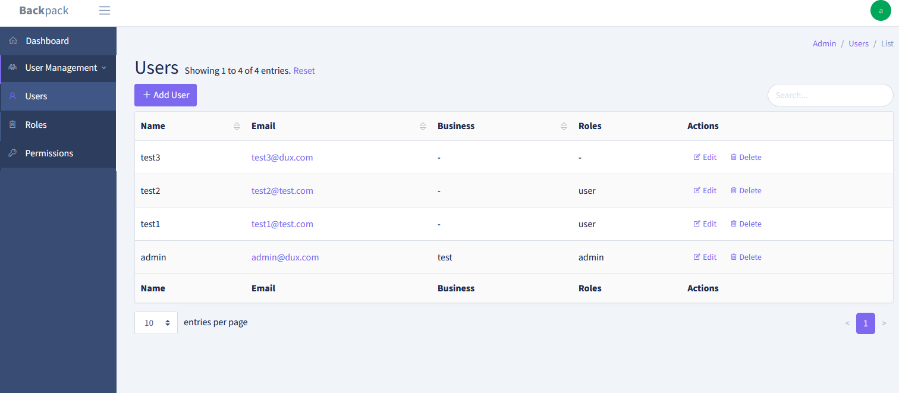

- Extended UserCrudController in order to add fields to the default user controller by following steps

- Copied UserCrudController from Backpack\PermissionManager\app\Http\Controllers\UserCrudController to
App\Http\Controllers\Admin\UserCrudController

- Bind new controller to backpack controller in AppServiceProvider

public function register()
{
$this->app->bind(
\Backpack\PermissionManager\app\Http\Controllers\UserCrudController::class, //this is package controller
\App\Http\Controllers\Admin\UserCrudController::class //this should be your own controller
);
}

* this tells Laravel that when UserCrudController is requested, your own UserCrudController should be served
- added new fields inside UserCrudController’s addUserFields function
[
'name' => 'business_name',
'label' => "Business Name",
'type' => 'text',
],
[
'name' => 'business_address',
'label' => "Business/Organization Street address",
'type' => 'text',
],
[
'name' => 'city',
'label' => "City",
'type' => 'text',
'attributes' => [ 'placeholder' => 'Enter City'],,
[
'name' => 'state_name',
'label' => "Province/State",
'type' => 'text',
'attributes' => [ 'placeholder' => 'Enter State Name'],
],

Date: 28-03-2022
- Added Custom view for Create and Edit User pages under resources\views\vendor\backpack\base\crud\users\
- Call Custom views for add and edit user from controller
public function setupCreateOperation() {
$this->crud->set('create.contentClass', 'col-md-12'); // make use of full width
$this->crud->setCreateView('backpack::crud.users.create', $this->data);
$this-> addUserFields ();
$this->crud->set Validation(StoreRequest::class);
} public function setupUpdateOperation() {
$this->crud->set('edit.contentClass', 'col-md-12');
$this->crud->setUpdateView('backpack::crud.users.edit', $this->data);
$this->addUserFields();
$this->crud->setValidation(UpdateRequest::class);
}
- Placed 2 fields in one row by adding wrapperAttributes for every fields
$this->crud->addFields([ [
'name' => 'name',
'label' => 'Full Name',
'type' => 'text',
'attributes' => [ 'placeholder' => 'Full Name'],
'wrapperAttributes' => [
'class' => 'form-group col-md-6'
]
],
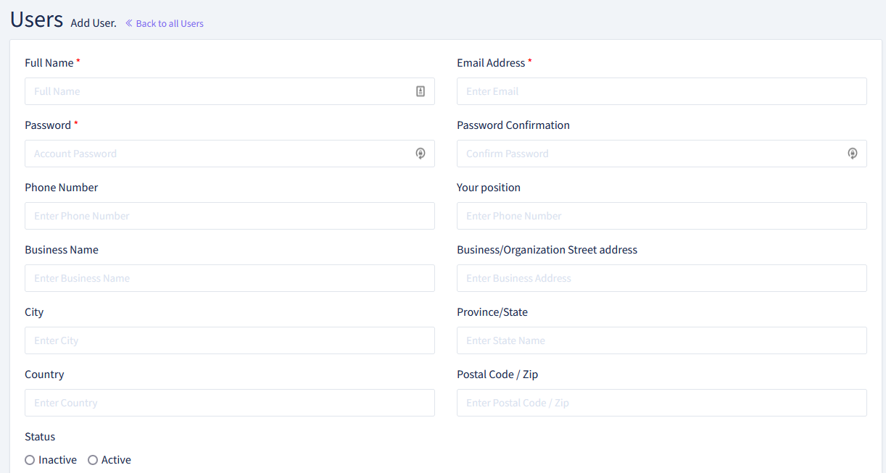

- Created CRUD permissions for User CRUD in permission page
- Added code to check permissions of User CRUD in UserCrudController

//Check CRUD permission for the user and grant access
if(!backpack_user()->hasPermissionTo('create-user'))
{
$this->crud->denyAccess('create');
}
if(!backpack_user()->hasPermissionTo('edit-user'))
{
$this->crud->denyAccess('update');
}
if(!backpack_user()->hasPermissionTo('delete-user'))
{
$this->crud->denyAccess('delete');
}
if(!backpack_user()->hasPermissionTo('list-user'))
{
$this->crud->denyAccess('list');
}

- Created UserStoreCrudRequest and UserUpdateCrudRequest to validate all additional fields

public function rules()
{
return [
'email' => 'required|unique:'.config('permission.table_names.users', 'users').',email',
'name' => 'required',
'password' => 'required|confirmed',
'phone' => 'required|min:6',
'business_address' => 'required|min:5',
'your_position' => 'required|min:5',
'city' => 'required|min:4',
'state_name' => 'required|min:4',
'country' => 'required|min:4',
'business_name' => 'required|min:4',
'is_active' => 'required|min:1',
'zip_code' => 'required|min:3',
];
}

- Call UserStoreCrudRequest and UserUpdateCrudRequest from UserCrudController

use App\Http\Requests\UserStoreCrudRequest as StoreRequest;
use App\Http\Requests\UserUpdateCrudRequest as UpdateRequest;

- Created promotions crud page by ruing following command,

php artisan backpack:crud promotion

The code above will have generated:

a model (app/Models/Promotion.php);
a controller (app/Http/Controllers/Admin/ Promotion CrudController.php);
a request (app/Http/Requests/ Promotion CrudRequest.php);
a resource route, as a line inside routes/backpack/custom.php;
a new item in the sidebar menu, in resources/views/vendor/backpack/base/inc/sidebar_content.blade.php;

- Created promotion table as per dux_db in new backpack db

- Updated column names from created_date to create_at and modified_date to updated_at

- Created CRUD permissions for Promotion CRUD in permission page
- Added code to check permissions of User CRUD in PromotionCrudController

//Check CRUD permission for the user and grant access
if(!backpack_user()->hasPermissionTo('create-promotion'))
{
$this->crud->denyAccess('create');
}
if(!backpack_user()->hasPermissionTo('edit-promotion'))
{
$this->crud->denyAccess('update');
}
if(!backpack_user()->hasPermissionTo('delete-promotion'))
{
$this->crud->denyAccess('delete');
}
if(!backpack_user()->hasPermissionTo('list-promotion'))
{
$this->crud->denyAccess('list');
}

- Added Columns in setupListOperation()

CRUD::column('location_ids');
CRUD::column('promotion_title');
CRUD::column('promotion_description');
CRUD::column('promotion_fineprint');
CRUD::column('start_date');
CRUD::column('end_date');
CRUD::column('vip_promotion_description');

- Added Custom JS file to handle show/hide columns based on radio button
Widget::add()->type('script')->content('packages/backpack/base/js/custom_ui.js');
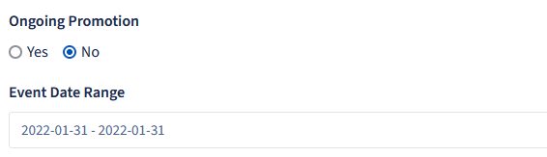

- Added validation rules PromotionRequest

return [
'promotion_title' => 'required|min:5|max:255',
'promotion_description' => 'required|min:5|max:255',
'promotion_fineprint' => 'required|min:5|max:255',
'vip_promotion' =>'required',
'vip_promotion_description' => 'required_if:vip_promotion,==,1',
];

