**Integration Framework**

**Operations Part One**

**Scenario Administration and Monitoring**

**Last Modified: July 26, 2022**

1 Scenario Administration 3

1.1 Setup and Activation Options for Scenario Packages 3

1.1.1 Setting Up a Scenario Package 4

1.1.2 Setting Up Scenario Steps 8

1.1.3 Setting Up Senders and Receivers 10

1.1.4 Defining Scheduler Settings 14

1.1.5 Activation and Deactivation 15

1.1.6 Defining Properties and Value Mappings in Data Management 21

1.1.6.1 Setting Up Global and Local Properties 21

1.1.6.2 Setting Up Value Mappings 22

1.1.7 Using Tools 24

1.1.7.1 Generating XSDs 24

1.1.7.2 Generating WSDLs 25

1.1.7.3 Clearing the Setup of a Scenario Package 27

1.2 Controlling Scenario Packages 27

1.3 Running Reports for Scenario Packages 33

1.4 Importing and Exporting Scenario Packages 37

1.4.1 Importing a Scenario Package or a Scenario Step 37

1.4.2 Exporting a Scenario Package or Scenario Step 40

2 Monitoring 42

2.1 Message Logs 42

2.1.1 Introduction 42

2.1.2 Selecting Message Logs 43

2.1.3 Displaying Message Logs 46

2.1.4 Displaying the Flow Analysis 47

2.1.5 Debugging the Flow 49

2.1.6 Displaying Last Exceptions 51

2.1.7 Exporting and Importing Message Logs 51

2.1.8 Analyzing Imported Message Logs 52

2.1.9 Tracing 53

2.2 Displaying Error Inbox, Processing Errors and Technical Errors 53

2.2.1 Using the Error Inbox 53

2.2.2 Displaying Processing Errors 56

2.2.3 Displaying Technical Errors 56

2.3 Process Control 56

2.4 Monitoring Canceled Transactions 60

2.5 SAP Business One (B1) Event Monitor 61

2.5.1 SAP Business One Event Checks in the Integration Framework 61

2.5.2 Event Filter and Monitor 61

2.5.3 Editing and Resending Events in the Failure Section 63

2.6 Queue Monitor 63

2.7 Call Monitor 65

2.8 Audit Control Monitor 70

2.9 Authentication Monitor 71

2.10 Message Log History 71

2.11 BPM Monitor 73

2.12 Inbound Channel Namespace Report 73

3 Using the Cockpit 74

4 Importing B1iSN Integration Content 77

Copyrights, Trademarks, and Disclaimers 78

# 1 Scenario Administration

The browser-based administration user interface of the integration framework allows you to configure and control your scenario packages from any location. Display an overview of available scenario packages and display scenario details. You can set up, activate and deactivate scenario package*s* and you have the option to import and export them.

## 1.1 Setup and Activation Options for Scenario Packages

The status of a scenario package indicates whether the package is in design mode or active. The picture below gives you some background information.

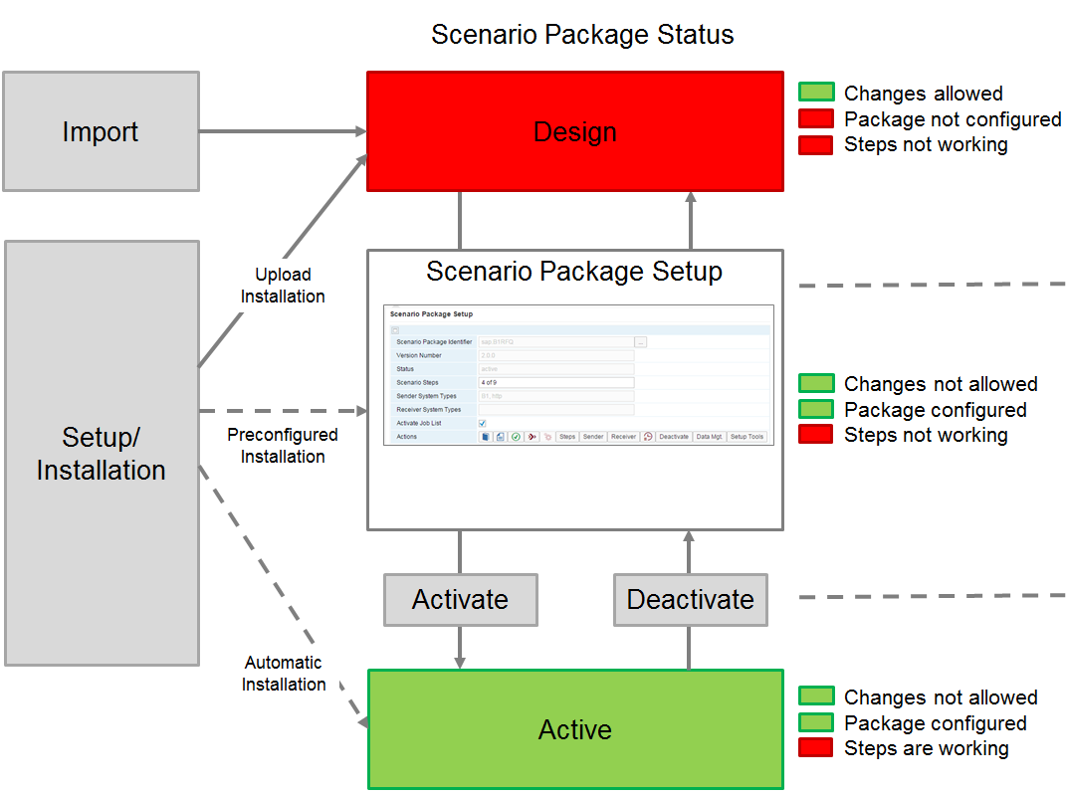

If a scenario package is in **design** mode, you can change everything with the according authorization. The scenario steps run in the test environment and do not respond to incoming calls from sender systems.

During **setup**, you configure the scenario package. You select the scenario steps, select the sender and receiver systems, and define parameters, properties, and so on. You can still change the design of scenario steps. If you change anything in design that influences the scenario setup, change the setup accordingly. The scenario steps run in the test environment and do not respond to incoming calls from sender systems.

When a scenario package is in **active** mode, you have set it up and activated it. Changes are no longer permitted, except for the settings in data management, where you can define global and local property values, value mappings and global table values. The scenario steps run in the test environment and also respond to incoming calls.

If you import a scenario package, the package is in design mode by default.

To optimize the deployment, the integration framework setup supports the following scenario package installation modes:

* An **upload installation** uploads the scenario package and the package is in design mode.
* A **preconfigured installation** uploads and sets up the package. It also creates the required entries in the System Landscape Directory (SLD). The scenario package is then in setup mode.
* The **automatic installation** uploads, sets up and activates the scenario package. It also creates the required SLD entries. This is , for example, the case for the package enabling the mobile app (sap.B1Mobile).

### 1.1.1 Setting Up a Scenario Package

The scenario package setup user interface is your entry point to set up and finally activate a scenario package. In scenario setup, you configure the scenario package for a specific system landscape by selecting scenario steps, sender and receiver systems that communicate with each other, and defining filters for systems. Additionally, you provide values for properties and value mappings.

To set up a scenario package, use either the scenario setup wizard or the setup functions for steps, sender and receiver systems and the data management.

To set up a scenario package, choose *Scenarios*→*Setup*.

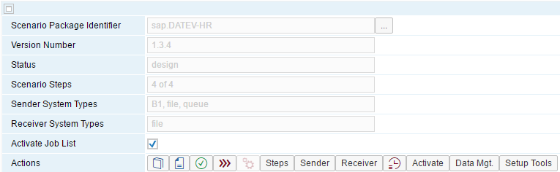

Scenario Package Identifier

The field displays the identifier of the scenario package. The identifier consists of the vendor namespace and the scenario package name. To display available scenario package*s*, click the […] button.

Version

The field displays the version of the scenario package.

Status

The field displays the status of the scenario package. The status can be design, set up, or active.

Scenario Steps

The field displays the number of scenario steps that are set up and the number of scenario steps assigned to the scenario package. The example above displays a scenario package with four steps that are set up. The package consists of four scenario steps.

Sender System Types

The field displays sender system types involved in at least one scenario step of the package.

Receiver System Types

The field displays receiver system types, involved in at least one scenario step of the package.

Activate Job List

If you want the integration framework to process automatic jobs based on events, select *Activate Job List*. The checkbox is disabled, if there are no job lists definitions available. The enabled field for the sap.DATEV-HR package automatically assigns new company databases to the setup.



The integration framework provides context-based documentation. If documentation is available, the integration framework displays the documentation icon. The greyed out icon indicates missing documentation. To open documentation, click the icon.

, , 

A consistency check validates the scenario package definitions against the integration framework model specification. The integration framework performs the check when you open the user interface. The green icon indicates that the definitions are correct and complete. The yellow icon indicates that some warnings exist. The red icon indicates an inconsistency caused by definition errors or incomplete definitions.

If the integration framework displays a yellow or red icon, click the icon. The integration framework displays result details with one line for each warning and inconsistency.

Each line consists of an incident number, a description and the [Design] button. To display and solve the problem in the design user interface, click the button.

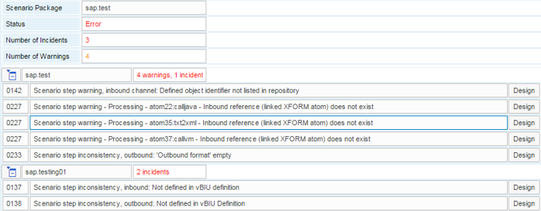



The integration framework supports to provide documentation for scenario packages.

To save the documentation to the BizStore, use the control center. For more information, see the *Development Environment Guide*, *Document Handling*, *Uploading a Document*. Provide the document in pdf format and save it to the base directory of the scenario package: /com.sap.b1i.vplatform.scenarios.design/vPac.*<name>*/vPac.pdf

To generate a document based on definitions, choose *Scenarios*→*Package Design* →[*Tools*]→ *Generate documentation*.

If both documents exist, select the document you want to display.

 [Setup Wizard]

The wizard provides the following steps:

1. Selecting scenario steps

The framework displays steps that belong to the package.

* To select steps for setup, select *Activate*.
* To enable or disable the generation of documents (XSL, BFD) for steps, select *Generate*.
* If processes have been defined for the package and you want to use them to enter filter definitions, select the *Apply Processes* checkbox.

If you select the checkbox, the framework adds the direction information of the scenario step to the user interface. Processes simplify the setup of filter definitions. Note that selecting or deselecting the checkbox removes setup entries.

For more information about processes, see the *Scenario Development* guide, section *Defining Processes*

1. Selecting sender and receiver systems for the package.

The framework displays a list of sender and receiver systems.

* Select the sender and receiver systems you want to use in the scenario package.

1. Setting filter definitions.

The framework displays a *Sender Filters* and a *Sender Receivers Filters* section.

In the *Sender Filters* section, define filter criteria that are the same for all receiver systems.

In the *Sender Receivers Filters* section, define filter criteria that are different for the receiver systems.

The framework displays combinations for active scenario steps and selected sender and receiver systems in both filter sections. For each criteria field definition, you can define al filter or filter range.

All combinations are selected with the checkbox in front of each row by default. Do not deselect any combination, even if you do not define any filters for the combination. If you deselect any combination, the integration framework filters everything.

**Setting a Filter Definition**

* For each filter, select an operator, click the […] button in the Operator field.
* If you have selected an operator that requires one filter value, enter the value in the *Filter from* field. If the operator requires two entries, enter a value in the *Filter from* and in the *Filter to* field.
* To combine a filter with an existing one, click the […] button. You can connect filters using and or or. The default is and.

1. Defining global property values and tables

The integration framework displays global tables and global properties. For more information about global tables and properties and how to set values, see the *Scenario Development* guide, sections *Global Properties*, *Global Tables* and section *Setting up Properties*

1. Defining local property values

The integration framework displays all activated scenario steps.

* For each scenario step, select a sender and receiver system, select a local property, set the value, and save your settings.
* To add a property value for the same scenario step, sender and receiver sytem, click the [Add] button at the end of the row.
* To delete a local property value, click the [Del] buton at the end of the row.

1. Defining value mappings

For more information, see *Setting up Value Mappings*

1. Defining scheduler settings

If your scenario package contains timer-triggered steps, you can define the scheduler settings. The integration framework displays timer-triggered steps.

* To enter scheduler settings, click the [Setup] button.

For more information, see section *Defining Scheduler Settings*

1. To finalize the wizard, click Deploy.

 [Scenario Administration]

If a scenario-specific administration is available for a scenario package, click the button to open the user interface and provide the required values.

[Steps]

For more information, see *Setting up Scenario Steps*

[Sender]

For more information, see *Setting up Senders and Receivers*

[Receiver]

For more information, see *Setting up Senders and Receivers*

[Timer]

For more information, see *Defining Scheduler Settings*

[Activate]

For more information, see *Activation and Deactivation*

[Data Mgt.]

For more information, see *Defining Properties and Value Mappings in Data Management*

[Setup Tools]

For more information, see *Using Tools*

### 1.1.2 Setting Up Scenario Steps

To work on scenario steps and selectively activate them, choose *Scenarios*→*Setup*, and click the [Steps] button.

The integration framework displays the *Setup Scenario Steps* user interface. Scenario packages consist of one or multiple scenario steps. Select the scenario steps, you want to work on. The list displays one line for each scenario step.

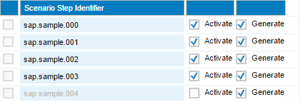

First checkbox

To activate inconsistent scenario steps, select the checkbox.

The checkbox is only available in front of each row, if you have selected the *Deselect Inconsistent Steps in Setup* checkbox in the *Cfg Dev Env* section of the Maintenance menu. If the scenario package is active, the integration framework disables the checkbox for all scenario steps. The integration framework also disables the checkbox for all scenario steps that have passed the consistency check without errors.

You can select the checkbox, if you have selected the *Allow Manual Setup of Inconsistent Steps* checkbox in the *Cfg Dev Env* section of the Maintenance menu.

Activate

To activate a step, select the checkbox.

If the scenario package is active, the checkbox is disabled for all scenario steps. If the consistency check returns an error for a scenario step, the integration framework disables the checkbox for the scenario step.

Generate

To activate the generation of required XSL (Extensible Stylesheet Language) and BFD documents for scenario steps before activation, select the *Generate* checkbox. If the scenario package is active, the checkbox is disabled for all scenario steps. If the consistency check returns an error for a scenario step, the integration framework disables the checkbox for the scenario step.

[All Activate]

To select all scenario steps of the scenario package for activation, click the button. The integration framework checks all steps that have passed the consistency check for activation and displays the name of the scenario step in black. If a scenario step does not successfully pass the consistency check, the integration framework displays the name of the step in red and deselects the checkbox.

[No Activate]

To deselect all scenario steps of the scenario package for activation, click the button. The integration framework displays all scenario steps names in grey. If a scenario step does not successfully pass the consistency check, the integration framework displays the step name in red.

[All Generate]

To select all scenario steps for the generation of XSL and BFD documents before activation, click the button. This is the default setting.

[No Generate]

To deselect all scenario steps from the generation of XSL and BFD documents, click the button.

### 1.1.3 Setting Up Senders and Receivers

The integration framework uses a publish-subscribe mechanism. Sender systems publish entities, such as business object changes, calls, triggers, and so on, and receiver systems subscribe to the entities to receive them.

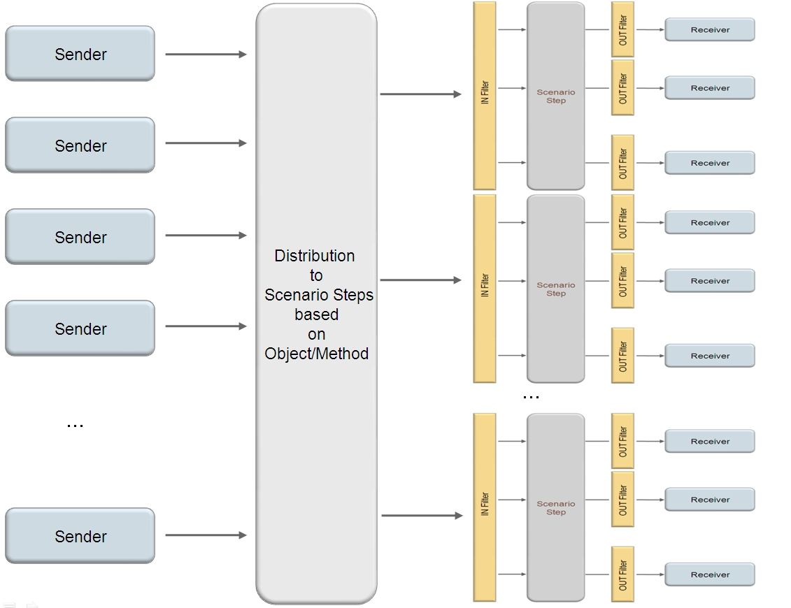

A sender system provides data to the integration framework. For example, an SAP Business One system publishes all changes of the business partner object. The integration framework distributes the entity to the scenario steps that registered to the object. In each scenario step, the integration framework checks the sender filter (IN Filter) before processing. If the message meets the filter condition, the integration framework processes the message. After processing, the integration framework sends the message to all subscribed receiver systems. Receiver systems can be, for example, other SAP Business One systems. The integration framework checks the receiver filter (OUT Filter) and does not forward the message to a receiver, if the filter condition is not met.

Even for quite simple scenarios, such as, for example, sending a message from one system using one registered scenario step to one receiver system without using any sender or receiver filter, the publish-subscribe mechanism allows you various, even complex, setups.

If you do not need filters, set up the sender and receiver systems without configuring filters.

[Sender]

To select sender systems or to set sender filter definitions, click the button. You have the following options:

* Define Sender List
* Define Sender Filter Definitions

Configuring the Sender List

The integration framework displays sender systems types and available systems defined in SLD for the system type. The integration framework sorts sender systems by SysId.

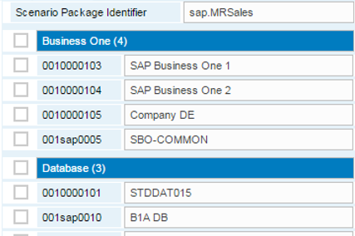

* To select or deselect all sender systems of a system type, click the checkbox in front of the system type.
* To select or deselect a system from SLD, click the checkbox in front of the system.
* To save the selection, click [Save].

Configuring Sender Filter Definitions

To exclude sender systems for some scenario steps or to define a condition, under which the integration framework accepts incoming messages, select Maintain Sender Filter Definitions. The integration framework displays the scenario steps of the package, each with all applicable and selected sender systems.

You have the following options:

* To exclude a sender system for a scenario step, enter no in the input field or deselect the scenario step.
* To define a condition for a sender system for a scenario step, enter an XPath expression. You can use the $msg variable for the incoming sender message, for example $msg/root/@flag=’A’.
* For more complex conditions, use boolean operators, such as and, or, and not, for example:

(//b1e:objecttype='4') and (not(//b1e:transactiontype='U'))

The statement above processes B1 events for items only, if the items are not updated.

note.gif NOTE

If the defined filters do not work at runtime, and the integration framework does not display the filter in the input fields, and you can no longer save the definitions, there is a syntax error in your filter definitions. To resolve the issue, delete the com.sap.b1i.vplatform.scenarios.setup/ vPac.<package name> folder in the BizStore. Then, repeat the scenario package setup.

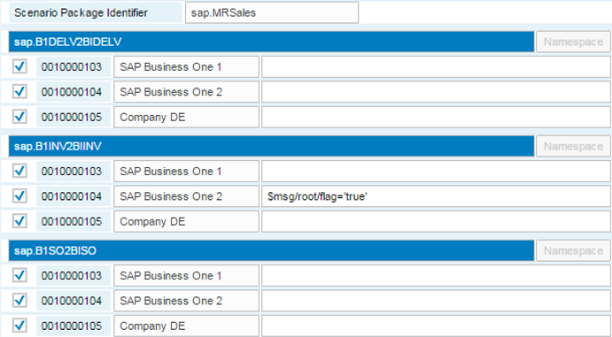

Namespace

If the step uses an individual namespace, click the button to display the namespace.

[Receiver]

To select receiver systems or set receiver filter definitions, click the [Receiver] button. You have the following options:

* Define Receiver List
* Define Receiver Filter Definitions

Configuring the Receiver List

The integration framework displays systems types and systems from SLD. The integration framework sorts the receiver systems by SysId.

* To select or deselect all receiver systems select the checkbox in front of the system type.
* To select a system from SLD; select the checkbox in front of the system.
* To save the selection, click [Save].

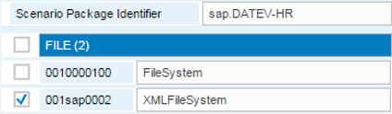

Configuring Receiver Filter Definitions

To exclude receiver systems for some scenario steps or to define a condition, under which the integration framework sends messages, select Maintain Sender Filter Definitions. The integration framework displays all scenario steps, each with all applicable and selected receiver systems. You have the following options:

* To exclude a receiver system for a scenario step, enter *no* in the input field or deselect the scenario step.
* To define a condition for a receiver system and a scenario step, enter the XPath expression in the input field. You can use the $msg variable for the incoming sender message, for example, $msg/root/@flag=’A’.

note.gif NOTE

To use individual namespaces, define them in scenario step design.

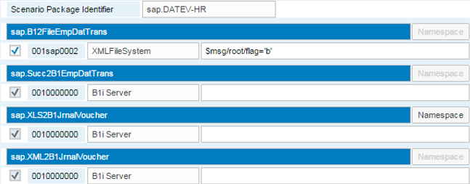

Namespace

If the step uses an individual namespace, click the button to display the namespace.

### 1.1.4 Defining Scheduler Settings

For scenario steps that are defined to run periodically, configure the scheduler.



For scenario steps triggered by a timer, define scheduler settings. Scenario steps usually have a default setting.

The user interface displays timer settings for scenario steps belonging to the scenario package.

If the scenario package does not contain scenario steps triggered by a timer, the user interface only displays the scenario package name.

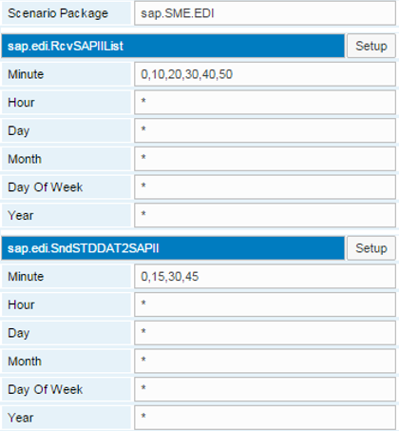

[Setup]

To change settings, click the button.

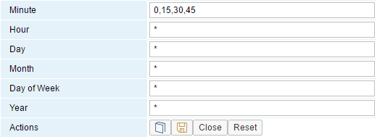

The scheduler definition is based on the CRON syntax. CRON is a time-based job scheduler in Unix-like computer operating systems. A CRON entry has six fields to specify the day, date and time. The integration framework triggers the scenario step, if the entries are true comparing the entries with the system time zone settings of the machine the integration framework runs on.

Minute

Set the value for the *minute* part of the time. Use * or a list of elements separated by comma. An element is either a number in the range of 0 to 59 or two numbers in the range separated by a hyphen. This is an inclusive range.

Hour

Set the value for the *hour* part of the time. Use * or a list of elements separated by comma. An element is either a number in the range 0 to 23 or two numbers in the range separated by a hyphen. This is an inclusive range.

Day

Set the value for the *day* part of the date. Use * or a list of elements separated by comma. An element is either a number in the range 1 to 31 or two numbers in the range separated by a hyphen. This is an inclusive range.

Month

Set the value for the *month* part of the date. Use * or a list of elements separated by comma. An element is either a number in the range 1 to 12 or two numbers in the range separated by a hyphen: This is an inclusive range.

Day of Week

Set the value for the *day of the week*. Use * or a list of elements separated by commas. An element is either a number in the range 0 to 6 (Sunday = 0) or two numbers in the range separated by a hyphen. This is an inclusive range.

Year

Set the value for the *year* part of the date. Use * or a list of elements separated by comma. An element is either a number, specifying a year, for example, 2015, or two numbers in the range separated by a hyphen. This is an inclusive range.

### 1.1.5 Activation and Deactivation

The integration framework uses **scenario process steps** (IPO steps) for internal processing when scenario steps are active. IPO steps are generic steps per system. For each system in SLD that uses at least one active scenario step, generic scenario process steps are available for processing in the integration framework.

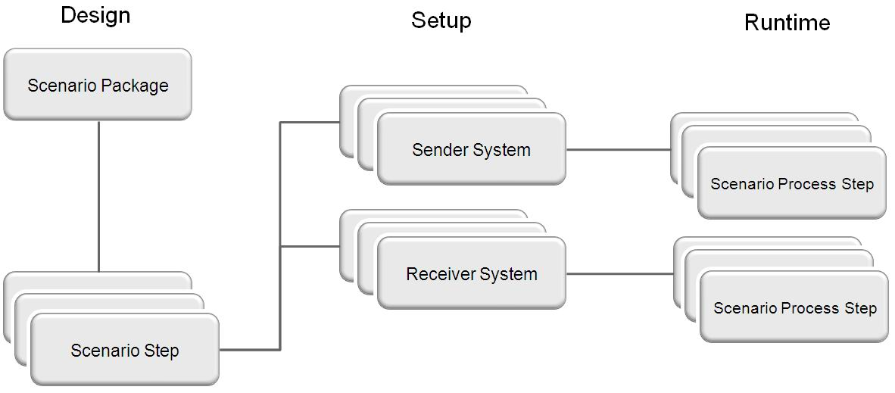

Contrary to other integration solutions where you generate inbound and outbound proxies for each integration scenario, the integration framework works with generic process steps shared by multiple, different scenario packages.

The integration framework runtime supports, for example, a B1 Inbound process step. The step is responsible for generic inbound processing of an SAP Business One system. All scenario steps, for which you define an SAP Business One sender system, use the process step. To set up a scenario package, you define sender and receiver systems. The activation creates an instance of the B1 Inbound process step for each SAP Business One sender system. If an instance for an SAP Business One system is already active because a scenario step of another active scenario package uses it, the system then shares the instance.

All scenario process steps are generic and all inbound processes for the different system types are also generic. This is the reason why you specify the object identifier in the scenario package inbound definition. For more information, see the *Scenario Development Guide*, section *Developing a Scenario Step*

You can find a list of scenario process step types in the *Scenario Development Guide*, appendix C.

**Example**

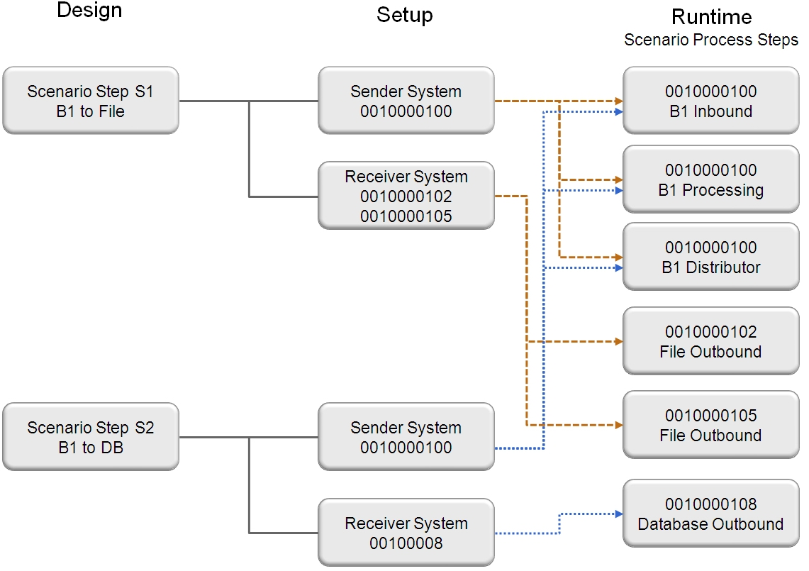

The example above displays the Scenario Step S1 and Scenario Step S2 scenario steps.The steps can belong to different scenario packages.

S1 sends sales orders from SAP Business One to a file system. S2 sends business partner data from SAP Business One to a database system. Both scenario steps have the same SAP Business One sender system with the 0010000100 SysId in SLD. B1 events trigger both steps. The steps share the scenario process steps for B1 Inbound, Processing and Distributor. The scenario process steps for the outbound phase are different, because S1 sends data to a file system, S2 sends data to a database. The integration framework creates the following processes:

Scenario process steps, shared by S1 and S2

* 0010000100.INB_B1_EVNT_ASYN_EVT (B1 Inbound)
* 0010000100.PRC_B1 (B1 Processing)
* 0010000100.PRQ_B1 (B1 Distributor)

Scenario process steps for S1

* 0010000102.OUT_FILE (File Outbound)
* 0010000105.OUT_FILE (File Outbound)

Scenario process step for S2

* 0010000108.OUT_DB (Database Outbound)

[Activate/Deactivate]

The button label displays either activate or deactivate. The button label depends on the mode of the scenario package. To activate a scenario package, click the [Activate] button.

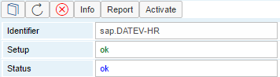

The integration framework checks whether the setup is consist and displays the result. Activation is only possible, if there are no errors in setup.

[Report]

To display details, click the button.

The *Scenario Setup Result* report displays for each scenario step the number of sender and receiver systems and the scenario step status.

**Reports for Activate and Inactive Scenario Packages**

If you click the *[Report]* button for an inactive scenario package, the integration framework displays setup details.

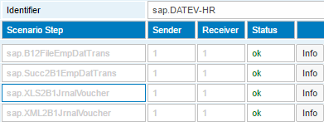

If there is an error in setup, click the [Info] button to open an alert with the error message. The message contains information about errors in setup.

If setup is consistent, the [Activate] button is active. The scenario package is still in design mode. To prepare for activation, click the [Activate] button. The integration framework confirms the activation with the Activation completed message. To display the activation window, click [OK]. The integration framework updates the information:

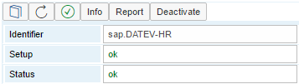

[Info]

To display information about the current status, click the button.

[Deactivate]

To deactivate the scenario package, click the button.

[Report]

To display reports of the activation process, click the button. The reports are also available in scenario package control. The following options are available:

* Setup Details

The *Setup Details* list is the same list available before first activation.

* Setup Report

The *Setup Report* lists all scenario steps*.*

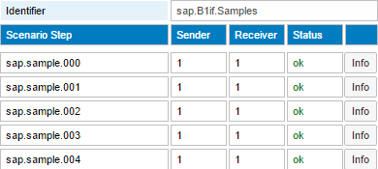

* Activation Report

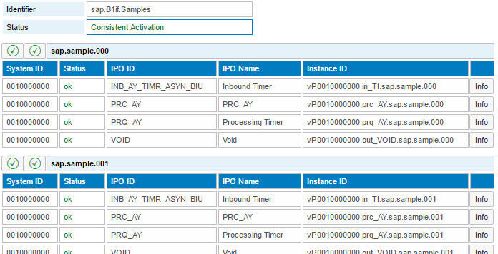

The integration framework sorts the activation report by scenario step and displays all scenario step processes (IPO steps) with their setup status. The status displays, whether the scenario package is set up consistently with respect to other scenario packages. The following situations lead to errors during activation or activation conflicts:

* File Inbound: There are scenario packages already active for the same sender channel (file inbound) with a different ruledoc definition for file inbound.
* HTTP/Web Service Inbound: There are scenario packages already active for the same sender channel (http inbound, WS inbound) with a different authorization model.

To resolve conflicts, deactivate the scenario packages, change the configuration, and activate the scenario packages again.

recommendation.gifRECOMMENDATION

We recommend defining the same ruledoc and the same authorization concept for all involved scenario packages. The easiest way is to use different file inbound and http/Web service inbound SLD entries for the different scenario packages orscenario steps.

[Info]

To display technical processes that are set up for a step, select the button.

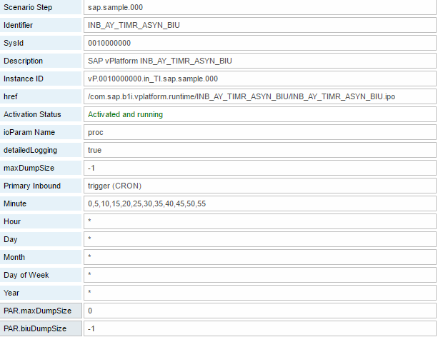

### 1.1.6 Defining Properties and Value Mappings in Data Management

Data Management allows entering values for global or local properties and value mappings. The setup for data management is only available, if the scenario package definition requires setting up properties and value mappings. You can enter values for active scenario packages.

#### 1.1.6.1 Setting Up Global and Local Properties

Global properties are valid for the scenario package, local properties are valid for the scenario step.

To display global properties for a scenario package, select the scenario package, click the [Data Management] button and select Global Properties. The integration framework displays property names and default values.

To display local properties for a scenario step, select the scenario step, click the [Data Management] button and select Local Properties. The integration framework displays property names and default values.

If the scenario package developer has defined enumerations, you can display the values clicking the […] button.

In the *Scenario Setup* user interface, click the [Data Management] button and select Global or Local Properties. The integration framework displays the properties the scenario package developer has defined. Adjust the values and save your settings.

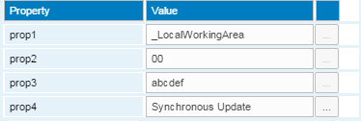

#### 1.1.6.2 Setting Up Value Mappings

The integration framework supports value mapping. It allows externalizing mappings between sender and receiver systems instead of hardcoding them at design time. You can enter value mappings for active scenario packages.

**Prerequisites**

The integration developer has selected *Scenarios* → *Package Design* →*[Definitions]* →*Value Mappings* and has defined that the integration framework performs value mappings for certain fields.

To enter values for value mapping, in the *Scenario Setup* user interface, click the [Data Management] button and select Value Mapping.

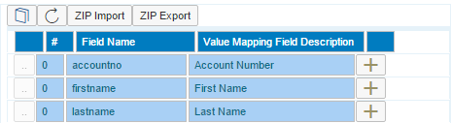

[ZIP Import], [ZIP Export]

To import or export all mapping definitions for the scenario package, click the [ZIP Import] or [ZIP Export] button.

The table displays the defined value mapping definitions for the fields. For each field you can define many mapping domains. To add a new mapping domain to a field, click the  button. The integration framework adds a mapping domain and displays it.

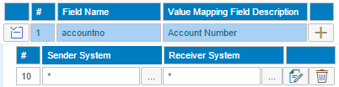

The first row displays the existing value pairs (from-to) for a mapping domain. The second row specifies the sender system(s) for which the system processes the mapping. The third row specifies the receiver system(s) for which the system processes the mapping. To select a system from SLD, click the […] button. You always find the default entry - all -, which the system represents as an asterisk (*) in the field.

[Delete]

To delete a mapping domain, click the button.

Edit Value Mappings 

To edit value pairs for a mapping domain, click the button.

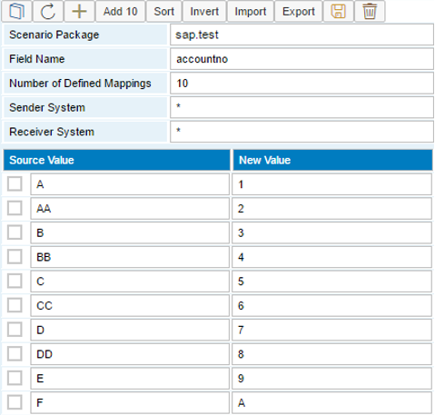

[Add], [Add10]

To add one or ten value pairs to the list, click the [Add] or [Add10] button.

[Sort]

To sort the value pairs by the *From* value, click the button. This helps you easily finding duplicates.

[Inverse]

To invert the value pairs, click the button. The integration framework sets *From* values to *To* values and vice versa.

[Delete]

To delete selected value pairs, click the button. Select the value pair for deletion.

[Import], [Export]

To import or export value pairs for a mapping domain from or into DSV (delimiter-separated values) files, click the [Import] or [Export] button. You can import value mapping pairs in Microsoft Excel. In Microsoft Excel save the file as a DSV file and import the file here. The integration framework checks for duplicates during import.

note.gif NOTE

For export, use the CSV extension and define the semicolon as the delimiter.

### 1.1.7 Using Tools

Tools support you in providing Web services to external parties by generating XSD and WSDL documents. Additionally, you can reset the setup of a scenario package.

#### 1.1.7.1 Generating XSDs

XSD (XML Schemal Definition) generation allows you to generate an XML schema definition based on a sample XML document. For each scenario package, the integration framework generates the XSD for the inbound and for the outbound message.

**Inbound**

To generate an XSD for the inbound message, the integration framework searches for an inbound document for the scenario package in the message log. The integration framework performs the XSD generation based on the last message the integration framework has processed. If the integration framework cannot find such a message in the message log, it searches the base directory of the scenario package. If you have defined an inbound test message, the integration framework uses the message. If the integration framework cannot find an inbound message, it does not perform the generation for the step.

**Outbound**

To generate an XSD for the outbound message, the integration framework searches for an outbound document for the scenario package in the message log. The integration framework performs the XSD generation based on the last message the integration framework has processed. If the integration framework cannot find such a message in the message log, it searches the base directory of the scenario package. If you have run the scenario in the test environment, the integration framework uses the last generated outbound message. If the integration framework cannot find an outbound message, it does not perform the generation for the step.

**Prerequistes**

To have the inbound and outbound documents in place for XSD generation, test the scenario steps in step design processing.

**Procedure**

Choose Scenarios → Setup, select your scenario package, click [Setup Tools], and select XSD Generation.

The integration framework displays the result of the XSD generation. All inbound and outbound XSD documents must be available. The integration framework displays Successfully generated in the *Status* field.

Alternatively, provide the XSD documents manually in the base directory of the scenario step in the following way:

/com.sap.b1i.vplatform.scenarios.design/vBIU.<name>/<name>_in.xsd

/com.sap.b1i.vplatform.scenarios.design/vBIU.<name>/<name>_out.xsd

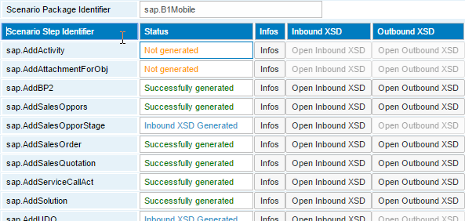

The integration framework does not support multiple namespaces in one document. The XSD generation fails, if you do not define the inbound document conform to XML schema. If the generation fails, create the XSD document manually.

#### 1.1.7.2 Generating WSDLs

If you develop a scenario package with scenario steps specified as Web services, provide the Web Services Description Language (WSDL) document to the one who wants to call the Web service. The WSDL documents contains all information the caller of a Web service requires to implement and call the service. WSDL is an XML-based language that describes the functions exposed by a Web service. A WSDL document provides a machine-readable description that describes how the client must call the service, which parameters the service expects and which data structures it returns.The generated WSDL document covers all scenario steps which are defined as Web Service inbound.

The integration framework supports the following Web service related specifications:

* SOAP 1.1
* WSDL 1.1
* WS-I Basic profile 1.0

note.gif NOTE

Any well-formed XML message that conforms to the guidelines defined in the specifications of *WS-I Web-Service Basic Profile 1.0* and *SOAP 1.1* is valid.

caution.gif CAUTION

The following restrictions apply:

* SOAP 1.1 specification, that are also cited in the WS-I Basic Profile 1.0:
* R1008: A message must not contain a Document Type Declaration (DTD).
* R1009: A message must not contain XML Processing Instructions.
* The integration framework does not support multiple namespaces for inbound or outbound message.

note.gif NOTE

You can only generate a WSDL, if the scenario package is active.

caution.gif CAUTION

The following restrictions apply:

* The adapter only supports one message part per inbound, outbound and error message. This restriction is necessary because payload messages passed to and coming from the adapter must be well-formed. Then the platform processes them. Messages must have exactly one root element.
* There is no support for SOAP attachments.
* The WSDL generation currently does not support the SOAP RPC operation mode, whereas the adapter can pass SOAP RPC style data, if the rule to have well-formed payload messages available is not violated. This operation mode is outdated and all contemporary environments provide other message passing modes. We do not recommend using the SOAP RPC operation mode.
* For WSDL generation, the XML-schema document that defines the request, response and fault message must have exactly one global element to refer to. The schema generation uses the first global element as the root element for a message type. An error occurs, if no such global element is available.

**Prerequisites**

* The XSD documents for all inbound and outbound Web service scenario steps are available for the generation of the WSDL document. Use the XSD generator or provide the XSD documents manually in the base directory of each scenario step in the following way:

/com.sap.b1i.vplatform.scenarios.design/vBIU.<name>/<name>_in.xsd

/com.sap.b1i.vplatform.scenarios.design/vBIU.<name>/<name>_out.xsd

* For each scenario step with Web service inbound you have run a successful test in scenario step processing.
* You have defined and configured the Web service system or systems in SLD.

**Procedure**

1. To generate the WSDL document, activate the scenario package.
2. Choose Scenarios → Setup, click [Setup Tools] and then select WSDL Generation.

The integration framework displays the scenario steps, the status of XSD generation and provides buttons to open the inbound and outbound XSD documents.

1. To generate the WSDL document, click the *Generate WSDL* button.
2. In the WSDL Generator user interface, click the *Open* button.

The WSDL document opens in a Web browser window or in the internal embedded XML editor.

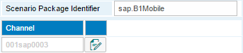

**Result**

Once the scenario package is active, the integration framework provides the trigger of the scenario steps. To display the trigger of the scenario steps, choose *Scenarios* → *Control*, and for your scenario package, click the [Trigger] button.

#### 1.1.7.3 Clearing the Setup of a Scenario Package

If strange effects happen during processing of a scenario package, you can delete all scenario package definitions, sender and receiver definitions including filters, all property settings, and all value mappings. Use the *Clear Setup* function.

recommendation.gifRECOMMENDATION

If you have many value mapping definitions, we recommend exporting the definitions to your file system before starting the *Clear Setup* function.

## 1.2 Controlling Scenario Packages

This function allows you to control scenario packages available in the integration framework. You can run reports for different views, display scenario package details, and you can call the design and setup functions. Additionally, display documentation for the scenario package. To open the control function, choose *Scenarios*→*Control*.

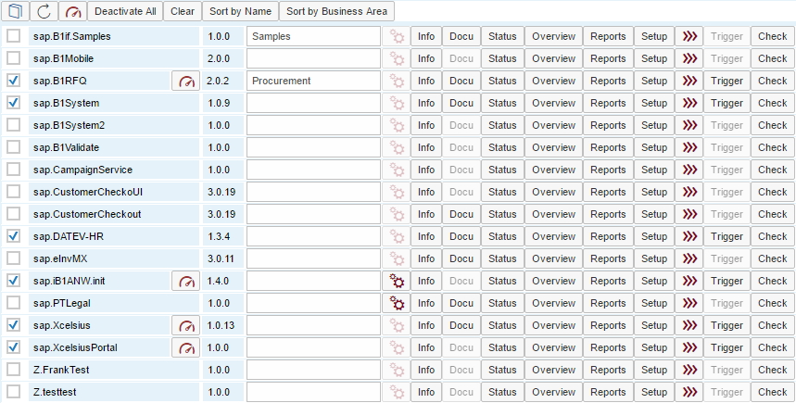

The scenario package overview displays the scenario packages available in the integration framework. The integration framework displays each package with the current status. Selected scenario packages are active, not selected scenarios are in design phase.

You have the following functions available:

* To display documentation, click the [Book] icon.
* To refresh the scenario list, click [Refresh].
* To enable simplified calls for active scenario packages, click the button.
* To deactivate all scenario packages, click [Deactivate All].
* To remove all scenario activation settings, click [Clear].
* To sort scenario packages by name, click [Sort by Name]. This is the default.
* To sort the scenario packages by business area and then by name, click the [Sort by Buiness Area] button.

For each scenario package, the following functions are available

Checkbox for Activation or Deactivation

To activate a scenario package, select the checkbox in front of the scenario package identifier. To deactivate a scenario package, deselect the checkbox.



For **active** scenario packages, the icon indicates that there are synchronous scenario steps (with HTTP or Web services inbound) available in the package that can be processed faster using simplified calls.

If you use simplified calls, the integration framework does not perform the following activities:

* Identifying the subscribed scenario step by the inbound Identifier definition.
* Inbound processing usually checks the consistency of subscribed scenario steps. In a simplified call, the consistency check does not take place.
* For each scenario step, you can define sender filter definitions in the setup. In a simplified call, you cannot use the filter definitions.
* You cannot record test messages in a simplified call.
* The integration framework provides the option to hand over information of the scenario step to a successor step. You cannot use this option in a simplified call.
* At the end of scenario step processing, the integration framework checks whether the message has the correct format. In a simplified call, the check does not take place.
* No standard value mapping takes place. However, you can use the *Conversion Value Mapping* atom instead.

You develop, set up and invoke the simplified HTTP call in the same way as the standard HTTP inbound call. In the development phase, use all checks the standard call provides. For production, switch to the simplified call to improve the performance.

To enable simplified calls, click the icon. The integration framework displays scenario packages with synchronous scenario steps. For each synchronous step, select the sender systems for which you want to enable the simplified call. Use [All+] or [All-] to select or deselect all.

To enable the creation of message logs for simplified calls, select *MsgLog*. To enable or disable the message log for all entries, click [All MsgLog+] or [All MsgLog-].

If you use simplified calls for all synchronous scenario steps, the icon color changes to green.

note.gif NOTE

You can only simplify calls using the root tag and URL parameter identification method. The XPath identification method is not supported on the server side.

Note that you can also enable simplified calls on the client side. For more information, see the *HTTP Inbound* and *Web Service Inbound* documents.

The sap.B1Mobile package uses simplified calls by default.



If a scenario-specifc administration is available, click the button to open the user interface.

[Info]

To display the settings and definitions of a scenario package, click the button.

In the header, the integration framework displays the timestamp of the last change and the package identifier. Below, the integration framework displays general information about the scenario package and a table displaying the scenario steps assigned to the package. If the consistency check returns a warning for a scenario step, the integration framework displays the step in yellow letters. If the consistency check returns an error for a scenario step, the integration framework displays the step in red letters.

For further evaluation, click the [Details] button.

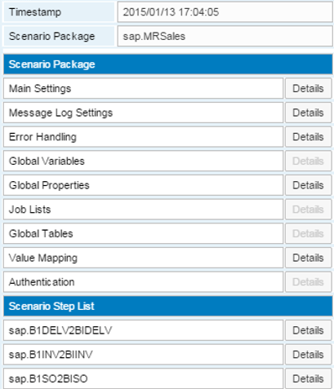

[Open XML]

To display an XML document containing all scenario package information, click the button.

[Details]

To display details, click the button.

The integration framework displays scenario package details about main settings, message log settings, error handling, global variables, global properties, job lists, global tables, value mapping and authentication.

For the scenario steps you can display the definitions for the inbound, processing and outbound phase, information about local variables, consistency checks, and you can display the process flow. If a scenario package does not use, for example, global properties, the integration framework displays this entry in grey and it is not possible to click the [Details] button.

[Docu]

The integration framework supports providing documentation for scenario packages. Create a document and use the control center to save to document to the BizStore. Provide the document in pdf format, call it vPac.pdf and save it to the base directory of the scenario package:

/com.sap.b1i.vplatform.scenarios.design/vPac.*<name>*/vPac.pdf

For information about uploading documents, see the *Development Environment Guide*, section *Document Handling, Uploading a Document*.

You can generate a document based on the definitions (*Scenarios*→*Package Design* →[*Tools*]→ *Generate documentation*). If both documents exist, a dropdown list opens that allows you to select the document.

[Status]

To display the status of processes that run for the scenario package, click the button.

The integration framework displays scenario steps with an entry for each sender and receiver system:

* The green icon indicates that the process is set up.
* The yellow icon indicates a generic process that other scenario packages use, but not necessarily the selected one.
* The red icon indicates a deactivated process.

For an active scenario package, all icons should be green. For a deactivated scenario package, there are red and potentially yellow icons.

For asynchronous inbound processing, there are three processes handing over the message using the internal queuing mechanism. The integration framework displays three icons in one line. For synchronous processes, the integration framework displays only one icon. For outbound processing there is only one process involved.

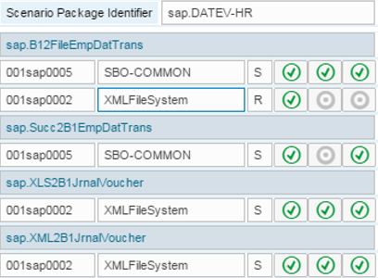

[Overview]

To open a window displaying scenario steps belonging to a scenario package, click the button. Each line represents one scenario step. Icons represent the sender and receiver system types. For an asynchronous scenario step, the integration framework displays the inbound, processing and outbound processing phases. For a synchronous scenario step, the integration framework displays the inbound and processing processing phases.

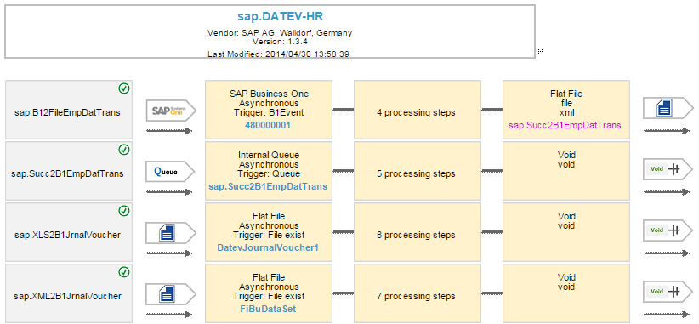

Inbound

The inbound box represents the inbound channel, the communication mode (asynchronous or synchronous), the trigger and the event identifier. To go to the scenario package inbound design window click the box. Closing the window after changes in the design, updates the information in the overview. For more information about scenario step inbound design, see the *Scenario Development Guide*, section *Developing a Scenario Step, Inbound*.

Processing

The processing box displays the number of process steps. To open the graphical flow designer, click the box.

For more information about the graphical flow designer, see the *Scenario Development Guide*, section *Developing a Scenario Step, Processing*

Outbound

The outbound box displays the outbound channel, adapter, data handover details and the successor scenario step, if it exists. To go to the scenario step outbound design window, click the box. Closing the window after changes in the design updates the information in the overview.

For more information about scenario step outbound design, see the *Scenario Development Guide*, section *Developing a Scenario Step, Outbound*.

[Reports]

To display further details about a scenario package, click the button. For deactivated packages, the integration framework opens the *Setup Details* report. For active scenario packages, select one of the following reports:

* Setup Details
* Setup Report
* Activation Report

For more information, see section *Activation and Deactivation*, section about reports

[Setup]

To open the user interface, click the button.

For more information, see *Setting Up Scenario Steps*

[Trigger]

To display triggers for scenario steps, click the button. The integration framework only displays triggers for active scenario packages.

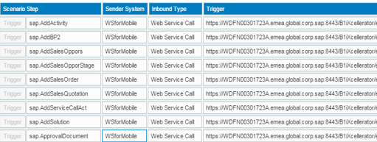

The trigger of a scenario step depends on the inbound definition. For SAP Business One systems, the integration framework displays the B1 event triggering the step. For scheduler-based scenario steps, the integration framework displays the timer. For scenario steps, triggered by internal queue, the integration framework displays the name of the queue and the stream. For scenario steps, triggered by file, the integration framework displays the directory and the file pattern. For steps triggered by incoming HTTP calls, for example Web services, the integration framework displays the URL the system calls to trigger the process.

note.gif NOTE

If the integration framework identifies your scenario step by URL parameters, add them to the URL.

If a timer triggers the scenario step, you can manually trigger it here. You can only trigger an active scenario step.

[Check]

To run the consistency check for scenario steps assigned to a scenario package, click the button.

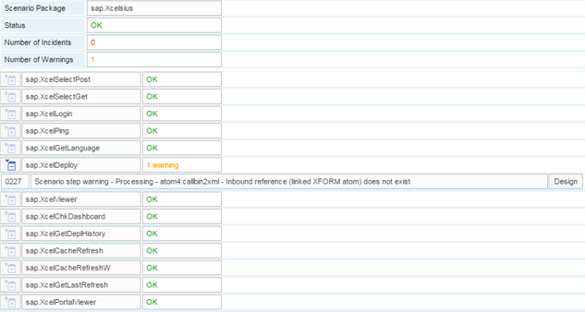

The integration framework displays the scenario steps. The right column displays the result of the consistency check.

If there are warnings or incidents, expand the section to display incident messages. The integration framework displays each incident message with the number and the incident text. To resolve the incident, click the [Design] button. The integration framework navigates to the correct place.

## 1.3 Running Reports for Scenario Packages

To get an overview of the integration framework, the available scenario packages, scenario steps, objects that trigger scenario steps and so on, you can run reports that give you detailed information.

To generate and display reports, choose *Scenarios*→*Reports*.

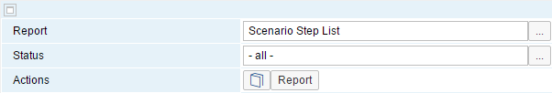

Report

The following reports are available:

* Scenario List (This is the default.)
* Scenario Step List
* Object List
* Sender Object List

Status

Filter reports by status. The default is no filter (- all -). To set a filter, click the […] button to select the status. The following options are available:

* all
* design
* active

[Report]

To generate and display the report, click the button.

Scenario List

The report displays the control list of scenario packages. For more information, see section *Controlling Scenario Packages*

Scenario Step List

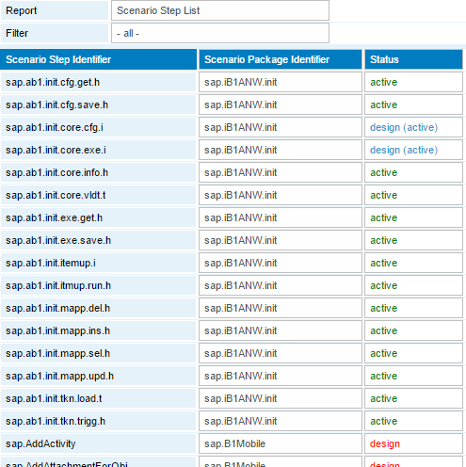

The scenario step list displays all scenario steps, sorted by step identifier. For each scenario step, the integration framework displays the scenario step identifier; the identifier of the scenario package and the current status of the scenario step.

The step has the design status, if the scenario step is in the design phase. The status is design (active), if the scenario package is active, but the scenario step is not active. The status is active if the scenario package and the scenario step is active.

Object List

In the integration framework, object is a general term for the entity that triggers a scenario step. An object can be an event, linked to a business object change, it can be a time interval of a scheduler, and it can be the existence of a file in a defined directory of the file system, a value of a URL parameter, and so on.

The object list gives you the option to check which objects trigger which scenario steps. This gives you an overview, especially if you are not familiar with the scenario.

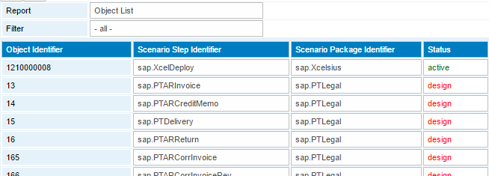

The integration framework sorts the list by the object identifier. The integration framework displays the object identifier, the scenario step name, the scenario package identifier and the current status of the scenario step.

The list helps you in the following cases:

* An incoming call ends in a filtered message due to missing subscribed scenario steps. Check if a scenario step exists for the relevant object. This can for example be an incoming event for a business partner change from SAP Business One.
* Using the report, you can identify, if multiple scenario steps are subscribed to the same object (event). The integration framework technically allows it. Consider whether this makes sense from the business logic point of view, especially if scenario packages are provided by different partners.

The above example indicates that there are two scenario packages in the integration framework triggered by changes of object 13, which indicates changes in the business object Invoice of the SAP Business One system.

Sender Object List

To list all objects (events) from all sender systems with assigned scenario steps, use the *Sender Object List*.

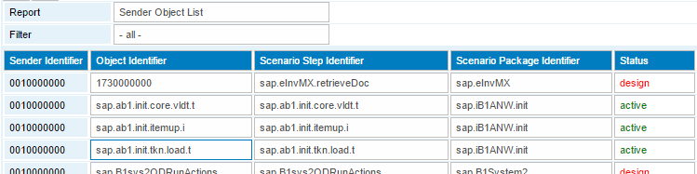

The list is in alphabetical order (sender and object). For each sender object and event combination, it displays the subscribed scenario step, the scenario package and the status of the scenario step.

The list helps you to identify incoming calls from a sender system that end in a filtered message due to missing subscribed scenario steps. Check if a scenario step exists for the object (event). The object can for example be an incoming event for a business partner change from SAP Business One. The status indicates, if the scenario step is active. Only active scenario steps process messages. If you find sender object combinations with active scenario steps, where the sender is missing, deactivate the scenario package, add the missing sender system to the sender list and activate the scenario package again.

## 1.4 Importing and Exporting Scenario Packages

The integration framework allows importing and exporting scenario packages using the zip format. Each scenario package is one zip file including the package definition, optionally the authorization concept and all scenario steps including inbound and outbound definitions and the processing logic. You can also import or export scenario steps. If the scenario package is assocatied to a business process, the business process definitions are included in the import and export.

### 1.4.1 Importing a Scenario Package or a Scenario Step

To import a scenario package or step, choose *Scenarios*→*Import*.

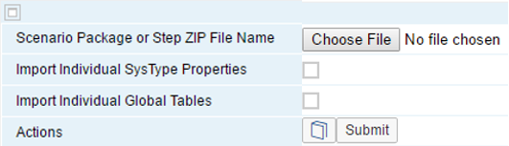

Scenario Package of Step ZIP File Name

To select the zip package from the file system, click the [Browse…] button. The zip file can contain a scenario package or a scenario step exported by the integration framework export function.

Import Individual SysType Properties

If the scenario package that you want to import contains individual SysType properties for sender and receiver systems that are relevant for your integration scenario, select the checkbox. During import, the integration framework merges the SysType properties with already existing ones.

Import Individual Global Tables

If the scenario package that you want to import is not yet available, you have the following options:

* Do not select the checkbox to import only the global table definition in the vTbl.xml document that is the prerequisite to generate the individual tables for the package.
* Select the checkbox to import individual global tables with values in addition to the table definitions in the vTbl.xml document.

If the scenario package that you want to import is already available in the integration framework, you have the following options:

* Do not select the checkbox to import only the global table definition in the vTbl.xml document. The import does not overwrite individual tables and values of the already existing package version.
* Select the checkbox to overwrite global table information of the already existing package version.

[Submit]

To start the import of the scenario package or step from the file system into the BizStore, click the button. The integration framework calculates the location, dataset and group, using information in the zip file.

Import Version Control

Import and export functions have an inbuilt version control. During export, the integration framework saves the version to the zip file. If a scenario package is active during import, the integration framework deactivates the scenario package. After import the integration framework activates the scenario package again.

**Importing a Scenario Step**

If you import a scenario step, the integration framework provides the following functions:

* Archiving the current version before import
* Creating a scenario package for the step
* Assigning the setp to a scenario package

During import, the integration framework compares the version in the zip file with the current version in the integration framework. The following cases are possible:

| **Package Import** | **Description** | |
| --- | --- | --- |
| Scenario package not available in the integration framework | To start import, click the button. | |
| Scenario package available with the same version | To start import, click the button.  The integration framework overwrites existing documents without notification. | |
| Scenario package available with a higher version | To start import, click the button.  The integration framework overwrites existing documents without notification. | |
| Scenario package available with lower version | To start the import, click the button.  The integration framework overwrites existing documents without notification. | |
| Scenario step is not assigned to any scenario package and is not available | To start import, click the button.  To assign the scenario step to a scenario package, select *Assign to Scenario Package*, and select a scenario package. | |
| Scenario step not available in the integration framework, but is assigned to a scenario package that is available in the integration framework | To start import, click the button.  The integration framework assigns the scenario step to the scenario package. | |
| Neither the scenario step nor the scenario package available | To start import, click the button.  To create a scenario package with the same identifier provided in the zip file, click *Create New Scenario Package and Assign Step*.  To adjust the package definition, select *Scenarios* → *Package Design*. | |
| Scenario package and assigned scenario step available | | To start import, click the button. The integration framework overwrites existing documents without notification.  A scenario package already exists with the same version in the integration framework. To archive the version before import, select Archive Current Version.  The integration framework assigns the scenario step to the scenario package. |
| Scenario step available and assigned to a scenario package, but the scenario step in the integration framework is not assigned to a scenario package | | To start import, click the button. The integration framework overwrites existing documents without notification.  The scenario package is available with the same version in the integration framework. To archive the existing version before import, select Archive Current Version. This is the default setting.  The integration framework assigns the scenario package to the scenario package. |
| Scenario step available and assigned to a scenario package; scenario step in the integration framework is not assigned to a scenario package | | To start import, click the button. The integration framework overwrites existing documents without notification.  The scenario package is available with the same version in the integration framework. To archive the existing version before import, select Archive Current Version. This is the default setting.  To create a scenario package with the same identifier, click Create New Scenario Package and Assign Step.  To adjust the package definition, select *Scenarios*→*Package Design*. |
| Scenario step available; scenario step is not assigned to any scenario package | | To start import, click the button. The integration framework overwrites existing documents without notification.  The scenario package already exists with the same version in the integration framework. To archive the existing version before import, click Archive current version. |
| Scenario step avalaible; scenario step is not assigned to a scenario package, scenario step in the integration framework is assigned to a scenario package | | To start import, click the button. The integration framework overwrites existing documents without notification.  The scenario step already exists with the same version in the integration framework. To archive the existing version before import, click Archive Current Version. This is the default setting.  The integration framework assigns the scenario step to the scenario package. |

After import, the integration framework displays the list of documents imported to the BizStore.

### 1.4.2 Exporting a Scenario Package or Scenario Step

To export a scenario package or a scenario step, choose *Scenarios*→*Export*.

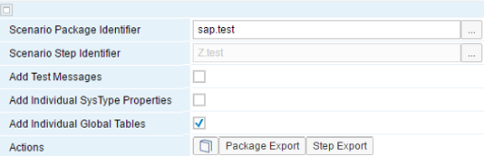

Scenario Package Identifier

To select a scenario package for export, click the […] button.

Scenario Step Identifier

To select the scenario step you want to export, click the […] button.

Add Test Messages

If you want to add test messages to the export, select the checkbox.

Add Individual SysType Properties

If you have defined individual SysType properties for system types that you use as sender or receiver systems in your scenario package, you have the option to export property definitions with the scenario package. The integration framework exports the SysType properties and adds then to the com.sap.b1i.vplatform.directory folder in the export file. During import, the integration framework merges the SysType properties with already existing ones.

Add Individual Global Tables

If you do not select the checkbox, the export contains the global table definition in the vTbl.xml document. To also export the generated global tables with values, select the checkbox.

[Package Export] and [Step Export]

To start the export of a scenario package or several packages to the file system, click the button.

If you do not select a scenario package, the integration framework displays scenario packages available in the integration framework.

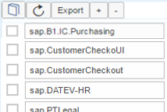

[+][-]

Select a package. To select all packages, click [+]. To deselect all packages, click [-].

The integration framework collects all documents and adds them to Scenario_Export.zip. The standard operating system dialog opens to save the file to a location in the file system.

To start the export of a scenario step to the file system, click the [Step Export] button. The integration framework collects all documents and adds them to a zip file. The standard operating system dialog opens to save the file to a location of your choice in your file system.

To save the zip file to a location in your file system, click [Save].

**Business Process and Scenario Export**

If a scenario package is associated to business process, the export function also exports all business process-related documents.

# 2 Monitoring

To analyse the integration framework runtime, the integration framework provides monitoring of messages and processes. You have various options to analyze even the smallest details.

note.gif NOTE

All time-related information in setup, processing and monitoring of integration framework messages; such as message log timestamps or scheduler timer setting, comes from the integration framework server and its local time zone.

## 2.1 Message Logs

### 2.1.1 Introduction

Message logs give you an overview of messages processed by the integration framework. Logs help you to track messages, to find errors that occurred, and help you to establish what caused the errors. When messages enter the integration framework, the framework starts writing message logs and updates message logs during message processing. If you only need the information of the final message log, select *Final Message Log Only* in the *Message Log Handling* user interface of the *Maintenance* menu.

You can select different log levels. The log levels define, which parts of the processed message the integration framework logs. If you switch the message log on, you can select to log the infoset, the full message, or the full message including binary *data*.

If you use the VOID outbound option, messages are only displayed in the message log, if you define something in the final transformation atom (atom0).

**Indexed Access to Message Log Information**

Message logs are documents in the BizStore. As of integration framework version 1.20.0, the integration framework provides indexed access to message log information. If the MSGLOG table is available, the integration framework starts writing index information to the table. The installation of the integration framework creates the table. The IFDBUSR provides access to the table. The user has the permission to select, update, insert, and delete records in the MSGLOG table. As of integration framework version 1.21.0, the integration framework uses the message log with indexed access by default.

For more information, see the *Operations Guide 2*, section *Configuring the Message Log*

**Message Log Settings in the Productive Environment**

For a productive environment, we recommend switching off the message log or to use it with the lowest infoset level. If you switch off the message log, the integration framework still logs errors that occur. If you enable the message log, define the automatic deletion of message logs in the Message Log Handling function of the Maintenance menu. The integration framework removes debugging information by the automatic garbage collection without further configuration.

For a productive environment, we recommend switching off the generation of debugging information, because it can have an impact on the integration framework performance. The default settings for log levels in xcellerator.cfg are set to SEVERE.

**Message Log Settings in the Development Environment**

If you develop new scenario steps in your dedicated development system, switch on the message log and log the complete message.

In addition to log information, you can enable the generation of debug information. If you work in the design phase, switch debugging on. Switch debugging off to run performance tests. Debugging supports troubleshooting, if an error occurs at runtime. Debugging allows you to access the most detailed processing information.

To switch debugging on, set the log levels in xcellerator.cfg to CONFIG, choose *Monitoring* → *Process Control*, and select the process you want to debug. For more information, see section *Process Control*

An inbuilt garbage collector regularly removes debugging information from the integration framework.

As of integration framework version 1.22.1, you can define settings for a production and for a development system in the *System Information* user interface of the *Maintenance* menu. The function also enables you to switch from production to development profile.

**Garbage Collection**

The integration technology provides garbage colletion jobs that run regularly.

* Queue garbage collection
* Transaction log garbage collection
* BizStore garabge collection

A message put in internal queues triggers the garbage collections. The integration technology performs garbage collections message block by message block. Triggered by the message, garbage collection works on the first block. After completing the block, the garbage collections push the message back to the first position of the queue. The message triggers garbage collections again that start working on the next block. You can observe the message in the queue monitor and have the impression that the message blocks the queue. This is not the case. The message changes each time the collectors push it back to the queue.

To change the timer of garbage collections jobs, see the Operations Guide Part 2

### 2.1.2 Selecting Message Logs

**Prerequisites**

* You have switched on the message log.
* If you have switched on the message log, we recommend scheduling the automatic daily deletion of message logs. The integration framework deletes debugging information using the inbuilt garbage collection.

For more information, see section *Configuring the Message Log*

To open the message log, choose *Monitoring*→*Message Log*. The integration framework displays the following message log filter options:

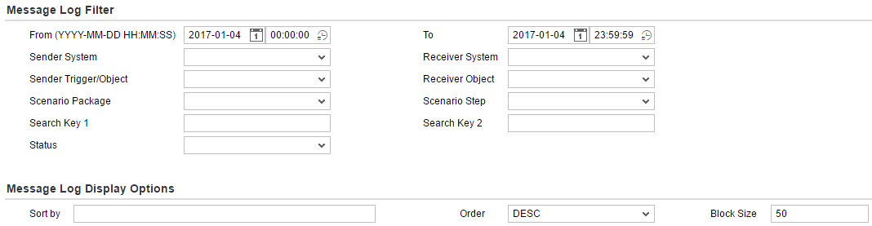

From / To

Select or enter a date and a timestamp.

Sender System. Receiver System

Select a sender and receiver system from the list.

Sender Trigger/Object

Select an identifier for an entity that triggers message processing. The entity can be an object identifier or a trigger. The selection list displays triggers and objects defined in the scenario packages definitions that are part of your integration framework. You can select objects or triggers of active scenario packages or scenario packages in design mode.

Receiver Object

Select an identifier for a receiver object. The selection list displays triggers and objects defined in the scenario packages definitions that are part of your integration framework. You can select objects or triggers of active scenario packages or scenario packages in design mode.

Scenario Package, Scenario Step

Select a scenario package and a scenario step from the list.

Search Key 1, 2

For each scenario step, you can define two search keys. Search keys are XPath expressions that point to the values in messages you want to search for.

To define search keys, choose Scenarios → Package Design, click [Definitions] and select Message Log. In the Scenario Message Log user interface, click [Search Key].

For more information, see the *Scenario Development* guide, section *8.2 Defining the Individual Message Log Step for the Scenario Package*

Status

Select the message status. Message processing always starts with the Processing status, followed by Success or Failure, or Filtered.

Filtered messages are messages that no scenario step has subscribed to, or messages that the processing logic has filtered.

If you have selected the Final Message Log Only option in the Configuration Message Log function, the integration framework does not display messages with Processing status.

**Message Log Display Options**

Sort by

Click the field to display the options.

Select the fields you want to use to sort the message log list.

Order

Sort the entries ascending or descending by start time. The descending order is the default.

Block Size

The integration framework displays the default block size set in the *Message Log Configuration* function. You can overwrite the default. The block size is the number of messages the integration framework displays on one page.

Collapse/Expand  

To collapse or expand the message log filter and display options, click the icon in the upper right corner.

### 2.1.3 Displaying Message Logs

To display the message log list, choose *Monitoring*→*Message Log* and click [Display/Refresh]. The integration framework displays the message log list. The example below displays the failure section of the message log.

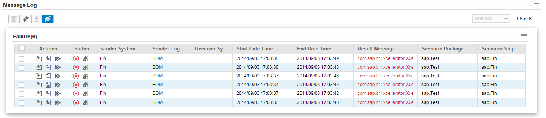

**Message Log Functions**

| **Icon or String** | **Description** |
| --- | --- |
| Select/Deselect | To select or deselect all messages, click the checkbox in the header.  To select or deselect single messages, click the checkbox in front of the row. |
|  | To delete selected messages, click the icon. |
|  | To delete imported messages, click the icon. |
|  | To export selected messages, click the icon. |
|  | To display or hide columns, click the icon and select or deselect the column names. If you hide columns, the integration framework displays the blue icon. |
| Page Numbers | Click the page numbers or the arrows to browse pages. |
| View | On the right side, select the view of the message log.   * List   Displays message logs in a list.   * Grouped   Groups message logs by *Success*, *Failure*, *Processing* and *Filtered*.  You can set the default in the configuration of the message log. |

**Actions in the Message Log List**

| **Action** | **Description** |
| --- | --- |
|  | Opens the transaction ID panel for debugging |
|  | Displays the message |
|  | To resend the message, select the icon. Use this function in your scenario package development environment.  caution.gif CAUTION  Do not use the function in a productive environment. In a productive environment, use the retry mechanism of the error inbox. |

**Status Information for Messages**

| **Status Icon** | **Description** |
| --- | --- |
|  | Success |
|  | Success. At runtime the message had the INCOMMIT status at a time. To display details, click the icon. |
|  | Failure |
|  | Failure. At runtime, the message had the INCOMMIT status at a time. To display the details, click the icon. |
|  | Filtered |
|  | In processing |
|  | Internal log message, message of the local integration framework |
|  | Imported log message, message of another integration framework |

### 2.1.4 Displaying the Flow Analysis

The flow analysis monitor or transaction ID panel displays all process steps or transactions that the integration framework performs for a message. To open the monitor, choose *Monitoring*→*Message Log*, click [Display/Refresh] and click the  (Debug Message) icon.

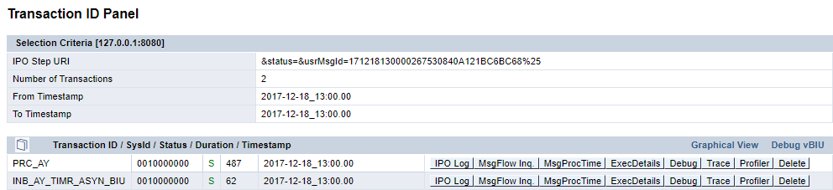

The monitor displays the message flow from bottom to top. In the example above, the start process is INB_AY_TIMR_ASYN_BIU. It defines a timer-triggered inbound. This process triggers the PRC_AY process that handles the processing phase of the scenario step. Each process is a transaction on B1iP level.

For more information, see the *Scenario Development Guide*, appendix A, *Table of Inbound Channels*.

For each process, you can click several buttons to obtain further details. The most important button for troubleshooting is the [Debug] button.

[IPO Log]

The Inbound, Processing, Outbound (IPO) log provides detailed processing information. To display the information, it is a prerequisite that the integration framework has generated detailed log information. If an error or exception occurs, you find error information and the call stack at the end of the list.

[MsgFlow Inq.] (Message Fow Inquiry)

If process flows are complex, different scenario steps subscribe to a message and send data to multiple receiver systems with optional multiple receiver messages, the processing in the integration framework results in a tree. Using the message flow inquiry information, you can follow the tree on low level, starting with the first step and then moving from successor to successor. For each step, you can display the flow analysis.

[MsgProcTime] (Message Process Time)

Display a process and the processing time. The integration framework also displays follow up steps including execution details.

[ExecDetails] (Execution Details)

To display step execution details in one document, click the button. You can search for steps; display inbound parameters and the inbound message for all steps. You can access the same information clicking the [Debug] button to display execution details in a graphical representation.

[Debug]

To open flow debugging, click the button. You can display the process flow and call information for subflows. The integration framework displays the processing duration and the size of the inbound message for each step. You can display the inbound message for each atom. For more information, see section *Debugging the Flow*

[Profiler]

The profiler allows you to check potential performance issues. The integration framework displays the following information:

* All process steps with processing details sorted by duration.
* Internal database interactions sorted by duration
* The size of the inbound message sorted by size for all process steps.

[Delete]

To delete the log entry, click the button. If the transaction is still running with either the INCOMMIT or INROLLBACK status, the integration framework cancels the transaction.

Graphical View

To display the processing logic in a graphical representation, click the button.

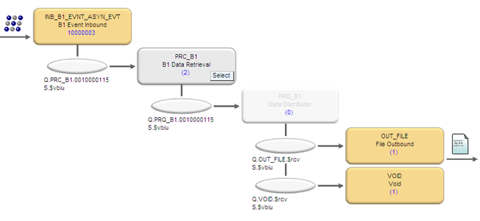

The integration framework displays the start point of message processing in the upper left corner. The integration framework triggers the inbound processing step and displays the channel identifier (INB_B1_EVNT_ASYN_EVT), the channel name (B1 Event Inbound) and the trigger or object ID (10000003). The message is handed over to an internal queue where the PRC_B1 processing step picks up the message, and so on. Finally, the integration framework uses the file adapter to write a file. To display the BizFlow for the processing steps, click the rectangle.

Synchronous Processing

Synchronous process flows have only one process step. They send back the response to the caller. The integration framework processes your individual scenario step inside this process step.

Asynchronous Processing

Asynchronous process steps hand over the message to subsequent process steps using internal queues. The queue monitor allows you to display messages in internal queues. In the picture, the integration framework displays the name of the queue and the stream (sub queue). Further processing depends on the scenario packages in your environment. For each scenario step subscribed to the incoming message, a process step (PRC_*) is available. If there is more than one step, the rectangle is grey. To select the scenario step you want to debug, click [Select]. The integration framework processes your own scenario step inside this process step and displays it in the following way:

If there is only one receiver system, the integration framework leaves out the distribution step. The integration framework indicates this with a white rectangle. If there are multiple receiver systems, click [Select] to select the receiver system processing, you want to debug.

The last process step is the outbound to receiver systems. If there is one receiver object, the rectangle is coloured, otherwise it is grey. To select the receiver object processing, you want to debug, click [Select].

To display the flow debugger, click a coloured rectangle. For more information, see the next section

Debug vBIU

To display the individual processing phase of the scenario step, click the link.

### 2.1.5 Debugging the Flow

The flow debugger is a graphical tool that displays the process flow of the integration framework. The process flow is called BizFlow. A BizFlow is one transaction and one step in the message flow.

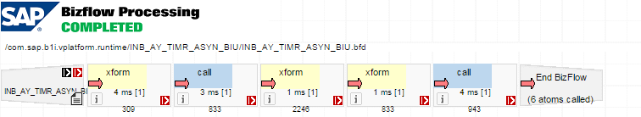

**Prerequisites**

To use flow debugging, you have switched on the generation of debugging information.

* In Xcellerator.cfg the log levels are set to CONFIG.
* To enable detailed debugging, choose Maintenance → Cfg Dev Environment, in the Activate Scenarios with Detailed Logging field, select 1 – Switch on Step Debugging or 2 – Switch on Full Debugging, and deactivate and activate running scenarios.

Step debugging only provides debugging information for the processing phase of your scenario steps, not for the integration framework processes. Full debugging provides debugging information for all processes.

* Alternatively, switch debugging on or off or enable step debugging in the integration framework choosing Monitoring → Process Control and click the [Debug Full], [Debug Step] or [Debug Off] button. The setting is valid until the next reactivation.

**Flow Debugging User Interface**

On the top of the user interface, the integration framework displays the transaction status.

* STARTED

The integration framework started the transaction.

* INCOMMIT

The integration framework finished the transaction and waits for commitment by adapters.

* INROLLBACK

The transaction failed and is in the roll back phase.

* COMPLETED

The integration framework successfully finished the transaction.

* CANCELED

The integration framework finished the transaction with an exception.

To display process overview data, such as the duration time, the size of the incoming message, the maximum size of the message during processing, the size increase in per cent and the timestamp of processing, click the transaction status.

This integration framework displays the following information:

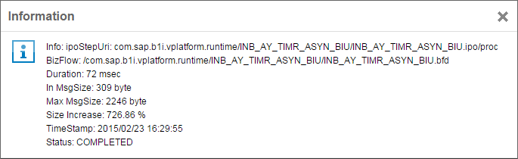

The *BizFlow Processing* user interface displays the main flow. The integration framework displays the flow functions (atoms), as a pictogram. The *Include* and *vBIU Call* flows call subflows. To open the subflows, click the pictogram.

For more information about the BizFlow language, see the *Scenario Development Guide*; section *Processing*, *The BizFlow Language*.

Each pictogram of an atom provides the following information:

* The red arrow indicates that the integration framework has processed the atom. To display the inbound XML document for the atom, click the red arrow.

If an exception occurs at runtime, the BizFlow processing helps you to identify the location. It is the last step with a red arrow in the flow. If the arrow is grey, you enabled step debugging.

* To open information about the atom, click the i icon. The displayed information depends on the atom type. For an xform atom, display the XSL style sheet the integration framework has called. For a PATH atom, display the condition.
* xxxx ms [n] nnnn provides analytic processing information. xxxx displays the processing duration in milliseconds. [n] displays the number of calls of the atom and nnnn displays the size (in byte) of the inbound document of the atom.
* The flow debugger displays your individual development in the following way:



* If you click, for example, a call atom, the integration framework displays the call atom definition on B1iP level.

### 2.1.6 Displaying Last Exceptions

To display a list of process steps that ended with an exception during last processing, click the [Last Exception] button.

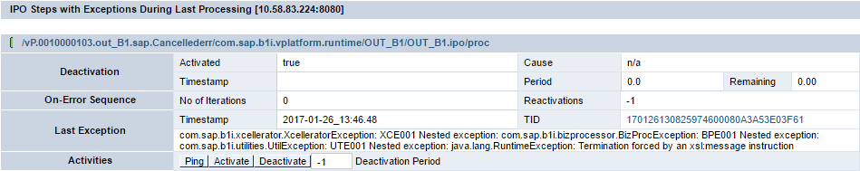

You can do the following:

[Ping]

To test whether connections are available for the process step, click the button.

[Activate], [Deactivate]

To activate or deactivate the process step, depending on the current status, click the [Re-activate] or [De-Activate] button. For information about activation or deactivation of process steps, see section *Process Control*

TID (Transaction ID)

The field displays the transaction ID of the failed message. To open the flow analysis, click the link. For more information about flow analysis, see section *Displaying the Flow Analysis*

### 2.1.7 Exporting and Importing Message Logs

**Exporting Message Logs**

In the message log, you can export messages including detailed debug information, if you have switched on detailed debugging.

**Procedure**

1. Select the message you want to export and click the  *Export* button.
2. Save the collectdebuginfo.zip file to a folder.
3. Provide the file to the support organization, or a partner. The information enables them to analyse issues related to the message.

**Result**

The collectdebuginfo.zip file contains the following information:

* The com.sap.b1i.xc.iodata dataset contains all transaction information.
* The com.sap.b1i.vplatform.tmp dataset contains information about the scenario package, and the scenario step that has created the message. The information enables the integration framework, where you import this message, to display detailed debug information.

**Importing Message Logs**

Use the *ZIP Import* function to load the message into the integration framework.

For more information, see the *Scenario Development Guide*, section *Importing a ZIP with Multiple Documents*

note.gif NOTE

To display the imported message log, the integration framework must have at least version 1.19.3.

### 2.1.8 Analyzing Imported Message Logs

note.gif NOTE

* The display of imported messages does not depend on settings for the message log and debugging in your integration framework.
* You can delete imported message logs exactly like other message logs.

**Differences in the Message Log List**

In the message log, you can distinguish imported from other messages in the following way:

* The *Export* button is greyed out.
* The *Retry* button is disabled.
* For imported messages, the integration framework displays the SysId in brackets for the sender and receiver system, because the names are unknown. The SysIds are the ones from the integration framework, where the message has been exported from.
* If you click the *Message* icon to display the message, the imported message has the following additional attribute: externalmsg="true"
* To debug the message, click the *Debug* button.
* The integration framework opens the Transaction ID Panel.

**Differences in the Transaction ID Panel**

* Next to *Selection Criteria*, the integration framework displays *External Message*.
* Click the *Message* link to display the following information:
* Message identifier
* Scenario step identifier
* Scenario package identifier
* Processing start and end time
* Export time
* Version of the integration framework source system
* Development prefix of the integration framework source system
* Development name of the integration framework source system
* To display the above information in XML format, click the *XML* link

The following functions are not available:

* [MsgFlow Inq.] (Message flow Inquiry)
* [MsgProcTmng.] (Message Process Timing)
* [Delete]

## 2.1.9 Tracing

##B1iP

## 2.2 Displaying Error Inbox, Processing Errors and Technical Errors

### 2.2.1 Using the Error Inbox

The integration framework provides an error inbox for each receiver system. If an error occurs while the integration framework tries to hand over a message to a receiver system, the integration framework removes the message from the processing queue (Q.Out_*) and puts the message into the error inbox. In the error inbox, you have the option to resend the message or to delete it.

In the outbound phase, it is not unusual that errors occur:

* There can be problems with the connection to the receiver system.
* A receiver system is not available.
* A receiver system rejects data, because data mappings are wrong, references are missing in the receiver system, or plausibility checks for the business logic of the receiver system fail.

If an exception happens in a synchronous call, the integration framework cancels processing with an HTTP error or SOAP fault. In asynchronous processing, an error **in internal process steps** causes the process to cancel the currently running transaction and enforces a rollback. The integration framework moves the message to an internal queue. The integration framework stops processing and activates processing again after one minute, trying to resend the message.

The behaviour for all outbound process steps is different, because all outbound steps directly interact with the receiver systems. The error inbox provides a function to resend messages to the receiver system.

To open the error inbox, choose Monitoring → Error Inbox.

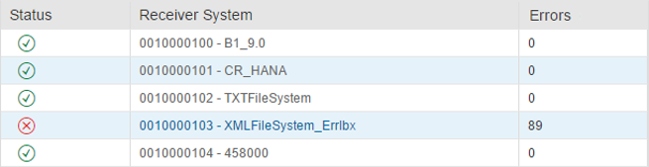

The integration framework displays one entry for each receiver system in SLD. If an error occurs, click the link to display further details.

Status

The integration framework displays a green icon, if there are no messages in the error inbox. If there are messages in error status for a receiver system, the integration framework displays a red icon and provides a link to the specific error inbox.

Errors

The integration framework displays, how many failed messages are available in the error inbox. To open the system-specific inbox, click the link. The integration framework displays all messages that it has been unable to deliver.

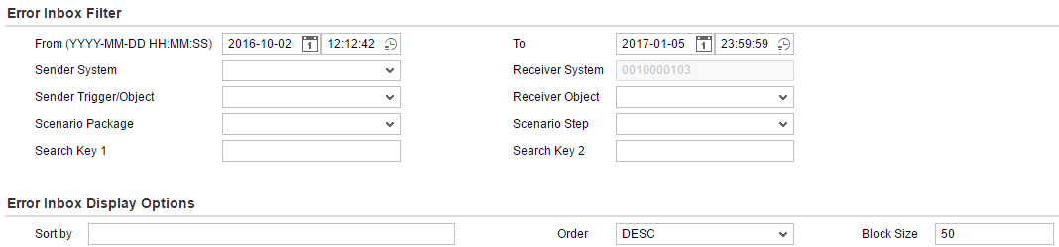

From / To

Select or enter a date and a timestamp.

Sender System. Receiver System

Select a sender system. The receiver system is set.

Sender Trigger/Object

Select an identifier for an entity that triggers message processing. The entity can be an object identifier or a trigger. The selection list displays triggers and objects defined in the scenario packages definitions that are part of your integration framework. You can select objects or triggers of active scenario packages or scenario packages in design mode.

Receiver Object

Select an identifier for a receiver object. The selection list displays triggers and objects defined in the scenario packages definitions that are part of your integration framework. You can select objects or triggers of active scenario packages or scenario packages in design mode.

Scenario Package, Scenario Step

Select a scenario package and a scenario step from the list.

Search Key 1, 2

For each scenario step, you can define two search keys. Search keys are XPath expressions that point to the values you want to search for.

To define search keys, choose Scenarios → Package Design, click [Definitions] and select Message Log. In the Scenario Message Log user interface, click [Search Key].

For more information, see the *Scenario Development* guide, section *8.2 Defining the Individual Message Log Step for the Scenario Package*

**Display Options**

Sort by

Click the field to display the options.

Select the fields you want to use to sort the message log list.

Order

Sort the entries ascending or descending by start time. The descending order is the default.

Block Size

The integration framework displays the default block size set in the *Message Log Configuration* function. You can overwrite the default. The block size is the number of messages the integration framework displays on one page.

  Collapse/Expand

To collapse or expand the message log filter and display options, click the icon in the upper right corner.

Each line displays a detailed result message. To expand the Result Message field, double-click the field. Click the Display or Hide Column icon to select the information you want to display in each line.

Select one or more messages for the following actions:

[Delete]

To delete selected messages, click the button.

 [Resend Message]

To resend a message, click the button.

### 2.2.2 Displaying Processing Errors

The integration framework provides several configuration options for error handling. For the combination of configuration settings that could potentially lead to a message loss, the integration framework writes the messages to the processing error table. Note that you can configure the garbage collection for the processing error table. For more information, see the Operations Guide 1, section Configuring the Garbage Collection for Error Information

**Example**

In the maintenance function for default error handling, you have selected the remove from queue and continue with next message option for Asynchronous Transaction – Processing. If you remove messages from the queue, it is the assumption that you use an individual error handling step on scenario package level that takes over the error handling. If you do not assign an individual error handling step, the integration framework writes the message to the processing error table.

To select and display processing errors, choose *Monitoring* → Error Inbox and select the Processing Errors tab.

From / To

Select or enter a date and a timestamp.

Scenario Package, Scenario Step

Select a scenario package and a scenario step from the list.

The monitor displays the following information:

| **Field** | **Description** |
| --- | --- |
| Checkbox | Select the message for deletion. |
| Actions | Display the XML message  After fixing the issue, resend the message. |
| Scenario Package and Scneario Step |  |
| Timestamp | Timestamp of processing error |
| Result Message | Error message. Click the link to display the complete message. |

### 2.2.3 Displaying Technical Errors

To display technical errors on IPO step level, choose *Monitoring* → Error Inbox and select the Technical Errors tab.

Technical errors happen before the integration framework hands over the message to the receiver system. The integration framework displays the IPO step where the technical error occurred, the timestamp and the error description.

## 2.3 Process Control

Process control displays the integration framework process steps (IPO steps) and allows maintaining settings for the steps. It also provides an entry point to message debugging. To open process control, choose *Monitoring* → *Process Control*.

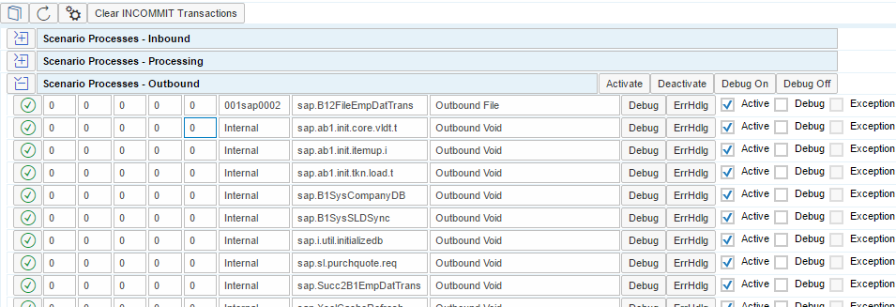

The process control list consists of the following sections, categorizing different process step types:

* Scenario Processes – Inbound
* Scenario Processes – Processing
* Scenario Processes – Outbound
* BPM Processes

For more information, see the Business Process Management guide

* Framework Processes
* Offline Client Processes
* Offline Server Processes
* Support Processes
* If you use the Intercompany Integration Solution for SAP Business One, you can display the processes here.

**Scenario Processes**

The scenario process sections display process steps that are part of active scenario packages. For standard operations, only scenario processes are relevant. The integration framework displays the process status. A green icon indicates that the IPO step is active, a red icon indicates that the step is inactive. The following fields display the number of transactions of the IPO step in the following order:

* Started transactions
* Transactions with INCOMMIT status
* Transactions with INROLLBACK status
* Cancelled transactions
* Completed transactions

The integration framework displays the IPO step name and a description of the IPO step type.

[Debug]

To open the flow analysis for the process steps of a processing time, click the button. The integration framework displays the latest transactions first.

note.gif NOTE

Note that detailed information is only available for a certain time interval, because a regular, automatic garbage collection is in place.

For more information about how to work with the flow analysis, see section *Displaying the Flow Analysis*

[ErrHdlg]

To open the error handling transaction for the step, click the button.

Activate

The *Activate* checkbox indicates the current IPO step status. You can change the status.

Debug

The *Debug* checkbox indicates the current IPO step status. You can change the status.

Exception

This *Exception* checkbox indicates, if an exception has occurred during last processing of the process step. The checkbox is always disabled. The next step processing overwrites the exception indicator.

**BPM Processes**

The integration framework displays active BPM processes and the internal processes of the business process engine.

In the BPM Processes section, the integration framework displays the active business processes with the following information:

* Number of started transactions
* Number of transactions with INCOMMIT status
* Number of transactions with INROLLBACK status
* Number of cancelled transactions
* Number of completed transactions

In the picture above, there is only one active business process.

The following business process engine-related processes are available:

* The timeout controller monitors and processes timeout settings for tasks
* The CleanUp process cleans up documents in BizStore after a business process instance is completed.
* The garbage collection main and worker processes perform the garbage collection for business processes.

[Debug]

To open the flow analysis for the process steps of a processing time, click the button. The integration framework displays the latest transactions first.

note.gif NOTE

Note that detailed information is only available for a certain time interval, because a regular, automatic garbage collection is in place.

For more information about how to work with the flow analysis, see section *Displaying the Flow Analysis*

[ErrHdlg]

To open the error handling transaction for the step, click the button.

**Framework Processes**

The section displays internal processes of the integration framework. Look into framework processes for troubleshooting. They give insight to internal processing.

**Offline Processing and Steps for Support**

Dedicated steps are additionally available for offline processing on the client and server and processes for support.

**Functions for Sections**

In each process section, several buttons are available. Clicking the button, you perform the function for all scenario process steps of the section. The following functions are available:

[Activate], [Deactivate]

To activate or deactivate all process steps in a section, click the [Activate] or [Deactivate] button.

note.gif NOTE

Activating or deactivating a process step is different from activating or deactivating a scenario package. If you activate a scenario package, you also activate all process steps for the scenario steps of the package. Here, you activate or deactivate a specific process step that is possibly valid for many scenario steps. All process steps are generic for all scenario steps of a specific type. For more information about the relationship between scenario package, scenario step and process step, see section *Activation and Deactivation*

[Debug Full], [Debug Off] [Debug Step]

Use the buttons to switch on or off the generation of detailed debugging information at runtime. During activation of a scenario package, the integration framework checks the configuration to switch debugging on or off. The debug step option generates debug information for your individual development, but not for processes delivered by SAP. The integration framework displays red arrows for your individual development and grey arrows for SAP process steps. For a productive environment, switch off the generation of debugging information, except for troubleshooting. If you work in the development environment, switch debugging on.

The following function is valid for all process steps:

 (Configuration)

To configure the display of process control, click the button.

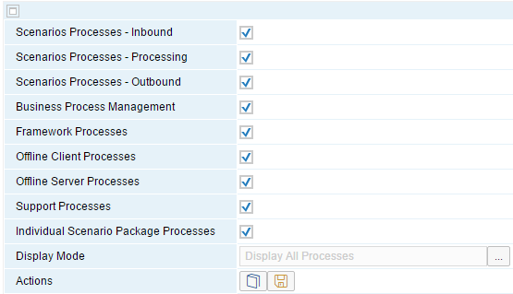

* Select or deselect the sections you want to display or exclude from process control.
* To only display processes for which transactions are available, select *Display Processes with Transactions*. By default, the integration framework displays all transactions.

[Clear INCOMMIT Transactions]

It is possible that the integration framework cannot close a transaction due to incorrectly working application APIs. In very seldom cases, it can happen that the transaction in the integration framework stays in INCOMMIT status waiting for the commit signal from the API. To enforce closing the transaction, click the button.

## 2.4 Monitoring Canceled Transactions

To display canceled transactions grouped by the error message, choose *Monitoring → Canceled Transactions*.

Note that it is may take some time to group the information, if there is a high number of canceled transactions in the system.



System ID

Scenario Step ID

If the transaction belongs to a scenario step, the integration framework displays the information.

Processing Step

The integration framework displays the internal processing step.

Count

Displays how many times the transaction was canceled

Error Message

Displays the error message

[Debug]

To open the transaction ID panel, click the button.

## 2.5 SAP Business One (B1) Event Monitor

To display events provided by SAP Business One company databases, use the SAP Business One (B1) event monitor. The event log is switched off by default. To switch on the event log and to display events, choose *Monitoring*→*B1 Event Monitor*.

### 2.5.1 SAP Business One Event Checks in the Integration Framework

If the SAP Business One event sender sends an event to the integration framework, the integration framework checks the following:

* Is the sender system part of the sender list for scenario packages.
* If the sender system is not part of any sender list, the integration framework writes the event to the *filtered* section.
* If the sender system is part of sender lists, the integration framework checks, if there are filter conditions available for the event.
* If there are no filter conditions available, the integration framework hands over the event to the integration framework target application.
* If there are filter conditions available and the event meets the filter conditions, the integration framework hands over the event to the integration framework target application for further processing.
* If the event does not meet the filter conditions, the integration framework writes the event to the *filtered* section.

### 2.5.2 Event Filter and Monitor

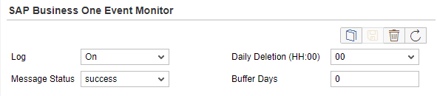

Log

Switch the creation of event logs on or off. The default is that the integration framework does not create logs (*Off*).

Buffer Days

Enter the number of days that you want to keep the log.

Daily Deletion (HH:00)

Set the hour of the day when the integration framework deletes B1 event logs.

Message Status

Select the messages you want to display. You have the following options:

* Success

Display events that the integration framework has successfully processed.

* Filtered

Display events that the integration framework has filtered, because the sender system is not part of any sender list, or the events have not met the filter criteria.

* Failure

Display events that the integration framework has failed to deliver. This can happen, if, for example, the scenario package or the scenario step is not active.

It can also happen that the IPO (Inbound, Processing, Outbound) step is not active. To check whether the IPO step is inactive, choose *Control Center* → *Monitoring*→ *IPO Step Status*. Select the *Deactivated steps only* and the *Exception on last execution* checkboxes and click the [Submit] button.



To delete the event log, click the button.



To search for log entries or to refresh the log entry list, click the button.

The integration framework displays the following information:

Source Company

The integration framework displays the name of the SAP Business One company database that has created the event.

Object ID

This is the object ID of the SAP Business One object.

Object Key(s)

The integration framework displays the key or keys ot the object.

Key Value(s)

The integration framework displays the value of the object key.

Send Date Time

This is the time when the event sender has sent the event.

For successfully forwarded events and failed events the integration framework additionally diplays the following information:

Target Host

This is the value that has been set in the event sender when installing the integration framework.

Target B1i Application

The target application is /vP.<sender_system>.in_BEAE/com.sap.b1i.vplatform.runtime/INB_B1_EVNT_ASYN_EVT/INB_B1_EVNT_ASYN_EVT.ipo/proc

<sender_system> is the SysId of the sender system

Error Message

For failed events, the integration framework displays the error message.

### 2.5.3 Editing and Resending Events in the Failure Section

If there is a data mismatch between SAP Business One company databases and integration framework information, you can edit the value of the target B1i application and resend the event.

When selecting events with failure status, the monitor offers additional functions.

* You can edit the target B1i application value.
* After correction, you can resend the event.
* Click the Retry All button in the monitor header line to try to resend all edited events
* Click the Timer Retry All button to set a timer for resending the events.



To change the target B1i application value:

* Click the *Edit* button.
* Enter the changes.
* Click the *Save* button.
* Click the *Resend* button.

## 2.6 Queue Monitor

Processing of asynchronous scenario steps consists of multiple internal process steps. The process steps hand over the message using the inbuilt queuing mechanism of the integration framework.

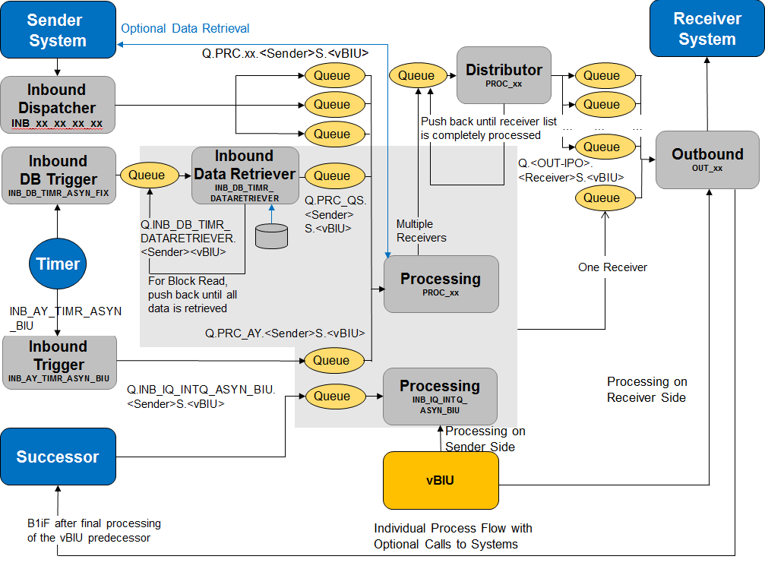

You can identify internal queues of the integration framework by the queue name and stream name. A stream is a sub queue.

The queue monitor allows you to check the current status in the internal queue. You can open or delete messages in a queue or stream. To open the queue monitor, choose *Monitoring*→*Queue Monitor*.



Due to fast processing, you typically do not see a message waiting in an internal queue. The example above shows the processing of an incoming B1 event; the first process step is completed. Two steps have subscribed to this incoming message. The inbound step places two messages, one for each scenario step, into the internal queue to trigger follow up processing. You can display this intermediate step when you deactivate the PRC step, for example. For more information, see section *Process Control*

Queues

In the first column, the queue monitor displays all existing queues containing at least one message.

Streams

To display all available streams in the second column, click the queue name. Together with the stream name, the integration framework displays the number of messages in the stream.

Messages

To display all available messages in the stream, click the stream. The integration framework displays the messages in the third column.

[Show]

To display a message, click the button.

[MsgFlowInq.]

To check the process that has created the queue entry, click the button.

[Delete]

To delete a message from the stream, click the button.

[Clear]

To delete the complete stream, click the button.

## 2.7 Call Monitor

The call monitor allows checking the last calls in the integration framework independent of the scenario context. It provides a technical view to investigate call-related issues. For troubleshooting, run your transaction and check the related calls in the monitor afterwards.

To display information in the call monitor, the integration framework runs through integration platform (B1iP) transaction information and displays all calls of the transactions. Calls happen in the inbound, processing, and outbound phase, during authentication and in the framework itself.

If you run a synchronous scenario step, for example, it consists of one transaction and displays two entries, plus optional additional authentication calls in the call monitor, if you do not define additional calls in the processing phase. Asynchronous scenario steps usually consist of three transactions, one for inbound, one for outbound, and one for the processing phase. If you choose the VOID outbound, the step consists of two transactions. If an asynchronous step has multiple receivers, a fourth transaction existis in the integration framework plus another outbound transaction per receiver. If you have multiple messages in the outbound phase, the integration framework creates an additional transaction per message.

**Prerequisites**

* For the production of call monitor information, you have set the following in xcellerator.cfg:

.level=CONFIG

com.sap.b1i.bizprocessor.level = CONFIG

com.sap.b1i.coordservice.level = CONFIG

com.sap.b1i.utilities.level = CONFIG

com.sap.b1i.dblayer.level = CONFIG

com.sap.b1i.xcellerator.level = CONFIG

* You have restarted the Integration Framework service. From this time on, you can display information in the call monitor.

To open the call monitor, choose *Monitoring*→*Call Monitor*.

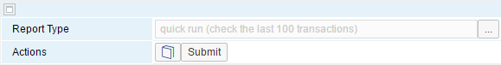

Report Type

Select the report type. You have the following options:

* quick run (check the last 100 transactions)
* midsize run (check the last 500 transactions)
* full run (unlimited)

Note that the garbage collections always keeps the last 3000 successful and the last 3000 failed transactions by default.

To change the default, choose Tools

[Submit]

To start the monitor, click the button.

The integration framework displays the following user interface that allows you to add selection options:

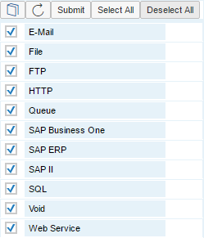

Checkbox

To select a call type, click the checkbox.

[Select All]

To select all call types, click the button.

[Deselect All]

To deselect all call types, click the button.

[Submit]

To start the call monitor, click the button.

The integration framework displays the following information:

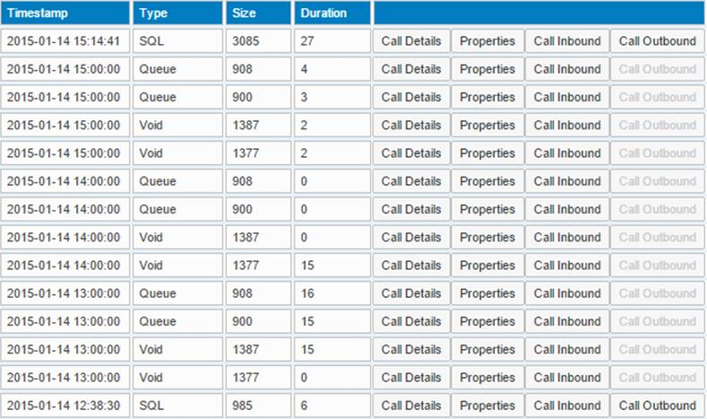

Timestamp

The integration framework displays the timestamp of the call.

Type

The integration framework displays the call type.

Size

The integration framework displays the size of the inbound message in bytes.

Duration

The integration framework displays the call time in milliseconds.

[Call Details]

The integration framework displays the following information, for example:

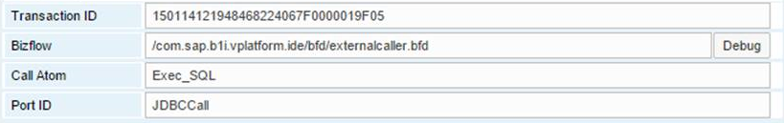

The integration framework always displays the transaction ID, the Bizflow, the call atom and the port ID. The values depend on the call type.

[Debug]

To display the BizFlow that contains the call, click the button. The integration framework displays the graphical flow designer in debug mode.

[Properties]

The integration framework displays the properties it hands over for the call.

The example below displays the properties of a queue call:

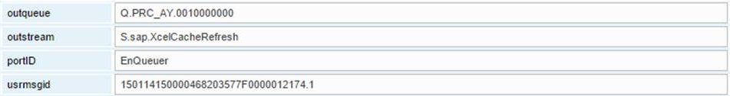

[Call Inbound]

The integration framework displays the inbound message for the call. This is an example for an SQL call:

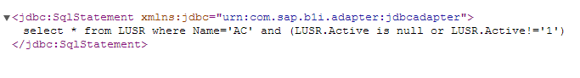

[Call Outbound]

The integration framework displays the information, the call returns.

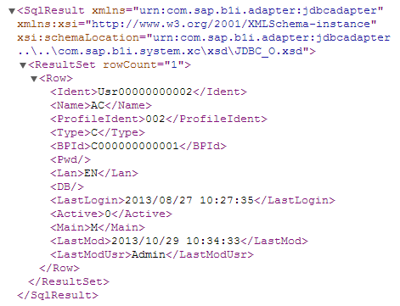

If the integration framework cannot display the information, the buttons above are disabled. For call type VOID or queue, for example, there is no outbound information available. If for an SQL call, for example, the inbound and outbound message information is missing, an error happened performing the call.

## 2.8 Audit Control Monitor

The audit control monitor displays information about changes in scenario design and scenario steps.

**Prerequisites**

You have configured the audit control monitor, choosing *Maintenance*→*Cfg Audit Control*.

For more information, see section *Configuring the Audit Control Function*

To display the audit control monitor, choose *Monitoring*→ *Audit Control Monitor*.

The integration framework displays the following information:

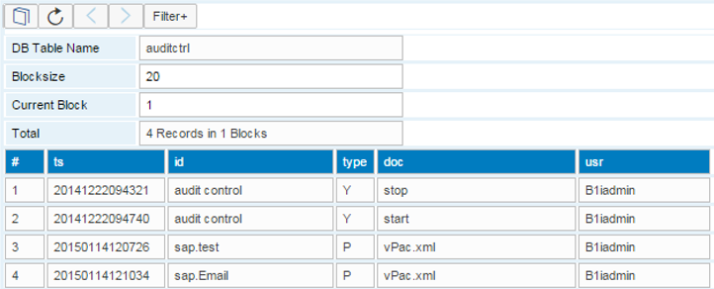

#

The integration framework displays the number of the record.

ts

This is the timestamp of record creation.

id

the field displays the identifier of the scenario package or scenario step that has been changed.

type

This field describes the type of change:

* P, if the changed document belongs to a scenario package
* S, if the changed document belongs to a scenario step
* Y, if the entry indicates that the audit control is switched on or off

doc

If the change affects a scenario package, the integration framework displays vBIU.bfd. If the change affects a scenario step, the integration framework displays the step identifier.

usr

The integration framework displays the user name of the user who has made the change.



To update the monitor, click the button.

[Filter+]

To define filter settings for displaying records, click the [Filter+] button. You can define filters for all fields the integration framework displays in the monitor.

## 2.9 Authentication Monitor

The authentication monitor displays authentication attempts for scenario packages that use a user-defined authentication for incoming HTTP calls.

**Prerequisites**

* You run scenario packages with a user-defined authentication. In the *Package Design* user interface, you have selected a user-defined authentication in the *Authentcation* field.
* You have enabled debugging in the integration framework.

To open the authentication monitor, choose Monitoring → Authentication Monitor.

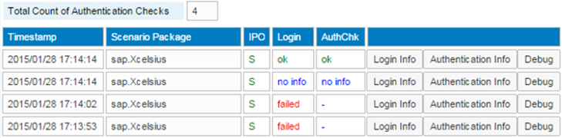

[Login Info], [Authentication Info]

To display login information, click the button.

The integration framework displays detaild login information, such as the claaer, the language, the SAP Business One server, the company database, the user and user ID, and so on.

The authentication information displays the result of the authentication and a message describing the result.

[Debug]

To open the debugging environment for the user-defined authentication, click the button.

## 2.10 Message Log History

If you have enabled the message log and you have configured the message log summary, the integration framework creates a message log history every day. It contains one record for the status, sender, receiver system and trigger combination. In the message log history, you can select and display the records.

**Prerequisites**

* You have switched on the message log.
* If you have switched on the message log, we recommend scheduling the automatic daily deletion. The integration framework deletes debugging information using the inbuilt garbage collection. the function currently does not delete the message log history.
* You have configured the message log summary (Maintenance→Daily Actions→Message Log Summary→[Config])

For more information, see section *Configuring Daily Actions*

To call the message log from the integration framework, choose *Monitoring*→*Message Log History*.

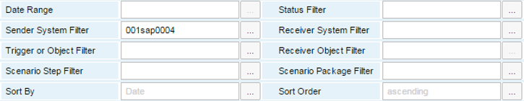

Data Range

Enter the data range for displaying the message log history.

To display all message log history information, leave the field empty.

Enter, for example, 1 to display the message log history from 2010-01-01 until today

Enter, for example, 08 to display the message log history for 2008.

Status Filter

Select the message status. Message processing always starts with the status processing and ends with success, failure or filtered.

Sender System Filter

Select a system from SLD.

Receiver System Filter

Select a system from SLD.

Trigger or Object Filter

Select an identifier for an entity which triggers the message processing. It can be an identifier for an object, for a trigger, and so on.

Receiver Object Filter

Select an identifier for an object for receiver systems.

Scenario Step Filter Filter

Select a scenario step from the list.

Scenario Package Filter Filter

Select a scenario package from the list.

Sort By

Select how the integration framework sorts the information.

Sort Order

Sort the information either ascending or descending.

The integration framework displays the following list:

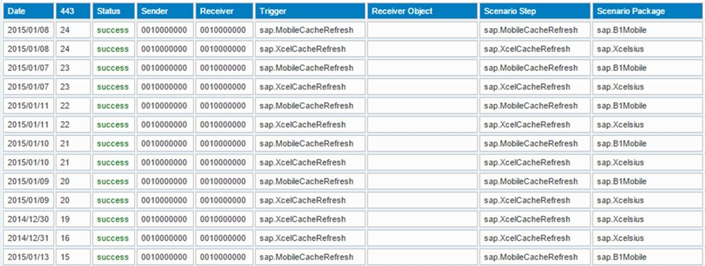

For each day it displays one line for the status, sender, receiver system and trigger combination.

## 2.11 BPM Monitor

For more information, see the *Business Process Management Guide*

## 2.12 Inbound Channel Namespace Report

In the inbound channel definition, you can define namespaces that uniquely identify elements and attributes of XML documents of your scenario step and package.

If you enter a namespace in the *Identification Namespace* field , the inbound channel definition function checks whether the prefix or namespace URI are already used by other scenario steps.

You cannot use a prefix with different namespace URIs or a namespace URI with different prefixes.

It is possible that conflicting definitions exist in your integration framework, for example,after importing a package with namespace declarations. It is not possible to correctly activate a scenario package that contains conflicting declarations.

To open the inbound channel namespace report, click the Namespace Conflicts tile in the Error Information section of the cockpit, or choose Help → Namespace Report.

The inbound channel namespace report displays namespaces reserved by the integration framework and scenario steps that use namespaces. If a conflict exists, the report displays the prefix or URI in red. The Information column describes the conflict.

To display specific information, you have the following selection options available:

* Channel
* Namespace prefix
* Namespace URI
* Scenario step
* Scenario package
* To only display information that causes a conflict, select Conflicting Namespaces Only

**Reserved Namespaces of Integration Framework**

| **Namespace Prefix** | **Description** |
| --- | --- |
| b1e | SAP Business One event |
| b1ie | SAP Business One event in the integration framework representation |
| bfa | Integration platform (B1iP) namespace for Bizflows, XML definitions for json, zip, csv, and so on |
| jdbc | Namespace for returned results from databases |
| rfc | Namespace for RFC adapter actions, inbound and outbound documents |
| sim | Namespace for model entities of the integration framework, for example, SysId |
| utils2 | Integration platform (B1iP) utilities namespace, for example, for encrypt and decrypt |
| vpf | Integration framework namespace |
| xci | Xcellerator internal documents, for example, for authentication check |

# 3 Using the Cockpit

The integration framework cockpit provides a home page with tiles displaying live status indicators, such as the number of processed messages, error and system information. Each tile represents a function that the user can launch. The launchpad displays tiles according to the user’s view. To display detailed information, click the tile. To return to the cockpit, use the *Back* icon of the Web browser.

The following groups are available in the cockpit:

* Messages, Transactions and Errors

The group displays the following information:

* The *Message* tiles display the number of messages for each status that the integration framework has processed today. To open the message log, click the tile.
* The *Error Inbox: Receiver Systems* tile displays the number of receiver systems for which at least one error has occurred. To open the error inbox, click the tile.
* The Error Inbox: Processing Errors tile displays the number of errors that happened in scenario step processing phase that were not picked up by an individual error handling.
* The *Error Inbox: Technical Errors* tile displays the number of technical errors that have occurred, before the message has been handed over to a receiver system. To open the technical error information, click the tile.
* The *Blocked Queues* tile displays the number of currently blocked queues. To display the currently and resolved blocked queues, click the tile.
* The *Canceled Transactions* tile displays the number of canceled transactions. To display details, click the tile. The user interface displays canceled transactions grouped by exception messages.
* The *Scenario Transactions* tile displays the number of currently available transactions. To open process control, click the tile.
* Integration Scenarios
* The *Scenario Packages (total)* tile displays the number of scenario packages in the integration framework. To display process control, click the tile.
* The *Scenario Packages (non-SAP)* tile displays the number of scenario packages in the integration framework that are not in the SAP namespace. To display process control, click the tile.
* The *Scenario Packages (active total)* tile displays the number of active scenario packages in the integration framework. To display process control, click the tile.
* The *Scenario Packages (active non-SAP)* tile displays the number of active scenario packages in the integration framework that are not in the SAP namespace. To display process control, click the tile.
* The *Scenario Processes (active total)* tile displays the active scenario process steps. To open process control, click the tile.
* The *Scenario Processes (deactivated total)* tile displays the inactive scenario process steps. To open process control, click the tile.
* The *Activation Conflicts* tile displays the number of activation conflicts. Activation conflicts can happen in the following cases:
* More than one scenario step use the same file inbound system with different rule documents.
* Scenario packages try to use the same scenario authentication.

To display scenario packages with activation conflicts, click the tile. The integration framework displays the following information:

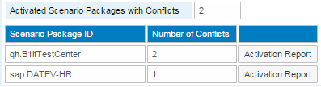

To display more details, click [Activation Report].

* The Namespace Conflicts tile displays the number of namespace conflicts. To display details, click the tile.

For more information, see section *2.11 Inbound Channel Namespace Report*

* System Status Information

The group displays the following information:

* Integration framework database size in GB
* Number of BizStore Documents
* Used Memory (Tomcat) by the integration framework in GB
* Used Memory by the integration framework in percent
* Used CPUs

**Detailed View for Blocked Queues**

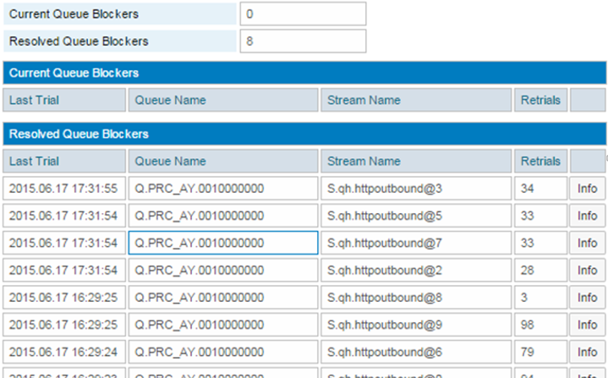

For each queue and stream, the report displays the number of attempts to process a message again and the timestamp of the last attempt.

To display more detailed information, click the [Info] button. The integration framework displays the following information:

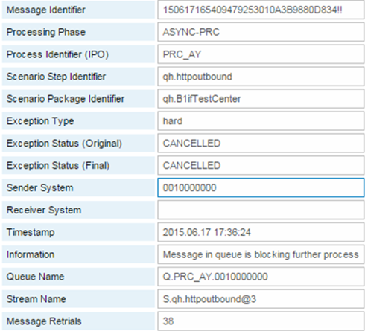

If a message blocks a queue, the integration framework rolls back processing and deactivates the step for one minute and tries to process the message again. If the last process attempt to process the message is longer ago than five minutes, the issue was resolved and the message could be processed. The integration framework moves the information to the *Resoved Queue Blockers* section.

The Control Center (B1iP) also provides a cockpit. To display the Control Center cockpit, choose *Tools* →*Control Center*. There are tiles displaying the same information as the integration framework cockpit. Possible differences in numbers in the Control Center cockpit and the integration framework cockpit are due to different points in time the data is requested.

# 4 Importing B1iSN Integration Content

This function is only available in the integration framework for SMEs.

* To import integration scenarios delivered for the subsidiary integration use case, choose Scenarios → B1iSN Integration Content. The subsidiary integration scenarios are displayed.
* To displays details of an integration scenario, click Details.
* The function displays the details.
* To import the integration scenario to the BizStore, click Import.

## Copyrights, Trademarks, and Disclaimers

© Copyright 2022 SAP SE. All rights reserved.

The current version of the copyrights, trademarks, and disclaimers at <https://www.sap.com/about/legal/copyright.html> is valid for this document.