**Integration Framework**

**Business Process Management Guide**

**Last Modified: Oktober 18, 2019**

Table of Contents

1 Getting Started with Business Process Management 3

1.1 Introduction 3

1.2 Business Process Modeling Notation (BPMN) Specification 3

1.3 Execution Semantics and Support in the Integration Framework 3

1.3.1 Pools and Lanes 4

1.3.2 Events 4

1.3.3 Activities 6

1.3.4 Gateways 6

1.3.5 Data Objects 7

1.3.6 Connections 7

2 Business Process Operations 8

2.1 Activating the Timeout Controller Process 8

2.2 Configuring Garbage Collection for Business Processes 8

2.3 Deleting Browser Cache after Upgrade 9

3 Business Process Development 9

3.1 Creating and Configuring Business Processes 9

3.2 Designing Business Processes 10

3.3 Using Business Process Functions 11

3.3.1 Status Information for the Business Process and the Scenario Package 11

3.3.2 Providing Business Process Documentation 11

3.3.3 Creating and Changing the BPMN Definition 12

3.3.4 Assigning Additional Scenario Packages 12

3.3.5 Subscribing to Events of Business Process Engine 13

3.3.6 Reinitializing the Package BPM ID 13

3.3.7 Further Business Process Functions 13

3.4 Using the Process Modeler 14

3.4.1 Areas of the Business Process Modeler 15

3.4.2 Providing General Process Information 16

3.4.3 Defining Events 16

3.4.4 Defining Gateways 19

3.4.5 Defining Tasks 19

3.4.6 Defining Data Objects 22

3.4.7 Defining Sequence Flows 24

3.4.8 Defining Directed Data Associations 25

3.5 Correlating Send and Receive Tasks 25

3.6 Obtaining a Consistent BPMN Model 26

3.7 Using the Instance Information Pool for Process Design 27

3.8 Exporting and Importing Business Processes 27

3.9 Using SAP Business Process Library Functions 27

3.10 Creating Documents for Script Tasks 27

3.10.1 Creating BizFlow Definition Documents 27

3.10.2 Creating XSL Documents 29

3.10.3 Creating JavaScript Documents 29

4 Monitoring Business Processes 30

4.1 Displaying Business Processes in Process Control 30

4.2 Using the Business Process Monitor 32

4.3 Using the Business Process Instance Control Monitor 33

4.4 Displaying Business Process Instance Details 34

4.5 Displaying the Execution Plan 36

4.6 Displaying Instance Processing in the Process Monitor 36

Copyrights, Trademarks, and Disclaimers 38

# 1 Getting Started with Business Process Management

## 1.1 Introduction

Business process management in general is a discipline to standardize and continuously optimize operational processes that have the largest impact on achieving corporate performance goals. A business process coordinates the behavior of people, systems, information, and things to produce business outcomes based on the business strategy. Processes can be structured and repeatable or unstructured and variable. Structured and repeatable processes can be supported by information technology.

## 1.2 Business Process Modeling Notation (BPMN) Specification

The Business Process Model and Notation (BPMN) specification provides a standardized graphical notation for drawing the steps of a business process. BPMN allows the modeling of business processes in a standard manner that is understandable by business analysts, managers and developers. The specification helps closing the gap between business process design and process implementation.

For more information about BPMN, see http://www.bpmn.org. The integration framework supports the BPMN version 2.0.

Using BPMN, you can describe the following:

* What triggers a business process and what is the result of the business process?
* Which steps does the business process require?
* What are the dependencies between steps, what does the sequence flow of steps look like?
* Is a decision required in the sequence flow, or must the process flow be split or merged depending on a condition?
* Which information is relevant in the process?
* What are the interaction points with other systems or processes?

BPMN is specified in XML format. A graphical design user interface supports modelling and visualizing the business process. The integration framework provides such a graphical user interface, the process modeler that is based on the BPMN specification. The process modeler offers elements the integration framework supports.

## 1.3 Execution Semantics and Support in the Integration Framework

Business process management is available as a layer on top of scenario packages.

**Business Process**

One business process is associated with one main scenario package. The scenario steps of the package represent the tasks of the business process, except for the script task that you define on business process level. You can define further scenario packages that contain your library functions or contain sub processes that you want to use in business process design.

**Business Process and Business Process Instance**

*Ordering Notebook* is a business process that describes the various tasks from placing the order in the system until delivery, including approval process and payment. An instance for the process is created when an employee starts the ordering process; another instance is created for another employee. The instances can run in parallel, because they are independent of each other.

**Orchestration of Tasks**

With business process management, you can orchestrate tasks. While, for example, the intercompany purchasing scenario delivered with SAP Business One integration for SAP NetWeaver, provides steps for sending a purchase order from SAP Business One to SAP ERP automatically creating a sales order and eventually sending back delivery and invoice information to SAP Business One, the scenario steps are not explicitly related to each other. Using the business process management layer, you can orchestrate tasks (scenario steps) and let the process wait, for example, until a certain information arrives at the process, or let the process end in an exception after a defined timeout.

**Workflow Versus Business Process Management**

The workflow provided in SAP Business One supports you in defining processes in one company database. The business process management layer in the integration framework allows defining and running business processes that span across SAP Business One and other systems.

**Business Process Example**

The pictures in the following sections use the sap.ColdStoreDemo business process example. The business process monitors a cold store and the goods inside the cold store. Triggered every minute, the business process obtains the cold store temperature and the status of the cold store door (open/closed). If the door remained open for too long, the best before date of the stored goods is reduced.

### 1.3.1 Pools and Lanes

To define participants of a business process, BPMN provides pools and lanes. Pools distinguish internal from external participants of a business process. Participants who are internal to the process are part of the active pool. Lanes help separating the different participants within a pool.

The integration framework supports the active pool without lanes.

### 1.3.2 Events

An event represents something that happens during a process. An event can, for example, be an incoming e-mail message, wait 5 minutes, send a message, procedure completed, an error occurred, and so on. A BPMN event is graphically represented with a circle.

* Events happen at the beginning, in the process or at the end of the process. The specification distinguishes between start, intermediate and end events.
* The single outer circle defines a start event.
* The double outer circle defines an intermediate event.
* The filled outer circle defines an end event.
* Symbols in the circle describe the event type.
* An envelope represents a message-based event.
* A clock represents a timer-based event.
* A flash represents an exception-based event.
* An event either reacts to something (message catch event) or produces a result (message throw event).
* For a message catch event, the symbol in the circle is unfilled.
* For a message throw event, the symbol in the circle is filled.
* You can position events in the sequence flow, or you can attach an event at the boundary of a task.
* An event interrupts processing or not.

The integration framework supports the following events:

|  |  |  |  |  |
| --- | --- | --- | --- | --- |
| **Types** | **Start** | **Intermediate** | | **End** |
| **Catch** | **Boundary** |
| **Generic** |  |  |  |  |
| **Message** |  |  |  |  |
| **Timer** |  |  |  |  |

| **Event Type** | **Element** | **Description** | **Scope** |
| --- | --- | --- | --- |
| Start message event |  | An incoming message starts a business process instance.  You can define exactly one start message event. | A start message event is a scenario step with Business Process outbound. |
| End message event |  | An outgoing message terminates the business process instance. You can define exactly one end message event. | An end message event is a scenario step with Business Process inbound. |
| End event |  | The event marks the end of the process without a defined result. You can define exactly one end event. |  |
| Intermediate timer event |  | Use the event to define a time interval after or before performing a task in the process flow. |  |
| Boundary timer event |  | Attach the event to a task to define a time interval that the task waits before following the process path that is attached to the event. |  |

### 1.3.3 Activities

An activity is any work that is being performed in a process. There are two types of activities, tasks and sub processes.

The integration framework supports the following tasks:

| **Activity Type** | **Element** | **Description** | **Scope** |
| --- | --- | --- | --- |
| Send task |  | A send task sends a message to another communication partner. The task is completed once the message is sent. | A send task is a scenario step that has Business Process inbound and any (except Business Process) outbound. You can use scenario steps as send tasks several times in the business process. Design, for example, a generic scenario step that sends notification e-mails. |
| Receive task |  | A receive task indicates that the process is relying on an incoming message from a communication partner. Upon receiving a message, the task has been performed. | A receive task is a scenario step that has any (except Business Process) inbound and Business Process outbound.  In the receive task, a unique key is included that defines the **correlation** to the business process instance. |
| Script task |  | The business process engine executes the script task. | You define a script task in the business process layer. |
| Service task |  | A service task is any task that uses an automated application or Web service to complete the task. | A service task performs any automated procedure. In the integration framework, it is a scenario step that has Business Process inbound and outbound. You can use a scenario step designed as a service task exactly once in the business process. |

The integration framework allows you to include a business sub process into another business process.

### 1.3.4 Gateways

Gateways indicate that a decision is required, or that the process flow must be split or merged depending on conditions.

The following gateway types are available in the integration framework:

| **Gateway Type** | **Element** | **Description** | **Scope** |
| --- | --- | --- | --- |
| Inclusive diverging gateway |  | When splitting the process flow, this gateway takes one or more flows based on conditions. | The integration framework processes all sequence flows where the conditions are met. If no condition is met, the integration framework hands over to the default branch. If a default branch is not defined, the integration framework throws an exception. |
| Inclusive converging gateway |  | When merging the process flow, the gateway awaits all incoming flows to complete. |  |
| Exclusive diverging gateway |  | An exclusive gateway represents a decision to take exactly one path in the flow. More than one path cannot be taken. | When splitting the process flow, the exclusive diverging gateway routes the sequence flow to exactly one of the outgoing branches based on conditions. If no condition is met, the integration framework hands over to the default branch. If a default branch is not defined, the integration framework throws an exception. |
| Exclusive converging gateway |  | When merging the process, the gateway awaits one incoming branch to complete before triggering the outgoing flow. Each incoming branch activates the gateway. |  |

### 1.3.5 Data Objects

A data object allows you to provide additional information in the process. Use data objects to define input and output data that you associate to a task in the process. You can define exactly one incoming and one outgoing data association. Data objects are required to define correlations and conditions.

### 1.3.6 Connections

The following connection types are available:

* The sequence flow connects flow objects like events, activities and gateways. It defines the order of performance of the flow objects. Each sequence flow connection has one source and one target. During performance of the process, a token leaves the source flow object, traverses down the sequence flow, and enters the target flow object.
* Data associations show the flow of information between data objects, inputs, and outputs. For tasks and events, dataInputAssociation and dataOutputAssociation define the inbound and outbound message. The definition points to a dataObject. Data associations are directed dotted lines, which define the order of data flow. Tokens do not flow along a data association. Thus, data associations have no direct effect on the flow of the process

The integration framework supports the sequence flow and directed data associations. It depends on the element types you want to connect with each other in the process modeler, whether you create a sequence flow or a directed data association.

| **Connection Type** | **Element** | **Definition** | **Scope** |
| --- | --- | --- | --- |
| Sequence flow |  | The sequence flow defines the order of performance of flow objects. |  |
| Conditional sequence flow |  | The conditional sequence flow is a sequence flow with a condition expression that is evaluated at runtime to determine whether the sequence flow is used. |  |
| Default sequence flow |  | The default flow is a special sequence flow used in combination with conditional flows. It is taken, if all the corresponding conditional flows are not taken at runtime. | To add a default flow in the process modeler, draw a flow and in the condition field, delete the entry. |
| Directed data association |  | A data association shows the flow of information between flow objects in a business process. |  |

# 2 Business Process Operations

You can define and run business processes with scenario steps of framework version 1 and version 2.

## 2.1 Activating the Timeout Controller Process

The timeout controller process takes care that timers defined in a business process are active. The process is inactive by default to not put additional load on the integration framework. If you do not use business process management, deactivate the process.

**Procedure in Framework Version 1**

1. To activate the process, choose Monitoring → Process Control.
2. Expand the BPM Processes section.
3. For the BPMN Engine - Timeout Controller process, click the Activate button.

**Procedure in Framework Version 2**

1. To activate the process, choose Monitoring → Service Monitor., expand Business Process Services.
2. For the BPMN Engine - Timeout Controller process, click the Activate button.

## 2.2 Configuring Garbage Collection for Business Processes

##Fehlt in Version 2 ###

Before using BPM, initially define and save the garbage collection settings to start the garbage collection. To configure the garbage collection, you have the following options:

* Choose *Maintenance* → *Cfg BPM*.
* Choose *Maintenance* → Daily Actions and click the [Config] button in the Garbage Collection – BPM line.

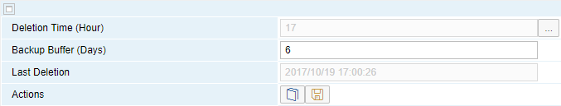

Deletion Time (Hour)

Select the hour of deletion from the list. The integration framework deletes the log on the hour. By default, the integration framework deletes the message log at midnight.

Backup Buffer (Days)

Enter for how many days you want to keep information. The default is 6 days.

Last Deletion

The integration framework displays the timestamp of the last automatic daily deletion.

[Save]

To save the configuration, click the button.

## 2.3 Deleting Browser Cache after Upgrade

If an upgrade of the integration framework contains changes of the business process modeler, it is possible that the modeler does not display models anymore after the upgrade in the Web browser. Clear the browser cache and open the modeler again.

# 3 Business Process Development

## 3.1 Creating and Configuring Business Processes

* In framework version 1, the Business Process Handling user interface is the starting point to define a business process. To open the user interface, choose Scenarios → Business Processes.
* In framework version 2, calling the business process designer is part of the navigation tree of the package explorer for each scenario package. To configure settings for a business process, click  (Configuration) in the process modeler. You can also open the BPM configuration in the Maintenance menu.

**Procedure**

1. In Business Process Handling of framework version 1, click  (Creates Business Process).
2. In the Business Process Identifier field, enter the business process identifier.

When saving the definition, the integration framework adds the namespace. The identifier including namespace can have up to 20 characters.

1. In the Associated Scenario Package field, select the scenario package. In framework version 2, the value is preset.

The function creates the BPM identifier for the scenario package and displays the vendor information.

1. In the Version field, the integration framework adds the 1.0.0 version.

You can change the version later for business process versioning.

1. In the *Description* field, enter the description of the business process.
2. To allow that more than one business process instance can run at a time, select Allow Multiple Instances.

For the Ordering Notebook business process, you can allow running multiple instances, because the instances do not depend on each other. For the sap.ColdStoreDemo business process, only run one instance at a time and start a new instance, if the previous instance is completed.

1. To allow that process instances can run for multiple deployments, select Allow Multiple Deployments.

(Not relevant for the integration framework version 1.)

1. Save your settings.

**Results**

The Timestamp field displays the timestamp of the last change. The integration framework does not reflect changes in the associated scenario package or steps, only of the business process definition.

## 3.2 Designing Business Processes

* To design a business process in framework version 1, choose Scenarios → Business Processes and click  (Open Process Modeler*)*.
* To design a business process in framework version 2, open the scenario package in the package explorer and click BPM in the navigation tree.

**Prerequisites**

* You created a scenario package that is going to contain scenario steps that are the tasks of your business process.
* Library steps are available in a separate package that you want to use in the business process.

**Procedure**

1. In the process modeler, drag and drop the elements to the design area and enter the required information in the input area for the objects.
2. While creating the business process definition, create scenario steps and provide at least the inbound and outbound definitions.

* For the start event, create a scenario step with any, except Business Process, inbound and Business Process outbound
* For a send task, create a scenario step with Business Process inbound and any (except Business Process) outbound.
* For a receive task, create a scenario step with any (except Business Process) inbound and Business Process outbound.
* For a service task, create a scenario step with Business Process inbound and outbound.

1. Save the model.
2. If errors occur, change the model until it is consistent.
3. Add the processing phase to the steps and test the steps.
4. In framework version 1, set up the scenario package and activate it.

In framework version 2, create a deployment for the scenario package.

1. To activate the business process, click  (Status of Business Process).
2. Once the business process is running, use the business process monitoring functions to monitor the business process.

**Results**

The business process handling user interface is your entry point to activate and monitoring the business process.

## 3.3 Using Business Process Functions

### 3.3.1 Status Information for the Business Process and the Scenario Package

  Status of Business Process

The icon displays the status of the business process, either design or active. To activate or deactivate the business process, click the icon.

  Status of Associated Scenario Package

The icon displays the status of the associated scenario package. The following options are available:

* A green icon indicates that the scenario package is active. To deactivate the scenario package, click the icon.
* A yellow icon indicates that there is no scenario package associated to the business process.
* A red icon indicates that the scenario package is inactive. To activate the package, click the icon.

### 3.3.2 Providing Business Process Documentation

Document the business process. Describe the following aspects:

* Purpose of the business process
* Prerequisites for the business process
* Description of start and end
* Description of the scenario package and additional packages that the business process uses

**Procedure**

1. Create the document and save it as vBP.pdf.
2. To upload the document, select *Tools* → *Control Center* → *Maintenance* → *BizStore Upload*.
3. Save the document to the following BizStore location: com.sap.b1i.vplatform.bp.design.<your business process>

For more information, see the guide *Development Environment*, *Document Handling*, *Uploading a Document*

1. To display the documentation, click the  Display Documentation for the Business Process button.

### 3.3.3 Creating and Changing the BPMN Definition

If you design the business process in the process modeler and you save the definitions, the modeler creates the bpmn.xml document that contains the instructions for the business process at runtime. Find the definition in the BizStore:

com.sap.b1i.vplatform.bp.design.<your business process>

If you already have a BPMN XML definition document, you can upload the definition from the file system and edit it.

**Procedure**

1. To upload a BPMN definition from the file system to the BizStore, click the  Upload BPMN Definition button. The integration framework saves the definition to the following location: com.sap.b1i.vplatform.bp.design/<your_business_process>/bpmn.xml

The upload function is inactive, if the business process is active.

1. If the business process is inactive, click the  (*Open and Edit BPMN Definition)* button to open and edit the BPMN definition. If the business process is active, you can display the BPMN document.
2. To indicate whether the definition is valid or invalid, the integration framework displays the  icon. If the color is red, open the document and change it.

### 3.3.4 Assigning Additional Scenario Packages

When designing the scenario steps of your business process, you can either assign the steps to one scenario package, or you can assign them to different scenario packages. This gives you the option to design, for example, the steps of the main process in one package and add helper steps of a certain type to another package. Or you can collect generic steps that you want to reuse in many business processes in a library package.

**Procedure**

1. To assign additional scenario packages to the business process, click Tools and select Add Scenario Packages.

The integration framework displays scenario packages in your namespace.

1. Select one or more packages you want to add to the business process and save your settings.

### 3.3.5 Subscribing to Events of Business Process Engine

If you want to develop an individual monitoring or alerting for your business process, you can subscribe to generic events provided by the business process engine.

**Prerequisites**

You have developed one or more scenario steps with internal queue inbound that process the event information for your monitoring or alerting.

**Procedure**

1. To subscribe to business process engine events, click Tools and select Subscribe to Events.

The integration framework displays available events.

1. For each event, you can select a scenario step of the main scenario package or additionally assigned packages that handle the events. The steps must have internal queue inbound.

### 3.3.6 Reinitializing the Package BPM ID

For each business process, the integration framework creates an identifier for the main scenario package associated to the business process. The scenario import and export functions take care that the identifier is unique after importing a scenario and business process from another integration framework. If an identifier is not unique, use the reinitialize function to reset and create new IDs.

### 3.3.7 Further Business Process Functions

 Open Process Modeler

To design the business process, open the process modeler.

For more information, see section *Using the Process Modeler*

  BPMN Validation Check

The integration framework validates your definitions against the required schema. If there are errors, the integration framework displays the details.

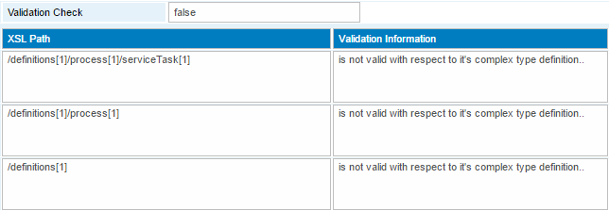

 Business Process Monitor

Once the business process is running, click the button to open the Instance Control Monitor. Display instance-specific information of the business process.

For more information, see section Using the Business Process Instance Monitor

 Display Documentation

The integration framework provides context-based documentation. If documentation is available, the integration framework displays the documentation icon. The grey icon indicates not yet available documentation. To open documentation, click the icon.

## 3.4 Using the Process Modeler

The process modeler provides a graphical user interface that enables you to design business processes. In the process modeler, you can use elements based on the BPMN 2.0 standard that the integration framework supports.

### 3.4.1 Areas of the Business Process Modeler

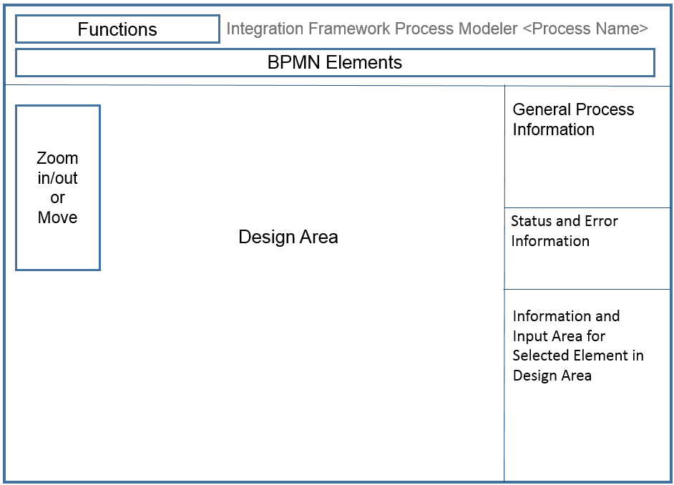  
Process Modeler User Interface

**Functions**

The first row displays functions for process design. For business processes in your namespace, all functions available. For business processes that are not in your namespace, you can display documentation, and display or hide data objects.

**BPMN Elements**

The second row displays the BPMN elements that the integration framework supports. Use the elements to design your business process.

**Design Area**

In the design area, assemble the elements of your business process. You can drag and drop elements from the BPMN Elements area or click an element and click again in the design area to place an element.

**Zoom In/Out**

On the left side of the design area, functions are available for zooming in or out in the model or for moving the model in the design area.

**General Process Information**

Enter the process name.

**Status and Error Information**

While designing, or saving a business process, you find status and error information in this area. If you try to place an element or connection in a place that BPMN does not allow, the modeler displays explanations.

**Information and Input Area for Selected Elements**

The modeler displays information and input fields for the selected element in the design area.

For each element, you can add documentation.

### 3.4.2 Providing General Process Information

In the general process information, define a name for the process model and assign a scenario step that provides an individual error handling.

**Procedure**

1. In the *General Process Information* section, in the Process Name field, enter a name for the business process model.
2. In the Documentation field, enter information about the process.

The modeler displays it below the element.

### 3.4.3 Defining Events

To define an event, drag and drop the element to the design area and enter the required information in the input area of the process modeler.

#### 3.4.3.1 Defining a Start Message Event

When using a start message event, an incoming message creates a business process instance. A start message event is a scenario step with Business Process outbound. You can define exactly one start message event.

**Procedure**

1. Click Start Message Event element and click in the design area to drop the element.
2. On the right side, in the Name field, enter the name displayed in the model below the element. Note that the modeler displays six characters.
3. In the Scenario Step field, select the scenario step that triggers the business process.
4. In the Documentation field, enter information about the start message event.

#### 3.4.3.2 Defining an End Message Event

If an outgoing message terminates the business process instance, define an end message event. An end message event is a scenario step with Business Process inbound. You can define exactly one end message event.

**Procedure**

1. Click End Message Event element and click in the design area to drop the element.
2. On the right side, in the Name field, enter a name displayed in the model. Note that the modeler displays six characters.
3. In the *Scenario Step* field, select a scenario step that sends the message terminating the business process.
4. In the Documentation field, enter information about the end message event.

#### 3.4.3.3 Defining an End Event

The end event marks the end of the process and terminates the process instance. You can define exactly one end event.

**Procedure**

1. Click End Event element and click in the design area to drop the element.
2. On the right side, in the Name field, enter a name the process modeler displays below the element.
3. In the Documentation field, enter information about the end event.

#### 3.4.3.4 Defining Intermediate Timer Events

To add delays to a process flow, define intermediate timer events. For example, in a process that updates databases you add a timer that delays the process some minutes to ensure that all databases are updated when the process continues.

You can configure the intermediate timer event to wait until a specific date or to wait for a certain period.

**Procedure**

1. Click Intermediate Timer Event element and click in the design area to drop the element.
2. On the right side, in the Name field, enter the name displayed in the model below the element. Note that the modeler displays six characters.
3. In the Duration field, enter the duration or starting date.

BPMN uses the ISO 8601 specification.

P[n]Y[n]M[n]DT[n]H[n]M[n]S

P[n]W

P[YYYY]-[MM]-[DD]T[hh]:[mm]:[ss]

| **Indicator** | **Description** |
| --- | --- |
| n | Defines a number that represents the number of years, months, or days |
| P | Indicates that the following duration is specified by the number of years, months, days, hours, minutes, and seconds |
| T | Indicates that a time value follows. Any value with a time must begin with T. |
| Y | Indicates the year followed by the value for the number of years |
| M | Indicates the month followed by the value for the number of months |
| W | Indicates that the duration is specified in weeks. |
| D | Indicates day value that follows. |
| H | Indicates that an hour value proceeds the character in a duration |
| M | As part of a time, indicates that a minute value proceeds the character in a duration |
| S | Indicates the second value proceeds the character in a duration |

The integration framework does **not** support the following format: PYYYYMMDDThhmmss

**Examples**

* PT5M

Duration of 5 minutes.

* P2Y5M4DT12H30M5S

Duration of two years, five months, four days, twelve hours, thirty minutes, and five seconds

1. In the Documentation field, enter information about the intermediate timer event.

#### 3.4.3.5 Defining Boundary Timer Events

A specific time-date, for example, after five minutes, triggers the boundary timer event. Such a timer event attached to the boundary of a receive task changes the normal flow into an exception flow when it is triggered. The boundary timer event interrupts the task. You define an outgoing sequence flow from the receive task and another sequence flow leaving the boundary timer event.

**Procedure**

1. Click Boundary Timer Event element and click in the design area to drop the element at the boundary of a receive task.
2. On the right side, in the Name field, enter the name displayed in the model below the element. Note that the modeler displays six characters.
3. In the Duration field, enter the duration or starting date.

BPMN uses the ISO 8601 specification.

P[n]Y[n]M[n]DT[n]H[n]M[n]S

P[n]W

P[YYYY]-[MM]-[DD]T[hh]:[mm]:[ss]

|  |  |
| --- | --- |
| **Indicator** | **Description** |
| n | Defines a number that represents the number of years, months, or days |
| P | Indicates that the following duration is specified by the number of years, months, days, hours, minutes, and seconds |
| T | Indicates that a time value follows. Any value with a time must begin with T. |
| Y | Indicates the year followed by the value for the number of years |
| M | Indicates the month followed by the value for the number of months |
| W | Indicates that the duration is specified in weeks. |
| D | Indicates day value that follows. |
| H | Indicates that an hour value proceeds the character in a duration |
| M | As part of a time, indicates that a minute value proceeds the character in a duration |
| S | Indicates the second value proceeds the character in a duration |

The integration framework does **not** support the following format: PYYYYMMDDThhmmss

**Examples**

* PT5M

Duration of 5 minutes.

* P2Y5M4DT12H30M5S

Duration of two years, five months, four days, twelve hours, thirty minutes, and five seconds

1. In the Documentation field, enter information about the boundary timer event.

### 3.4.4 Defining Gateways

Gateways indicate that a decision is required. The integration framework supports inclusive and exclusive gateways. For a valid business process model, add a converging gateway for each diverging gateway that you define.

**Procedure**

1. Click Gateway element and click in the design area to drop the element.
2. On the right side, in the Name field, enter the name displayed in the model below the element. Note that the modeler displays six characters.
3. In the Documentation field, enter information about the gateway.

### 3.4.5 Defining Tasks

Tasks are any work performed in the business process. The integration framework supports send, receive, service and script tasks.

#### 3.4.5.1 Defining Send Tasks

A send task sends a message to a third party outside the process. The task is completed once the message is sent. The process instance continues.

The send task has the same behavior as a throwing intermediate message event. However, when using a task, you can attach a boundary event to capture the task’s exception conditions.

**Setting Correlations**

If your business process contains a receive task that continues processing a business process instance, define correlation information in a previously processed send task. This way, a receive task can use the ID to pick up the correct message that is related to the process instance.

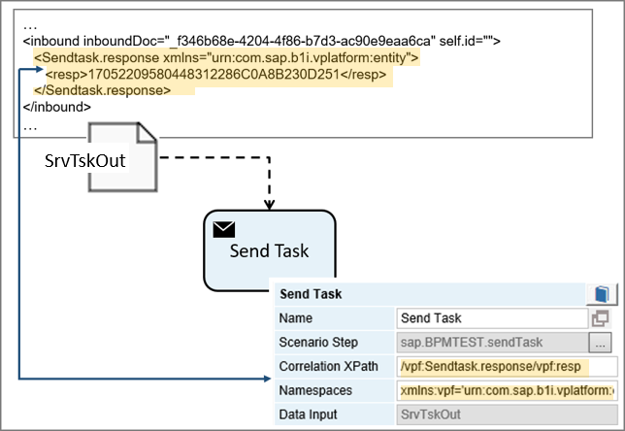   
Correlation Definition in Send Task

In the example, the data object associated to the send task contains the identifier for the business process instance and hands over the information to the task in an inbound document. To set the correlation in the send task, enter the XPath statement that points to the place in the inbound document and define the namespace prefix that you use in the XPath statement.

**Procedure**

1. Click the Send Task element and click in the design area to drop the element.
2. On the right side, in the Name field, enter the name displayed in the model below the element. Note that the modeler displays six characters.
3. In the *Scenario Step* field, select a scenario step that performs the task. The integration framework displays steps with BP inbound.
4. In the *Correlation XPath* field, enter an XPath expression that retrieves the correlation value from the data message.

The integration framework does not set a correlation, if the field is empty or it cannot retrieve a correlation using the XPath statement.

1. In the Namespaces field, enter namespace prefixes and namespaces, separated by blank to that you use in the XPath statement.
2. In the Documentation field, enter information about the send task.

#### 3.4.5.2 Defining Receive Tasks

A receive task indicates that the process is relying on an incoming message from a third party. Upon receiving the message, the task is performed. You can use a receive task in several places in the business process. If you use a receive task several times, take care that the task always gets the correct information by using a correlation.

**Using Correlations**

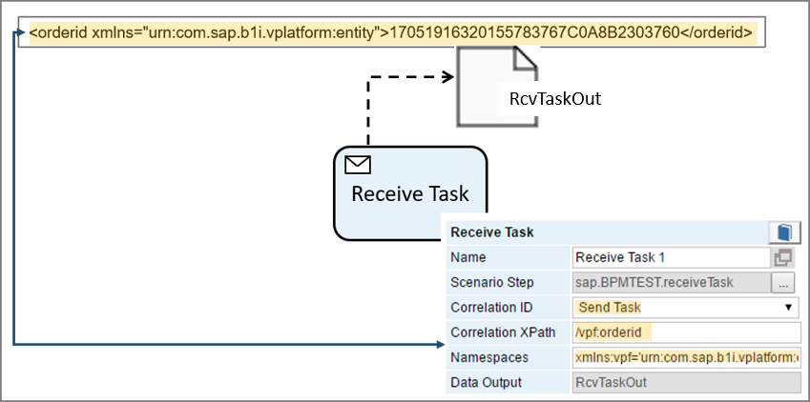  
Using Correlation Information in Receive Task

In the example, the instance information is availble

**Procedure**

1. Click Receive Task element and click in the design area to drop the element.
2. On the right side, in the Name field, enter the name displayed in the model below the element. Note that the modeler displays six characters.
3. In the *Scenario Step* field, select a scenario step that performs the task. The integration framework displays steps with BP outbound.
4. In the *Correlation ID* field, select the element ID that defines the correlation.
5. In the Correlation XPath field, define the XPath statement to extract the correlation value from the data object.
6. In the Namespaces field, enter namespace prefixes and namespaces, separated by blank that you use in the XPath statement.
7. In the Documentation field, enter information about the receive task.

#### 3.4.5.3 Defining Service Tasks

A service task is any task that uses an automated application or service to complete the task. In the integration framework, it is a scenario step with business process inbound and outbound.

**Procedure**

1. Click Service Task and click in the design area to drop the element.
2. On the right side, in the Name field, enter the name displayed in the model below the element. Note that the modeler displays six characters.
3. In the *Scenario Step* field, select a scenario step that performs the task. The integration framework displays steps with BP inbound and outbound for selection.
4. In the *Operation Type* field, select the service task type, either b1if for a scenario step, or bpmn for another business process.
5. In the documentation field, enter information about the service task.

#### 3.4.5.4 Defining Script Tasks

A script task is directly executed by the business process engine and is written in a language that the engine can parse. The integration framework supports XSL, JavaScript and the BizFlow definition (BFD) language.

**Prerequisites**

You have loaded the script file to the com.sap.b1i.vplatform.bp.design.<your business process> location in the BizStore.

For more information, see the guide *Development Environment*, *Document Handling*, *Uploading a Document*

**Procedure**

1. Click Script Task and click in the design area to drop the element.
2. On the right side, in the Name field, enter the name displayed in the model below the element. Note that the modeler displays six characters.
3. In the *Script Format* field, select the format of the script task. The following options are available:

* xsl: XSL document
* js: JavaScript document
* bfd: B1iP BizFlow definition document

1. In the Script Document field, select the file in the BizStore. To select the file, select a dataset, then a group and finally the document. To create a document, select the – Create new Script – option, and enter the script name in the input field
2. In the Documentation field, enter information about the script task.

For more information about script task documents, see section *Creating Documents for Script Tasks*

### 3.4.6 Defining Data Objects

A data object represents information flowing through the business process. A data object can be a business document that is, for example, a result of a task performed in the process flow.

**Example**

A new sales order is the result of the Create Sales Order service task.

Use data objects to define input and output data. Data objects provide information about what tasks require to be performed (input data) and what tasks produce (output data).

* The data object that is data input for a service or send task contains the inbound information for the scenario step. The information is handed over to the Payload Role="S" section of the integration framework message of the scenario step.
* The Payload Role="R" section of the final transformation atom (atom0) of the scenario step that is a service or receive task, contains the information handed over to the data object that is the data output of the task.

To connect a data object to a task, the BPMN specification defines using directed data associations.

Connecting Data Objects Using Directed Data Association:

* You can connect exactly one data object for data input and one data object for data output to a service task.
* You can connect exactly one data object for data output to a receive task.
* You can connect exactly one data object for data input to a send task.

You have the following options to create a data object:

* Create a dynamic data object. The information is taken from the instance information pool.
* Create a static data object. Define a data object in the base directory of the business process design folder of the BizStore and provide the content in the object. The static data object is the same for all instances of the business process.

**Procedure**

1. Click Data Object and click in the design area to drop the element.
2. On the right side, in the Name field, enter the name displayed in the model below the element. Note that the modeler displays six characters.
3. To define a static data object, provide the data object XML file in the base directory of business process in the BizStore.
4. For a static data object, add the BizStore file name in square brackets to the name of the data object.
5. In the Documentation field, enter information about the data object.

**Example for Static Data Object**

In the sap.ColdStoreDemo business process example, a send task requires the temperature and the door status of the cold store as input data. The information is available, however in two data objects, the Temperature data object and the Door Status data object. BPMN does not allow setting two directed data associations to a task. Thus, we create and use a static data object instead.

In the base directory of the business process, you can find the cs1.xml data object with the following content:

?xml version="1.0" encoding="UTF-8"?>

<root xmlns:bfa="urn:com.sap.b1i.bizprocessor:bizatoms">

<in id="in1">Door Status</in>

<in id="in2">Temperature</in>

</root>

The input for the data object consists of the Door Status and Temperature data objects.

To define the static data object in the process modeler, enter the following name for the data object: AlertDoc [cs1]

At runtime, the document has, for example, the following content, and hands over the door status and the temperature to the task:

<?xml version="1.0" encoding="UTF-8"?>

<sequence instanceID="170516083200696002460A570BB4C5CD" ts="2017/05/16 08:32:06" actionDIR="out" actionID="_b23566ce-b261-4376-a168-111718d5c160" actionType="sendTask" actionName=" Send Internal Alert" vBIU="sap.CS.SendInternalAlert" BPId="sap.ColdStoreDemo" vPac="sap.ColdStoreDemo" streamID="IIP.0010.170516083200696002460A570BB4C5CD" guid.subBP="">

<inbound inboundDoc="_4871edc6-16e6-4fc3-a3a7-6ddb0423e3fe" self.id="cs1">

<indoc id="in1" uri="_25433914-86e2-436d-b509-c03c39b80864">

<doorstatus>open</doorstatus>

</indoc>

<indoc id="in2" uri="_e3ffdff6-ce17-4d74-8693-68f962cf7875">

<Temperature>-1</Temperature>

</indoc>

<root>

<in id="in1">Door Status</in>

<in id="in2">Temperature</in>

</root>

</inbound>

</sequence>

### 3.4.7 Defining Sequence Flows

The sequence flow defines the order in which tasks are performed in the business process. The sequence flow is represented with a solid arrow. Each sequence flow has exactly one source and one target. The conditional sequence flow is a sequence flow with a condition expression that is evaluated at runtime to determine whether the sequence flow is used.

**Procedure**

1. Click Arrow element, place it on the element you want to connect, click and move the cursor to the other element you want to connect.
2. On the right side, in the Name field, enter the name displayed in the model below the element. Note that the modeler displays six characters.
3. For sequence flows leaving a gateway, you can define conditions. In the XPath to Condition field, enter the XPath expression leading to the condition in the data object.

If you leave the field empty, the modeler displays the default flow.

The default flow is a special sequence flow used in combination with conditional flows. It is taken, if all the corresponding conditional flows are not taken at runtime.

1. In the Data Object field, select the data object that contains the condition.
2. In the Namespaces field, enter namespace prefixes and namespaces, separated by blank that you use in the XPath statement.

### 3.4.8 Defining Directed Data Associations

The directed data association is an information flow, not a sequence flow. It does not represent the order of activities but instead the flow of information in the process. It is represented with a dotted arrow (data association).

**Procedure**

1. Click Arrow, place it on the element you want to connect, click and move the cursor to the other element you want to connect.
2. On the right side, in the Name field, enter the name displayed in the model below the element. Note that the modeler displays six characters.

**Result**

The modeler displays incoming and outgoing data associations in *Data Input* and *Data Output* fields of tasks.

## 3.5 Correlating Send and Receive Tasks

In send and receive tasks, you can define a correlation XPath pointing at an identifier that correlates a message of a send task leaving the business process to an incoming message of a receive task to ensure that they both belong to the same process instance.

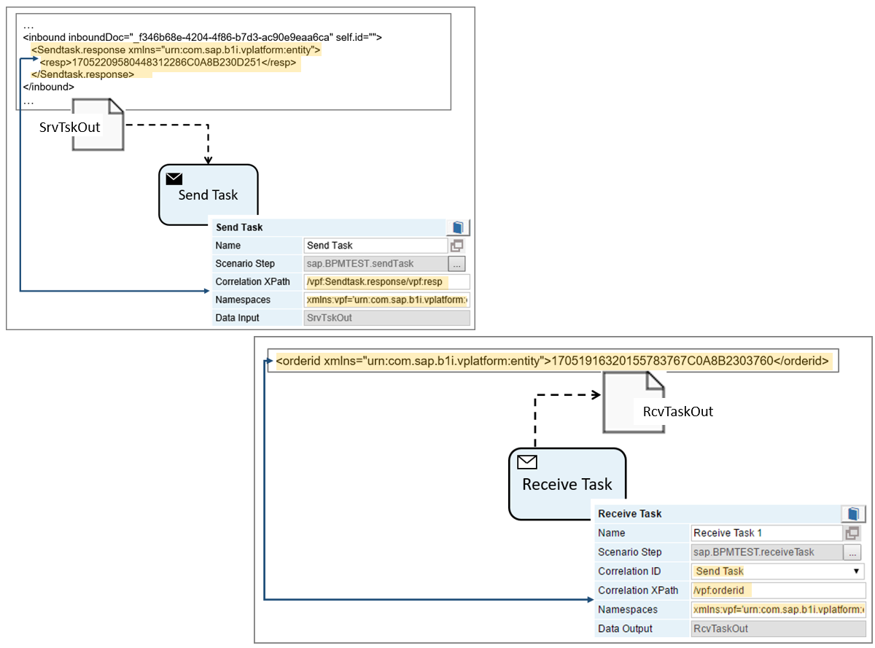Correlation Settings

In the example above, the send task obtains instance information in the SrvTskOut data object. The correlation XPath field value leads to the instance identifier that is handed over to the send task. The receive task uses the Send Task correlation ID that is the name of the send task and obtains the instance identifier from the RcvTaskOut data object. The correlation XPath leads to the identifier.

## 3.6 Obtaining a Consistent BPMN Model

The process modeler supports you in defining a consistent business process that you can run. It either does not allow to drag elements to the design area or it displays error messages and warnings when you try to save the model.

**Procedure**

1. To obtain a consistent model, click (*Check Process Model Syntax)*.

The modeler displays the number of syntax errors in the Status and Error Information area, highlights the first element using a dashed orange rectangle in the design area and displays the error message and the input area of the element.

1. To solve errors, use the arrows in the Status and Error Information area to move to the next error.

## 3.7 Using the Instance Information Pool for Process Design

After activation of the scenario package or packages used in a business process and the business process, the business process engine starts creating and running instances.

Use the instance information pool to test your business process. For more information, see section 3.3 Using the Business Process Instance Control Monitor

## 3.8 Exporting and Importing Business Processes

Use the import and export functions of the Scenarios menu for business process import and export. If a business process is associated with a scenario package, the functions import and export the business process information, too.

## 3.9 Using SAP Business Process Library Functions

The sap.BPMN.Lib scenario package contains steps that you can use in your business processes. You do not have to assign the package to your business process. The steps are directly available in the business process for selection.

**Procedure**

To use the sap.BPMN.Lib scenario package functions, active the package.

1. To activate the package, choose Scenarios → Step Design, click *Steps* and select all steps for activation.
2. Click Activate.
3. To display documentation about how to use the library steps, choose Scenarios → Control and click the Documentation button for sap.BPMN.Lib.

## 3.10 Creating Documents for Script Tasks

A script task is an automated task that is executed by the business process engine. The person modeling the process defines the script in a language that the engine can interpret. In the integration framework, you can define XSL documents, JavaScript documents or BizFlow definition language (bfd) documents.

### 3.10.1 Creating BizFlow Definition Documents

The BizFlow definition document must follow the bizflow.xsd schema available in the BizStore in the following place: com.sap.b1i.system/xsd/bizflow.xsd

A BizFlow definition document has the following structure:

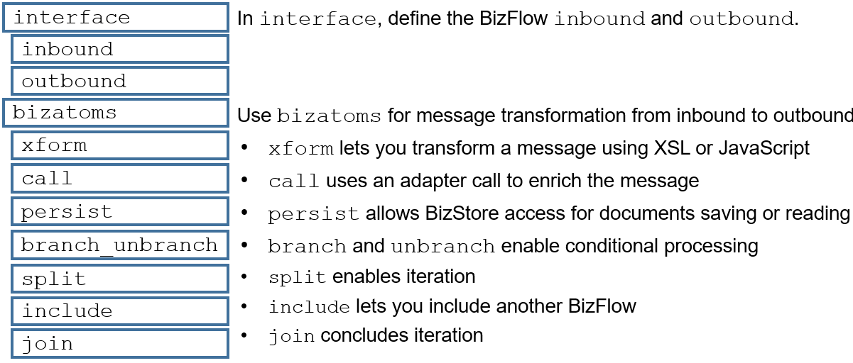

* <bizflow2> is the root tag.
* In the <interface> tag, you can define the BizFlow inbound and outbound with a list of properties.
* In the <bizatoms> tag, define the atoms you use in processing between inbound and outbound that transforms the inbound to the required outbound. The following BizAtoms are available for transformation:
* <xform> to transform the incoming message. In the section, you define the document that performs the transformation, either an XSL or a JavaScript document.
* <call> for calls to systems for message enrichment
* <persist> to store information to the BizStore or to access information in the BizStore
* <branch_unbranch> to define several paths based on conditions
* <split> to split for iteraction
* <include> to include another BizFlow
* <join> to join after split

**Example**

<?xml version='1.0' encoding="UTF-8"?>

<bizflow2 xmlns:bfa="urn:com.sap.b1i.bizprocessor:bizatoms" xmlns:xsi="http://www.w3.org/2001/XMLSchema-instance" xmlns="urn:com.sap.b1i.bizprocessor:bfdefinition" xsi:schemaLocation="urn:com.sap.b1i.bizprocessor:bfdefinition ../../com.sap.b1i.system/xsd/bizflow.xsd" active="true" name="Config_Detail" schemaversion="1.0">

<interface>

<description></description>

<inbound></inbound>

<outbound></outbound>

</interface>

<bizatoms>

<xform name="call1">

<description></description>

<rule optional="false">

<intended bfxp_href="#scripttask.xsl"></intended>

</rule>

</xform>

<xform name="call2">

<description></description>

<rule optional="false">

<intended bfxp_href="#prepareJSON.xsl"></intended>

</rule>

</xform>

</bizatoms>

</bizflow2>

In the example BizFlow above, there are no specific settings for inbound and outbound in the interface tag. In the bizatoms tag, the BizFlow uses the xform atom call1 to transform the message by calling the scripttask.xsl document. Then it calls the xform atom call2 to further transform the message by calling the prepareJSon.xsl document.

### 3.10.2 Creating XSL Documents

In the XSL document, define the script task.

**Example for XSL Definition Document**

<?xml version='1.0' encoding="UTF-8"?>

<xsl:stylesheet xmlns:bfa="urn:com.sap.b1i.bizprocessor:bizatoms" xmlns:vpf="urn:com.sap.b1i.vplatform:entity" xmlns:xsi="http://www.w3.org/2001/XMLSchema-instance" xmlns:xsl="http://www.w3.org/1999/XSL/Transform" version="1.0" bfa:force="" vpf:force="" xsi:force="">

<xsl:template match="/">

<scripttask>

<result>this is the result</result>

</scripttask>

</xsl:template>

</xsl:stylesheet>

### 3.10.3 Creating JavaScript Documents

The integration framework provides the following functions in the com.sap.b1i.bizprocessor.ScriptIO class that you can use in JavaScript files:

| **Function Name** | **Description** |
| --- | --- |
| scripIO.getJsonInMessage (false) | Retrieve inbound message |
| scriptIO.getProperty (property) | Retrieve an inbound property |
| scriptIO.setJsonOutMessage (outData2, false) | Produce outbound message |

**Example for JavaScript Definition Document**

var inval = getInboundMsg ();

// var inpar = getParameter ("par1");

var inpar = "par1";

genOutboundMsg (inval + "*" + inpar);

function getInboundMsg () {

// how to retrieve the inbound message

var data = scriptIO.getJsonInMessage (false);

var inMsg = JSON.parse (data);

var f1 = inMsg.f1;

var f2 = inMsg.f2;

var f3 = inMsg.f3;

return (f1 + f2 + f3);

}

function getParameter (p) {

// how to retrieve a parameter

var par = scriptIO.getProperty (p);

return (par);

}

function genOutboundMsg (val) {

// how to produce an outbound message

var outMsg = '{"InVal":"' + val + '","field1":"Hello","field2":"Integration","field3":true,"answer":42}';

scriptIO.setJsonOutMessage (outMsg, false);

}v

# 4 Monitoring Business Processes

## 4.1 Displaying Business Processes in Process Control

To open the process control monitor, choose Monitoring → Process Control.

The integration framework displays the following business process-related processes in the process control monitor:

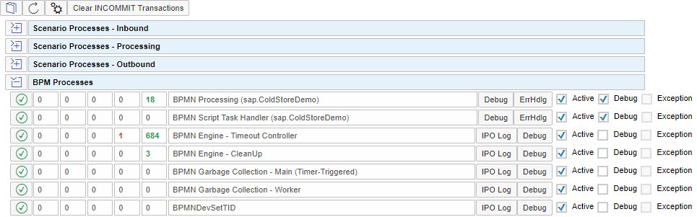

In the BPM Processes section, the integration framework displays the active business processes with the following information:

* Started transactions
* Transactions with INCOMMIT status
* Transactions with INROLLBACK status
* Cancelled transactions
* Completed transactions

In the picture above, there are two active business processes.

The following business process engine-related processes are available:

* Timeout Controller monitors and processes timeout settings for tasks
* CleanUp removes documents from BizStore after a business process instance is completed.
* Garbage Collection Main and Worker perform the garbage collection for business processes.
* BPMNDevSetTID is not relevant for the integration framework.

**Functions for BPM Processes**

[Debug]

To open the flow analysis for the process steps, click the button. The integration framework displays the latest transactions first.

note.gif NOTE

Note that detailed information is only available for a certain time. A regular garbage collection removes older information.

For more information about how to work with the flow analysis, see section *Displaying the Flow Analysis*

[ErrHdlg]

To open the error handling transaction for the step, click the button.

Activate

The *Activate* checkbox indicates the current IPO step status. You can change the status.

Debug

The *Debug* checkbox indicates the current IPO step status. You can change the status.

Exception

The *Exception* checkbox indicates that an exception occurred during last processing of the process step. The checkbox is always disabled. The next step processing overwrites the exception indicator.

**Functions for Processes of the BPM Engine**

[IPO Log]

The integration framework displays the transaction IDs, the execution timestamp and the execution duration in milliseconds.

[Debug]

To open the flow analysis for the process steps, click the button. The integration framework displays the latest transactions first.

note.gif NOTE

Note that detailed information is only available for a certain time interval, because the regular garbage collection removes older information.

Activate

The *Activate* checkbox indicates the current IPO step status. You can change the status.

Debug

The *Debug* checkbox indicates the current IPO step status. You can change the status.

Exception

The checkbox indicates that an exception occurred during last processing of the process step. The checkbox is always disabled; you cannot select it. The next step processing overwrites the exception indicator.

## 4.2 Using the Business Process Monitor

Use the business process monitor to display and manage business processes. To open the business process monitor, choose *Monitoring* → *BPM Monitor*.

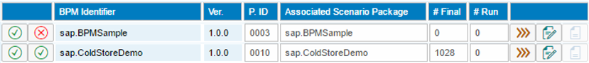

The integration framework displays the available business processes. The icons in front of each process display the status of the business process and the status of the associated scenario package. A grey icon indicates that there is no scenario package associated to the business process. The monitor displays the BPM identifier and version, the BPM ID and name of the scenario package.

#Final

The field displays the number of completed business process instances.

#Run

The field displays the number of running business process instances.

 Open Business Process Instance Monitor

To display the instances of the business process, click the button.

 Display BPMN Definition

To display the BPMN definition of the business process, click the button.

 Display Documentation for Business Process

To display documentation for the business process, click the button.

## 4.3 Using the Business Process Instance Control Monitor

For each business process that is active and running, display information about the business process instances in the business process instance monitor.

To open the monitor, you have the following options:

* Choose *Monitoring* → *BPM Monitor* and click the  icon of the business process.
* Choose Scenarios → Business Processes, select the business process and click the  icon.

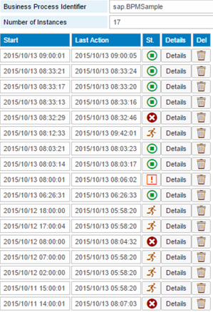

For each business process instance, the monitor displays the following information:

* Start timestamp
* Timestamp of the last action of the business process
* The status of the instance.

|  |  |
| --- | --- |
| **Icon** | **Instance is …** |
|  | Running |
|  | Finished |
|  | Finished with exception |
|  | Killed by user |

* To display process instance details, click [Details]
* To delete the business process instance, click [Delete]

You can delete instances independent of the status. For running instances, click [Delete]. If you confirm the message, the integration framework cancels the instance and changes the status to Killed by User. Then, you can delete the instance.

## 4.4 Displaying Business Process Instance Details

For each business process that is active and running, you can display detailed information of a business process instance in the details function of the business process instance monitor.

To display details, you have the following options:

* Choose *Monitoring* → *BPM Monitor*, click the  icon of the business process, and then click [Details].
* Choose Scenarios → Business Processes, select the business process, click the  icon and then [Details].

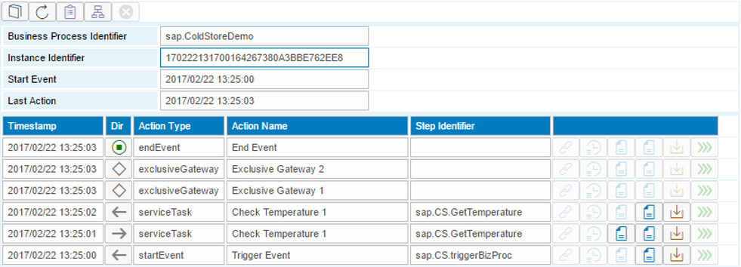

The monitor displays the business process identifier the instance identifier, the timestamp of the start event and the timestamp of the last action. You have the following functions available:

* Display the execution plan
* Display the status in process modeler
* Cancel the business process instance

The details monitor displays information about the actions of the business process from bottom to top.

| **Icon** | **Description** |
| --- | --- |
|  | Incoming event in the business process |
|  | Outgoing event |
|  | Exclusive or inclusive gateway |
|  | End event of business process instance |
|  | Canceled by user |
|  | Exception in business process instance |
|  | Timeout trigger |
|  | Filtered incoming event or task. Per the execution plan, the entry is not possible, however, a message arrived. |

 Display Correlation Identifier

The correlation identifier is used to associate an incoming receive task message to an instance of a process. Set the identifier in the send task.

 If you have defined a timeout for the next task of the business process, display the timestamp of the timeout.

 Display the inbound or outbound document of the task.

 Debug Scenario Step

If debugging is enabled for the scenario step that performs the task, click the button to open the transaction ID panel. You have several options available, to obtain details about the scenario step processing and you can debug the process phase of the scenario step.

## 4.5 Displaying the Execution Plan

For a business process instance, the execution plan displays all execution semantics, such as actions, tasks, events, gateways, and so on, and indicates with the lock and unlock icon if the inbound is currently open or closed. Depending on the flow definition and parallel processing, an execution semantic can be open several times. The *#Open Inbound* field displays the number of currently open execution semantics.

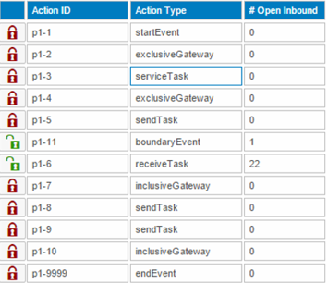

## 4.6 Displaying Instance Processing in the Process Monitor

In the process monitor, you can display the progress of a business process instance. The monitor uses the business process model to display the path or paths the instance takes.

In the first picture below, the business process instance is completed. The monitor displays processed elements in green. The conditions are available in such a way that the instance does not run through most elements.

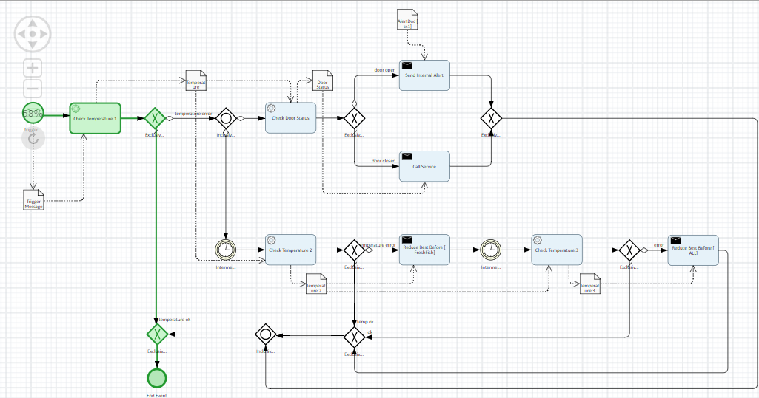

In the picture below, another instance of the same business process meets different conditions that let the instance run through almost all elements. The business process instance is also completed.

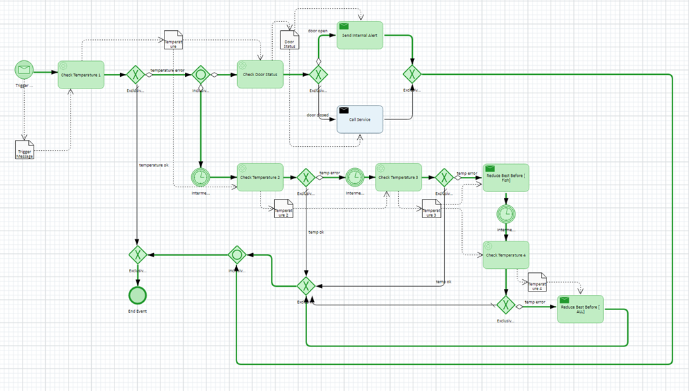

* Double-click tasks representing scenario steps, you can display the Transaction ID Panel. From the panel, you can display the scenario step debugging for further analysis.
* To display the value of a data object, double-click the data object.

# Copyrights, Trademarks, and Disclaimers

© Copyright 2019 SAP SE. All rights reserved.

The current version of the copyrights, trademarks, and disclaimers at <https://www.sap.com/about/legal/copyright.html> is valid for this document.