**Integration Framework**

**Cloud Integration Landscape**

**iPaaS Controller and iPaaS Clients**

**Last Modified: Mai 26, 2020**

1 Getting Started with the Cloud Integration Landscape 3

1.1 Target Audience 3

1.2 Container Cluster and Components Definitions 3

1.3 SAP Business One Cloud Control Center 4

1.4 SAP Business One Databases 5

1.5 Communication Between iPaaS Controller and Clients 6

1.6 SAP Business One Event Handler 6

1.7 How Data Synchronization Works 6

2 Initial Configuration of the Integration Landscape 7

2.1 Introduction to iPaaS Controller Landscape Functions 7

2.2 Selecting Cloud Operation Mode and Connecting to Tenant Shell 8

2.3 Connecting to and Synchronizing with Cloud Control Center 9

2.4 Data Management 10

2.4.1 Configuring the SMTP Server 11

2.4.2 Administering Customers 12

2.4.3 Administering Partners 13

2.4.4 Administering SAP Business One Common and Company Databases 13

2.4.5 Defining Filters for Data Administration and Synchronization 15

2.5 Requesting and Synchronizing iPaaS Clients 15

2.6 Working with the Synchronization Inbox 16

2.7 Deleting iPaaS Clients 16

3 Tasks after Initial Landscape Configuration 17

3.1 Setting Up Regular Synchronization 17

3.1.1 Setting Up Regular Synchronization with Cloud Control Center 17

3.1.2 Setting Up Regular Synchronization to iPaaS Clients and Controller SLD 17

3.2 Regular Tasks for Stand Alone Operation Mode 18

3.2.1 Adding Customers to a Partner 18

3.2.2 Adding Partners and Associated Customers 18

3.3 Using iPaaS Client Administration Details 19

3.4 Monitoring Access Through iPaaS API 20

3.5 Accessing iPaaS Clients in Support Cases 21

4 iPaaS Controller and Client Monitors 21

4.1 iPaaS Controller Service Monitor 21

4.2 SAP Business One Event Handler Console 21

4.2.1 Event Handler Overview 21

4.2.2 Elements of the Event Console 24

4.2.3 Configuring the Event Handler 24

4.2.4 Configuring Technical Steps 25

4.2.5 Displaying Log Information 25

4.2.6 Displaying Entries in SEVT Tables 25

4.2.7 Displaying the XML Documents 26

4.2.8 Configuring the Timer for Event Retrieval 26

4.3 Monitoring Queues 26

5 iPaaS Administration in iPaaS Clients 26

5.1 Registering at the iPaaS Controller and Giving Access to Support 27

5.2 Requesting SLD Entries for SAP Business One Companies 27

5.3 Customer Data and Scenario Packages Across iPaaS Clients 28

5.4 Uploading SAP Integration Content 28

Copyrights, Trademarks, and Disclaimers 29

# 1 Getting Started with the Cloud Integration Landscape

## 1.1 Target Audience

The guide provides information for cloud operators who set up the integration landscape in the SAP Business One cloud. Section 5 of the guide is relevant for partner administrators.

## 1.2 Container Cluster and Components Definitions

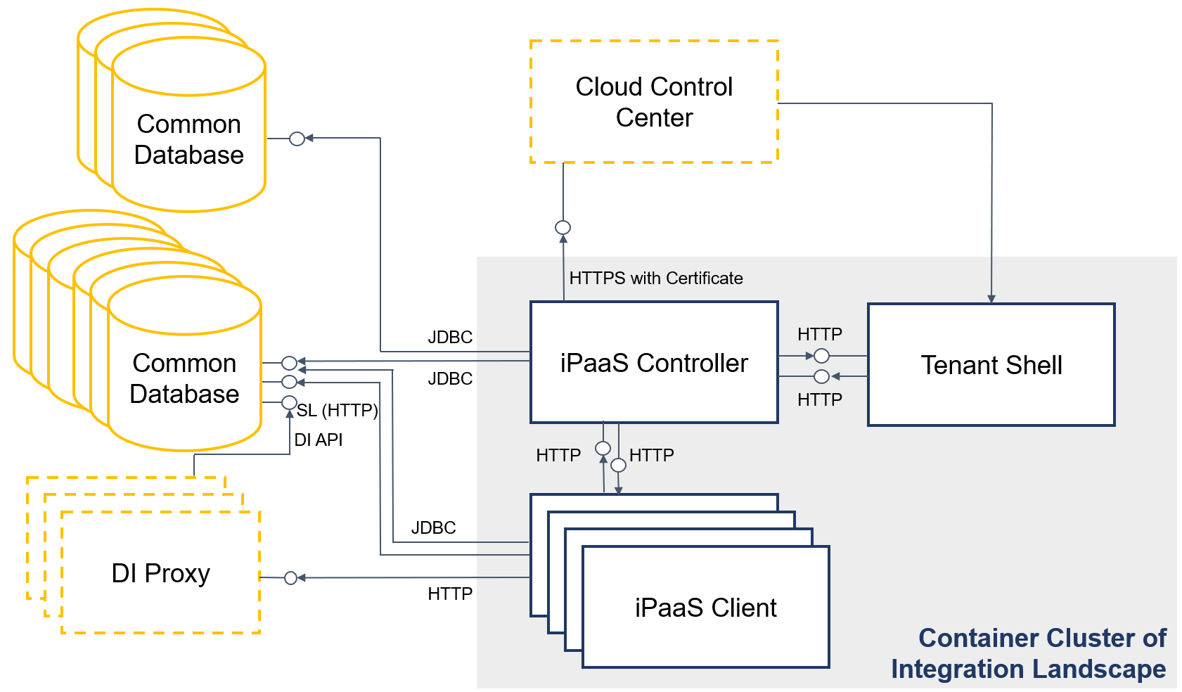  
SAP Business One and Integration Landscape Components

**Container Cluster**

The container cluster of the integration landscape consists of tenant shell, the iPaaS controller and iPaaS clients. Communication between components of the container cluster is encrypted.

**Tenant Shell**

Tenant shell is a lifecycle management and orchestration tool for the container cluster. During first landscape setup, tenant shell does the following:

* Creates the reverse proxy for access to the container cluster from outside.

The reverse proxy is not part of the illustration above

* Creates the iPaaS controller
* Creates, updates or deletes iPaaS clients upon request

The tenant shell REST API allows the iPaaS controller, for example, to request new, delete and back up iPaaS clients.

**iPaaS Controller**

The integration Platform as a Service (iPaaS) controller is the central landscape component that communicates with all other components, for example, the SAP Business One Cloud Control Center, tenant shell and the iPaaS clients that are integration frameworks of partners. The controller performs the following tasks:

* Synchronizes frequently with the cloud control center and keeps information about SAP Business One, databases, credentials, customers, resellers and their relationships up to date.
* Synchronizes frequently with iPaaS clients and sends CRUD (create, read, update, delete) events to clients to update customer data and SAP Business One company databases.
* Subscribes to shared resources, such as SAP Business One events, SAP ERP IDocs, and so on, and distributes the events to iPaaS clients that use the events to trigger scenario steps with SAP Business One inbound.

The iPaaS controller is a special integration framework for the integration landscape administration with specific monitoring functions.

**iPaaS Client**

The integration Platform as a Service (iPaaS) client is an isolated integration framework for a partner or reseller. The partner uses the integration framework to run integration scenarios for customers. A reseller or partner can run more than one iPaaS client. The iPaaS client accesses the assigned customer SAP Business One company databases using JDBC, DI API or the service layer.

* The iPaaS administration function in the Maintenance menu allows registering the iPaaS client at the iPaaS controller. The registration is required to update the client with customer and SAP Business One information, such as, new company databases or SAP Business One events. The function allows a partner administrator to request credentials of SAP Business One company databases for customers.
* The synchronization inbox contains changes coming from the iPaaS controller about customers and SAP Business One SLD entries. The administrator can apply or ignore the changes.

All other functions for on premise and cloud are identical.

## 1.3 SAP Business One Cloud Control Center

To set up and run the integration landscape, connect to the SAP Business One Cloud Control Center. Load and regularly update information about SAP Business One common and company databases, customers and resellers through the SAP Business One SLD service API.

However, using the cloud control center is optional. You can also manually add the required SAP Business One landscape information, the resellers and customers to the iPaaS controller. The integration landscape does not require and does not consider service units.

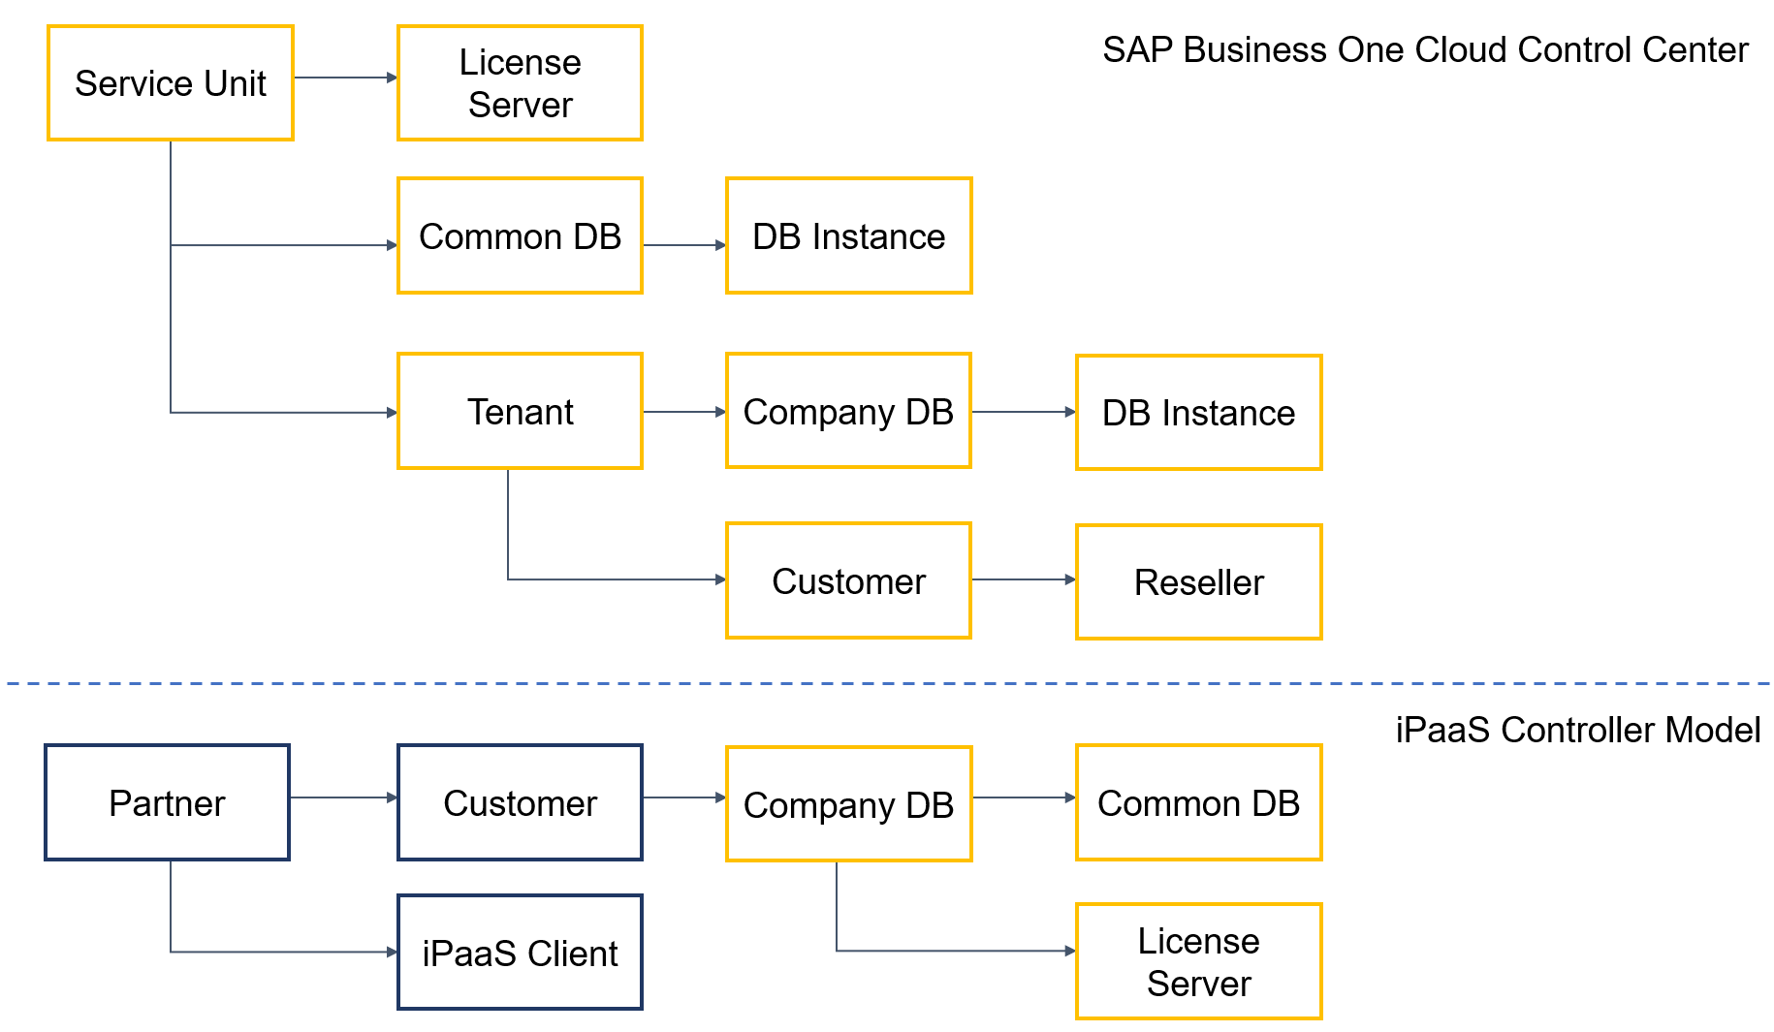  
Models

The upper part of the illustration displays the entities of the SAP Business One Cloud Control Center. The iPaaS controller retrieves the information but maps it to a simpler model that meets the integration requirements. The partner is the reseller of the cloud control center. A partner can run one or more iPaaS clients. The partner has customers that run integration scenarios. A customer is related to an SAP Business One company database. The company database is connected to a common database and a license server.

The model supports the following use cases:

* Several SAP Business One systems with several common databases
* A partner can run several iPaaS clients
* A customer can belong to more than one iPaaS client

## 1.4 SAP Business One Databases

The iPaaS controller must have JDBC access to all SAP Business One common and company databases in the cloud. All SAP Business One systems must be part of the iPaaS controller SLD. In the iPaaS clients, the synchronization provides the company database SLD entries of the customers.

When using the SAP Business One DI API in integration scenarios, make sure that you set a password for the user in each company database that you want to connect to. By default we recommend using the existing B1i user and setting the same password in each company database. This user is excluded from the B1 event mechanism.

Ensure that the SAP Business One B1i user has been assigned with the following two (free) licenses:

* B1iINDIRECT_MSS
* B1i

## 1.5 Communication Between iPaaS Controller and Clients

The iPaaS controller and the iPaaS clients communicate through an internal API.

**iPaaS Controller API Methods**

| **Method** | **Description** |
| --- | --- |
| register | Registers the iPaaS client at the iPaaS controller |
| ping | Pings the iPaaS controller to check the connection |
| PaaSSubscriber | If a scenario step of an iPaaS client uses SAP Business One inbound triggered by SAP Business One events, the iPaaS client subscribes at the controller to enable the creation and obtain the relevant SAP Business One events. |
| setb1httpclt | Set the B1 system for http calls |
| scenlist | Get the scenario list |

**iPaaS Client API Methods**

| **Method** | **Description** |
| --- | --- |
| event | Sends an SAP Business One event to the subscribed iPaaS client to trigger a scenario step. |
| getsceninfo | Gets scenario information |
| getsld | Gets information about an SAP Business One SLD entry |
| setsld | Sets information for an SAP Business One SLD entry |
| setsmtp | Synchronizes SMTP server and e-mail settings for the Request New Password process |
| setcust | Synchronizes customer information |
| ping | Pings the iPaaS client |

## 1.6 SAP Business One Event Handler

The SAP Business One event handler takes care of the creation and distribution of SAP Business One events for integration scenarios that use SAP Business One inbound. The event handler connects to SEVT tables of the SAP Business One cloud landscape. In cloud landscapes, the event handler replaces the event sender that can only connect to one SAP Business One system. Do not use the event handler and the event sender at the same time.

## 1.7 How Data Synchronization Works

The iPaaS controller has customer, partner and SAP Business database **data pools**. The data comes either from the SAP Business One Cloud Control Center or the administrator adds the data manually to the data pools. Not all details, especially for SAP Business One SLD entries come from the cloud control center. The administrator can adjust and add information to the data pool.

The **synchronization** distributes the data to the iPaaS clients, except for the SAP Business One SLD entries. For SLD entries, the iPaaS client administrator can request the data. However, the synchronization adds the SAP Business One SLD entries to the iPaaS controller SLD. The iPaaS controller requires working JDBC connections to all common and company databases to handle SAP Business One events.

Data changes from cloud control center are displayed in the **synchronization inbox**. The administrator can decide to apply the changes to the data pools or ignore them. Applied changes become part of the data pool for synchronization.

After synchronization to the iPaaS clients, the iPaaS client administrator finds new customer entries in the customer function. The administrator can request SAP Business One company SLD entries from the controller. Incoming data changes are displayed in the **synchronization inbox**. The administrator applies changes to the customer function and SLD entries or ignores the changes.

# 2 Initial Configuration of the Integration Landscape

## 2.1 Introduction to iPaaS Controller Landscape Functions

After installation and initial setup on operating system level, the iPaaS controller is available in the integration landscape and you can log on to the controller. Integration landscape administration functions are part of the Landscape menu. The required configuration steps to initially set up the integration landscape depend on whether you use the SAP Business One Cloud Control Center in your system landscape or run the landscape stand alone.

**Setup with the SAP Business One Cloud Control Center**

1. In iPaaS Administration, select the option to synchronize with SAP Business One Cloud Control Center.

Configure and test the connection to tenant shell.

1. In B1 CCC Administration, configure and test the connection to cloud control center.

Download service units, resellers and customers.

You can find new entries in the Data Administration section of the data management function.

1. In Data Management, check and adjust the reseller, customer information and SLD entries of SAP Business One systems. Configure SMTP settings. In data management, you find the data pools for partners, customers and SAP Business One SLD entries.
2. In iPaaS Client Administration, request iPaaS clients for partners.

The controller sends an e-mail with the iPaaS client URL and intial credentials to the iPaaS administrator of the partner.

1. Ask the iPaaS client administrator to log on to the iPaaS client and register the client at the iPaaS controller.
2. In Data Management, synchronize data to the iPaaS clients and the SLD entries to the controller SLD.
3. In the controller SLD, check the JDBC section of the SAP Business One entries and test the connections.

**Stand Alone Setup (without Cloud Control Center)**

1. In iPaaS Administration, select the option to run stand lone, configure and test the connection to tenant shell.
2. In Data Management, add reseller and customer information and enter SLD entries of SAP Business One systems.

Configure SMTP settings.

1. In iPaaS Client Administration, request iPaaS clients for partners.

The controller sends an e-mail with the iPaaS client URL and intial credentials to the iPaaS administrator of the partner.

1. Ask iPaaS client administrators to access the iPaaS client and register at the iPaaS controller.
2. In Data Management, synchronize data to iPaaS clients and the SLD entries to the controller SLD.
3. In the controller SLD, check the JDBC section of the SAP Business One entries and test the connections.

## 2.2 Selecting Cloud Operation Mode and Connecting to Tenant Shell

In the iPaaS controller administration, define to interact with the SAP Business One Cloud Control Center or to run the integration landscape stand alone.

For both options, configure the connection to tenant shell and ping tenant shell. Later, the iPaas controller uses the connection, for example, to request iPaaS clients for partners.

**Prerequisites**

* You know the user name and password of the connection to tenant shell. The credentials were created after starting tenant shell on Linux.
* You decided to run the integration landscape stand alone or connected to the SAP Business One Cloud Control Center.

**Procedure**

1. Choose *Landscape* → iPaaS Administration and in the Cloud Operation Mode field, select how you want to operate your integration landscape and then, save your settings:

* Linked to B1 Cloud Control Center
* Standalone

1. To connect the iPaaS controller to tenant shell, click Tenant Shell.
2. Enter the following information:

| **Parameter** | **Description** |
| --- | --- |
| Tenant Shell User | Enter the user name. The user was created during tenant shell start. |
| Tenant Shell Password | Enter the password. The password was created during tenant shell start. |
| Security Level | Select the security level for the connection between iPaaS controller and tenant shell. You have the following options:   * HTTPS with Encryption * HTTP   For a productive landscape, we recommend setting the security level to HTTPS with encryption. |

1. Save your settings, click Ping to test the connection to tenant shell and close the window.

**Results**

The iPaaS controller is connected to tenant shell.

## 2.3 Connecting to and Synchronizing with Cloud Control Center

When running together with the SAP Business One Cloud Control Center, enter connection parameters. Then, the function retrieves SAP Business One service units, customers and resellers. You can retrieve information manually or set up a timer for automated and regular synchronization.

**Prerequisites**

The SAP Business One Cloud Control Center administrator provided you with the required connection information and the certificate for server authentication, if required.

**Procedure**

1. To configure the connection to the SAP Business One SLD service API, choose *Landscape* → *B1 CCC Administration*.
2. Enter the following information:

| **Parameter** | **Description** |
| --- | --- |
| Server URL | Enter the server name or IP address of the SAP Business One Cloud SLD service API |
| Port | Enter the port of the SLD service API |
| Base Service | Enter the base service. The default is /sld/sld0100.svc |
| User | Enter the user name for access to the API |
| Password | Enter the password for access to the API. |
| Proxy Host | If you use a proxy server in the network to connect to the SAP Business One server, enter the IP address of a proxy server. Leave the field empty, if a proxy is not required. |
| Proxy Port | If you use a proxy, enter the port number. Leave the field empty, if a proxy is not required. |
| Security Level | Select the security level for the connection between iPaaS controller and the SLD service API. You have the following options:   * HTTPS with Encryption and Server Authentication   You need a valid certificate in the BizStore   * HTTPS with Encryption * HTTP   For a productive landscape, we recommend setting the security level at least to HTTPS with encryption |
| Truststore File Available | A selected checkbox indicates that the truststore file for a secure connection is available in the iPaaS Controller BizStore. |

1. If Truststore File Available is not selected but you want to use https with encryption and server authentication, click save and then Certificate. You have the following options to load a certificate:

| **Option** | **Procedure** |
| --- | --- |
| 1. Load Keystore (jks) with Certificate from File System | In the File in JKS Format field, click Browse, select the file and click Submit. |
| 2. Load Keystore (jks) with Certificate from BizStore | Select the dataset, the group, the document and click *Load* |
| 3. Create Keystore (jks) based on Certificate (.der Format) in File System | In the File in JKS Format field, click Browse, select the file and click Submit. |
| 4. Create Keystore (jks) based on Certificate (.der Format) in BizStore | Select the dataset, the group, the document and click *Load* |
| 5. Create Keystore (jks) based on Pasting Certificate (.der Format) | Copy the certificate information and paste it to the *.der Certificate* field and click *Load* |

1. After setting up the secure connection, choose iPaaS Administration and click Restart to apply the new settings.
2. Go back to the B1 CCC Administration and to test the connection to the SAP Business One SLD Service API, click Ping.
3. To synchronize SAP Business One service units, customers and resellers from cloud control center to the iPaaS controller, click Synchronize and in the Metadata Synchronization window, click Synchronize.

The function displays the last synchronization timestamp of service units, customers and resellers.

**Results**

The synchronized information is available in the following functions of the Landscape menu:

* To display resellers (partners), choose *Landscape* → Data Management → Partner Administration, and click Edit.
* To display customers, choose *Landscape* → Data Management → Customer Administration, and click Edit.
* To display information about the SAP Business One system landscape, choose *Landscape* → Data Management → B1 SLD Administration , and click Edit.

The information from the cloud control center is available in the BizStore:

com.sap.b1i.system.paas.controller/directory

* ccc.resellers.xml
* ccc.serviceunits.xml
* ccc.customers.xml

## 2.4 Data Management

In data management, administer partners, customers and SAP Business One SLD entries. Set up the connection to an SMTP server that is part of your cloud landscape. After working on customer, partner and SAP Business One SLD entry pools, synchronize data to the iPaaS clients.

### 2.4.1 Configuring the SMTP Server

To support the password reset process for iPaaS clients and the e-mail notification informing partners about a new iPaaS client, connect to an SMTP server in your cloud landscape. Configure the connection to the SMTP server and define the e-mail content that users get in the password reset process.

The SMTP connection and e-mail information are distributed to all iPaaS clients.

**Procedure**

1. To configure the SMTP parameters and e-mail information, choose *Landscape* → Data Management → *SMTP Configuration*.
2. Enter the following information:

| **Parameter** | **Description** |
| --- | --- |
| SMTP Protocol | Select a protocol:   * SMTP (Plain) * SMTP (SSL) * SMTP (TLS) |
| SMTP Server | Enter the server name or IP address. |
| SMTP Port | Enter the SMTP port |
| SMTP User | Enter the user name to access the SMTP server. If the server does not require authentication, leave the field empty. |
| SMTP Password | Enter the password for SMTP server access. If the server does not require authentication, leave the field empty. |
| Sender E-Mail Address | Enter the sender e-mail address of the outgoing e-mail. |
| E-Mail Subject for Password Reset | Enter the subject, for example:  Integration Framework - Your password reset request |
| E-Mail Textfor Password Reset | Enter the e-mail text.   * Use /n for a line break. * Use the following variables: * $fullName to add the Full Name value of the user defined in Maintenance → User Administration → Admin Users. * $host to add the domain host name * $newPwd for the new temporary password |
| Trusted Host | You can add the name of the e-mail server to the list of trusted hosts. If the e-mail server requires a certificate for a secure connection, you do not need to import the certificate to the Java keystore. To add the name of the e-mail server to the list of trusted hosts, select true. |

1. Save your settings, click Test E-Mail and enter the receiver e-mail address to test your settings.

**E-Mail Example**

Dear Mrs./Mr. $fullName\n\nYou requested to reset your password for the Integration Framework on $host.\nYour new temporary password is \n\n $newPwd\n\n Please log on and change your password now.

Subject: Integration Framework - Your password reset request

Dear Mrs./Mr. Test User

You requested to reset your password for the Integration Framework on xxxxxx-xxxxx.smbintegration-ondemand.com.

Your new temporary password is

65%h(/23x

Please log on and change your password now.

### 2.4.2 Administering Customers

**Function in iPaaS Controller**

In the iPaaS controller, enter customer information, if you run the integration landscape stand alone. If you synchronize with the SAP Business One Cloud Control Center, use the function to check the customer information. The function contains the customer pool for the integration landscape.

**Function in iPaaS Clients**

In iPaaS clients, a deployment is a customer-specific setup and activation of a scenario package. You can assign the customer to deployments.

**Procedure**

1. To create a customer record, choose Maintenance or Landscape → Data Management → Customer Administration.
2. Click the Create Customer button and enter a company name.

For internal purposes, the integration framework adds a company ID.

1. Enter the address, contact information and save your settings.

Local Customer is selected, if the customer is not synchronized with the SAP Business One Cloud Control Center.

1. To display a picture loaded by the customer API, click the Open Attachment button.
2. To display scenario packages deployed for the customer, click .

The customer scenario information displays package information and the number of messages in package-related queues.

1. To display the SAP Business One company SLD entries assigned to the customer, click SLD Entries.

**Results**

**iPaaS Controller**

Assign customers to partners.

**iPaaS Clients**

In the deployment panel, assign a customer to a deployment. In the transaction monitor, you can select transactions processed for a customer. In the scenario queue monitor, you can display details about scenario package-based queues of the customer.

### 2.4.3 Administering Partners

If you do not synchronize with the cloud control center but run the integration landscape stand alone, enter partner (reseller) information.

When running with cloud control center, the partner information is provided to you. Check the data and add the partner development prefix for distribution to iPaaS clients of the partner. This function contains the partner information pool of the integration landscape.

**Procedure**

1. To enter partner information, choose *Landscape* → Data Management → *Partner Administration*, and click Edit.
2. Enter the following information:

| **Parameter** | **Description** |
| --- | --- |
| Company Name | Enter the company name |
| Company ID | The function displays the partner identifier |
| Street and House Number | Enter street name and number |
| Zip Code and City | Enter Zip code and city |
| Country | Select the country |
| Contact Person | Enter a contact person |
| Telephone Number | Enter the telephone number |
| E-Mail | Enter the e-mail address |
| Category | Select to either have a test or a productive partner |
| Development Prefix | Enter the partner development prefix for scenario development. Enter a short prefix. You only have limited space available for scenario package and step names. Do not use a point (.) as part of the prefix. |
| Local Partner | A selected checkbox indicates that the partner was added manually and was not synchronized with the cloud control center. |

1. Click Customers to assign customers to the partner.
2. In the user interface, click  (Add Customer Assignment) and select a customer.

You can also delete assignments.

1. Later, you can click iPaaS Clients to display the assignment of iPaaS clients to the partner.

### 2.4.4 Administering SAP Business One Common and Company Databases

The iPaaS controller requires all information about SAP Business One common databases, company databases and credentials of the JDBC section in the cloud integration landscape. All SAP Business One common and company database information must become part of the controller SLD.

The controller prepares the information for iPaaS client SLDs enabling the correct distribution of SAP Business One events to subscribed integration scenarios in iPaaS clients and connecting integration scenarios to the company databases.

* When running with the cloud control center, the SAP Business One common and company databases are available in the iPaaS controller after synchronization. Some credentials do not come from the cloud control center and you must add them manually.
* When running in stand-alone mode, enter the SLD entries and perform the data synchronization to make SLD entries available for iPaaS clients that request them and to synchronize the SAP Business One SLD entries to the controller SLD.

The function contains the SAP Business One SLD entry information pool of the integration landscape.

**Procedure with Cloud Control Center**

1. To get an overview of SLD entries and assigned system IDs, click Overview.

The function displays common and company databases with their indentifiers.

1. To administer SAP Business One systems of the integration landscape, choose Landscape → Data Management → B1 SLD Administration, and click Edit.
2. For each SAP Business One common and company database, click Credentials, check the entries, and add entries.
3. Check the customer association and display customer details, if required.

**Procedure without Cloud Control Center (Stand Alone)**

1. To administer the SAP Business One systems of the integration landscape, choose Landscape → Data Management →B1 SLD Administration and click Edit.
2. To add an SAP Business One system, click  (Add SAP Business One System).

The integration framework creates a line for the SAP Business One common database.

1. Click Credentials and in the SLD Credentials window, enter the credentials of the common database and close the window.
2. In the B1 System (SBO COMMON) line, click  (Add Company Database) and Expand.

The integration framework creates a line for the SAP Business One company database.

1. Click Credentials and in the SLD Credentials window, enter the credentials of the SAP Business One company database.
2. Repeat the above steps for all company databases.
3. Create the next SAP Business One system.
4. For each company database, select the customer in the Associated Customer field. Click Details to display customer information.

**Results**

You defined all SAP Business One systems with common and company databases. You assigned a customer to each company database.

### 2.4.5 Defining Filters for Data Administration and Synchronization

You can define filter settings for the partner, customer, service units and SAP Business One SLD entry data pool. The filters are valid for the data administration **and** synchronization.

**Procedure**

1. To define filters, choose Landscape → Data Management and click the Edit button for partners, customers, service unit or SAP Business One company databases.
2. In the list, select the entries that you want to filter on and close the window.

Filters are set for data administration and synchronization.

1. In partner, customer and B1 SLD administration, the  icon indicates that filters are set. Click the icon to reset the filters.

## 2.5 Requesting and Synchronizing iPaaS Clients

In the iPaaS client administration function, you can request new or back up iPaaS clients. Requesting a client is a call to tenant shell to create a new iPaaS client. The function adds the new client to the iPaaS administration. Assign a partner to the client and ask the client administrator to register the client at the controller.

Note that the first entry in the list is always the iPaaS controller.

**Procedure**

1. To create an iPaaS client, choose Landscape → iPaaS Clients and click  (Deploy iPaaS Client).

The iPaaS controller requests a new iPaaS client at tenant shell and adds a line to the iPaaS client administration as soon as the client is available.

1. In the Partner Assignment field, select a partner. In the iPaaS Client field, enter a name or description for the client.
2. Provide the iPaaS client administrator with the connection information, the user name and a temporary password. Alternatively, the partner gets an e-mail notification.
3. Ask the administrator to log on to the iPaaS client, choose Maintenance → iPaaS Administration and click the Register button.

In the iPaaS client administration of the iPaaS controller, the iPaaS client is updated with the registration timestamp and actions for the iPaaS client are enabled.

1. To verify the registration, click  to ping the iPaaS client.
2. To provide the iPaaS client with data, choose Landscape → Data Management, in the Data Synchronization section, set Manual Synchronization by to iPaaS Client, select the iPaaS client in the Manual Synchronization by field and click Open in the Manual Synchronization field.

Note that filter settings also apply.

1. The Data Synchronization function displays SLD entries that are going to be synchronized with the controller SLD. The SLD entries are also ready to be requested by iPaaS client administrators. Then the function displays synchronization data of your manual selection and possible filter settings.
2. Expand all entries, select or deselect entries for synchronization, select or deselect all.
3. To synchronize SLD entries with the controller SLD and synchronize data to the iPaaS clients, click Synchronize.

**Results**

Customer information is synchronized to the iPaaS clients. The partner administrator can request the relevant SAP Business One SLD entries from iPaaS controller.

## 2.6 Working with the Synchronization Inbox

In the synchronization inbox, you find details about incoming **changes** from the cloud control center. To give you control about changes, open the inbox after synchronization with cloud control center and descide about applying or ignoring the changes.

New data from cloud control center are directly added to the information pools for customers, partners and SAP Business One SLD entries.

The inbox displays one line for each synchronization and category. Categories are the following:

* sld for SAP Business One SLD entries
* cus for customers
* ptr for partners (only on the controller)

**Procedure**

1. To displays changes after synchronization, choose *Landscape* → *Inbox*.

On the iPaaS client, choose *Maintenance* → *Inbox*.

The function displays the timestamp, category and identifier for each change.

1. For each change, you can do the following:

* Click Details to display the details of the changes with the value in the pool and the new value coming from cloud control center.
* For each detail, you can either click Apply to apply the change or Ignore to ignore the change.

Applied changes are added to the information pools.

* Ignored changes are written to the change history.
* Click the History button to restore previously ignored changes.

1. You can also apply or ignore the changes from the synchronization inbox without displaying the details.

**Results**

Applied changes become part of the next synchronization to the controller SLD and the iPaaS clients. On the iPaaS clients, changes are written to the customer function and the SLD.

## 2.7 Deleting iPaaS Clients

If an iPaaS client is no longer required or you accidentially assigned an iPaaS client to the wrong partner, remove the iPaaS client using tenant shell.

For more information, see the Administratior’s Guide Integration Framework for Cloud

**Procedure**

1. In the iPaaS Client Administration, Remove iPaaS Client Entry is only enabled, if the iPaaS client was deleted using tenant shell.
2. Click Synchronize in the Last Sync with Tenant Shell line. The function synchronizes with tenant shell and detects that the iPaaS client is no longer available. The Delete icon is enabled.
3. Click the Delete icon to remove the client from the list.

Also follow the procedure, if you accidentially assigned an iPaaS client to the wrong partner.

# 3 Tasks after Initial Landscape Configuration

## 3.1 Setting Up Regular Synchronization

### 3.1.1 Setting Up Regular Synchronization with Cloud Control Center

After initial synchronization with the cloud control center, set up a regular synchronization.

**Procedure**

1. To configure a regular synchronization with the cloud control center through the SAP Business One SLD service API, choose *Landscape* → *B1 CCC Administration* and click the Synchronize button.
2. Click Setup in the Automatic Synchronization line.
3. Add the timer configuration, save your settings and close the window.

To synchronize every two hours with the cloud control center, for example:

* Enter 0 in the Tens Seconds and Minute fields.
* Enter 0,2,4,6,8,10,12,14,16,18,20,22 in the Hour field.
* Enter * in all other fields.

1. Select Automatic Synchronization and close the window.

**Results**

The iPaaS controller synchronizes regularly with the SAP Business One Cloud Control Center. Regularly check for new entities in the function. You can obtain new service unit, reseller and customer information.

### 3.1.2 Setting Up Regular Synchronization to iPaaS Clients and Controller SLD

After initial synchronization to iPaaS clients and the controller SLD, set up a regular synchronization.

**Procedure**

1. To automate synchronization to iPaaS clients and the controller SLD, choose *Landscape* → *Data Management* and click Automatic Synchronization in the Data Synchronization section.
2. To define the regular synchronization, click Open for Setup of Automatic Synchronization.
3. Add the timer configuration, save your settings and close the window.

To synchronize every two hours with the cloud control center, for example:

* Enter 0 in the Tens Seconds and Minute fields.
* Enter 0,2,4,6,8,10,12,14,16,18,20,22 in the Hour field.
* Enter * in all other fields.

## 3.2 Regular Tasks for Stand Alone Operation Mode

### 3.2.1 Adding Customers to a Partner

To add a customer to a partner, do the following:

| **Task** | **Description** |
| --- | --- |
| Create customer record | Choose *Landscape* → Data Management → Customer Administration and click Edit. |
| Assign customer to partner | Choose *Landscape* → Data Management → *Partner Administration* and click Customers |
| Create SAP Business One company database entry and assign to customer | Choose *Landscape* → Data Management → *B1 SLD Administration* and create the SAP Business One company database, click Credentials, enter the credentails and assign the customer. |
| Synchronize data to iPaaS client | Choose *Landscape →* Data Management and synchronize the data to the related iPaaS client and the controller SLD. |

### 3.2.2 Adding Partners and Associated Customers

To add a partner and customers, do the following:

| **Task** | **Description** |
| --- | --- |
| Create customer records | Choose *Landscape* → Data Management → Customer Administration |
| Create partner record and assign the customers | * Choose *Landscape* → Data Management → *Partner Administration* and create the partner record. * In the partner administration, click Customers and assign the customers |
| Create SAP Business One databases and assign customers | * Choose *Landscape* → Data Management → *B1 SLD Administration* and create the SAP Business One common and company databases, click Credentials, enter the credetails and assign customers |
| Configure connection to the SMTP server | * Choose *Landscape → SMTP Server Configuration* |
| Synchronize data to iPaaS client | * Ask the partner to register * Choose *Landscape →* Data Management and synchronize the data to the related iPaaS client and the controller SLD. * For the iPaaS client of the partner, click Synchronize |

## 3.3 Using iPaaS Client Administration Details

The iPaaS Client administration provides an overview of iPaaS clients in the integration landscape. The information comes from tenant shell and from registrations of iPaaS clients at the controller.

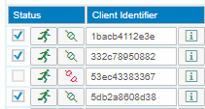

The status information gives you a first overview of clients in the integration landscape:

* Use the checkbox to disconnect the iPaaS client from the controller API.
* Tenant shell provides the first status information.
* A runner indicates that the client is deployed and running.
* An exclamation mark in a triangle indicates that the iPaaS client is not deployed.
* A bed indicates that the client is deployed and stopped.
* The second status gives more details, such as:
* The client is disconnected and not deployed
* The client is disconnected, deployed, but stopped
* The client is connected.

The third line in the illustration above displays a client that is running, but it is disconnected and not yet registered.

**iPaas Client Information**

To display details about an iPaaS client, click the Info button. The function displays contact information and technical details.

* To display information about client logins at the controller, click Logins.

You can filter by the number of messages that you want to display, by status and for a period.

* To display changes performed in the controller for the client, click Changes. Reduce the number of displayed messages and select the period time.

## 3.4 Monitoring Access Through iPaaS API

iPaaS clients and the iPaaS controller communicate through an internal API. The access to the API is active by default. The monitor offers information about the API activation status, login attempts, and transactions related to API access. In the monitor, you can enable logging and display logs available around the API access.

**Procedure**

1. In the iPaaS controller, choose *Landscape* → iPaaS Administration and click Monitor.

In the iPaaS client, choose *Maintenance* → iPaaS Administration and click Monitor.

1. To deactivate access to the API, click Deactivate.
2. To clear the cache of values obtained from the file system about the container cluster, click Clear Cache.
3. To configure the production of log information, click Open in the API Configuration section and set the following:

| **Parameter** | **Description** |
| --- | --- |
| Transaction Log Level | Select the log level to determine the amount of logging information that you require:   * durable   Records all information of the transaction (previously the only option available)   * transient   Transactions are still completely traceable, but a temporary outdated state can happen   * anemic   Transactions that need a proof that they were processed but do not need a per-instance traceability   * spooky   No transaction logs |
| Transaction Debug Information | Switch the production of debug information on or off |
| Log Level | Switch the log on or off |
| Log Record Number | Enter the maximum number of log entries until the oldest log entry is overwritten |
| Authentication Log | Switch the log for authentication transactions on or off |

1. To activate the log settings, click Activate and close the window.
2. You can display the following information:

| **Function** | **Description** |
| --- | --- |
| Last Login | Displays detailed information about each iPaaS client’s last login to the iPaaS controller API |
| Settings and Environment Variables | Display environment details |
| Transaction Status | Displays the status. Click Open to display details and error handling information |
| Transaction List | Display the transaction ID panel for API-related transactions |
| API Log Information | Display API log information. You can select the number of records that you want to display, the log status, logs for a specific iPaaS client and API method.  To export log information in support cases, click Export |

## 3.5 Accessing iPaaS Clients in Support Cases

If iPaaS client administrators require assistance, they can enter an e-mail address of a support contact person in the Support E-Mail field of the iPaaS administration function and select Support Account Activated.

**Procedure**

1. In the iPaaS controller, choose *Landscape* → iPaaS Administration and click the Open Client Administration button.
2. In the User Name field, enter B1iSupport.
3. Click the Request New Password link.

**Results**

The user receives an e-mail with a temporary password to access the iPaaS client.

After the support case is completed, the iPaaS client administrator deselects Support Account Activated. The support user has no longer access.

# 4 iPaaS Controller and Client Monitors

## 4.1 iPaaS Controller Service Monitor

In the monitor, find iPaaS controller services, SAP Business One event handler services and common services. You can activate or deactivate each service. If the configuration icon is enabled, you can configure the service by, for example, setting a transaction log level, and display log information.

* Click the log icon to display the logs
* Click the Display Available Transactions icon to display the transactions for the service.

## 4.2 SAP Business One Event Handler Console

### 4.2.1 Event Handler Overview

In the cloud integration landscape, the SAP Business One event handler is responsible for SAP Business One event creation, retrieval and forwarding. The event handler replaces the event sender. Do not use both functions simultaniously. The event sender was designed for an on premise installation of SAP Business One for one customer.

* The event handler supports more than one SAP Business One common database.
* For the event handler, the definition of filter settings for event creation is not required. The handler triggers the event creation exactly for the events that iPaaS clients and other subscribers request.

All settings of the event handler are predefined. You do not have to enter any configuration information. The following sections are for your information and for support cases.

The event handler consists of two parts, one part runs in the iPaaS controller and the other part runs in each iPaaS client.

**Event Handler in the iPaaS Controller**

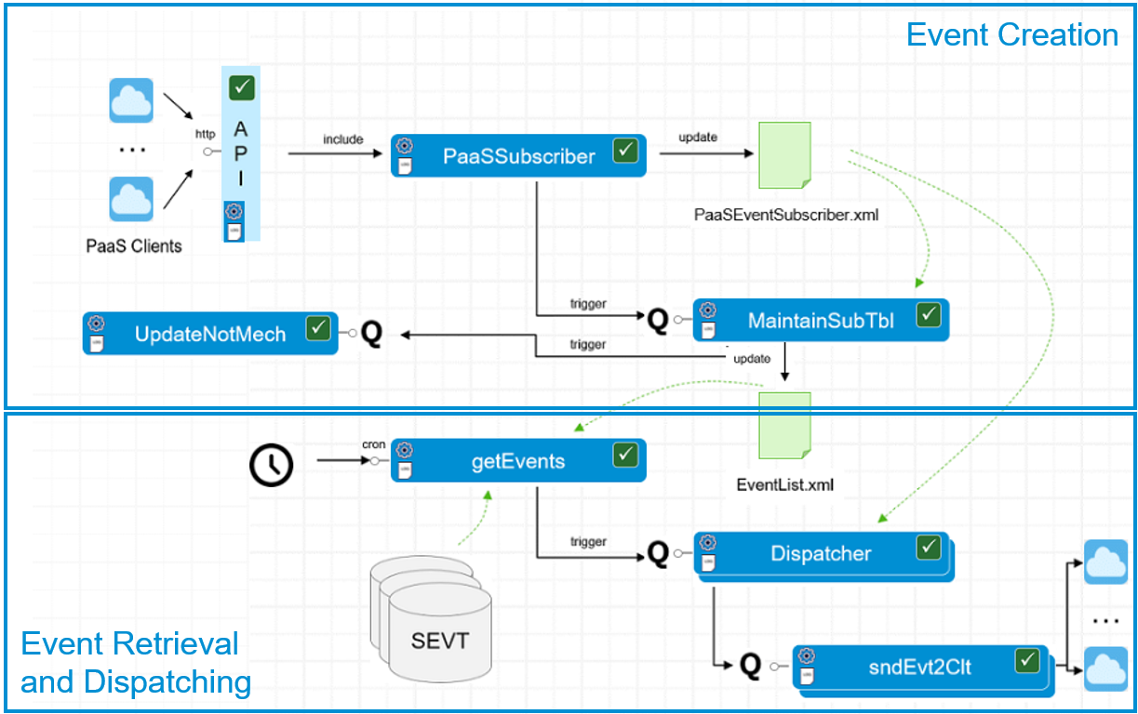

Event Console in iPaaS Controller

**Event Creation**

iPaaS clients call the iPaaS controller and hand over SAP Business One event subscription requests. The PaaSSubscriber technical step administers the event subscriptions, updates information about subscribers and hands over to the MaintainSubTbl technical step that updates the EventList.xml file. This technical step generates the event settings and generates the retrieval logic. The UpdateNotMech technical step updates the SCFG table in the SAP Business One common database and the CINF and CTNS tables in the affected SAP Business One company database with the information for event creation.

**Event Retrieval and Dispatching**

A configurable timer triggers the getEvents technical step that retrieves SAP Business One events from SEVT tables and deletes the events in the table. The Dispatcher technical step dispatches the events. The sndEvt2Clt step finally sends out the events to subscribed clients.

**Event Handler in iPaaS Clients**

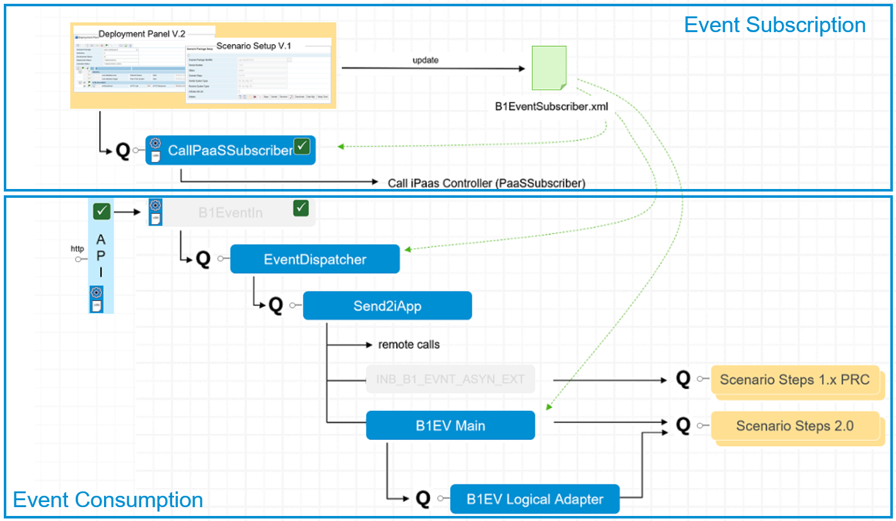   
Event Console in iPaaS Clients

**Event Subscription in iPaaS Clients**

When you activate scenario steps with SAP Business One inbound in framework version 1 or 2, you subscribe to SAP Business One events that trigger the steps. To enable the process, the handler writes information to a queue that triggers the CallPaaSSubscriber technical step. The step calls the iPaaS controller to hand over the subscription requests for event registration. Additionally, the event subscription is saved to the following BizStore file: com.sap.b1i.system.eventdispatcher.directory/B1EventSubscriber.xml/B1EventSubscriber.xml

**Event Consumption in iPaaS Controller**

The iPaaS controller sends SAP Business One events to subscribed iPaaS clients using the API. The EventDispatcher technical step dispatches events to iPaaS clients and to external consumers. The Send2iApp technical step hands over to INB_B1_EVNT_ASYN_EVT, SAP Business One inbound, framework version 1. The step also hands over to B1EventIn technical step. The step is the inbound B1 event service that runs on premise and in iPaaS clients. The step hands over to B1EVMain, the SAP Business One inbound for framework version 2 and finally to B1EVLogical Adapter, the logical inbound adapter of version 2.

In the event console, you can configure, monitor and troubleshoot the event handler

### 4.2.2 Elements of the Event Console

The event console displays processes for event subscription, event pickup and event dispatching. Each box represents a technical (IPO) step of the process. The box is blue, if the step is active and light grey, if the step is inactive.

For each technical step, you can do the following:



* Click the gearwheel to open the configuration user interface to activate or deactiate the step, activate log creation and set log levels.
* Click the file icon underneath the gearwheel to search for and display logs.
* Click the box to display available transactions for the technical step.

**Tasks of the Technical Steps in iPaaS Controller**

| **Technical Step** | **Task** |
| --- | --- |
| PaaSSubscriber | Maintains event subscriptions |
| UpdateNotMech | Updates notification service in B1 |
| MaintainSubTable | Generates B1 event setting and retrieval logic |
| GetEvents | Retrieves timer-triggered B1 events |
| Dispatcher | Locally dispatches events to iPaaS clients and to external consumers |
| sndEvt2Clt | Sends B1 events to iPaaS clients |
| ErrorHandler | Error handler for event handler services |

**Tasks of the Technical Steps in iPaaS Clients**

| **Technical Step** | **Task** |
| --- | --- |
| CallPaaSSubscriber | Calls iPaaS Servicer to register events |
| EventDispatcher | Locally dispatches events to iPaaS clients and to external consumers |
| Send2iApp | INB_B1_EVNT_ASYN_EVT: SAP Business One inbound, framework version 1 |
| B1EventIn | Inbound B1 event service, runs on premise and in iPaaS clients |
| B1EVMain | SAP Business One inbound framework version 2 |
| B1EVLogical Adapter | Logical inbound adapter for SAP Business One |
| ErrorHandler | Error handler for event handler services |

### 4.2.3 Configuring the Event Handler

In the event console configuration, you can do the following:

* Activate all transactions
* Deactivate all transactions
* Activate all transactions for deployment
* Export all log files for support cases

The function creates the ExportEDLog.zip file.

### 4.2.4 Configuring Technical Steps

In the IPO configuration of each technical step, you can set the following:

* Click Activate or Deactive to activate or deactivate the technical step
* For inactive steps, select the log level to determine the amount of logging information that you require:
* durable

Records all information of the transaction (previously the only option available)

* transient

Transactions are still completely traceable, but a temporary outdated state can happen

* anemic

Transactions that need a proof that they were processed but do not need a per-instance traceability

* spooky

No transaction logs

* For the log level, you can set the following:
* Log off
* Log results
* Log results and settings

The setting is only available for the UpdateNotMech step. It allows you to additionally log the settings of the notification mechanism.

* Enter the number of log records you want to obtain. The log file is a circular file. The first records is overwritten once the number of log records has reached predefined number.

### 4.2.5 Displaying Log Information

For each technical step, you can display log information, if you switched the log on in log configuration.

**Procedure**

1. To display log information, click the file icon in each blue box (technical step).
2. Change the display by defining the maximum number of records displayed, the status, and some more step-specific settings.
3. In each log table, you can click Export to export the log information to a zip file.

### 4.2.6 Displaying Entries in SEVT Tables

**Procedure**

1. To display entries in the SEVT table of the common databases, click the SEVT icon.
2. To display events, click Events.

The function displays the object ID and task.

1. To display subscribers of the events, click Subscriber.

The function displays the subscribers of the events.

### 4.2.7 Displaying the XML Documents

Click the XML documents, for example, EventList.xml to display the content of the document.

### 4.2.8 Configuring the Timer for Event Retrieval

Configure the timer for event retrieval.

**Procedure**

To make settings for regular retrieval of events from SEVT tables, click the clock icon in the event console.

To retrive events every two minutes, for example:

* Enter 0 in the Tens Seconds field.
* Enter 0,2,4,6,8,10,12,14,16,18,20,22,24,26,28,30,32,34,36,38,40,42,44,46,48,50,52,54,56,58, in the Minute fields.
* Enter * in all other fields.

## 4.3 Monitoring Queues

For more information, see the Operations Guide in the integration framework version 1 or 2 Help sections

# 5 iPaaS Administration in iPaaS Clients

If the integration framework runs for a partner in a cloud landscape, the partner integration framework is an integration Platform as a Service (iPaaS) client in the integration landscape.

The Maintenance menu contains the following additional entries:

* Use the iPaaS Administration function for the following tasks:
* Register at and connect the iPaaS client to the controller.
* Activate a user account for support cases.
* In the SAP Business One SLD administration function, request SAP Business One SLD entries for your customers.
* Get an overview of your customers that are running integration scenarios on other iPaaS clients.
* The Monitor provides detailed information about the internal API the controller and clients use for data exchange. For more information, see Monitoring Access Through iPaaS API
* Use the Synchronization Inbox to display, apply or ignore changes coming from the iPaaS controller.

## 5.1 Registering at the iPaaS Controller and Giving Access to Support

The partner administrator registers the iPaaS client (the integration framework) at the iPaaS controller to get landscape updates about customers, SAP Business One databases and SAP Business One events.

If you require support and want to give access to the integration framework, enter an e-mail address and activate the support account.

**Procedure**

1. To register at the iPaaS controller, choose Maintenance → iPaaS Administration and click Register.

The iPaaS client registers at the iPaaS controller and obtains information about customers, and SAP Business company databases.

1. To check the successful registration, click Ping. The function displays the API status.
2. To check the customers, choose Maintenance → Customers.
3. To allow access to a user for support purposes, enter the e-mail address of the user in the Support E-Mail field, click Support Account Activated and click Save.

From the iPaaS controller administration, the user can access the integration framework, log on and provide support.

1. After the support case is completed, deselect Support Account Activated and click Save.

The user has no longer access to the integration framework.

1. The iPaaS controller and the iPaaS client communicate through APIs. To monitor the API access, click Monitor. For more information, see the section Monitoring Access Through iPaaS API

## 5.2 Requesting SLD Entries for SAP Business One Companies

SAP Business One SLD entries coming from the cloud control center do not have settings for all parameters. The iPaaS controller only requires the JDBC sections configured and running. You can request the SAP Business One company SLD entries for your customers. After the request, they are part of your SLD and the SLD system identifier is displayed in the function.

**Procedure**

1. To request SAP Business One SLD entries for your customers, choose Maintenance → iPaaS Administration and click the B1 SLD Admin button.

The user interface displays your customers and the SLD entries that are available for your customers on the controller.

1. For SAP Business One SLD entries that you require for integration scenarios, click the Request button.

The entries are added to your SLD and the function displays the SysId.

1. Close the function and choose SLD to complete the SAP Business One SLD entries and test the connections.

## 5.3 Customer Data and Scenario Packages Across iPaaS Clients

A partner can run more than one iPaaS client and a customer can run integration scenarios on different iPaaS clients. In each iPaaS client, you can request the information about other iPaaS clients and the scenarios the customer runs in the other iPaaS clients.

**Procedure**

1. To display scenario packages deployed for a customer across iPaaS clients, choose Maintenance → iPaaS Administration and click the Scenarios button.
2. In the function, request the information about the customer and integration scenarios in other iPaaS clients.

## 5.4 Uploading SAP Integration Content

After installation, there is no integration content in the iPaaS client. To load your integration content to the iPaaS client, use the scenario import functions of version 1 and 2.

To load and run integration content delivered by SAP, use the Integration Content function of the Maintenance menu.

**Procedure**

1. To load or update integration content delivered by SAP, choose Maintenance → Integration Content.

The function displays the available integration content for framework version 1 and 2. The Countries field displays the validity of the scenario package. An asterisk (*) indicates that the package is valid for all countries.

1. To displays Details, click the button.

The function displays the model version, the scenario package identifier, country support, the package version, and so on.

1. If the package is already part of the BizStore, the Scenario Package Exists checkbox is selected. If SLD entries other than SAP Business One SLD entries are required for the package, the function displays the entries in the SLD Entries line.
2. To load te scenario package to the BizStore, click Import.
3. To create the required SLD entries in the iPaaS SLD, click Create.

## Copyrights, Trademarks, and Disclaimers

© Copyright 2020 SAP SE. All rights reserved.

The current version of the copyrights, trademarks, and disclaimers at <https://www.sap.com/about/legal/copyright.html> is valid for this document.