✦ COSMETIC
USER MANUAL
คู่มือการใช้งาน

Version | 1.0.0
Date | 2026-05-01
Prepared by | Development Team
Document type | User Manual — Public Site & Admin Panel

1. Introduction
This manual describes how to use the Cosmetic website — both the public-facing pages and the admin management panel.
คู่มือนี้อธิบายวิธีการใช้งานเว็บไซต์ Cosmetic ทั้งหน้าสาธารณะและแผงการจัดการสำหรับผู้ดูแลระบบ

Public URL | http://localhost:5173/
Admin URL | http://localhost:5173/admin/login
Languages | Thai (TH) / English (EN)
Browser | Chrome, Firefox, Edge (latest version)

2. Public Website
The public website is a single-page application. All content is on one page — use the navigation bar to jump between sections.

2.1 Navigation Bar

The navigation bar stays fixed at the top of the screen as you scroll. It contains:
• Brand name (left)
• Menu links: Home, Catalog, Products, Contact
• Language switcher button (right)

Step | Action | Expected Result
1 | Click any menu link (e.g. "Products") | Page scrolls smoothly to that section
2 | Scroll down the page | Navbar gets a white background and shadow
3 | Click "Home" | Page scrolls back to the top
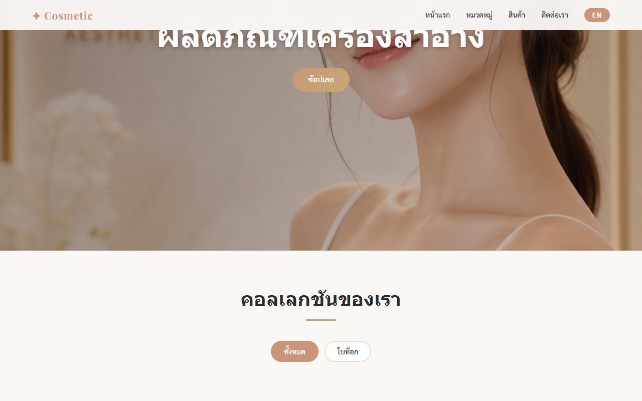

2.2 Language Switcher
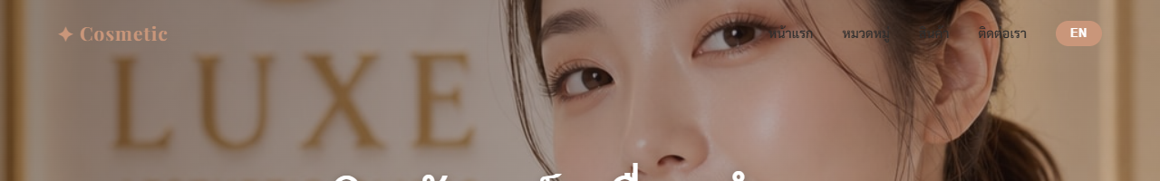
The website supports Thai and English. The language button is in the top-right corner of the navigation bar.

Step | Action | Expected Result
1 | Find the language button (shows "EN" when site is in Thai) | Button visible in navbar
2 | Click the button | All text switches to English. Button now shows "TH"
3 | Reload the page | Language stays as English (preference is saved)
4 | Click again to switch back | Text returns to Thai

📌 Note: Language preference is saved in your browser. It will stay the same next time you visit.

2.3 Banner Slider

The banner section is a full-screen image slideshow at the top of the page.

Step | Action | Expected Result
1 | Load the homepage | First banner image displays with title and subtitle
2 | Wait 4–5 seconds | Slider automatically advances to the next image
3 | Click the right arrow (›) | Advances to the next slide manually
4 | Click the left arrow (‹) | Goes back to the previous slide
5 | Click a dot at the bottom | Jumps directly to that banner
6 | Click "Shop Now" button | Page scrolls to the Products section


2.4 Category Filter
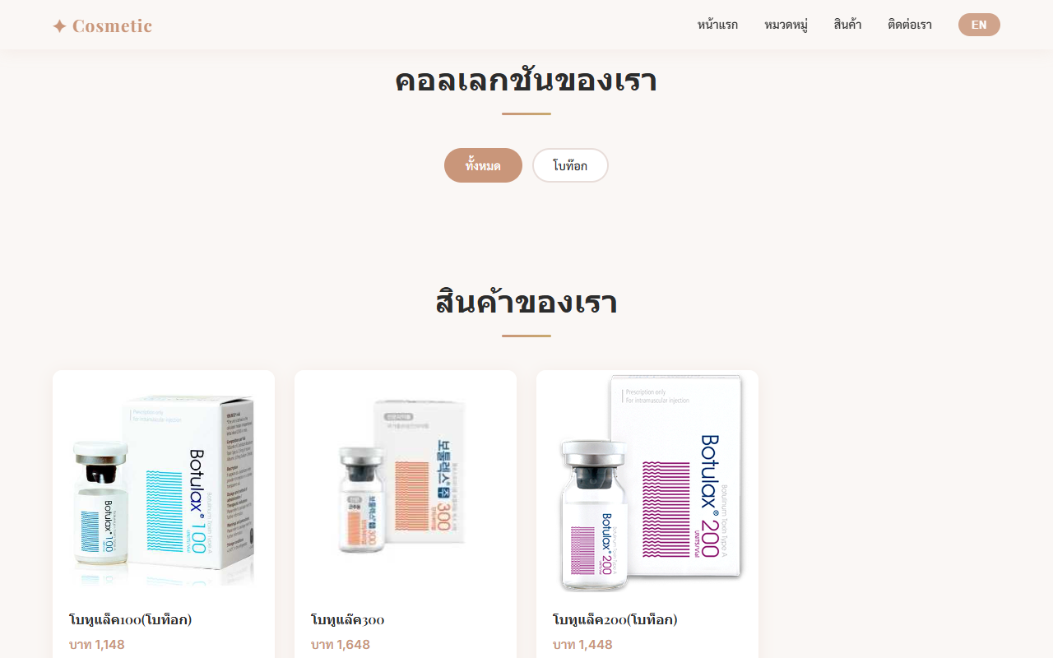
The catalog section shows product category buttons. Click a category to filter which products appear below.

Step | Action | Expected Result
1 | Scroll to the Catalog section | Category buttons (pills) are displayed
2 | Click any category (e.g. "Face Care") | Products grid updates to show only that category
3 | Click "All" | All products are shown again
4 | Active category | Selected button turns rose gold to show selection
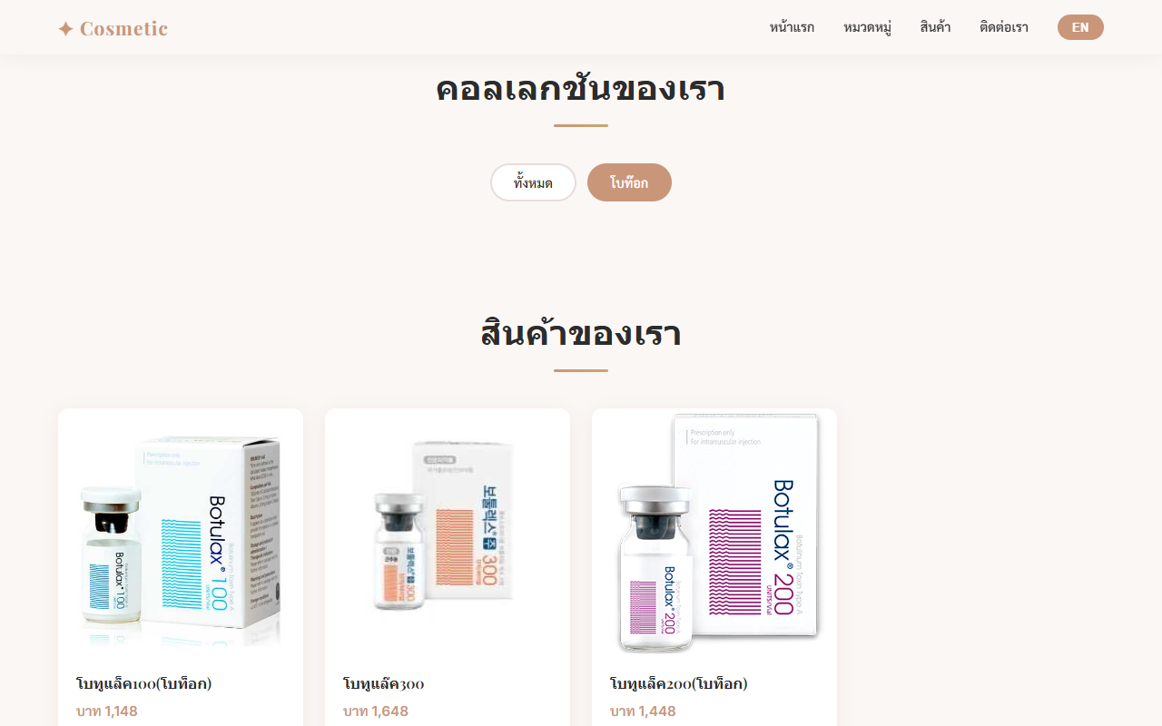

2.5 Product Grid
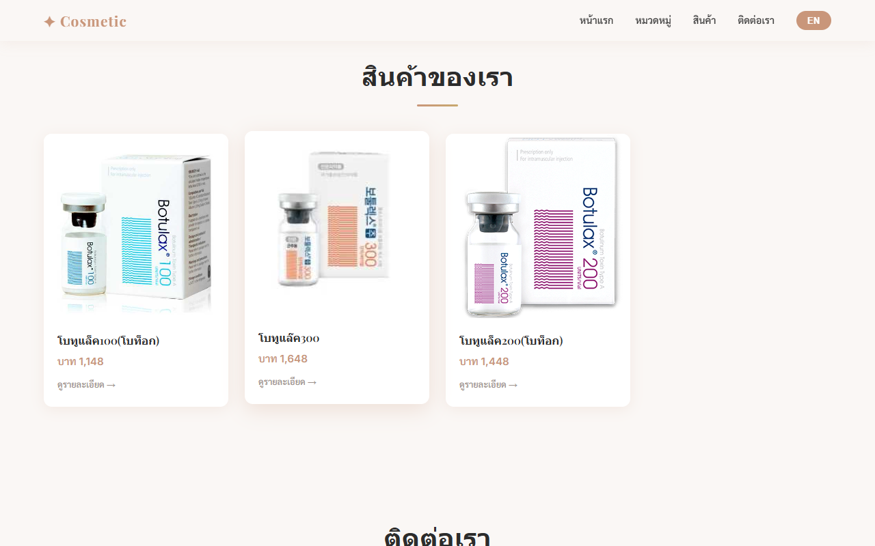
Products are displayed in a responsive grid. Each card shows the product image, name, and price (if available).

Step | Action | Expected Result
1 | Scroll to the Products section | Products displayed in grid layout
2 | Hover over a product card | Card lifts with a subtle shadow effect
3 | Click any product card | Product detail popup opens
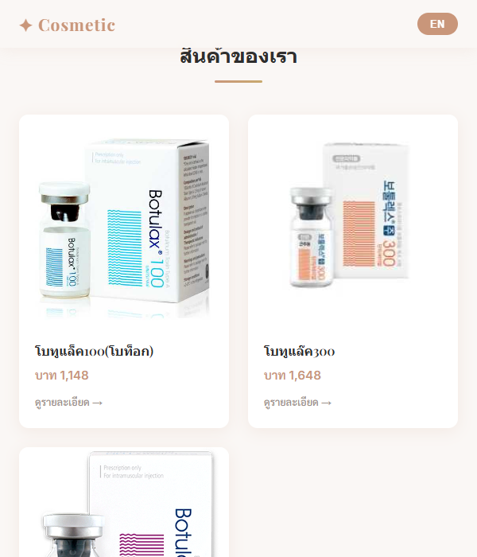

2.6 Product Detail Popup
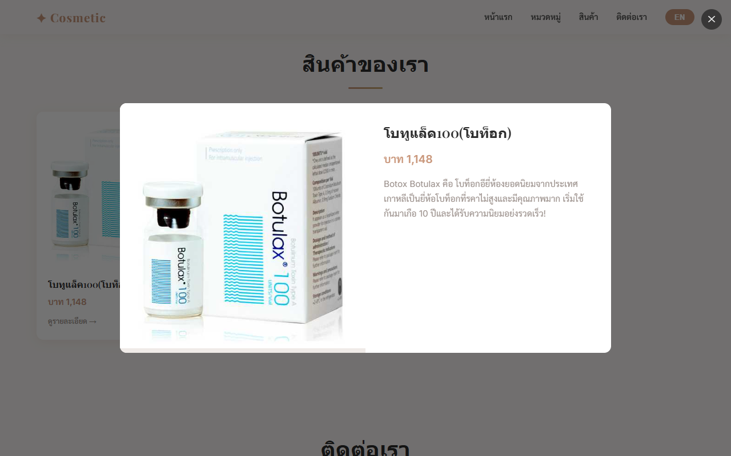
Clicking a product opens a popup with full product details, image gallery, and descriptions.

Step | Action | Expected Result
1 | Click any product card | Popup opens. Left side shows images, right side shows info
2 | Click the right/left arrows in the image area | Switch between product images
3 | Click a thumbnail image below | Main image changes to that thumbnail
4 | Read product details | Name, price, description, ingredients, usage shown in current language
5 | Click outside the popup (dark overlay) | Popup closes
6 | Click the ✕ button (top-right) | Popup closes

📌 Note: Product text (name, description) will display in whichever language is currently selected.

2.7 Contact Form
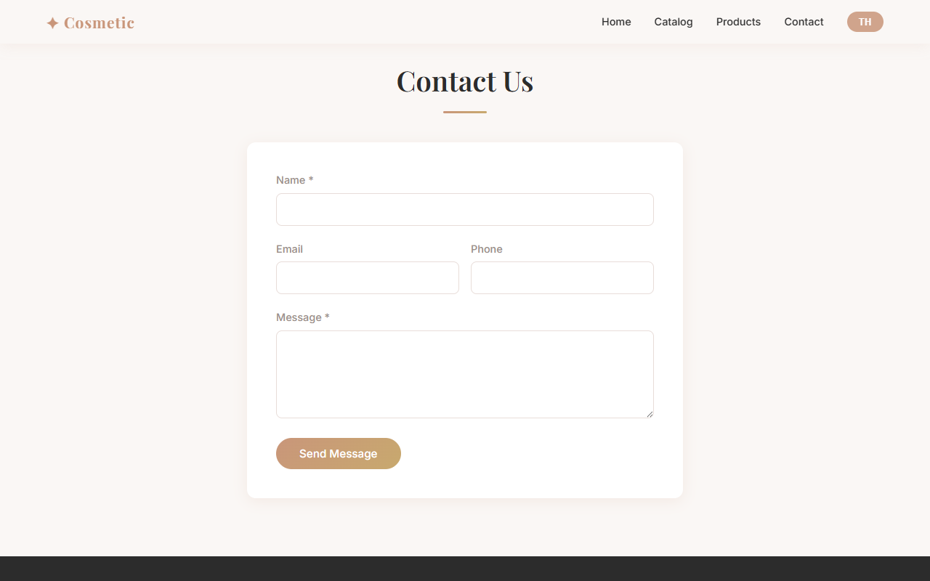
Use the contact form to send a message. Required fields are Name and Message.

Step | Action | Expected Result
1 | Scroll to Contact section | Form with Name, Email, Phone, Message fields is visible
2 | Fill in Name (required) | Text entered in Name field
3 | Fill in Email (optional) | Text entered in Email field
4 | Fill in Phone (optional) | Text entered in Phone field
5 | Fill in Message (required) | Text entered in Message field
6 | Click "Send Message" | Green success message appears. Form resets.
7 | Click "Chat on LINE" | Opens LINE Official Account chat
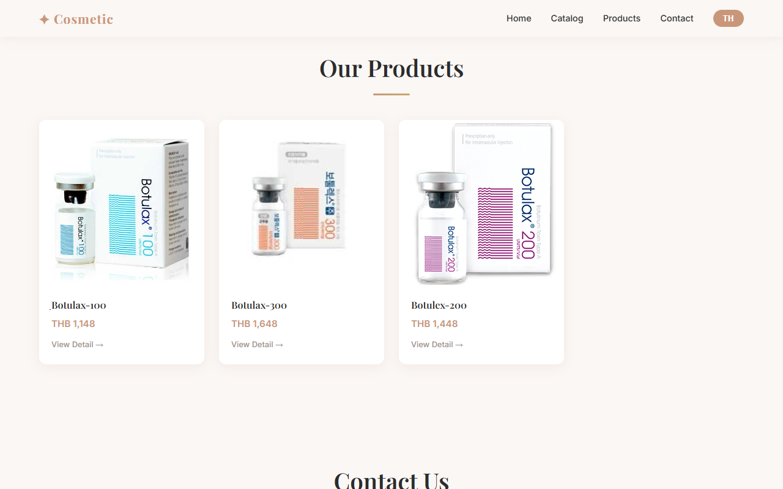
📌 Note: If you see a red error message, the server may not be running. Contact your administrator.

2.8 Footer
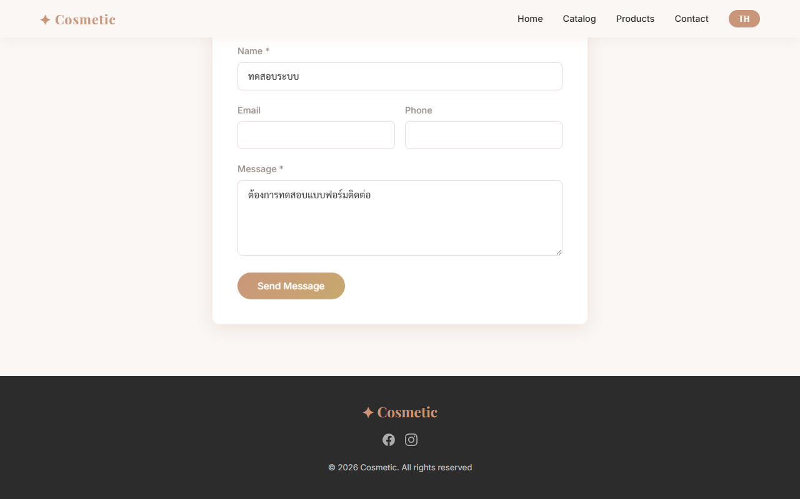
The footer is at the bottom of the page. It contains:
• Brand name
• Facebook and Instagram icon links
• Copyright year

3. Admin Panel
The admin panel allows authorised staff to manage all website content. Access requires a username and password.
📌 Note: Admin panel URL: http://localhost:5173/admin/login

3.1 Login
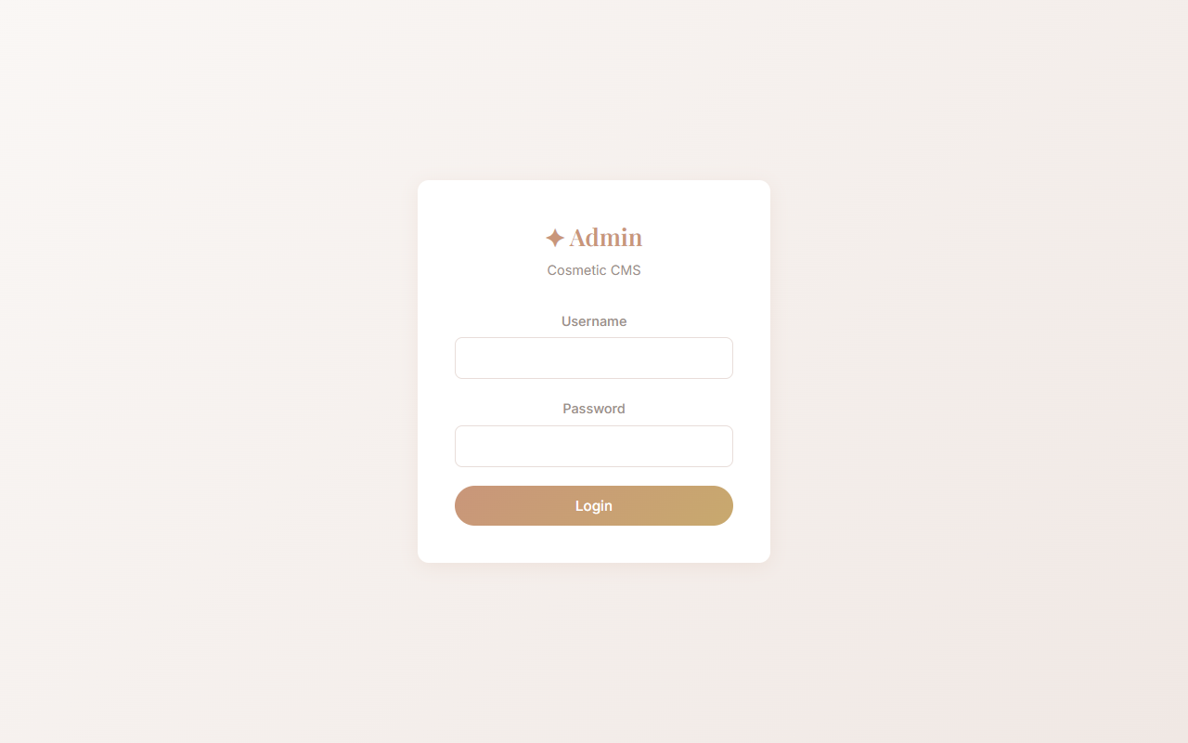

Step | Action | Expected Result
1 | Go to http://localhost:5173/admin/login | Login page shows with username and password fields
2 | Enter username: admin | Username typed in field
3 | Enter password: admin1234 | Password typed (hidden as dots)
4 | Click "Login" | Redirected to Admin panel — Banners page
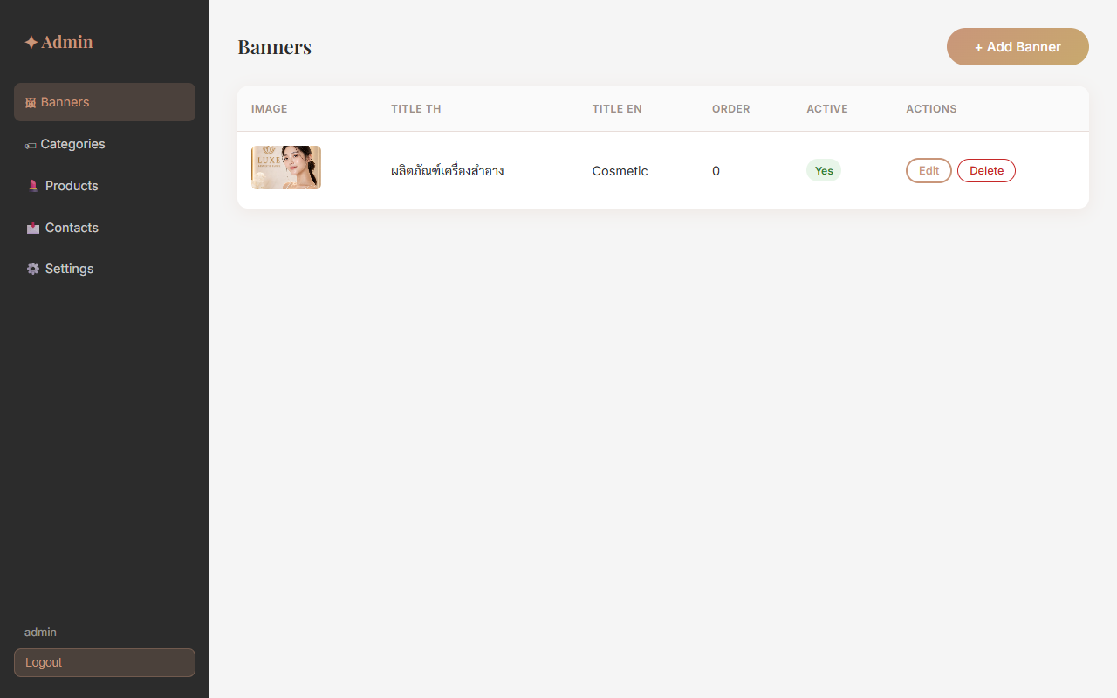

Default username | admin
Default password | admin1234
Session duration | 24 hours (auto logout after 24h)
📌 Note: Change the default password immediately after first login for security.

3.2 Admin Sidebar
After login, the left sidebar has navigation links to each management section:
• Banners — manage homepage slider images
• Categories — manage product categories
• Products — manage products and images
• Contacts — view contact form submissions
Click "Logout" at the bottom of the sidebar to sign out.

3.3 Banner Management

Manage the homepage image slider. You can add, edit, delete, and reorder banners.

Add New Banner
Step | Action | Expected Result
1 | Click "+ Add Banner" | Form popup opens
2 | Click "Choose File" and select an image | Image selected (JPEG, PNG, or WebP, max 5MB)
3 | Fill in Title TH (Thai title) | Thai title entered
4 | Fill in Title EN (English title) | English title entered
5 | Fill in Subtitle TH / EN (optional) | Subtitle entered
6 | Set Sort Order (0 = first) | Number entered
7 | Check "Active" checkbox | Banner will be visible on public site
8 | Click "Save" | Banner added to list. Appears on homepage immediately.



Edit Banner
Step | Action | Expected Result
1 | Click "Edit" next to the banner | Form opens pre-filled with current data
2 | Change any fields | Updated values entered
3 | To replace image: select new file | New image chosen (leave blank to keep current)
4 | Click "Save" | Changes saved and reflected on homepage

Delete Banner
Step | Action | Expected Result
1 | Click "Delete" next to the banner | Confirmation dialog appears
2 | Click "OK" to confirm | Banner permanently deleted
📌 Note: Deleted banners cannot be recovered.

3.4 Category Management
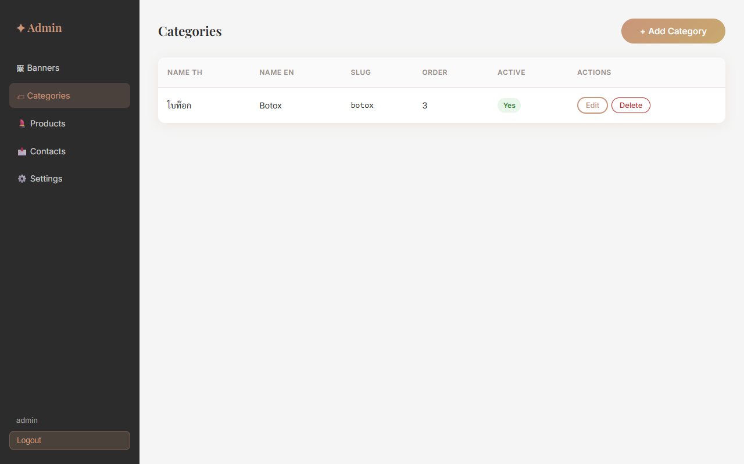
Categories group your products. They appear as filter buttons on the public site.

Add New Category
Step | Action | Expected Result
1 | Click "+ Add Category" | Form popup opens
2 | Enter Name TH (Thai name) | e.g. ดูแลผิวหน้า
3 | Enter Name EN (English name) | e.g. Face Care
4 | Enter Slug (or leave blank for auto) | e.g. face-care (auto-generated from EN name)
5 | Set Sort Order | Lower number = shown first
6 | Click "Save" | Category added. Appears as filter button on public site.
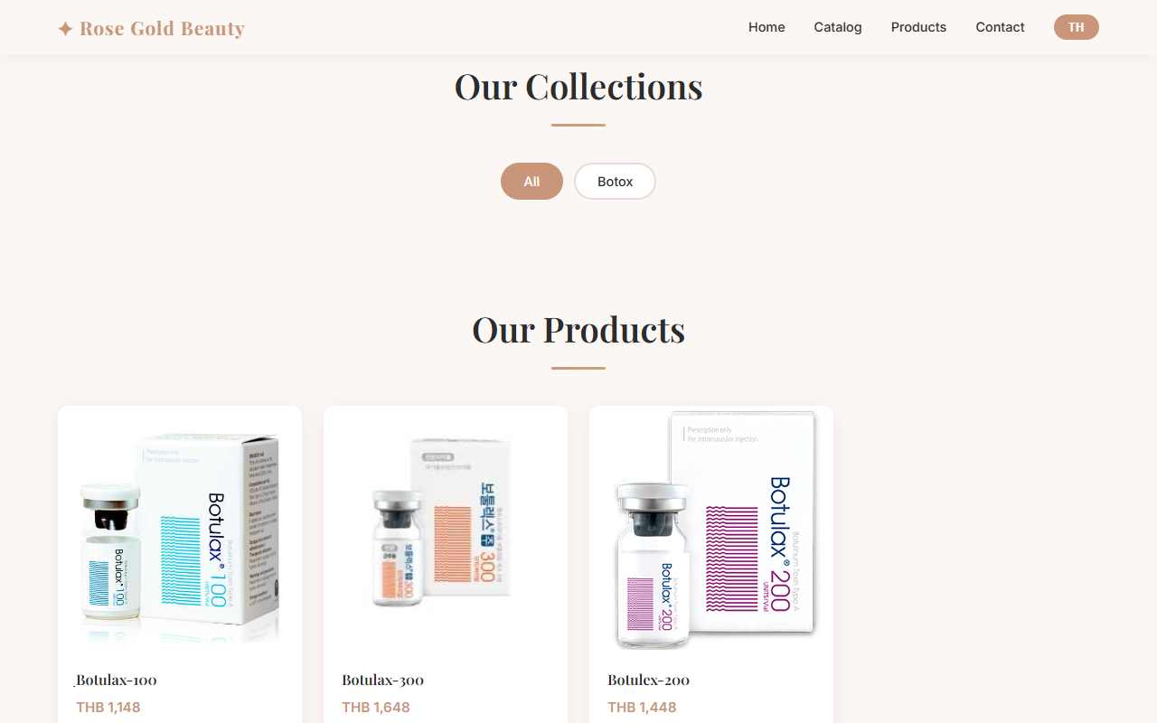

3.5 Product Management
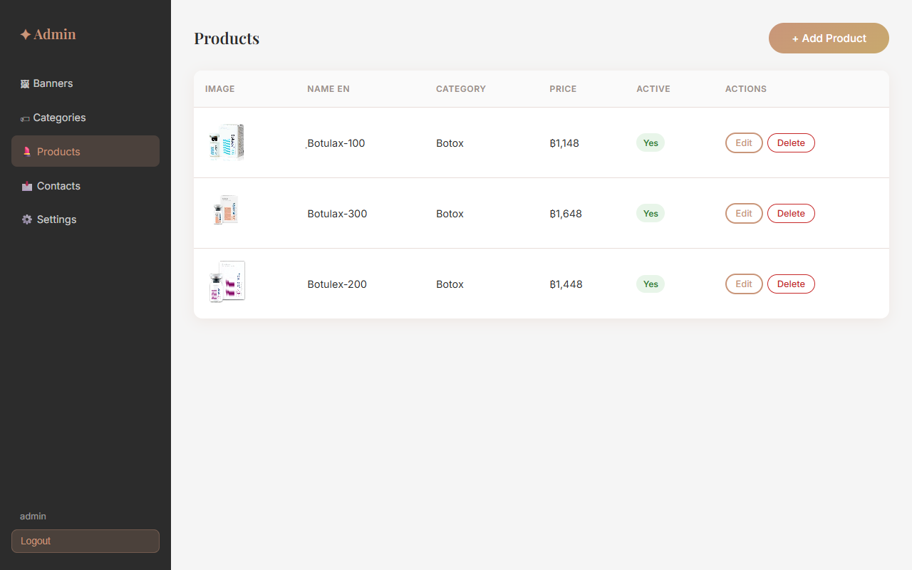
Manage all products including their names, descriptions, images, and pricing.

Add New Product
Step | Action | Expected Result
1 | Click "+ Add Product" | Form popup opens
2 | Select Category (optional) | Choose from dropdown list
3 | Enter Name TH (required) | Thai product name
4 | Enter Name EN (required) | English product name
5 | Enter Description TH / EN | Product description in both languages
6 | Enter Ingredients TH / EN (optional) | List of ingredients
7 | Enter Usage TH / EN (optional) | How to use the product
8 | Enter Price (optional) | Leave blank if price is not displayed
9 | Set Sort Order | Display position in grid
10 | Click "Choose Files" — select up to 10 images | Images selected. First image = primary (shown in grid)
11 | Click "Save Product" | Product created and visible on public site

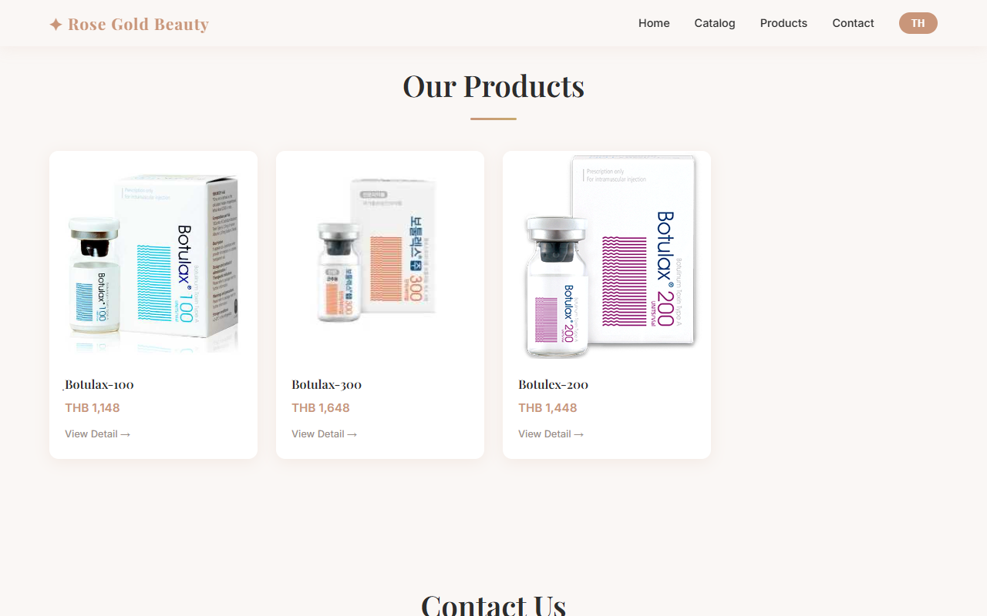

Edit Product
Step | Action | Expected Result
1 | Click "Edit" next to product | Form opens with existing data
2 | Update any fields | Changes entered
3 | To add more images: select files | New images added to existing gallery
4 | To remove an image: click ✕ on thumbnail | Image removed immediately
5 | Click "Save Product" | Changes saved
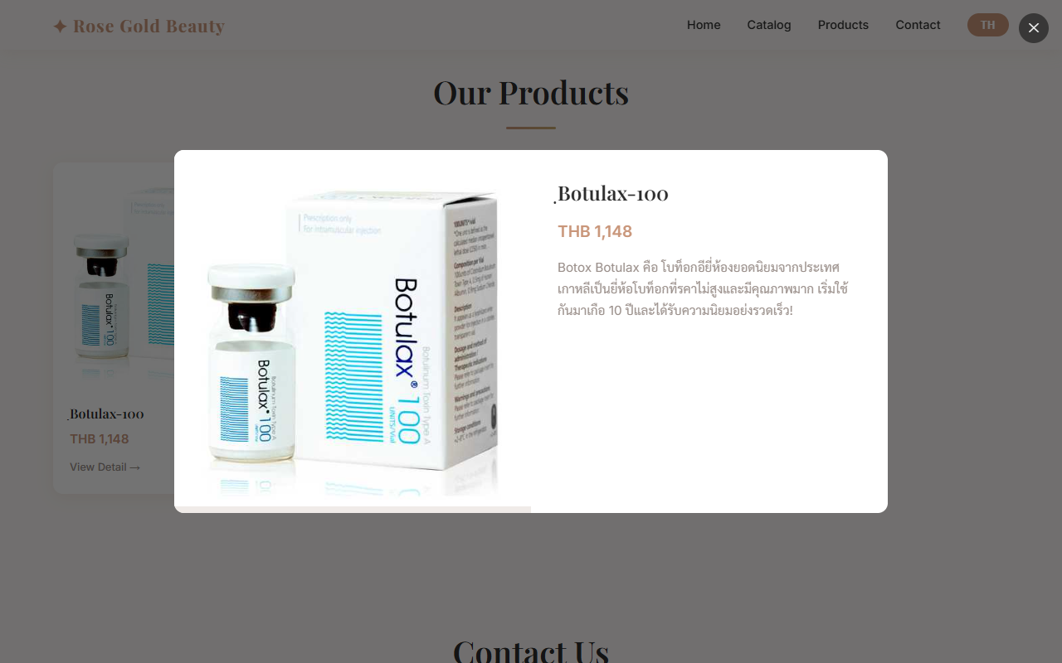

Delete Product
Step | Action | Expected Result
1 | Click "Delete" next to product | Confirmation dialog
2 | Click "OK" | Product and all its images permanently deleted

3.6 Contact Submissions
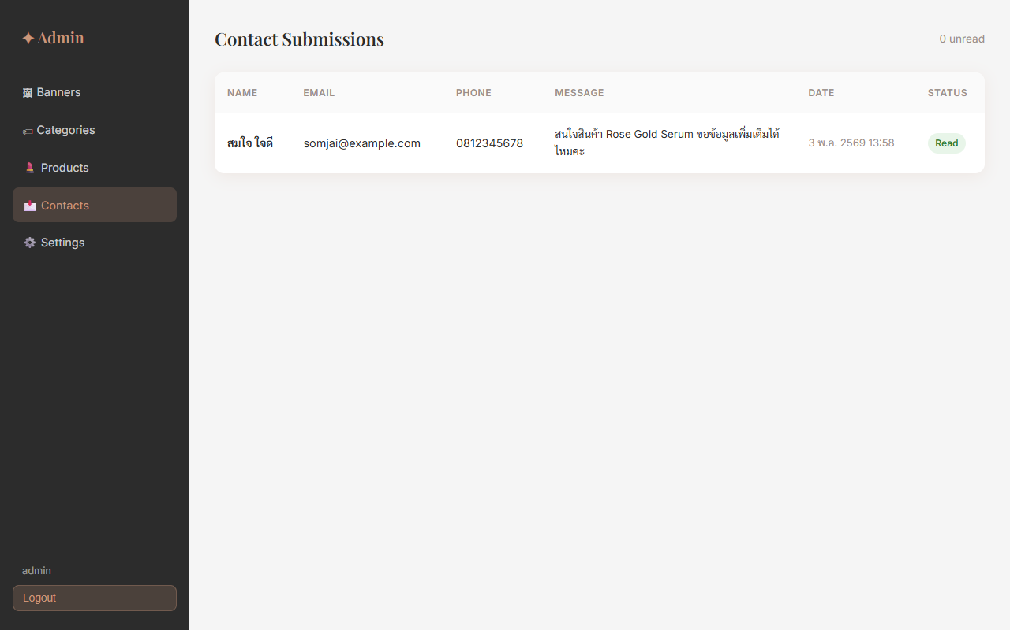
View messages submitted via the public contact form.

Step | Action | Expected Result
1 | Click "Contacts" in sidebar | All submissions listed, newest first
2 | Unread count shown in header | Number of unread messages displayed
3 | Unread rows highlighted | Rows with unread messages have light background
4 | Click "Mark Read" on a submission | Status changes to green "Read" badge
[ Screenshot: TC-13-04.png — Contact marked as read ]
📌 Note: Contact submissions cannot be deleted from the admin panel in this version.

3.7 Site Settings
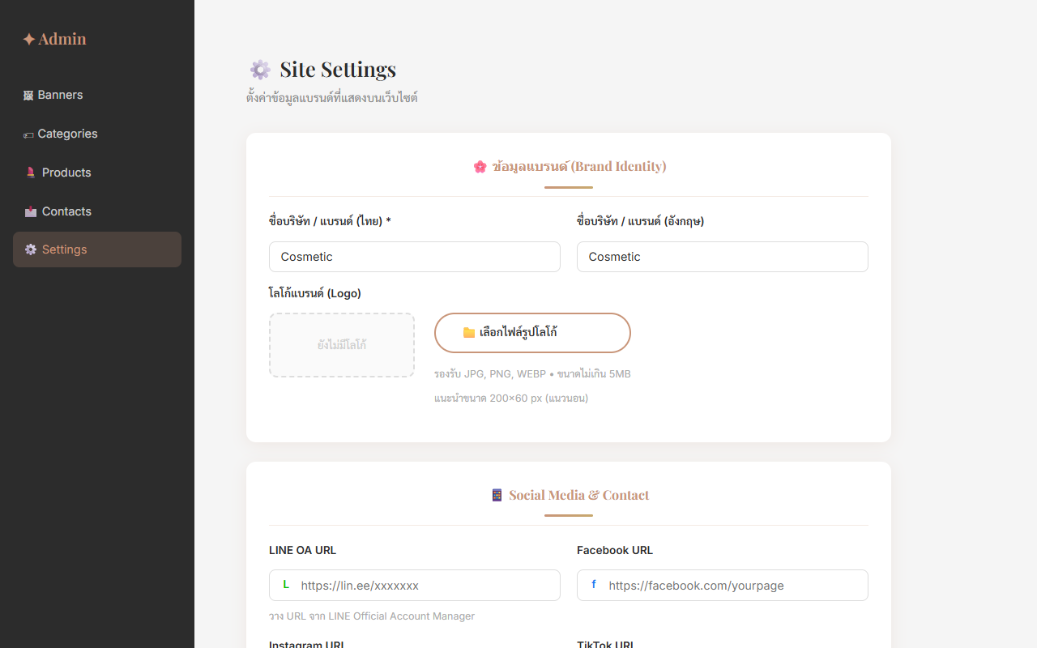
Configure your brand identity, social media links, and footer text. Changes reflect on the public site immediately after saving.

How to Open Settings
Step | Action | Expected Result
1 | Log in to the admin panel | Admin dashboard opens
2 | Click "⚙️ Settings" in the left sidebar | Site Settings page opens with 3 sections

Brand Identity
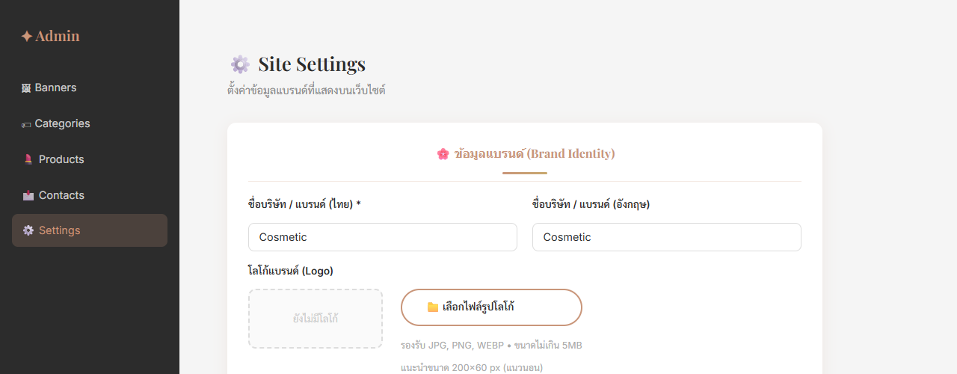
Step | Action | Expected Result
1 | Enter Company Name (Thai) — e.g. ร้านความงาม Rose Gold | Shown in Navbar and Footer when language is Thai
2 | Enter Company Name (English) — e.g. Rose Gold Beauty | Shown in Navbar and Footer when language is English
3 | Click "เลือกไฟล์รูปโลโก้" to upload a logo image | Logo preview appears in the box
4 | Click "💾 บันทึกการตั้งค่า" | Success message shown. Navbar now displays logo
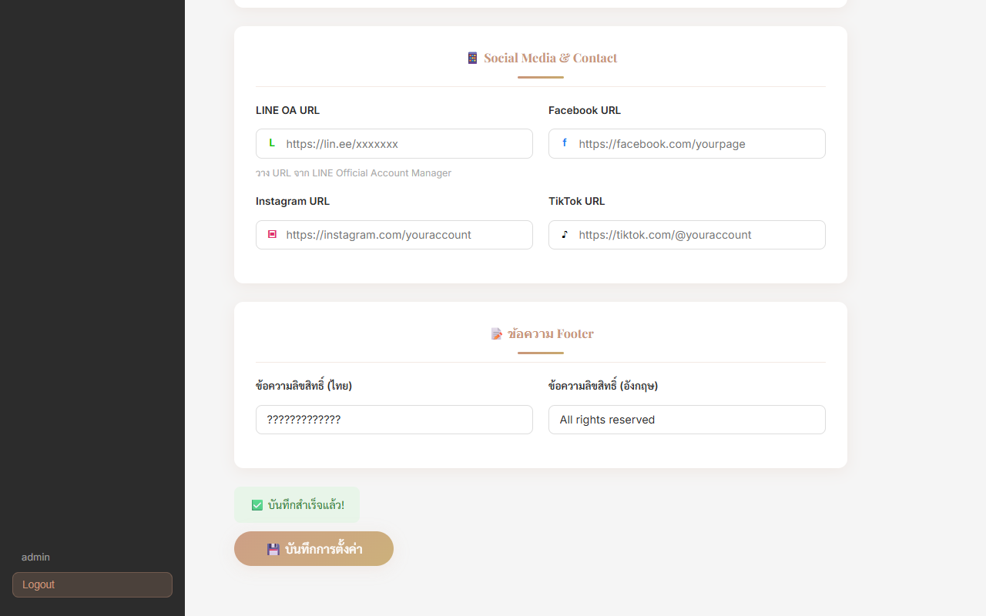
📌 Note: Logo image should be horizontal (landscape). Recommended size: 200×60 px. Accepted formats: JPG, PNG, WebP (max 5 MB).

Social Media & Contact
Step | Action | Expected Result
1 | Enter LINE OA URL (from LINE Official Account Manager) | LINE button appears in Contact section on public site
2 | Enter Facebook URL | Facebook icon appears in Footer
3 | Enter Instagram URL | Instagram icon appears in Footer
4 | Enter TikTok URL | TikTok icon appears in Footer
5 | Click "💾 บันทึกการตั้งค่า" | Success message. Public site updated.
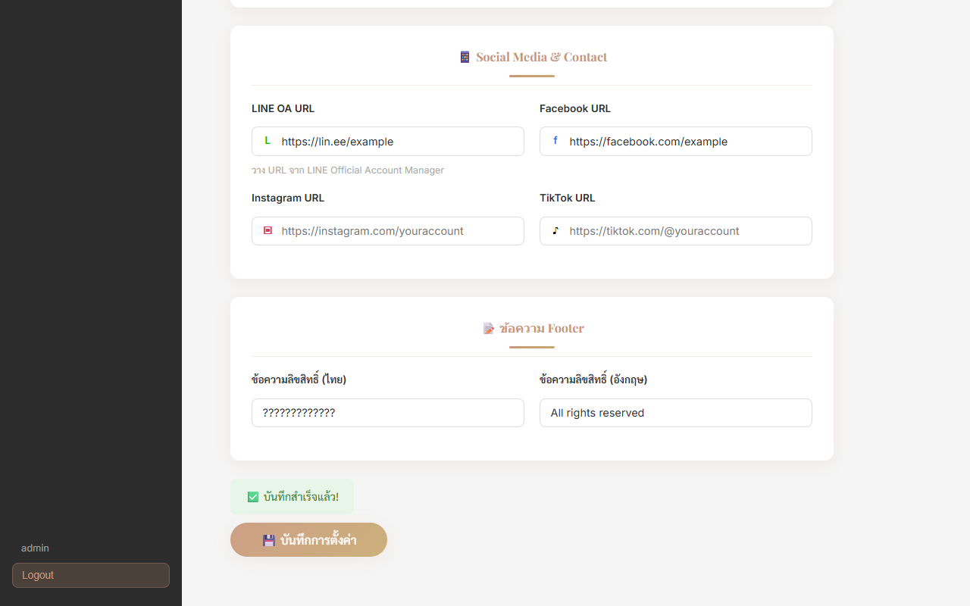
📌 Note: Social icons only appear in the Footer when a URL is entered. Leave blank to hide.

Footer Text
Step | Action | Expected Result
1 | Enter copyright text (Thai) — e.g. สงวนลิขสิทธิ์ | Shown in Footer when language is Thai
2 | Enter copyright text (English) — e.g. All rights reserved | Shown in Footer when language is English
3 | Click "💾 บันทึกการตั้งค่า" | Success message shown

4. Troubleshooting

Problem | Possible Cause | Solution
Products / banners not loading | Backend server not running | Start backend: cd backend && npm run dev
Contact form shows error | Backend not running or DB offline | Check both backend and MySQL are running
Admin login fails | Wrong credentials or backend down | Verify username/password. Check backend is running.
Images not showing | Backend static files not served | Restart backend server
Language not switching | localStorage blocked by browser | Check browser privacy settings
White page / no content | Frontend build error | Check browser console (F12) for errors

5. Quick Reference

5.1 URLs
Public Website | http://localhost:5173/
Admin Panel | http://localhost:5173/admin/login
Admin — Banners | http://localhost:5173/admin/banners
Admin — Categories | http://localhost:5173/admin/categories
Admin — Products | http://localhost:5173/admin/products
Admin — Contacts | http://localhost:5173/admin/contacts
Admin — Settings | http://localhost:5173/admin/settings

5.2 Image Upload Limits
Max file size | 5 MB per image
Allowed formats | JPEG, JPG, PNG, WebP
Max images/product | 10 images
Banner image | 1 image per banner (replace to update)

5.3 Admin Credentials
Default username | admin
Default password | admin1234
Session expires | 24 hours after login
📌 Note: Change the default password after first use.

