**Theory:**

**1. In the context of dimensional modelling: what is a fact, and what is a dimension?**

A fact is data surrounded by dimensions.

A dimension is a way of filtering the data. It’s like having a cube and then using a knife to create slices of the cube.  
  
An example would be the raw data of payments and the dimensions would be the surrounding information of said payment, like payment date, who made the payment and so on.

**2. E-R modelling**

**1. An apartment is located in a house in a street in a city in a country. Create an ER diagram for this, and remember to include cardinalities and keys. State any assumptions you feel are needed. Are there any weak entities?**

In the model below, the weak entities are apartment, street and city. Because apartments only exist within a house, streets only exists within cities. If a street exists outside a city it’s called a road which in this model is different than a street. Cities must exist within a country. A country must have at least one City.

For cardinalities and keys:   
Apartment’s keys are a unique combination of floor number and room number. An apartment can only exist within a house.

In this model a house can have 0 or more apartments in this model, as a house with only 1 apartment is just a house, which means there is no need for floor number or room number.   
Houses can only exist on streets. But a street doesn’t need to have any houses. And a house can only be tied to one street. The house unique key address is made up of the components that makes an address.

Streets have a street name, and a street doesn’t need to have any houses on it. But they must be tied to a city, or else they’d be roads. In this relation streets only has a street name.

A city can only exist in one country, but a country can have many cities. In this model a city’s unique key is the city name, as they are a weak entity ith a relation to Country that has a unique country name as well  
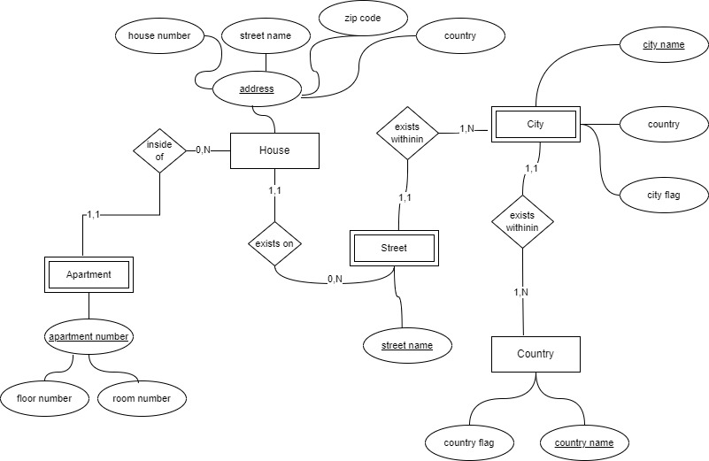

**2 .Olympic games happen in a certain year at a certain time. Each year, there is at most one instance of Olympic games. In each discipline in an olympic game, there is exactly one gold medalist, one silver medalist and one bronze medalist. All these medalists are athletes. Give an ER model for this mini world. Identify the keys and give the cardinalities of all relationships. State any assumptions you feel are needed.**

In the model below, an organizer can only organize 1 olympic game each year.  
The name of the Olympic game is the unique combination of the city name and year it’s held. In this world an organizer doesn’t need to be a city specifically. The Olympic game can have many disciplines, but the disciplines only belong to that Olympic game, as different years of event can include or exclude disciplines, like winter or summer Olympics will not have the same disciplines. Each discipline has Medals, where there’s only 1 of each kind. Medalists are athletes. Athletes can only win 1 medal per discipline, but can win 1 medal per unique discipline they compete in. Athletes are not always medalists, as only some athletes win medals.

**Level 1: Bank**

I assume that the bank keeps joined tables of the information that is shared between the tables according to the model provided. For example, they keep loans and accounts balance separately. And that you only can loan from a bank branch and not from the bank itself.

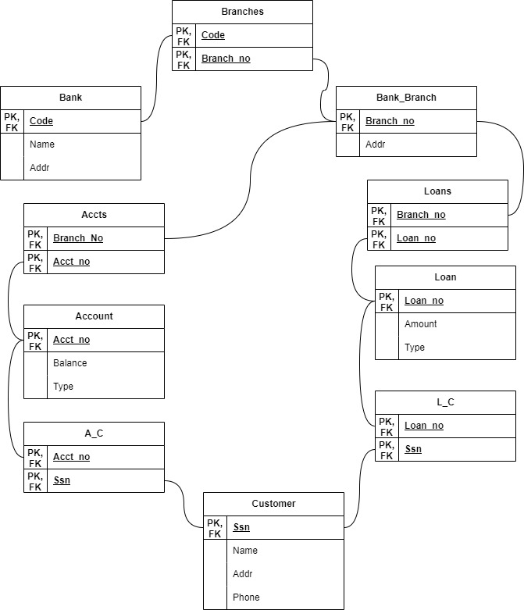

**Level 1: Doctors and Patients**

In the model below I interpreted the needs of the warehouse to be as follows.  
You have data for blood pressure, location, medication and the health outcome, where you filter on the patient. I interpret that the patient always has a docttor, which has mediciation prescribed through patient. Even though in real life medication is prescribed through doctors, for the sake of flexible analysis, the medication is tied to the patient, with the ability to see which doctor prescribed what. In this model, you wll be able to include or exclude the doctor from the patient, depending on what type of data analysis the user is after. As this model is tied to patient, you will only be able to see the location of successrates if you include the patient. However the patient here isn’t actually the patient as a person, but rather the collective entity where the data is stored. You could slice the location and health outcomes in this model and still have no data on the individual patients as their age group and gender are separate slices.

**Level 2: Books**