Bachaw- A CNG based ride sharing app.

Bachaw is a great initiative to create a communication between a rider and a CNG driver. With some amazing features like multiple stops or multiple rider in a same CNG is one of the most revolutionary ridesharing application in the market. We are currently creating Android Application Support for the riders and driver because around 80% Bangladesh mobile market acquired by Android Smartphone. Here is some technical details for the application-

Minimum SDK Version: 16 (Because around 97% device has still this SDK version)

Target SDK Version: 27

Map API: Mapbox (We are not using Google Map direction API because it’s not free and it will increase the price in the system)

FAQ / Customer Care Service: Dialogflow (A trained based bot API by google. Previously known as api.ai).

**Topic: Implementation Mapbox in Android**

Firstly we checked Internet connection in the device so we take permission in AndroidManifest.xml also for getting location we take permission in AndroidManifest.xml file.

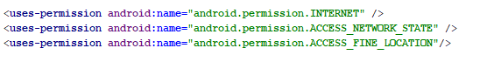

In StartupActivity.java class we create a thread that runs 3sec. On this 3 sec it checks internet connection. If the device is not connected to Internet then it takes to NoInternetnet.java class to get device to connect to Internet. Else the device is connected to Internet the application will redirect to MainActivity.java class. For development perpose we are not implementing User Login & Signup Activity in here. When we are implementing that part then we will check Login Status.

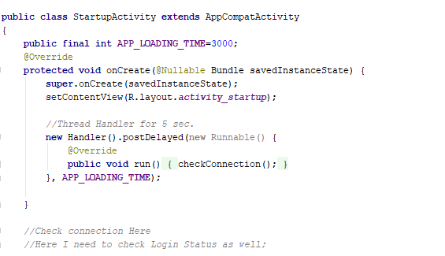

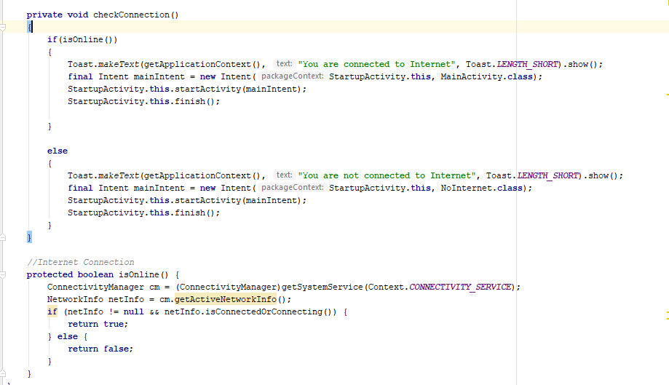

For implementing MapBox in our system we add the following dependencies in the system.

**'com.mapbox.mapboxsdk:mapbox-android-sdk:6.4.0'** **'com.mapbox.mapboxsdk:mapbox-android-plugin-locationlayer:0.5.0'**

In content_main.xml layout file we call to **com.mapbox.mapboxsdk.maps.MapView** view map in the system.

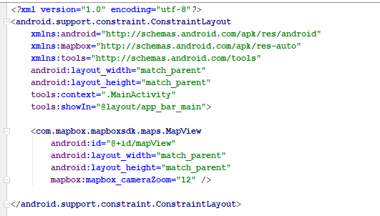

In our System we implement NavigationDrawer to give users great User experience (UX) to navigate between options menu.

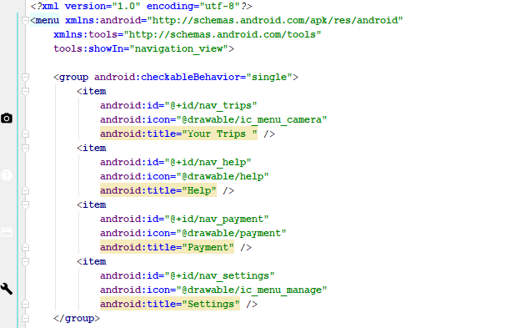

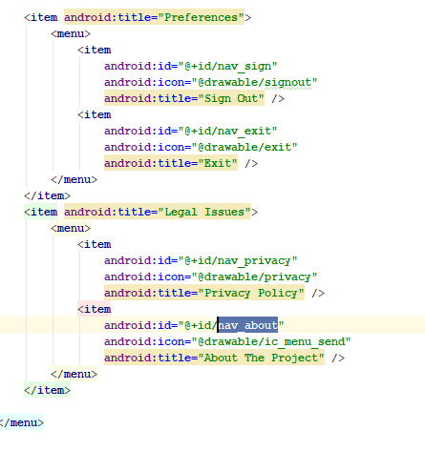

In MainActivity.java class we implement Mapbox to view Map and Our Current Location.

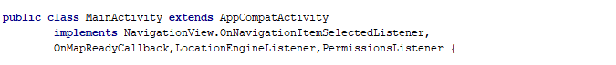

In here we inherit AppCompactActivity and implements NavigationView.onNavigationItemSelectedListener for NavigationDrwaer.

Also implement OnMapReadyCallback, LocationEngineListener & PermissionListener to view map and current location.

In onCreate() method we call Mapbox with a specific access-token generate in Mapbox.com website.

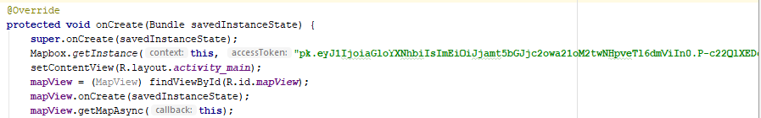

Also we call a FloatingActionButton to plot our latitude & longitude in the map. This feature is currently under development process.

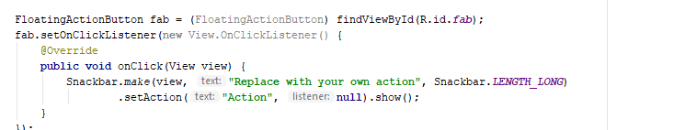

Mapbox has a very cool feature to handle android SDK permission handler. For using this feature we call PermissionManager in the system. To check if the connection is enabled or not and onMapReady we implement the following method.

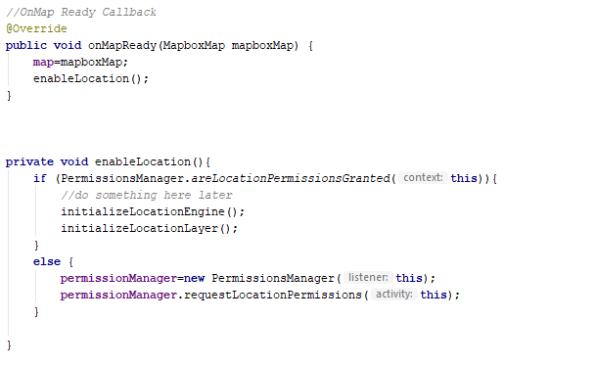

Also we create 2 methods to check the current location and locationengine is enabled or not.

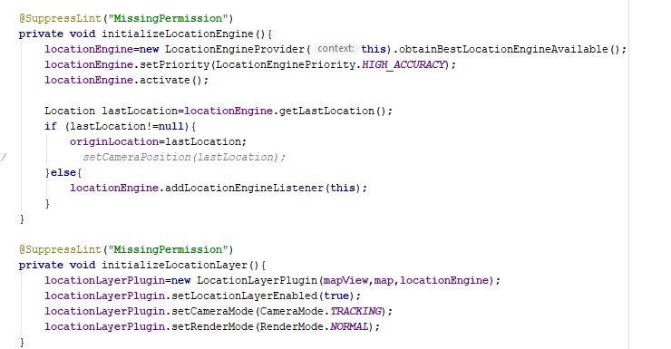

Also here @SuppressLint(**"MissingPermission"**) to handle error we use to omit the error because Mapbox handle this missing permission.

To start location Engine and Set Permission in the system we implement following-

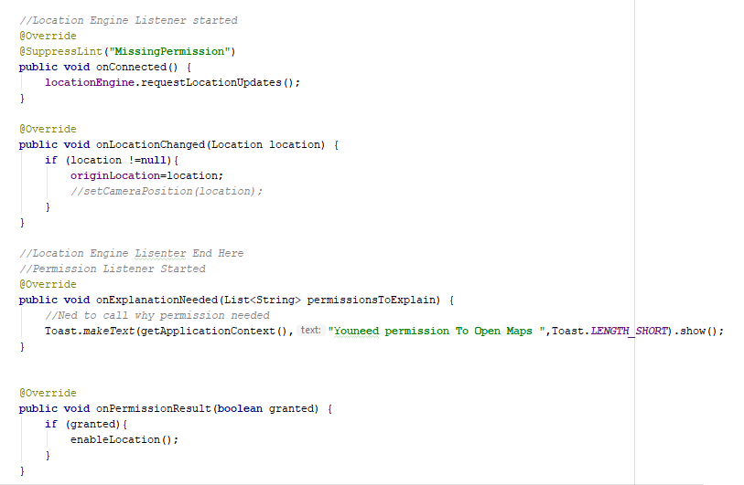

On Android Activity specially on onStart(), onStop() & onDestroy() Method we declare Mapbox to handle memory licking

