A Comparative Study of Cross-Regional Housing Price Prediction Models Using LightGBM with Ridge Residual Correction
Chih-Sen Huang, and Yan-Liang Pan
[NKNU, Kausiung, Taiwan]
Email: 74807480xx@gmail.com
Abstract—This paper presents a comparative study of housing price prediction models across four representative urban districts in Taiwan: Banqiao (New Taipei), Zuoying (Kaohsiung), Taoyuan (Taoyuan), and Zhubei (Hsinchu). Using publicly available cadastral transactions from the Ministry of the Interior, we construct a unified preprocessing and feature-engineering pipeline that yields 45 predictive features per transaction, including spatial-distance, point-of-interest density, building, and macroeconomic price-index features. For each region, a hybrid model combining a Light Gradient Boosting Machine (LightGBM) regressor with a Ridge-regression residual-correction stage is trained and evaluated under a 70/10/20 train, validation, and test split with 5-fold cross-validation. The proposed framework attains coefficient of determination (R-squared) values ranging from 0.834 to 0.943 and symmetric mean absolute percentage error (SMAPE) values between 11.31% and 15.42% on the held-out test sets. Cross-regional comparison shows that the predictive performance is strongly modulated by market heterogeneity: districts with wider price ranges and bimodal building-age distributions, such as Banqiao, exhibit systematically lower explanatory power. The results provide quantitative evidence that a single regional model is well suited to spatially homogeneous markets but should be supplemented with segmented sub-models or additional micro-spatial features when applied to highly heterogeneous urban districts.
Index Terms—Feature engineering, gradient boosting, hedonic price modeling, real-estate analytics, Ridge regression, urban heterogeneity.

I. INTRODUCTION
Accurate prediction of residential property prices is a long-standing problem in urban economics and a critical decision-support task for buyers, lenders, and policy makers. Hedonic price modeling has provided the conceptual foundation for decades, attributing transaction prices to a bundle of structural, locational, and neighborhood attributes [1]. The recent availability of large-scale open cadastral data, together with advances in machine-learning regressors, has revived interest in data-driven approaches that move beyond traditional linear hedonic specifications [2], [3].
Tree-based ensemble methods, in particular gradient-boosted decision trees, have emerged as a strong baseline for tabular real-estate problems because they capture non-linear interactions among features and are robust to mixed-scale predictors [4]. Light Gradient Boosting Machine (LightGBM) has been shown to deliver competitive accuracy at substantially lower training cost than earlier implementations [5]. At the same time, linear and regularized linear models such as Ridge regression remain valuable for interpretability and as residual correctors that absorb global trends not fully captured by tree splits [6].
Despite these methodological advances, a single global model rarely transfers cleanly across urban districts. Real-estate markets are spatially heterogeneous: a neighborhood with predominantly aging walk-up apartments and one dominated by new high-rise condominiums respond differently to the same set of covariates [7]. Cross-regional comparisons of model behavior, including how predictive accuracy degrades in heterogeneous markets, remain underexplored in the Taiwanese context.
This paper makes three contributions. First, we develop a unified preprocessing and feature-engineering pipeline that turns raw cadastral transaction records into 45 features per observation, integrating distance-based, density-based, and macroeconomic indices. Second, we train and evaluate a hybrid LightGBM with Ridge-residual-correction model for four districts that span a wide range of price levels and market structures: Banqiao, Zuoying, Taoyuan, and Zhubei. Third, we contrast model performance across districts and identify the sources of remaining error, with a particular focus on Banqiao, whose lower explanatory power is shown to arise from intrinsic market heterogeneity rather than from model misspecification.
The remainder of this paper is organized as follows. Section II describes the dataset and the feature-engineering pipeline. Section III presents the modeling framework and reports the cross-regional results. Section IV discusses why Banqiao exhibits relatively lower explanatory power than the other three districts. Section V concludes and outlines future work.
II. DATA AND FEATURE ENGINEERING
A. Data Sources
Cadastral transaction records were obtained from the open Lvr-Land platform maintained by the Ministry of the Interior of Taiwan, covering residential transactions from 2020 through 2025 in four districts: Banqiao (New Taipei), Zuoying (Kaohsiung), Taoyuan (Taoyuan), and Zhubei (Hsinchu). After deduplication, removal of pre-sale and parking-only transactions, and exclusion of trades smaller than three pings, the working dataset comprises 9,731 records: 3,167 in Banqiao, 1,546 in Zuoying, 3,640 in Taoyuan, and 1,378 in Zhubei. A quarterly housing-price index was further joined to each transaction to control for time trends.
B. Feature Engineering Pipeline
Fig. 1 summarizes the end-to-end pipeline from raw transactions to per-region modeling datasets. Five categories of features are derived from each transaction:
1) Structural features such as total area in pings, building age, number of rooms, halls and bathrooms, and floor-to-total-floor ratio.
2) Spatial-distance features computed by Haversine distance from each transaction coordinate to the nearest high-speed rail (HSR) station, metro rapid transit (MRT) station, school, and commercial cluster.
3) Point-of-interest (POI) density features such as the count of convenience stores within 500 m and 1 km radii.
4) Macroeconomic features including a quarterly housing-price index and a rolling three-month unit price.
5) Interaction features such as area times log distance to HSR, age times MRT distance, and area times floor ratio, motivated by hedonic theory.
After feature engineering, 45 predictors are available per transaction. A standardized data dictionary is maintained across regions so that each per-region modeling script consumes the same feature schema.
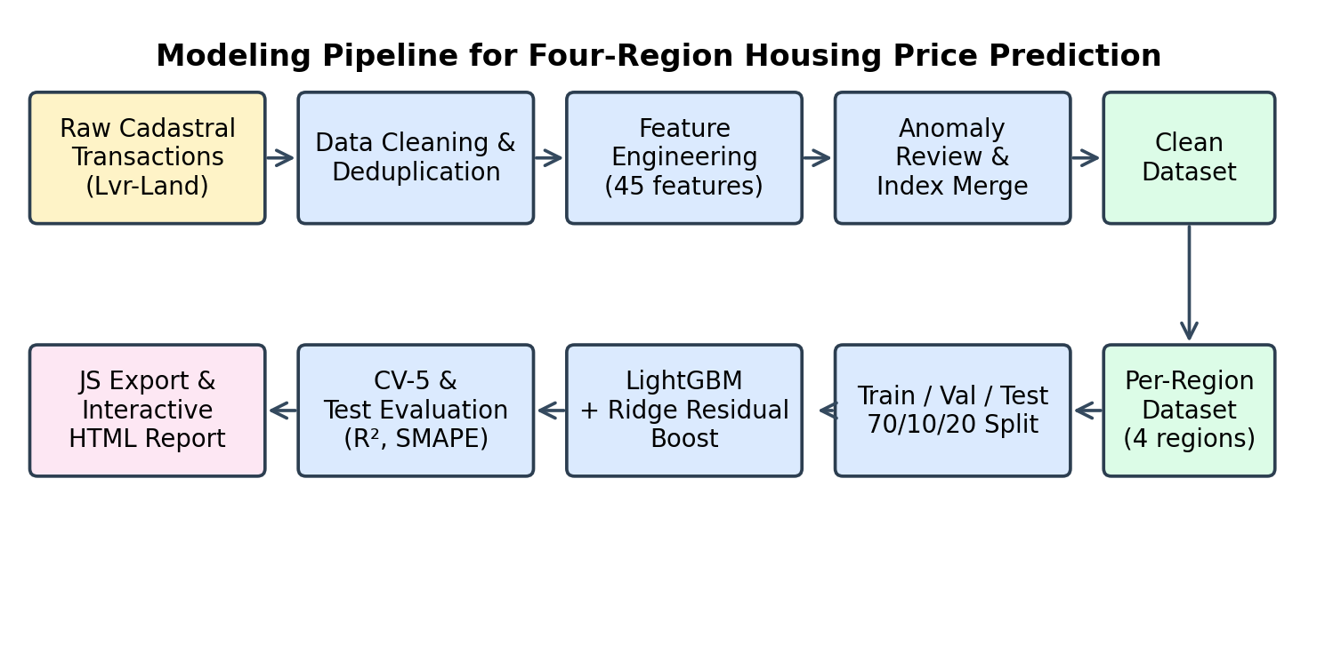
Fig. 1. End-to-end modeling pipeline from raw transactions to per-region housing-price models and the interactive HTML report.
III. MODELING FRAMEWORK AND CROSS-REGIONAL RESULTS
A. Hybrid LightGBM with Ridge Residual Correction
For each region, the data are randomly partitioned into 70% training, 10% validation, and 20% test subsets with a fixed random seed for reproducibility. A LightGBM regressor with 1500 trees, learning rate 0.03, num_leaves 63, and early stopping on the validation set is trained as the base learner [5]. Let f_LGB(x) denote the LightGBM prediction for feature vector x. A Ridge-regression model with coefficient alpha equal to 1.0 is then fit on the residuals r equal to y minus f_LGB(x), restricted to the training fold, using the same feature set. The final prediction is given by:
f(x) = f_LGB(x) + f_Ridge(r | x). (1)
This residual-boost structure preserves the non-linear capacity of the gradient-boosting base while letting the linear corrector absorb residual global trends. In addition, a linear Ridge surrogate is trained directly on the original features to provide an interpretable companion model for export to JavaScript for use in an interactive web report.
B. Evaluation Protocol
Predictive performance is reported with three complementary metrics: coefficient of determination (R-squared), root-mean-squared error (RMSE), and symmetric mean absolute percentage error (SMAPE). Five-fold cross-validation is performed on the training fold to estimate variance, and final metrics are computed on the held-out test set. All experiments are run with scikit-learn 1.3 and LightGBM 4.0 on a single machine.
C. Cross-Regional Results
Table I summarizes test-set performance across all four districts. Taoyuan attains the highest accuracy (R-squared equals 0.943, SMAPE equals 11.31%), followed by Zhubei, Zuoying, and Banqiao. The cross-validated R-squared closely tracks the test R-squared in all four cases, with a maximum train-test gap of 0.062, indicating that the framework is not overfitting.
TABLE I
Test-set performance of the hybrid model across four districts.
Region | n | R² test | RMSE | SMAPE | CV-R² | Gap
Banqiao | 3,167 | 0.834 | 491.3 | 15.42 | 0.867 | 0.057
Zuoying | 1,546 | 0.876 | 200.4 | 11.99 | 0.908 | 0.062
Taoyuan | 3,640 | 0.943 | 213.3 | 11.31 | 0.944 | 0.019
Zhubei | 1,378 | 0.918 | 357.8 | 13.75 | 0.898 | 0.027
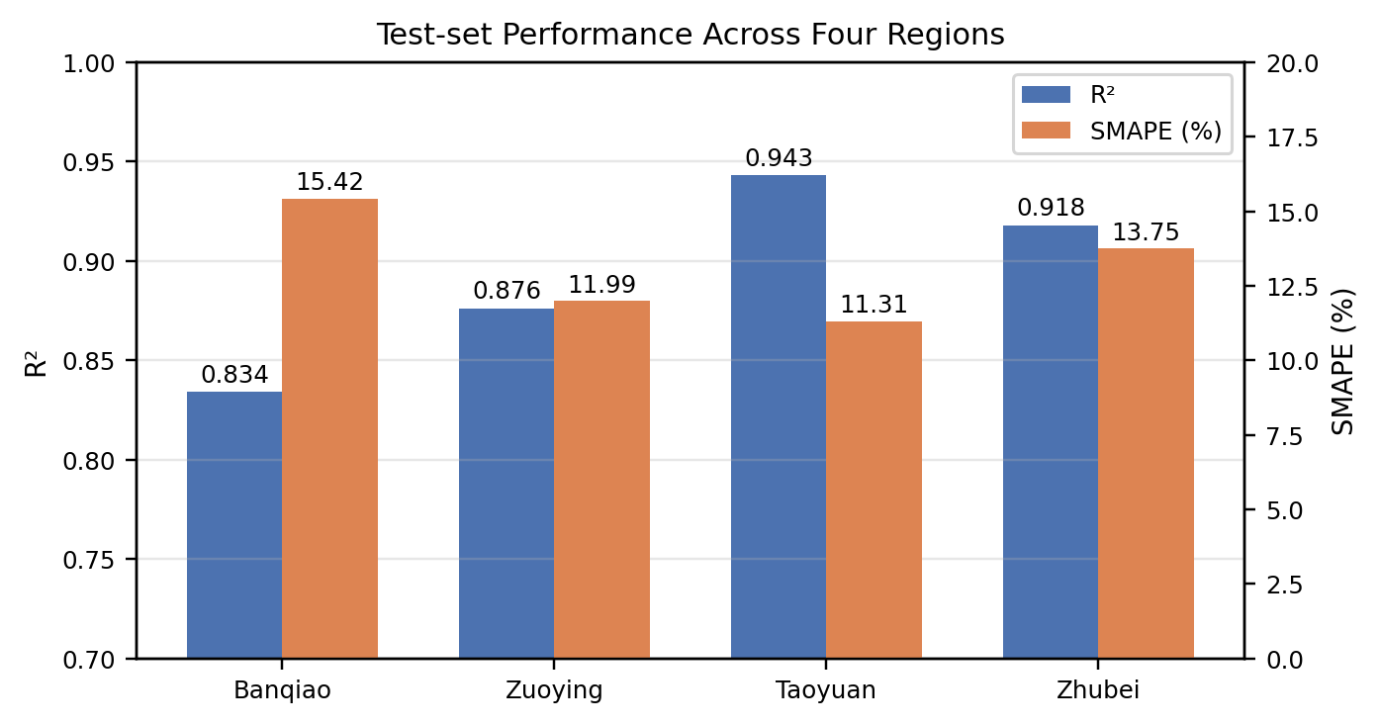
Fig. 2. Comparison of R-squared and SMAPE on the held-out test set across the four districts.
Fig. 3 presents predicted versus actual total prices on the test set. All four districts exhibit dense alignment along the identity line, indicating that the hybrid model captures the dominant trend even at the upper end of the price distribution. Banqiao is visually noisier than the other three districts, particularly in the low-price segment, an observation that motivates the deeper analysis in Section IV.
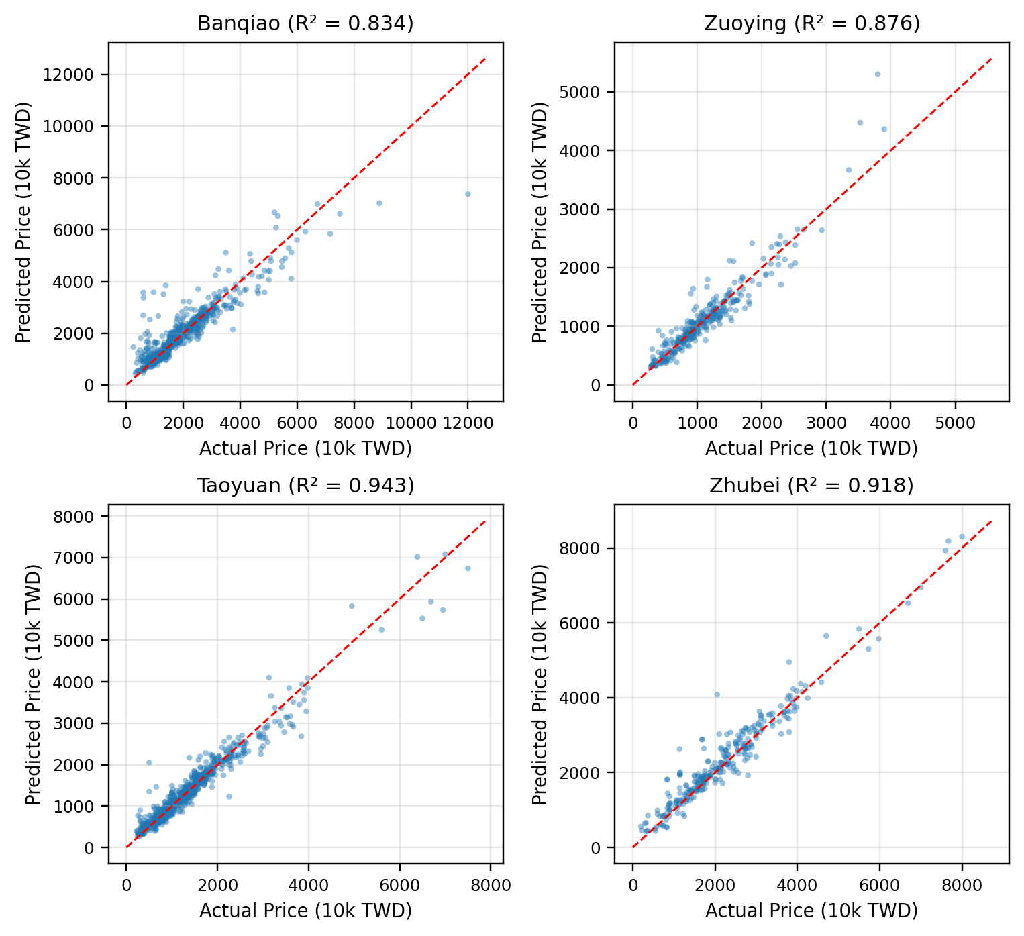
Fig. 3. Predicted versus actual total prices on the held-out test set for each district. The red dashed line marks the identity reference.
D. Feature Importance
Across all four districts, the dominant predictors are log-transformed area, building age, and distance-based features such as distance to MRT or HSR, in addition to interaction terms such as area times log HSR distance. Fig. 4 shows a normalized importance heat map of the top features used by the LightGBM stage in each district. The qualitative consistency across districts indicates that the framework is not exploiting region-specific spurious features.
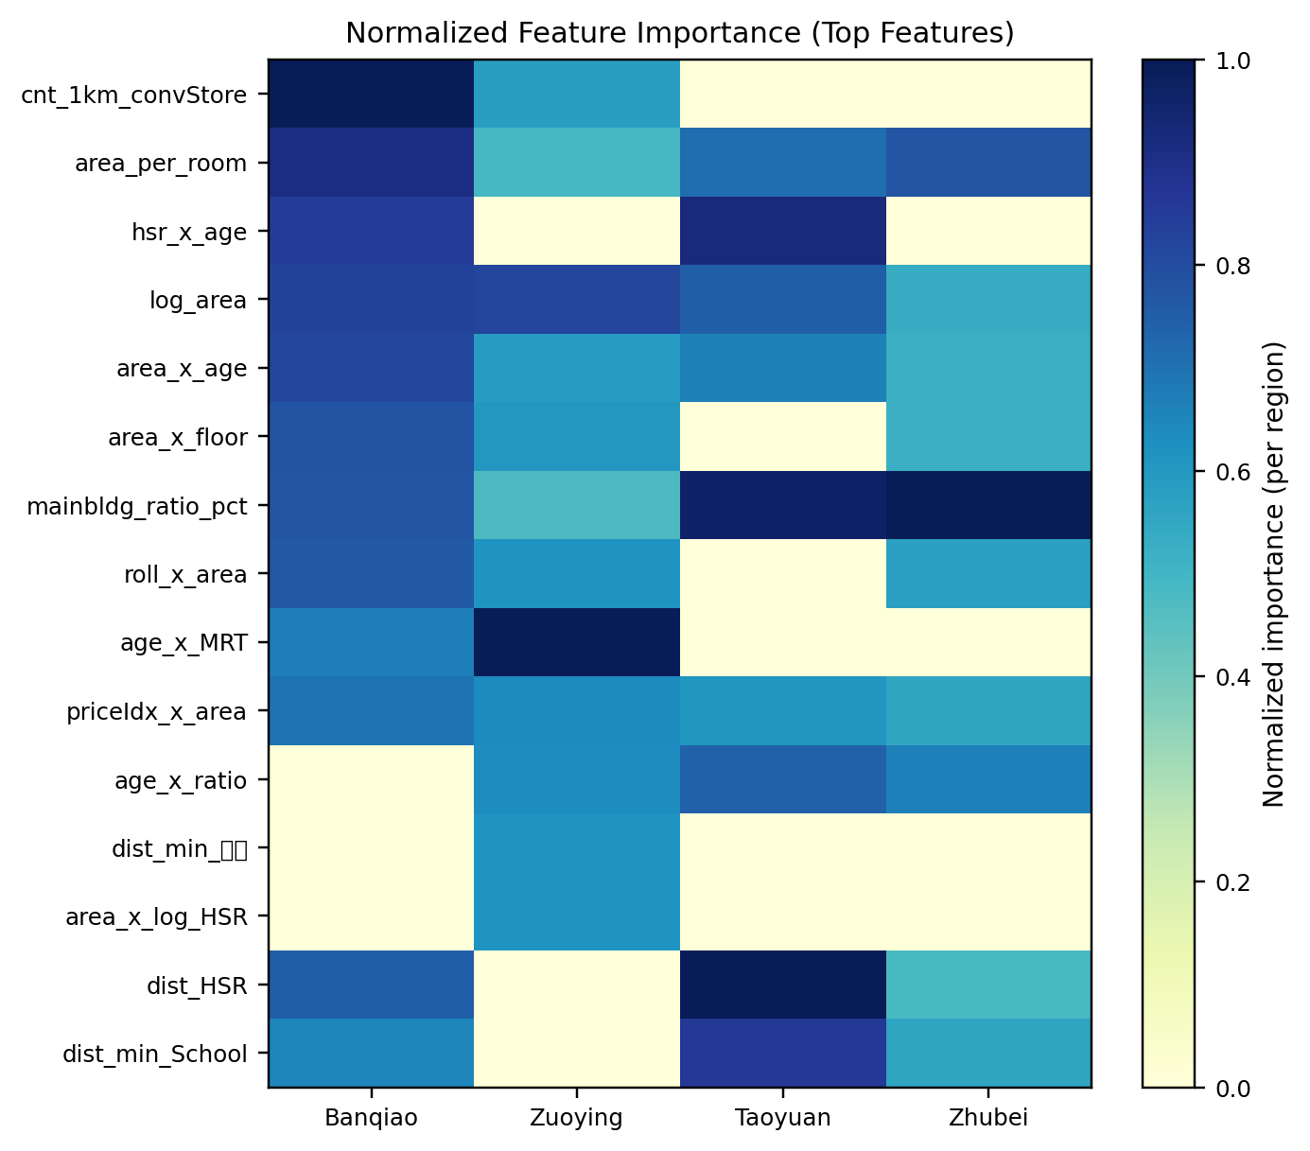
Fig. 4. Normalized LightGBM feature importance for the top features in each district. Importance is rescaled to the maximum within each region.
IV. WHY BANQIAO YIELDS LOWER EXPLANATORY POWER
Although Banqiao achieves an absolute R-squared of 0.834, which is acceptable for a hedonic model on raw market data, it lags the other three districts by 4 to 11 percentage points. The CV-test gap is only 0.057, indicating that the deficit is not driven by overfitting. We attribute the gap to three structural properties of the Banqiao market.
1) Wider price range and higher market heterogeneity:
The unit price in Banqiao spans 6 to 125 (ten thousand TWD per ping), with total prices ranging from 200 to 12,269 (ten thousand TWD), giving a price range approximately twice that of Zuoying or Taoyuan. The 5th to 95th percentile gap of the unit price is 60 in Banqiao, against 34, 33, and 46 in Zuoying, Taoyuan, and Zhubei respectively. This reflects the coexistence of high-rise new-development clusters such as Jiangcui Redevelopment Zone with aging walk-up apartments around Fuzhong and Houpu, all within the same administrative boundary.
2) Bimodal age distribution:
Fig. 5 displays the building-age histograms for the four districts. Banqiao alone exhibits a clearly bimodal distribution: 17.5% of transactions correspond to buildings five years old or younger while 22.6% are over forty years old, jointly accounting for over forty percent of the sample. By contrast, Zuoying, Taoyuan, and Zhubei have at most 8.0% of transactions in the over-forty bin. The median unit prices for the new-build and old-build modes in Banqiao differ by a factor of more than 1.5, complicating the task of fitting a single regression surface.
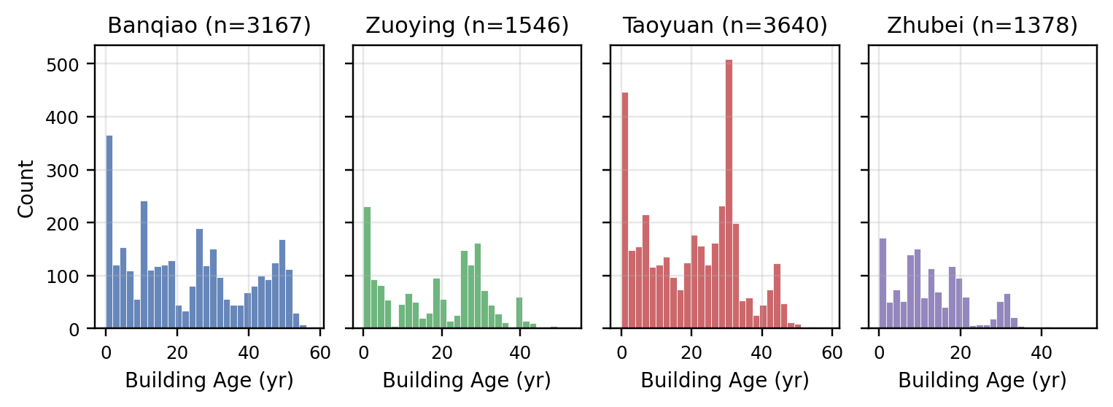
Fig. 5. Building-age distributions for the four districts. Banqiao shows a bimodal pattern absent from the other three.
3) Error concentration in the low-price tail:
Test-set residuals in Banqiao are highly non-uniform across price segments. Binning the test sample by total price (Fig. 6), the median absolute percentage error (APE) in the under-800 segment reaches 43.0%, with a 75th-percentile APE above 100%, while the 1,500 to 4,000 bins achieve a median APE of only 6.8 to 7.1%. The fifteen highest-APE samples are all small-area or aged units below 1,400 (ten thousand TWD), whose transaction prices are strongly affected by private negotiation and idiosyncratic property condition rather than by quantifiable features.
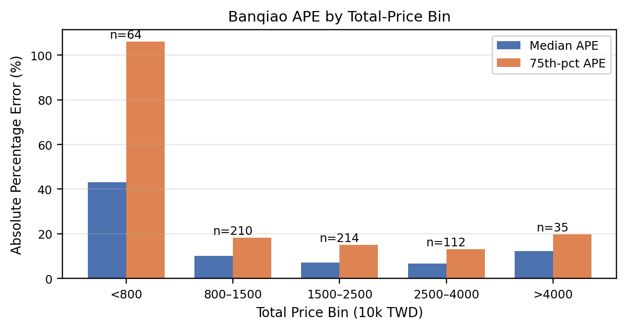
Fig. 6. Banqiao absolute percentage error stratified by total-price bin. Errors are concentrated in the low-price tail.
4) Implications for modeling:
These three observations suggest that the lower explanatory power of the Banqiao model is a property of the underlying market rather than of the algorithm. Three concrete remedies are proposed for future work: (1) training a dedicated sub-model for transactions below 800 (ten thousand TWD); (2) enriching the feature set with micro-spatial descriptors such as block frontage, alley width, and redevelopment-zone indicators; and (3) introducing a quantile-regression head that explicitly models the dispersion of the conditional price distribution.
V. CONCLUSION
We presented a unified feature-engineering and hybrid modeling framework for housing-price prediction across four Taiwanese districts. A LightGBM regressor coupled with a Ridge-regression residual corrector achieves test-set R-squared between 0.834 and 0.943 and SMAPE between 11.31% and 15.42%, with cross-validated metrics closely tracking the test results. The framework is exposed through an interactive web report so that practitioners can probe regional predictions without re-running the training pipeline.
A cross-regional comparison reveals that residual explanatory power is governed mainly by market heterogeneity. Taoyuan, with a relatively narrow price range and a unimodal age distribution, attains the highest accuracy, while Banqiao, whose market combines new-development high-rises with aging walk-ups, exhibits the lowest R-squared and the heaviest low-price-tail error. Future work will extend the framework with segmented sub-models for the low-price tail, additional micro-spatial features, and quantile-regression heads to capture conditional dispersion.
ACKNOWLEDGMENT
The author thanks the Ministry of the Interior of Taiwan for providing open access to the Lvr-Land cadastral transaction database, and the open-source maintainers of LightGBM, scikit-learn, and pandas for the software infrastructure used in this study.
REFERENCES
[1] S. Rosen, "Hedonic prices and implicit markets: Product differentiation in pure competition," J. Polit. Econ., vol. 82, no. 1, pp. 34–55, Jan. 1974.
[2] J. C. Ho, B. Tang, and J. Wong, "Predicting property prices with machine learning algorithms," J. Property Res., vol. 38, no. 1, pp. 48–70, Jan. 2021.
[3] B. Park and J. K. Bae, "Using machine learning algorithms for housing price prediction: The case of Fairfax County, Virginia housing data," Expert Syst. Appl., vol. 42, no. 6, pp. 2928–2934, Apr. 2015.
[4] T. Chen and C. Guestrin, "XGBoost: A scalable tree boosting system," in Proc. 22nd ACM SIGKDD Int. Conf. Knowl. Discovery Data Mining, San Francisco, CA, USA, Aug. 2016, pp. 785–794.
[5] G. Ke, Q. Meng, T. Finley, T. Wang, W. Chen, W. Ma, Q. Ye, and T.-Y. Liu, "LightGBM: A highly efficient gradient boosting decision tree," in Proc. Adv. Neural Inf. Process. Syst., Long Beach, CA, USA, Dec. 2017, pp. 3146–3154.
[6] A. E. Hoerl and R. W. Kennard, "Ridge regression: Biased estimation for nonorthogonal problems," Technometrics, vol. 12, no. 1, pp. 55–67, Feb. 1970.
[7] S. Basu and T. G. Thibodeau, "Analysis of spatial autocorrelation in house prices," J. Real Estate Finance Econ., vol. 17, no. 1, pp. 61–85, Jul. 1998.
[8] F. Pedregosa et al., "Scikit-learn: Machine learning in Python," J. Mach. Learn. Res., vol. 12, pp. 2825–2830, Oct. 2011.
[9] Ministry of the Interior, "Real estate transaction price registration platform (Lvr-Land)," Taipei, Taiwan. [Online]. Available: https://lvr.land.moi.gov.tw, Accessed on: May 1, 2026.
[10] C. Manski, "Daniel McFadden and the econometric analysis of discrete choice," Scand. J. Econ., vol. 103, no. 2, pp. 217–229, Jun. 2001.

