

**import** pandas **as** pd **import** numpy **as** np **import** seaborn **as** sns

**import** matplotlib.pyplot **as** plt **import** warnings warnings**.**filterwarnings("ignore")

|  |  |  |  |  |  |  |  |  |  |  |  |  |
| --- | --- | --- | --- | --- | --- | --- | --- | --- | --- | --- | --- | --- |
|  | **fixed acidity** | **volatile acidity** | **citric acid** | **residual sugar** | **chlorides** | **free sulfur dioxide** | **total sulfur**  **dioxide** | **density** | **pH** | **sulphates** | **alcohol** | **quality** |
| **0** | 7.4 | 0.700 | 0.00 | 1.9 | 0.076 | 11.0 | 34.0 | 0.99780 | 3.51 | 0.56 | 9.4 | 5 |
| **1** | 7.8 | 0.880 | 0.00 | 2.6 | 0.098 | 25.0 | 67.0 | 0.99680 | 3.20 | 0.68 | 9.8 | 5 |
| **2** | 7.8 | 0.760 | 0.04 | 2.3 | 0.092 | 15.0 | 54.0 | 0.99700 | 3.26 | 0.65 | 9.8 | 5 |
| **3** | 11.2 | 0.280 | 0.56 | 1.9 | 0.075 | 17.0 | 60.0 | 0.99800 | 3.16 | 0.58 | 9.8 | 6 |
| **4** | 7.4 | 0.700 | 0.00 | 1.9 | 0.076 | 11.0 | 34.0 | 0.99780 | 3.51 | 0.56 | 9.4 | 5 |
| **...** | ... | ... | ... | ... | ... | ... | ... | ... | ... | ... | ... | ... |
| **1594** | 6.2 | 0.600 | 0.08 | 2.0 | 0.090 | 32.0 | 44.0 | 0.99490 | 3.45 | 0.58 | 10.5 | 5 |
| **1595** | 5.9 | 0.550 | 0.10 | 2.2 | 0.062 | 39.0 | 51.0 | 0.99512 | 3.52 | 0.76 | 11.2 | 6 |
| **1596** | 6.3 | 0.510 | 0.13 | 2.3 | 0.076 | 29.0 | 40.0 | 0.99574 | 3.42 | 0.75 | 11.0 | 6 |
| **1597** | 5.9 | 0.645 | 0.12 | 2.0 | 0.075 | 32.0 | 44.0 | 0.99547 | 3.57 | 0.71 | 10.2 | 5 |
| **1598** | 6.0 | 0.310 | 0.47 | 3.6 | 0.067 | 18.0 | 42.0 | 0.99549 | 3.39 | 0.66 | 11.0 | 6 |



data**.**info()

<class 'pandas.core.frame.DataFrame'> RangeIndex: 1599 entries, 0 to 1598 Data columns (total 12 columns):

# Column Non-Null Count Dtype



1599 rows × 12 columns

data **=**pd**.**read_csv("F:/winequality-red.csv") data

1. fixed acidity 1599 non-null float64
2. volatile acidity 1599 non-null float64
3. citric acid 1599 non-null float64
4. residual sugar 1599 non-null float64
5. chlorides 1599 non-null float64
6. free sulfur dioxide 1599 non-null float64
7. total sulfur dioxide 1599 non-null float64
8. density 1599 non-null float64
9. pH 1599 non-null float64
10. sulphates 1599 non-null float64
11. alcohol 1599 non-null float64
12. quality 1599 non-null int64 dtypes: float64(11), int64(1)

memory usage: 150.0 KB



**fixed acidity**

**volatile acidity**

**citric acid**

**residual sugar**

**chlorides**

**free sulfur dioxide**

**total sulfur**

**dioxide**

**density**

**pH s**

data**.**describe()

|  |  |  |  |  |  |  |  |  |  |
| --- | --- | --- | --- | --- | --- | --- | --- | --- | --- |
| **count** | 1599.000000 | 1599.000000 | 1599.000000 | 1599.000000 | 1599.000000 | 1599.000000 | 1599.000000 | 1599.000000 | 1599.000000 159 |
| **mean** | 8.319637 | 0.527821 | 0.270976 | 2.538806 | 0.087467 | 15.874922 | 46.467792 | 0.996747 | 3.311113 |
| **std** | 1.741096 | 0.179060 | 0.194801 | 1.409928 | 0.047065 | 10.460157 | 32.895324 | 0.001887 | 0.154386 |
| **min** | 4.600000 | 0.120000 | 0.000000 | 0.900000 | 0.012000 | 1.000000 | 6.000000 | 0.990070 | 2.740000 |
| **25%** | 7.100000 | 0.390000 | 0.090000 | 1.900000 | 0.070000 | 7.000000 | 22.000000 | 0.995600 | 3.210000 |
| **50%** | 7.900000 | 0.520000 | 0.260000 | 2.200000 | 0.079000 | 14.000000 | 38.000000 | 0.996750 | 3.310000 |
| **75%** | 9.200000 | 0.640000 | 0.420000 | 2.600000 | 0.090000 | 21.000000 | 62.000000 | 0.997835 | 3.400000 |
| **max** | 15.900000 | 1.580000 | 1.000000 | 15.500000 | 0.611000 | 72.000000 | 289.000000 | 1.003690 | 4.010000 |



data**.**isna()**.**sum()

fixed acidity 0

volatile acidity 0

citric acid 0

residual sugar 0

chlorides 0

free sulfur dioxide 0

total sulfur dioxide 0

density 0

pH 0

sulphates 0

alcohol 0

quality 0

dtype: int64

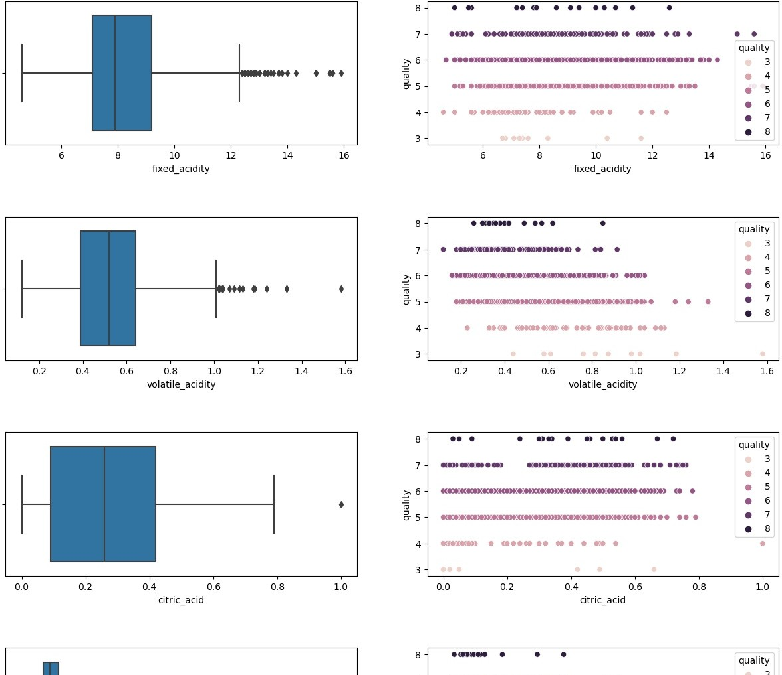



data**.**rename(columns**=**{

"fixed acidity": "fixed_acidity",

"volatile acidity": "volatile_acidity", "citric acid": "citric_acid", "residual sugar": "residual_sugar", "chlorides": "chlorides",

"free sulfur dioxide": "free_sulfur_dioxide", "total sulfur dioxide": "total_sulfur_dioxide"

},inplace**=True**)



Index(['fixed_acidity', 'volatile_acidity', 'citric_acid', 'residual_sugar', 'chlorides', 'free_sulfur_dioxide', 'total_sulfur_dioxide', 'density', 'pH', 'sulphates', 'alcohol', 'quality'],

dtype='object')

data**.**columns



columns**=**list(data**.**columns)

fig,ax **=**plt**.**subplots(11,2,figsize**=**(15,45)) plt**.**subplots_adjust(hspace**=**0.5)

**for** i **in** range(11): sns**.**boxplot(x**=**columns[i],data**=**data,ax**=**ax[i,0])

sns**.**scatterplot(x**=**columns[i],y**=**"quality",data**=**data,hue**=**"quality",ax**=**ax[i,1])

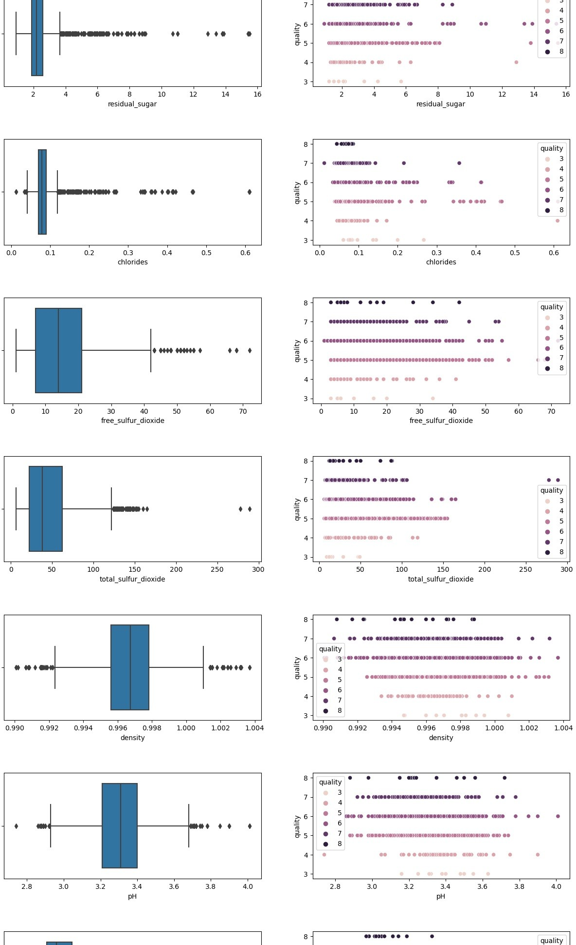

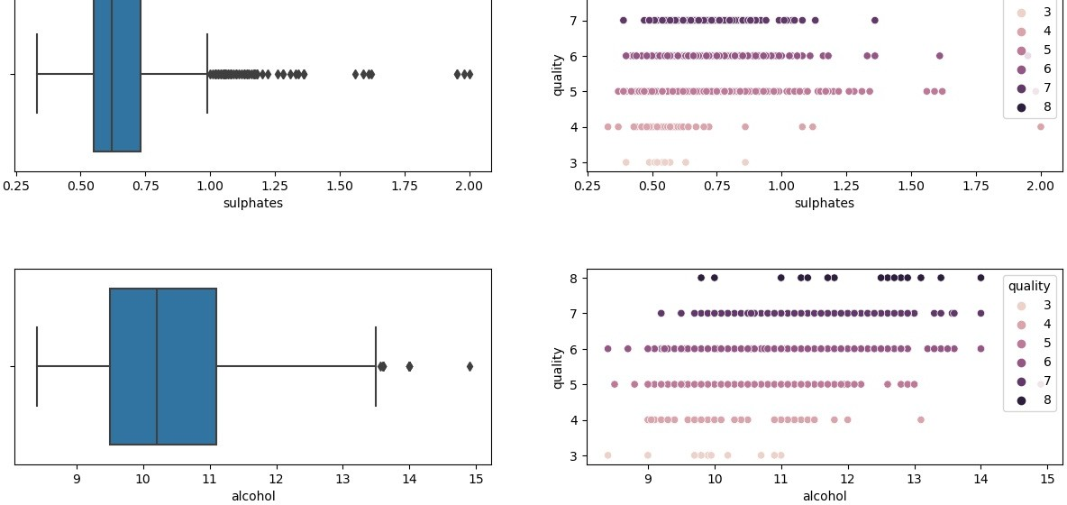

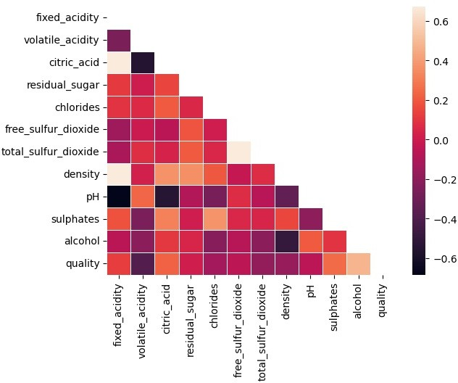

corr**=**data**.**corr() sns**.**heatmap(corr,annot**=True**,linewidth**=**0.5,mask**=**np**.**triu(corr)) plt**.**show()



<seaborn.axisgrid.PairGrid at 0x1e0449879d0>

sns**.**pairplot(data,hue**=**"quality",corner**=True**)

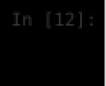

correlation_matrix **=** data**.**corr(method**=**'spearman') sns**.**heatmap(correlation_matrix, annot**=True**, cmap**=**'coolwarm') plt**.**show()

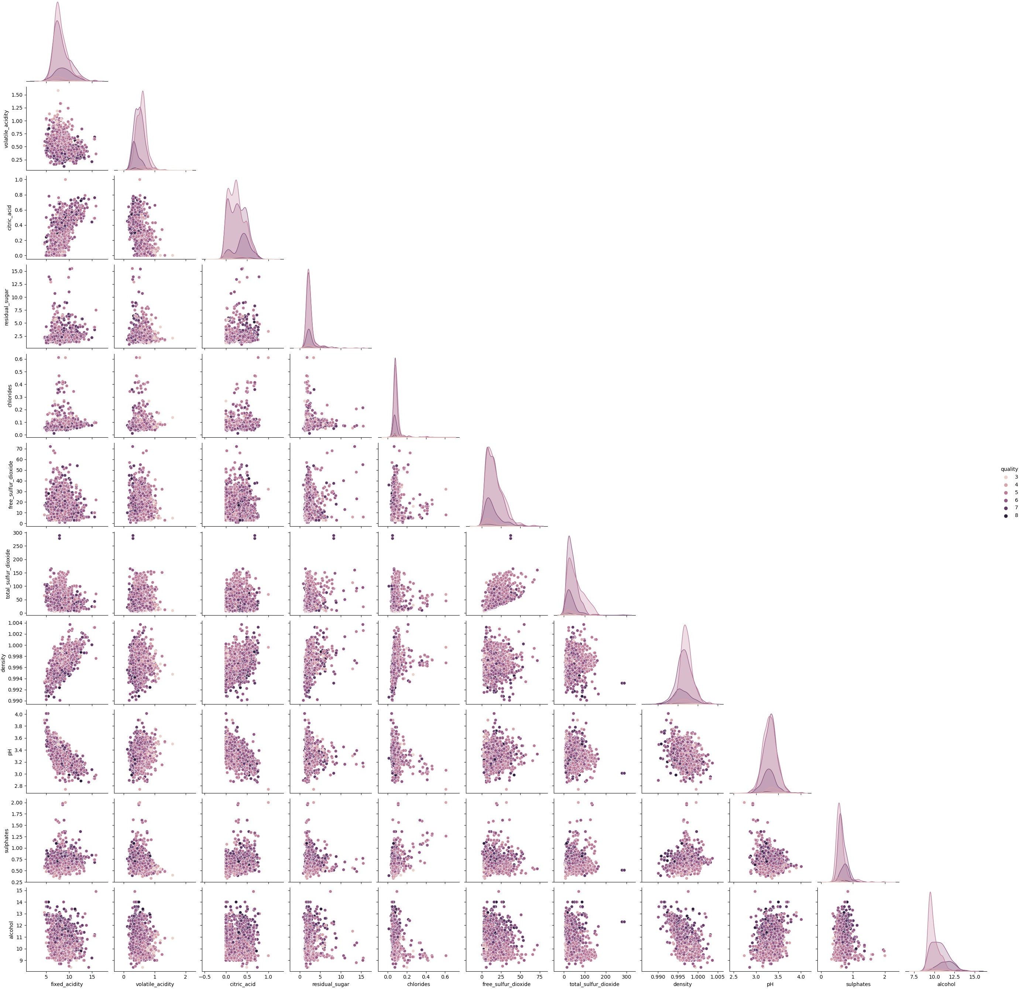

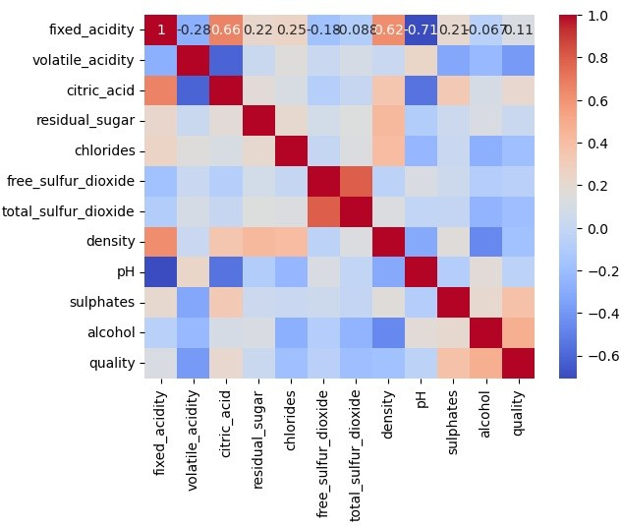

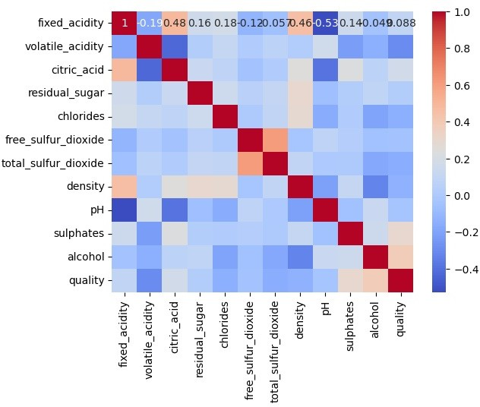

correlation_matrix **=** data**.**corr(method**=**'kendall') sns**.**heatmap(correlation_matrix, annot**=True**, cmap**=**'coolwarm') plt**.**show()



correlation_matrix **=** data**.**corr(method**=**'pearson') sns**.**heatmap(correlation_matrix, annot**=True**, cmap**=**'coolwarm') plt**.**show()

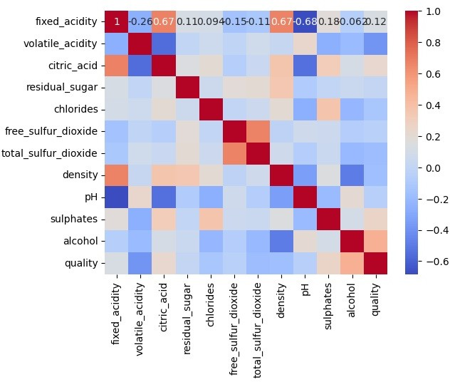

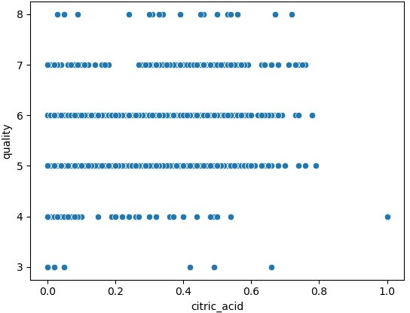

sns**.**scatterplot(x**=**'citric_acid', y**=**'quality', data**=**data) plt**.**show()



*# Pearson Correlation*

pearson_corr **=** data['fixed_acidity']**.**corr(data['citric_acid']) print(f'Pearson Correlation: {pearson_corr}')

*# Spearman Correlation*

spearman_corr **=** data['fixed_acidity']**.**corr(data['citric_acid'], method**=**'spearman') print(f'Spearman Correlation: {spearman_corr}')

*# Kendall Correlation*

kendall_corr **=** data['fixed_acidity']**.**corr(data['citric_acid'], method**=**'kendall') print(f'Kendall Correlation: {kendall_corr}')

Pearson Correlation: 0.6717034347641059

Spearman Correlation: 0.6617084166678848

Kendall Correlation: 0.484271229113174



<Axes: >

sns**.**scatterplot(data**=**columns)

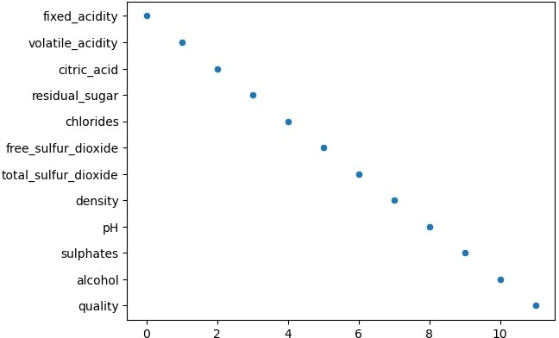



1599 rows × 12 columns



array([5, 6, 7, 4, 8, 3], dtype=int64)

data**.**quality**.**unique()



data**=**data**.**replace({"quality":{8 : 'Good',

7 : 'Good',

6 : 'Middle',

5 : 'Middle',

4 : 'Bad',

3 : 'Bad',}})

|  |  |  |  |  |  |  |  |  |  |  |
| --- | --- | --- | --- | --- | --- | --- | --- | --- | --- | --- |
| data |  | | | | | | | | | |
|  | **fixed_acidity** | **volatile_acidity** | **citric_acid** | **residual_sugar** | **chlorides** | **free_sulfur_dioxide** | **total_sulfur_dioxide** | **density** | **pH** | **s** |
| **0** | 7.4 | 0.700 | 0.00 | 1.9 | 0.076 | 11.0 | 34.0 | 0.99780 | 3.51 |  |
| **1** | 7.8 | 0.880 | 0.00 | 2.6 | 0.098 | 25.0 | 67.0 | 0.99680 | 3.20 |  |
| **2** | 7.8 | 0.760 | 0.04 | 2.3 | 0.092 | 15.0 | 54.0 | 0.99700 | 3.26 |  |
| **3** | 11.2 | 0.280 | 0.56 | 1.9 | 0.075 | 17.0 | 60.0 | 0.99800 | 3.16 |  |
| **4** | 7.4 | 0.700 | 0.00 | 1.9 | 0.076 | 11.0 | 34.0 | 0.99780 | 3.51 |  |
| **...** | ... | ... | ... | ... | ... | ... | ... | ... | ... |  |
| **1594** | 6.2 | 0.600 | 0.08 | 2.0 | 0.090 | 32.0 | 44.0 | 0.99490 | 3.45 |  |
| **1595** | 5.9 | 0.550 | 0.10 | 2.2 | 0.062 | 39.0 | 51.0 | 0.99512 | 3.52 |  |
| **1596** | 6.3 | 0.510 | 0.13 | 2.3 | 0.076 | 29.0 | 40.0 | 0.99574 | 3.42 |  |
| **1597** | 5.9 | 0.645 | 0.12 | 2.0 | 0.075 | 32.0 | 44.0 | 0.99547 | 3.57 |  |
| **1598** | 6.0 | 0.310 | 0.47 | 3.6 | 0.067 | 18.0 | 42.0 | 0.99549 | 3.39 |  |



**from** sklearn.preprocessing **import** MinMaxScaler

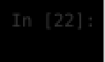

X_temp**=**data**.**drop(columns**=**"quality") y**=**data**.**quality



scaler**=**MinMaxScaler(feature_range**=**(0,1))**.**fit_transform(X_temp) X**=**pd**.**DataFrame(scaler,columns**=**X_temp**.**columns)



X**.**describe()



|  |  |  |  |  |  |  |  |  |
| --- | --- | --- | --- | --- | --- | --- | --- | --- |
|  | **fixed_acidity** | **volatile_acidity** | **citric_acid** | **residual_sugar** | **chlorides** | **free_sulfur_dioxide** | **total_sulfur_dioxide** | **densit** |
| **count** | 1599.000000 | 1599.000000 | 1599.000000 | 1599.000000 | 1599.000000 | 1599.000000 | 1599.000000 | 1599.00000 |
| **mean** | 0.329171 | 0.279329 | 0.270976 | 0.112247 | 0.125988 | 0.209506 | 0.142996 | 0.49021 |
| **std** | 0.154079 | 0.122644 | 0.194801 | 0.096570 | 0.078573 | 0.147326 | 0.116238 | 0.13857 |
| **min** | 0.000000 | 0.000000 | 0.000000 | 0.000000 | 0.000000 | 0.000000 | 0.000000 | 0.00000 |
| **25%** | 0.221239 | 0.184932 | 0.090000 | 0.068493 | 0.096828 | 0.084507 | 0.056537 | 0.40602 |
| **50%** | 0.292035 | 0.273973 | 0.260000 | 0.089041 | 0.111853 | 0.183099 | 0.113074 | 0.49045 |
| **75%** | 0.407080 | 0.356164 | 0.420000 | 0.116438 | 0.130217 | 0.281690 | 0.197880 | 0.57011 |
| **max** | 1.000000 | 1.000000 | 1.000000 | 1.000000 | 1.000000 | 1.000000 | 1.000000 | 1.00000 |



**from** sklearn.model_selection **import** train_test_split,GridSearchCV,cross_val_score,KFold

**from** sklearn.ensemble **import** RandomForestClassifier

**from** sklearn **import** metrics

**from** sklearn.linear_model **import** LogisticRegression

**from** sklearn.svm **import** SVC

**from** sklearn.tree **import** DecisionTreeClassifier **from** sklearn.neighbors **import** KNeighborsClassifier **from** sklearn.naive_bayes **import** GaussianNB



**def** confusion_plot(y_test,y_prediction): cm**=**metrics**.**confusion_matrics(y_test,y_prediction) ax**=**plt**.**subplot()

ax **=** sns**.**heatmap(cm, annot**=True**, fmt**=**'', cmap**=**"Purples") ax**.**set_xlabel('Prediced labels', fontsize**=**18) ax**.**set_ylabel('True labels', fontsize**=**18) ax**.**set_title('Confusion Matrix', fontsize**=**25) ax**.**xaxis**.**set_ticklabels(['Bad', 'Good', 'Middle']) ax**.**yaxis**.**set_ticklabels(['Bad', 'Good', 'Middle']) plt**.**show()



**def** clfr_plot(y_test,y_pred): cr**=**pd**.**DataFrame(metrics**.**Classification_report(y_test,y_pred_rf,digits**=**3,output_dict**=True**))**.**T cr**.**drop(columns**=**"support",inplace**=True**) sns**.**heatmap(cr,annot**=True**,cmap**=**"Purples",linecolor**=**"white",linewidths**=**"0.5")**.**xaxis**.**tick_top()



**def** clf_plot(y_pred): cm**=**metrics**.**confussion_matrics(y_test,y_pred)

cr**=**pd**.**DataFrame(metrics**.**classification_report(y_test,y_pred_rf,digits**=**3,output_dict**=True**))**.**T cr**.**drop(columns**=**"suport",inplace**=True**)

fig,ax**=**plt**.**subplot(1,2,figsize**=**(15,5))

ax[0] **=** sns**.**heatmap(cm, annot**=True**, fmt**=**'', cmap**=**"Purples", ax**=**ax[0]) ax[0]**.**set_xlabel('Prediced labels', fontsize**=**18) ax[0]**.**set_ylabel('True labels', fontsize**=**18) ax[0]**.**set_title('Confusion Matrix', fontsize**=**25) ax[0]**.**xaxis**.**set_ticklabels(['Bad', 'Good', 'Middle'])

ax[0]**.**yaxis**.**set_ticklabels(['Bad', 'Good', 'Middle'])

*# Right AX : Classification Report*

ax[1] **=** sns**.**heatmap(cr, cmap**=**'Purples', annot**=True**, linecolor**=**'white', linewidths**=**0.5, ax**=**ax[1]) ax[1]**.**xaxis**.**tick_top()

ax[1]**.**set_title('Classification Report', fontsize**=**25) plt**.**show()



quality Middle 1319

Good 217

Bad 63

Name: count, dtype: int64

data**.**quality**.**value_counts()



X_train,X_test,y_train,y_test**=**train_test_split(X,y,test_size**=**0.25,random_state**=**0)



**from** sklearn.ensemble **import** RandomForestClassifier parameters **=** {

'n_estimators': [50, 150, 500],

'criterion': ['gini', 'entropy', 'log_loss'],

'max_features': ['sqrt', 'log2']

}

*# Initialize the classifier*

rf **=** RandomForestClassifier(n_jobs**=-**1)

*# Perform grid search*

rf_cv **=** GridSearchCV(estimator**=**rf, cv**=**20, param_grid**=**parameters) rf_cv**.**fit(X_train, y_train)

*# Print the results*

print('Tuned hyper parameters:', rf_cv**.**best_params_) print('Accuracy:', rf_cv**.**best_score_)

Tuned hyper parameters: {'criterion': 'gini', 'max_features': 'sqrt', 'n_estimators': 150} Accuracy: 0.8657203389830508

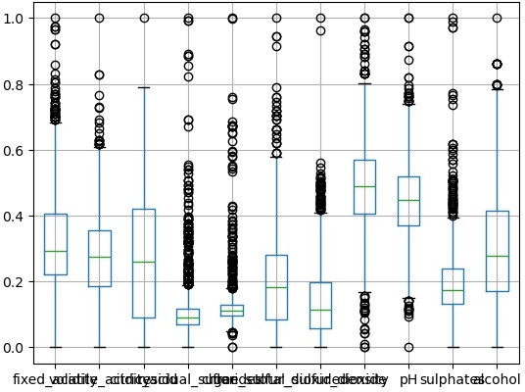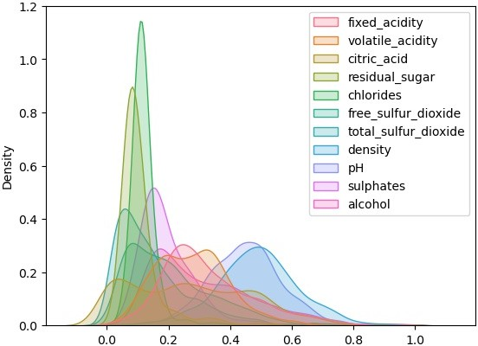

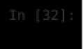

X_temp**=**data**.**drop(columns**=**"quality") y**=**data**.**quality



scaler**=**MinMaxScaler(feature_range**=**(0,1))**.**fit_transform(X_temp) X**=**pd**.**DataFrame(scaler,columns**=**X_temp**.**columns)



<Axes: >

X**.**boxplot()

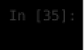

<Axes: ylabel='Density'>

*# KDE plot*

sns**.**kdeplot(data**=**X, shade**=True**)



**import** numpy **as** np

**import** pandas **as** pd

**from** sklearn.model_selection **import** train_test_split

**from** sklearn.ensemble **import** RandomForestClassifier

**from** sklearn.metrics **import** classification_report, confusion_matrix

**from** sklearn.datasets **import** load_iris

*# Load the Iris dataset*

*# Split the data into training and testing sets*

X_train, X_test, y_train, y_test **=** train_test_split(X, y, test_size**=**0.3, random_state**=**42)

*# Initialize the RandomForestClassifier*

clf **=** RandomForestClassifier(n_estimators**=**100, random_state**=**42)

*# Train the classifier*

clf**.**fit(X_train, y_train)

*# Make predictions on the test data*

y_pred **=** clf**.**predict(X_test)

*# Evaluate the model*

print("Classification Report:") print(classification_report(y_test, y_pred))

print("Confusion Matrix:") print(confusion_matrix(y_test, y_pred))

Classification Report:

|  |  |  |  |
| --- | --- | --- | --- |
| precision | recall | f1-score | support |
| Bad 1.00 | 0.06 | 0.11 | 18 |
| Good 0.60 | 0.51 | 0.55 | 67 |
| Middle 0.88 | 0.94 | 0.91 | 395 |
| accuracy |  | 0.85 | 480 |
| macro avg 0.83 | 0.50 | 0.52 | 480 |
| weighted avg 0.85 | 0.85 | 0.83 | 480 |
| Confusion Matrix: |  |  |  |

|  |  |  |
| --- | --- | --- |
| [[ | 1 | 0 17] |
| [ | 0 | 34 33] |
| [ | 0 | 23 372]] |



X_train, X_test, y_train, y_test **=** train_test_split(X, y, test_size**=**0.3, random_state**=**42)

*# Initialize the RandomForestClassifier*

lr**=** LogisticRegression( random_state**=**42)

*# Train the classifier*

lr**.**fit(X_train, y_train)

*# Make predictions on the test data*

y_pred **=** lr**.**predict(X_test)

*# Evaluate the model*

print("Classification Report:") print(classification_report(y_test, y_pred))

print("Confusion Matrix:") print(confusion_matrix(y_test, y_pred))

Classification Report:

|  |  |  |  |
| --- | --- | --- | --- |
| precision | recall | f1-score | support |
| Bad 0.00 | 0.00 | 0.00 | 18 |
| Good 0.59 | 0.19 | 0.29 | 67 |
| Middle 0.84 | 0.98 | 0.91 | 395 |
| accuracy |  | 0.83 | 480 |
| macro avg 0.48 | 0.39 | 0.40 | 480 |
| weighted avg 0.78 | 0.83 | 0.79 | 480 |
| Confusion Matrix: |  |  |  |

|  |  |  |
| --- | --- | --- |
| [[ | 0 | 0 18] |
| [ | 0 | 13 54] |
| [ | 0 | 9 386]] |



*# Initialize the Support Vector Classifier*

svc **=** SVC(kernel**=**'linear', random_state**=**42)

*# Train the classifier*

svc**.**fit(X_train, y_train)

*# Make predictions on the test data*

y_pred **=** svc**.**predict(X_test)

*# Evaluate the model*

print("Classification Report:") print(classification_report(y_test, y_pred))

print("Confusion Matrix:") print(confusion_matrix(y_test, y_pred))

Classification Report:

|  |  |  |  |
| --- | --- | --- | --- |
| precision | recall | f1-score | support |
| Bad 0.00 | 0.00 | 0.00 | 18 |
| Good 0.00 | 0.00 | 0.00 | 67 |
| Middle 0.82 | 1.00 | 0.90 | 395 |
| accuracy |  | 0.82 | 480 |
| macro avg 0.27 | 0.33 | 0.30 | 480 |
| weighted avg 0.68 | 0.82 | 0.74 | 480 |
| Confusion Matrix: |  |  |  |

|  |  |  |
| --- | --- | --- |
| [[ | 0 | 0 18] |
| [ | 0 | 0 67] |
| [ | 0 | 0 395]] |



**from** sklearn **import** datasets

**from** sklearn.model_selection **import** train_test_split **from** sklearn.preprocessing **import** StandardScaler **from** sklearn.svm **import** SVC

**from** sklearn.metrics **import** classification_report, confusion_matrix

*# Introduce imbalance by removing some instances of one class*

X **=** X[y **!=** 2]

y **=** y[y **!=** 2]

*# Split the data into training and testing sets*

X_train, X_test, y_train, y_test **=** train_test_split(X, y, test_size**=**0.3, random_state**=**42)

*# Standardize features by removing the mean and scaling to unit variance*

scaler **=** StandardScaler()

X_train **=** scaler**.**fit_transform(X_train) X_test **=** scaler**.**transform(X_test)

*# Initialize the Support Vector Classifier with class weight adjustment*

svc **=** SVC(kernel**=**'linear', class_weight**=**'balanced', random_state**=**42)

*# Train the classifier*

svc**.**fit(X_train, y_train)

*# Make predictions on the test data*

y_pred **=** svc**.**predict(X_test)

*# Evaluate the model*

print("Classification Report:") print(classification_report(y_test, y_pred))

print("Confusion Matrix:") print(confusion_matrix(y_test, y_pred))

Classification Report:

|  |  |  |  |
| --- | --- | --- | --- |
| precision | recall | f1-score | support |
| Bad 0.14 | 0.89 | 0.24 | 18 |
| Good 0.40 | 0.84 | 0.54 | 67 |
| Middle 0.96 | 0.55 | 0.70 | 395 |
| accuracy |  | 0.60 | 480 |
| macro avg 0.50 | 0.76 | 0.50 | 480 |
| weighted avg 0.85 | 0.60 | 0.66 | 480 |
| Confusion Matrix: |  |  |  |

|  |  |  |
| --- | --- | --- |
| [[ 16 | 0 | 2] |
| [ 4 | 56 | 7] |
| [ 93 | 84 218]] | |



X **=** X[y **!=** 2]

y **=** y[y **!=** 2]

*# Split data into training and test sets*

train_X, test_X, train_y, test_y **=** train_test_split(X, y, random_state**=**42, test_size**=**0.3)

*# Scale the data*

scaler **=** StandardScaler()

X_train **=** scaler**.**fit_transform(train_X) X_test **=** scaler**.**transform(test_X)

*# Train the SVM classifier*

svc **=** SVC(kernel**=**"linear", class_weight**=**"balanced", random_state**=**42) svc**.**fit(X_train, train_y)

*# Predict quality based on user input*

**try**:

user_input **=** [float(x) **for** x **in** input("Enter values separated by spaces (e.g., '1.5 2.5'): ")**.**split()] user_input_scaled **=** scaler**.**transform([user_input]) *# Scale the input using the same scaler* prediction **=** svc**.**predict(user_input_scaled)

print("Predicted quality is:", prediction[0])

**except** Exception **as** e: print("Error:", e)

Enter values separated by spaces (e.g., '1.5 2.5'): 7.4 0.700 0.00 1.9 0.076 11.0 34.0 0.99780

3.51 0.56 9.4

Predicted quality is: Middle



Loading [MathJax]/jax/output/CommonHTML/fonts/TeX/fontdata.js