Jurnal Kejuruteraan (Journal of Engineering) Online First | ISSN: 0128-0198 E-ISSN: 2289-7526
Mode Choice Modelling in Palembang’s Integrated Public Transport Network Using Multinomial Logit
ABSTRACT
Service integration does not automatically increase public transport use unless the attributes considered by travellers are understood. This study analyses mode choice within Palembang’s integrated LRT Sumsel, Teman Bus, and Angkot Feeder network using a multinomial logit model. The survey was conducted from 1 August to 16 September 2026 among 400 respondents who lived and routinely travelled in Palembang and knew the available transport options. Each respondent specified an origin and destination for a routine trip; the application then generated public transport, private-vehicle, and paid non-public transport alternatives characterised by travel time, cost, transfers, access distance, comfort, and reliability. Following data auditing, consolidation of identical alternatives, and exclusion of singleton choice sets and extreme values, 318 observations were retained. Adding a private-vehicle alternative-specific constant improved fit over the basic model (McFadden ρ²=0.0514; AIC=518.10). Reliability had a positive significant effect (β=0.353; p<0.05), while the private-vehicle constant was also positive and significant (β=0.610; p<0.05), indicating a baseline inclination towards private vehicles beyond measured attributes. Access distance was positive and significant but contrary to theory and was therefore not interpreted causally. Time, cost, and transfers were insignificant; removing transfers did not significantly reduce model fit (p=0.3790). The findings emphasise service reliability and unobserved preferences, while showing that system-derived attributes and intended choices require validation against operational data and realised travel before the model informs policy recommendations or application personalisation.
Keywords: mode choice; multinomial logit; integrated public transport; reliability; Palembang

INTRODUCTION
Urban public transport must provide connectivity and service quality capable of competing with private vehicles. In Palembang, LRT Sumsel, Teman Bus, and Angkot Feeder form a network that enables intermodal trips. Network availability alone, however, does not explain how users value time, cost, transfers, access, comfort, and reliability when choosing a mode. Behavioural analysis is required so that service integration extends beyond infrastructure provision.
Random utility theory represents choice as a comparison of alternative utilities (McFadden 1974; Ben-Akiva & Lerman 1985). Multinomial Logit (MNL) is widely used because choice probabilities can be linked directly to alternative attributes and estimated by maximum likelihood (Train 2009). Travel time and cost are normally expected to reduce utility, whereas comfort and reliability should increase it. Access and transfers are also important because out-of-vehicle time is often valued differently from in-vehicle time (Wardman 2004), and travel-time uncertainty carries its own disutility (Bates et al. 2001).
A basic model remains limited. Responsiveness to service attributes may vary across individuals (Bhat 1998), while alternative-specific constants can capture baseline preferences omitted from measured attributes (Ben-Akiva & Lerman 1985). Moreover, a choice stated before travelling is not equivalent to observed realised behaviour; choice context and scenario realism must therefore be reported transparently (Louviere et al. 2000).
This study uses a route-search application as an instrument to generate choice sets for respondent-defined routine origin–destination pairs. Dijkstra’s algorithm (Dijkstra 1959) only generates alternatives; the main contribution is the estimation of mode-choice determinants. The objectives are to: (1) describe choices across mode groups; (2) estimate a basic MNL and an MNL with a private-vehicle alternative-specific constant (ASC); and (3) examine robustness through reduced specifications and sample sensitivity.
METHODOLOGY
Study Context and Transport Network
The study concerns routine trips in Palembang. The application network includes eight Angkot Feeder corridors, two Teman Bus corridors, and LRT Sumsel. Alternatives are grouped as public transport, private vehicles, and paid non-public transport. The last category includes demand-responsive or hired services outside the public transport network and is not treated as private-vehicle ownership.
Application-Generated Choice Sets
Respondents specified origins and destinations representing their routine activities. Departure time was automatically set to the survey or interview time. The application connected these points to the network, ran Dijkstra routing, calculated access and transfer legs, and displayed several alternatives with the same six attributes. Respondents selected one preferred alternative before travelling; subsequent trip realisation was not verified.

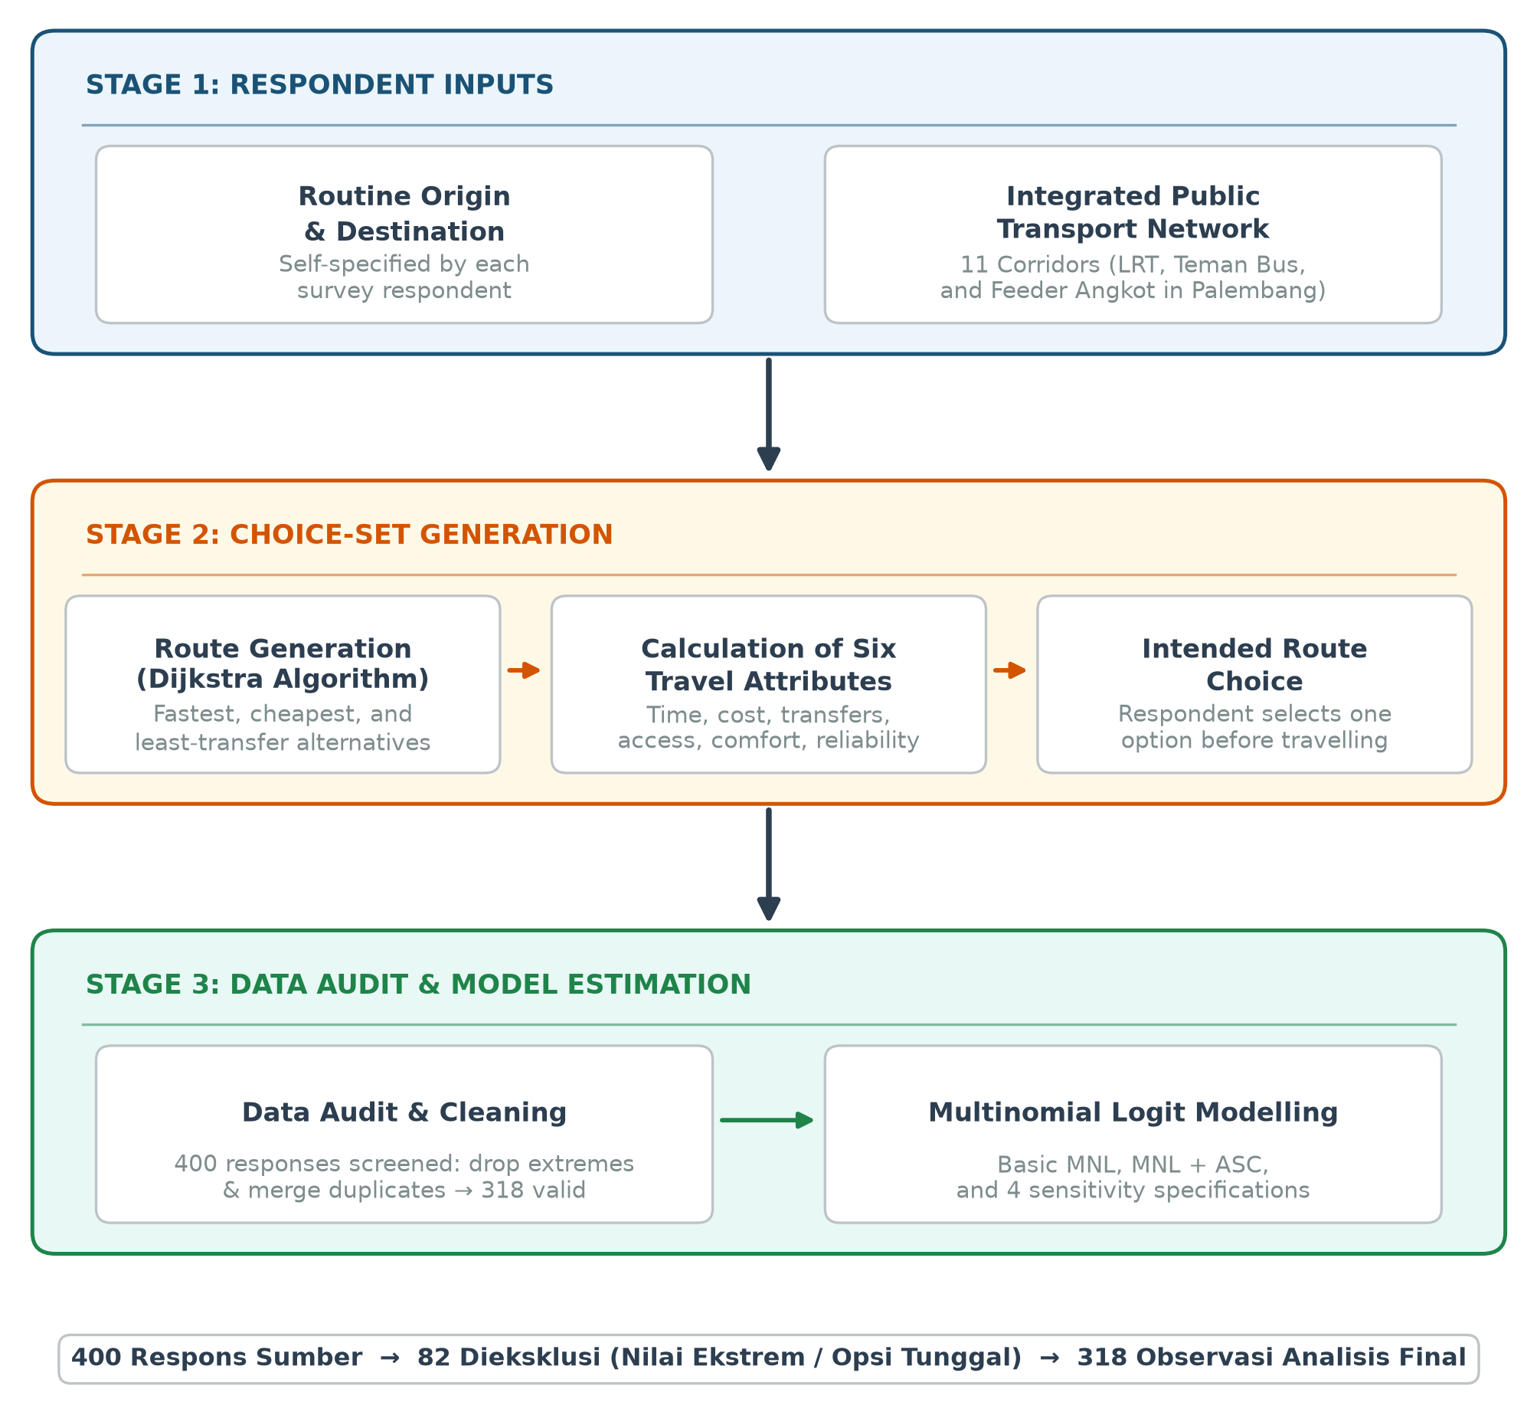
FIGURE 1. Route-alternative generation, choice collection, data audit, and MNL estimation

Survey Design and Data Collection
The survey was conducted from 1 August to 16 September 2026 using non-probability convenience sampling. Inclusion required living and routinely engaging in activities in Palembang and knowing the available local transport choices. The instrument was administered through direct interviews with the general public, student networks, and social media. During interviews, enumerators neutrally read and explained the same questions and alternative order displayed by the application without recommending an option. Participation was voluntary, consent was obtained before completion, and data were recorded anonymously.
Variables
TABLE 1. Model-variable definitions
Variable | Definition and unit | Expected sign
Time | Total travel time, minutes | −
Cost | Total travel cost, Indonesian rupiah | −
Transfers | Number of vehicle changes | −
Access distance | First/last-mile distance, km | −
Comfort | System score, 0–5 | +
Reliability | System score, 0–5 | +
Private-vehicle ASC | Private-vehicle indicator | Unrestricted

Comfort and reliability are system parameters assigned by mode rather than objective field measurements. They are therefore treated as proxies and discussed as a limitation.
TABLE 2. Characteristics of the 318 respondents in the analytical sample
Characteristic | Dominant category | n (%)
Gender | Female | 157 (49.4)
Occupation | Student | 204 (64.2)
Monthly income | <IDR1 million | 142 (44.7)
Vehicle ownership | Motorcycle | 164 (51.6)
Trip purpose | School/university | 164 (51.6)
Public transport frequency | Several times a week | 116 (36.5)

Eight observations lacked complete profiles; percentages use the entire analytical sample as denominator.
Data Audit and Cleaning
The source CSV contained 400 observations from 400 unique respondents. Alternatives with identical values across all six attributes within a choice set were consolidated because they represented the same trip despite different interface labels. Choice sets with fewer than two unique alternatives were excluded. Observations were also excluded when travel time exceeded 1,000 minutes or cost exceeded IDR100,000; these conservative thresholds clearly separated an anomalous cluster from the remaining distribution. Each final observation required exactly one chosen alternative.
TABLE 3. Construction of the analytical sample
Stage | Observations
Source data | 400
Excluded: extreme values | 22
Excluded: <2 unique alternatives | 60
Final analytical sample | 318

A total of 136 duplicate alternative rows were consolidated, leaving 748 final alternative rows. The source SHA-256 checksum is `93fcf7d061e8e294f2ebefd8dc8a52b7b5632484085b960e30820fc615219c2a`.
MNL Specification
The utility of alternative j for respondent i is:
U_{ij}=\beta_{time}Time_{ij}+\beta_{cost}Cost_{ij}+\beta_{transfer}Transfer_{ij}+\beta_{access}Access_{ij}+\beta_{comfort}Comfort_{ij}+\beta_{reliability}Reliability_{ij}.
The MNL probability is:
P_{ij}=\frac{\exp(U_{ij})}{\sum_m\exp(U_{im})}.
The main model adds \(\alpha_{private}I(private)_{ij}\), with public transport as the reference. Parameters were estimated using Newton–Raphson. Ordinary standard errors are the primary inference because each final UUID contributes one observation. Fit is assessed through log-likelihood, McFadden ρ², AIC, and BIC.
Sensitivity Analysis
The main model is compared with specifications excluding access distance, transfers, both variables, and paid non-public transport. Likelihood-ratio tests are used only for nested models estimated on the same sample. The sample-sensitivity model is not directly compared using AIC/BIC with full-sample models.
RESULTS AND DISCUSSION
Analytical Sample and Choice Patterns
Among 318 final choices, 176 (55.3%) selected public transport, 136 (42.8%) selected a private vehicle, and 6 (1.9%) selected paid non-public transport. Public transport held a narrow majority, while private vehicles remained competitive even when choices were presented within an integrated public transport context.

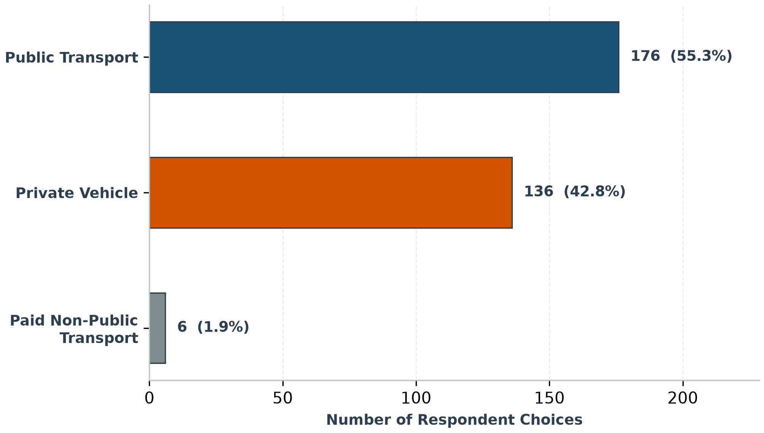
FIGURE 2. Choice distribution by mode group

Attribute Variation and Correlation
Time and reliability varied in every choice set; cost and comfort varied in 98.1%, access distance in 95.6%, but transfers in only 41.2%. Limited transfer variation reduces information available for identifying its parameter. Correlations of 0.606 between time and transfers and −0.521 between transfers and comfort also suggest that parts of their effects are difficult to separate.

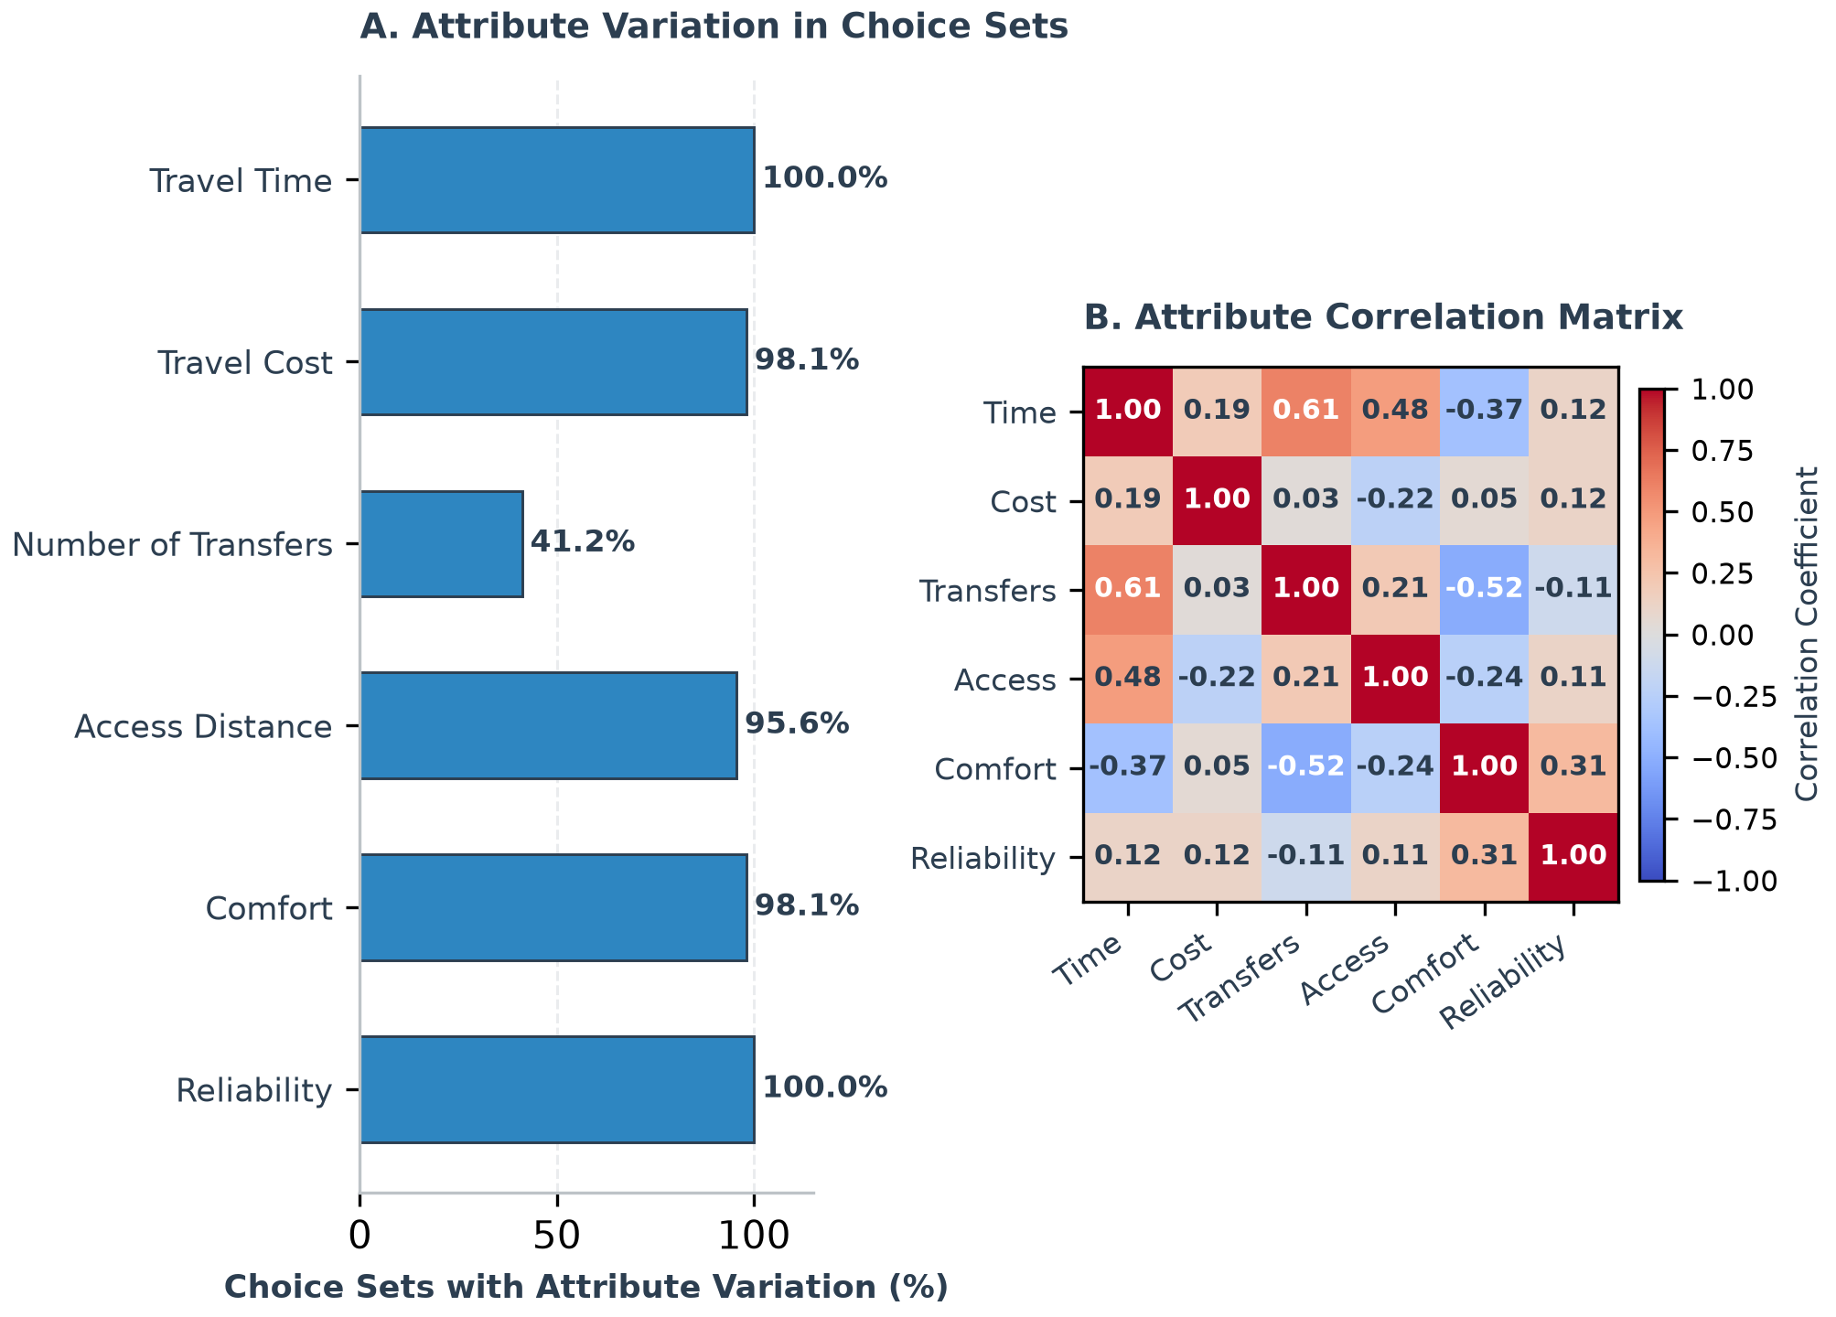
FIGURE 3. Within-choice-set variation (Panel A) and attribute correlations (Panel B)

MNL Estimation Results
TABLE 4. Basic model and private-vehicle ASC model estimates
Variable | Basic β (SE) | MNL+ASC β (SE)
Time | −0.00693 (0.00841) | −0.00239 (0.00861)
Cost | −0.0000225 (0.0000174) | −0.0000211 (0.0000179)
Transfers | 0.240 (0.258) | 0.231 (0.263)
Access distance | 0.336 (0.194) | 0.502 (0.214)
Comfort | 0.413 (0.164) | 0.255 (0.174)
Reliability | 0.118 (0.132) | 0.353 (0.166)
Private-vehicle ASC | — | 0.610 (0.247)
Log-likelihood | −255.166 | −252.049
McFadden ρ² | 0.0397 | 0.0514
AIC | 522.33 | 518.10
BIC | 544.91 | 544.43

Note: significant at 5% (|t|>1.96); ordinary SE in parentheses.
The ASC improved log-likelihood and AIC, although the increase in ρ² from 0.0397 to 0.0514 still indicates low explanatory power. The private-vehicle ASC was positive and significant (β=0.610), indicating an inclination towards private vehicles beyond measured attributes. Reliability was positive and significant as theoretically expected. Time and cost were negative but insignificant.
Access distance was positive and significant, contrary to theory. This is not interpreted as a preference for longer access. Zero access for private vehicles, differences in network coverage, and system-derived proxies may cause the parameter to capture alternative structure or unmodelled spatial factors. Comfort became insignificant after including the ASC, suggesting association between the comfort proxy and mode identity.

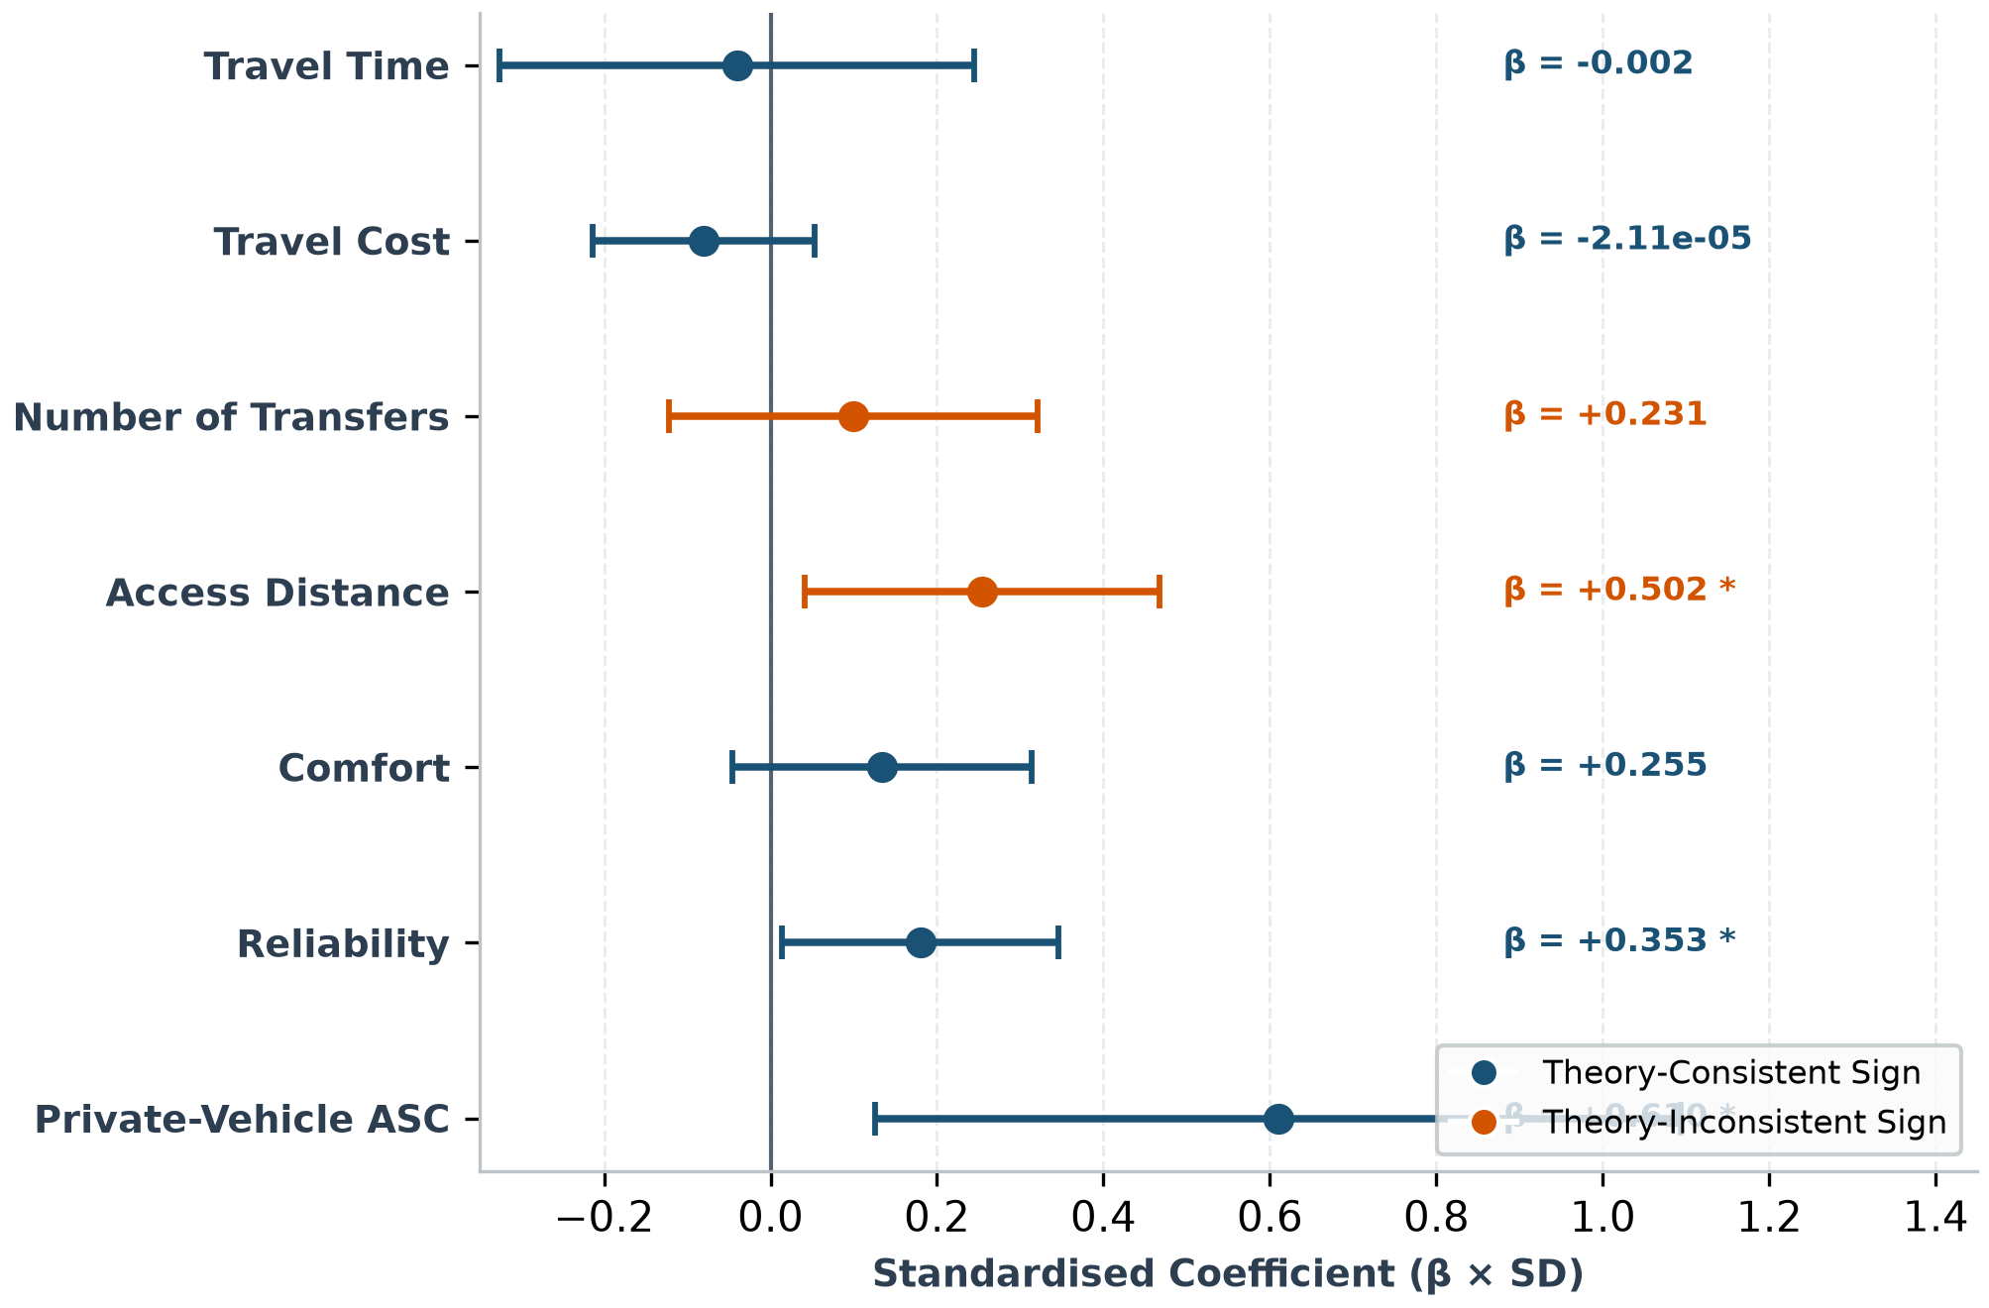
FIGURE 4. MNL+ASC coefficients and 95% confidence intervals

Sensitivity and Model Selection
TABLE 5. Model-specification sensitivity

Specification | LL | ρ² | AIC | BIC | LR p-value
Full + ASC | −252.049 | 0.0514 | 518.10 | 544.43 | —
Without access | −255.122 | 0.0399 | 522.24 | 544.82 | 0.0132
Without transfers | −252.436 | 0.0500 | 516.87 | 539.44 | 0.3790
Without access and transfers | −255.143 | 0.0398 | 520.29 | 539.10 | 0.0453
Without paid non-public transport† | −237.397 | 0.0404 | 488.79 | 514.67 | —

Note: †N=298; AIC/BIC are not directly compared with N=318 models.
Removing access significantly reduced fit (p=0.0132), showing that access contains information despite its problematic sign. Removing transfers did not significantly reduce fit (p=0.3790) and yielded a lower AIC. The no-transfer model is therefore a useful robustness specification, while the full model is retained as the main conceptual model.

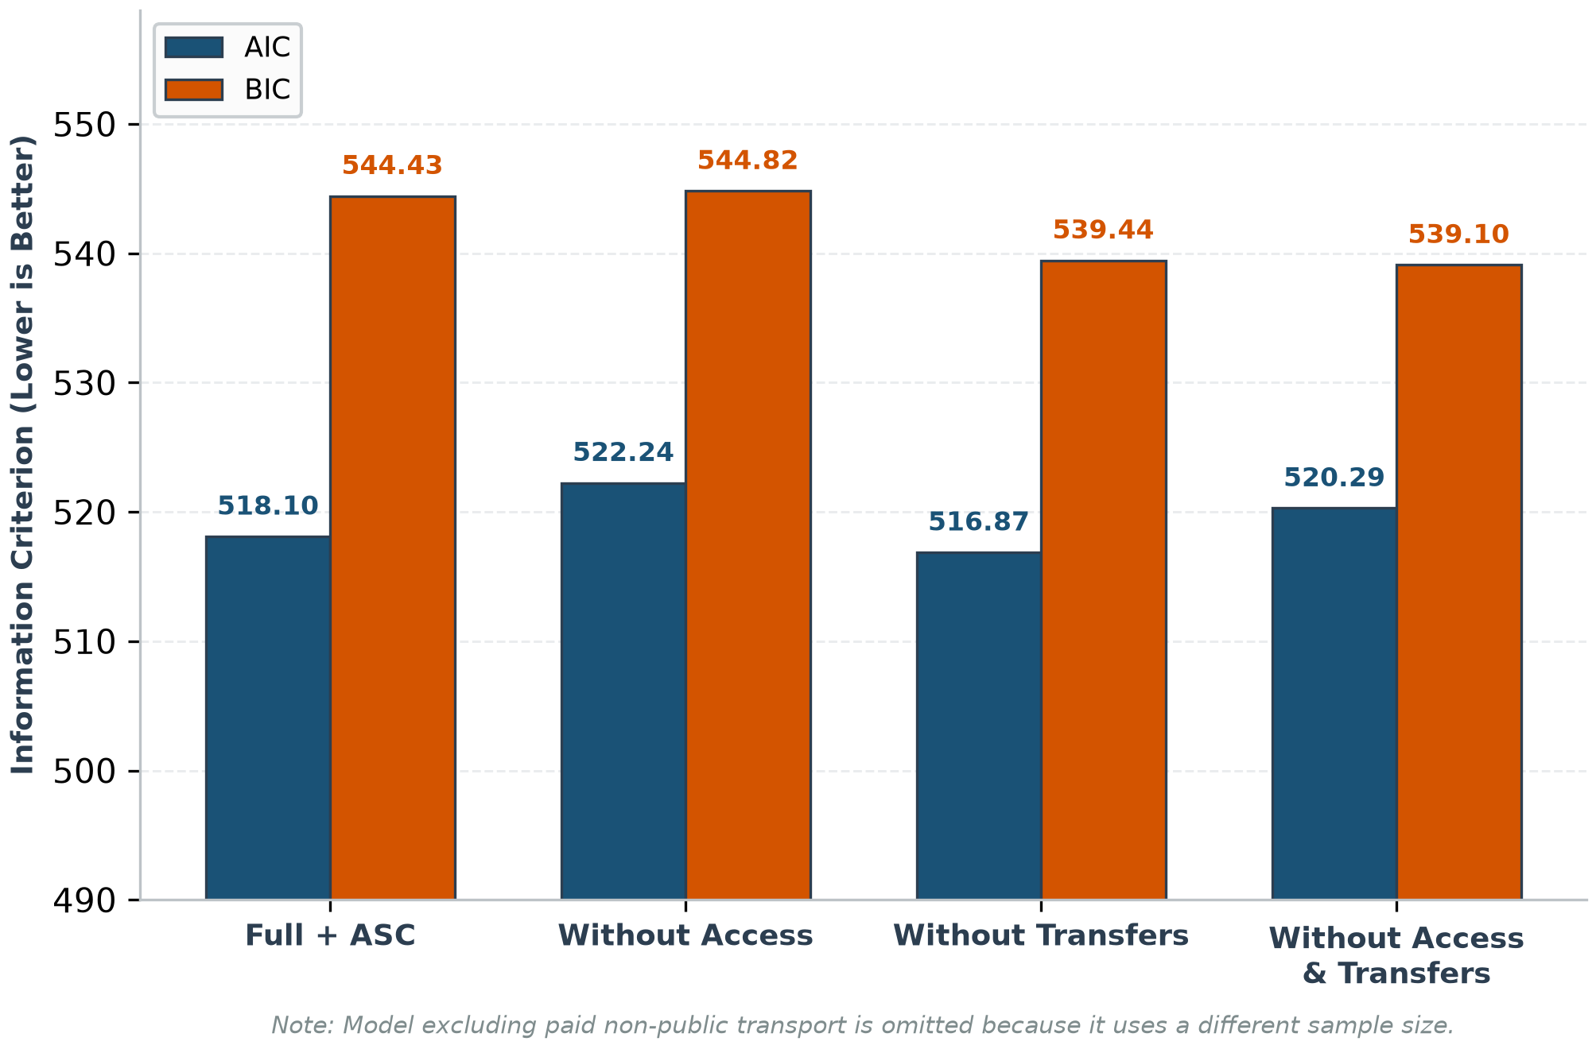
FIGURE 5. AIC and BIC for models estimated on the same sample

Comfort, reliability, and ASC remained positive across specifications. In contrast, time and cost changed sign in some sensitivity analyses. This instability limits interpretation of value of time and indicates that six attributes do not fully separate the mechanisms underlying choice.

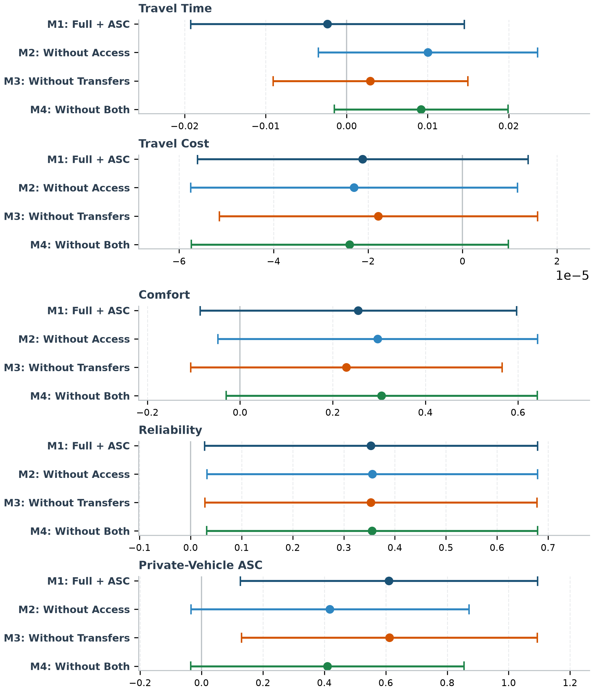
FIGURE 6. Coefficient stability relative to the full model

Implications and Limitations
The results support prioritising reliability: more predictable schedules and consistent arrival information may strengthen public transport attractiveness. The positive ASC suggests that habit, privacy, flexibility, vehicle availability, or other omitted factors continue to favour private vehicles. Policy should therefore address uncertainty and transfer barriers rather than focusing solely on travel time.
Interpretation is limited by convenience sampling, unverified trip realisation, two collection modes, and comfort, reliability, headway, and speed parameters partly based on system assumptions. MNL also imposes the independence of irrelevant alternatives property (Train 2009). Low explanatory power and the unexpected access sign indicate the need for observed operations, richer access measures, attitudinal variables, and heterogeneity models.
CONCLUSION
This study links application-generated choice sets for routine trips with MNL analysis of mode choice in Palembang’s integrated public transport network. Of 400 respondents, 318 observations met the quality rules. MNL+ASC performed better than the basic model, but explanatory power remained low. Reliability and the baseline inclination towards private vehicles were significant and stable, whereas time, cost, and transfers were insignificant. Access contributed statistical information but had a theoretically unexpected sign and cannot support direct behavioural interpretation.
The findings direct service improvement towards reliability and omitted factors sustaining private-vehicle use. The no-transfer model supports partial robustness, but unstable time and cost signs require caution. Coefficients have not been deployed for production recommendations. Further validation should combine observed operations, realised trips, validated perception measures, and more representative sampling.
ACKNOWLEDGEMENT
This research was supported by `[FUNDING AGENCY]` under grant number `[GRANT NUMBER]`.
DECLARATION OF COMPETING INTEREST
None.
REFERENCES
Badan Pusat Statistik Kota Palembang. 2024. Kota Palembang dalam Angka 2024. Palembang: BPS Kota Palembang.
Bates, J., Polak, J., Jones, P. & Cook, A. 2001. The valuation of reliability for personal travel. Transportation Research Part E 37(2–3): 191–229. https://doi.org/10.1016/S1366-5545(00)00011-9
Ben-Akiva, M. & Lerman, S.R. 1985. Discrete Choice Analysis: Theory and Application to Travel Demand. Cambridge, MA: MIT Press.
Bhat, C.R. 1998. Accommodating variations in responsiveness to level-of-service measures in travel mode choice modeling. Transportation Research Part A 32(7): 495–507. https://doi.org/10.1016/S0965-8564(98)00011-1
Dijkstra, E.W. 1959. A note on two problems in connexion with graphs. Numerische Mathematik 1: 269–271. https://doi.org/10.1007/BF01386390
Direktorat Jenderal Perkeretaapian. 2023. Profil Pengoperasian LRT Sumatera Selatan. Jakarta: Kementerian Perhubungan Republik Indonesia.
Hensher, D.A., Rose, J.M. & Greene, W.H. 2015. Applied Choice Analysis. Cambridge: Cambridge University Press. https://doi.org/10.1017/CBO9781316136232
Louviere, J.J., Hensher, D.A. & Swait, J.D. 2000. Stated Choice Methods: Analysis and Applications. Cambridge: Cambridge University Press. https://doi.org/10.1017/CBO9780511753831
McFadden, D. 1974. Conditional logit analysis of qualitative choice behavior. In Frontiers in Econometrics, edited by P. Zarembka, 105–142. New York: Academic Press.
Train, K.E. 2009. Discrete Choice Methods with Simulation. 2nd ed. Cambridge: Cambridge University Press.
Wardman, M. 2004. Public transport values of time. Transport Policy 11(4): 363–377. https://doi.org/10.1016/j.tranpol.2004.05.001

