Angular Forms - Lab

Initial Setup
Create a new angular application. You are provided with an HTML & CSS files containing the form itself with styles and font awesome icons.
Go to fontawesome.com and add the provided HTML link inside index.html:
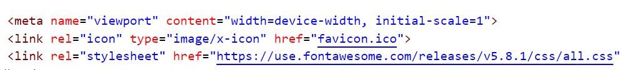

Template-Driven Form
Generate a register-form component and use the provided HTML to create a template-driven form. Attach all the needed directives like (ngForm, ngModel).
Use @ViewChild to reference the NgForm inside the component.
Handle submitting of the form. Inside the handler function reset the form.
Define the options for both select lists as an array of strings and loop through the arrays inside the template. Add a default value to both select lists.
Define the following CSS inside register-form.component.css:
input.ng-valid {
border-left: 5px solid #42A948; /* green */
}

input.ng-invalid.ng-touched {
border-left: 5px solid #A94442; /* red */
}

Validation
- The full name input field must contain two names (letters only) separated by a space. Both should start with a capital letter.
- The email input field must be a valid email address.
- The phone number input field must be a 9 digit number.
- The password input field must be between 3 and 16 symbols and must contain only letters and digits.
- Both passwords must match.
Output error messages inside a div with class "alert alert-danger" when an input field is invalid and touched, also disable the submit button if an input field is invalid.

Grouping
Wrap both password fields inside a common ngModelGroup and add the password validation after the group definition.
At the end your form should look like this:
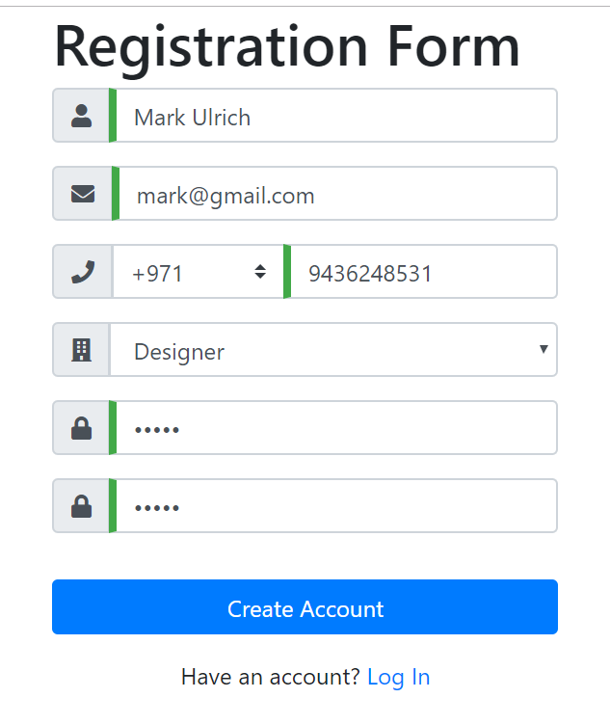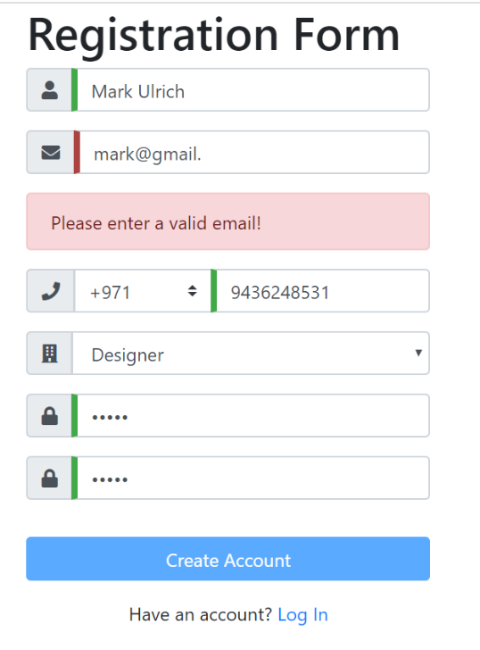

Create a Custom Attribute Directive
Let's add another input field containing an image URL to a profile picture (use 'fa fa-image' for the font awesome icon). Validate this input field by writing your own attribute directive.
The directive should listen to input events and validate if the input value starts with http and ends with jpg/png.
Use Renderer2 to set the border-left styling of the field to either red or green. To manually change the state of an input field to invalid you must inject the NgForm inside the directive and use the setErrors({ 'incorrect': true }) method on the control to mark it as invalid. Clearing the errors is done with setErrors(null)
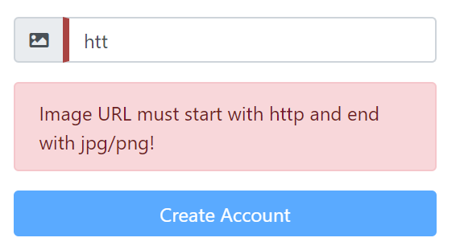

Reactive Form
Create a new component register-form-reactive and now build the same form using the reactive approach. Create your own form groups and form controls (optionally you can inject the form builder). Validate the fields using Validators and etc.

