SoftUni Forum Workshop - Part 1
This application is created as a workshop for the Angular Couse @ Software University

Task Requirements
You will be provided with skeleton (HTML and CSS). When starting the index.html, the following page will appear:
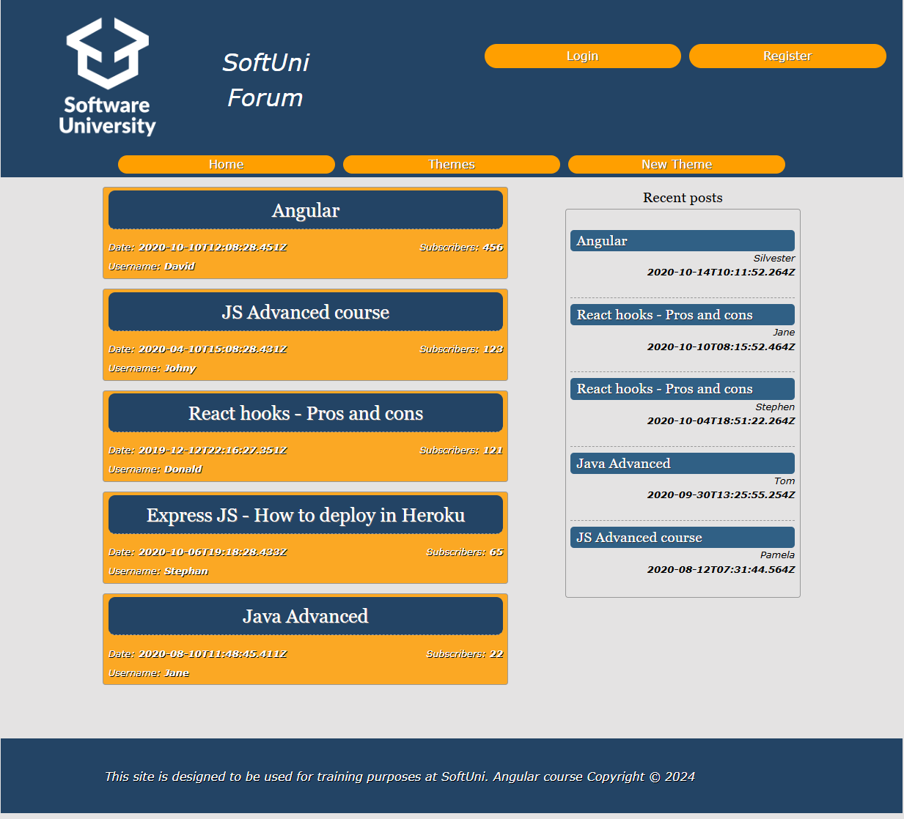
The application is a forum, where each registered user can create a theme or post a comment. For now, your task is to check the given skeleton (HTML and CSS files) and split them into components, so each part can be reusable. Be careful when you structure the components.

MongoDB
Before you start with creating a new project in Angular you need to install MongoDB. You can find an installation guide in the provided document:
MongoDB-Installation-Guide.docx
After the successful installation your database will be empty, so you can load the provided from us initial data in it as follows:
- Download the provided folder named "resources".
- Open the "forum" folder inside "resources" and copy the path:

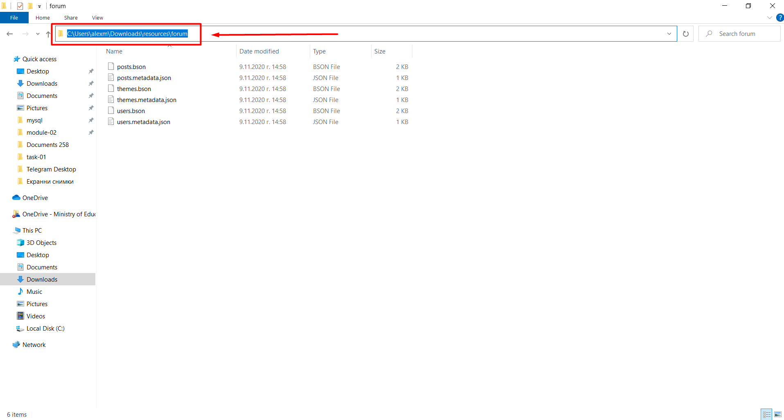
- Navigate to the mongo tools folder:
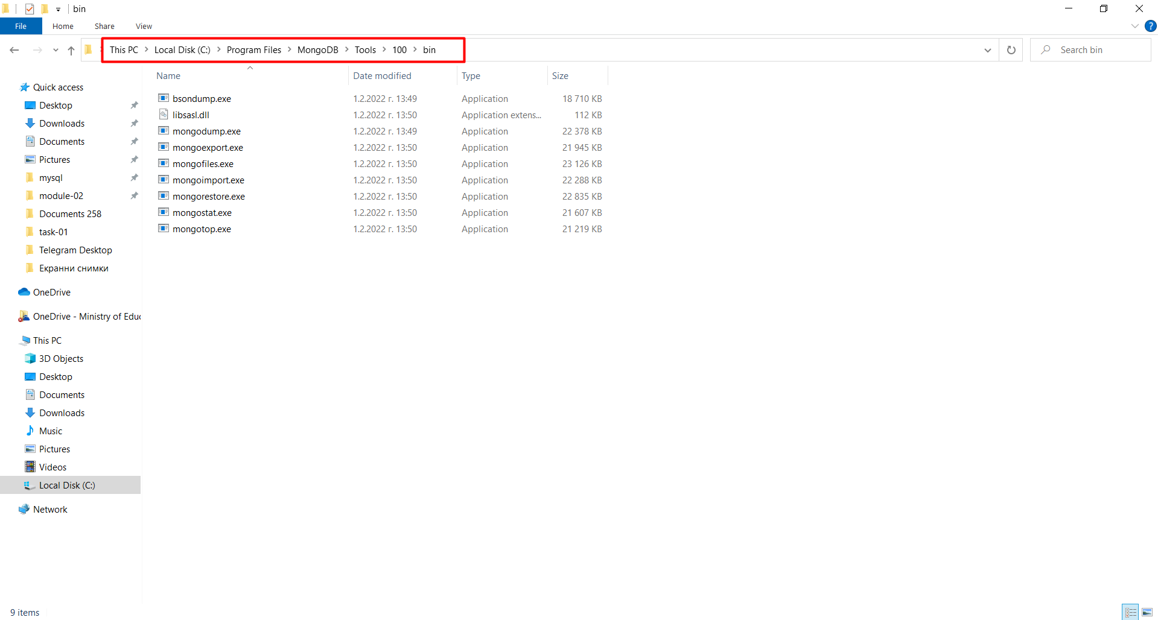
- Open the command prompt inside of this folder
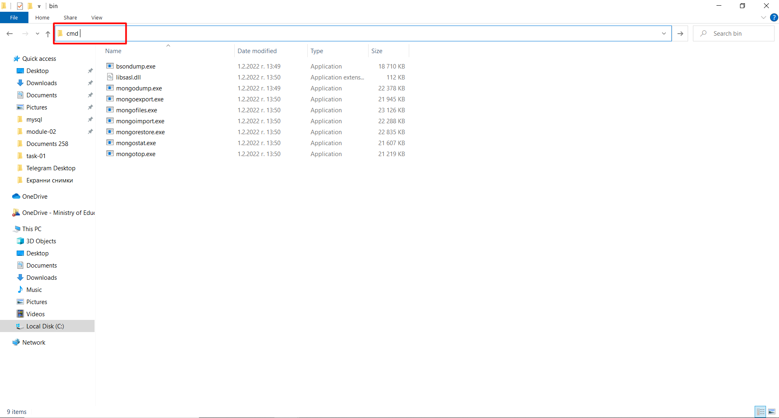
- In the console write the following command:
mongorestore -d forum C:\Users\Name\Downloads\resources\forum
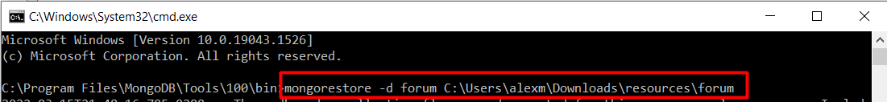
- Note* C:\Users\Name\Downloads\resources\forum – replace with the path of the folder "forum" in your computer that you copied in the beginning.
- You will see something like this:
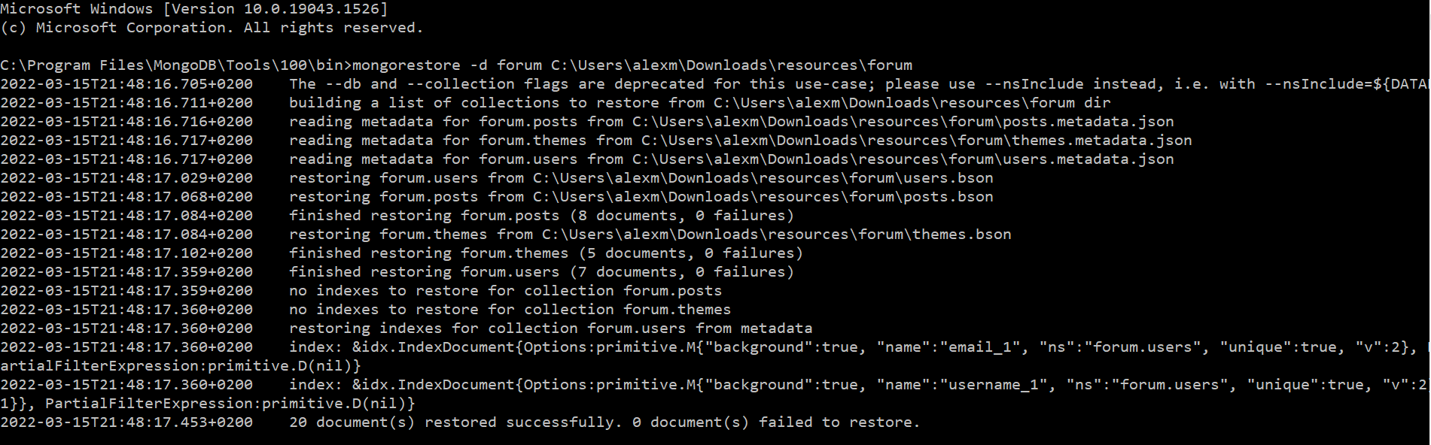
- That's it! You can now find the db in MongoDB Compass if you have installed it:
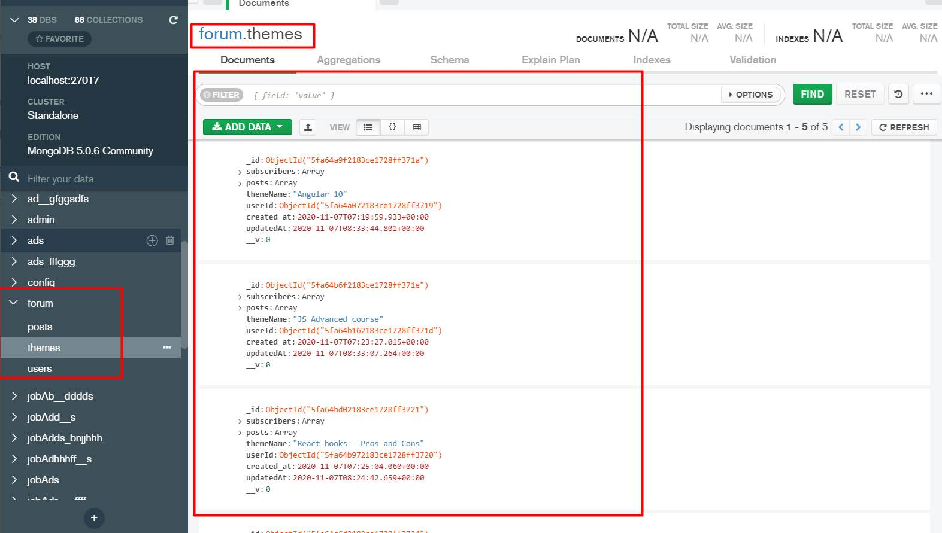
- If you haven't installed MongoDB Compass, you can check the DB in the following way:
- Navigate to the MongoDB server folder

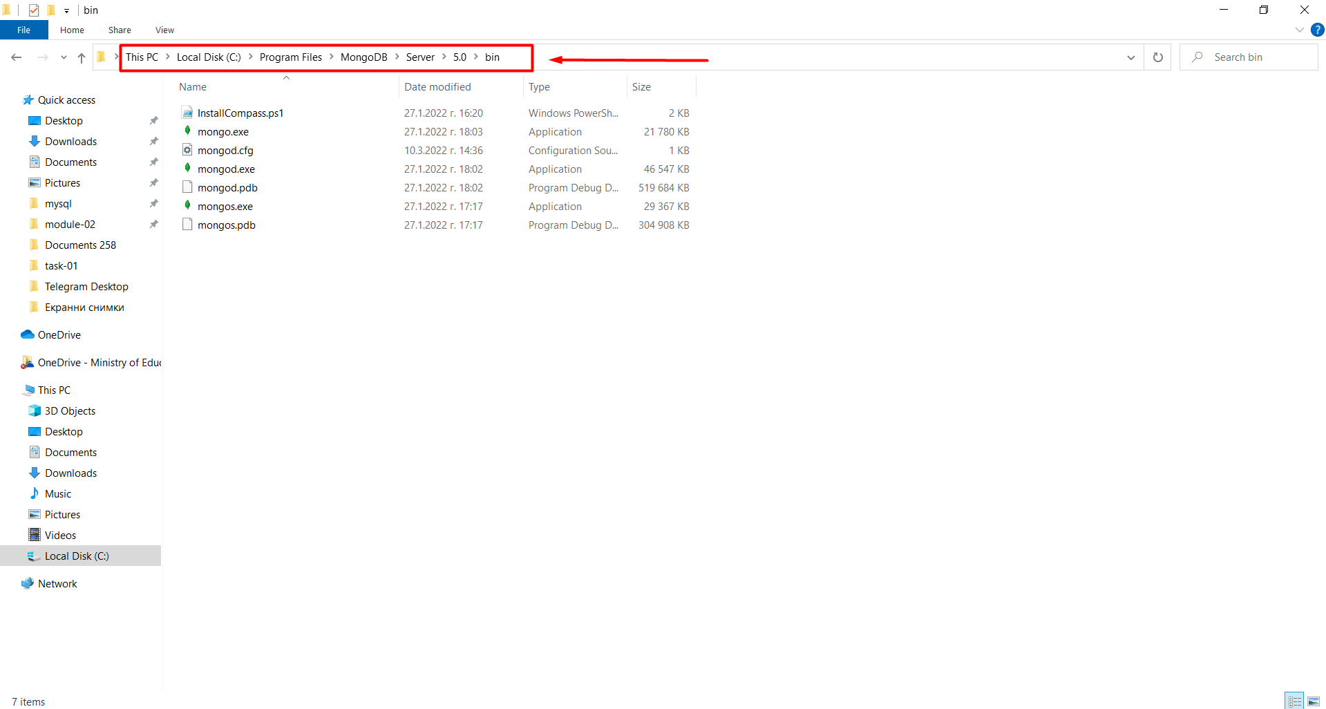
- Open cmd inside of this folder
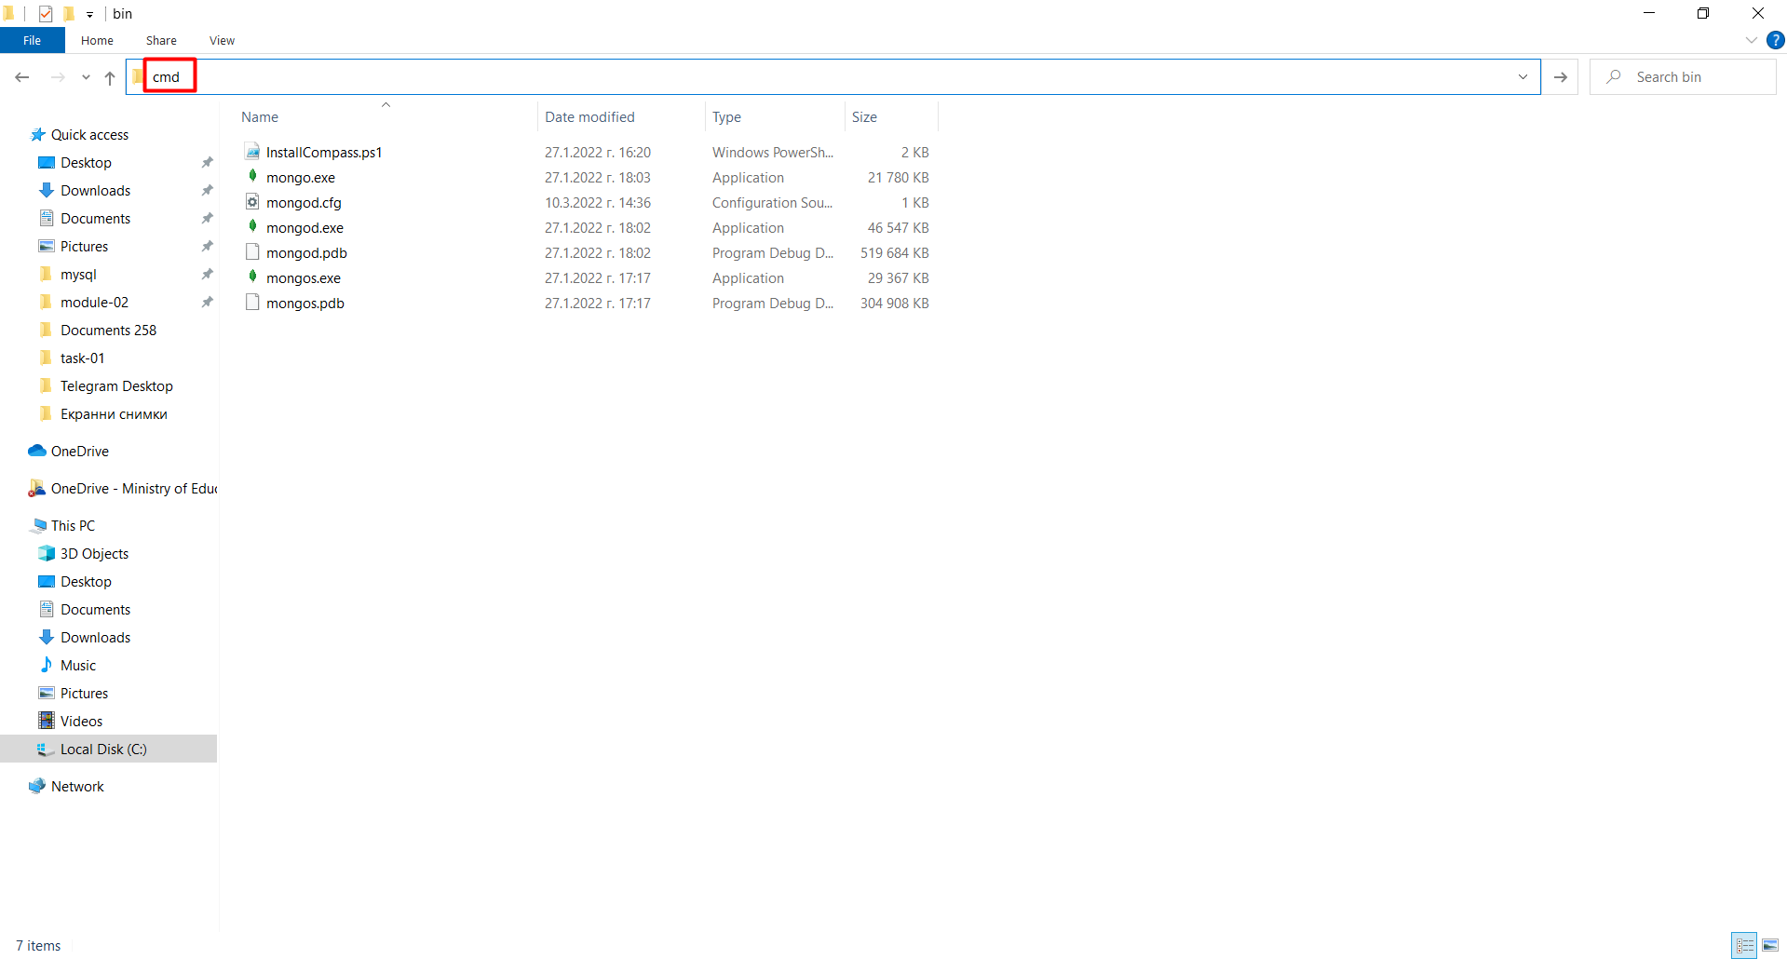
- Run the command "mongo"
- Run the command "show dbs"
- You should be able to find and use the "forum" db
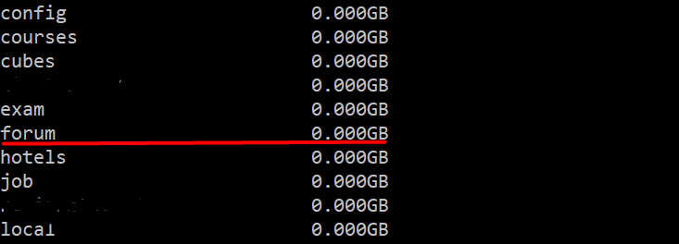
- Install dependencies with the npm install command
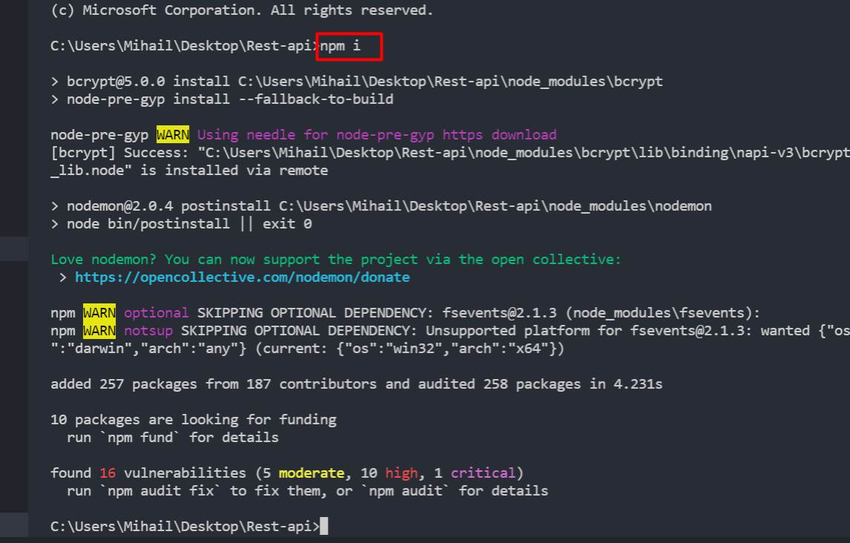
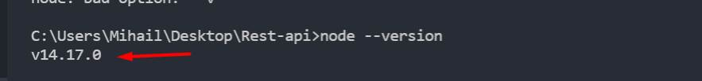
- With this version of node there is no problem to start the server. As it is not necessary to change anything.
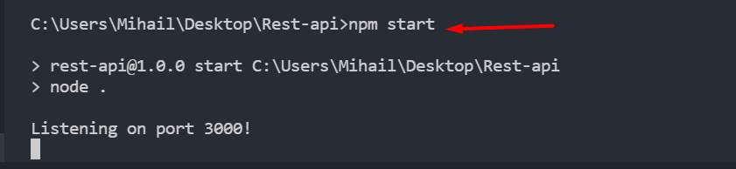
- If you have another version and it gives you an error, go to this configuration file and fix this dbURL:
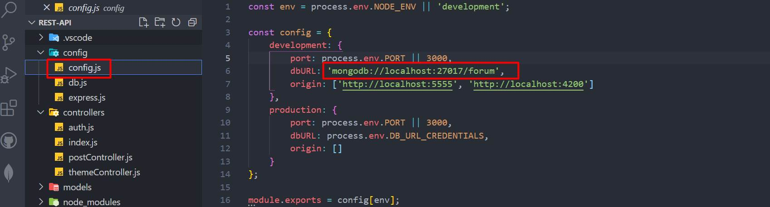

REST API
You are provided also with REST API. To bring life on that API you should first install the dependencies with the command "npm install". After that, type the command "npm start". In order to fetch the themes, you will have to make a GET request on "localhost:3000/api/themes".

Logged/Unlogged User
NOTE: Because we haven't covered authentication yet (how to login and register), you can hardcode it with a variable.
Logged out users see the Login and Register buttons/links.

Implementation of the Main Section
After the backend is ready to use, you should fetch all themes and list them on the home page in the format you saw in the skeleton.
The themes in the main section should be descending sorted by the subscribers.
Each theme should have a title, date (when the theme is created), the username of the creator, count of the subscribers of the theme.
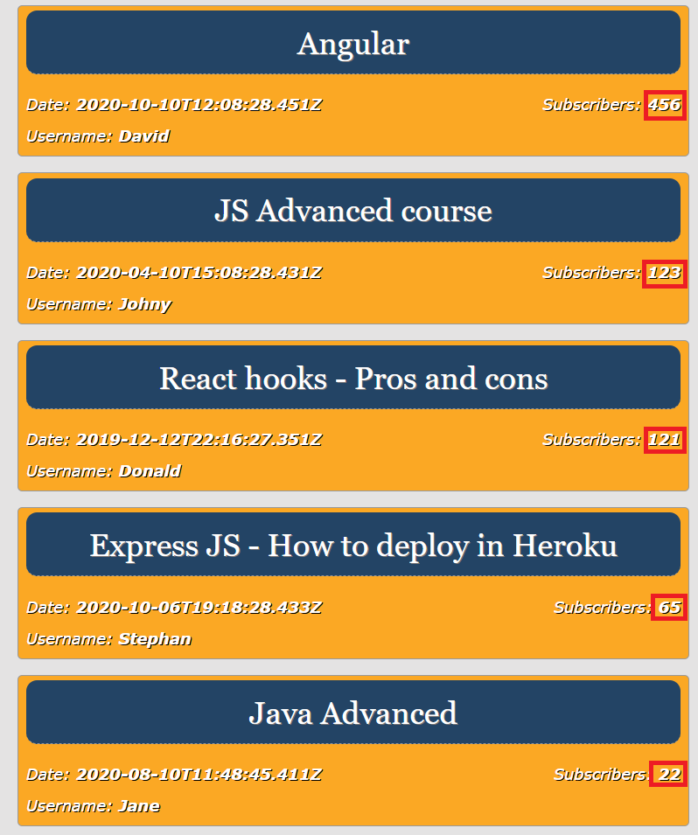

Implementation of the Aside Section
In the Recent posts section, only the 5 latest posts must be shown! (https://localhost:3000/api/posts?limit=5) The posts will be returned from the REST-api sorted by the time of creation.
Each component should have a title (the title of the theme), a username of the user, whom the last comment in the theme belongs, and the time the post was created.
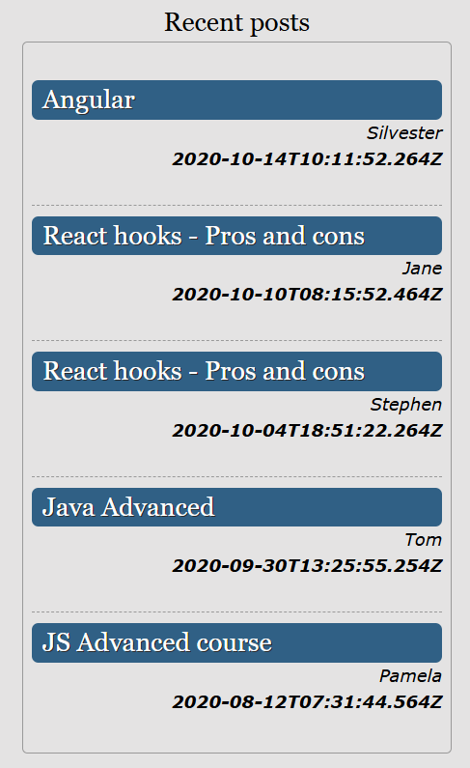
GOOD LUCK!

