为了画这个图参考的帖子：

<https://stackoverflow.com/questions/54407648/connecting-grouped-points-with-lines-in-ggplot/54408429#54408429>

<https://stackoverflow.com/questions/44656299/lines-connecting-jittered-points-dodging-by-multiple-groups/44657850#44657850>

<https://stackoverflow.com/questions/37992654/plotting-all-data-as-geom-point-and-including-lines-showing-means-in-ggplot2-is>

<https://community.rstudio.com/t/how-to-connect-points-within-each-subjects-data-in-a-plot/74786/2>

<https://stackoverflow.com/questions/70322686/making-paired-points-in-ggplot-for-multiple-categories>

in this code, the position of lines change, but the position of dots doesn't change, means the geom_ponit(position) code doesn't work, can you tell me why

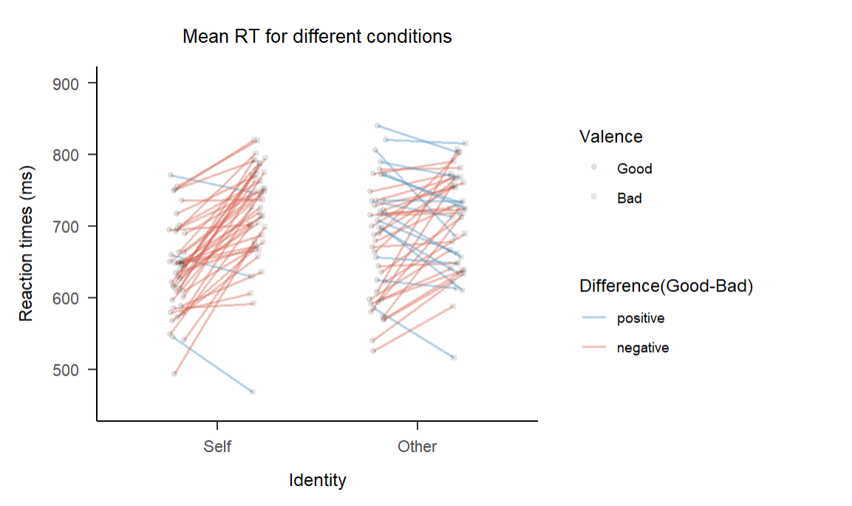

ggplot(df.subdot.merged, aes(x=Identity, y=RT_mean)) +

geom_blank() +

geom_line(aes(x=conds,

color = Diff,

**group = grouping), #在这里，一个被试的self是一组，other是一组**

alpha = 0.4,

position = position_dodge(0.08)) +

geom_point(aes(x = conds,

shape = Valence),

alpha = 0.2,

position = position_dodge(0.08)) +

scale_color_manual(values = popsicle)+

scale_shape_manual(values = c("circle", "square"))+

labs(title="Mean RT for different conditions",

x="Identity",

y="Reaction times (ms)",

color = "Difference(Good-Bad)") +

papaja::theme_apa()

问题是我希望point和line位置全都dodge一下，但是只有line doge了，point却没有，原因是：

大意就是，dodge是垂直地用来分散位置的，那你就要说明垂直的有哪些，在这个例子里，因为线是两点连，线的位置是两点变，所以点也得相应的两点变，也就是一组一组变。

In your code, the position of lines is changing **because you have specified the position = position_dodge(0.08) argument in the geom_line function.** This argument is used to dodge the lines horizontally, creating separate groups for each value of grouping. As a result, the lines are shifted horizontally to avoid overlap.

However, the position of dots (points) is not changing because you have also specified the position = position_dodge(0.08) argument in the geom_point function. This argument is used for dodging points horizontally as well, but it seems that you don't have a categorical variable mapped to the x aesthetic in geom_point. **Without a categorical variable, dodging the points doesn't have any effect. If you want to dodge the points, you need to map a categorical variable to the x aesthetic in the aes function of geom_point.**

To summarize, the geom_line function is being dodged horizontally because of the position = position_dodge(0.08) argument, but the geom_point function is not being dodged because there is no categorical variable mapped to the x aesthetic.

**what is the usage of aes(group) ?**

The aes(group) function is used in data visualization libraries, such as ggplot2 in R, to define a grouping variable for plotting. It allows you to specify a categorical variable that will be used to group the data and apply different visual attributes, such as color or line type, to each group.

By using aes(group), you can create visualizations that display distinct groups within your data, making it easier to compare and analyze different categories or subsets. For example, **you can use it to create separate lines or bars for each group in a line or bar plot, respectively.**

In summary, aes(group) is used to specify a grouping variable for plotting purposes, enabling the visualization of distinct groups in a dataset.

**geom_blank():** Therefore, in your particular code, adding geom_blank() before geom_line() prevents the x-axis scale from being affected by the subsequent geom_line() layer, maintaining the original identity scale.