Step to store data into hive:

Put the csv file into hadoop folder called *DM*





Then create an external table named *data_table* in hive.

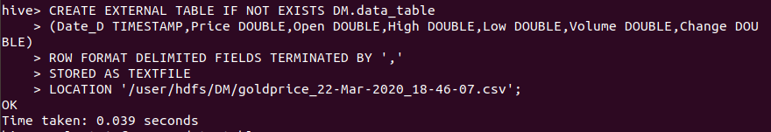



Load the csv file into the table in hive.

