Name: Hii Nian Yu

Matric Number: 17007070/1 (WQD180038)

Github link: <https://github.com/hiinianyu/DataMining>

Video link: https://www.loom.com/share/1d115fd969b441c6b4044a24bb5d8c6d

Title: Gold Price Prediction

**Milestone 2**

Step to store data into hive:

The data file has been saved into HDFS system based on Milestone 1. Double check whether it is stored inside the system using *-ls* command.



Then create an external table named *data_table* in hive.

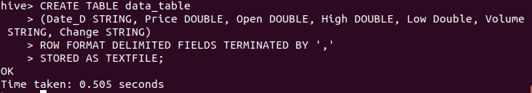

Load the csv file into the table in hive.

