Name: Hii Nian Yu

Matric Number: 17007070/1 (WQD180038)

Github link: <https://github.com/hiinianyu/DataMining>

Video link: https://www.loom.com/share/01c7d2995084443cacbf816b8eb7e713

Title: Gold Price Prediction

**Milestone3**

In terminal, start Hadoop and hiveserver2

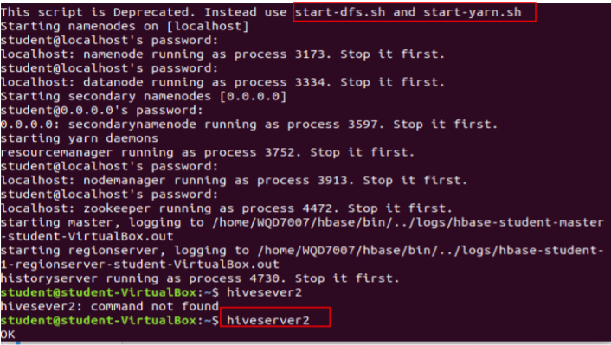

In python, import the pyhive library to connect to hive server

Host = localhost, port = 10000, database = default

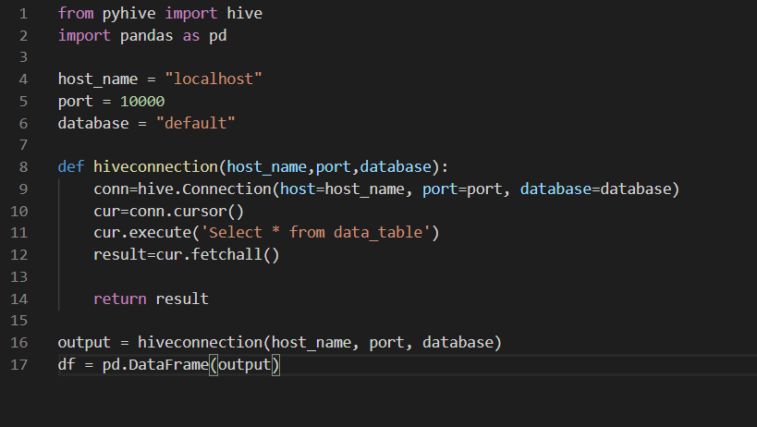

Read the top 10 lines of the data



